# DEVELOPING QUEST-BASED WEB SYSTEM OF CAREER PROGRESSION FOR EMPLOYEES OF YOONET INFORMATION TECHNOLOGY COMPANY USING POINTWISE RANKING ALGORITHM

A Thesis Project Presented to the Faculty of the College of Computer Studies

Bataan Peninsula State University Main Campus

In Partial Fulfillment

Of the Course Requirements in Bachelor of Science in Computer Science

Major in Software Development

By:

Atenta, John Mark M. Bacani, Christiane Relly Joselle A.

Dilig, Aldrin I. Ferrer, John Ronnel B.

JULY 2025

# Chapter INTRODUCTION

**Background of the study**

In today's rapidly moving technology landscape, onboarding and qualification courses have become key elements of software development companies' success. For the employees, the first few months of employment are extremely important. Because they are transferred from academic or previous professional settings to new company culture and expectations. A rapidly growing technology company, Yoonet’s Information Technology Company acknowledges the need to provide structured, attractive and efficient systems for managing new developers in the early stages of professional growth.

Traditional onboarding methods such as mentoring programs, static training modules, and manual monitoring often lack interactivity, scalability, and personalization. These approaches can lead to developing skills development, reduced commitment, and inconsistent knowledge acquisition of new settings. To address these challenges, integration of quest-based progression systems can provide a more dynamic and more gaming approach to employee development.

The Quest-based system is inspired by game design elements that perform tasks (quests) that unlock the following complexity levels: These quests are not only educational, but also motivated, providing clear goals and experience for your work engagement.

The proposed system will be used as a digital platform for career development and includes the quests expected with Yoonet's technical, collaborative and organizational skills. Visualizing progress diagrams enables

employees to clearly recognize their current position, future goals and logical paths and achieve them. Additionally, supervisors and representatives receive data- controlled insights into the progress of employees and areas that need to be improved.

This study aims to design and develop a quest-based web system of career progression for employees of yoonet information technology company, using a pointwise ranking algorithm to dynamically improve work engagement. Innovation lies in the combination of educational structures and algorithmic logic to optimize development for both individuals and organizations.

Ultimately, the system strives for all important attributes in the rapid software industry after improving onboarding efficiency, increasing employee motivation and promoting continuous learning

# Statement of the Problem

The main problem of this study is how to develop and implement a quest- based web system for career progression using pointwise ranking algorithm that enhances career progression for the employees of Yoonet

# Specific Problems

* How will the users register before logging in into the web system?
* How will the system track the employees progress?
* How will the HR and Management handle the quest for employees?
* How will the system users know how the system works?
* How will the employees recognize their skills in a hierarchical way?
* How will the HR and Management Maintain the system?

# Objectives of the Study

The main objective of the study is to develop a Quest-Based Web System for Career Progression for Employees of Yoonet using Pointwise Ranking algorithm that is capable of streamlining career growth through quest-based progression thereby improving the efficiency of onboarding and skill development.

Specially, the study aims to:

* Quest-Based Web System of Career Progression for Employees of Yoonet Information Technology Company using Pointwise Ranking Algorithm that is capable of:
  1. Allowing the HR and employee to register by providing personal details in the registration.
  2. Allowing the system to manage the progress of employees by Implementing a progress tracker to visualize skill their growth.
  3. Allowing the HR and Management to manage the web system using adding, deleting, and updating the information inside the system.
  4. Creating a Demo tutorial to guide the users on how to use the system.
  5. Creating a Leaderboard feature for employees in the hierarchical order.
* Create a System using VSCode, XAMPP Control Panel, HTML, CSS, PHP and JavaScript as Software Requirements and Laptop Computer, Router as Hard Requirements.
* Test and Improve the developed system in terms of acceptability and efficiency; and
* Evaluate the acceptability of the developed system based on the criteria of ISO 25010 to meet the stated and implied needs of the user based on acceptability, efficiency and reliability.

# Scope and Delimitations of the Study

The Gamified Career Progression System with Pointwise Ranking is designed to enhance employee development through quest-based skill advancement, providing transparent progression tracking and competitive motivation. This system will be used exclusively by registered employees with organizational email accounts, featuring role- based dashboards (Quest Taker/Giver), XP-based leveling, public leaderboards, and customizable quest creation with attachment submissions. The application includes:

1. Employee ranking through pointwise XP accumulation
2. Quest creation with difficulty-based XP rewards (1-100)
3. Public/private quest visibility settings
4. Group collaboration functionality
5. Dark/light mode interface customization
6. Submission management with file uploads (PDF, JPG, DOC ≤5MB)
7. Career path specialization (Tech/Leadership/Business)
8. Real-time leaderboard with global rankings
9. Personal stat tracking (completed quests, level, rank)
10. Mobile-responsive dashboards

The research study is conducted by students from Bataan Peninsula State University – Main Campus.

# Significance of the Study

This study will benefit the following groups or individuals:

**Employees.** The study can help employees to provide clear goals and task(quest) to complete, which helps them to master their foundational skills.

**HR Department and Management.** The study can serve as helpful tool for their employee work distribution management that can use for future developments.

**Tech Companies.** This study will further enhance their skills and knowledge in developing successful application projects.

**Future Researchers.** The study can serve as their basis in developing their own version of the project. To develop an application that is related to the system allowing for further improvements on their studies.

# Chapter 2

## CONCEPTUAL FRAMEWORK

This chapter represents the various related literature and studies including the knowledge, software and hardware requirements and the conceptual model of the study. This Chapter includes an operational Definition of terms, to assist users in understanding unfamiliar technical terms.

### Review of Related Literature and Studies

This paper aims to examine the related literature and relevant studies that the researchers uncovered while establishing the importance of the current study. It explores existing works on Web Development, Career Progression, and Gamification.

### Web Development

Web development is the process of designing, constructing, and managing websites and web applications. It covers everything from web design to programming and database management. Web development is typically classified into three main categories: frontend development, backend development, and full stack development.

According to Alex Mika (2025) Organizations use websites to interact with the digital platform. Web developers play a critical role in ensuring that customers receive important information via a browser. In addition, websites are essential tools for modern businesses. Web development is an essential process for businesses to remain relevant in a highly competitive digital market. Since

everyone is on the internet today, websites must meet the highest possible standards to stand out.

With the help of web development, our proposed system will benefit Yoonet’s for their business success. Alex Mika (2025) underscores that websites are indispensable for modern businesses to deliver information and remain competitive. This principle extends internally to quest-based career progression system, which functions as a dedicated web platform for the employees of Yoonet by leveraging responsive design, real-time analytics, and HR-customizable workflows. Furthermore, it paradoxically trains developers using the very web technologies they deploy professionally—reinforcing their role as enablers of business innovation.

According to Henry (2025) Web development combines creativity and technical skills to create a variety of digital products, including websites, web apps, and even games. Whether you prefer front-end design, back-end logic, or full-stack development, this field provides a variety of paths to suit your interests and strengths. With increasing job opportunities, competitive salaries, and the ability to work remotely, web development remains an appealing career option in 2025.

In relation to our proposed system, Henry highlights the diverse career opportunities in web development, which mirrors our system’s goal of structuring career progression for the employees of Yoonet. By using quests, we provide a clear and motivating pathway for developers to acquire skills and advance in their careers, aligning with the broader trends in the tech industry.

According to WeeTech Solution (2023) Web development is an important part of today's business world, offering companies a variety of advantages and opportunities. A website can help businesses achieve their objectives by

increasing their online presence and marketing efforts, as well as streamlining business processes and providing valuable data.

As technology evolves, the importance of web development for businesses and organizations will only increase, making it a critical investment for companies looking to stay ahead of the competition.

WeeTech Solution positions web development as a catalyst for business efficiency, data intelligence, and competitive differentiation. These principles manifest in the proposed quest-based system. the system delivers WeeTech’s promised ‘operational advantages’: HR gains reusable quest templates and performance analytics, while developers receive structured skill paths. Crucially, the system’s data dashboards transform progression metrics into strategic insights, allowing Yoonet to rapidly address skill gaps and retain top talent in a competitive tech landscape.

### Career Progression

According to Lorelei Trisca (2025) Employees become disoriented when there is no clear map to follow. And if they get lost, they may as well leave. A clear career progression framework enables employees to understand where they are in their careers and what opportunities for professional development exist within the company to help them build a successful career.

According to HiPeople (2023) Career advancement is a path toward personal and professional development. It is about constantly improving your skills, setting and achieving goals, and moving forward in your chosen field. Whether you're an individual looking to advance your career or an HR professional guiding others, the principles of career progression are the same.

According to Nadine von Moltke (2020) Traditional job structures based on

hierarchical roles were originally intended to facilitate job evaluations and compensation schemes. These structures can limit employees to narrowly defined roles at multiple traditional levels. Unfortunately, this extensive grading system can lead to counterproductive behaviors, such as employees prioritizing title pursuits and promotions over excelling in their current positions. Organizations can now implement a modern career progression framework that is in line with today's work environment while also adapting to changing market trends and essential skills.

The three literature highlights three critical needs that our system addresses: clarity (Trisca, 2025), continuous development (HiPeople, 2023), and flexibility beyond hierarchies (von Moltke, 2020). Yoonet's quest-based platform exemplifies these principles. It frames growth as a series of incremental accomplishments, mirroring HiPeople's view of career advancement as continuous skill development. By decoupling progression from traditional titles and anchoring it to skill mastery, the system operationalizes von Moltke's call for adaptive frameworks. Together, these features ensure developers pursue meaningful growth over empty promotions.

### Gamification

According to Zippia (2024) 90% of employees say gamification makes them feel more motivated and productive at work. Using gamification to increase employee engagement transforms your workplace culture, enhances productivity, and creates a more engaged workforce. By understanding the benefits, following best practices, and leveraging creative gamification ideas, your organization can create a dynamic and motivated team ready to achieve new heights.

Bitrian et al. (2020) found that users are satisfied in terms.of competency,

autonomy, and relevance to the achievement-related game Achievements and

immersion-related elements; and socially related elements met the user's need for relatedness.

According to Ozdamli (2023), gamification has brought a new level of There was previously no sense of fun in the fitness culture. Game elements, Scores, leaderboards, and challenges are mechanics that help create a sense of adventure, as the user/subject is constantly engaged in a game-like activity.

Our proposed system quest-based progression system utilizes evidence- based gamification principles to transform employee development. Zippia's (2024) discovery that 90% of employees report increased motivation through gamification informs the core design: actionable quests replace passive training, resulting in goal-driven engagement that boosts productivity. Bitrian et al.'s (2020) psychological framework is put into practice through validated skill badges and collaborative challenges. Ozdamli's (2023) "sense of adventure" is expressed through point-based leveling, time-bound epic quests, and explorable skill graphs, which turn career advancement into an immersive journey. Together, these mechanics form a unified ecosystem in which motivation, psychological fulfillment, and experiential engagement work together to accelerate mastery.

### Game on: Can gamification enhances productivity?

According to the research of Habeeb Ur Rahiman et al (2023) gamification can increase work engagement by giving employees a sense of autonomy, competence, and relatedness while also creating a fun and engaging work environment. Gamification is intended to increase consumer and employee engagement and ensure that they work together to achieve a common goal. The concept of gamification is as old as learning itself; yet, the term "gamification" is of

recent origin.

It was studied to examine the impact of gamification in various organizations and its relationship to job engagement and productivity. A primary investigation was conducted to determine the relationship between the various variables, with data collected from 400 respondents working in various sectors of the economy, both public and private, from Gulf countries. The structural equation model and SPSS have been used to analyze the results.

The study's findings indicate that variables such as perceived adoption and usefulness in the gamified system are significantly associated with job engagement. Similarly, employee recognition and perceived motivation improve productivity. The study identified job engagement as a mediating factor for increasing organisational productivity in a gamified system.

Gamification's effectiveness in increasing work engagement may be determined by factors such as system design, individual employee preferences and motivations, and organizational culture and goals. The findings have important implications for understanding how employees in the service sector become aware of the gamified working environment and respond to it through work engagement and productivity.

### Effect of Gamification on Employee Engagament with Special Reference to School Teachers

According to P. Saranya et al. (2023) This study investigates the role of gamification in improving employee engagement. Levels such as engagement, leadership, enablement, alignment, and development. Gamification will Employees can refresh their minds, reduce work stress, improve physical fitness, and enhance Their mental health. It is also discovered that gamification outcomes have a

significant impact on Employee engagement at school. Overall, the study

emphasized the importance of the Gamification can help boost employee engagement.

### Understanding the effects of gamification on work engagement: The role of basic need satisfaction and enjoyment among millennial

According to Taylor and Francis (2023) Study found positive effects of gamification on work engagement, specifically that gamification positively influenced work engagement, mediated by basic need satisfaction and enjoyment The following three (3) studies are all studies that describes on gamification on work engagement or in work in general. All of the studies used gamification as a test to see if gamification has an impact to employees work performance. The aim of our proposed system is to have more engagement to their work activity. The difference of our studies compared to our proposed system

is mostly just testing how gamification works on an aspect of the perso

### Software Requirements

The software requirements that will be used for the development of the Quest-Based Web System of Career Progresion for Employees of Yoonet Information Technology Company using Pointwise Ranking Algorithm are VSCode, Xampp, HTML, JavaScript, CSS.

### VSCode

Visual Studio Code is a free, lightweight but powerful source code editor that runs on your desktop and on the web and is available for Windows, macOS, Linux, and Raspberry Pi OS. It comes with built-in support for JavaScript, TypeScript, and Node.js and has a rich ecosystem of extensions for other programming languages (such as C++, C#, Java, Python, PHP, and Go), runtimes (such as .NET and Unity), environments (such as Docker and Kubernetes), and clouds (such as Amazon Web Services, Microsoft Azure, and Google Cloud Platform).

### XAMPP Control Panel

A XAMPP provides a Control Panel for efficient management of the software in the XAMPP package. You can use the Control Panel to determine whether Apache and MySQL are currently running and to start or stop them. Before you can use your development environment, Apache and MySQL must be running. This section tells you how to use the Control Panel to start and stop Apache and MySQL. The XAMPP Control Panel can run continuously, ready for you to use at all time.

## HTML

Hypertext Markup Language (HTML) is the standard markup language for documents that will be displayed in a web browser. It determines the content and structure of web content. Cascading Style Sheets (CSS) and scripting languages like JavaScript are frequently used to aid in this process. Web browsers receive HTML documents from a web server or from local storage and convert them into multimedia web pages. HTML describes a web page's structure semantically and used to include appearance cues.

## CSS

CSS (Cascading Style Sheets) is a style sheet language used to specify the presentation and styling of a document written in a markup language such as HTML or XML (including XML dialects such as SVG, MathML, or XHTML). CSS is a cornerstone technology of the World Wide Web, alongside HTML and JavaScript. CSS is designed to enable the separation of content and presentation, including layout, colors, and fonts. This separation can improve content accessibility, because the content can be written without concern for its presentation; provide more flexibility and control in the specification of presentation characteristics; and enable multiple web pages to share formatting by specifying the relevant CSS in a separate.css file, which reduces complexity and repetition in the structural content; and enable the .css file to be cached to improve the page load speed between the pages that share the file and its formatting.

### JavaScript

JavaScript, commonly abbreviated as JS, is a programming language and core technology of the World Wide Web, alongside HTML and CSS. On the client side, 99% of websites use JavaScript to control webpage behavior. Web browsers have a dedicated JavaScript engine that runs client code. These engines are also used in a number of servers and applications. Node.js is the most popular runtime system for use outside of the browser. JavaScript is a high-level, just-in-time- compiled language that follows the ECMAScript standard. It features dynamic typing, prototype-based object-orientation, and first-class functions. It has multiple paradigms, including event-driven, functional, and imperative programming styles. It includes APIs for working with text, dates, regular expressions, standard data structures, and the Document Object Model (DOM).

### Draw.io

Draw.io is a free, online diagramming tool that allows you to create flowcharts, diagrams, mind maps, organize charts, and much more. A web-based application, Draw.io is fully integrated with Google Drive. This means that you can automatically save the results of your work in your Google Workspace or Gmail account. This is an open source, self-hosted, diagramming tool that can help your team create visual charts using pre-designed templates on a drag-and-drop interface, while also being able to import and export diagrams in various formats.

### Hardware Requirements

Include a paragraph discussing the summary of the hardware used the development of the Quest-Based Web System of Career Progression for Employees of Yoonet Information Technology Company using Pointwise Ranking Algorithm.

A Laptop, according to Zach Cabading (2024), A laptop, also known as a notebook, is a portable personal computer with a built-in keyboard, screen, and trackpad or pointing device. Laptops run full desktop operating systems and are designed to handle a wide range of tasks, from basic web browsing to complex productivity applications and even gaming. The average laptop typically runs for about four to eight hours due to the power demands of their hardware components.

A Laptop will be needed for developing our System. VSCode is accessed by using a computer as well as XAMPP Control Panel, HTML, CSS, JavaScript and Draw.io, Currently, researchers only need a computer capable of running all of these, and since the application is not too heavy and is designed to run on an Web browser, the Programmers will not need a powerful computer to create the website.

A Wireless Router, according to Alison Grace Johansen (2023), A wireless router connects directly to a modem via a cable. This enables it to receive information from and transmit data to the internet. The router then establishes and communicates with your home Wi-Fi network via built-in antennas. This connects all of the devices on your home network to the internet.

A Wireless Router (With Provided ISP) would be used for developing our system. To enable to access the full function of software requirements of VSCode, HTML, CSS, JavaScript, XAMPP Control and Draw.io.

## ISO 25010

According to Nistala et al. (2019), the International Organization for Standardization (ISO) developed the ISO-25010 Software Quality Model. ISO- 25010 is a model designed to assess the quality of software used by an organization or individual (Nistala et al., 2019). ISO 25010:2011 is an international standard guideline for software evaluation published by the Canadian Standards Association in 2011.

According to Karima Moumane, et. et al., (2024), ISO/IEC 25023:2016, which is part of the SQuaRE standard series, provides metrics for evaluating the quality of systems and software products. It is based on the characteristics and sub-characteristics established by ISO/IEC 25010.

According to Keibach and Shayesteh (2022), the ISO product quality model integrates the evaluation of functional suitability, performance efficiency, compatibility, usability, reliability, security, maintainability, and portability.

An international standard called ISO 25010 establishes a quality approach for assessing systems and software. This standard will serve as a roadmap for evaluating the quality, usability, compatibility, performance efficiency, and functional applicability of Our system's dependability, security, maintainability, and portability.

### Conceptual Model of the Study

According to Creswell (2019), a conceptual framework can guide research by providing a visual representation of theoretical constructs (and variables) of interest. Designing a conceptual model begins with conducting a thorough review of the literature. Search peer-reviewed journal articles, books/monographs, conference papers, and other relevant reference

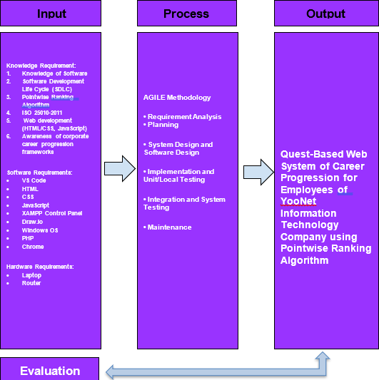

*Figure 1. Conceptual Model of the Proposed Study*

The conceptual framework for Quest-Based Web System of Career Progression for Employees of Yoonet Information Technology Company using Pointwise Ranking Algorithm presented in Figure 1, and it has four (4) phases that includes input phase, process phase, output phase, and evaluation phase.

The input phase contains the knowledge requirements which includes the concept of Quest-Based Web System of Career Progression for Employees of Yoonet Information Technology Company and further facilitating the knowledge required in developing the developed system. Additionally, the software requirements needed are identifies as VSCode, HTML, CSS, JavaScript, XAMPP Control Panel and PHP. Also, the hardware requirements are a computer system, laptop and a wireless router with ISP. All these input requirements are necessary to start and complete the thesis project.

In addition to that, the proponents implemented the AGILE model as the methodology in processing the input to the development of the system. It involves different phases that are vital in the system’s development. These phases are analysis, planning, testing, and evaluation.

Moreover, after processing the input, the proponents have the output and the developed system quest- based web system for employees of Yoonet. Application characteristics which include acceptability, efficiency and reliability

### Operational Definition of Terms

**Quest-Based Web System for Employees of Yoonet -** Quest-Based Web System of Career Progression: A digital platform created for Yoonet Company to manage career advancement for employees of Yoonet using in-game elements and task (quests) and role-based Dashboard Interface, with Pointwise Ranking Algorithm used to track progress and display achievements to employees.

**Web Development** – it’s the process of making websites and web apps that work on the internet. Web developers create websites using languages such as HTML, CSS, JavaScript (front-end) and Python, PHP, and Node.js (back-end).

**Career Progression** – Career progression refers to the advancement you make in your professional life. It is the journey from your starting point to your long-term professional objectives. It entails accepting more responsibility, learning new skills, increasing your earning potential, and achieving a higher level of professional satisfaction.

**Gamification** – Gamification is the use of game-like elements and principles in non-gaming settings. It is about using the psychological triggers that make games appealing—such as points, badges, and leaderboards—to encourage participation, engagement, and loyalty in activities such as work, learning, or fitness. The central idea is to appeal to people's natural desires for competition, achievement, status, and collaboration in order to make mundane or difficult tasks more enjoyable and rewarding.

**ISO 25010** - ISO 25010 is the foundation of a product quality evaluation system. The quality model specifies which quality characteristics will be considered when assessing the properties of a software product.

**AGILE** – Agile is way of project management that involves dividing large projects into smaller, more manageable pieces, receiving feedback often, and making adjustments to the plan as needed. Instead of simply conforming to a strict, predetermined plan, it's about being adaptable and cooperative.

**Software** – Software is a set of instructions that tells a computer's hardware what to do. It is the non-physical part of a computer that you cannot touch.

**Hardware** –All of a computer's or electronic system's tangible, physical parts are referred to as hardware. It's hardware that you can be able to see, feel, or touch. Imagine it as a computer's body and bones.

# Chapter 3

## METHODOLOGY

This chapter discusses various information that was thoroughly specified and simplified by the researchers for a better understanding of the system. Present the Data Flow Diagram, Context Diagram, Level 0 Diagram, and Child Diagram. Use Case Diagram, Activity Diagram, Entity Relationship Model, Data Dictionary and Gantt Chart.

### Data Flow Diagram (DFD)

According to blog.hubspot.com (2021), A data flow diagram (DFD) is a visual representation of the information flow through a process or system. DFDs help you better understand process or system operation to discover potential problems, improve efficiency, and develop better processes. They range from simple overviews to complex, granular displays of a process or system. Moreover, Data flow diagrams provide a straightforward, efficient way for organizations to understand, perfect, and implement new processes or systems. They’re visual representations of your process or system, so they make it easy to understand and prune.

### Context Diagram

According to Khusid, A. (2011). A context diagram shows how an internal software system and external entities interact. It's principally used to assist organizations with truly understanding the extent of a framework. Thus, they can sort out how best to plan another framework and its prerequisites or how to work

on a current framework. Because they are high-level diagrams, context diagrams do not go into the specifics of the system. Instead, they provide a straightforward, easy-to- understand map of the entire system.

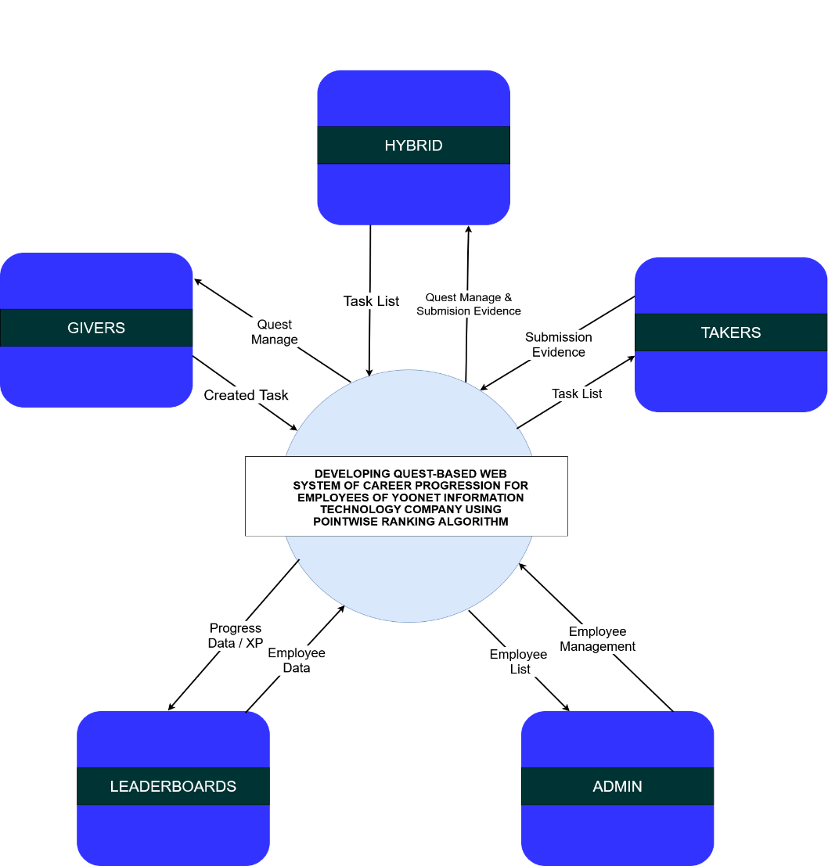According to venngage.com (2022), A context diagram is a high-level view of a system. It’s a basic sketch meant to define an entity based on its scope, boundaries, and relation to external components like stakeholders. Otherwise known as a Level 0 data flow diagram, a context diagram provides a general overview of a process, focusing on its interaction with outside elements rather than its internal sub-processes. The latter is typically reserved for more advanced data flow diagrams.

***Figure 2.*** Context Diagram

Figure 2 presents the context diagram for the Quest-Based Web System of Career Progression, illustrating the system's boundaries and its interactions with external entities. The diagram identifies four key external entities**: Admin,** Giver, Taker Hybrid and the **Leaderboard** as a central output component.

The **Admin** is responsible for the core system maintenance and user management, handling the Employee List and overall Employee Management to ensure the platform runs smoothly for all users.

The Employee interacts with the system in three primary roles, as defined by the system's role-based dashboards. As a Giver, an employee can create and assign tasks, sending a Created Task into the system. As a Taker, an employee receives a Task List, works on quests, and submits Submission Evidence for review. A Hybrid role encompasses both capabilities. All employee roles receive Progress Data / XP from the system, which fuels the pointwise ranking algorithm, and can view the Leaderboards to see their standing.

Finally, the system itself processes all these interactions, managing the Employee Data, calculating XP, and generating the public Leaderboards in real-time. This diagram establishes the scope of the system, highlighting its function as a central platform for gamified career progression, driven by clear inputs and outputs between the users and the application.

### Level 0 Diagram

According to Ibrahim R. (2010). Level 0 DFDs, also known as context diagrams, are the most fundamental type of data flow diagram. They provide an overview that is simple to understand, but they do not go into great detail. Level 0 information stream diagrams depict a single cycle hub and its relationships with external elements.

The Level 0 diagram provides a detailed depiction of the modeled system. It demonstrates how the system is divided into processes, each of which handles one or more data flows to or from an external agent while providing the entire system's functionality. Internal data stores required by various parts of the system are also identified.

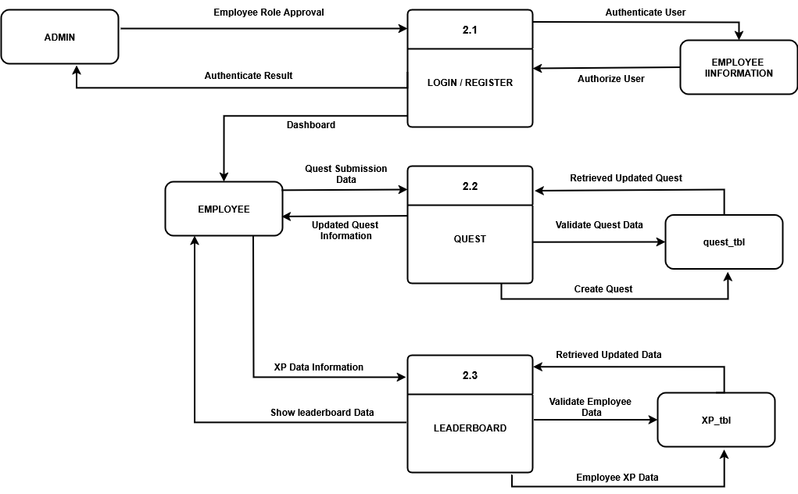

***Figure 3.*** Level 0 Diagram

In Figure 3 shows the major high-level processes of the proposed Quest-Based Web System. The system is decomposed into three main functions:

The first process is 2.1 LOGIN / REGISTER, which handles user authentication and authorization to control access to the system.

The second process is 2.2 QUEST, which manages the core functionality of creating, validating, and retrieving all quest-related data for users.

The third process is 2.3 LEADERBOARD, which is responsible for processing employee XP data and generating the ranked leaderboard

.

### Child Diagram

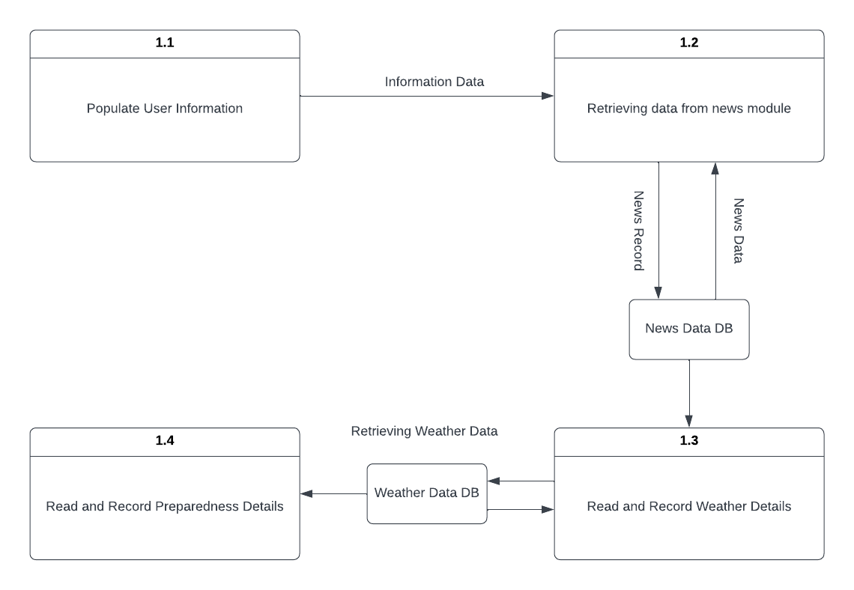Each process on Diagram 0 may in turn be exploded to create a more detailed child diagram. The process on Diagram 0 that is exploded is called the parent process, and the diagram that results is called the child diagram. The primary rule for creating child diagrams, vertical balancing, dictates that a child

diagram cannot produce output or receive input that the parent process does not also produce or receive. All data flow into or out of the parent process must be shown flowing into or out of the child diagram.

***Figure 4.*** Child Diagram of user

Figure 4 shows the child diagram of the user of the Damage Assessment and Disaster Management Application System using Dijkstra's Algorithm. The diagram shows the data flow in every process of the user process.

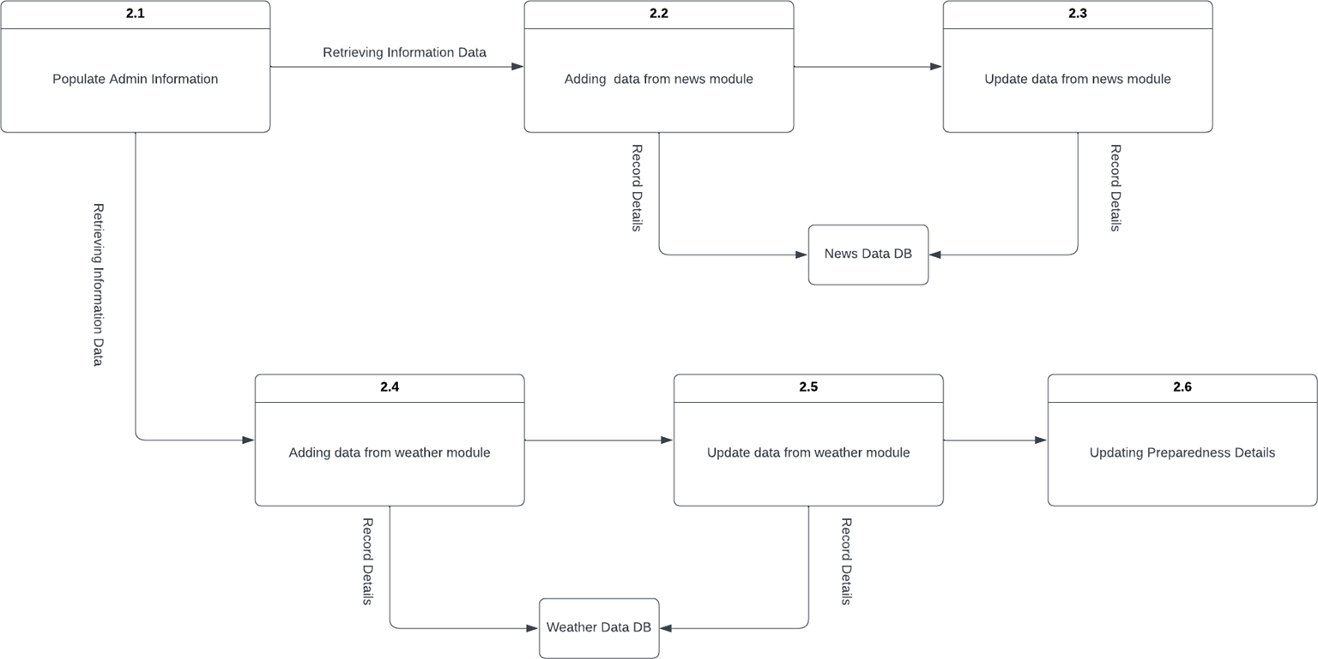

**2,5**

**Assessment**

***Figure 5.*** Child Diagram of admin

Figure 5 shows the child diagram of the admin of the Damage Assessment and Disaster Management Application System using Dijkstra's Algorithm. The diagram shows the data flow in every process of the admin process.

### Database Design

Database design contains entity-relationship model and data dictionary used in the developed system.

### Entity-Relationship Model

According to Li, Q., & Chen, Y. L. (2009). The Entity-Relationship Diagram (ERD) is a common design method for database systems and data structures. This chapter introduces the syntax and semantics of ERD for data modeling.

Additionally, a structured approach to the creation of ERD models is discussed. Understanding the fundamental characteristics of information or data is necessary for managing it. Data are meaning-filled, symbolic representations of facts. A fact that does not have a meaning is of no use, and a fact that has the wrong meaning may be problematic.

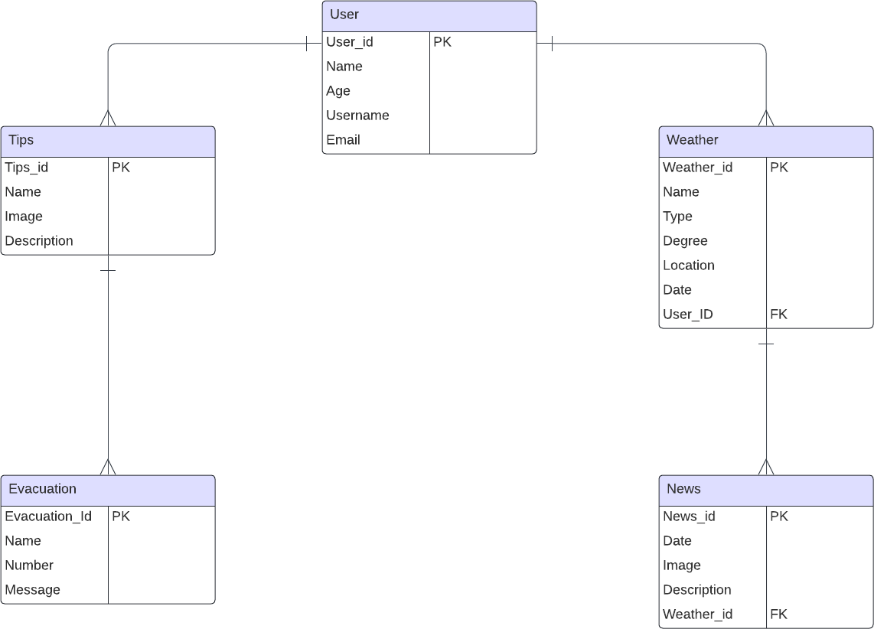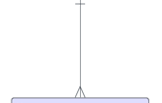

***Figure 7.*** Entity-Relationship Model

Figure 7 shows the Entity Relationship Model of the proposed Damage Assessment and Disaster Management Application System using Dijkstra’s Algorithm. The figure shows the five tables used in the system and each table will store all the data that the user will place on the system.

### Data Dictionary

According to library.ucmerced.edu (2023), A Data Dictionary is a collection of names, definitions, and attributes about data elements that are being used or captured in a database, information system, or part of a research project. It

describes the meanings and purposes of data elements within the context of a project, and provides guidance on interpretation, accepted meanings and representation. A Data Dictionary also provides metadata about data elements. The metadata included in a Data Dictionary can assist in defining the scope and characteristics of data elements, as well the rules for their usage and application.

|  |  |  |  |  |  |
| --- | --- | --- | --- | --- | --- |
| Data Dictionary | | | | | |
| System Name: DEVELOPING QUEST- BASED WEB SYSTEM OF CAREER PROGRESSION FOR EMPLOYEES OF YOONET INFORMATION TECHNOLOGY USING POINTWISE RANKING ALGORITHM | | | | | |
| Subject: Employee_Groups | | | | | |
| PK | FK | Field Name | Data | Length | Description |
| Yes | No | Employee_Gro ups ID | int | (11) | employee_id of the employee_grou  ps |
| No | No | Group_Name | varchar | (100) | group_name of the employee_grou ps |
| No | No | Description | text |  | Description of the employee_grou ps |
| No | No | Created_by | varchar | (20) | Created_by the employee_grou ps |
| No | No | Created_at | Timestamp |  | Created_at the employee_grou ps |

#### Table 1.

Table 1 shows the Employee_Groups table of the proposed system Developing Quest-Based Web System Of Career Progression for Employees of Yoonet Information Technology Company Using PointWise Ranking Algorithm. This table stores all the information that the user will place in the system. The table consists of the following fields: employee_id, group name, description, created by and created at.

|  |  |  |  |  |  |
| --- | --- | --- | --- | --- | --- |
| Data Dictionary | | | | | |
| System Name: DEVELOPING QUEST- BASED WEB SYSTEM OF CAREER PROGRESSION FOR EMPLOYEES OF YOONET INFORMATION TECHNOLOGY USING POINTWISE RANKING ALGORITHM | | | | | |
| Subject: Group_Members | | | | | |
| PK | FK | Field Name | Data | Length | Description |
| Yes | No | Group_Membe rs ID | int | (11) | group_mem bers ID of the group_mem  bers |
| No | No | Group_ID | int | (11) | group_id of the group_mem bers |
| No | No | Employee_ID | varchar | (20) | Employee_i d of the group_mem bers |
| No | No | Joined_at | timestamp |  | Joined_at of the group_mem bers |

#### Table 2.

Table 2 shows the Tips table of the proposed system Developing Quest-Based Web System Of Career Progression for Employees of Yoonet Information Technology Company Using PointWise Ranking Algorithm. This table stores all the information that the user will place in the system. The table consists of the following fields: group_id, employee_id, joined_at.

|  |  |  |  |  |  |
| --- | --- | --- | --- | --- | --- |
| Data Dictionary | | | | | |
| System Name: DEVELOPING QUEST- BASED WEB SYSTEM OF CAREER PROGRESSION FOR EMPLOYEES OF YOONET INFORMATION TECHNOLOGY USING POINTWISE RANKING ALGORITHM | | | | | |
| Subject: Leaderboard | | | | | |
| PK | FK | Field Name | Data | Length | Description |
| Yes | No | Leaderboard_I D | int | (11) | Leaderboar d_id of the leaderboard |
| No | No | Employee_ID | int | (11) | Employee_i d |
| No | No | Total_xp | int | (11) | total_xp of the leaderboard |
| No | No | Last_updated | timestamp |  | last_update d of the leaderboard |

#### Table 3.

Table 3 shows the Tips table of the proposed system Developing Quest-Based Web System Of Career Progression for Employees of Yoonet Information Technology Company Using PointWise Ranking Algorithm. This table stores all the information that the user will place in the system. The table consists of the following fields: leaderboard_id, employee_id, total_xp and last_updated.

|  |  |  |  |  |  |
| --- | --- | --- | --- | --- | --- |
| Data Dictionary | | | | | |
| System Name: DEVELOPING QUEST- BASED WEB SYSTEM OF CAREER PROGRESSION FOR EMPLOYEES OF YOONET INFORMATION TECHNOLOGY USING POINTWISE RANKING ALGORITHM | | | | | |
| Subject: Quest | | | | | |
| PK | FK | Field Name | Data | Length | Description |
| Yes | No | Quest_ID | int | (11) | quest_id of the quest |
| No | No | Title | varchar | (100) | title of the quest |
| No | No | Description | text |  | Description of the quest |
| No | No | XP | int | (11) | xp of the quest |
| No | No | Status | Enum(‘active  ’, ‘archived’) |  | status of the quest |
| No | No | Due_Date | date |  | duedate of the quest |
| No | No | Created_by | varchar | (50) | created_by of the quest |
| No | No | Created_at | datetime |  | created_at of the quest |

|  |  |  |  |  |  |
| --- | --- | --- | --- | --- | --- |
| No | No | Updated_at | datetime |  | updated_at the quest |
| No | No | Category_ID | int | (11) | Category_id of the quest |
| No | No | Quest_Type | enum(‘single  ’ ,‘recurring’) |  | quest_type of the quest |
| No | No | Visibility | Enum(‘privet e’, ‘public’) |  | visibility of the quest |
| No | No | File_path | varchar | (255) | file_-path of the quest |
| No | No | Recurrence_patt ern | varchar | (50) | recurrence_ pattern of the quest |
| No | No | Recurrence_end date | datetime |  | recurrence_ enddate of the quest |
| No | No | Publish_at | datetime |  | publish_at of the quest |

#### Table 4.

Table 4 shows the Tips table of the proposed system Developing Quest-Based Web System Of Career Progression for Employees of Yoonet Information Technology Company Using PointWise Ranking Algorithm. This table stores all the information that the user will place in the system. The table consists of the following fields: quest_id, title, description, xp, status, due_date, created_by, created_at,

updated_at, category_id, quest_type, visibility, file_path, recurrence_pattern,recurrence_enddate and publish_at.

|  |  |  |  |  |  |
| --- | --- | --- | --- | --- | --- |
| Data Dictionary | | | | | |
| System Name: DEVELOPING QUEST- BASED WEB SYSTEM OF CAREER PROGRESSION FOR EMPLOYEES OF YOONET INFORMATION TECHNOLOGY USING POINTWISE RANKING ALGORITHM | | | | | |
| Subject: Quest_attachments | | | | | |
| PK | FK | Field Name | Data | Length | Description |
| Yes | No | Quest_Attachm ents ID | int | (11) | quest_attac hments id of the quest_attac  hments |
| No | No | Quest_ID | int | (11) | quest_id of the quest_attac hments |
| No | No | File_name | varchar | (255) | file_name of the quest_attac hments |
| No | No | File_size | int | (11) | file_size of the quest_attac hments |
| No | No | File_type | varchar | (100) | file_type of the quest attachment s |
| No | No | Uploaded_at | timestamp |  | uploaded_a t of the quest attachment  s |

#### Table 5.

Table 4 shows the Tips table of the proposed system Developing Quest-Based Web System Of Career Progression for Employees of Yoonet Information Technology Company Using PointWise Ranking Algorithm. This table stores all the information that the user will place in the system. The table consists of the following fields: quest_attachment id, quest_id, file_name, file_size, file_type and uploaded_at.

|  |  |  |  |  |  |
| --- | --- | --- | --- | --- | --- |
| Data Dictionary | | | | | |
| System Name: DEVELOPING QUEST- BASED WEB SYSTEM OF CAREER PROGRESSION FOR EMPLOYEES OF YOONET INFORMATION TECHNOLOGY USING POINTWISE RANKING ALGORITHM | | | | | |
| Subject: Quest_Categories | | | | | |
| PK | FK | Field Name | Data | Length | Description |
| Yes | No | Quest_Categori es ID | int | (11) | quest_categ ories id of the quest_categ  ories |

|  |  |  |  |  |  |
| --- | --- | --- | --- | --- | --- |
| No | No | Name | varchar | (50) | name of the quest categories |
| No | No | Description | text |  | description of the quest categories |
| No | No | Icon | varchar | (50) | Icon of the quest categories |

#### Table 6.

Table 6 shows the Tips table of the proposed system Developing Quest-Based Web System Of Career Progression for Employees of Yoonet Information Technology Company Using PointWise Ranking Algorithm. This table stores all the information that the user will place in the system. The table consists of the following fields: quest_categories id, name, description and icon.

|  |  |  |  |  |  |
| --- | --- | --- | --- | --- | --- |
| Data Dictionary | | | | | |
| System Name: DEVELOPING QUEST- BASED WEB SYSTEM OF CAREER PROGRESSION FOR EMPLOYEES OF YOONET INFORMATION TECHNOLOGY USING POINTWISE RANKING ALGORITHM | | | | | |
| Subject: Quest_Submission | | | | | |
| PK | FK | Field Name | Data | Length | Description |

|  |  |  |  |  |  |
| --- | --- | --- | --- | --- | --- |
| Yes | No | Quest_Submiss ion ID | int | (11) | quest_subm ission id of the quest_subm  ission |
| No | No | Employee_ID | varchar | (50) | employee_i d of the quest_subm ission |
| No | No | Quest_ID | int | (11) | quest_id of the quest_subm ission |
| No | No | Submission_Ty pe | Enum(‘file’  ,’link’) |  | submission_ type of the quest_subm ission |
| No | No | File_path | varchar | (255) | file_path of the quest_subm ission |
| No | No | Drive_Link | varchar | (255) | drive_link of the quest_subm ission |
| No | No | Submitted_at | datetime |  | submitted_ at of the quest_subm ission |
| No | No | Status | Enum(‘pendi ng’,’approve d’,’rejected’,’ changes_req  uested’) |  | status of the quest_subm ission |
| No | No | Reviewed_by | varchar | (50) | reviewed_b y of the quest submission |
| No | No | Reviewed_at | datetime |  | reviewed_at of the quest_subm ission |
| No | No | Feedback | text |  | feedback of the quest_subm ission |

|  |  |  |  |  |  |
| --- | --- | --- | --- | --- | --- |
| No | No | Additional_xp | int | (11) | additional_x p of the quest_subm ission |

#### Table 7.

Table 7 shows the Tips table of the proposed system Developing Quest-Based Web System Of Career Progression for Employees of Yoonet Information Technology Company Using PointWise Ranking Algorithm. This table stores all the information that the user will place in the system. The table consists of the following fields: quest_submission id, employee_id, quest_id, submission_type,file_path, drive_link, submitted_at, status,reviewed by, reviewed_at, feedback and additional_xp.

|  |  |  |  |  |  |
| --- | --- | --- | --- | --- | --- |
| Data Dictionary | | | | | |
| System Name: DEVELOPING QUEST- BASED WEB SYSTEM OF CAREER PROGRESSION FOR EMPLOYEES OF YOONET INFORMATION TECHNOLOGY USING POINTWISE RANKING ALGORITHM | | | | | |
| Subject: Quest_Subtasks | | | | | |
| PK | FK | Field Name | Data | Length | Description |
| Yes | No | Quest_SubtaskI ID | int | (11) | quest_subta sks id of the quest_subta sks |
| No | No | Quest_ID | int | (11) | quest_id of the quest_subta sks |
| No | No | Description | text |  | Description of the quest_subta sks |
| No | No | Is_completed | tinyint | (1) | Is_complete d of the quest_subta sks |

#### Table 8.

Table 6 shows the Tips table of the proposed system Developing Quest-Based Web System Of Career Progression for Employees of Yoonet Information Technology Company Using PointWise Ranking Algorithm. This table stores all the information that the user will place in the system. The table consists of the following fields: quest_subtasks id, quest_id, description and is_completed.

|  |  |  |  |  |  |
| --- | --- | --- | --- | --- | --- |
| Data Dictionary | | | | | |
| System Name: DEVELOPING QUEST- BASED WEB SYSTEM OF CAREER PROGRESSION FOR EMPLOYEES OF YOONET INFORMATION TECHNOLOGY USING POINTWISE RANKING ALGORITHM | | | | | |
| Subject: User_Profile | | | | | |
| PK | FK | Field Name | Data | Length | Description |
| Yes | No | User_ID | int | (11) | user_id of the user_profile |
| No | No | Employee_ID | int | (11) | employee_i d of the user_profile |
| No | No | Full_Name | varchar | (100) | Full_name of the user_profile |
| No | No | Email | varchar | (100) | email of the user_profile |
| No | No | Password | varchar | (255) | password of the user_profile |
| No | No | Role | enum(‘quest  _taker’,  ‘quest_giver’  ,’hybrid’) |  | role of the user_profile |
| No | No | Xp | int | (11) | xp of the user_profile |
| No | No | Level | int | (11) | leevel of the user_profile |
| No | No | Created_at | datetime |  | Created_at of the user_profile |

|  |  |  |  |  |  |
| --- | --- | --- | --- | --- | --- |
| No | No | Updated_at | datetime |  | Updated_at of the user_profile |
| No | No | Theme | varchar | (20) | Theme of the user_profile |
| No | No | Darkmode | tinyint | (1) | Darkmode of the user_profile |
| No | No | Font_Size | varchar | (10) | font_size of the user_profile |

#### Table 9.

Table 9 shows the Tips table of the proposed system Developing Quest-Based Web System Of Career Progression for Employees of Yoonet Information Technology Company Using PointWise Ranking Algorithm. This table stores all the information that the user will place in the system. The table consists of the following fields: user_id, employee_id, full_name, email, password, role, xp, level, created_at, updated_at, theme, darkmode and font_size.

|  |  |  |  |  |  |
| --- | --- | --- | --- | --- | --- |
| Data Dictionary | | | | | |
| System Name: DEVELOPING QUEST- BASED WEB SYSTEM OF CAREER PROGRESSION FOR EMPLOYEES OF YOONET INFORMATION TECHNOLOGY USING POINTWISE RANKING ALGORITHM | | | | | |
| Subject: User_preferences | | | | | |
| PK | FK | Field Name | Data | Length | Description |
| Yes | No | User_preferenc es ID | int | (11) | id of the user preference |
| No | No | Employee_ID | int | (11) | employee_i d of the user_prefer ences |
| No | No | Preferred_cate gories | longtext |  | Preferred_c ategories of the user_prefer  ences |
| No | No | Difficulty_prefe rence | enum('begin ner', 'intermediate'  , 'advanced') |  | Difficulty_pr eference of the user preferences |

#### Table 10.

Table 10 shows the Tips table of the proposed system Developing Quest-Based Web System Of Career Progression for Employees of Yoonet Information Technology Company Using PointWise Ranking Algorithm. This table stores all the information that the user will place in the system. The table consists of the following fields: user_preferences id, employee_id, preferred_categories and difficulty_preference.

|  |  |  |  |  |  |
| --- | --- | --- | --- | --- | --- |
| Data Dictionary | | | | | |
| System Name: DEVELOPING QUEST- BASED WEB SYSTEM OF CAREER PROGRESSION FOR EMPLOYEES OF YOONET INFORMATION TECHNOLOGY USING POINTWISE RANKING ALGORITHM | | | | | |
| Subject: User_Quest | | | | | |
| PK | FK | Field Name | Data | Length | Description |
| Yes | No | User_Quest ID | int | (11) | Id of the user quest |
| No | No | Employee_ID | int | (11) | employee_i d of the user quest |
| No | No | Quest_ID | int | (11) | Quest_id of the user quest |
| No | No | Status | enum('assign ed', 'in_progress', 'completed',  'failed') |  | status of the user quest |
| No | No | Assigned_at | datetime |  | Assigned_at of the user quest |
| No | No | Completed_at | datetime |  | Completed_ at of the user quest |

#### Table 11.

Table 8 shows the Tips table of the proposed system Developing Quest-Based Web System Of Career Progression for Employees of Yoonet Information Technology Company Using PointWise Ranking Algorithm. This table stores all the information that the user will place in the system. The table consists of the following fields: user_quest id, employee_id,

quest_id, status, assigned_at, and completed_at.

|  |  |  |  |  |  |
| --- | --- | --- | --- | --- | --- |
| Data Dictionary | | | | | |
| System Name: DEVELOPING QUEST- BASED WEB SYSTEM OF CAREER PROGRESSION FOR EMPLOYEES OF YOONET INFORMATION TECHNOLOGY USING POINTWISE RANKING ALGORITHM | | | | | |
| Subject: Xp_history | | | | | |
| PK | FK | Field Name | Data | Length | Description |
| Yes | No | Xp_History ID | int | (11) | id of the xp_history |
| No | No | Employee_ID | int | (11) | employee_i d of the xp history |
| No | No | XP_change | int | (11) | xp_change of the xp_history |
| No | No | Source_Type | enum('quest',  'bonus', 'penalty') |  | source_type of the xp history |
| No | No | Source_ID | int | (11) | source_id of the xp_history |
| No | No | Description | varchar | (255) | Description of the xp_history |
| No | No | Created_at | datetime |  | created_at of the xp_history |

#### Table 11.

Table 11 shows the Tips table of the proposed system Developing Quest-Based Web System Of Career Progression for Employees of Yoonet Information Technology Company Using PointWise Ranking Algorithm. This table stores all the information that the user will place in the system. The table consists of the following fields: id, employee_id, xp_change, source_type, source_id, description and created_at.

### Project Development

The proponents will be using the Spiral methodology as a basis for the system’s development. In the development stage, the researchers used the Spiral Model as a basis for developing the application. Software models contribute to the over-all success of a project; thus, it is important to consider utilizing a model as a guide in developing an application (Peripheral, 2013).

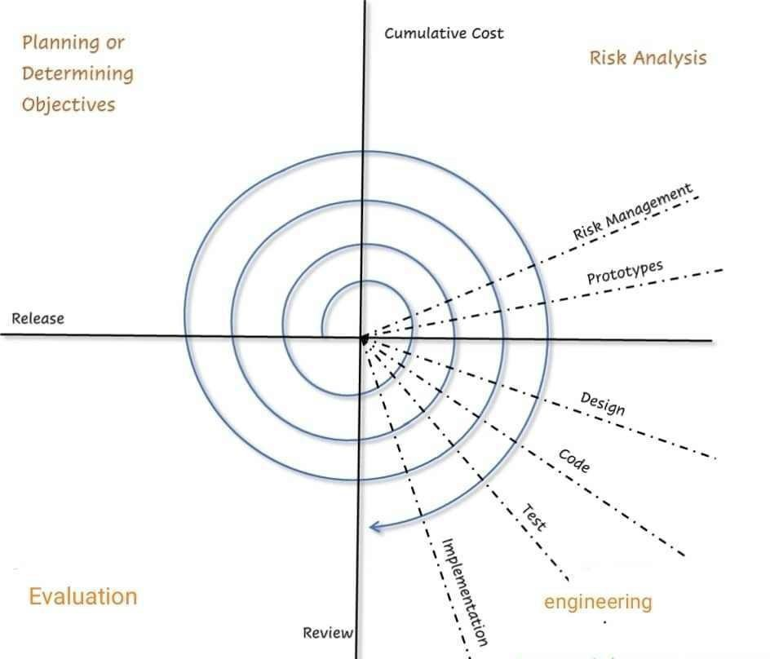

***Figure 8.*** Spiral Model

### Planning Phase

The primary goal of this phase was to establish a solid foundation for the application's development. The researchers determined how the application was developed, its scope, and how it would operate. During this phase, requirements are gathered so that the application can be developed properly. During this phase, the researchers created a Gantt chart to guide the development of the application. Gantt chart is an effective tool in software and application development projects to identify the activities, tasks, or events, with corresponding intended time and date to complete and finish them.

### Risk Analysis Phase

This phase of the Spiral Model guided the researchers in analyzing the potential risks and alternatives to various problems that could arise with the developed application. Risk analysis, as defined by WhatIs.com (2018), is the "process of identifying and analyzing potential issues that could negatively impact key business initiatives or critical projects in order to help organizations avoid or mitigate those risks". During this phase, the researchers created a Use-Case diagram to identify the roles of the various actors in different processes. In addition, a flow chart was created to demonstrate how the application's processes worked. This guided the researchers in modifying features and identifying potential problems with the application.

### Engineering Phase

This phase involved developing the application based on the gathered requirements and the results of the previous Spiral Model phases. The developed application was built with Node.js, which supports the JavaScript programming language. This is done using the Visual Studio Integrated Development Environment. A Graphical User Interface (GUI) "enables a person to communicate with a computer through the use of symbols, visual metaphors, and pointing devices" (Levy, S., 2019). The researchers create a user-friendly graphical user environment for the application because it is critical that users are satisfied and comfortable using it to ensure high levels of acceptance and use.

To ensure quality, the application underwent testing. Different testing techniques were used, including exploratory testing, graphical user interface testing, and usability testing. Exploratory Testing allowed the researchers to explore the application and look for defects. It is an informal testing technique used to identify potential application defects. The researchers also carried out Graphical User Interface Testing to ensure that the GUI met the application's development objectives. Finally, Usability Testing was carried out to determine whether users could easily understand the application or not. These tasks are completed during the Engineering phase of the Spiral Model. The researchers were able to create the application using the activities described above.

### Evaluation Phase

The evaluation phase of the Spiral Model allowed the researchers to assess the respondents' technical qualities as well as the quality of their use of the application. The results of the evaluation phase served as the basis for the application's enhancement and improvement.

### Gantt chart

According to proofhub.com (n.d), A Gantt Chart, in its simplest form, is a timeline that illustrates how the project will progress during the project management process. And the timeline view offered by the Gantt chart app is proven quite useful for planning and scheduling projects. It helps project managers and project teams to assess how long a project should be taken, determine the resources needed, understand the dependencies between tasks, and plan the order in which each task will be completed if the whole project is to deliver on time. Moreover, Henry Gantt, an American mechanical engineer, designed the Gantt chart. According to gantt.com (2018). A Gantt diagram, generally utilized in projecting the board, is one of the most famous and helpful approaches to showing exercises (undertakings or occasions) shown against time. On the left of the graph is a rundown of the exercises and along the top is a reasonable time scale. A bar represents each activity; The activity's beginning, middle, and end dates are indicated by the bar's position and length.

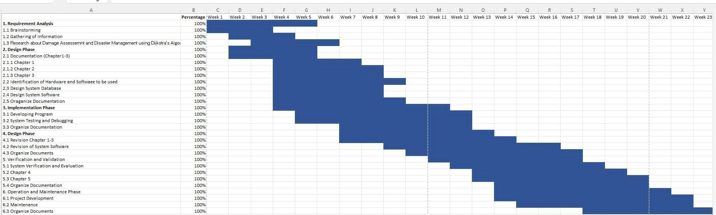

### Operation and Testing Procedure

The operation procedure and testing procedure will be discussed in this section. The different testing procedures such as unit testing, integration testing, system testing and acceptance testing will be also explained.

### Testing Procedure

Testing procedure shows how the proponents will perform testing using unit testing, integration testing, system testing and acceptance testing.

### Unit Testing

According to spiceworks.com (2022), Unit testing is a process where the minor functional parts of the software are tested individually to ensure the smooth running of the unit. Unit testing is a program testing method used to ascertain individual software components’ functionality, accuracy, and efficiency. These units could be usage procedures, unique functions, modules in a program, etc.

Unit testing is the first layer of the entire testing process software has to go through before its launch and release. This preliminary testing is often carried out by the team of developers or the software engineer that wrote the code for the software. Moreover, the primary aim of unit testing is to ensure that a code works as it should, enabling the early detection of potentially fatal errors that can affect the performance of the software.

### Integration Testing

According to simplilearn.com (2023), Integration testing is known as the second level of the software testing process, following unit testing. Integration testing involves checking individual components or units of a software project to expose defects and problems to verify that they work together as designed.

In this testing phase, the system's functions will be assessed individually and in combination with other units. During integration testing, the project team will evaluate whether the various processes are functioning correctly and without errors and ensure that each module meets the necessary requirements.

### System Testing

According to softwaretestinghelp.com (2023), System Testing is done after Integration Testing. This plays an important role in delivering a high-quality product. System Testing means testing the system. All the modules/components are integrated to verify if the system works as expected or not.

During system testing, the project team will assess the entire system by following the step-by-step processes as a user or company admin. This will involve testing the system's functionalities and ensuring that it meets the requirements and specifications.

### Acceptance (or Performance) Testing

According to softwaretestinghelp.com (2023), Acceptance Testing, which is the last phase of the Software Testing Process. This phase during which the user determines whether the product should be developed must be strictly adhered to. Joint efforts of the development and the testing team will be awarded by the customer by either accepting or rejecting the Product developed.

***Table* 4.** Test Script Form

|  |  |  |  |
| --- | --- | --- | --- |
| **Date:** | |  | |
| **Tested By:** | |  | |
| **Test Case Number:** | |  | |
| **Test Case Name:** | |  | |
| **Test Case Description:** | |  | |
| **Item(s) to be tested** | |  | |
|  | |  | |
| **Procedural Steps** | |  | |
|  | |  | |
| **Specifications** | |  | |
| **Input Expected** | **Input Expected** | **Input Expected** | **Input Expected** |
|  |  |  |  |

### Evaluation Procedure

These are the activities following that the researcher will perform during the evaluation.

* + 1. The researchers will explain the concept of the system and its operation to the respondents.
    2. The researchers will set up the system.
    3. The researcher will demonstrate the system so that the respondents will be able to use the system.
    4. The researchers will distribute evaluation forms to the respondents to fill out.
    5. The researcher will collect the evaluation forms and compute the average mean per criterion as well as the overall mean. The overall rating will be interpreted using the Likert’s Scale presented below.

Table 5. **Likert’s Scale**

|  |  |  |
| --- | --- | --- |
| **Rank** | **Numerical Scale** | **Interpretation** |
| 5 | 4.51 – 5.00 | Excellent |
| 4 | 3.51 – 4.50 | Very Good |
| 3 | 2.51 – 3.50 | Good |
| 2 | 1.51 – 2.50 | Fair |
| 1 | 1.00 – 1.50 | Poor |