Christian Felt and Jadon Wagstaff

Data Mining Spring 2017

Instructor: Jeff Phillips

March 9, 2017

Intermediate Report

Using ArcMap software, I computed the centroids of the polygons that represent the ranges of terrestrial species in the IUCN Endangered Species Red List shapefiles. Using my own Python code, I turned the latitude and longitude coordinates of these centroids into a 2-dimensional matrix and performed various kinds of clustering, trying to find areas of especially high density of endangered species.

To measure distance, I used the great-circle distance as given by d from the Haversine formula:

a = sin²(Δφ/2) + cos φ1 ⋅ cos φ2 ⋅ sin²(Δλ/2)

c = 2 ⋅ atan2( ,  )

d = R ⋅ c

Since the Earth is not perfectly spherical, the great-circle distance may be wrong by up to approximately 0.3% or 22km according to the analysis at <http://gis.stackexchange.com/q/25494>. In their article “Global Patterns of Terrestrial Vertebrate Diversity and Conservation,” Jenkins et al set 100km as a reasonable lower limit for “fine-grained spatial analysis” in this field.

Hierarchical clustering ran too slowly for the full dataset (74,529 points) or for amphibians alone (18,694 points). K-means++ worked for small numbers of clusters (20 or less) but became obnoxiously slow for larger k. Lloyd’s was also too slow for more than about 20 clusters.

Gonzalez clustering processed the entire dataset in less than 10 seconds. Using the “elbow” principle, I chose k=40 (see Figure 1). The resulting clusters (see Figure 2) seem surprisingly reasonable, often lining up with the “25 Global Biodiversity Hotspots” shown in Figure 3. For instance, Gonzalez gives Madagascar, New Zealand, and the Caucasus Mountains their own clusters, separates the Pacific Northwest from the rest of the Rockies, and divides up the Amazonian, Congo, and Indonesian rainforests in roughly canonical ways. Also, the Aleutian and Canary Islands, Newfoundland, and Hawaii are given their own clusters, and the Andes, Himalayas, and other mountain chains are not too broken up.

On the other hand, areas with low density of endangered species, such as Siberia or the Sahara Desert, seem to get partitioned in fairly meaningless ways. Also, my clusters assign the Mediterranean Basin, somewhat oddly, to 3 different centers.

But if my clustering inspires confidence by reflecting the common knowledge in some areas, then perhaps where it deviates from the usual boundaries, the results should not be immediately dismissed. They might provide questions for further research. For instance, is there really a significant difference in the species and habitats of the western half of the Mediterranean Basin versus the half that lies to the east of Sicily? What (if anything) justifies the separation of India from Indochina, Scotland from the rest of the U.K., or the area along the coast of West Africa from the Congo River Basin at a right angle to the south?

My clusters may or may not help shed light on such questions, but they do at least provide a fresh way of looking at the IUCN data. For comparison, Figures 3 through 6 provide a sample of other people’s maps of endangered species density using IUCN Red List data.

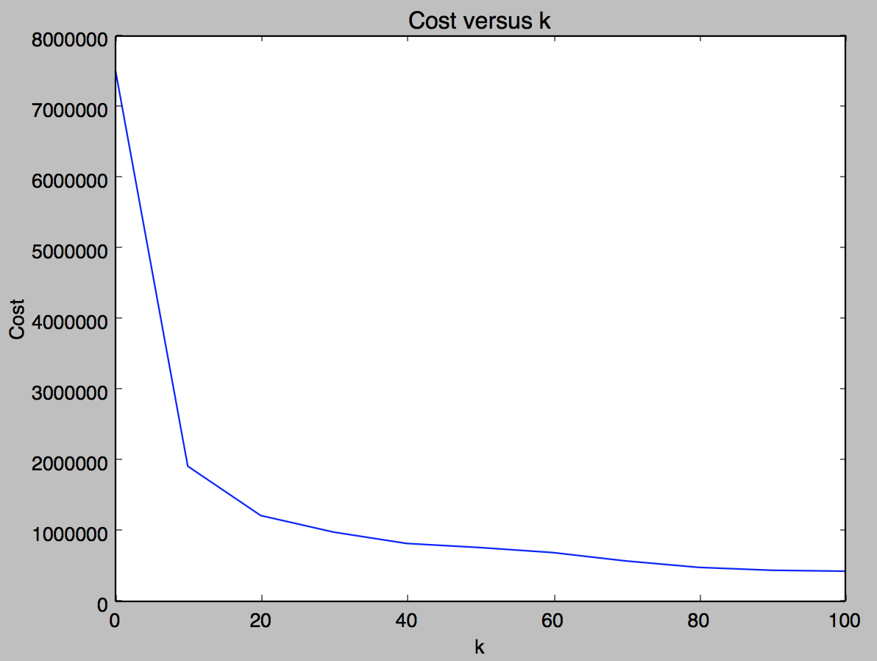

Figure 1: k-means cost in meters for Gonzalez

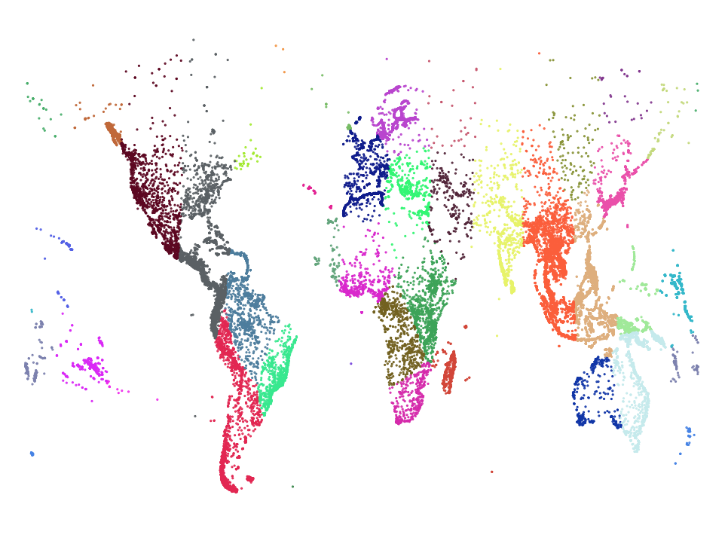

Figure : Gonzalez with k=40

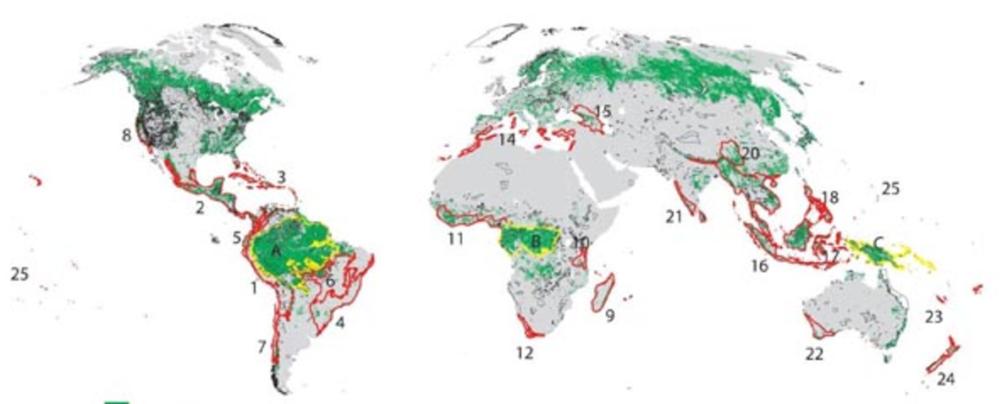

Figure 3: 25 Biodiversity “Hot Spots” from lesson plans available at <https://myweb.rollins.edu/jsiry/USAENDA.html>

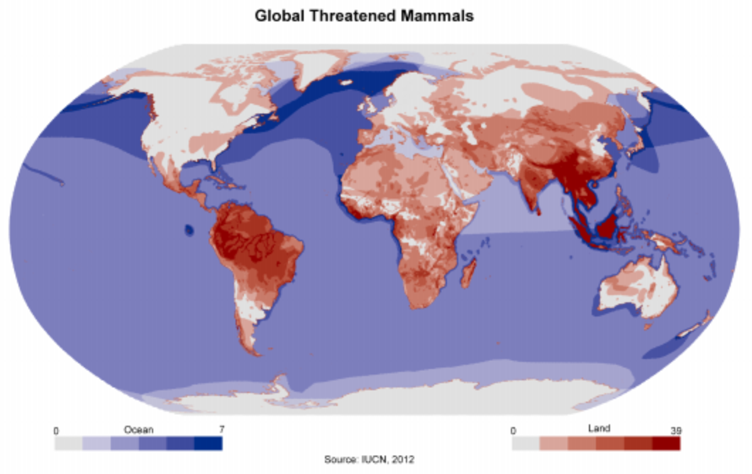

Figure 4: From Nitin Saxena's (works at National Thermal Power Corporation) maps on quora: <https://qph.ec.quoracdn.net/main-qimg-5f82bd6271b72e81c6de32e0afc8b1ed>

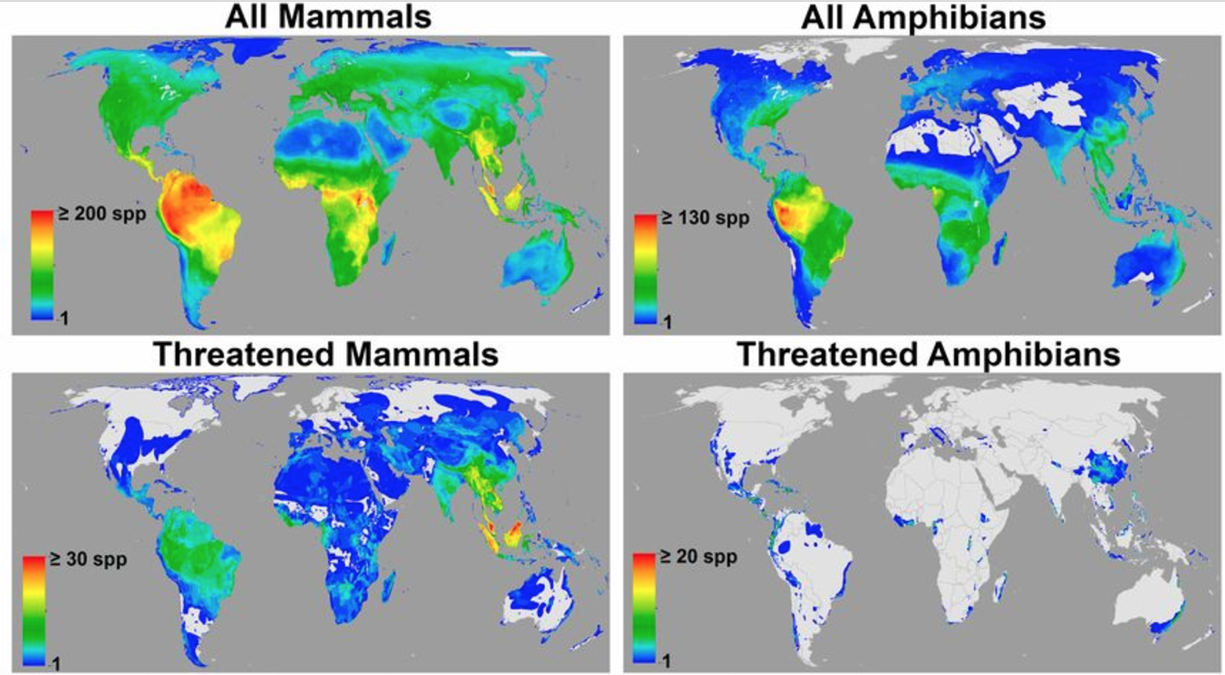

Figure 5: From Jenkins, Pimm, Joppa, "Global patterns of terrestrial vertebrate diversity and conservation", 2013. Figures accessible at <http://www.pnas.org/content/110/28/E2602.figures-only>

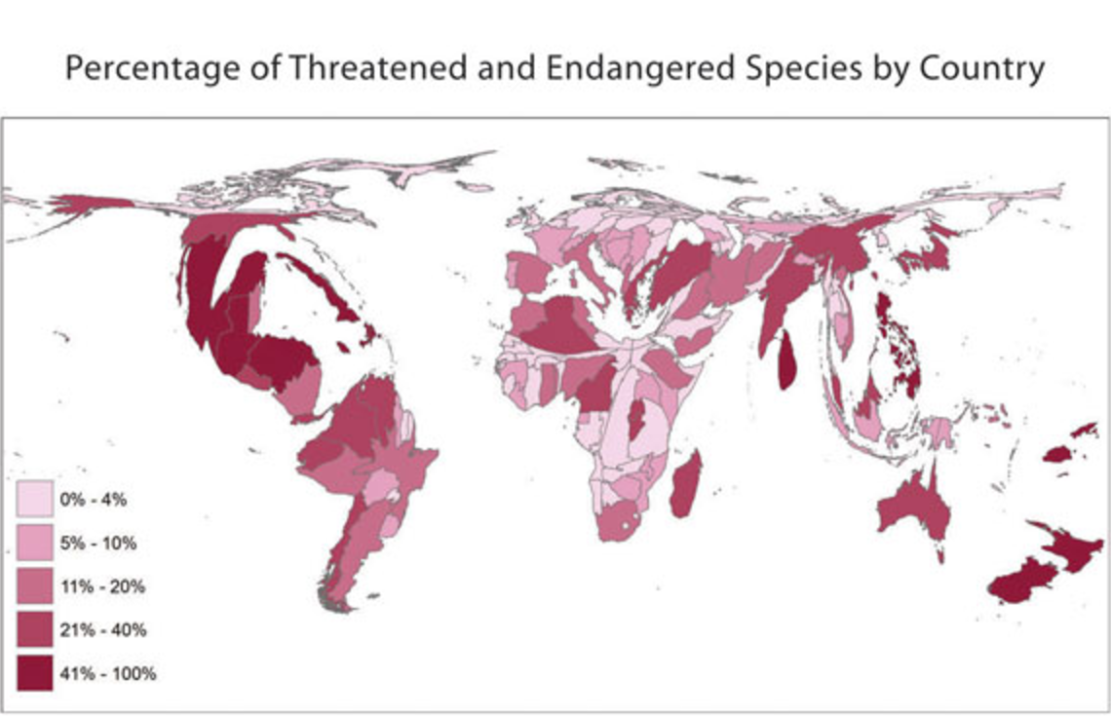

Figure 6: Amphibian data from "Visualizing AmphibiaWeb Data with Continuous Cartograms" by Koo, Vredenburg, et al. at http://www.amphibiaweb.org/amphibian/cartograms/