EMC Express Care Open every day 10AM-8PM 817-503-8800 EMCexpresscare.com

**POISON IVY** 9/19/17 fg

Got an itchy rash? Maybe you came in contact with poison ivy 1 to 4 days ago. Poison ivy rash is an allergic contact dermatitis. About 70% of people are allergic. Your body has to develop an allergic response, so if you’re experiencing a reaction, this is not your first exposure.

Poison Ivy, *Toxicodendron radicans*, is common throughout the United States, and usually lives in shady habitats. It is easily identifiable because it is one of the few plants that has a compound leaf with **three leaflets**. You may have heard the term, “Leaves of three, let it be!”

The leaves are **highly variable** in size and shape. Also, the growth habit is variable. It may grow as a ground cover, a trailing vine, or a climbing vine. All parts of the plant contain an oil called urishiol, which causes the rash.

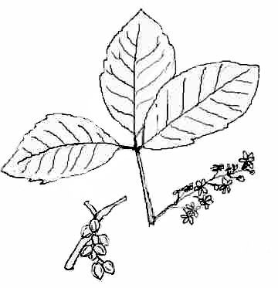

Poison ivy *(Toxicodendron radicans*)

There are other plants in the same Genus as Poison Ivy that contain the same urishiol (Poison Oak, Poison Sumac). Poison Oak looks like a hairy vine climbing a tree. Its trunk can grow from pencil thin to a few inches across.

Itching is mediated by histamine. The histamine released is in response to antibodies in your body reacting to exposure to poison ivy (or oak or sumac). The specific antibody is called IgE and mediates allergic reactions. With repeated exposures, your IgE may increase so future reactions may be worse. The good news is, that with repeated exposures, you can also increase a different antibody called IgG. IgG has a higher affinity for allergens (compounds that cause allergic reactions) and is known as a “blocking antibody”. That is the basis for allergy treatments by allergists. With repeated exposure over time, you may experience progressively milder symptoms (after some miserable initial reactions).

Treatment:

* Keep cool. You will itch less when you are cool and more when you get hot. Turn up the air conditioner, apply a cool compress, take a cool shower. Don’t exercise and get sweaty.
* Don’t scratch. As bad as the rash looks, it generally heals well without infection or scarring (unless you scratch).
* Apply Calamine lotion to the rash (not Caladryl – this contains Benadryl and more people may become allergic to Benadryl if it is applied to the skin than if it is taken by mouth).
* For small areas, OTC steroid creams may help. For larger areas, especially if delicate areas are involved like the face and genital regions, steroids by mouth or injection may help get the itching under control. Prescription steroids may be needed for several days, even if an injection is given initially.
* Anithistamines (by mouth, not applied to the skin) help decrease the itch. Benadryl is more effective but only lasts about 6 hours and can be sedating, especially at higher doses (50 mg in adults). Newer antihistamines (Allegra, Claritin, Zyrtec) are less sedating and last longer. One strategy is to take one of these less sedating antihistamines in the morning and Benadryl at bedtime.