Due to that the application is not signed, then following warning is appearing:

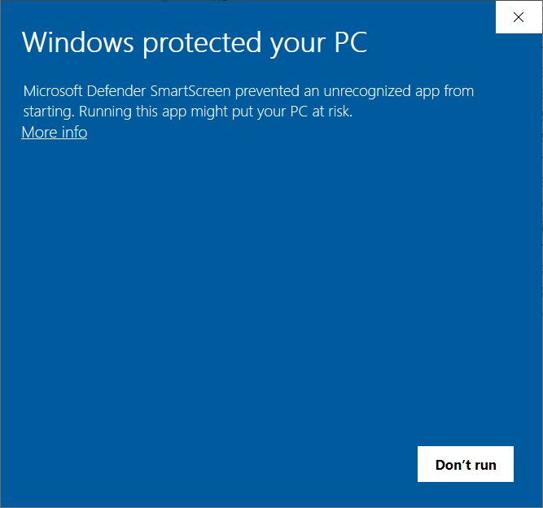

The application is not signed because it requires payment of 60$ a year to a certificate provider. You still can install the application by selecting **More info**.

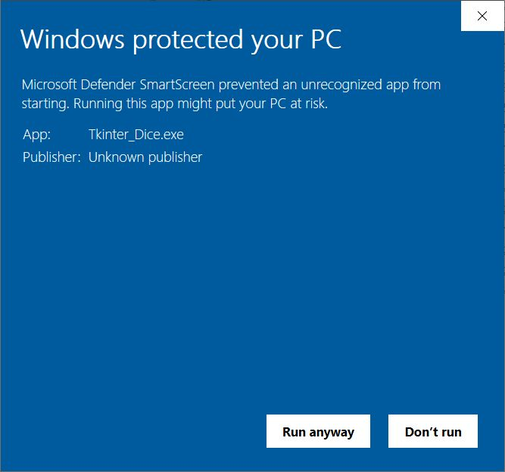

Select **[Run anyway]**