**CSE211 Web Programming, Fall Semester 24/25**

**Assignment #1: Websites conceptual Design and mock-up**

**222101191, Christian Hany Roshdy**

**Part 1: Research**

**Evolution of the Web from Web 2.0 to Web 4.0**

**Introduction**

The evolution of the internet has transformed how individuals and organizations connect, communicate, and conduct business. Each phase of the web, from Web 2.0 to Web 4.0, has introduced distinct characteristics and technologies that have expanded its capabilities. Understanding the progression of the web provides valuable insights into its potential for influencing business and professional practices. This report examines the defining characteristics, key features, and transformative technologies associated with each stage in the progression from Web 2.0 to Web 4.0.

**Web 2.0: Defining Characteristics and Network Power**

Web 2.0, emerging in the early 2000s, marked a transition from static web pages to dynamic and user-driven content. Unlike Web 1.0, which primarily delivered information, Web 2.0 empowered users to interact, create, and share content. Key features of Web 2.0 include user-generated content, social networking, and social media platforms. This era brought an emphasis on collaboration, encouraging the creation of forums, blogs, wikis, and platforms like Facebook, YouTube, and Twitter.

The hallmark of Web 2.0 lies in the power of networks, often referred to as the "network effect." This effect amplifies the value of a network as more users join, enabling faster dissemination of information and ideas. Social bookmarking, tagging, and sharing allowed users to collectively organize and rate content, making information more accessible. Through these networks, businesses gained new opportunities for direct engagement with consumers, leveraging social media for marketing, customer feedback, and community building.

**Web 3.0: Data Meaning and Knowledge Connection**

Web 3.0, often described as the “semantic web,” brought advancements that emphasized understanding the meaning of data. Rather than relying solely on human interaction for content generation, Web 3.0 utilized data interconnection, machine learning, and artificial intelligence to create contextually relevant information. This phase introduced technologies such as blockchain, which enabled secure data transactions, and smart contracts, transforming industries like finance and supply chain management.

Web 3.0’s focus on the semantic web allowed data to be interconnected more meaningfully, providing personalized and precise user experiences. Search engines and applications could understand context, preferences, and relationships between data, facilitating greater insights and connections. This stage improved knowledge-sharing capabilities, as platforms like LinkedIn used intelligent algorithms to match professionals with job opportunities and relevant industry knowledge.

**Web 4.0: Intelligence and Contextual Awareness**

Web 4.0, often referred to as the “intelligent web,” is an evolving phase that focuses on integrating artificial intelligence, machine learning, and real-time data processing to create highly responsive and intuitive systems. It emphasizes intelligence connections, where machines not only understand data but also predict and adapt to user needs. Technologies such as the Internet of Things (IoT), 5G networks, and advanced AI are foundational to Web 4.0, allowing devices and applications to seamlessly interact and respond to context. This phase aims to create a web where interactions are fully integrated into everyday life, fostering automation and offering contextualized support for decision-making.

Web 4.0 promises to transform business by enabling systems that can automatically respond to market changes, customer behavior, and operational needs. Companies can gain predictive insights from vast data sources, improving efficiency, productivity, and customer satisfaction.

**Importance of Collective Intelligence and Social Networking**

Collective intelligence, social networking, social media, and social bookmarking have been instrumental throughout Web 2.0 and beyond. These elements enhance information sharing, allowing individuals and organizations to collaboratively solve problems and innovate. For businesses, collective intelligence offers a valuable tool for crowdsourcing ideas, refining product offerings, and gathering consumer insights. Social networking platforms have transformed marketing and brand engagement, while social media and bookmarking provide visibility, driving traffic and fostering brand loyalty.

**Impact on Current and Future Business Plans**

The technological advances from Web 2.0 to Web 4.0 empower businesses with new methods for customer engagement, data-driven decision-making, and process automation. With Web 4.0 technologies, companies can adopt intelligent systems that streamline operations and personalize consumer experiences, which will be crucial in an increasingly competitive digital marketplace. These technologies also support remote work, collaboration, and operational efficiency, making them indispensable in future business planning.

**Application of Latest Technologies in Professional Practice**

In my profession, I intend to leverage these technologies to enhance collaboration, improve efficiency, and deliver value-driven services. Web 4.0’s emphasis on intelligence connections and automation can support efficient project management, personalized client interactions, and predictive analysis. By staying informed about evolving web technologies, I can integrate advanced tools to meet changing industry demands and achieve strategic goals.

**Conclusion**

The progression from Web 2.0 to Web 4.0 highlights an evolving internet characterized by enhanced interactivity, data intelligence, and predictive capabilities. Each phase has introduced features that have reshaped how people and businesses operate within a digital ecosystem. Understanding these developments allows professionals and businesses to harness current and emerging technologies to stay relevant and innovative in a dynamic digital landscape.

**Referencing and Bibliography**

Cornell Networks Course Blog: [New Generations of the Web: Past 2.0, onto 3.0 and Moving onto 4.0 : Networks Course blog for INFO 2040/CS 2850/Econ 2040/SOC 2090](https://blogs.cornell.edu/info2040/2015/10/20/new-generations-of-the-web-past-2-0-onto-3-0-and-moving-onto-4-0/)

HashDork: [Web 4.0 Explained – Defining The Next Big Leap in Tech - HashDork](https://hashdork.com/web-4-explained/)

TechTarget: [airccse.org/journal/ijwest/papers/3112ijwest01.pdf](https://airccse.org/journal/ijwest/papers/3112ijwest01.pdf)

**Part 2: website planning**

**1. The purpose of your intended website.**

The purpose of this website is to create a space where people can share recipes, plan meals, and discover culinary inspiration. It serves as a community for food enthusiasts who want to improve their cooking skills, explore diverse cuisines, and manage their weekly meals in a structured way.

**2. What would you like the website to accomplish?**

The website should make it easy for users to share and discover recipes, plan their weekly meals, and create personalized grocery lists. It should foster a community of food lovers, offering tools that make meal planning less stressful and encourage healthier eating habits.

**3. Who is your intended audience?**

The primary audience includes home cooks, busy professionals, families, and anyone interested in cooking or meal planning. It’s also ideal for individuals looking to try new recipes, save time on meal prep, and make healthier choices.

**4. What opportunities, problems, or issues does your planned website address?**

The website addresses common issues like lack of time for meal planning, difficulty in finding reliable recipes, and the challenge of organizing grocery lists. It also provides an opportunity for users to build a community around shared culinary interests and tips.

**5. What kind of content could be incorporated on your website?**

The website will include recipes (text, photos, and videos), meal plans, grocery lists, user-generated content (reviews, comments), interactive forms, blog articles, nutritional information, and possibly a forum for user discussions.

**6. How will the site serve the client?**

The site will provide tools to simplify meal planning, inspire creativity in the kitchen, and allow clients to save and organize recipes and meal plans. It helps users streamline meal preparation, save time, and potentially improve their diet quality.

**7. What's the best method for the user to do what's wanted?**

Users should have clear access to search and filter functions to find recipes based on dietary preferences, cuisine type, ingredients, or prep time. A drag-and-drop calendar for meal planning, a save feature for favorite recipes, and easy integration to generate shopping lists would make the process seamless.

**8. How will users find the function?**

Clear, intuitive navigation should lead users to the recipe database, meal planner, and grocery list generator. A search bar and categorized menus will make it easy for users to locate these features quickly.

**9. How will the results of the function be received?**

Users will be able to view their meal plans on a calendar, access printable versions of recipes, and generate shopping lists. Results can also be emailed or shared via the user’s account, with options to export or sync to mobile devices.

**10. What will the receiver do with the received entries?**

Users will be able to add recipes to their favorites, share their meal plans, or download their grocery lists. They can also interact with other users by commenting on or rating recipes, fostering community engagement.

**11. How will the receiver deal with results?**

Users can save or edit their meal plans and grocery lists within their accounts, adjusting them as needed. Notifications or reminders about upcoming meals or low-stock pantry items could also be incorporated to enhance user convenience.

**12. What follow-up will be needed?**

User feedback on recipes and meal planning tools can help the site improve and expand features. Regular updates and recipe additions will keep users engaged, and sending newsletters with new recipes or meal-planning tips would be beneficial.

**13. List at least two related or similar sites found on the Web.**

1. AllRecipes: This site offers extensive recipe collections, user-generated content, and a meal planner, similar to the intended site. AllRecipes has a large community and strong search functionality, which would serve as a model for building a recipe database.
2. Mealime: This site focuses on meal planning with personalized recipes based on dietary preferences, offering a seamless way to generate grocery lists. Mealime’s integration of meal planning with shopping lists is a feature the intended site aims to replicate.

**14. Planning Analysis Sheet**

a. Website Goal: The goal is to create a comprehensive recipe sharing and meal planning platform that simplifies meal prep, fosters a community of food enthusiasts, and promotes healthy eating.

b. Working Title for Pages (excluding the Home Page):

1. Recipe Search
2. Recipe Submission
3. Meal Planner
4. Grocery List Generator
5. Blog
6. Community Forum
7. Profile
8. About Us
9. Contact Us
10. FAQ

c. Page Descriptions:

1. Homepage: Intro to the site, featuring popular recipes, meal planning tools, and links to other main sections.
2. Recipe Search: A search function to browse recipes by category, cuisine, and dietary needs. Includes images, instructions, ratings, and comments.
3. Recipe Submission: Form where users can share their recipes, upload images, and add descriptions, ingredients, and instructions.
4. Meal Planner: Drag-and-drop calendar where users can schedule meals and save weekly plans.
5. Grocery List Generator: Generates a list based on meal plans; users can edit and categorize items by aisle or department.
6. Blog: Features articles on cooking tips, nutritional advice, and kitchen hacks.
7. Community Forum: Space for users to discuss recipes, share meal ideas, and connect over shared interests.
8. Profile: Allows users to manage their saved recipes, meal plans, and grocery lists.
9. About Us: Provides the background and mission of the site, team details, and contact info.
10. Contact Us: Includes a contact form for feedback or support queries.
11. FAQ: Common questions about using the site, managing accounts, and using meal planning features.

d. Form Usage Examples:

* Recipe Submission Form: Allows users to contribute recipes by adding ingredients, instructions, and images.
* Contact Form: For users to reach out for help or provide feedback.
* Forum Registration Form: To participate in community discussions.
* Newsletter Signup Form: Users can subscribe to receive new recipes and updates.

**Flowchart (Website Organization):**

**Part 2: website design**

**1. Law of Prägnanz (Good Figure, Law of Simplicity)**

Implementation: The design will prioritize a clean and minimalistic layout across all pages. Each section (e.g., recipes, meal planner, blog) will avoid unnecessary elements, making navigation easy. Users will see only the essential information, with ample whitespace to prevent clutter.

**2. Closure (Link Individual Elements to Form a Pattern)**

Implementation: Related content, like individual recipe cards, will be grouped together, and users will visually "complete" these groups even if they’re partially divided by whitespace. This allows users to naturally perceive each set of recipes or meal planning items as cohesive sections.

**3. Symmetry and Order (Effectively Communicate Information Quickly)**

Implementation: The layout on each page will be balanced, with sections like "Featured Recipes" or "Meal Planner" aligned in a grid format. Consistency in placement—such as buttons, headers, and images in a predictable order—will improve readability and make navigation feel intuitive.

**4. Figure/Ground (Relationship Between Positive Elements and Negative Space)**

Implementation: Each page will use a clear contrast between content (figure) and background (ground) to make elements stand out. For instance, the meal planner’s active items will have a highlighted background, while the rest remains neutral, allowing users to focus on specific elements and avoid distraction.

**5. Connectedness (Relationship Between the Elements)**

Implementation: Elements like a recipe’s title, image, and description will be grouped within a single border or box to convey they’re part of the same item. Forms and input sections will use borders or lines to show that these fields belong together, making it clear which items are related.

**6. Uniform Connectedness**

Implementation: Uniform connectedness will be implemented with color and borders to group related elements, such as the "Weekly Planner" section or each day’s meal options. This use of consistent visual connections makes it easy for users to understand the relationships within each group.

**7. Common Region (Connection Between Elements)**

Implementation: Content sections on each page, like blog posts or recipes, will be placed within boxed areas or colored backgrounds to indicate they belong together. This will help users quickly identify and relate each group of information, like distinguishing between blog articles and recipe listings.

**8. Proximity (Utilizing Empty Space to Create Relationships)**

Implementation: Related items, like meal planner days or recipe categories, will be positioned closely together, while unrelated sections will be separated by whitespace. This clear use of proximity helps users intuitively understand the organization without additional labels or indicators.

**9. Continuation (Continuous Perception of Shapes)**

Implementation: The website will use alignment and visual lines to guide the user’s eyes across each page. For example, in the "Weekly Meal Planner" section, days will be aligned horizontally, leading the user to scan naturally from left to right.

**10. Common Fate (Synchrony)**

Implementation: Interactive elements, like hovering over a recipe card, will create synchronized changes (e.g., color or shadow changes) to indicate that these items are interactive and related. Sliders and menus that move together will further communicate that items are connected.

**11. Parallelism (Parallel Elements Are Seen as Related)**

Implementation: Content like blog posts or daily meals will be displayed in parallel rows or columns to visually communicate that these items are of equal importance and belong to the same category. This will make the layout more visually organized and clear.

**12. Similarity (Elements with Similar Characteristics Are More Related)**

Implementation: Similar buttons and icons will use consistent colors and shapes. For example, all call-to-action buttons will have a similar style, helping users quickly recognize interactive elements like “Add to Meal Plan” or “Save Recipe.”

**13. Past Experience (Observer's Past Experience)**

Implementation: Recognizable icons (e.g., a shopping cart for grocery list, a bookmark for saving recipes) will be used to make navigation intuitive. Familiar layouts, like a sidebar for categories or filters, will leverage users' past experience with similar websites, allowing them to quickly understand the website’s structure.

**Color palete:**

#ff6347

#f8b400

**HOMEPAGE:**

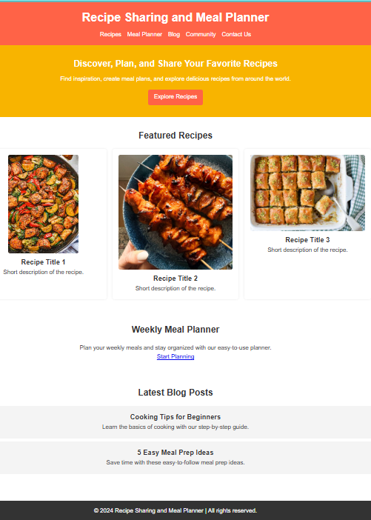

**COMMUNITY PAGE:**

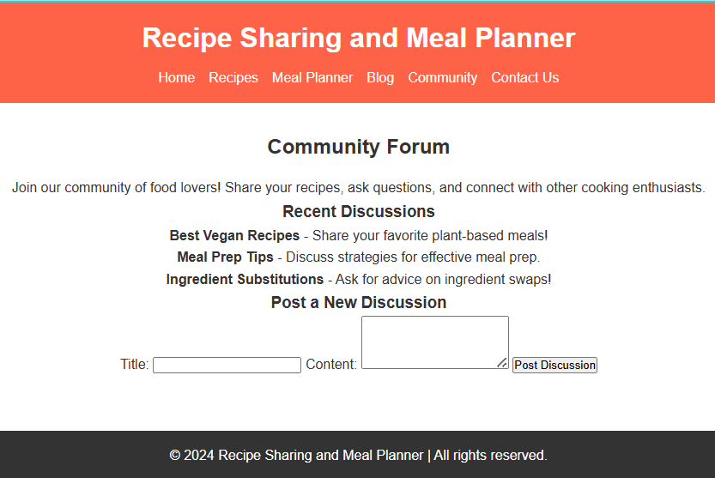

**CONTACT PAGE:**

