SYSTEM DEVELOPMENT PROGRESS REPORT
Group 4

INTERNTRACK: INTERNSHIP MANAGEMENT SYSTEM FOR
UNIVERSITY OF CABUYAO
Group Members:
Monteralegre, Clarence D.
Taduran, Mark Joseph V.
Valinado, Christian Hero A.

Date: July 13, 2026

SYSTEM DEVELOPMENT PROGRESS TABLE
The table below presents the objectives and scope of the INTERNTRACK system, along with their corresponding development updates, percentage of completion, and explanations.
Objectives / Scope (from Manuscript) | Development Update | % Done | Explanation / Notes | Progress Screenshots
Obj. 1.1 & 2.1–2.2  Manages student profiles and records through centralized data storage and profile management; enables administrators to tag internship status (active, completed, suspended, deferred, expelled) with a mandatory reason for status changes; protects access through role-based access control. | High-fidelity screens for student profile creation, records viewing, and status tagging have been completed for all six user roles (Student Intern, PALD Director, Internship Coordinator, Faculty Supervisor, Industry Supervisor, and Authorized Academic Personnel). Date fields such as enrollment date and status-change date are functional. Centralized database storage and role-based access control logic are not yet implemented. | 40% | Currently a high-fidelity, role-complete prototype; backend data persistence and access control are still pending. | 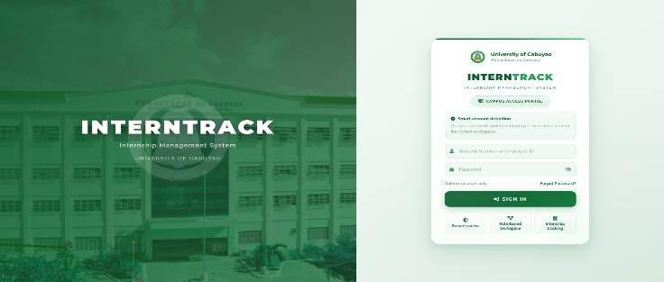  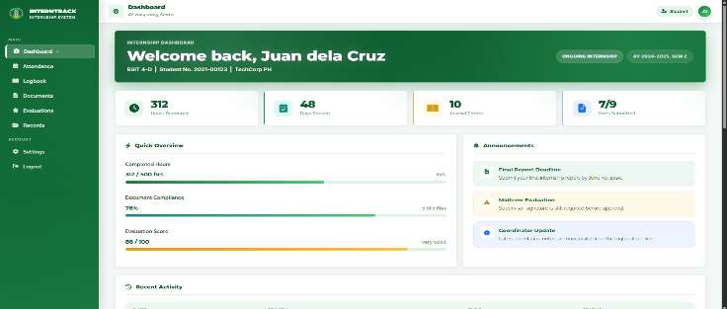
Obj. 1.2  Supports internship lifecycle management, including placement, deployment, status tracking, and progress monitoring, with dedicated monitoring of MOA status with partner companies and HTE accreditation status. | High-fidelity screens for placement assignment, deployment logging, and status/progress tracking have been designed for all roles. Deployment date and MOA validity date fields are functional. Automatic MOA/HTE validation and real-time status synchronization are not yet functional. | 35% | Deployment-blocking logic for expired MOAs or inactive HTEs still needs to be built. | 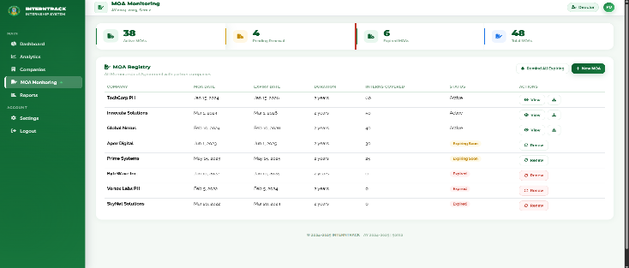  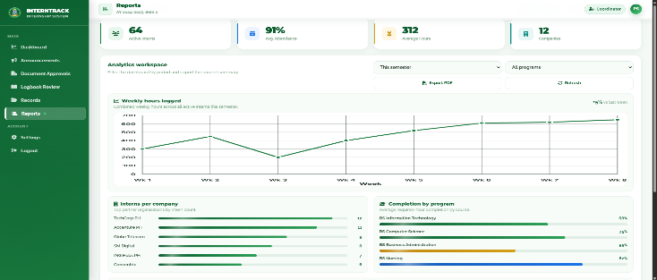
Obj. 1.3  Facilitates internship documentation, including digital journal submission and review, and document compliance, submission, verification, and routing. | High-fidelity interfaces for daily journal entries, DTR uploads, and document compliance/routing are complete for all roles. Date fields for journal entries and DTR are functional. Real-time hour validation, discrepancy detection, and verification workflows are pending. | 40% | Journal and DTR screens are usable for data entry; validation logic is not yet active. | 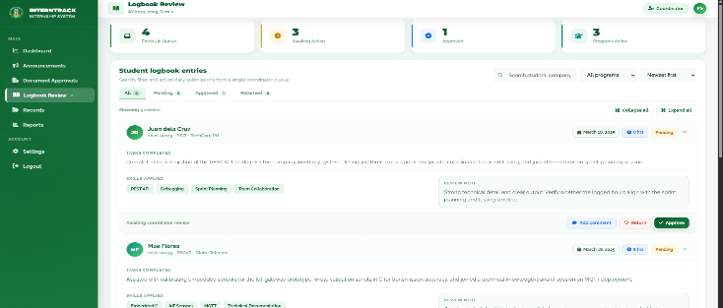  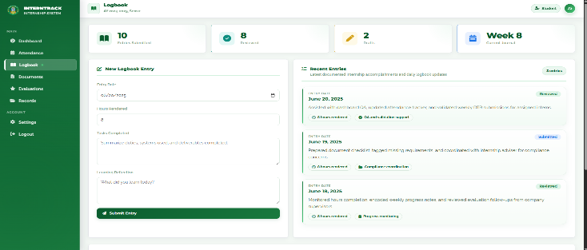
Obj. 1.4  Provides monitoring and supervision tools, such as dashboards, real-time status updates, notifications, and performance tracking. | Role-specific dashboard layouts have been completed in high fidelity for all six user roles. Scheduling fields (e.g., orientation and consultation dates) are functional. Real-time status updates, at-risk student flagging, and automated notifications are not yet implemented. | 35% | Dashboards currently display static/sample data rather than live data. | 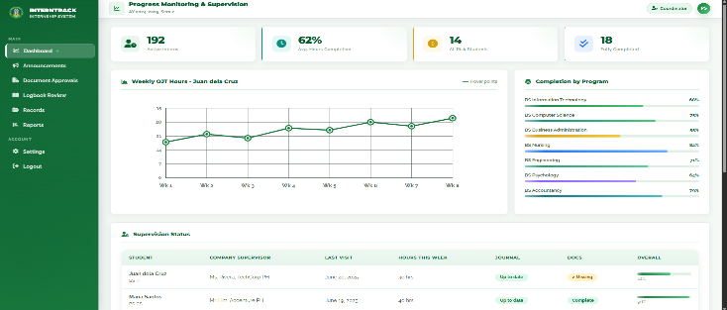  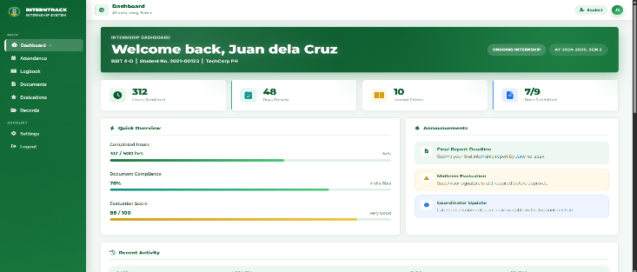
Obj. 1.5  Enables communication and coordination among student interns, PALD Director, internship coordinators, faculty supervisors, industry supervisors, and authorized academic personnel. | High-fidelity screens for announcements and feedback threads have been designed for all roles. Date/time fields for scheduling communications are functional. Real-time messaging and automated notification delivery are not yet active. | 35% | Messaging interface is complete but not yet wired to a live backend. | 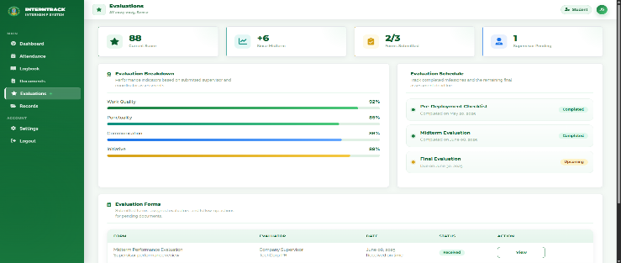  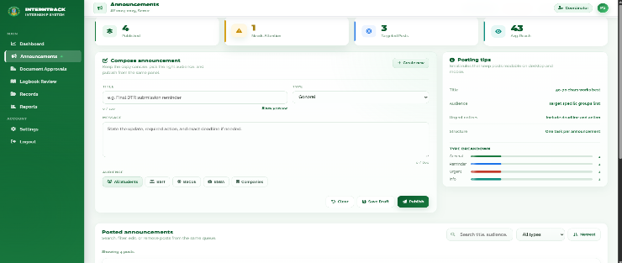
Obj. 1.6  Generates reports and outputs, including performance evaluations, completion certificates, and internship-related reports. | High-fidelity templates for evaluation forms, completion certificates, and reports have been designed. Date fields (evaluation date, certificate issue date) are functional. Automatic score consolidation and certificate/report generation logic are not yet implemented. | 30% | Output generation and analytics (deployment trends, retention rate, etc.) are not yet functional. | 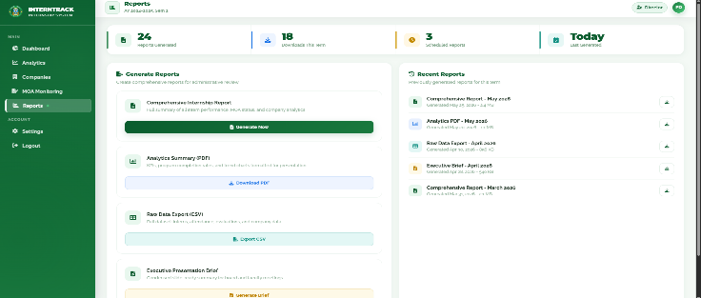  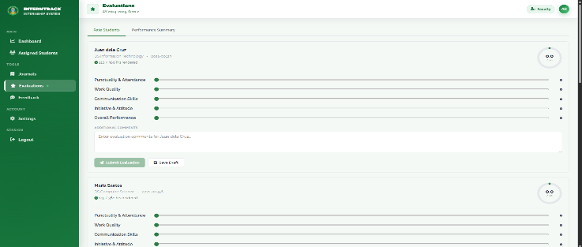
Scope — System Integration (MISD Coordination)  Considers integration with the University's Management Information Systems Division (MISD) to enable data synchronization and interoperability with existing institutional systems. | Not yet started. Planned for a later development phase pending confirmation of MISD data-sharing requirements and access. | 0% | Outside the current development priorities; to be scoped once core modules are functional. | [N/A]
Obj. 2 & 3 — System Evaluation  Evaluate the acceptability of the system based on selected ISO/IEC 25010 software quality characteristics through end-user assessment (functional suitability, usability, performance efficiency, reliability) and IT expert assessment (functional suitability, reliability, performance efficiency, security). | The system is currently a high-fidelity, role-complete prototype with only limited working functions (e.g., date fields). Formal ISO/IEC 25010 evaluation with end users and IT experts has not yet started. | 5% | Evaluation instrument will be administered once core functional modules are implemented and tested. | [N/A]
Summary of Pending Items:
The following items remain unfinished as of the current high-fidelity prototype phase and are targeted for completion prior to final testing and deployment:
1. Centralized Database & Backend Integration — Data storage, retrieval, and persistence across all modules are not yet connected; screens currently function as high-fidelity mockups.
2. Role-Based Access Control — Login and permission logic differentiating the six user roles is not yet implemented.
3. Real-Time Status Updates & Notifications — Dashboards, alerts, and at-risk student flagging are not yet functional.
4. Document & Hour Validation Logic — Automatic DTR/hour validation and discrepancy detection between uploaded documents and entered data are pending.
5. Report & Certificate Generation — Automatic score consolidation, completion certificate issuance, and analytics/reporting tools are not yet implemented.
6. MISD System Integration — Coordination with the University's Management Information Systems Division for data synchronization has not yet begun.
7. Formal ISO/IEC 25010 Evaluation — End-user and IT expert assessments are pending completion of the remaining functional modules.

Updated Adviser Consultation:
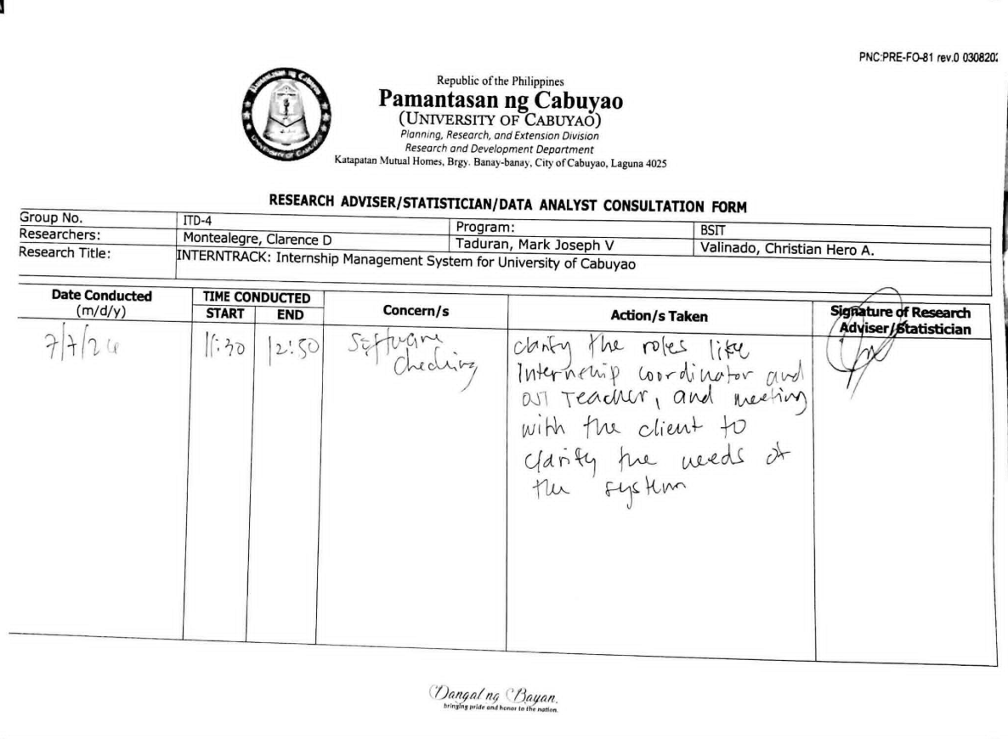

AI Checker:

