HOME NETWORK SECURITY LAB
Project Portfolio
Christian Alverio | christianjalverio@gmail.com | Coral Springs, FL
OVERVIEW
This project is a fully self-built home network and server infrastructure designed and administered from the ground up, with an emphasis on network security, access control, and monitoring. What began as a personal NAS setup grew into a segmented, multi-layer environment covering firewall administration, VPN-based remote access, intrusion detection, PKI/certificate management, virtualization, and self-hosted application deployment. The project was built incrementally over several months, with each addition treated as a real design decision — not just what is required to make it work, but what configuration would be most secure and most observable in production.
ENVIRONMENT
- Physical topology: ISP fiber gateway to pfSense firewall/router to segmented internal LAN, running behind a double-NAT boundary.
- Core infrastructure: pfSense CE (firewall/router/VPN/IDS), TrueNAS SCALE (network storage), Proxmox VE (virtualization host).
- Remote access: self-hosted WireGuard VPN, no reliance on third-party mesh VPN services.
- Virtualized/containerized services: Docker (via LXC on Proxmox), managed through Portainer.
PHYSICAL BUILD
The infrastructure runs on a compact wall-mounted 10-inch rack, built and wired from individual components, including custom 3D-printed mounting brackets designed to fit the rack's non-standard dimensions.
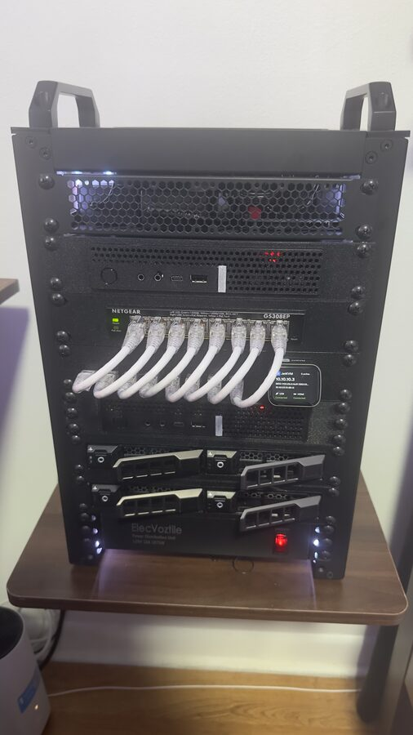  Completed rack — pfSense, switch, Proxmox host, and UPS in a wall-mounted 10" rack. | 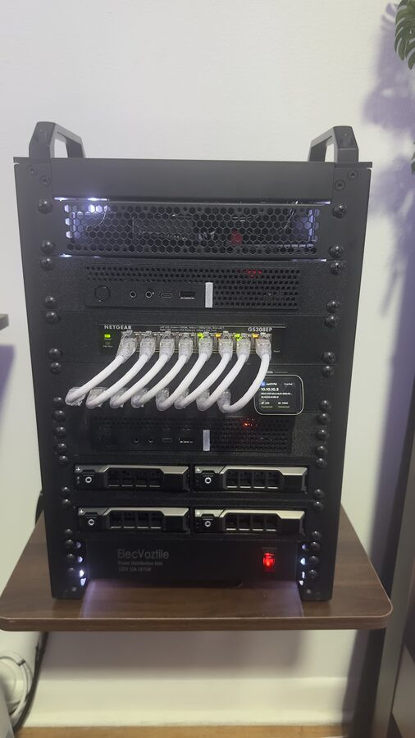  Structured patch cabling from the switch to rack-mounted equipment. | 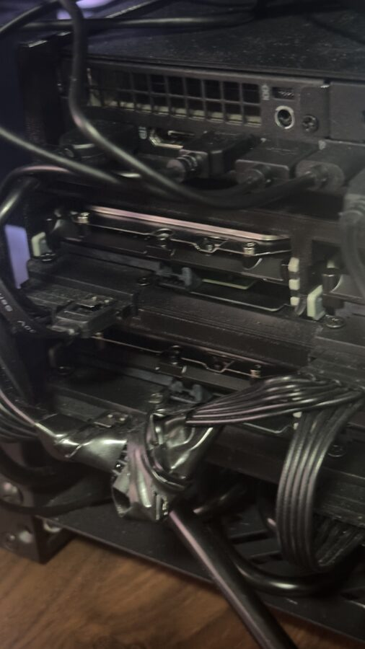  Cable management detail inside the rack.
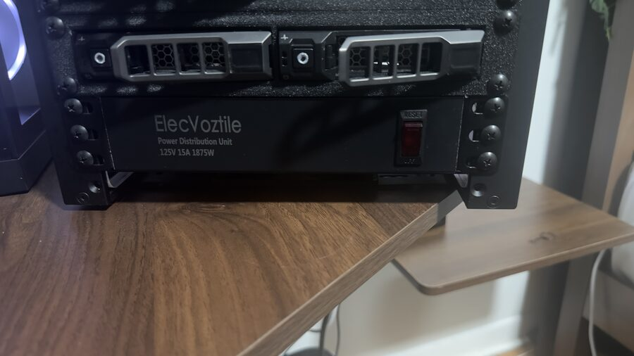  Rear cable routing and connections. | 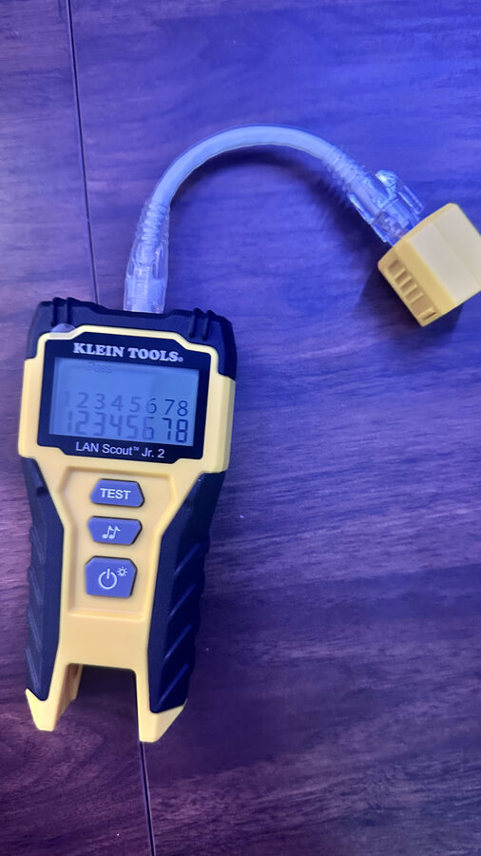  Verifying cable runs with a network cable tester. | 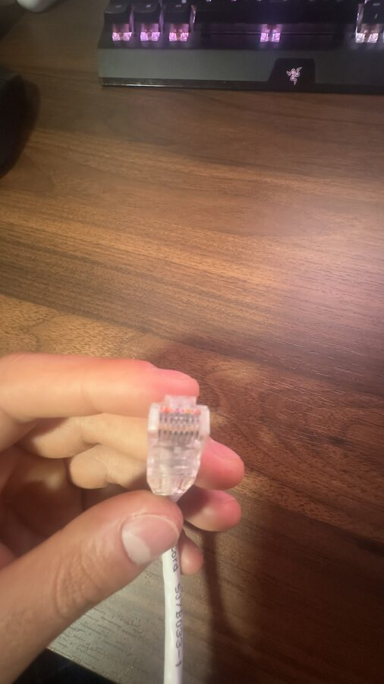  Terminating and testing an Ethernet cable.
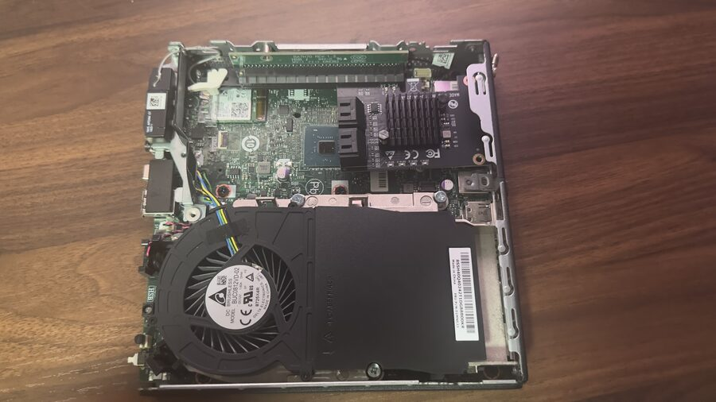  Proxmox host internals during a hardware upgrade. | 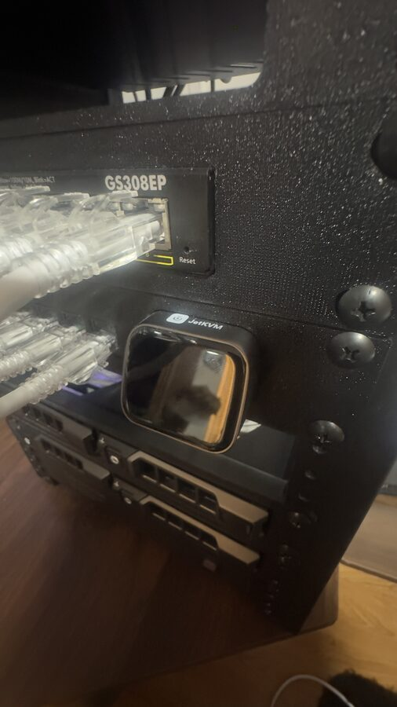  Internal drive bay and SSD storage installation. | 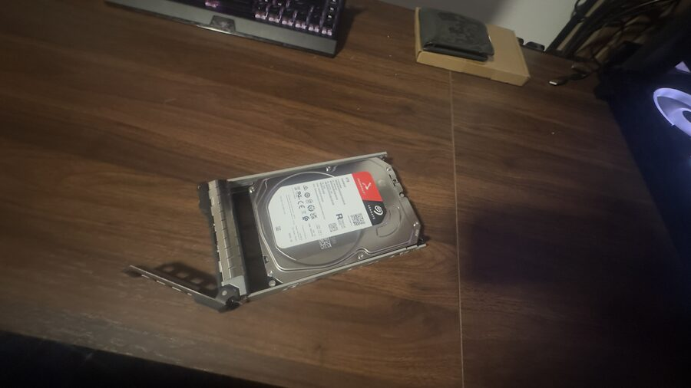  NAS storage drive prior to installation in TrueNAS.
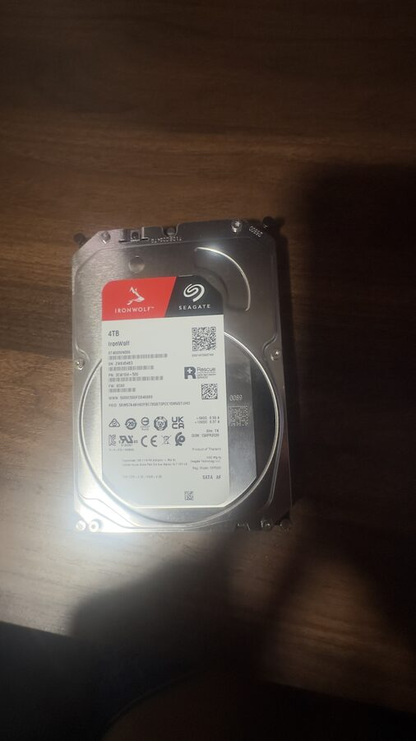  Rack-mounted PDU for organized power distribution. | 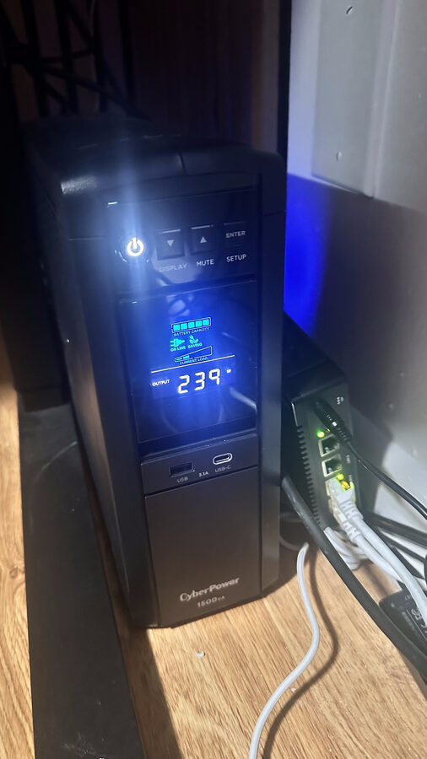  UPS providing battery backup, monitored via NUT. | 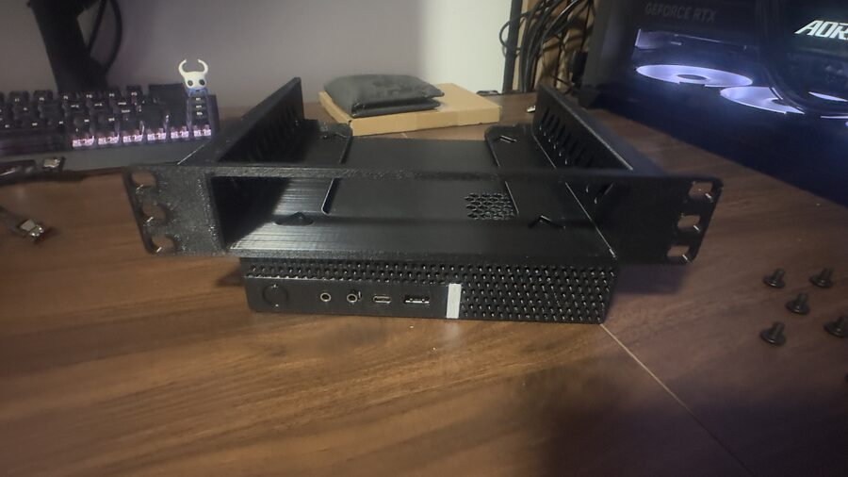  Custom 3D-printed mounting bracket for the rack.

NETWORK SECURITY & FIREWALL (PFSENSE)
Configured and administer a pfSense firewall as the network's perimeter defense. Designed firewall rules following a least-privilege, default-deny model — every rule was scoped to a specific source, destination, and port rather than left broad, including tightening auto-generated NAT-associated rules down to their exact intended destination. Set up DHCP (Kea), DNS resolution, NTP, and system logging, and configured WAN-facing settings deliberately, including reasoning through bogon vs. private-network filtering trade-offs when they conflicted with legitimate internal testing traffic.
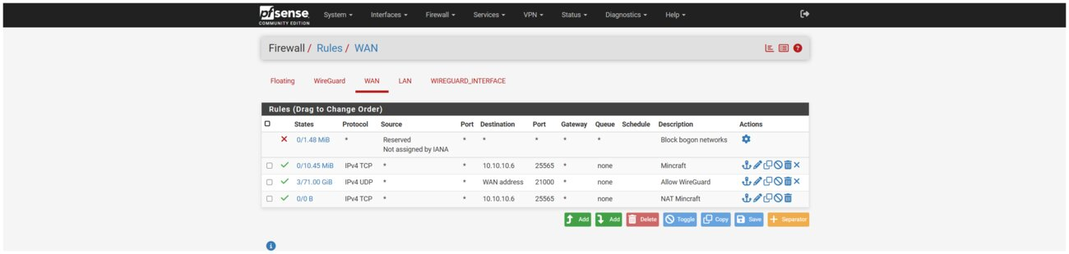
pfSense dashboard showing system status and gateway health.
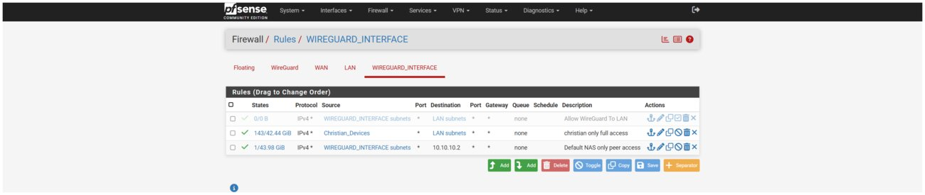
pfSense LAN firewall rules, configured with a least-privilege, default-deny approach.
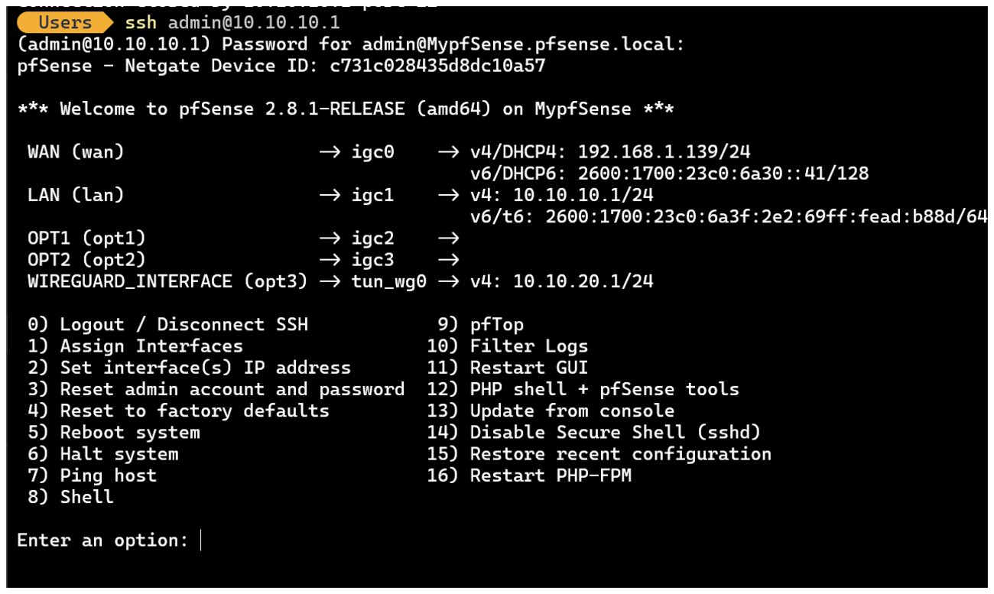
SSH access into pfSense for command-line administration.
VPN INFRASTRUCTURE (WIREGUARD)
Replaced a third-party mesh VPN with a fully self-hosted WireGuard deployment on pfSense, including port forwarding through a double-NAT ISP gateway. Designed a tiered access model using firewall aliases: the administrator's own devices receive full internal network access, while any future peer is restricted by default to a single internal host, enforced entirely at the firewall layer rather than by trusting client configuration. Generated and distributed per-peer keys and preshared keys, and diagnosed a real-world NAT hairpin/reflection issue that was silently dropping same-network test traffic, tracing it back to a WAN interface bogon-filtering setting.
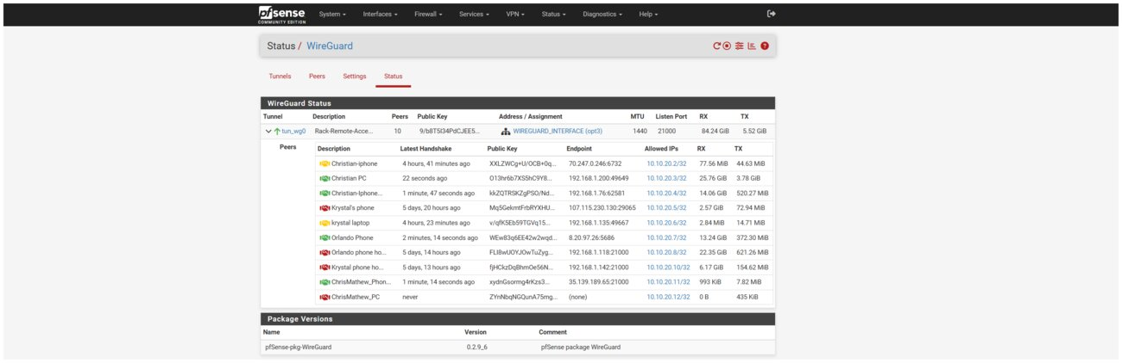
WireGuard VPN configuration on pfSense.
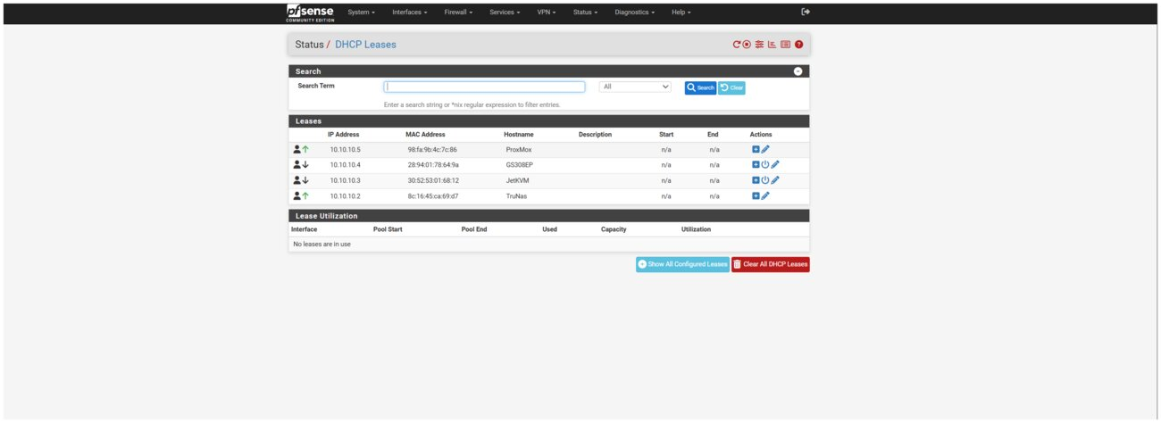
WireGuard peer configuration.
INTRUSION DETECTION & PREVENTION (SNORT)
Deployed Snort as an active IDS/IPS on the WAN interface, in inline blocking mode rather than passive logging-only mode. Curated rule categories (Snort VRT/Subscriber, Emerging Threats Open, FEODO Tracker, GPLv2 Community, OpenAppID) balanced against the hardware's processing budget, and corrected a self-lockout risk in the block-target configuration before it could firewall off the router's own WAN address. Built a lightweight shell script, scheduled via cron, that tails Snort's alert log and pushes new detections to a Telegram bot in real time, giving immediate visibility into blocked and flagged traffic instead of relying on periodically checking a dashboard.
STORAGE, BACKUP & ACCESS CONTROL (TRUENAS)
Administer a TrueNAS SCALE server providing network storage for personal files, media, and application data. Configured SMB and NFS shares with scoped host/network restrictions, set up UPS monitoring (NUT) with a properly configured monitor user after diagnosing an initial misconfiguration, and built a self-signed internal certificate authority to issue trusted TLS certificates for internally hosted services, including troubleshooting a real client-side certificate rejection caused by exceeding the modern maximum certificate validity period. Scheduled automated backups of critical virtualized workloads from the hypervisor to this storage over NFS.
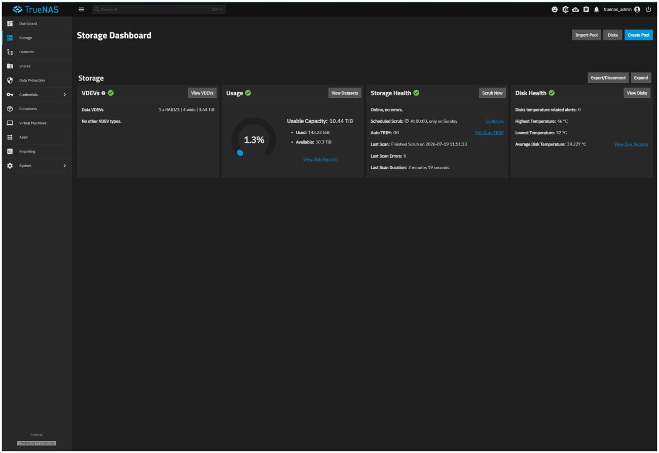
TrueNAS storage dashboard.
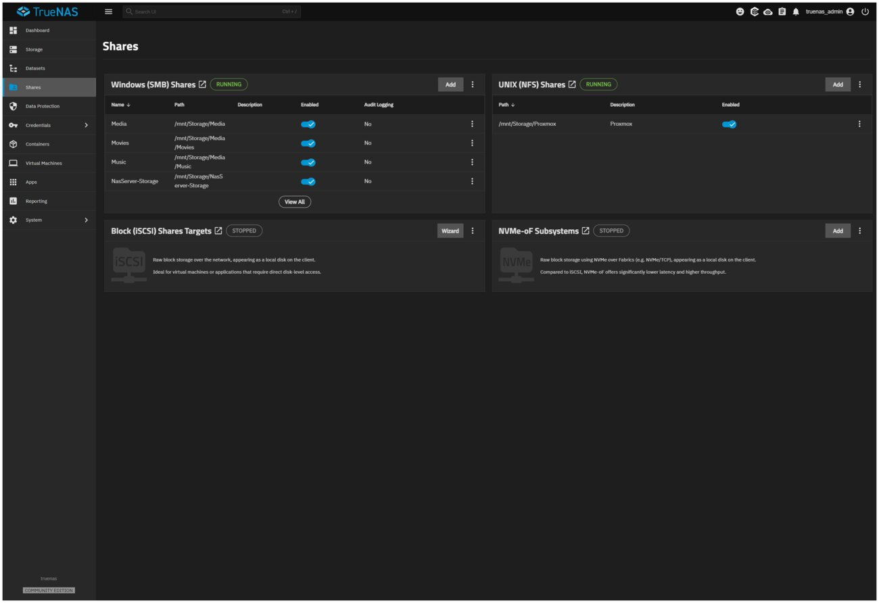
TrueNAS SMB/NFS share configuration with access controls.
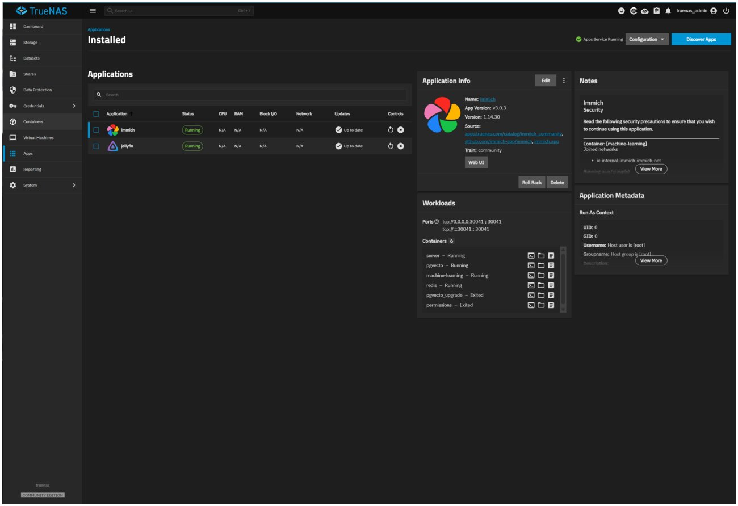
Installed applications on TrueNAS.

VIRTUALIZATION & SELF-HOSTED SERVICES (PROXMOX)
Built and manage a Proxmox VE host running a containerized services environment (Docker inside an LXC container, managed with Portainer). Deployed and secured multiple self-hosted applications: Vaultwarden (password manager) behind a Caddy reverse proxy terminating TLS with the internally issued CA certificate, Uptime Kuma for service and endpoint monitoring with Telegram alerting, and a resource-isolated application server with its own locked-down inbound firewall rule permitting traffic only to that single host and port. Diagnosed and resolved a chain of real infrastructure issues along the way, including Docker's default directory permissions blocking a file share, NAT/port-forward misconfigurations, and container resource sizing.
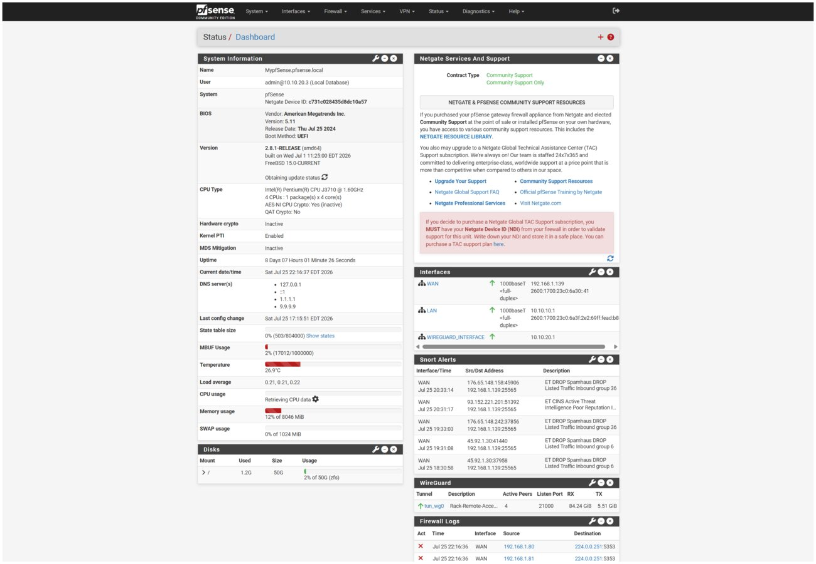
Portainer container list for Docker services running on Proxmox.
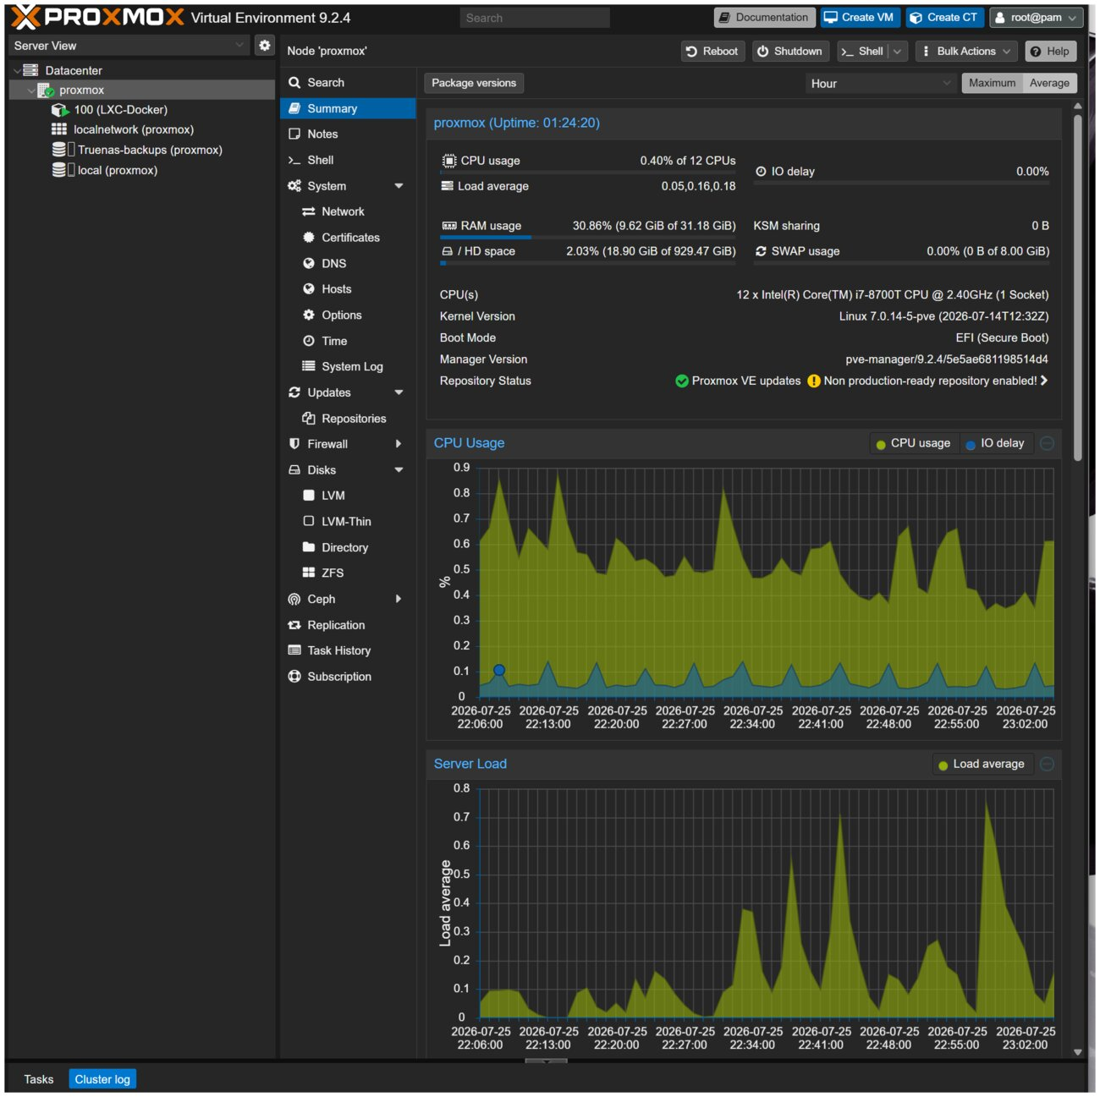
Proxmox host resource utilization (CPU/memory).
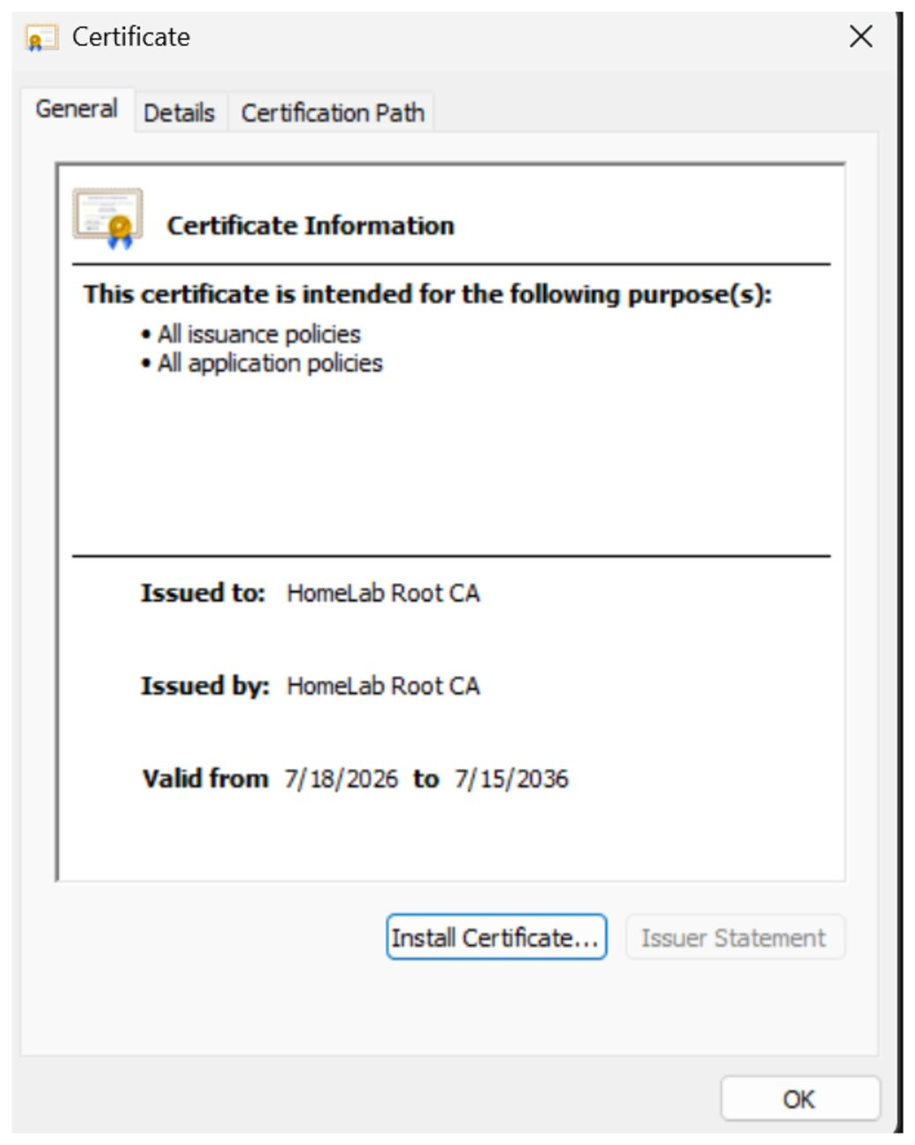
Self-signed CA certificate installed and trusted on a client device.
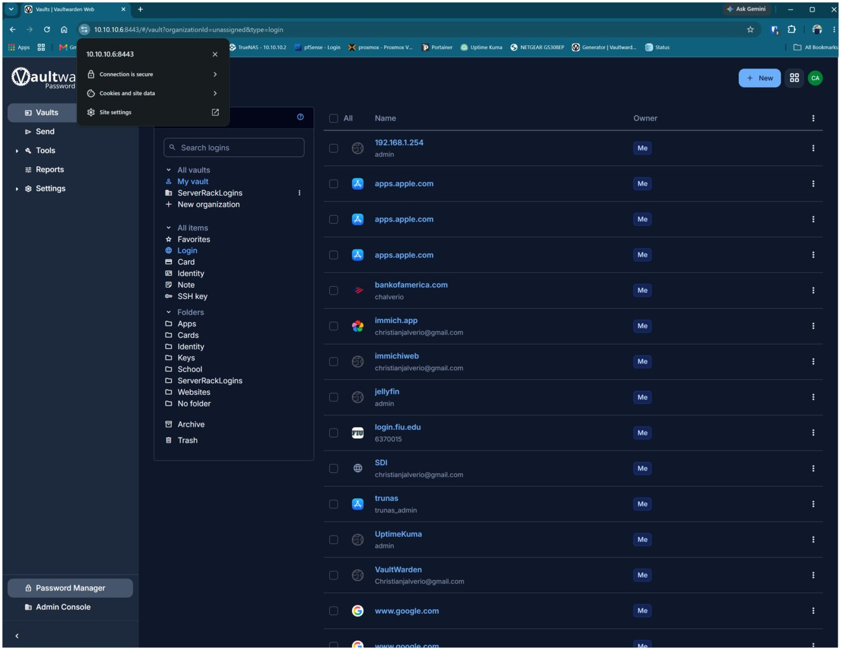
Vaultwarden self-hosted password manager.
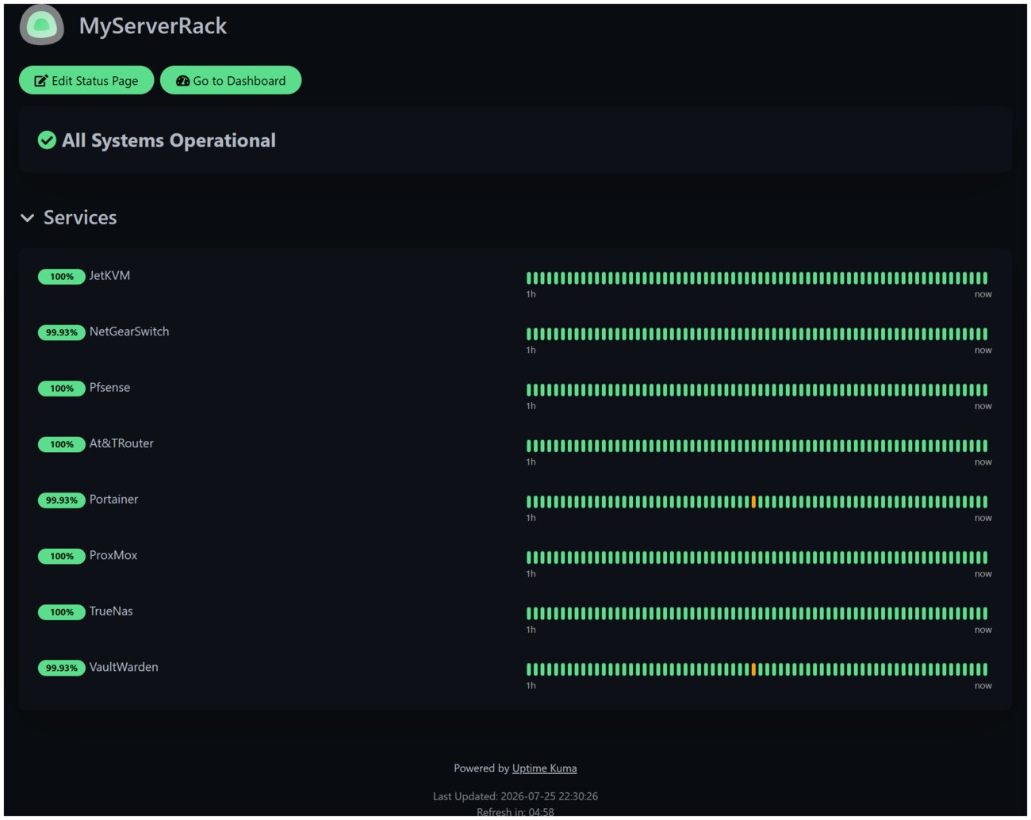
Uptime Kuma status page showing all monitored services operational.
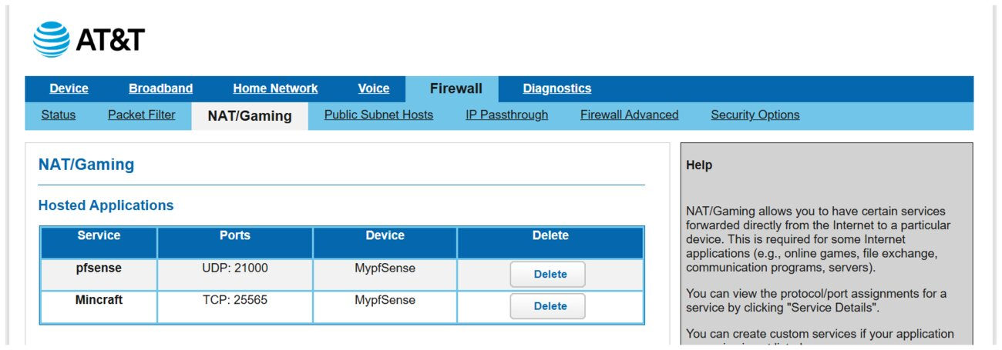
Port forwarding configuration for externally accessible services (Minecraft server).
SELECTED TROUBLESHOOTING & PROBLEM-SOLVING
A few concrete examples of root-cause diagnosis performed during this project, each representative of the kind of systematic troubleshooting expected in a SOC or help desk role:
- Traced a VPN client showing zero received traffic to a WAN interface setting silently dropping private-sourced packets, rather than assuming a misconfigured tunnel.
- Diagnosed a browser certificate rejection (NET::ERR_CERT_VALIDITY_TOO_LONG) back to a self-signed certificate exceeding the modern 398-day maximum validity policy, not a trust-chain problem, despite the error appearing identical to one.
- Isolated a file-share permission failure to a parent directory's restrictive Linux permissions several levels above the actual shared folder, rather than the share configuration itself, and resolved it with a scoped bind mount instead of loosening broad system directory permissions.
- Identified a severe server performance issue as CPU/I-O contention between a background data pre-generation task and live usage, and resolved it with an automated pause/resume mechanism instead of just reducing overall scope.
SKILLS DEMONSTRATED
- Firewall administration and rule design (least privilege, default-deny)
- VPN deployment and access-tiering (WireGuard)
- IDS/IPS deployment, rule tuning, and alert triage (Snort)
- PKI / certificate lifecycle management (CA creation, issuance, renewal, validity-policy troubleshooting)
- Network storage administration and access control (SMB/NFS, TrueNAS)
- Virtualization and container administration (Proxmox, Docker, LXC)
- Monitoring and automated alerting pipelines (Uptime Kuma, Telegram bot integration)
- Systematic troubleshooting and root-cause analysis across networking, storage, and application layers
- Technical documentation of infrastructure decisions and configurations

