# Language Input Prompt:

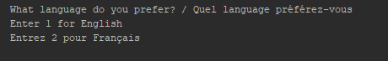

# English Menu:

## User Type Input Prompt:

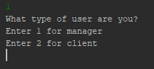

## Manager Menu:

### Main Menu :

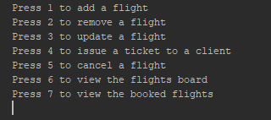

### Add Flight Option:

#### Flight Number Input Prompt:



#### Aircraft Name Input Prompt:



#### Origin Input Prompt:



#### Destination Input Prompt :



#### Duration Input Prompt :



#### Number of Seats Input Prompt:



#### Available Seats Input Prompt :

We do not ask input for this because we assume that the available seats is equal to the total number of seats when adding a new flight.

#### Flight Amount (price) Input Prompt:



#### Prompt to continue application:



1. Entering 1 (yes) will bring you back to the manager main menu and will allow you to continue the application.
2. Entering anything else than 1 will terminate the application.

## Client Menu:

# French Menu: