ENGI 8894 Real-Time Operating Systems
Lab 2

Joshua Bennett – 201428653
Christian Legge - 201422748
Serial Execution
Number of Runs | Mean | Standard Deviation
3 | 22.987 | 1.125
5 | 22.244 | 1.664
10 | 21.861 | 1.750
100 | 14.337 | 3.835
1000 | 11.794 | 5.23

Number of Jobs (Work per Job = 10) | Mean | Standard Deviation
10 | 15.99 | 0.972
100 | 7.872 | 1.318
1000 | 4.872 | 1.894
10000 | 1.899 | 0.841

Work Per Job (Number of Jobs = 10) | Mean | Standard Deviation
10 | 12.234 | 1.896
100 | 11.808 | 0.984
1000 | 2.123 | 1.849
10000 | 2.149 | 2.973

As seen in the figure above, as the number of jobs and work per job is increased, in the serial program, the average time per work also decreases.
POSIX Threads
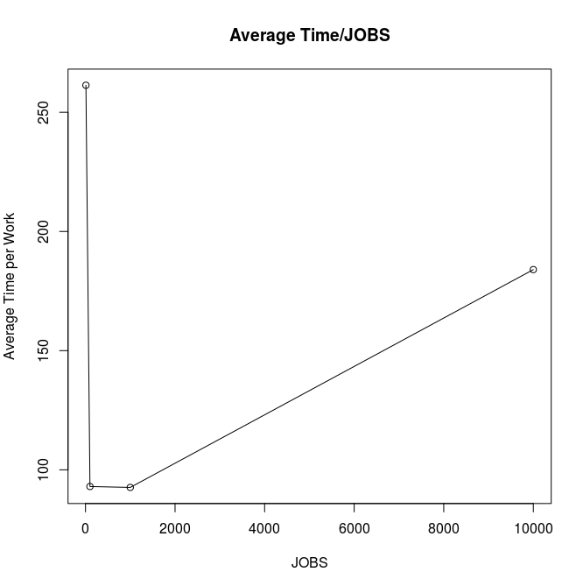
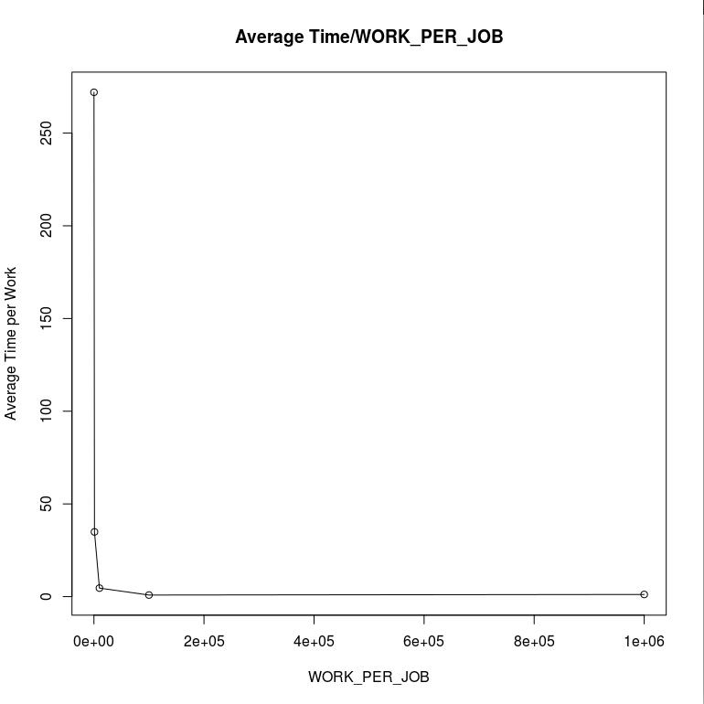
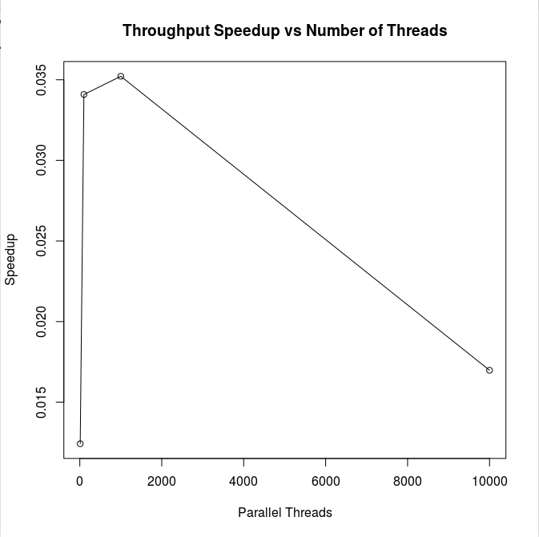
Libdispatch
