**DOCUMENTATION**

**Name: Ryan Christian P. Lepio**

**BSCS – 3A**

Software Engineering

**Login Frame**

Filename: Loginfrm.java

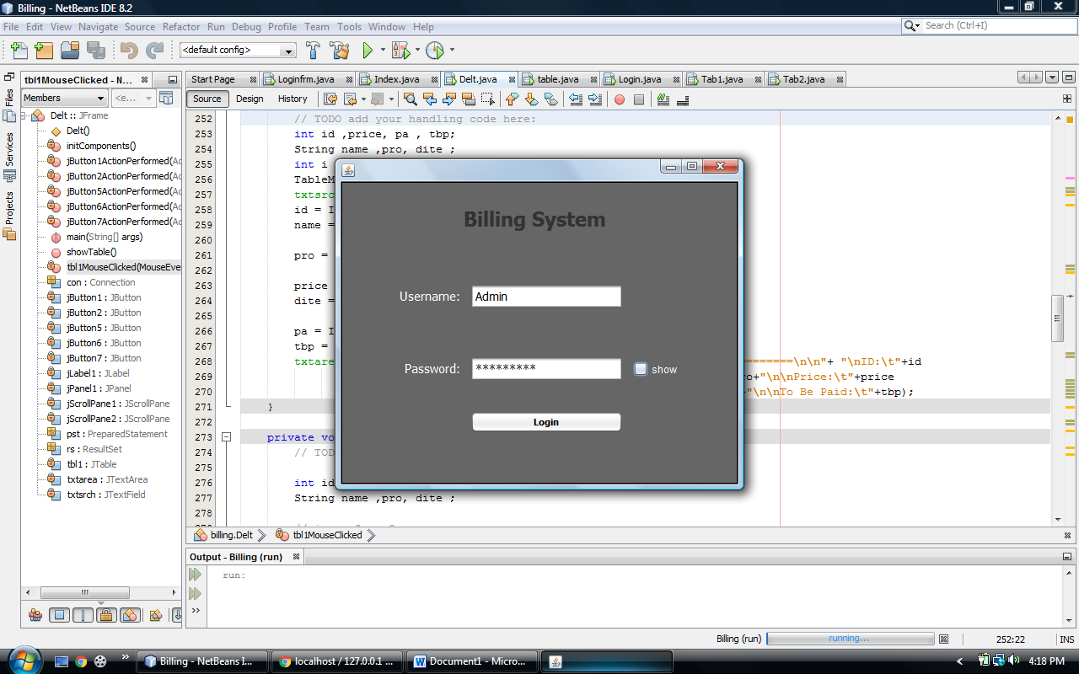

**Index Frame**

Filename: Index.java

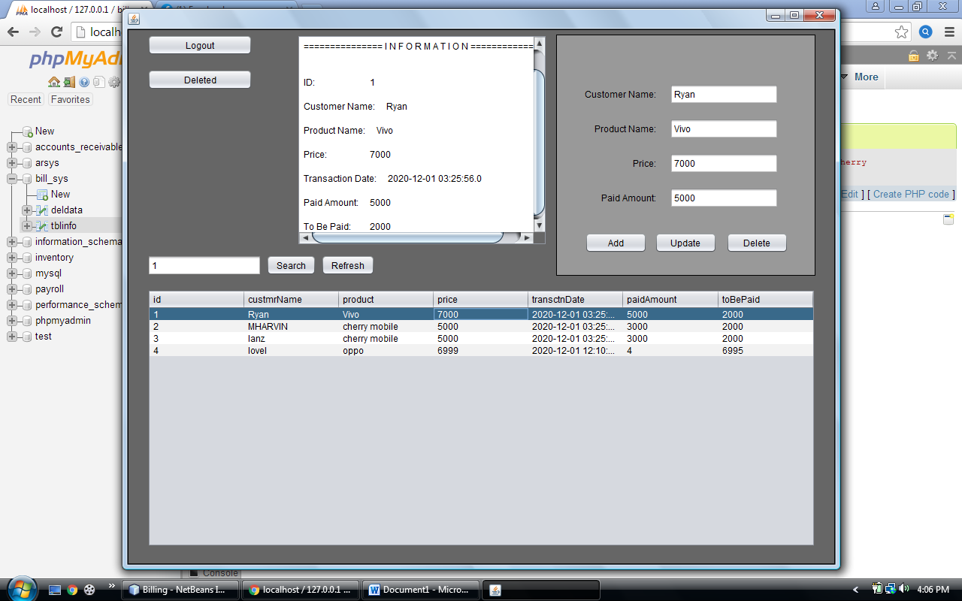

**This is where data goes when it is already deleted.**

Filename: Deltfrm.java

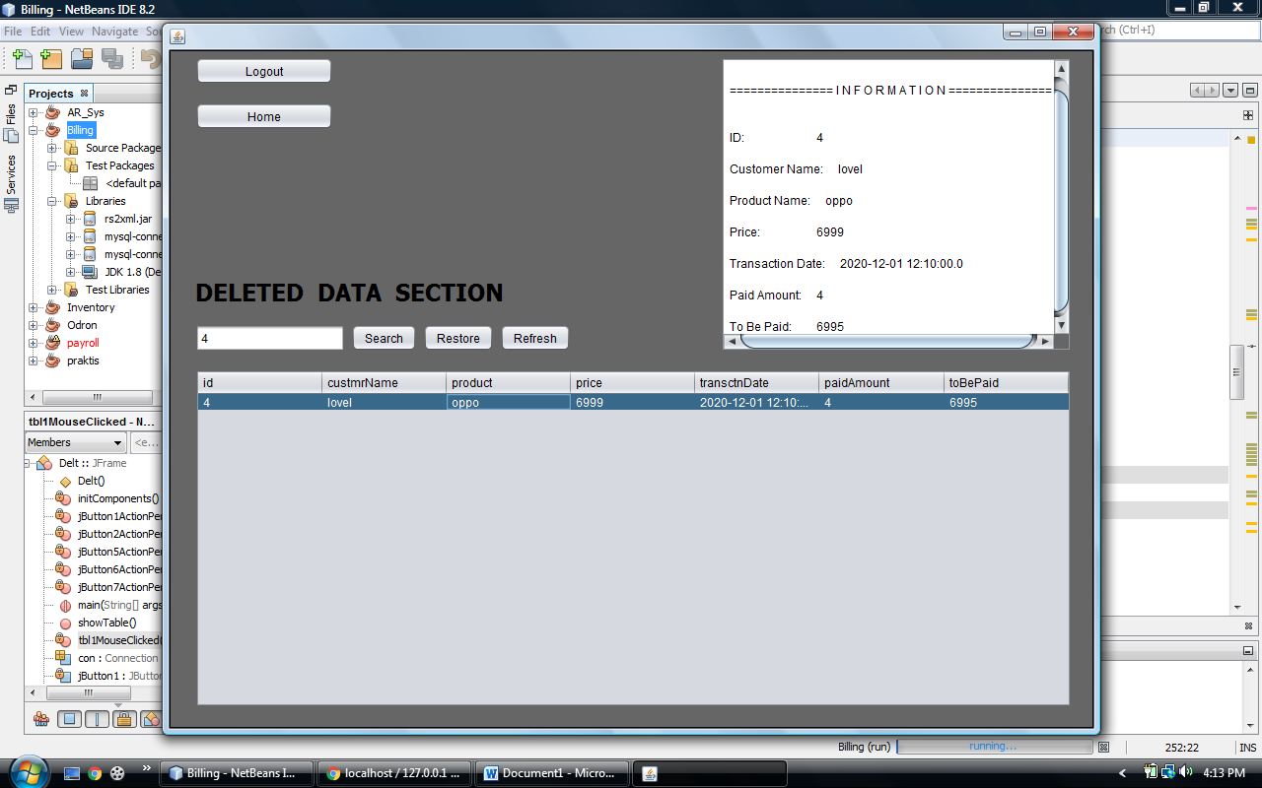

**SYSTEM DATABASE , TABLES AND COLUMNS**

