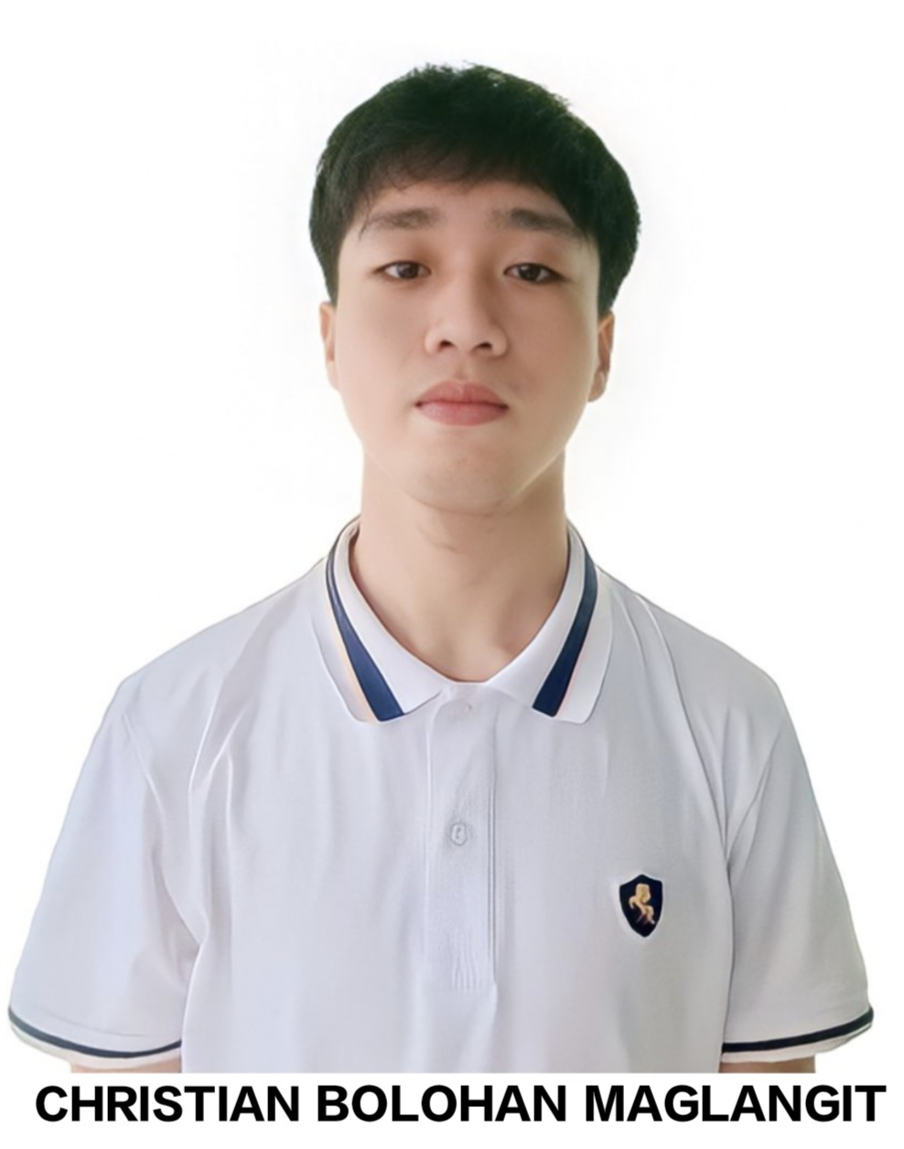**CHRISTIAN B. MAGLANGIT**

Address: Zone Leo Suarez, Iligan City, Lanao del Norte

Contact #: +63935-735-5890

E-mail: christianbolohanmaglangit@gmail.com

**OBJECTIVE:**

Pursuing opportunity which will allow me to grow personally and professionally where I will be able to utilize my educational background, strong organizational skills, ability to work well with people, give me different kind of new experiences and exceed team goals.

**PERSONAL INFORMATION**

Age: 24

Date of Birth: January 20, 2000

Gender: Male

Civil Status: Single

Height: 5’8(172 cm)

Weight : 61 kg

Religion: Roman Catholic

Mother: Evangeline B. Maglangit

Father: Carlito H. Maglangit

**EDUCATIONAL BACKGROUND**

**Elementary :** South II Central School

Brgy. Suarez, Iligan City, Lanao del Norte

(S.Y. 2006 - 2012)

**Secondary :** Suarez National High School

Brgy. Suarez, Iligan City

(S.Y. 2012 - 2016)

St. Laurence Institute of Technology

7-B Mariano Badelles St, Iligan City, Lanao del Norte

(S.Y. 2016 - 2018)

**Tertiary :** Bachelor of Science in Information Tecnology

St. Peter’s College

Sabayle St, Iligan City, Lanao del Norte

(S.Y. 2018 - 2020) (1st - 2nd year)

(S.Y. 2022 - 2023) 1st Semester (2nd year)

(S.Y. 2023 – (Present)

**QUALIFICATION:**

* Communication Skills
* Time Management
* Self-Motivation
* Adaptability

**SKILLS:**

* Computer Literacy Proficient at MS Word, MS Excel, and MS PowerPoint)
* Communication skills comfortable speaking and writing
* Basic Video Editing and Photo Editing
* Know Programming Languages like Java, PHP, C++, Python, HTML

**ORGANIZATIONAL EXPERIENCE:**

* 2019-2020 1st Semester - Secretary of Collage of Computer Studies Organization,

St. Peter’s Collage

* 2019-2020 2nd Semester - President of Collage of Computer Studies Organization, St. Peter’s Collage
* 2024-2025 Upcoming Semester - President of Collage of Computer Studies Organization, St. Peter’s Collage