**Do Economic Incentives Work? Evaluating the Effect of Incentives Designed to Attract Investment on State-Industry Growth Rates**

A Thesis

submitted to the McCourt School of Public Policy

in partial fulfillment of the requirements for the

degree of

Master of Public Policy

By

Christian Conroy

Abstract

Economic development scholars remain divided over whether economic incentives designed to attract businesses to a locality ultimately promote job growth, higher wages and economic development or just give away taxpayer dollars. While some research has found that economic incentives may nudge a company to choose one location over a similar location, others have argued that companies make location decisions based on strategic considerations like human capital and supply chains, and not based on economic incentives. At the same time, even if companies are choosing to locate to a particular locality based on an economic incentive package, it is not clear that the growth they bring is enough to compensate for the loss of tax revenue. In this paper we evaluate the impact of five different types of state-level economic incentives on GDP growth. We use a novel *Panel Database on Incentives and Taxes* established by the W.E. Upjohn Institute for Employment Research that contains data on marginal business taxes and business incentives for 45 industries in 47 cities in 33 states collected from 1990 to 2015. Using several estimation strategies, including short and long term two-way fixed effects regression modeling and propensity score stratification, we find that economic incentives in the aggregate have a positive impact on state-industry GDP growth but the effects differ across economic incentive types.

1. **Introduction**

The almost reality-television style competition 19 U.S. cities and Toronto found themselves in over 2018 as a result of Amazon’s public bid for the company’s next headquarters renewed a conversation in America over whether the economic incentives that these cities offered the market platform behemoth actually result in development and employment. Economic development scholars have suggested that there is a causal relationship between the use of economic incentives designed to attract businesses and resulting growth in state-level GDP growth over time in the United States. The most common argument is that a company that chooses to locate in a state offering an incentive package will ultimately bring jobs, wage increases, and state and local economic growth that will more than compensate for the short-term loss in tax revenues (Peters and Fisher 2004, Bartik 2003, Bartik 1991). Others have further argued that it is often the case that the incentives are what pushes a company to choose one location over another similar location that is offering less in cost reductions (Bartik 2005, Rubin 1991, Chapman and Walker 1991, Walker and Greenstreet 1989, Schmenner 1982).

If the theory of change is as these scholars argue, namely that tax-incentive packages nudge large companies to choose specific locations and those companies subsequently create jobs and economic output that benefits the local economy, then it makes logical sense that local economic development authorities would continue to leverage this tool. However, only a few empirical studies provide evidence economic incentives like property tax abatements, R&D tax credits, job creation tax credits, and other tools lead to economic growth at the local and state levels (O’Connor 2011, Busso and Kline 2008, Bartik 2005, Wu 2005, Peters and Fisher 2004, Wasylenko and McGuire 1985, Newman 1983). For example, Peters and Fisher (2004) find that offering a job creation tax credit equal to $2,800 per job for a branch plant would result in an increase of 30% in the probability of a firm choosing the offering location over a similar location not offering the incentive. Busso and Kline (2008) evaluated the federal urban Empowerment Zone program and found evidence that local economic development incentives led to significant gains in employment and economic growth. The findings of these studies, however, have not gone unchallenged.

A greater portion of the literature argues that economic incentives are not effective in attracting companies that in turn will provide jobs and economic growth. Several studies argue that economic incentives are not a significant factor in the decision making calculus of a firm and such tools therefore provide taxpayer money to a firm that had already chosen to locate to the area due to factors related to ease of living, human capital support, or corporate strategy (Peters and Fisher 2004, Weber 2000, Rondinelli and Burpitt 2000, O’Mara 1999, Lynch 1996). Rondinelli and Burpitt (2000) found through surveys that executives of multinational firms place factors like quality of life and transportation infrastructure high while ranking state taxes and finance consistently low. Even accepting that an economic incentive package might lure a company to a particular location, some studies have argued that once there the economic benefits will not outweigh the costs (Blomström 2002, Rodríguez‐Pose and Arbix 2001). According to another prominent argument, economic incentives might attract large companies and translate to increased short-term growth, but they also will crowd out investment or create sub-optimal capital allocation in the long-term (Wilson 2009, Gorin 2008, Peters and Fisher 2004, Fisher and Peters 1997). Wilson (2009) looks specifically at R&D tax incentives, arguing that while they do increase R&D spending within the state in the short-term, they also draw it away from other localities in the long-term, resulting in no net gain overall. With challenges presented at each point along the causal chain, it seems difficult to prove the effect of incentives on increasing economic growth over time.

The empirical evidence showing no relationship or even a negative relationship between economic incentives and state-level GDP growth naturally accentuates that challenge. Numerous studies have shown that economic incentives packages do not return the economic development benefits over time that they purport to (De Blasio, Fantino, and Pellegrini 2014, Peters 2002, Rodriguez-Pose and Arbiz 2001, Boarnet and Bogart 1996, Schweke, Rist, and Dabson 1994, Carlton 1983). For example, De Blasio, Fantino, and Pellegrini (2014) exploited a shortage of funding for an innovation subsidy program to apply a regression discontinuity design (RDD) and find that the program was not effective in producing the economic spillovers through increased innovation that it was intended to. The central finding of all the studies cited above was that there was a breakdown somewhere in the mechanism that translates tax reduction incentives into company attraction into increased economic development.

Rather that attributing the breakdown in the causal relationship between economic incentives and state-level GDP growth to the concept of the incentive itself, other scholars have pointed out design features that may make incentives more or less likely to promote economic growth in the long-term. Some have pointed to skill gaps in local economic development authorities that doom complex incentives structures from the start (Dewar 1998). Others sympathize with heads of economic development authorities as they are bound by the competing incentives of higher-level government authorities with electoral interests (Jensen and Malesky 2018, Dewar 1998). Bartik (2017) argues that shorter-term incentives that front-load tax breaks and subsidies have a higher likelihood of influencing relocation decisions and affecting long-term economic development prospects due to the way corporate accounting processes function. The most developed strand of the literature emphasizes the importance of including clawback provisions and performance requirements within economic incentives deals in order to hold recipient companies accountable to the jobs and economic growth they promised to bring when initially seeking the tax reductions (Bartik 2005, Ledebur and Woodward 1990, Bartik 2003). Given the complexities of locational tax effects, this strand of the literature appears to offer the most applied evidence for policymakers tasked with considering both whether incentives are useful and how they should be designed.

Clearly, the empirical literature that seeks to identify the effects of economic incentive programs on economic growth is mixed. While there are many potential reasons for the inconclusiveness, in part, methodological shortcomings in several of the studies highlighted above may be to blame. Specifically, several studies, such as Fleischmann, Green, and Kwong (1992), Rondinelli and Burpitt (2000), Schmenner (1982), Walker and Greenstreet (1989), and Rubin (1991) rely on data collected through surveys. While much can be learned, results that are produced are not useful in interpreting the effect of incentives as answers are subjective, question items can be interpreted differently, and respondents might even be incentivized to exaggerate the positive effects of an incentive package if they think they might be soliciting such bids again at some point in the future. Others used case-studies that held little external validity (Bartik 1987). Several studies taking econometric approaches mismatched geographic targets, analyzing the effect of city-level incentives on state economic growth or state-provided incentive programs on the economic prospects of a city within that state (Coughlin and Cartwright 1987). Several looked at specific incentive programs without creating a sufficient control group upon which to compare how a company made its allocation decision or whether a company’s entrance resulted in increased economic development in the absence of incentive programs.

Studies of enterprise zones and other relatively "large" economic development programs suffer from a second problem: it is difficult to determine what would have happened to the local area without the program (Busso and Kline 2008). Lastly, some studies like Wu (2005) and Wilson (2009) focus only on the immediate effects of an incentive (i.e. whether R&D tax credits increase R&D spending) as opposed to the long-term effects on economic growth.

Given the competing narratives and empirical shortfalls, this thesis will ask the research question:

*Do incentives offered by state and local governments to attract businesses actually result in increased business activity and positive GDP growth*?

In attempting to answer the research question posed, this study will be carrying out one of the most comprehensive causal studies of the effect of economic incentives on state and industry level economic growth to date. This paper employs a longitudinal analysis model controlling for fixed effects and propensity score stratification to evaluate both the short and long term effects of economic incentives on state-industry GDP. Unlike previous studies that have focused on one specific incentive program or one type of tax incentive, this study will evaluate five different types of business incentives, including: job creation tax credits, investment tax credits, R&D tax credits, property tax abatements, and customized job training packages.

This study overcomes the challenge in creating a counterfactual against which to identify a causal relationship by leveraging a database developed through a “tax and incentive simulation” (Bartik 2017). First applied to economic incentives by Peters and Fisher (2002), under this modeling structure, a business in some industry *i* creates a new branch facility to be set up in city *c* in state *s* that will start operation in year *t* (Bartik 2017). State and local taxes, the nominal value of incentives, and the changes in inputs and outputs over time for a firm are calculated for each year using real information for each city, state, industry, and incentive format. Overall, what amounts to 65 percent of total state and local business taxes is covered in the dataset, with that number being higher for industries that are not subject to taxes left out of the database such as public utility taxes and insurance premium taxes.

Several studies have applied unique approaches to studying the causal effect of fiscal incentives, though few have effectively applied such approaches to analyzing the impact of multiple types of incentives on GDP growth in those industries receiving the incentives. Cleeve (2008) applies a multiple regression analysis that controls for autocorrelation and heteroscedasticity of standard errors through rho transformation and the application of robust standard errors to conclude that fiscal incentives like tax holidays are important in attracting foreign direct investment. Wilson (2009) applied a difference-in-difference estimator allowing for state and year fixed effects with state-level panel data from 1981-2004 to find that R&D tax incentives may have short term benefits but only at the cost of crowding out R&D spending in surrounding states in the long-term. Lastly, De Blasio, Fantino, and Pellegrini (2014) exploit a temporary lapse in funding for an innovation subsidy program to argue that incentive recipients do not end up producing more patents compared to firms not receiving the subsidy. While each of these studies took an innovative approach to analyzing a specific incentive, the research questions they posed did not align with the question of whether economic incentives actually lead to economic development at the state level.

The rest of the paper is organized as follows. The second section provides background on economic incentive programs and how they are structured at the state and local levels. The third section covers the sampling methodology, data sources, and design used in our analysis. The fourth and fifth sections detail the statistical approach and empirical results. The final section concludes.

1. **Background: Types of Economic Incentives**

To assess the relationship between economic incentives and economic growth, we focus on five different types of economic incentives: job creation tax credits, investment tax credits, R&D tax credits, property tax abatement, and custom job training subsidies. While this list is not exhaustive – the database does not include geographically targeted incentives like opportunity zones or tax increment financing (TIF) incentives – it does cover the majority of incentive dollars spent by at the state and local level to attract medium to large size firms. Each of the five types of incentives included in this study operate differently in general and across states and industries and it is therefore important to provide an overview of how the incentives work.

Investment tax credits consist of relief applied against a company’s tax liability based on specific criteria regarding the type of incentive. Criteria is typically set based on the amount of investment, the target of the investment, the size of the investing firm, and the industry that the firm carrying out the investment operates within. For example, the *InvestArk* investment tax credit program in Arkansas provides tax credits against sales and use tax to firms in specific industries that invest at least $5 million in a plant or “equipment for new construction, expansion, or modernization” (Summary of Tax Incentive Programs 2016). Investment tax credits in Connecticut and Oklahoma offer tiered investment tax credits based on both the level of investment and the number of employees at the investing firm (Summary of Tax Incentive Programs 2016). The tax liability will differ and industry and state and local governments therefore often tailor investment tax credits based on specific criteria as opposed to uniform application across industries.

Job creation tax credits are similar to investment tax credits and only differ, as the name suggests, by what the company must do in order to receive the tax credit. Firms receiving job creation tax credits against tax liabilities usually have to demonstrate a number of jobs that will be created, types of jobs that will be created (full-time, part-time, temporary, etc.), and an average payroll for those jobs, with the level of credit received often tiered based on different levels of annual payroll. For example, Delaware provides a job creation tax credit of $500 for each job while Mississippi provides the credit as a percentage of new payroll (Francis 2016). The level of investment and scale of job creation are typically parts of every economic incentive deal package and there are few occasions when the job creation tax credit will be offered without the accompaniment of the investment tax credit and vice versa.

While the job creation and tax credits apply to tax liabilities a company will incur for operating in a specific location, the R&D tax credit applies to expenses a company chooses to spend. While the administration of R&D tax credits looks slightly different across states and industries, all programs typically measure the level of credit against tax liabilities based on change from a base year R&D spending and a set forward carry based on the timeline of research. For example, Indiana provides companies a tax credit against liabilities on 15% of the first $1 million in R&D spending above the prior three-year base that can be carried forward for ten years (Miller and Wathen 2014). R&D tax credits often differ across states and industries by what spending qualifies as R&D, what industries or research purposes qualify for the credit, what percentage of spending qualifies for the credit, and what the carry forward time is for the given credit.

The central difference between the tax credits laid out above and the property tax abatement is that credits are applied to reduce tax liabilities whereas abatements simply reduce the liability level from the start. In the case of property taxes, abatement consists of delaying taxes on existing property and improvements or expansions until a specified period. For example, Indiana provides 100% tax abatement for three years for companies that occupy 50,000 square feet of vacant building space, invest at least $10 million in property, locate in a high unemployment tract, or rehabilitate a dilapidated building in a designated area (Miller and Wathen 2014). Different states maintain different R&D tax credit policies, but all typically involve some level of property tax abatement for property expansions, renovations, or improvements related to manufacturing, supply chain, R&D, and information technology (Miller and Wathen 2014).

Unlike tax credits and abatements, the custom job training subsidy simply provides a lump-sum grant distribution to firms based on demonstrated training needs, typically on a per employee basis. For example, New Mexico’s Job Training Incentive Program provides funding for up to six months for green and manufacturing companies that export a significant portion of products out of state (New Mexico Economic Development). Grants can be distributed up front based on a firm’s demonstrated need or through reimbursement after qualified training is conducted.

1. **Data Sources and Collection**

The empirical analysis is based on several sources of data. Data on incentives come from the Panel Database on Incentives and Taxes; Annual industry output and state GDP from the Bureau of Economic Analysis (BEA); and state-government finance variables from the Census Bureau. The data sets and the construction of the sample is discussed below.

***Data Sources***

The W.E. Upjohn Institute for Employment Research Panel Database on Incentives and Taxes is the only open-access database that aggregates all the information used in calculating incentives, taxes, and economic returns by city, state, and industry into one database, and contains data on marginal business taxes and business incentives for 45 industries in 47 cities in 33 states collected from 1990 to 2015.[1] The database covers five types of business incentives, including: job creation tax credits, investment tax credits, research and development tax credits, property tax abatements, and customized job training packages. While not all cities and states that have used incentives to attract businesses are covered in the dataset, the coverage is more than representative: the 33 states compose 92 percent of US GDP and the 45 industries compose 91 percent of US labor compensation (Bartik 2017). Such coverage will allow assessment of both the overall effects of incentive packages on GDP growth and the effects broken down by industry, geographical grouping, and type of incentive offered.

It is important to note that the dataset is not a repository of actual incentives that state and local governments have offered to businesses like that maintained by Incentives Monitor. Instead, the database is derived from carrying out a “tax and incentive simulation” whereby a business in some industry *i* creates a new branch facility to be set up in city *c* in state *s* that will start operation in year *t*. The “output, value-added, real and personal property, labor, and purchases of intermediate inputs” the branch facility would bring comes from a constructed balance sheet derived from BEA Industry accounts data, IRS data on Statistics and Income, and National Science Foundation data on R&D spending (Bartik 2017). State and local taxes, the nominal value of incentives, and the changes in inputs and outputs over time for a firm are then calculated for each year using real information for each city, state, industry, and incentive format. Information on state and local taxes includes: business property taxes from the Lincoln Institute of Land Policy and the Minnesota Center for Fiscal Excellence, state taxes on corporate income, and state gross receipts taxes from the Commerce Clearing House’s *State Tax Guides*. Information on incentive rates comes primarily from the Council for Community and Economic Research (C2ER), Good Jobs First, documents describing local laws and policies, and the websites of city and state economic development authorities.

In addition to the merged datasets that comprise the database, the panel is merged with a dataset drawn from the BEA system containing annual GDP by state in aggregate and for each industry. The GDP data collected by BEA is comprised of three components: labor income (wages, salaries, and other benefits), business taxes (excise, sales, property, and other business expense taxes), and capital income (income earned by individual or business and deprivation) (Cole 2015). Each data point is collected through a rigorous methodology that includes estimation using BEA’s state personal income (SPI) and industry accounts, business payment and financial data from the Census Bureau, and value-added data from the Department of Agriculture.

In addition to state-industry level controls drawn from the Panel Database on Incentives and Taxes, state-level control characteristics and state government finance variables were collected from BEA and the Census Bureau, respectively. State-level control variables are used as part of the propensity score matching process and included as control variables in all three of the model specifications. Due to the fact that Washington DC is dropped from the sample when incorporating state government finance variables, all model specifications are run both with government finance variables and without.

The challenge with merging the Panel Database on Incentives and Taxes with the BEA GDP by state for each industry is that there is a discontinuity in the data at 1997 due to the decision by BEA to convert from industries defined by SIC codes to those defined by NAICS codes. Federal statistical agencies use NAICS to collect and analyze data related to the U.S. economy, with each digit of the code system, representing a progressively narrower detail: the first two digits represent the economic sector, the third the subsector, the fourth the industry group, the fifth the NAICS industry, and the sixth the national industry (North American Industry Classification System 2017). While tools to crosswalk SIC and NAICS codes do exist, it is impossible to match the definitions without over or under counting the GDP levels of specific industry groupings and BEA even cautions scholars against trying to append the datasets together to develop a consistent timeline for 1963 to 2016.[2] The state economic profile variables that serve as control covariates also only capture 1998 onwards. In light of this challenge, the decision was made to reduce the dataset down to the years 1998 through 2015. The resulting dataset contains 19,568 observations.

While the primary research question of this paper focuses on the effect of each of the five economic incentive types on the GDP growth of an industry in given state over time, we will also seek to evaluate the *aggregate* effect of the economic incentives. Not only will this allow us to determine whether the package of economic incentives promotes economic growth for industries, but in comparing the aggregate effect with the individual effects, we can better determine whether or not one incentive or a few incentives comprise the majority of the effect (if there is an effect) of the aggregate economic incentive impact on GDP growth. Furthermore, industries are often not receiving one incentive type but are instead often receiving the combined tax abatement of all types of economic incentives, so including an aggregate measure of incentive abatement allows us to control for the confounding effects of all economic incentives.

To create a measure of aggregated incentive tax abatement, we build an index constructed from the tax abatement levels for all five incentive types that each state-industry receives on an annual basis. Using the methodology described by the University of Warwick Centre for the Study of Globalisation and Regionalisation (CSGR) for replicating the UNDP Human Development Index (HDI), we construct the index by 1) normalizing the five annual tax abatement levels for each state-industry, 2) averaging the normalized tax abatement levels into one variable, and 3) weighing the normalized index by multiplying the average normalized tax abatement level by each state-industry’s annual percent GDP contribution for the state (Guide to Using the Index).

Table 1 provides descriptive statistics for all the variables used in the analysis. The primary variables are state-industry level GDP (dependent variable) and the industry-state level of tax abatement for each of the economic incentive types (explanatory variables). In the table below, we also include summary statistics for variables used in different model specifications.

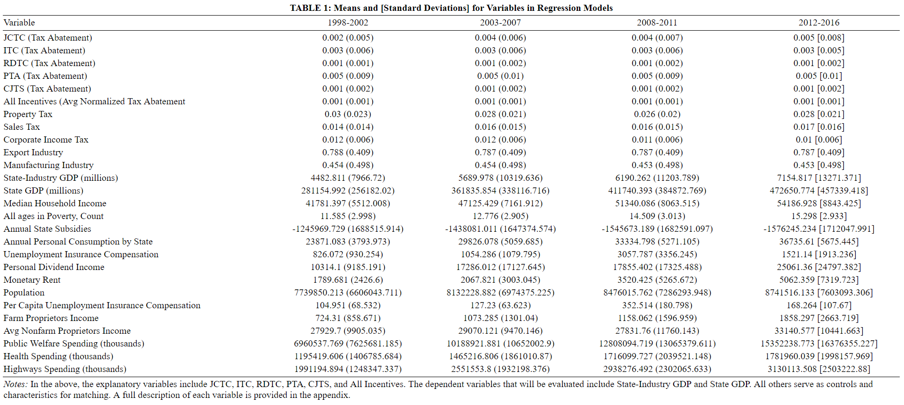*Sources: Bureau of Economic Analysis, US Census Bureau, W.E. Upjohn Institute for Employment Research*

Figure 1 below shows the number of state-industries that received each incentive in any given year. The unit of analysis in this case is the state-industry as the tax abatement associated with the economic incentives differs for each industry in each state and not just for each industry or each state. The number of state-industry units receiving R&D tax credits grew sharply between 1997 and 2015, ultimately surpassing those receiving job training subsidy packages during the heart of the financial crisis. At the same time, more and more state-industries began receiving job creation tax credits over the data collection period, with a significant jump occurring around 2006. Property tax abatements tend to be utilized the least, which makes sense given that property taxes often serve as the primary source of revenue for municipalities across the country. It is important to note that the incentives are not mutually exclusive, and one state-industry may have received several or all of the incentives on any given year.

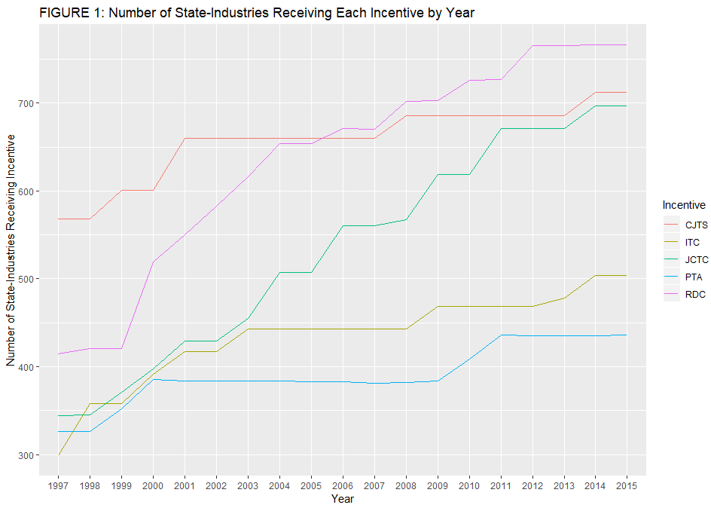

Figure 2 below shows the distribution of average economic incentive tax abatement received for all state-industries over the dataset period. As the figure shows, state governments significantly increased the amount of job creation tax credit tax abatement as a tool to attract businesses, which makes sense given the need for politicians to create jobs to get reelected. At the same time, in absolute terms, property tax abatement tends to provide the highest level of relief for companies, though the level of abatement provided for the job creation tax credit reaches roughly the same average level by 2015. The level of tax abatement over time is consistently lowest for the research and development credit and custom job training subsidy, which may potentially be related to the hypothesis that companies relocating will pay more attention to incentives like property tax abatement than they will to R&D tax credits or custom job training subsidies. It is important to note that there appears to be an almost inverse relationship between Figure 1 and Figure 2 with states providing more expensive economic incentives to less industries and vice versa.

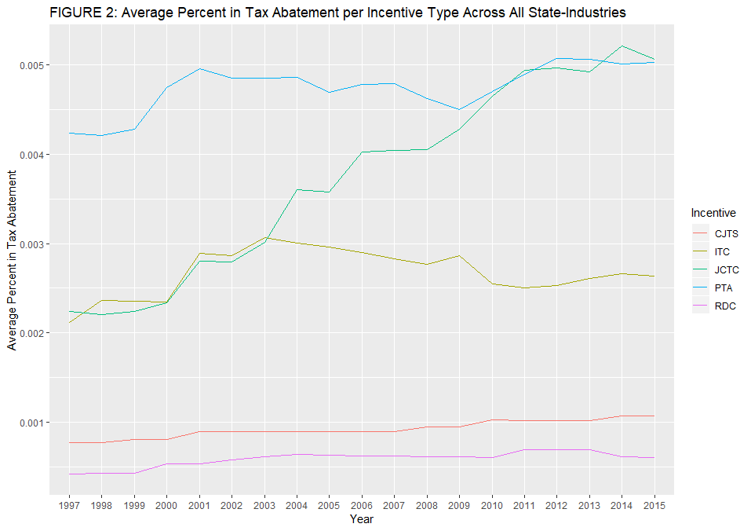

1. **Analytical Approach**

The empirical evaluation of tax incentives is notoriously hard, and absent randomization, there is no single methodology that dominates. For that reason, this thesis employs three parallel methodological approaches to test the hypotheses that five different types of economic incentives – job creation tax credits, R&D tax credits, investment tax credits, custom job training subsidies, and property tax abatement – each and jointly have a positive effect on economic growth at the state-industry level.

*Two-Way Fixed Effects Regression Modeling*

In the first approach, we will model an OLS regression specification with the tax abatement at the state-industry level for each economic incentive type being included as independent variables and GDP at the state-industry level as the dependent variable. While we are interested in assessing the effect of the tax abatement for each incentive type, because GDP growth will vary based on all the incentives being offered by a state to an industry in any given year, each incentive must be included to control for the effect of the incentive in question on GDP growth. Specifically, we estimate the following OLS specification:

$$Y_{ist}= α +β_{1} X_{ist}^{JCTC}+β_{2}X_{ist}^{RDC}+β_{3}X_{ist}^{ITC}+β_{4}X_{ist}^{CJTS}+β_{5}X_{ist}^{PTA}+ ε_{ist}$$

where $Y_{ist}$ is the GDP for industry *i* instate *s* in year *t*; $α$ is a constant; $X^{k}$ represents each of the five tax incentives, and is equal to some number less than one equivalent to the rate of tax abatement for each economic incentive (k=1,2,3,4,5); $ε$ is the error term.

To control for differences across states that do not vary across years and for years that do not vary across states, we use an adjusted multivariate regression including two-way fixed effects. State-level factors like household spending and firm dividend income may influence the GDP contribution of an industry in a given state and the degree of tax abatement received by an industry, and the omission of such factors could lead to omitted variable bias. At the same time, economic shocks that affect all states may limit both the GDP contribution and the tax abatement incentives received by a firm in a given year, and failure to control for economic shocks could therefore lead to omitted variable bias. First, state fixed effects are included to capture differences across the 33 states included in the sample. Second, year fixed effects will be included to account for potential shocks in a given year (e.g., covering the financial crisis). The adjusted model can be written as:

$${GDP}_{ist}= α+β_{1} X_{ist}^{JCTC}+β_{2}X_{ist}^{RDC}+β_{3}X_{ist}^{ITC}+β_{4}X_{ist}^{CJTS}+β_{5}X_{ist}^{PTA}+δZ_{ist}+{ ξ}_{s}+φ_{t}+ ε_{sit}$$

where ${ ξ}_{s} and φ_{t}$ represent state and year dummies respectively and $Z_{ist}$ represents characteristics of state-industries that differ over time not controlled for by state-industry fixed effects. The $β_{k} X^{k}$ terms represent the effect of the tax abatement of each incentive on the GDP of a specific state-industry. All incentives are included in the model as the level of abatement for each incentive will affect the effect of the level of tax abatement for each economic incentive we are interested in on state-level GDP at time *t*. The *ist* subscript signifies that the average value of the dependent variable will differ for each state-industry and year.

Because of the panel nature of our data, there is a natural risk that the economic incentive tax abatement for a state-industry in one year, $X_{ist}$, will be correlated with the abatement level for that same state-industry the next year. At the same time, something like the 2008 financial crisis may not only influence economic incentive levels in the year the crisis reached its peak, but may also create a ripple effect that is felt in abatement levels for years to come. Just as in OLS, there are certain assumptions that must be met for fixed effects estimation to provide the best linear unbiased estimator, one of which is that errors are not autocorrelated. Also just as in OLS, failing to sufficiently control for autocorrelated standard errors will provide invalid standard errors that are derived under false assumptions (Stock and Watson 2015).

While we can use sandwich estimators to ensure heteroscedasticity-robust standard errors in cross-section regression, the same process is invalid in the case of panel data because of the potential existence of autocorrelation. Instead, we employ heteroscedasticity-consistent standard errors (HAC). More simply known as clustered standard errors, these HAC standard errors allow correlation between errors across all the industries in one state while assuming that the errors across states are uncorrelated (Stock and Watson 2015). Clustered standard errors are therefore reported for all two-way fixed effects model specifications included in this study.

*Reducing Observed Bias through Propensity Score Stratification*

Ideally the evaluation of the impact of tax credits would rely on the random assignment of each type of financial incentive to industries and states. Without such randomization, there is a risk the characteristics of states where industries receive a given economic incentive or combination of incentives (the “treatment” group) are different from states with industries receiving no incentives (the “control” group). For example, households may be earning and spending more in one state than another, meaning that firms may be more likely to relocate without the need of economic incentives. While controlling for state and industry variables may allow us to estimate the conditional treatment effect on the sample, as Austin (2011) argues, covariate adjustment will not guarantee that the average effect of treatment on the individual coincides with the average effect of treatment on the population, or the marginal effect. It is entirely possible that the characteristics of states with and without incentives are so different that there is little overlap, thus violating the “common support” assumption and rendering any comparison meaningless.

We use propensity score stratification to identify states with common support and reduce the bias of sample selection across observable variables in the *Panel Database*. A propensity score consists of the probability that an observation would be assigned to a treatment group or control group if random sampling had been used. This approach involves coding state-industry-year observations as binary based on whether an industry in a given state and year received a particular incentive (rate of abatement is non-zero) or did not receive an incentive (rate of abatement is zero).

Because we are interested in evaluating both whether individual economic incentives impact state-industry GDP growth and whether the combination of economic incentives lead to state-industry GDP growth, we employ six separate propensity score stratification processes whereby the state-level control variables are regressed on binary variables signifying whether or not a state-industry received any incentive or each of the five incentives specifically in any year, respectively:

$$P\left(I_{is}=1\right)=Φ(Z_{is}β)$$

The coefficients $\hat{β}$ are then used to generate a propensity score – predicted probability a state-industry pair has a tax incentive – for each observation regardless of whether one is in place. Propensity score stratification works under the assumption that if some range of propensity scores spans the same region for the treatment and control groups then the covariates underlying those scores are likely to show common support between the groups within that range. Weights are retained and used in determining which observations to drop or count more than once.

This procedure generates the average treatment effect on the treated (ATT). The alternative would be to calculate the average treatment effect (ATE), which would be more suited to multiple treatment studies that seek to evaluate the compound effect of receiving one treatment up to receiving all treatments. Calculating the ATT involves comparing the mean GDP of a state-industry that received an incentive with the mean GDP of those same state-industries had they not received the incentive given similar propensity scores.

After stratification and obtaining the weights, the weighted (frequency weights) two-way fixed effects is run to obtain coefficient estimates for groups subset by each stratum used in the study. The doubly-robust estimate of the weighted ATT is represented by the weighted average of the coefficients from each of the five regression specifications. The process of averaging these estimates preserves the elimination of bias that came through within stratum estimation (Murnane and Willett 2010).

*Long-Run Effects*

The impact of tax-incentive packages on economic activity likely occurs with some lag, and may accumulate over time as firms take advantage of the incentives and as other firms relocate to take advantage of agglomeration effects and industry clustering. Policymakers granting incentives arguably expect these types of long-term (or permanent) gains from incentives. As such, a primary outcome of interest is the long-run GDP. Because we have 18 years of economic incentives and state-industry GDP growth, we are well positioned to estimate the long-run effects of economic incentives on state-industry GDP growth.

We use a common approach based on the *exposure* of a state-industry pair to tax incentives over the duration of the period (see Neumark and Shirley 2018). Logistically, this involves interacting for each year period a dummy indicating the presence of an economic incentive for an industry in a state (used in the propensity score stratification analysis) with the single-period values of the associated tax abatement (used in the two-way fixed effects regression). We then compute the average of the resulting products across the time period of our dataset. Because the dummies were generated based on whether a tax abatement for a specific incentive was zero or non-zero, this translates into computing the average tax abatement for each economic incentive type, as well as for the weighted average index of the incentives, across the 18 years of the dataset. Because we still need to ensure that we do not confound the effects of the economic incentives in the long-term, we also still include in the model specification a term representing state and industry control characteristics in 1998 at the start of the dataset time period. Specifically, we evaluate the following model:

$${GDP}_{is2015}= α+ βE_{is}+δX_{is}+ γX_{is1998}+ ε_{si}$$

where ${GDP}_{is2015}$ is the state-industry GDP in 2015 at the terminal year of our measurement period, $βE_{si}$ is the average long-term effect of tax abatement for each state-industry, $δX_{is}$ captures the long-term effect of industry-level characteristics, and $γX_{is1998}$ serves as a vector of state-level control variables collected at the baseline measurement period in 1998.

1. **Empirical Results**

This section presents the results for the methods described above.

*Two-Way Fixed Effects Regression*

Table 2 below shows the results for the two-way fixed effects regression with both the aggregate incentives variable and each individual incentive serving as the independent variables and state-industry GDP serving as the dependent variable.

|  |  |  |  |  |  |  |  |  |
| --- | --- | --- | --- | --- | --- | --- | --- | --- |
| **TABLE 2: Two-Way fixed Effects regression results analyzing economic incentives and their impact on State-Industry GDP** | | | | | | | | |
|  | | | | | | | | |
|  | **State-Industry GDP** | | | | | | | |
|  | **Basic OLS** | **Basic OLS** | **Basic OLS** | **Basic OLS** | **Two-Way Fixed Effects** | **Two-Way Fixed Effects** | **Two-Way Fixed Effects** | **Two-Way Fixed Effects** |
|  | **(1)** | **(2)** | **(3)** | **(4)** | **(5)** | **(6)** | **(7)** | **(8)** |
|  | | | | | | | | |
| **All Incentives** | 0.348*** | 0.353*** |  |  | 0.363*** | 0.367*** |  |  |
|  | (0.016) | (0.016) |  |  | (0.086) | (0.087) |  |  |
|  |  |  |  |  |  |  |  |  |
| **Job Creation Tax Credit** |  |  | -0.012 | -0.025*** |  |  | -0.055** | -0.056** |
|  |  |  | (0.008) | (0.007) |  |  | (0.022) | (0.022) |
|  |  |  |  |  |  |  |  |  |
| **Investment Tax Credit** |  |  | -0.020*** | -0.031*** |  |  | -0.050 | -0.044 |
|  |  |  | (0.006) | (0.007) |  |  | (0.081) | (0.082) |
|  |  |  |  |  |  |  |  |  |
| **Research and Development Credit** |  |  | 0.062*** | 0.063*** |  |  | 0.064** | 0.066** |
|  |  |  | (0.009) | (0.009) |  |  | (0.030) | (0.030) |
|  |  |  |  |  |  |  |  |  |
| **Property Tax Abatement** |  |  | 0.089*** | 0.087*** |  |  | 0.107*** | 0.112*** |
|  |  |  | (0.006) | (0.007) |  |  | (0.040) | (0.043) |
|  |  |  |  |  |  |  |  |  |
| **Customized Job Training Subsidy** |  |  | -0.004 | -0.001 |  |  | -0.002 | 0.002 |
|  |  |  | (0.004) | (0.004) |  |  | (0.036) | (0.037) |
|  |  |  |  |  |  |  |  |  |
| **State fixed effects** | NO | NO | NO | NO | YES | YES | YES | YES |
| **Time fixed effects** | NO | NO | NO | NO | YES | YES | YES | YES |
| **Government Finance Controls** | NO | YES | NO | YES | NO | YES | NO | YES |
| **Robust Standard Errors** | YES | YES | YES | YES | NO | NO | NO | NO |
| **Clustered Standard Errors** | NO | NO | NO | NO | YES | YES | YES | YES |
| **Observations** | 19,568 | 19,008 | 19,568 | 19,008 | 19,568 | 19,008 | 19,568 | 19,008 |
| **R2** | 0.486 | 0.489 | 0.380 | 0.383 | 0.497 | 0.498 | 0.392 | 0.391 |
| **Adjusted R2** | 0.485 | 0.488 | 0.380 | 0.382 | 0.495 | 0.496 | 0.389 | 0.389 |
| **Residual Std. Error** | 0.717 (df = 19550) | 0.724 (df = 18987) | 0.788 (df = 19546) | 0.795 (df = 18983) | 0.711 (df = 19501) | 0.718 (df = 18939) | 0.781 (df = 19497) | 0.791 (df = 18935) |
| **F Statistic** | 1,086.585*** (df = 17; 19550) | 906.671*** (df = 20; 18987) | 571.287*** (df = 21; 19546) | 490.204*** (df = 24; 18983) | 291.392*** (df = 66; 19501) | 276.327*** (df = 68; 18939) | 179.273*** (df = 70; 19497) | 168.868*** (df = 72; 18935) |
|  | | | | | | | | |
| Notes: | ***Significant at the 1 percent level. **Significant at the 5 percent level. *Significant at the 10 percent level. | | | | | | | |
|  |  | | | | | | | |
|  |  | | | | | | | |

All variables have been standardized to facilitate interpretation of the regression coefficients.[3] The first striking finding is that while economic incentives in the aggregate showed a positive statistically significant effect, the effect for each incentive individually is much more complex, with some showing a positive effect, some a negative effect, and others no statistically significant impact.

According to our two-way fixed effects regression model, the results show that a one standard deviation increase in the economic incentive tax abatement offered to a state-industry is associated with a .363 standard deviation increase (significant at the 1 percent level) in the GDP generated by that industry (Table 2, Column 5). Given the positive effect of offering economic incentives, it therefore makes sense that, as our descriptive statistics showed, that the number of state-industries receiving all incentive types would rise consistently across our panel time period.

Disaggregating the impact of economic incentives by type shows that property tax abatement played the most significant role. When we control for state-level and industry level characteristics and include state and time level fixed effects, the coefficient on property tax abatement is positive and statistically significant at the 1 percent level (Table 2, Column 7, Row5). This suggests that a standard deviation increase in property tax abatement is associated with a 0.107 standard deviation increase in the GDP generated by that industry. Though not as statistically significant (significant only at the 5 percent level), there is a positive coefficient for the R&D tax credit (0.064) as well.

It is also important to note that the magnitude of the positive effect of economic incentives in the aggregate is being pulled down by the negative effect of the job creation tax credit, which is statistically significant at the 5 percent level. Though the negative effect of the tax abatement for the job creation tax credit (-0.055) is not as strong in absolute terms as either the R&D tax credit or property tax abatement (0.064 and 0.107, respectively), it is enough to allow us to conclude that it is not enough to simply estimate the effect of economic incentives in the aggregate.

Results show that though the correlation coefficients for investment tax credit and custom job training subsidy (Table 2, Column 7) indicate negative directionality, the absolute values of the coefficients are quite low. Not only do the absolute values of the coefficients for the investment tax credit and custom job training subsidy remain consistently low – -0.050 and -0.002 respectively – but neither variable is statistically significant at the 10 percent level or below. There is therefore no evidence to suggest that the offering of either economic incentive is correlated with higher GDP growth in the targeted industry.

The results remain relatively unchanged when government finance variables are added to the model. In fact, for those variables that were statistically significant in the two-way fixed effects model not controlling for government spending – economic incentives in the aggregate, the job creation tax credit, the R&D tax credit, and property tax abatement – adding government finance variables to the model consistently increases the magnitude of the respective effects (Table 2, Columns 6 & 8). The addition of government finance variables has no impact on the statistical insignificance of the investment tax credit and customized job training subsidy variables.

The second striking result is that the effects are surprisingly consistent across model specifications as we adapt the analysis to estimate long-run effects, as shown in Table 3. Column 1 of Table 3 shows the estimated long-term effects of economic incentives in the aggregate. The long-term effect (0.350) is similar to that found in the short-term effects model specification (0.363), with both coefficients statistically significant at the 1 percent level. It is surprising that the coefficient would be smaller in magnitude as we might expect industry GDP in states to be relatively inelastic and only reflect the benefits of economic incentives over a longer period of time. Especially for those industries that begin receiving incentives in the middle of our measurement period, we would expect a stronger demonstrated effect when economic incentives have accumulated for an industry over time or increased as new incentives yielded positive results in the eyes of policymakers. However, based on the empirical results of our long-term estimation, this is not the case.

Rows 2-6 of Column 3 in Table 3 report estimates for the long-term effects of exposure to individual economic incentives, controlling for whether an industry was also simultaneously receiving the other four economic incentives. While the effect of the job creation tax credit remains negative in the long-term, the magnitude of the effect is less severe, with a one standard deviation increase in the tax abatement of the job creation tax credit being associated with a .047 standard deviation reduction in state-industry GDP over the long-term. While only statistically significant at the 5 percent level, the coefficient on the R&D tax credit reflects a stronger effect over the long-term (0.078) compared to the short-term (0.064). While the difference of coefficients appears negligible, given that they have been standardized in our model, the difference between a one standard deviation increase in the tax abatement of the research and development credit causing a 0.064 and 0.078 standard deviation increase in state-industry GDP, respectively, approaches the millions of dollars. While the magnitude of the coefficients on the job creation tax credit and R&D tax credit increased under the long-term effects specification, it decreased for the property tax abatement variable, going from 0.107 to 0.99 at the same level of statistical significance.

|  |  |  |  |  |
| --- | --- | --- | --- | --- |
| **TABLE 3: Long-Term Effects regression results analyzing economic incentives and their impact on State-Industry GDP** | | | | |
|  | | | | |
|  | **State-Industry GDP** | | | |
|  | **Long-Term Effects** | **Long-Term Effects** | **Long-Term Effects** | **Long-Term Effects** |
|  | **(1)** | **(2)** | **(3)** | **(4)** |
|  | | | | |
| **Avg. All Incentives** | 0.350*** | 0.357*** |  |  |
|  | (0.058) | (0.059) |  |  |
|  |  |  |  |  |
| **Avg. Job Creation Tax Credit** |  |  | -0.047** | -0.047** |
|  |  |  | (0.023) | (0.024) |
|  |  |  |  |  |
| **Avg. Investment Tax Credit** |  |  | -0.032 | -0.030 |
|  |  |  | (0.025) | (0.026) |
|  |  |  |  |  |
| **Avg. Research and Development Credit** |  |  | 0.078* | 0.078* |
|  |  |  | (0.042) | (0.042) |
|  |  |  |  |  |
| **Avg. Property Tax Abatement** |  |  | 0.099*** | 0.119*** |
|  |  |  | (0.025) | (0.028) |
|  |  |  |  |  |
| **Avg. Customized Job Training Subsidy** |  |  | 0.002 | -0.006 |
|  |  |  | (0.014) | (0.016) |
|  |  |  |  |  |
| **State fixed effects** | NO | NO | NO | NO |
| **Time fixed effects** | NO | NO | NO | NO |
| **Government Finance Controls** | NO | YES | NO | YES |
| **Robust Standard Errors** | YES | YES | YES | YES |
| **Clustered Standard Errors** | NO | NO | NO | NO |
| **Observations** | 1,087 | 1,056 | 1,087 | 1,056 |
| **R2** | 0.496 | 0.498 | 0.397 | 0.397 |
| **Adjusted R2** | 0.488 | 0.489 | 0.385 | 0.383 |
| **Residual Std. Error** | 0.715 (df = 1069) | 0.723 (df = 1035) | 0.784 (df = 1065) | 0.794 (df = 1031) |
| **F Statistic** | 61.952*** (df = 17; 1069) | 51.412*** (df = 20; 1035) | 33.357*** (df = 21; 1065) | 28.282*** (df = 24; 1031) |
|  | | | | |
| Notes: | ***Significant at the 1 percent level. **Significant at the 5 percent level. *Significant at the 10 percent level. | | | |
|  |  | | | |
|  |  | | | |

The estimates in Column 1 simply reflect the accumulation of contemporaneous effects across many years, and the cumulative effect may be stronger.[4] Controlling for government finance variables generates results that are consistent with the expectation that the effect of economic incentives will increase state-industry GDP to a larger degree in the long-term compared to the short-term. As Columns 2 and 4 in Table 3 show, the negative magnitude for the job creation tax credit is reduced while the positive magnitude on the R&D tax credit and property tax abatement, as well as that for economic incentives in the aggregate, are increased under the long-term effects model including government finance variables. The coefficient on property tax abatement (0.119) is both larger than that of the long-term model specification without government financing variables (0.099) in Column 3 of Table 3 and the short-term effects model specification with government financing variables (0.112) in Column 8 of Table 2. This pattern suggests that economic incentives improve state-industry GDP growth most in states where firms already may be relocating due to better public amenities.

*Two-Way Fixed Effects Stratified by Propensity Score Matching*

After estimating the first-stage logistic regression where a treatment indicating whether or not a state-industry received any incentive or each incentive at any point in time serves as the dependent variable, we correct for any potential bias stemming from how characteristics of a state make an industry more or less likely to receive economic incentives in the first place by stratifying on the resulting predicted probabilities, or propensity scores. Prior to stratification, we first evaluate the areas of common support, in both the aggregate effects specification and by type. Rosenbaum and Rubin (1984) show that nine-tenths of observed bias can be eliminated through stratifying into five strata. Following this procedure with even percentile ranges, we find – within each stratum – state-industries that did and did not receive at least one type of any incentive in any given year (Table 4). It is worth noting that the values of the propensity scores, median family income, and baseline state-industry GDP for both groups of state-industries fall within similar ranges and are not statistically different between incentive and non-incentive states, within each stratum. This means the two groups are comparable, conditional on the propensity score.

Table 5 below reports the within-stratum estimates of the effect of economic incentives in the aggregate and each individual economic incentive controlling for state and state-industry level characteristics and including time and state-level fixed effects. Coefficients have again been standardized to ensure easier interpretation. Within each stratum, we estimate the same two-way fixed effects regression model. While controls for the other four economic incentive types are included in each of the stratified second-stage regression specifications, the first-stage logistic regression used to estimate each coefficient for the analysis of individual incentive type effects is different because the dependent variable is defined as an indicator of whether the state-industry received *that* economic incentive.

Across strata, the within-stratum estimates for the aggregate impact range from 0.324 to 0.422. These impacts are used to generate a weighted average treatment effect (ATT) of 0.378, where the weights are the percentages of observations in each propensity score stratum. The estimate is remarkably close to the statistically significant coefficient reported for the aggregate impact of economic incentives in the fixed effects specification that directly controlled for state and industry level characteristics. The effects are even more similar when matching on and controlling for government finance variables, with the propensity score matching process yielding a statistically significant estimate of 0.367 and the weighted ATT an estimate of 0.379.

The results for each individual economic incentive using propensity score stratification is not as well aligned to the two-way fixed effects regression estimation. Not only is there significant variability across each stratum for all five economic incentives, but the weighted ATT for each incentive also differs substantially from the respective coefficients from the two-way fixed effects regression estimation without propensity score stratification. For example, while a one standard deviation increase in property tax abatement was associated with a 0.107 standard deviation increase in state-industry GDP in the original OLS regression (Table 2, Column 7, Row 5), the weighted ATT reported under stratification matching was only 0.0669 (Table 5, Column 6, Row 5). Given that the coefficient in stratums 1 (0.093), 2 (0.101), and 3 (0.123) are closer to the effect reported in the original OLS estimation, we suspect that we have not entirely eliminated bias and that the estimation of individual effects may partly be due to a state-industry being more or less likely to receive an economic incentive based on the characteristics of the state that industry is in. It could also be that the economic incentives included in this study are occasionally combined with those not included in this study (e.g., tax increment financing) and that the disaggregated models still contain a source of bias stemming from the omission of those types. The only consistency is that the effects for those economic incentives that were not statistically significant in the previous estimation – investment tax credit and customized job training subsidy – remain statistically insignificant under the propensity score matching estimation. At the same time, those economic incentives that were statistically significant previously – job creation tax credit, R&D tax credit, and property tax abatement – demonstrate statistical significance across almost all stratum (the job creation tax credit effect is not statistically significant in the first stratum) and demonstrate the same direction of impact on state-industry GDP.

The different relationship between the weighted ATT impacts and the basic specifications for the aggregate versus the individual incentive effects suggests the characteristics of states may lead to specific industries receiving a given tax incentive. When it comes to whether that state-industry would receive any economic incentive at any point in time, the bias appears to be eliminated to a larger degree through the propensity score stratification process.

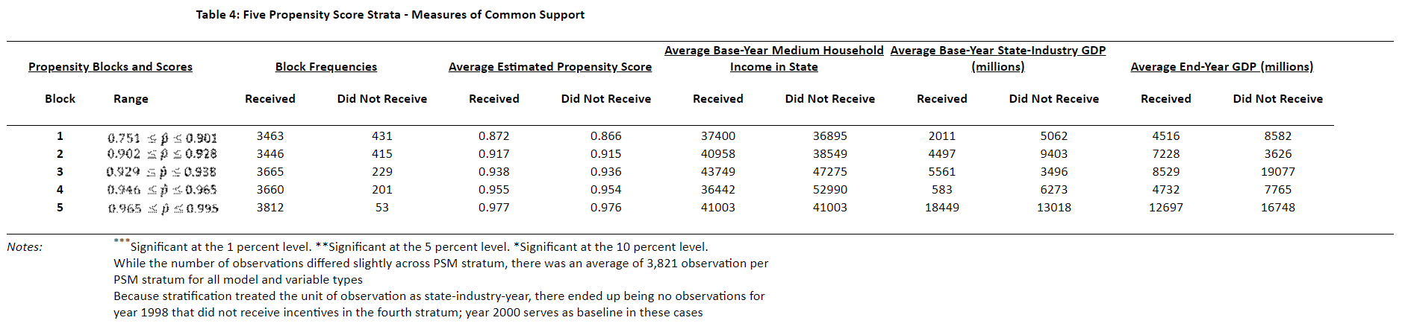



*Robustness Checks*

Calcagno and Thompson (2004) find general-equilibrium specific-factor models of production generate a negative correlation between economic incentives and industry value-added. This occurs because firms provided economic incentives pull resources from those not provided incentives. More precisely, the logic is that economic incentives result in labor gravitating towards the industry receiving the subsidized capital, resulting in a lower ratio of capital to labor and a decreased output for the rest of the economy (Thompson 1985). To evaluate whether any improvement in one state-industry might come at the cost of negative effects on the broader state economy, we estimate a model using state GDP – as opposed to state-*industry* GDP – as the dependent variable. For example, while tax incentives provided to the metal manufacturing industry may increase GDP growth for that industry in the long-term, there is a possibility that it might crowd out economic growth in other industries, resulting in net neutral or negative impact on state level-GDP growth.

The hypothesis in this thesis is based on the assumption that a company will choose to relocate to a state based on the economic incentives being offered. However, firms may choose to locate to a specific place for many reasons other than economic incentives, such as local amenities, access to human capital, and economic agglomeration effects. To account for these factors, we also control for government spending on healthcare, welfare, and highways. Other fiscal variables (like education spending and intergovernmental transfers) also motivate firm location decisions, but including them leads to significant multicollinearity. For that reason, only variables related to healthcare, welfare, and highways spending are used.

It would have been reasonable to include the fiscal variables in the main specifications, but that would have excluded the District of Columbia from the analysis. As such, these variables are excluded in the basic specifications. They are included to evaluate the first-stage in the propensity score approach and as controls in the primary specifications.

*Crowding Out and the Effect on State-Level GDP*

While the effect of economic incentives in the aggregate on state-level GDP is statistically significant at the 10% level when controlling for state and industry characteristics (Column 5, Row 1 in Appendix Table 2), this effect becomes statistically insignificant when government finance variables are included and the magnitude of the standardized coefficient is reduced to near zero. There is no statistical significance for the effects of any of the individual economic incentives, implying that providing economic incentives does not crowd out overall economic growth in the short-term by creating inefficient capital reallocation.

Of course, the bigger concern is that subsidized firms receiving economic incentives would pull resources away from firms in industries not receiving incentives or receiving a lower level of tax abatement. The long-term effects model serves as a better test of this concern because it allows for lags in the adjustment to economic incentives. Appendix Table 3 reports no statistically significant effects for economic incentives in the aggregate in the long-term as well (Columns 1 and 2). However, in the long-term effects model that includes individual economic incentives, all effects are statistically significant when government finance variables are included, which is consistent with both the modeling and the conclusions in Calcagno and Thompson (2004). While the effects are small in magnitude, the coefficients are standardized, and therefore a one standard deviation increase in the tax abatement of customized job training subsidies over time being associated with a 0.011 decline in state-level GDP is not inconsequential.

The results of the long-term effects estimation with state GDP as the dependent variable, however, are not all negative. In fact, not only are the effects for variables that demonstrated statistical significance in the short-term estimation with – R&D tax credits and property tax abatement – positive and statistically significant in the long-term estimation, but the effect for the job creation tax credit, which was negative and statistically significant in the short-term estimation where government finance variables were included (-0.056), is also positive and statistically significant in the long-term estimation with state GDP as the dependent variable. This surprising finding may be due to the elasticity of local labor markets and suggests that either firms receiving tax abatement through job creation tax credit are not spending the savings on job creation or, more likely, they are and it just takes longer for this to be reflected into economic growth numbers.

The findings only align with those of Calcagno and Thompson (2004) in the case of the job training subsidy, though not perfectly as the subsidy had no statistically significant impact on industry output in the short-term. It is notable that Calcagno and Thompson (2004) assume the resource reallocation that occurs consists of sector-specific capital and labor moving *across* state lines to take advantage of tax incentives and higher wages, respectively. In contrast, our model focuses mainly on *intra*-state effects, hence labor and capital employed within disadvantaged industries would over time switch to industries in that same state to take advantage of tax incentives. For the remaining economic incentives, however, the story is different: agglomeration effects may be lifting the economic tide of *all* industries in the state.

1. **Discussion and Conclusion**

Using data from the W.E. Upjohn Institute for Employment Research, the U.S. Census Bureau, and the Bureau of Economic Analysis, this study finds a positive relationship between economic incentives in the aggregate and the economic growth of an industry in a particular state in both the short and long term. However, when we disaggregate economic incentives into the five types included in the Panel Database on Incentives and Taxes, the results are not as consistent. According to the results of the two-way fixed effects regression estimation controlling for state and industry level control variables and including government finance variables, in the short-term, only the effects of tax abatement associated with the research and development credit and property tax abatement are associated with higher growth in state-industry GDP. The results are surprisingly consistent in the long-term with the magnitude on the coefficients for both incentive types increasing compared to the short-term model estimation.

The finding that property tax abatement has a positive impact on state-industry growth refutes findings like that of Fullerton and Aragones-Zamudio (2006) that property tax abatements are ineffective, though that study in particular focused on employment, real estate values, personal income, and retail sales as opposed to economic output. Our findings align and supplement the findings of other studies like that of Gillen (2008), which found property tax abatements to have a positive impact on real estate development and household income over a ten-year period. Especially for capital-intensive companies, property tax abatements free up significant capital that can be reallocated into production or labor investment that can increase economic output and ultimately compensate for the reduction of tax revenue provided through the incentive. In some cases, it may be that a firm faces a funding gap for a project and the property tax abatement pushes them over their investment hurdle rate (Hayes 2018).

This study finds that a one standard deviation increase in the average tax abatement for an industry in a given state received through the R&D tax credit for an industry is associated with a 0.066 standard deviation increase and a 0.078 standard deviation increase in the GDP output for that industry in the short-term and long-term, respectively. The R&D tax credit is unique in that it is not a standard deduction but rather a credit against a firm’s tax burden, and it allows a firm to expense qualifying R&D in the year the cost is incurred (alliantgroup). Because the R&D tax credit is associated specifically with actions designed to boost economic output – engineering a new product, applying research findings to commercial purposes, experimenting with novel technologies, conducting research to increase efficiencies, etc. – is makes sense that this economic incentive type would show a positive impact. The finding of a statistically significant positive effect for the R&D tax credit is surprising as one would expect for the longer cycles of R&D to place any expected benefit to the tax abatement primarily in the long term.

Not all economic incentive types, however, lead to higher economic output. The property tax abatement and the R&D tax credit expanded GDP, while the job creation tax credit had the opposite effect. Several studies have found job creation tax credits to have minimal to no impact in terms of aggregate jobs created (Chirinko and Wilson 2014, Chirinko and Wilson 2010, Sohn and Knaap 2005), but few have noted a *negative* effect of job creation tax credits on state-industry GDP output. Because our dataset focuses specifically on the *statutory* provision of tax incentives and does not include any information related to performance requirements or clawback provisions, it could also be the case that a hypothetical firm receiving the credit in our simulated dataset would not meet the stipulations of the credit and therefore would fail to produce the economic output associated with increased hiring.

Neither the investment tax credit nor the customized job training subsidy demonstrated any effect on state-industry GDP that was statistically different from zero. The magnitude of the insignificant coefficient for the effect of the custom job training subsidy was also very low (0.002 in the short-term and -0.006 in the long term), showing that there is no clear pattern in terms of how the custom job training subsidy impacts state-level GDP. The average value of the custom job training subsidy received was low compared to most of the other incentives (Figure 2), so it could simply be that the abatement level is not high enough to have influenced the firm’s operations in a substantial enough way that would translate to changed economic output in the short or long term.

The analysis arguably eliminated a substantial portion of the bias stemming from the selection of industries receiving economic incentives, but the substantial variability in effect sizes across the five propensity score matching strata for each individual incentive suggests some bias clearly remains. Without access to a clean randomized control trial where firms in industries in some localities receive economic incentives while firms in similar industries in other similar localities do not, it is difficult to eliminate the observable bias entirely. The consistency between the short-term and long-term effects, as well as the quantitative similarity across estimation methods credibly suggest the estimated impact can be interpreted as representing a causal relationship between economic incentives and GDP.

This study addresses the *what* of the impact of economic incentives but not the *how*. The data are simply too limited to explore the channels through which the impacts occur. Recent large-scale economic incentive schemes – such as New York’s incentives to Amazon to locate its second headquarters in Queens or Wisconsin’s incentives to Foxconn to locate its LCD panel manufacturing facilities in the state – have clearly shown that the structure of packages can have a big impact on their effectiveness in growing the economy and creating jobs. For example, if a firm receives a job creation tax credit with no performance requirements or clawback provisions attached, the company may fail to meet job targets and deprive the state of tax revenue without creating enough economic growth in the long-run to make up the lost revenue. State spending on public services and amenities would then decline, potentially creating a backlash where firms become *less* willing to locate in the state. Researchers should work to create a database of actual incentive programs to capture information on how packages are structured so that a comparison can be made beyond *what* works and into *how* economic incentives work.

With access to a database of the actual economic incentive programs in states and localities across the country, future research can also better address the evolving ad-hoc nature of economic incentive packages. States are moving away from standardized statutory formulas and instead crafting packages on a case by case basis. While this is a positive outcome in that it will hopefully subject every economic incentive consideration to greater public scrutiny, it means that new means of tracking and organizing economic incentives data must be developed. The investment tax credit Wisconsin offered Foxconn in 2017, for example, reached a sum far beyond what Wisconsin has traditionally allotted for incentive packages in statutes and legal documentation. As companies receiving economic incentives become less traditional capital-intensive factory focused and more lean software companies primarily investing money into human capital, future work should move beyond evaluating *statutory* provisions for tax abatements to examining the effective incentives and the channels through which they operate.

**References**

alliantgroup. “The Benefits of the R&D Tax Credit.” *Alliantgroup*, https://www.alliantgroup.com/services/r-d-tax-credit-2/the-benefits-of-the-rd-tax-credit/. Accessed 30 Mar. 2019.

Austin, Peter C. "An introduction to propensity score methods for reducing the effects of confounding in observational studies." *Multivariate behavioral research* 46.3 (2011): 399-424.

Bartik, Timothy J., et al. "Saturn and state economic development." (1987).

Bartik, Timothy J. "Who benefits from state and local economic development policies?." (1991).

Bartik, Timothy. "Local economic development policies." (2003).

Bartik, Timothy J. "Solving the problems of economic development incentives." *Growth and Change* 36.2 (2005): 139-166.

Bartik, Timothy J. "A new panel database on business incentives for economic development offered by state and local governments in the United States." (2017).

Blomström, Magnus. "The economics of international investment incentives." (2002).

Boarnet, Marlon G., and William T. Bogart. "Enterprise zones and employment: evidence from New Jersey." *Journal of Urban Economics* 40.2 (1996): 198-215.

Busso, Matias, and Patrick Kline. "Do local economic development programs work? Evidence from the federal empowerment zone program." (2008).

Calcagno, Peter T., and Henry Thompson. "State economic incentives: Stimulus or reallocation?." *Public Finance Review* 32.6 (2004): 651-665.

Carlton, Dennis W. "The location and employment choices of new firms: An econometric model with discrete and continuous endogenous variables." *The Review of Economics and Statistics* (1983): 440-449.

Chapman, Keith, and David F. Walker. *Industrial location: principles and policies*. Blackwell, 1991.

Chirinko, Robert S., and Daniel J. Wilson. "Job creation tax credits and job growth: whether, when, and where?." *Federal Reserve Bank of San Francisco Working Paper* 25 (2010).

Chirinko, Robert S., and Daniel J. Wilson. "Job Creation Tax Credits: Still Worth Consideration?." *Employment Research Newsletter* 21.3 (2014): 2.

Cleeve, Emmanuel. "How effective are fiscal incentives to attract FDI to Sub-Saharan Africa?." *The Journal of Developing Areas* (2008): 135-153.

Cole, Alan. “A Walkthrough of Gross Domestic Income.” *Tax Foundation*, 20 May 2015, https://taxfoundation.org/walkthrough-gross-domestic-income/.

Coughlin, Cletus C., and Phillip A. Cartwright. "An examination of state foreign export promotion and manufacturing exports." *Journal of Regional Science* 27.3 (1987): 439-449.

De Blasio, Guido, Davide Fantino, and Guido Pellegrini. "Evaluating the impact of innovation incentives: evidence from an unexpected shortage of funds." *Industrial and Corporate Change* 24.6 (2014): 1285-1314.

Dewar, Margaret E. "Why state and local economic development programs cause so little economic development." *Economic Development Quarterly* 12.1 (1998): 68-87.

Eissa, Nada, and Hilary Williamson Hoynes. 2004. “Taxes and the Labor Market Participation of Married Couples: The Earned Income Tax Credit.” *Journal of Public Economics* 88(9-10): 1931-58.

Fisher, Peter S., and Alan H. Peters. "Tax and spending incentives and enterprise zones." *New England Economic Review* 109 (1997).

Fleischmann, Arnold, Gary P. Green, and Tsz Man Kwong. "What's a city to do? Explaining differences in local economic development policies." *Western Political Quarterly* 45.3 (1992): 677-699.

Francis, Norton. “State Tax Incentives for Economic Development.” *Urban Institute*, 4 June 2016, https://www.urban.org/research/publication/state-tax-incentives-economic-development.

Fullerton, Thomas, and Victor Aragones-Zamudio. "El Paso property tax abatement ineffectiveness." (2006): 79-94.

Gillen, Kevin. "Philadelphia’s Ten-Year Tax Abatement: Updated Statistics on the Size and Distribution of Abated Properties in Philadelphia." (2008).

Gorin, Dan. "Economic development incentives: Research approaches and current views." *Federal Reserve Bulletin*(2008): A61.

*Guide to Using the Index*. University of Warwick Centre for the Study of Globalisation and Regionalisation, https://warwick.ac.uk/fac/soc/pais/research/researchcentres/csgr/index/guide2.pdf.

Hayes, Andy. “The Win-Win of a Tax Abatement.” *MSU Extension*, 1 Mar. 2018, https://www.canr.msu.edu/news/the_win-win_of_a_tax_abatement.

Ledebur, Larry C., and Douglas Woodward. "Adding a stick to the carrot: Location incentives with clawbacks, recisions, and recalibrations." *Economic Development Quarterly* 4.3 (1990): 221-237.

Lynch, Robert G., and Robert G. Lynch. *Do State & Local Tax Incentives Work?*. Economic Policy Institute, 1996.

Jensen, Nathan M., and Edmund J. Malesky. *Incentives to pander: How politicians use corporate welfare for political gain*. Cambridge University Press, 2018.

“Job Training Incentive Program (JTIP).” *New Mexico Economic Development*, [https://gonm.biz/business-development/edd-programs-for-business/job-training-incentive-program. Accessed 31 Dec. 2018](https://gonm.biz/business-development/edd-programs-for-business/job-training-incentive-program.%20Accessed%2031%20Dec.%202018).

Miller, Mark and Wathen, Greg. “Tax Incentives for Business Investment, Job Creation and Job Retention.” https://www.southwestindiana.org/wp-content/uploads/2014/10/Tax-Incentives.pdf. Economic *Development Coalition of Southwest Indiana*, October 2014.

Murnane, Richard J., and John B. Willett. *Methods matter: Improving causal inference in educational and social science research*. Oxford University Press, 2010.

Newman, Robert J. "Industry migration and growth in the South." *The Review of Economics and Statistics* (1983): 76-86.

Neumark, David, and Peter Shirley. *The Long-Run Effects of the Earned Income Tax Credit on Women’s Earnings*. No. w24114. National Bureau of Economic Research, 2017.

*North American Industry Classification System*. Executive Office of the President Office of Management and Budget, 2017, https://www.census.gov/eos/www/naics/2017NAICS/2017_NAICS_Manual.pdf.

O'Connor, Amanda L. *The impact of state R&D tax credits in an economic downturn*. Diss. Georgetown University, 2011.

O’Mara, Martha. "Strategic drivers of location decisions for information-age companies." *Journal of Real Estate Research*17.3 (1999): 365-386.

Peters, Alan H. *State enterprise zone programs: Have they worked?*. WE Upjohn Institute, 2002.

Peters, Alan, and Peter Fisher. "The failures of economic development incentives." *Journal of the American Planning Association* 70.1 (2004): 27-37.

Rodríguez‐Pose, André, and Glauco Arbix. "Strategies of waste: bidding wars in the Brazilian automobile sector." *International Journal of Urban and Regional Research* 25.1 (2001): 134-154.

Rondinelli, Dennis A., and William J. Burpitt. "Do government incentives attract and retain international investment? A study of foreign-owned firms in North Carolina." *Policy Sciences*33.2 (2000): 181-205.

Rosenbaum, Paul R., and Donald B. Rubin. "Reducing bias in observational studies using subclassification on the propensity score." *Journal of the American Statistical Association* 79.387 (1984): 516-524.

Rubin, Marilyn Marks. "Urban enterprise zones in New Jersey: Have they made a difference?." *Enterprise zones: New directions in economic development* (1991): 105-21.

Schmenner, Roger W. *Making business location decisions*. Prentice Hall, 1982.

Schweke, William, Carl Rist, and Brian Dabson. *Bidding for Business: Are Cities and States Selling Themselves Short?*. Corporation for Enterprise Dev, 1994.

Sohn, Jungyul, and Gerrit-Jan Knaap. "Does the job creation tax credit program in Maryland help concentrate employment growth?." *Economic Development Quarterly* 19.4 (2005): 313-326.

*Summary of Tax Incentive Programs in Other States*. Nebraska Department of Revenue, 2016, http://www.revenue.nebraska.gov/incentiv/annrep/16an_rep/neb_adv/neb_adv_compare.html.

Stock, James H., and Mark W. Watson. *Introduction to econometrics*. 2015.

Thompson, Henry L. 1985. International capital mobility in a specific factor model. *Atlantic Economic Journal* 13 (1): 76-79.

Walker, Robert, and David Greenstreet. "Public policy and job growth in manufacturing: an analysis of incentive and assistance programs." *36th North American meeting of the Regional Science Association, Santa Barbara, CA, November*. 1989.

Wasylenko, Michael, and Therese McGuire. "JOBS AND TAXES: THE EFFECT OF BUSINESS CLIMATE ON STATES'EMPLOYMENT GROWTH RATES." *National Tax Journal* (1985): 497-511.

Weber, Rachel. "Why Local Economic Development Incentives Don't Create Jobs: The Role of Corporate Governance: 1998 R. Marlin Smith Student Writing Competition Award Winner." *The Urban Lawyer* (2000): 97-119.

“What Is Industry Value Added?” *Frequently Asked Questions*, Bureau of Economic Analysis, 20 Mar. 2006, https://www.bea.gov/help/faq/184.

Wilson, Daniel J. "Beggar thy neighbor? The in-state, out-of-state, and aggregate effects of R&D tax credits." *The Review of Economics and Statistics* 91.2 (2009): 431-436.

Wu, Yonghong. "The effects of state R&D tax credits in stimulating private R&D expenditure: A cross‐state empirical analysis." *Journal of Policy Analysis and Management: The Journal of the Association for Public Policy Analysis and Management* 24.4 (2005): 785-802.

**Appendix**

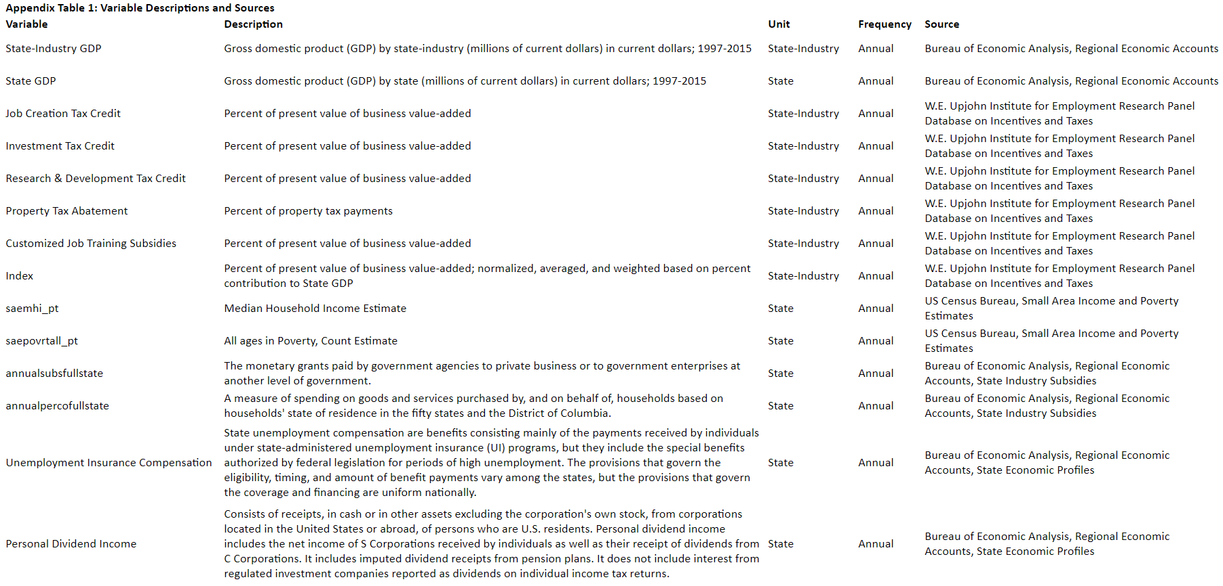

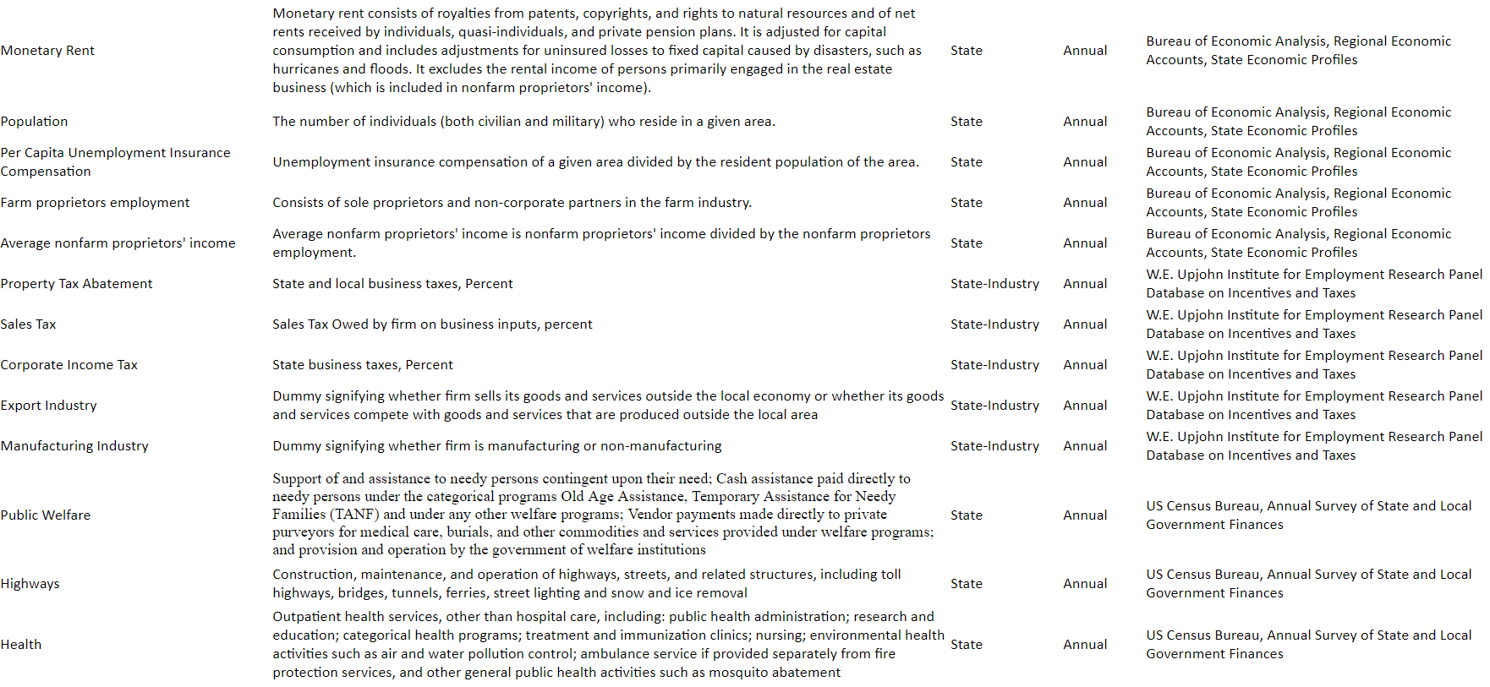

|  |  |  |  |  |  |  |  |  |
| --- | --- | --- | --- | --- | --- | --- | --- | --- |
| **Appendix Table 2: Two-Way fixed Effects regression results analyzing economic incentives and their impact on State GDP** | | | | | | | | |
|  | | | | | | | | |
|  | State GDP | | | | | | | |
|  | **Basic OLS** | **Basic OLS** | **Basic OLS** | **Basic OLS** | **Two-Way Fixed Effects** | **Two-Way Fixed Effects** | **Two-Way Fixed Effects** | **Two-Way Fixed Effects** |
|  | **(1)** | **(2)** | **(3)** | **(4)** | **(5)** | **(6)** | **(7)** | **(8)** |
|  | | | | | | | | |
| **All Incentives** | 0.012*** | 0.005*** |  |  | 0.001* | 0.000 |  |  |
|  | (0.001) | (0.001) |  |  | (0.001) | (0.000) |  |  |
|  |  |  |  |  |  |  |  |  |
| **Job Creation Tax Credit** |  |  | 0.034*** | 0.022*** |  |  | 0.009 | 0.001 |
|  |  |  | (0.002) | (0.001) |  |  | (0.007) | (0.003) |
|  |  |  |  |  |  |  |  |  |
| **Investment Tax Credit** |  |  | 0.008*** | -0.002** |  |  | -0.004 | -0.003 |
|  |  |  | (0.001) | (0.001) |  |  | (0.003) | (0.002) |
|  |  |  |  |  |  |  |  |  |
| **Research and Development Credit** |  |  | -0.004*** | -0.002*** |  |  | 0.001 | 0.000 |
|  |  |  | (0.001) | (0.001) |  |  | (0.001) | (0.001) |
|  |  |  |  |  |  |  |  |  |
| **Property Tax Abatement** |  |  | 0.013*** | -0.005*** |  |  | -0.002 | -0.002 |
|  |  |  | (0.001) | (0.001) |  |  | (0.003) | (0.002) |
|  |  |  |  |  |  |  |  |  |
| **Customized Job Training Subsidy** |  |  | -0.001** | 0.008*** |  |  | -0.003 | 0.000 |
|  |  |  | (0.001) | (0.001) |  |  | (0.002) | (0.002) |
|  |  |  |  |  |  |  |  |  |
| **State fixed effects** | NO | NO | NO | NO | YES | YES | YES | YES |
| **Time fixed effects** | NO | NO | NO | NO | YES | YES | YES | YES |
| **Government Finance Controls** | NO | YES | NO | YES | NO | YES | NO | YES |
| **Robust Standard Errors** | YES | YES | YES | YES | NO | NO | NO | NO |
| **Clustered Standard Errors** | NO | NO | NO | NO | YES | YES | YES | YES |
| **Observations** | 19,568 | 19,008 | 19,568 | 19,008 | 19,568 | 19,008 | 19,568 | 19,008 |
| **R2** | 0.982 | 0.989 | 0.983 | 0.989 | 0.996 | 0.997 | 0.996 | 0.997 |
| **Adjusted R2** | 0.982 | 0.989 | 0.983 | 0.989 | 0.996 | 0.997 | 0.996 | 0.997 |
| **Residual Std. Error** | 0.135 (df = 19550) | 0.107 (df = 18987) | 0.132 (df = 19546) | 0.105 (df = 18983) | 0.064 (df = 19501) | 0.052 (df = 18939) | 0.064 (df = 19497) | 0.052 (df = 18935) |
| **F Statistic** | 61,726.180*** (df = 17; 19550) | 82,439.830*** (df = 20; 18987) | 52,851.460*** (df = 21; 19546) | 71,373.410*** (df = 24; 18983) | 72,463.710*** (df = 66; 19501) | 105,925.200*** (df = 68; 18939) | 69,009.590*** (df = 70; 19497) | 100,268.400*** (df = 72; 18935) |
|  | | | | | | | | |
| Notes: | ***Significant at the 1 percent level. **Significant at the 5 percent level. *Significant at the 10 percent level. | | | | | | | |

|  |  |  |  |  |  |  |  |  |  |  |  |  |  |  |  |  |  |  |  |  |  |  |  |  |  |  |  |  |  |  |  |  |  |  |  |  |  |  |  |  |  |  |  |  |  |  |  |  |  |  |  |  |  |  |  |  |  |  |  |  |  |  |  |  |  |  |  |  |  |  |  |  |  |  |  |  |  |  |  |  |  |  |  |  |  |  |  |  |  |  |  |  |  |  |  |  |  |  |  |  |  |  |  |  |  |  |  |  |  |  |  |  |  |  |  |  |  |  |  |  |  |  |  |  |  |  |  |  |  |  |  |  |  |  |  |  |  |  |  |  |  |  |  |  |  |  |  |  |  |  |  |  |  |  |  |  |  |  |  |  |  |  |  |  |  |  |  |  |  |  |  |  |  |  |  |  |  |  |  |  |  |  |  |  |  |  |  |  |  |  |  |
| --- | --- | --- | --- | --- | --- | --- | --- | --- | --- | --- | --- | --- | --- | --- | --- | --- | --- | --- | --- | --- | --- | --- | --- | --- | --- | --- | --- | --- | --- | --- | --- | --- | --- | --- | --- | --- | --- | --- | --- | --- | --- | --- | --- | --- | --- | --- | --- | --- | --- | --- | --- | --- | --- | --- | --- | --- | --- | --- | --- | --- | --- | --- | --- | --- | --- | --- | --- | --- | --- | --- | --- | --- | --- | --- | --- | --- | --- | --- | --- | --- | --- | --- | --- | --- | --- | --- | --- | --- | --- | --- | --- | --- | --- | --- | --- | --- | --- | --- | --- | --- | --- | --- | --- | --- | --- | --- | --- | --- | --- | --- | --- | --- | --- | --- | --- | --- | --- | --- | --- | --- | --- | --- | --- | --- | --- | --- | --- | --- | --- | --- | --- | --- | --- | --- | --- | --- | --- | --- | --- | --- | --- | --- | --- | --- | --- | --- | --- | --- | --- | --- | --- | --- | --- | --- | --- | --- | --- | --- | --- | --- | --- | --- | --- | --- | --- | --- | --- | --- | --- | --- | --- | --- | --- | --- | --- | --- | --- | --- | --- | --- | --- | --- | --- | --- | --- | --- | --- | --- | --- | --- | --- |
| |  |  |  |  |  | | --- | --- | --- | --- | --- | | **Appendix Table 3: Long-Term Effects regression results analyzing economic incentives and their impact on State GDP** | | | | | |  | | | | | |  | **State GDP** | | | | |  | **Long-Term Effects** | **Long-Term Effects** | **Long-Term Effects** | **Long-Term Effects** | |  | **(1)** | **(2)** | **(3)** | **(4)** | |  | | | | | | **Avg. All Incentives** | -0.002 | -0.000 |  |  | |  | (0.002) | (0.002) |  |  | |  |  |  |  |  | | **Avg. Job Creation Tax Credit** |  |  | 0.011*** | 0.004** | |  |  |  | (0.003) | (0.002) | |  |  |  |  |  | | **Avg. Investment Tax Credit** |  |  | 0.004** | 0.005*** | |  |  |  | (0.002) | (0.002) | |  |  |  |  |  | | **Avg. Research and Development Credit** |  |  | 0.011*** | 0.006*** | |  |  |  | (0.002) | (0.002) | |  |  |  |  |  | | **Avg. Property Tax Abatement** |  |  | -0.019*** | 0.005* | |  |  |  | (0.004) | (0.003) | |  |  |  |  |  | | **Avg. Customized Job Training Subsidy** |  |  | 0.002 | -0.011*** | |  |  |  | (0.003) | (0.002) | |  |  |  |  |  | | **State fixed effects** | NO | NO | NO | NO | | **Time fixed effects** | NO | NO | NO | NO | | **Government Finance Controls** | NO | YES | NO | YES | | **Robust Standard Errors** | YES | YES | YES | YES | | **Clustered Standard Errors** | NO | NO | NO | NO | | **Observations** | 1,087 | 1,056 | 1,087 | 1,056 | | **R2** | 0.993 | 0.997 | 0.994 | 0.997 | | **Adjusted R2** | 0.993 | 0.997 | 0.994 | 0.997 | | **Residual Std. Error** | 0.082 (df = 1069) | 0.053 (df = 1035) | 0.080 (df = 1065) | 0.052 (df = 1031) | | **F Statistic** | 9,434.234*** (df = 17; 1069) | 18,703.660*** (df = 20; 1035) | 7,973.544*** (df = 21; 1065) | 16,324.030*** (df = 24; 1031) | |  | | | | | | Notes: | ***Significant at the 1 percent level. | | | | |  | **Significant at the 5 percent level. | | | | |  | *Significant at the 10 percent level. | | | | |  |
|  |  |
|  |  |



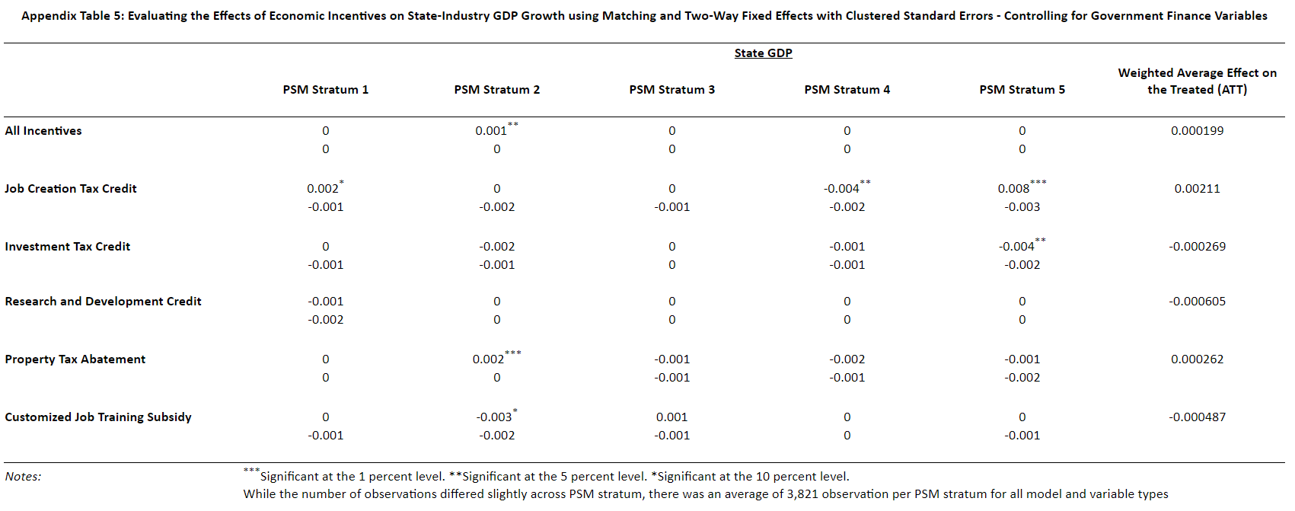

1. Industries defined according to NAICS codes at the three-digit level of specificity
2. Crosswalk can be accessed at https://www.naics.com/sic-naics-crosswalk-search-results/
3. The coefficients would be very large when the independent variables are measured in terms of percent tax abatement and the dependent variable is measured in terms of millions of dollars
4. In a different context, Eissa and Hoynes (2004) show the accumulated effects of the earned income tax credit on labor supply across years can be stronger than weak contemporaneous effects, particularly in relatively inelastic markets.