MATGEN-Q: Scaling a Two-Stage Generative Quantum Eigensolver to 40 Qubits on NVIDIA CUDA-Q for EUV Photoresist Chemistry
Team EIGENNEXUS — Advanced Materials (Mitsubishi Chemical Group & AIST) — GIC 2026 Phase 3
1. Focus Area and Rationale
Ground-state energy estimation governs reaction thermodynamics, redox behavior, and excited-state properties across materials chemistry, yet classical methods scale exponentially with electron correlation and the gold-standard CCSD(T) costs O(N⁷). The Generative Quantum Eigensolver (GQE; Nakaji et al. 2024, with AIST) replaces variational circuit optimization with a classical generative transformer that proposes quantum circuits, side-stepping the barren-plateau problem — but statevector GQE stayed small-scale, and QSCI-paired GQE only recently reached 32 qubits (Kemmoku, Gao et al. 2026). Scaling this generative approach to the ~40-qubit, industrially relevant regime — with executed, reproducible results — is the problem we address in Phase 3.
Our target is EUV semiconductor photoresist chemistry (tin-oxo clusters; Sn, Hf, Zr oxides), whose open-shell, multi-reference character is where DFT's 0.3–0.5 eV functional-dependent errors make candidate rankings unreliable, and which is the focus of an active quantum-simulation program by one of this challenge's providers (Kharazi et al., Xanadu & Mitsubishi Chemical, 2026). The MATGEN-Q pipeline — AI proposes candidate metal-oxide molecules → DFT filters → GQE refines with quantum accuracy → Bayesian optimization selects the next candidate — generalizes beyond photoresists to battery electrolytes, catalysts, and functional polymers central to Mitsubishi Chemical's portfolio and AIST's computational-materials mission. EUV photoresists grow at ~20% CAGR within an $800B+ semiconductor industry, and multi-fidelity Bayesian screening has shown up to 3× cost reduction (Fare et al., 2022) — acceleration MATGEN-Q targets through quantum-accurate pre-selection.
2. Target System and Data Modeling Strategy
Scaling vehicle. The linear hydrogen-chain series Hₙ (n = 2…20; 4–40 qubits, STO-6G, Jordan–Wigner) — the canonical strong-correlation benchmark; a single bond-length parameter tunes weak (area-law) to strong (volume-law) correlation, directly stressing the simulation layer that underpins any scaling claim.
Target chemistry. The same QSCI engine reaches chemical accuracy on real materials chemistry: Sn-oxide active spaces (Sn ECP-CASCI, validated on H₄ to 0.0000 mHa) — SnO 0.11 mHa (16q), SnO₂ 0.23 mHa (20q) — and genuine open-shell, multireference transition-metal oxides — CrO ⁵Π 0.038 mHa and NiO ³Σ⁻ 0.197 mHa at 20 qubits. We report these executed 20-qubit results; the 38-qubit regime is the GPU scaling target of §5, not a pre-claimed figure.
Data integrity. We adopt HamLib (Sawaya et al., Quantum 2024) and built a generation pipeline replicating its methodology (PySCF → OpenFermion → Jordan–Wigner, STO-6G). Validated against the published files: FCI reproduced to 0.00000 mHa (H₂–H₆), and at 28/32/40 qubits our Hamiltonians match HamLib exactly in term count (27,735 / 47,489 / 116,577) and to ~15 significant figures in coefficient magnitude (differing only by a spectrum-invariant orbital-phase convention) — third-party reproducible.
Accuracy anchors / classical references. FCI exactly (≤20q), CCSD(T) near equilibrium, and DMRG — verified to reproduce FCI to 0.000 mHa at 20q — as the reference under strong correlation where CCSD(T) breaks down.
3. GQE-Based Approach and Algorithmic Innovation
MATGEN-Q uses a two-stage GQE. Stage 1 (generative structure discovery): a decoder-only GPT-style transformer, trained by sequence–energy matching (Nakaji et al.), generates circuits as token sequences over a UCC single/double excitation pool. Stage 2 (continuous refinement): adjoint-gradient angle optimization converges to chemical accuracy. Four innovations make it scalable:
(1) Tensor-network (MPS) simulation — primary scaling enabler. CUDA-Q's tensornet-mps backend's memory scales with circuit entanglement rather than 2ⁿ; near-equilibrium area-law bounds bond dimension. Exact cuStateVec validates ≤~32 qubits; MPS carries 32–40+. This tensor-network tier is what we add beyond the QSCI-only 32-qubit prior art.
(2) QSCI energy evaluation — accuracy and noise-aware. Quantum-Selected Configuration Interaction (Kanno et al. 2023): dominant configurations are sampled from the generated circuit and H is classically diagonalized in that subspace — intrinsically noise-robust (the device defines only the subspace; ≤3.3 mHa even with 30% of measurements corrupted at 20q).
(3) Operator-pool compression — efficiency (demonstrated). Ranking the O(N⁴) double-excitation pool by active-space MP2 amplitude and keeping the top fraction shrinks the transformer vocabulary with negligible accuracy loss, where random pruning collapses. Deterministic CI-subspace test (CO/N₂/SiO, 12q): N₂ retains full-pool accuracy (2.26 mHa) keeping only 25% of doubles (vocabulary 1170→430) vs 50.4 mHa for random pruning at the same size (~22×); CO holds 3.7 mHa at 40% kept vs 29.7 mHa random.
(4) Distributed hybrid workflow. Detailed in §4.
Transfer across molecular families — an honest negative. We also tested a chemistry-conditioned generator (FiLM on an MP2 descriptor) for cross-family transfer under a pre-registered protocol on a deliberately diverse family (polar monoxides, isoelectronic BF, homonuclear strong-correlation N₂, ionic BeO). An un-conditioned warm-start already transfers to held-out molecules about as well; conditioning gave only a within-noise improvement (N₂ +2.1 mHa vs noise 3.6). We report this negative and lead the innovation story with pillars (1)–(3).
4. Hybrid Architecture
The classical transformer trains on GPU (PyTorch); circuit evaluations are dispatched across GPUs via CUDA-Q's mqpu in an asynchronous generate→evaluate→update loop. Quantum resources handle state preparation and energy estimation (MPS / QSCI); classical resources handle generation, optimization, and active-space selection. Stage 1 is sampling-bound and parallelizable; Stage 2 is gradient-bound and adjoint-efficient.
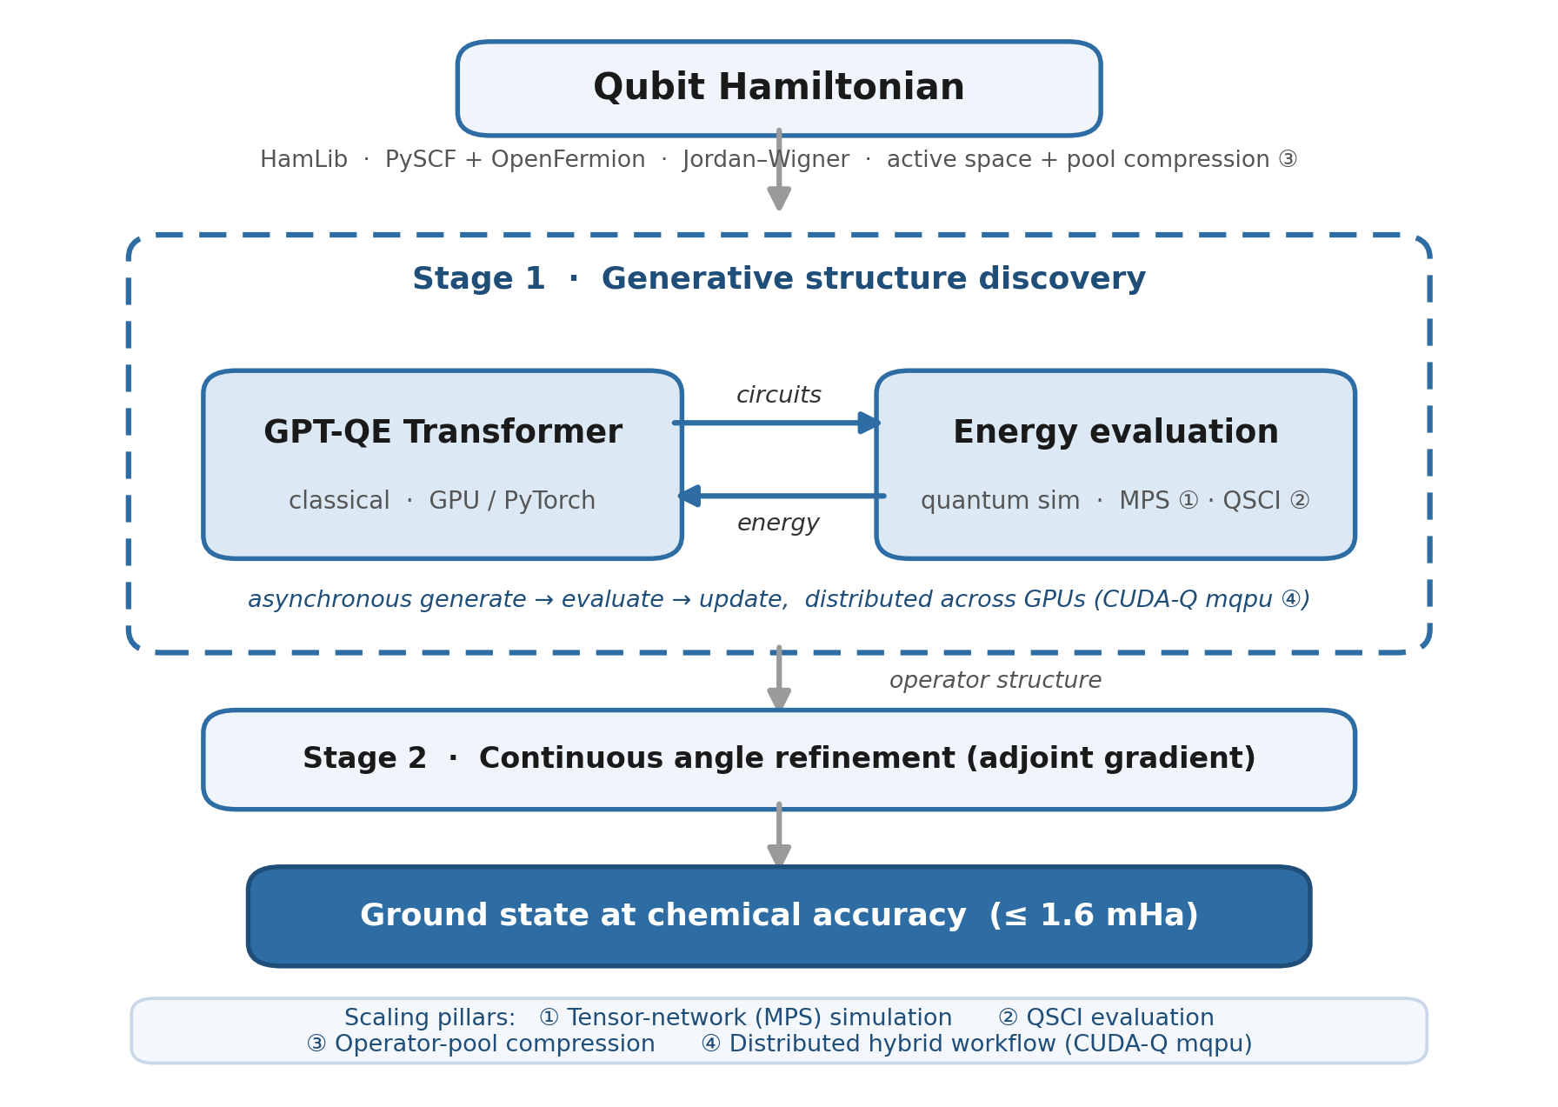
Figure 1. MATGEN-Q hybrid architecture: a classical generative transformer (Stage 1) and GPU-accelerated quantum simulation (MPS/QSCI) form an asynchronous loop; Stage 2 refines angles to chemical accuracy.
5. Phase 3 Execution and Results
Verified results (CPU; reproduced from a clean checkout via reproduce.py). All values below are reproduced against the committed result files (Table 1).
System | Qubits | Quantum (GQE/QSCI) | Classical ref. | Notes
H₂/H₄/H₆ | 4/8/12 | 0.146 / 0.009 / 0.298 mHa | FCI (exact) | two-stage GQE
H₆ GQE→QSCI | 12 | 1.05 mHa (51→1.05, ~50×) | FCI | measured pipeline
H₁₀/H₁₄ | 20/28 | 0.57 / 1.21 mHa | FCI / CCSD(T) | 2,401 / 18,201 dets
CrO ⁵Π / NiO ³Σ⁻ | 20 | 0.038 / 0.197 mHa | CASCI (exact) | open-shell multiref.
SnO / SnO₂ | 16/20 | 0.11 / 0.23 mHa | FCI | EUV target chemistry
Noise (H₁₀) | 20 | ≤3.3 mHa @ 30% corrupt | — | noise-aware bonus
Table 1. Verified quantum results vs classical references on matched instances (CPU).
Classical baseline and the exact wall (matched instances, timed). On identical STO-6G Hₙ geometries, classical FCI wall-clock grows ~24× from 20→24 qubits (0.33 s → 7.8 s) and is intractable by 32q on CPU; CCSD(T) stays cheap but its error climbs with correlation and breaks down under strong correlation (at H₂₄/48q, classical DMRG is itself 6.83 mHa off CCSD(T)). Exact quantum-state simulation needs ~16 TB at 40 qubits — the wall the MPS + QSCI tiers remove (Table 2).
System | Qubits | FCI (exact) wall-clock | CCSD(T) err vs FCI | CCSD(T) wall-clock
H₆ | 12 | 0.04 s | 0.026 mHa | 0.08 s
H₁₀ | 20 | 0.33 s | 0.173 mHa | 0.09 s
H₁₂ | 24 | 7.81 s | 0.282 mHa | 0.14 s
H₁₄ | 28 | minutes | — | ~0.2 s
H₁₆+ | 32+ | intractable (CPU) | — | —
Table 2. Classical reference cost on the Hₙ ladder (single-thread CPU) — the exact-method wall the quantum approach is measured against.
Executed scaling results on qBraid GPU. 40-qubit MPS GQE/QSCI on H₂₀ (primary criterion): [QBRAID-RUN: energy err vs DMRG, circuit depth, MPS bond dimension, shot budget, GPU wall-clock] (CPU baseline today: operational, converging through 39 mHa). CrO/NiO near-38 qubits on GPU: [QBRAID-RUN: accuracy achieved + wall-clock], presented as the scaling demonstration on real open-shell chemistry, building on the executed 20-qubit results. Quantum-vs-classical wall-clock: [QBRAID-RUN: MPS/QSCI vs exact statevector vs VQE]. Hardware validation: [QBRAID-RUN: selected circuits on IonQ/IBM at 10–16 qubits, depth + shots].
6. Platform Use and Resourcing
qBraid provides classical (CPU/GPU) and quantum (QPU) credits. We use NVIDIA H100/A100 (80 GB) with CUDA-Q: tensornet-mps for the 24–40-qubit tier and cuStateVec for exact validation to ~32 qubits. One high-memory GPU suffices for MPS; 4–8 GPUs (NVLink) enable distributed circuit evaluation (pillar 4) and the >40-qubit bonus attempt; QPU (IonQ/IBM) for 10–16-qubit validation. Per-run qubit/depth/shot/wall-clock figures: [QBRAID-RUN: from §5].
7. Limitations and Honest Scope
The integrated GQE→QSCI loop is measured at 12 qubits; larger QSCI uses perturbative determinant selection as a hardware-independent proxy, validated against the 12-qubit measured pipeline — quantum-inspired at scale until executed with real sampling. At ≤28 qubits, classical FCI/DMRG already solve these instances; we demonstrate correctness and scaling, not yet a regime where quantum beats classical — the genuine-advantage target is 40q+ strong correlation where DMRG bond dimension explodes. The 40-qubit result is operational, not yet at chemical accuracy on CPU; the GPU run is the deliverable. The chemistry-conditioned encoder is a tested negative, reported as such.
8. Conclusion and Reproducibility
MATGEN-Q is a working two-stage GQE whose tensor-network and QSCI tiers, plus MP2 operator-pool compression, target the 40-qubit regime on a single GPU, with every claim third-party reproducible. A one-command driver (reproduce.py) and a README with a “Launch on qBraid” button let judges re-run each headline result without modification.
References
[1] K. Nakaji, et al. “The generative quantum eigensolver (GQE) and its application for ground state search.” arXiv:2401.09253 (2024). [AIST]
[2] N. P. D. Sawaya, et al. “HamLib: A library of Hamiltonians for benchmarking quantum algorithms and hardware.” Quantum 8, 1559 (2024).
[3] S. Minami, K. Nakaji, et al. “Generative quantum combinatorial optimization … conditional generative quantum eigensolver.” Digital Discovery 4(8) (2025).
[4] K. Kanno, et al. “Quantum-selected configuration interaction … subspaces selected by quantum computers.” arXiv:2302.11320 (2023).
[5] NVIDIA Corporation. CUDA-Q and cuQuantum SDK (cuStateVec, tensornet / tensornet-mps backends).
[6] J. Tilly, et al. “The Variational Quantum Eigensolver: A review of methods and best practices.” Physics Reports 986 (2022).
[7] P. Fare, et al. “A multi-fidelity machine learning approach to high-throughput materials screening.” npj Computational Materials 8, 257 (2022).
[8] T. D. Kharazi, et al. “Quantum Simulations for Extreme Ultraviolet Photolithography.” arXiv:2602.20234 (2026). [Xanadu & Mitsubishi Chemical]
[9] R. Kemmoku, Q. Gao, S. Kanno, et al. “Generative Circuit Design for Quantum-Selected Configuration Interaction.” arXiv:2604.09756 (2026). [Mitsubishi Chemical]

