**TalentTrack. A DIGITAL RECRUITMENT MANAGEMENT SYSTEM FOR EXPEDISE AGENCY AT LAZADA LOGISTICS SAN PEDRO LAGUNA**

**A Thesis**

Presented to the Faculty of

**Computer Studies Department**

College of Science

Technological University of the Philippines

Ayala Boulevard, Manila

**By**

**Bule, Dem Charles**

**Lingal, Jeffree Allen**

**Montero, Christian**

**Retiza, John Albert**

**In Partial Fulfillment of the**

**Requirements for the Degree**

**Bachelor of Science in Information System**

**June 2024**

**TABLE OF CONTENTS**

**PRELIMINARIES Page**

Title Page i

Table of Contents ii

**Chapter 1 THE PROBLEM AND ITS SETTING**

Introduction 1

Background of the Study 3

Objectives of the Study 8

Scope and Limitations of the Study 10

Significance of the Study 12

**Chapter 2 CONCEPTUAL FRAMEWORK**

Review of Related Literature 15

Related Studies 59

Conceptual Model of the Study 65

Operational Definitions of Terms 68

**Chapter 3 METHODOLOGY**

Project Design 70

Project Development 120

Operation and Testing Procedures 125

Evaluation Procedure 133

References 136

**Chapter 1**

**THE PROBLEM AND ITS SETTING**

**Introduction**:

As the world keeps changing, it is noticeable that Information Technology becomes one of the main keys for development initiatives. In the process of innovation, technology is positioned at the core of making processes more efficient and streamline, both in the public and private sector. It is likewise a tool for people to do more tasks, hence making it helpful especially in working environments. Nowadays, we can see how various information technology (IT) tools have become useful for parents, students, teachers, workers and, most importantly, in offices. In fact, the Duterte Administration believed that enhancing (ICT) will improve the quality of life for Filipinos. In 2016, the Philippine Government established its own Department of Information and Communications Technology (RA 10844) to show its strong support to the ICT industry.

In a company, back and forth is largely determined by employees accompanied by increasing technology and science in all fields taking place so rapidly. Management systems are needed in order to be able to do the process of managing employee recruitment to be faster, more precise, effective, and efficient (Haryanto, H., Putra, Y. S., & Natasyah, N. 2020).

A recruitment management system (RMS) is a set of tools designed to manage the employee recruiting and hiring process. It might be the most important core human resources (HR) system. Recruiting is competitive, especially for candidates with high-demand technical skills, and it is driving interest in sophisticated recruiting systems. These systems are being designed to improve the efficiency of recruiters as well as job seekers (Zoho Recruit. 2024).

The role of IoT in improving the overall recruitment and manpower management system of the organization has been studied. Due to the rapid development of economic globalization and the advent of information technology, various organizations have shown changes under the influence of the technologies therefore organizations have focused on the manpower management of the organization and turn them into their competitive advantages. The recruitment process is the most critical aspect of the manpower management system of the organization as it plays an important role in the success of the organization. The organization needs to develop strategies to use the IoT-based application for the overall recruitment process and manpower management system of the organization. Numerous devices are connected to the internet with the development of computer and network communication technology. The introduction of IoT has blurred the differences between the real world and the virtual world. HR managers of the organizations use IoT to search the details of the candidates as IoT stores the various details such as objects, people, and web pages that are important for the manpower management and overall recruitment of an organization (Vijayalakshmi, N. S., Lourens, M. E., Agyei, I. T., Cotrina-Aliaga, J. C., Chabani, Z., & Hasan, A. 2022).

This study aims to propose a Digital Recruitment Management System for Lazada Logistics, in San Pedro City, Laguna. It is the result of careful planning, thorough investigation, and a deep understanding of the particular challenges Lazada Logistics faces in staff management. This innovative RMS, based on the concepts of effectiveness, flexibility, and empowerment, aims to completely transform the way HR functions are carried out within the company. Additionally, RMS integrates a wide range of features that are necessary for effective HR administration. It has transformed the job application process, improved talent development and performance evaluation. Every feature of the platform is carefully crafted to improve HR processes and empower HR professionals and factory workers. HRMS opens an opportunity for Lazada Logistics to achieve new levels of operational efficiency and employee engagement by utilizing technology to improve HR procedures and empower factory workers.

**Background of the Study:**

Implementing a Digital Recruitment Management System is crucial for enhancing the efficiency, organization, and service delivery within Lazada Logistics in San Pedro City Laguna. By adopting an DRMS, The Human Resource in Lazada Logistics can simplify its processes in managing job applicants, job recruiting processes, profiling of the most qualified applicant, monitoring the status of the applicant, identifying referral persons and improve the tracking of employee performance and talent management of the HR employee. Job Applicant and HR Staff can expect faster and more reliable service as processes and transactions are automated, fostering trust and confidence within the Lazada Logistics. Improved accessibility to services, information, and management for both factory workers and HR employee promotes transparency, better communication, and collaboration, ultimately leading to more effective problem-solving. The adaptability of the DRMS ensures that Lazada Logistics' HR department in San Pedro, Laguna, can stay relevant and effectively meet the evolving needs of the workforce as technology advances. Implementing a Digital Recruitment Management System is a vital step towards enhancing the overall functionality and effectiveness of Lazada Logistics' HR department, benefiting both job applicants and HR staff alike.

The Digital Recruitment Management System provides a platform for managing job applicants from the HR side. It facilitates applying for a job as a factory worker, including filling out general information, submitting resumes. This system enables HR coordinators to evaluate job applicant information, simplifying the process and eliminating the need for physical office visits. It is capable of managing the recruitment process, resume screening, and applicant communication. Additionally, it tracks and evaluates employees' performance and acquisitions for career development and succession planning. Currently, the Human Resource Department at Lazada Logistics in San Pedro, Laguna, uses manual paperwork to handle job applicant information and profiling of the most qualified applicant. The department lacks a system for performance of the applicant and job application system therefore, new job applicant often leads to mistakes in their job roles in the warehouse. Over the years, many paper requirements for factory worker applicants have been damaged or lost, and the need for factory workers to visit the office to submit these documents is time-consuming. Both HR staff and factory workers seek to update the procedure to secure paper requirements like resumes and birth certificates. They hope to implement technological methods to fulfill their obligations and improve transaction processes, involving the replacement of manual labor with automated solutions to keep up with technological advancements.

This study was anchored to the study of Recruitment Management System. It stated that recruitment management systems have a range of components and functions. They include applicant tracking systems (ATS) for managing job postings and applications, and customer/candidate relationship management (CRM) functions to keep applicants connected and engaged. Many of these tasks are automated. Routine tasks, such as posting jobs to job boards, parsing resumes, and scheduling phone calls and in-person interviews, comprise part of the work performed by these systems (Wright, G., St-Jean, E., & Thibodeau, P. 2024).

Several studies have been conducted and implemented on Recruitment Management Systems. A study by Edirisinghe, S. M. (2021). Stated that using a recruitment system, employers can effectively and efficiently manage their candidate flow and recruitment processes. It enables you to gather, edit, create and store a database of candidates, vacancy management, application processing, accepting rejecting applications and much more. This allows in optimizing the hiring process and increasing the recruitments of most fitted candidates. With the help of this, Recruitment agencies can ensure that candidate applications are processed accurately and efficiently during the recruiting period. It allows you to track and search for the most qualified candidates effectively. t makes the selection process much easier for the candidate. A good recruitment system serves both the employer and the candidate. A well-designed recruitment system mainly focuses on a positive candidate experience. It allows the application process to be simpler to understand and complete. Creating a quality candidate experience will favorably affect your company and in return, enable you to stand out among future employment.

Moreover, according to the website of Recruiteze (2024), a Recruitment Management System (RMS) offers a comprehensive suite of features designed to streamline the hiring process. Key functionalities include job posting and distribution, which enables recruiters to post job openings across multiple job boards, social media platforms, and the company’s career page from a single interface. Central to most RMS solutions is an Applicant Tracking System (ATS) that tracks and manages candidate applications, allowing for efficient sorting, filtering, and ranking based on predefined criteria. RMS also supports candidate sourcing through various channels, including internal databases, online job boards, and social networks. Resume parsing and screening are automated to quickly identify the most qualified candidates by extracting relevant information from resumes. The system enhances candidate relationship management by facilitating communication through automated emails, notifications, and reminders, thus improving the candidate experience. Interview scheduling is streamlined by coordinating the availability of candidates and interviewers, often integrating with calendar applications. Additionally, RMS provides reporting and analytics, offering insights into metrics such as time-to-hire, cost-per-hire, and source effectiveness, enabling data-driven decision-making. The benefits of using an RMS include improved efficiency through task automation, enhanced candidate experience, better quality of hires due to advanced screening and matching technologies, and data-driven decisions facilitated by built-in analytics. It also maintains a centralized candidate database for easy management and future hiring needs while ensuring compliance and security by adhering to legal regulations and protecting sensitive candidate data.

A study by G. L. L. Silva I, T. L. Jayasinghe, R. H. M. Rangalla, W. K. L. Gunarathna and W. Tissera. (2022), highlights that recruiting employees is a crucial aspect of a company's human resource management. Many companies still rely on manual recruitment processes, which can be time-consuming and prone to errors, potentially resulting in hiring unsuitable candidates. This inefficiency can lead to wasted time, money, and reduced company performance. To address this issue, the development of an automated recruitment process is being considered. Recruitment Management System aims not only to streamline recruitment but also to offer job seekers a platform to assess their skills, identify current skill trends demanded by employers, and automatically generate resumes. For employers, RMS will save significant time and money by automating tasks such as skill matching, resume shortlisting, and interview scheduling. Additional features include hosting online mock interviews, automated scheduling, and conducting pre-interview quizzes with monitoring capabilities. To implement these components, machine learning algorithms will be utilized alongside technologies like web scraping.

The purpose of this study is to develop a Digital Recruitment Management System for the HR department in Lazada Logistics in San Pedro City Laguna. The idea of DRMS came from an in-depth awareness of the difficulties that HR employees at Lazada Logistics encounter. Manual management of job applicants, Inefficient manual hiring procedures, lacks of profiling of the most qualified applicant and job application system for new job applicant factory workers and disconnected personnel management systems put a pressure on resources. Further challenges to organizational growth and development were the absence of clear frameworks for succession planning and performance evaluation.

The development and implementation of a Digital Recruitment Management System for Lazada Logistics in San Pedro City, Laguna, represents a significant advancement in the efficiency and effectiveness of HR processes. By transitioning from manual and paper-based methods to an integrated digital platform, Lazada Logistics can streamline job applicant management, job recruiting, referral management, profiling of the most qualified applicants, evaluation of practical training, monitoring of applicant status, and scheduling of job interviews. This transition not only enhances operational efficiency but also fosters better communication, transparency, and collaboration between HR and factory workers. Ultimately, the DRMS will not only improve the functionality of Lazada Logistics' HR department but also support the organization's growth and development by ensuring that HR processes are aligned with modern technological advancements. This transformation is vital for maintaining relevance in a fast-paced global economy and achieving new levels of operational efficiency and employee engagement.

**Objectives of the Study**:

***General Objective:***

The general objective of the study is to develop a Digital Recruitment Management System to streamline and improve the HR management processes of Lazada Logistics in San Pedro City, Laguna. *Specifically, the study aims to:*

1. Create and design the system with the following characteristics:
2. Online application system for applicants/users can fill out general information and answer questions about their skills and qualifications to become a factory worker at Lazada Logistics.
3. **Referral system** to allow current employees or partners to refer potential candidates and help HR identify suitable candidates based on specific criteria.
4. **Monitoring the status of the applicant system** to track the progress and status of each applicant throughout the recruitment process.
5. **Job applicant schedule system** to manage and schedule interviews, training sessions, and other necessary appointments for job applicants.
6. Video trainings to prepare individuals for working as factory workers
7. **Evaluation of practical training system** to track and evaluate the performance of applicants during their practical training sessions as factory workers.
8. **Analytics on applicants** to provide insights on the number of applicants applying per day, month, and year, helping HR to understand trends and improve the recruitment process.
9. Develop the system, using the following software development tools:
10. User Interface
11. Canva
12. Adobe XD
13. Figma
14. IDE
15. Visual Studio Code
16. Frontend Development:
17. For client-side development: Html, Css, Javascript, React.js for a responsive and dynamic user interface.
18. Backend Development:
19. For server-side development: PHP, or Node.js
20. Database: MySQL for storing structured data
21. Framework:
22. Bootstrap
23. Version Control:
24. GitHub
25. Deployment:
26. Server: Netlify or Vercel
27. Test and improve the ordering system website based on functional suitability,

reliability, performance efficiency, and maintainability.

1. Determine the system's acceptability using the ISO 25010 evaluation instrument, focusing on functional suitability, reliability, performance efficiency, and maintainability criteria.

**Scope and limitation:**

The scope of this study encompasses the development and implementation of a Digital Recruitment Management System (DRMS) specifically designed for Lazada Logistics in San Pedro City, Laguna. The DRMS aims to automate various HR processes, including job applicant management, job recruiting, monitoring the status of the applicant system, referral system, profiling of the most qualified applicants, evaluation of practical training, and managing job applicant schedules for interviews and training. It will utilize a range of technologies and frameworks such as Adobe XD or Figma for UI design, HTML, CSS, Javascript, ReactJS for front-end, Bootstrap for framework, Node.js or PHP for the backend, MySQL for database management, GitHub for version control, and Netlify or Vercel for deployment. The study will focus on enhancing efficiency, transparency, and employee engagement within Lazada Logistics' HR department, ultimately contributing to organizational growth and development.

The system is designed to comprehensively manage the analytics of job applicants applying per day, month, and year. It will provide auto-generated requirement forms for job applicants to fill out when applying for a job as a factory worker, including their work experience, job-related skills, school-related experience, and undergraduate status or year graduated. Once an application is submitted, a tracking system allows HR coordinators to monitor application statuses and maintain communication with applicants. The admin referral system enables the HR admin staff to track all referral persons, and the admin can increase the salary of the referral person if the referred job applicant has been hired through the job application process. The HR staff can send video training to the job applicant after they pass the screening process, and the admin can set a schedule/training for the job applicant, who will then receive it. The HR admin staff can also evaluate the job applicant's performance during their training in the warehouse. Additionally, the admin can manage job applicants' accounts, including editing, updating, or deleting job applicant information, and can post job listings in the system.

The system also includes a performance management module to track workers' progress and performance through their training and subsequent employment. An interview system is integrated, which generates questions for the applicants to answer post-training, ensuring a consistent and fair evaluation process. Finally, to further aid applicants, the system offers video training modules aimed at preparing them for their roles.

However, it's essential to acknowledge certain limitations within the scope of this study. Firstly, while efforts will be made to ensure data security and compliance with relevant regulations, the system may not comprehensively address all potential cybersecurity risks or legal considerations associated with HR data management. Secondly, our proposed system may not fully address all HR challenges faced by Lazada Logistics in San Pedro, Laguna, due to constraints in scope and resources. Lastly, the implementation of the HRMS may encounter challenges such as technological constraints, resource limitations, and organizational resistance to change, which could impact the effectiveness and timeline of the project. Despite these limitations, the study aims to provide valuable insights and recommendations for improving HR management practices within Lazada Logistics while also serving as a reference for future research in the field of Human Resource Monitoring Systems. The system does not have a payroll system for the job applicants/factory workers to track their payroll or salary. It does not have an attendance system for applicants to track their attendance, nor does it have a biometric system where applicants can scan their attendance. Additionally, the system does not support the submission of birth certificates or valid IDs after the job applicant has passed the job application screening, interview, and training.

**Significance of the Study:**

This study is about the development of Digital Recruitment Management System that can be used by the HR staff, Job Applicants, Factory Workers in Lazada Logistics San Pedro Laguna and it can be also used by the future researchers. Firstly, it makes HR tasks much easier in managing applicant recruitment, applicant information, profiling the most qualified job applicants, and handling referrals. This transition organizes various HR functions such as job recruiting, job application information management, performance evaluation, hiring the best applicant, and handling referrals, thereby saving time, minimizing errors, and enhancing overall productivity. Developing the Digital Recruitment Management System requires utilizing a variety of web development technologies and frameworks, including Adobe XD or Figma for UI design, HTML, CSS, JavaScript, and ReactJS for the frontend, Node.js or PHP for the backend, MySQL for database management, GitHub for version control, and any additional tools that might be needed.

The proposed system for managing factory worker recruitment and performance at Lazada Logistics holds significant implications for HR. By providing an online application platform and a job application system, the study aims to organize recruitment processes, reducing administrative burden and ensuring a clear and standardized approach to candidate selection. This efficiency not only enhances HR decision-making by identifying key hiring criteria but also contributes to improved productivity and employee satisfaction by recruiting candidates who better fit the demands of warehouse operations.

Moreover, it benefits the applicants or future factory workers by providing them with training, such as the inclusion of video training modules in the system, enhancing the effectiveness of training programs. This equips workers with essential skills and potentially reduces onboarding times or job errors in the warehouse. Through the performance management module, HR can systematically track and evaluate applicants' progress, enabling timely interventions and fostering a more efficient and motivated workforce. The tracking system and notification features promote clear communication between HR and workers, ensuring workers are informed about their employment status.

Furthermore, this study will serve as a valuable resource for future researchers embarking on their own thesis proposals related to Recruitment Management Systems. By providing a comprehensive overview of the development and implementation process, as well as detailing the specific objectives and methodologies employed, this study offers a solid foundation upon which future research can build. Researchers can draw upon the insights gained from this study to refine their hypotheses, design their methodologies, and identify potential areas for further exploration.

**Chapter 2**

**CONCEPTUAL FRAMEWORK**

This chapter lays the groundwork for the development of TalentTrack. A Digital Recruitment Management System for Expedise Agency at Lazada Logistics San Pedro Laguna. It contains a compilation of relevant literatures and studies related to the development of a Digital Recruitment Management System. The chapter also outlines the study’s conceptual model and define key terms for a clear understanding. This review provides a foundation to identify any gaps in existing knowledge.

**Review of Related Literature**

This study presents the key concepts and ideas relevant to the present study. It includes discussions on Web-based System, Web-Based-System Benefits, Monitoring The Status of The Applicants System, Online Recruitment, Inclusive – Talent – Management, Recruitment Management System, Benefits of Recruitment Management System, Employee Referral Programs, Profiling of The Most Qualified Applicant System***,*** Talent Management Benefits, Strategic Talent Management System, Human Resource Tools in Hiring Process, Generating Instant Feedback, Performance management System, Effectiveness of performance management system, Design and development of human resource management computer system, Unified Modeling Language, Wireframe, Hypertext Markup Language (HTML), Cascading Style Sheet (CSS), JavaScript, React.js, PHP, Node.js, MySQL, Bootstrap, GitHub, Canva, Adobe XD, Figma, Visual Studio Code, and ISO25010.

***Web-Based-System***

According to Senthil.k-Wp. (2024), A web-based system is an application that is accessed via HTTP. The term web-based is usually used to describe applications that run in a web browser. It can, though, also be used to describe applications that have a very small component of the solution loaded on the client’s PC. The host server for a web-based system could be local, or it could be accessed via the internet.

The researchers proposed a web-based monitoring system because it is easy to access from both factory workers and human resource’ employees compared to traditional desktop apps that still need to be download.

***Web-Based-System Benefits***

In the article by Technologies, O. (2024), Web-based systems, also known as cloud-based or online software, have become increasingly popular in recent years. Unlike traditional software, which is installed on individual devices and can only be used on that device, web-based systems can be accessed 24/7 online using a web browser. This allows users to access the software from any location and device. In this article, it will explore some of the benefits of using web-based systems.

* 24/7 Accessibility: Web-based systems can be accessed round-the-clock as long as an internet connection is available. In the current environment, where remote accessibility is a benefit, web-based systems allow customers and employees to access the system outside regular working hours and locations.
* Cross-platform Compatibility: Web-based systems are designed to be compatible with multiple hardware and operating systems, with user interfaces that can adapt to the device in use. User data is stored on remote cloud-based servers, which can be accessed anytime. On the other hand, traditional software typically does not support multiple operating systems. It may have specific system requirements for installation, with data storage limited to individual PCs.
* Scalability: Web-based systems can easily adapt to changing business requirements. This allows organizations to quickly scale up or down as their needs change without investing in new hardware or software. Traditional software systems need to roll out the upgrades to each user. The user has to install the upgrade on all the required PCs, which may incur more costs and require more installation time.
* Additional Security Layers: Web-based software stores data on servers with multiple layers of security and is automatically updated with the latest security patches and antivirus upgrades. This provides a higher level of protection compared to traditional software.
* Minimal Disruption: Web-based systems undergo upgrades and maintenance at the server level, minimizing disruption to end users.
* Collaborative: Web-based systems allow team members to collaborate and manage system information in real time, regardless of the location. Many web-based applications also facilitate version control, allowing users to easily track changes.
* Increased Productivity: Web systems may offer automated processes that help in delivering quantifiable business benefits over traditional desktop software. Centralized data storage can also enhance productivity and efficiency by allowing users to easily access and share data.

***Monitoring The Status of The Applicants System***

   According to Mleke & Dida (2020), Web Based Monitoring and evaluation systems are used by organizations or governments to measure, track progress, and evaluate the outcomes of projects. Organizations can improve their performance, effectiveness, and achieve results in project success by strengthening their monitoring and evaluation systems. Moreover, various studies reveal the need for information and communication technology systems in monitoring and evaluation activities.

***Online Recruitment***

According to A, E. T. J. (2021). E -recruitment, also known as online recruitment, is the practice of utilizing technology and in particular web-based means for tasks which involves finding, attracting, assessing, interviewing and hiring new personnel. It is intended to make the process involved more efficient and effective, as well as less costly. Online recruitment can reach a larger pool of potential employees and facilitate the selection process. She pointed out that the Effectiveness of the Internet as a Recruitment Source, the author stipulated that the internet as a recruitment source is an effective tool to use in reaching target markets when compared to more traditional recruitment sources.

Based on the study by Fachrizal, M. R., Radliya, N. R., & Manik, A. (2019), e-recruitment is an electronic-based system that significantly enhances the effectiveness of the Human Resource Department. The increasing number of applicants in many organizations and companies complicates the management of applicant data, resulting in a prolonged recruitment process and the potential hiring of employees who do not meet the desired competencies. By designing and implementing an e-recruitment system, these issues can be mitigated. The use of a profile matching method within the system further aids in selecting applicants who best fit the company's requirements.

In addition to Sima, V., Gheorghe, I. G., Subić, J., & Nancu, D. (2020). Online recruitment platforms allow better matching between the needs of the employers and the skills of the applicants to find suitable people for certain managerial functions. IT’s influences on communication are also generating implications for marketing managers dealing with increasingly demanded consumers in today’s digital environment.

***Inclusive – Talent – Management***

In a Study of Kaliannan, Darmanlinggam, and Doromsamy (2024) they pointed out the growing value of Inclusive Talent Development (ITD) within Talent Management Systems (TMS) they Highlight that Inclusive Talent Development (ITD) is a Crucial for the skill, talent growth and Organizational performance. IDT practices lead to Competitive advantage, particularly when analyzed through the Resource-Based View and VRIO model. Thus, the approach focuses on developing all employees, not just top or elite talent, thereby reducing skills mismatched and enhancing overall organizational capabilities.

***Recruitment management system***

According to Haryanto Haryanto, Yudha Surya Putra, and Nabillah Natasyah (2020), the increasing importance of era and technological know-how in all fields, the effectiveness of an organization’s operations is largely determined by using its employees. Literature, the HRD division at PT. Tropic Abadi faces demanding situations in coping with worker recruitment activities. The modern-day employee recruitment management system at PT. Tropic Abadi isn't running optimally, relying on a web recruitment website that gives restrained verbal exchange concerning task emptiness records. This system is less realistic and ok, highlighting the want for management systems to enhance the efficiency and effectiveness of worker recruitment. In this regard, this studies makes use of a dependent device management methodology thru UML (Unified Modeling Language) to increase an internet-based system for PT. Tropic Abadi. The system pursuits to deal with the issues of sluggish records provision and inefficient database control, thereby enhancing the general recruitment process.

***Benefits of Recruitment Management System***

***Employee Referral Programs***

According to Guido Friebel, Matthias Heinz, Mitchell Hoffman, and Nick Zubanov (2023), worker referral packages (ERPs) had been randomly introduced in a grocery chain. The direct results of large referral bonuses showed that they improved referral amount however decreased first-class, although the general increase in referrals from ERPs turned into modest.

However, the overall effect of having an ERP was considerable, resulting in a fifteen% reduction in attrition and a substantial lower in exertions fees. This turned into partially due to referrals staying longer than non-referrals, however specially due to indirect results. Specifically, non-referrals stayed longer in treated shops compared to manipulate shops. The maximum supported mechanism for those indirect results is that workers price being worried in hiring. The effect of attrition was determined to be large in higher-performing stores and higher neighborhood labor markets. According to Friebel (2023). ERPs had been proven to be an effective manner to lessen turnover and reduce labor charges. For instance, they located that ERPs can result in a enormous reduction in worker turnover and a lower in exertions charges. Additionally, they found that ERPs also can enhance employee morale and task pleasure. The introduction of ERPs in a grocery chain brought about a large discount in attrition and hard work costs. This changed into attributed to the elevated experience of involvement and empowerment among employees who have been involved inside the hiring procedure. The outcomes of this observe endorse that ERPs can be an effective approach for agencies seeking to reduce turnover and enhance employee retention.

***Profiling of The Most Qualified Applicant System***

According to Koyande, B. A., Walke, R. S., Jondhale, M. G., & Shrikhande, D. (2020). Human Resource Department consists of the people who select expert workforce of an organization or business sector. Human Resources ought to play variety of roles so as to pick skilled candidate for specific designation. System can rank the expertise and key skills needed for specific job position. This system can rank the CV’s supported the expertise and different key skills that square measure needed for specific job profile. This technique can facilitate the HR department to simply range the candidate supported the CV ranking policy. This technique can focus not solely in qualification and knowledge however conjointly focuses on different vital aspects that square measure needed for specific job position. This technique can facilitate the human resource department to pick right candidate for specific job profile that successively offer skilled force for the organization.

Based on Van Esch, P., Black, J. S., & Ferolie, J. (2019). Integrating candidate experiences of e-recruitment technologies could significantly bolster AI recruitment technology and its value cocreation component. Connecting potential candidates, current employees, and organizations to an advanced recruitment environment would create a technology-mediated recruitment service ecosystem where feedback is formative and immediate. Candidates who use e-recruitment technologies that incorporate AI have an opt-in choice, at which point the system will select the most qualified applicant. This provides timely notice to the candidate and benefits the organization in terms of employee quality as well as return on investment, considering the various costs associated with e-recruitment technologies.

***Talent Management Benefits***

In Study of Li Qi, Voon, and Jia Qi, (2021) on their examination in Government – Linked Companies or GLCs in Malaysia, they make point of the impact of Talent Management through employees engagement levels, highlighting various challenges such as bureaucratic interference, ineffective performance management systems(PMS), Talent retention obstacle, and talent shortages, *with proposed strategic intervention to address these issue and elevate employee engagement, fostering organizational growth and their performance.*

* To state these challenges, Li Qi, Voon and Jia Qi, Cheong Provide and Recommend Strategic Interventions for GLCs in Malaysia
* Establishing Clear Authority and Hierarchical Management: They proposed a defined management system to mitigate bureaucratic interference, following the Bureaucracy Theory of Mac’s Weber.
* Fair Performance Management System: Li Qi Voon, and Jia Qi Ensure Fairness in PMS to pin out inefficiencies and promote equity in evaluation and compensation.
* Understanding Workforce Needed: they enhance Maslow hierarchy of needs to identify and meet employee needs, thereby enhancing job satisfaction and retaining qualified talents
* Retaining and Acquiring the Right Talent: They Employed the Model 4B’s to minimize talent inefficiencies by acquiring suitable or capable talent and ensuring their commitment to their roles

***Strategic Talent Management System***

Based on Chen, Lee, and Ahlstrom (2019), The Strategic Talent Management System is a critical situation for developing and retaining talent, which helps organizations or a company compete effectively. By focusing investment on a talented group, STMS align employees’ job interpretation in terms of employee calling. This approach fosters excellence in employee behaviors such as entrepreneurship and voice, which enhances organizational performance. Study shows or provides observational evidence that worker calling acts as a key mediator in developing these beneficial work behaviors, Picturing the importance of STMS in improving or refined talent management strategies and build a competitive edge for organizations.

***Human Resource Tools in Hiring Process***

According to Boiko, Volianska-Savchuk, Bazaliyska, and Zelena Published in (2021) 11th International Conference on Advanced Computer Information Technologies (ACIT) They emphasize the Crucial role of modernized HR equipment or tools in enhancing the HR Hiring process. The study shows the necessity of employing recruitment services and proposes a scheme to improve recruitment practices through the system of smart recruiting methodologies. By applying advanced and modernized HR tools, the authors establish criteria for choosing the candidate search sources and develop a comprehensive set of specific skill sets required for HR positions within organizations. Particularly, the introduction of a smart recruitment evaluation system enables the ranking of candidates based on a calculation of the ratio between alternative and ideal HR criteria, using multi criterion competent analysis. This emphasis on leveraging advanced HR tools underscores their potential in facilitating more efficient and effective recruitment practices, contributing to centralized hiring processes and improved organizational results.

***Generating Instant Feedback***

According to Jia, Qinjin et al. (2022), timely feedback is critical for academic success, yet traditional methods often fall short due to resource limitations. To address this, automated feedback systems have emerged, spanning various educational tasks. However, research on automated feedback for student project reports remains limited. In their study, Jia, Qinjin et al. introduce "Insta-Reviewer," a data-driven system utilizing advanced natural language processing (NLP) models to provide instant feedback on project reports. Their research demonstrates near-human performance in generating feedback, highlighting the potential of automated systems to enhance learning outcomes.

***Performance management System***

Based on Vainieri, M., Noto, G., Ferre, F., & Rosella, L. C. (2020) Consistently practice all elements and measure the performance management system. Through a survey approach the study evaluated how well administrators and faculty members adhere to the performance management system. The results indicate that the institution has incorporated all components of a performance management system, such as planning, monitoring, evaluation, It is found that the institution's performance management system is effective and aligns with the belief that measuring leads to action, managing leads to improvement and rewarding leads to prompt action.

In addition to Minoza J. (2024). Research studies have highlighted the importance of performance management as a factor for organizational success. Within the hospitality industry performance management plays a role in motivating and empowering employees to provide services. According to Williams Principle of Performance Management measuring tasks ensures completion managing tasks leads to outcomes and rewarding tasks results in completion (Williams, n.d.). The findings indicate that the institution has successfully implemented also a components that was mentioned early on that a performance management system is capable when it comes on creating a plan, monitoring, evaluation, development and recognition of performance.

***Effectiveness of performance management system***

Based on Awan, S. H., Habib, N., Akhtar, C. S., & Naveed, S. (2020). A comprehensive performance management system is used by organizations to measure, track progress, and evaluate the effectiveness of employee performance; the mediating effect of work engagement was also examined. Organizations can improve their performance, effectiveness, and achieve results in employee success by strengthening their performance management systems. Moreover, various studies reveal the need for a comprehensive performance management system in order to enhance employee work engagement and task/contextual performance.

In addition to Maseke, B. F., Unengu, V. K., & Haufiku, T. (2022) Employees strongly believe that performance counseling should be introduced in the organization. Furthermore, organization must provide training to employees on managing work balance stress. In addition, employees find it difficult to achieve their goals because no clear career path is provided. Performance feedback needs to be introduced in the organization to identify areas of weakness and strength and offer training where it is necessary.

***Design and development of human resource management computer system***

Based on Wang, T., Li, N., & Li, H. (2021) The design and development of this system aims to provide technical support for the service quality of enterprise human resource management business, to improve the overall efficiency, promote the pace of enterprise strategic development, and enhance the market competitiveness of enterprises. this system can be used by users without geographical restrictions and system maintenance. In this system, performance logic and business logic are separated, which makes it convenient for the development and maintenance of the system. The system mainly includes six modules: personnel management, organizational management, recruitment management, training management, salary management and system management, which integrates enterprise information and realizes the functions of easy access and easy query of information databases.

*Understanding the system six module of Wang, T., Li, N., & Li, H. (2021)*

* *Personnel management* -  is used to input, query, add, modify and delete all the information of enterprise staff from entering the duty to exiting the duty.
* *Organizational management* - is a comprehensive management of enterprise architecture and job information, including comprehensive information of various departments, existing positions and vacant positions, so that enterprises can adjust and deploy relevant departments and positions in a timely manner in the development process.
* *Recruitment management* - is the most basic part of HRMS, which is mainly used to track and record the recruitment process of new employees, including recruitment content promotion, resume reception, appointment interview and entry approval.

In Addition to Pathinayake, Y. (2021) in Online Recruitment Management System, This system enables advertise vacancies via the website, client companies can send vacancy details to advertise, job seekers can apply for vacancies, schedule selection tests and interviews, held online selection tests, email notifications, report generation, get backups and restore backups. Using the Recruitment Management System the company can achieve the following benefits. Benefits of the system are reducing advertising costs, minimizing documentation, improving efficiency and productivity, reducing human error and saving time.

* *Training managemen*t - is an important part of HRMS, which is mainly used to track the whole process of enterprise training, including training plan, training implementation, training feedback and opinions.

***Design and Research of Intelligent Screening System for Graduate Recruitment Based on Big Data Assisted Ontology-Based Blockchain Design***

According to. ie Guo, Dong Wang, Carlos Enrique Montenegro-Marin, Vicente García-Díaz, (2021, Nov) According to recent advancements in e-recruitment, the use of digital tools for recruiting job applicants has expanded considerably. Companies frequently receive applications through e-recruitment tools and job portals, manually compiling lists of qualified candidates. However, existing mechanisms primarily focus on storing contact data for these candidates. This paper proposes a Big Data Assisted Ontology-Based Blockchain Design (BDOBD) as an intelligent screening system for evaluating job candidates using ontological mapping. BDOBD streamlines the recruitment process through three key steps:Ontology Document Construction: The system collects and constructs an ontology document detailing candidates’ characteristics. Job Requirement Ontology Mapping: Job openings and requirements are represented as an ontology. Candidate Matching: The system maps the job requirement ontology onto the candidate ontology documents, retrieving qualified applicants.

Base on Santosh Gopane & Radhika Kotecha (2021). Online teaching accommodates learners from distant locations, saving time and reducing traffic. Exams are a crucial component of online educational programs, yet student cheating during online exams is a widespread issue globally. Without proper monitoring, applicants are more likely to cheat. Therefore, effective exam proctoring and monitoring methodologies are essential. Recent years have seen the introduction of various research methods to ensure smooth and efficient online exam monitoring. However, these methodologies are often costly and require substantial human intervention. Precision and accuracy in online exam proctoring are also critical. The proposed methodology aims to enhance exam monitoring through continuous user validation and verification to ensure the integrity of the examinee. Key features of the proposed approach including Micro-Expression Detection: Identifying subtle expressions such as laughter, Eye Gaze Tracking: Monitoring the applicant’s viewing direction, Blinking and Eye Closure Duration: Tracking the duration of eye blinks and closures, Head Movement Detection: Observing head activity and movements.

Any suspicious activity by the applicant will be tracked, and appropriate penalties will be imposed. The system uses artificial intelligence to classify the applicant’s activities, providing a reliable and efficient proctoring solution. Remotely proctored exams can significantly reduce logistical efforts, shorten evaluation times, and facilitate access for distant test takers. Preliminary results demonstrate the efficiency of the proposed approach in achieving these goals.

***Unified Modeling Language***

According to Sheldon, R. (2023). Unified Modeling Language (UML) is a standard notation for modeling real-world objects as a first step in designing an object-oriented system. Its notation is derived from and unifies the notations of three object-oriented design and analysis methodologies:

* Grady Booch's methodology for describing a set of objects and their relationships.
* James Rumbaugh's object-modeling technique for modeling and designing software.
* Ivar Jacobson's object-oriented software engineering and its use case modeling.

The author stated that in 1994, Booch, Rumbaugh and Jacobson joined forces under the sponsorship of Rational Software, where they launched the original UML project. Soon, they were joined by others, and together, they integrated the three core methodologies, while also incorporating ideas from other sources. The author added that in 1997, Object Management Group (OMG) adopted the UML standard and published version 1.1 in December of that year. OMG is also home to other notable standards, including Business Process Management Plus, Common Object Request Broker Architecture, MetaObject Facility and Information Exchange Framework. Moreover, the author say that in 2005, UML was accepted by the International Organization for Standardization as an official ISO standard, and it is now widely embraced by the technology community. The most recent release of the UML standard is version 2.5.1, which OMG published in December 2017.

One of the purposes of UML was to provide the development community with a stable and common design language that could be used to develop and build computer applications. UML brought forth a unified standard modeling notation that IT professionals had been wanting for years. Using UML, IT professionals could now read and disseminate system structure and design plans -- just as construction workers have been doing for years with blueprints of buildings. It is now the twenty-first century and UML has gained traction in our profession. On 75 percent of the resumes I see, there is a bullet point claiming knowledge of UML. However, after speaking with a majority of these job candidates, it becomes clear that they do not truly know UML. Typically, they are either using it as a buzz word, or they have had a sliver of exposure to UML. This lack of understanding inspired me to write this quick introduction to UML, focused on the basic diagrams used in visual modeling. When you are finished reading you will not have enough knowledge to put UML on your resume, but you will have a starting point for digging more deeply into the language (Bell, D. 2023).

A picture is worth a thousand words, this idiom absolutely fits describing UML. Object-oriented concepts were introduced much earlier than UML. At that point in time, there were no standard methodologies to organize and consolidate object-oriented development. It was then that UML came into the picture. There are a number of goals for developing UML but the most important is to define some general-purpose modeling language, which all modelers can use and it also needs to be made simple to understand and use. UML diagrams are not only made for developers but also for business users, common people, and anybody interested to understand the system. The system can be a software or non-software system. Thus it must be clear that UML is not a development method rather it accompanies with processes to make it a successful system. In conclusion, the goal of UML can be defined as a simple modeling mechanism to model all possible practical systems in today’s complex environment (Mahara, N. 2020).

***Wireframe***

According to Hannah, J. (2024). Wireframes are visual representations of a web page or app interface, stripped down to its bare bones. She stated that we should think of it as the architectural blueprint of your design project. They outline the structure and functionality of your product without getting caught up in colors, visuals, or specific content. Wireframes provide a clear overview of the page structure, layout, information architecture, user flow, functionality, and intended behaviors. Styling, color, graphics, and other design elements are kept to a minimum. They can be drawn by hand or created digitally, depending on how much detail is required. Wireframing is a practice most commonly used by UX designers. This process allows all stakeholders to agree on where the information will be placed before the developers build the interface out with code.

Based on the website of Balsamiq (2024). The primary reason for wireframing is to generate and communicate ideas, so making wireframes is not limited to any single role or specialization in an organization.

According to him, here are some roles that commonly make and use wireframes:

* Founders and Business Owners use them to communicate or pitch their product or app ideas to investors or product teams.
* Product Managers and Business Analysts use wireframes to translate requirements into visual specifications for designers or developers.
* UX Designers use them to explore and refine concepts before moving to high fidelity.
* Developers use them to sketch out user interfaces when they don't have a designer or when working directly with clients.
* Marketers and Copywriters use wireframes to explore landing page concepts and visualize the placement and size of copy on the page.

Moreover, the author stated that the purpose of a wireframe is to define a skeletal layout that is easy to understand, and encourages iteration and feedback. Getting to agreement on a good interface structure is a critical part of the software design process. Wireframes are important because doing this work now, before any code is written and before the visual design is finalized, will save you lots of time and painful adjustment work later.

In addition to Hanak, A. (2023), there are several reasons why wireframing improves the web design process. Although the wireframing step requires an initial investment of time and effort, it enhances the overall website design process in multiple ways. To begin with, a wireframe helps all parties involved visualize the website. It translates abstract ideas into tangible visuals, displaying the complete site architecture. This allows everyone on the web design project to communicate their opinions and ensure alignment. They can approve or disapprove the wireframe, enabling designers to make necessary adjustments. Moreover, wireframing clarifies website features before designers begin building them. Instead of relying on confusing technical jargon to explain the website's features and functionalities, wireframes present them visually and clearly, helping everyone understand their purpose and how they fit together in the final project. Additionally, wireframes keep the project focused on user experience. A well-designed user interface enhances user experience, leading to higher conversions, while a poorly designed UX results in high bounce rates. Wireframes help avoid such issues by prioritizing user experience from the start. Prototypes based on wireframes are tested with real users to gather valuable feedback, identifying and fixing design flaws early on. This ensures a user-focused website that meets the needs and expectations of its target audience. Furthermore, wireframing makes changes easier to implement. By identifying design flaws early, such as poor navigation, corrections can be made before significant time and effort are invested in full page design. This process is quicker and less time-consuming than making adjustments later. Besides, wireframes help refine navigation. They allow designers to visualize the user journey and test website navigation. By observing how easily users can locate content and pages, potential navigational issues, such as confusing dropdown menus or vague calls-to-action, can be identified and resolved.

Moreover, wireframing saves time throughout the project development process. A clear wireframe ensures the design team understands what needs to be built to meet specific goals, reducing the time spent on redesigns later on due to early feedback and adjustments. Finally, wireframing helps save money in the long run. By addressing design flaws and usability issues early, it minimizes costly revisions and redesigns during later stages of development.

***Hypertext Markup Language***

Hypertext Markup Language (HTML) provides the foundational structure for web pages, as noted by Schwarz, L. (2022). HTML consists of a series of commands, or tags, that instruct a browser on how to interpret content. Specific tags indicate elements such as headlines, paragraph breaks, bold or italicized text, and hyperlinks. For the web to function, three elements are required: a web server, a web browser, and content. HTML serves as a simple language for writing this content. When a page written in HTML is placed on a server, it can be accessed by a web browser. HTML enables basic functionalities such as tagging content for display as headlines, subheadings, and bulleted lists, as well as linking documents.

According to S, A. (2023). HTML has various use cases. In web development, developers use HTML to design how a browser displays web page elements like text, hyperlinks, and media files. In internet navigation, HTML is heavily used to embed hyperlinks, facilitating easy navigation and link insertion between related pages and websites. For web documentation, HTML allows for the organization and formatting of documents, similar to Microsoft Word. It is important to note that HTML is not considered a programming language since it cannot create dynamic functionality, although it is an official web standard maintained and developed by the World Wide Web Consortium (W3C), which provides regular updates.

 Hayes, A. (2022). Further explains that HTML consists of markup symbols or codes inserted into a file intended for internet display. This markup instructs web browsers on how to display words and images on a webpage.

***Cascading Style Sheet (CSS)***

As eloquently stated by Ahmed, A. M., Mohammed, C. N., & Ahmad, A. M. (2023), Cascading Style Sheets (CSS) are essential in web development for designing and styling websites. CSS allows developers to control the layout, colors, fonts, and overall visual presentation of a site. It enables the separation of content (HTML) from design, making it easier to maintain and update. CSS enhances user experience by providing a consistent and attractive interface across different devices and browsers.

Based on Abramowski, N. (2023). CSS is one of the most powerful tools in a web designer’s arsenal. With it, you can drastically alter the entire mood and user experience of a website. Some further benefits you’ll find using CSS are:

* Freedom to position HTML elements anywhere on a web page, while allowing you to keep your markup (HTML) clean and organized.
* Ability to adjust for differences in the way browsers render a web page.
* Endless customization options to a web page including fonts, colors, borders, hover and transition effects, etc.
* CSS preprocessors change the game entirely for developers, allowing them to create more complex layouts more efficiently and use tools such as loops, variables, and if/else statements. You can learn more about it in [our guide to CSS preprocessors](https://careerfoundry.com/en/blog/web-development/css-preprocessors/).
* Ability to easily create, update and maintain styles simultaneously for a large number of web pages.
* Ability to use media queries and relative units (ems and %s) to create web pages which adapt to the user’s screen size—ideal for creating [mobile-responsive web pages](https://careerfoundry.com/en/blog/ui-design/responsive-vs-adaptive-design/).

In addition to Haim, I. (2024). CSS makes websites visually appealing and user-friendly. Its key advantage lies in its separation of content (HTML) from presentation (CSS). This means you can update styles across an entire website with minimal changes to the code.  This efficiency saves time and makes website maintenance a breeze. In short, if HTML builds the house, CSS paints the walls, decorates the rooms, and makes it a place you want to spend time in.

***Javascript***

According to Kugell, A. (2024). JavaScript is a fundamental technology in web development, playing a crucial role in creating dynamic and interactive websites. It is the principal client-side programming language used to add interactive elements to web pages, such as animations, form validations, and dynamic content updates without needing to reload the entire page.One of the primary reasons for JavaScript's importance is its ability to enhance user experience by making web pages more responsive and interactive. For instance, JavaScript frameworks like React, Angular, and Vue.js are widely used to build Single Page Applications (SPAs), which allow for seamless navigation and data fetching without full page reloads, thus improving performance and user experience.

Based on Paul, C. (2024). JavaScript is regarded by developers as a crucial language for web design and development for a number of reasons. These are evidently the primary causes;

* Famous as the Most Popular Language Among developers, JavaScript is practically the most widely used programming language. It offers enormous potential for future development and is currently being used to develop a variety of applications. It is a highly sought-after skill that professionals ought to have, according to the industry.
* Easy to Learn JavaScript is far simpler to start using than other programming languages. You can use JavaScript on a web browser without having to install any software on your computer.
* Fun to Work Working with multiple programs in different programming languages can cause stress. With the aid of a graphical user interface, you can deal with the same important issues in JavaScript. When development projects are conducted with this language, work becomes more enjoyable.
* Very Supportive Language JavaScript programming language is still available for free. It offers a sizable network of support teams to assist you with any issue you may run into while the project is still in development. Additionally, the community frequently hosts sporadic JavaScript meetups, which may facilitate your learning.

Moreover, JavaScript is essential for implementing client-side functionalities, such as interactive forms, modal windows, and sliders. It also enables the creation of complex web applications by managing user interactions and updating content dynamically in response to user inputs. (Jayatilleke, B. G., Ranawaka, G. R., Wijesekera, C., & Kumarasinha, M. C., 2019).

***React.js***

According to Fariz, M., Lazuardy, S., & Anggraini, D. ​(2022). Title React or also known as React.js or ReactJS is a Java Script-based front-end library for building user interfaces or UI components. React is managed by Facebook, a community of developers and companies. In a study conducted by Venkat in 2021, it was explained that web development technology before 2015 was about scripting and rendering. At that time HTML and CSS were used for the front-end, while the back-end used PHP. Developer puts static HTML pages in some folders and renders those files using PHP. Developers use this method for decades, so there is no visible revolution on a website until there is a Java Script library like React.js. React.js has several excellent features that make front-end web development faster and more responsive.

Based on Hutsulyak, O. (2024). Being a part of the JavaScript language, using React spawns many advantages. Products built with React are simple to scale, a single language used on the server/client/mobile side of things grants outstanding productivity, there are workflow patterns for convenient teamwork, UI code is readable and maintainable, and more. World-leading companies have used React and other JS technologies in some of the top market-defining products (Instagram, Reddit, and Facebook being the most vivid examples).

In front-end development, the function that react.js plays is becoming increasingly important, providing developers with new options to create new applications. React.js is utilized by a significant percentage of all websites today (Chen, S., Thaduri, U. R., & Ballamudi, V. K. R., 2019).

***PHP***

According to Singla, L. (2024), PHP stands as a widely used open-source scripting language, particularly renowned for its application in web development. Initially coined as an acronym for "personal home page," PHP now recursively stands for "hypertext preprocessor." Its integration within HTML allows for server-side scripting, empowering developers to generate dynamic content and interact with databases seamlessly. Singla highlights several distinguishing attributes of PHP. Firstly, as a scripting language, PHP is interpreted at runtime, eliminating the need for compilation. Moreover, it operates server-side, wherein a PHP interpreter processes the script on the web server, transmitting the resultant HTML output to the browser. Additionally, PHP's open-source nature fosters accessibility, enabling users to download and utilize it freely. With the advent of PHP5, the language embraced object-oriented programming (OOP), facilitating the creation of intricate and reusable web applications through the utilization of objects. Notably, PHP is lauded for its speed, leveraging memory efficiently to optimize server workload and enhance performance significantly. Comparative benchmarks showcase PHP's superior speed, outpacing languages like Python and Ruby by significant margins. Furthermore, PHP's simplicity underscores its appeal, boasting an easily comprehensible syntax conducive to both novice learners and seasoned developers alike. Singla emphasizes PHP's robust support infrastructure, noting compatibility with leading databases such as MySQL, SQLite, and ODBC, as well as seamless integration with popular servers like Apache and IIS. The language's cross-platform portability further enhances its versatility, with additional support provided by a plethora of frameworks such as Laravel, CodeIgniter, and Symfony, along with a rich assortment of meticulously vetted libraries. Based on S, A. (2024). Anyone can benefit from learning about PHP, but it is even more essential for those interested in web programming. PHP is available on all major operating systems, such as Linux, Microsoft Windows, and macOS. Most web servers, including [Apache](https://www.hostinger.ph/tutorials/what-is-apache) and IIS, also support PHP. One of the main benefits of using PHP is advancing the customization of a WordPress site. Other features include great online support and documentation, so even beginners can learn PHP quickly.

In addition to Bydec, I. (2020). PHP is one of the core languages of web development and has been around since 1995. It has been a part of web development since the start and is one of the most commonly used languages in that field. Many modern web applications are written in PHP, and some websites that use only PHP are among the most visited in the world. As we mentioned, PHP can be used to create any kind of dynamic website, including eCommerce sites. It’s also extremely easy to learn, which makes it ideal for beginners. Generally speaking, the more demanding the website, the more likely it is to be built on PHP. That’s because PHP is an extremely robust language and its core functionality can be extended with a variety of frameworks and libraries. According to Bydec, I. (2020). There are benefits of Using PHP for Web Development:

* Extremely Popular - Popularity is a good sign. It means that more people use it, and more companies are hiring people to work with it. The more people that use a tool, the more likely it is that it’s going to be supported and updated for years to come.
* Easy to Learn - PHP is a great language for beginners. Because it is so widely used, there are plenty of resources available to help you master it and build your skill set.
* Robust - As mentioned, the core functionality of PHP can be extended with a variety of frameworks and libraries. This makes it very robust and ideal for enterprise applications.
* Open Source - This may not be an advantage for everyone, but it definitely is for certain segments of the population. If you don’t have a lot of money to spend on developing your website, or you want to try something new without spending a lot of money, PHP is open source and free.

***Node.js***

According to Sufiyan, T. (2023). Node.js is an open-source, cross-platform JavaScript runtime environment and library for running web applications outside the client's browser. Developers use Node.js to create server-side web applications, and it is perfect for data-intensive applications since it uses an asynchronous, event-driven model.

Based on Bakhur, N. (2024), Node.js functions as a standalone environment for executing JavaScript code separate from the browser. It offers the capability to install on a server, akin to Python, enabling the execution of code and delivery of results to users. With Node.js, developers can create standalone applications utilizing additional frameworks. Prior to the emergence of Node.js, JavaScript applications were confined to browser environments. However, Node.js expands this scope, allowing JavaScript usage not only in browsers but also on servers. Bakhur outlines several benefits of Node.js. Firstly, it boasts high speed, with JavaScript code executing several times faster than equivalent code in languages like Ruby or Python. Node.js leverages an asynchronous programming model, enabling concurrent task execution without waiting for data transfer completion. Additionally, Node.js offers versatility and flexibility by enabling developers familiar with JavaScript to write both client-side and server-side code without the need to learn new tools. Furthermore, developers can swiftly adopt new ECMAScript standards within Node.js, gaining access to new language features upon installing compatible versions. Another advantage lies in Node.js's extensive ecosystem, facilitated by the NPM package manager, which hosts over 500,000 open-source modules and libraries. Lastly, Node.js operates on Google's V8 JavaScript engine, renowned for its efficiency and open-source nature, leveraging the efforts of numerous engineers. This engine, written in C++ with advanced libraries, ensures robust performance and compatibility with Chromium-based browsers, contributing to Node.js's appeal as a development platform.

In addition to Khare, M. (2023). Node.js is used for a wide variety of applications. According to the author, these are some popular use cases where Node.js is a good choice:

* Real-time chats - Due to its single-threaded asynchronous nature, Node.js is well-suited to processing real-time communication. It can easily scale and is often used in building chatbots. Node.js also makes it simple to build additional chat features like multi-person chat and push notifications.
* Internet of Things - IoT applications usually comprise multiple sensors, as they frequently send small chunks of data that can pile into a large number of requests. Node.js is a good choice since it’s able to handle these concurrent requests quickly.
* Data streaming - Companies like Netflix use Node.js for streaming purposes. This is mainly due to Node.js being lightweight and fast, besides which Node.js provides a native streaming API. These streams allow users to pipe requests to each other, resulting in data being streamed directly to its final destination.
* Complex single-page applications (SPAs) - In SPAs, the whole application is loaded in a single page. This usually means there are a couple of requests made in the background for specific components. Node.js’s event loop comes to the rescue here, as it processes requests in a non-blocking fashion.
* REST API-based applications - JavaScript is used both in the frontend and backend of sites. Thus, a server can easily communicate with the frontend via REST APIs using Node.js. Node.js also provides packages like Express.js and Koa that make it even easier to build web applications

***MySQL***

According to Giaquinto, R. (2022), MySQL stands as an open-source SQL relational database management system developed by Oracle. In a relational database like MySQL, data is organized into tables, which simplifies data retrieval and enhances organization. For instance, if one stores both customer purchase records and their contact details, MySQL stores each type of data in separate tables, facilitating efficient data management. This relational structure streamlines data retrieval, as one can easily access the specific table containing the desired information. Without the relational database structure, data storage would be less organized, making it challenging to locate relevant information and resulting in redundant data occupying unnecessary space. The efficiency of relational databases like MySQL stems from their ability to minimize redundancy and streamline data organization. Additionally, MySQL allows users to access multiple pieces of data using a unique identifier, known as a key. For example, to retrieve both contact information and purchase history for a customer like John Doe, one would utilize his unique ID to extract relevant data from multiple tables, ensuring comprehensive access to pertinent information.

Dobrovolska, V. (2024). Compares a website to a vibrant city, where the visual elements represent the HTML and CSS shaping its appearance, akin to buildings and streets. However, beyond this facade lies the intricate infrastructure necessary for functionality, akin to the network of pipes and power lines in a city. This underlying framework, managed by back-end technologies like PHP and MySQL, handles crucial tasks such as data management, user interactions, and dynamic content. These technologies ensure the smooth operation of the website, much like the unseen systems that keep a city running efficiently.

In addition to G, D. (2024). MySQL is indeed not the only RDBMS on the market, but it is one of the most popular ones. The fact that many major tech giants rely on it further solidifies the well-deserved position. Here are some of the reasons.

* Flexible and Easy to Use - As open-source software, you can modify the source code to suit your need and don’t need to pay anything. It includes the option for upgrading to the advanced commercial version. The installation process is relatively simple, and shouldn’t take longer than 30 minutes.
* High Performance - A wide array of cluster servers backs MySQL. Whether you are storing massive amounts of big eCommerce data or doing heavy business intelligence activities, MySQL can assist you smoothly with optimum speed.
* An Industry Standard - Industries have been using MySQL for years, which means that there are abundant resources for skilled developers. MySQL users can expect rapid development of the software and freelance experts willing to work for a smaller wage if they ever need them.
* Secure - Your data should be your primary concern when choosing the right RDBMS software. With its Access Privilege System and User Account Management, MySQL sets the security bar high. Host-based verification and password encryption are both available.

***Bootstrap***

According to Alexandrea, J. (2023). Bootstrap is an invaluable tool for web developers and, by using it, can avoid laboring for basic up functions for fast website development Bootstrap is full of web design features and components that use HTML, CSS and JS scripts. It does so for several reasons. The first point is that Bootstrap is very popular for its beginner friendly because it has a lot of tutorials and resources for that newbies. Simple file based (HTML CSS JS) unless you know enough that you are already using some html framework you can insert or modify the app in to. In addition to that, Bootstrap makes it easy to develop faster, with precompiled files and themes that are widely used in the most popular content management system such as WordPress. Moreover, with the help of Bootstrap's responsive grid system, you can avoid manual creation by having a set of rows and columns ready to specify layout with much ease. This grid system will also target laborious data entry tasks, and establishes a pattern for creating customized breakpoints on a per-project basis. And finally, the bourgeoning Bootstrap evokes the amounts of browser compatibility at least to that available by recent popular browsers, thereby increasing the web surf rate, ostensibly strengthening your site's positioning in search engines. Together, these features make Bootstrap the ideal option for web projects striving for the most rapid development speed and full platform and browser consistency.

Based on Ouellette, A. (2023).  Bootstrap saves you from writing lots of CSS code, giving you more time to spend on designing webpages. Bootstrap is a powerful tool that allows a developer to get up and running quickly and painlessly. It makes it easy to integrate many great features that enrich a user’s interaction with the web without having to code them from scratch. In addition to Singh, U. (2024). Bootstrap is one of the most popular frameworks for building websites and web apps. It is a great tool for web developers and designers because it:

* Speeds up development
* Makes responsive design easier and more consistent
* Allows you to customize your site without coding

He concluded that the most significant aspect of Bootstrap is its responsive grid system, which allows creation of websites that are easily adaptable for multiple devices.

***GitHub***

According to Gaba, I. (2023). GitHub is a Git repository hosting service that provides a web-based graphical interface. It is the world’s largest coding community. Putting a code or a project into GitHub brings it increased, widespread exposure. Programmers can find source codes in many different languages and use the command-line interface, Git, to make and keep track of any changes. GitHub helps every team member work together on a project from any location while facilitating collaboration. You can also review previous versions created at an earlier point in time.

Based on Lutkevich, B., & Courtemanche, M. (2023). GitHub facilitates social coding by providing a hosting service and [web interface for the Git code repository](https://www.techtarget.com/searchitoperations/video/Top-differences-between-GitHub-and-Git), as well as management tools for collaboration. The developer platform can be thought of as a [social networking](https://www.techtarget.com/whatis/definition/social-networking) site for software developers. Members can follow each other, rate each other's work, receive updates for specific opensource projects, and communicate publicly or privately.

According to them, the following are some important terms GitHub developers use:

* Fork. A [fork](https://www.theserverside.com/blog/Coffee-Talk-Java-News-Stories-and-Opinions/command-line-GitHub-fork-CLI-terminal-shell), also known as a branch, is a repository that has been copied from one member's account to another member's account. Forks and branches let a developer make modifications without affecting the original code.
* Pull request. If a developer would like to share their modifications, they can send a pull request to the owner of the original repository.
* Merge. If, after reviewing the modifications, the original owner would like to pull the modifications into the repository, they can accept the modifications and merge them with the original repository.
* Push. This is the reverse of a pull -- a programmer sends code from a local copy to the online repository.
* Commit. A [commit, or code revision](https://www.theserverside.com/blog/Coffee-Talk-Java-News-Stories-and-Opinions/gitkeep-push-empty-folders-git-commit), is an individual change to a file or set of files. By default, commits are retained and [interleaved onto the main project](https://www.theserverside.com/feature/Why-GitHub-renamed-its-master-branch-to-main), or they can be combined into a simpler merge via commit squashing. A unique ID is created when each commit is saved that lets collaborators keep a record of their work. A commit can be thought of as a snapshot of a repository.
* Clone. A clone is a local copy of a repository.

In addition to Juviler, J. (2024). The single biggest selling point of GitHub is its set of project collaboration features, including version control and access control. To illustrate what’s possible with GitHub, imagine this scenario. You want to code an online game, and you enlist your friend to help you.You create a repository on GitHub that stores all the files, including current and past versions, then give your friend collaborator access to this repo as well. A robust [online portfolio](https://www.theforage.com/blog/basics/online-portfolio) shows employers your [programming skills](https://www.theforage.com/blog/skills/programming-skills) and experience using common tools like GitHub. Through your public profile on GitHub, potential employers can gain insights into your organization, coding, and developing skills. In addition to including previous work in your portfolio, highlight your familiarity with GitHub and Git in job or internship descriptions on your [resume](https://www.theforage.com/blog/basics/what-is-resume). Including specific details about projects you’ve done, even if they’re not featured in your GitHub portfolio, can be beneficial. One great aspect of GitHub is you can use it to gain experience even if you don’t have any prior professional jobs or internships in coding or programming. Using open-source projects or building your own can help you develop a portfolio of work that speaks for itself outside of your resume or [cover letter](https://www.theforage.com/blog/basics/how-to-write-a-cover-letter) (Girardin, M. (2024).

***Canva***

According to Gareth (2023).  [Canva](https://www.canva.com/)is an online graphic design tool pre-loaded with thousands of templates to spark your creativity. Whether it be for internal use or for a client, the many benefits of using Canva make it easier than ever to knock up stunning visuals in no time. From magazines to [website design](https://welfordmedia.co.uk/services/web-design) to logos, Canva helps you design everything simply and efficiently without needing extensive graphic design experience or complicated Adobe programs. *Here are the benefits of using canva:*

* Create wireframes with ease.
* Pre-made size templates make creating size-specific content simple.
* The ability to use the transparency tool on all elements.
* Hundreds of elements, icons and graphics to choose from.
* The ability to add frames and vignette to imagery.
* The user-friendly interface is easy to use for all levels.
* The free design templates make designing content super quick.
* Access to free, safe stock imagery.
* Comment and collaborate with team access.
* There are endless possibilities for creation.

In addition to Clark, H. (2024). Canva enables you to create visually appealing websites in minutes. It is the perfect platform for beginners with little to no experience. Canva features an easy-to-use drag-and-drop website editor and a vast database of design templates, royalty-free images, and graphics. As a result, your web design process becomes quick, simple, and extremely cost-effective.You may use Canva online or by downloading the app for your Mac, PC, Chromebook, iOS, or Android device. Canva offers thousands of free templates and over 250,000 free photos, icons, illustrations, graphics, social media elements, videos, animations, and more that you can easily drag and drop into your website. The platform has other features, such as Styles, to help you find the perfect color and font combinations for image editing. Additionally, Canva features Magic Write, an AI writer & text generator powered by OpenAI and canva ships a color palette generator to create custom color palettes. Canva also allows you to add brand elements to your sites. Subsequently, Canva stores your logo, brand colors, and fonts in its Brand Kit. Stunning graphics can play a huge role when it comes to marketing your business and attracting customers. [Canva](https://www.elegantthemes.com/blog/refer/canva) offers a simple, free solution to help you create amazing professional designs with little effort. The biggest decision you’ll have to make is which types of graphics to focus on for your business (Hughes, J. (2023)

***Adobe XD***

According to Ap, B. (2021). You won’t develop a website or app indeed, through the Adobe Xd, you will design/prototype your system screens there. Therefore it is a useful tool for UI and UX professionals to validate a system usability concept, before starting code. You must think that you’re “spending time”, in a concept validation initial step, to be more assertive in the future, when you start to code your website/app. This is an important User experience concept. You have to test, test, and test again before going around coding. Adobe Xd is also a useful tool to create wireframes (that low fidelity prototypes), that are helpful when you want to quickly validate system usability without spending much time and before thinking about the layout.

Based on Lynch, L. (2022). Adobe XD relieves that burden by allowing us to design interactive elements, including dropdown navigation, pop-ups, and mobile touch-based behaviors. It’s also possible to incorporate links within the document, making it easier to demonstrate a specific kind of user flow. We can even share a link to the design document with our clients so that they can view the designs in their web browsers, as if it were a real website. All this makes it easier for them to envision what the final product will be like, and to provide feedback based on that prototype without worrying about whether they’ve understood our designs correctly.

In addition to Mishra, D. P., Rout, K. K., & Salkuti, S. R. (2021). For any Web application, its interface and design play an important role in business, because it directly reflects a customer’s usage. More the customers are satisfied, it helps in growing your business, you get many more customers. Keeping this in mind, it’s hard to straight away start designing the UI without having a feel of how our application would look like to our customers. This is where a need for UX arises. The most popular tool for UX/UI designing in Adobe XD. It’s user-friendly with many features and is available for both macOS and Windows. The part that any web designer would like about this software is that it gives a feel of the application we intend to make, a functional application, and design. So a developer could make a rough sketch of their entire application along with the design and its functionaries like a pop-up window (a modal in CSS), the link between pages in the web application, animation effects, fill color property, and many more. One more major advantage to a UI designer is that the names of the features used in Adobe Xd are the same in coding CSS properties.

***Figma***

According to Writes, B. (2023). Figma is primarily a browser-based design tool. Whether you’re using Chrome or Safari, Figma’s browser compatibility ensures a smooth, feature-rich experience without heavy software installations. You can use it on any device with an internet connection. However, you can also install Figma’s desktop app. It’s supported on MacOS, Windows, and Linux. Irrespective of your operating system, Figma remains consistent in its offering, ensuring a familiar and intuitive interface. And if you’re on the go and want to make some quick changes to your design when the inspiration kicks in, you can install the Figma mobile app on iOS and Android. Perhaps even more importantly, the browser version and app have almost the same features so you won’t miss out on anything, no matter your choice. As a fully remote agency owner, the author finds this cross-device compatibility invaluable. It means that my team, regardless of their location, device preference, or operating system, can collaborate effectively and efficiently.

Based on Fernandes, J. (2023). A wireframe allows the designer to work with a client or developer and walk through the structure of the website without getting sidetracked by other elements such as colors, images or illustrations. When working with large sites, wireframing helps the designer determine which elements should be included on the page and which functionality needs to be set for each section. While there are no hard and fast rules to where you can create wireframes, be it a low fidelity wireframe on paper or a high fidelity one on software, on Figma, you can create wireframes by making use of pre-existing tools that you would use to make your final website. You can use the frame tool, which has presets of desktop and mobile sizes, or create your own dimensions. You can add grids (columns and rows) to your wireframe and create rectangles to denote where the elements on the page would be placed. This is essentially your blueprint for your website.

In addition to Martinez, P. (2023). Since Figma is a web-based tool, you can access it on any browser or computer of your choice. Also, you can find a wide range of designing tools in Figma to create wireframes of low and high fidelity. Besides that, there are several other designing and interactive options that you can explore in Figma. To use Figma for wireframing, According to the author, *these are the recommended following steps:*

* Step 1: Get the Figma Wireframe Kit - Firstly, you can just go to the official website of Figma and access its online tool. Though, if you want to save your time, then you can get a readily available Figma wireframe kit from its website and include it in your account. There are all kinds of templates and designs in the kit to help you do wireframing in Figma easily.
* Step 2: Include the basic design elements - On the web interface of Figma, you can see all kinds of design elements on the side. All you need to do is just drag and drop the element and include it on your canvas. You can further adjust its CSS by changing its color, size, alignment, and so on. By following the same approach, you can work on multiple frames. For instance, if you want to create a wireframe of an app on Figma, then you can have different screens for it. You can just copy a design element and reuse it multiple times to provide a uniform appeal to your wireframe.
* Step 3: Finalize your Figma wireframe design - Using the same design elements, you can also create different versions of the Figma wireframe as well. In the end, you can use its inbuilt tool to link various screens and components of your wireframe with each other. This will provide high fidelity in the wireframe for Figma project of yours. When you are done, you can go to the Observation Mode of Figma to get a real-time preview of how your wireframe design would look like. Later, you can also share this design with others and save it to the cloud.

***Visual Studio Code***

According to Murali, M. (2023). When developers collaborate on coding projects and debugging, they typically do so through an integrated development environment (IDE). Microsoft’s Visual Studio is one of the most popular IDEs and has been around for 25 years. Visual Studio IDE allows programmers to create and edit their code collaboratively. It has extensions and includes tools to assist in building code. This lets you see in real-time what your teammates are working on so you can reduce redundancies. It has code completion with syntax highlighting, an AI coding model to assist with programming, and an analysis tool to help you with debugging.

Based on Quoy, L. (2024), there are pros to using Visual Studio Code (VSC):

* Comprehensive Development Environment: Visual Studio Code comes with a wide range of development tools pre-installed, eliminating the need for separate installations.
* IDE Capabilities: It functions as a robust Integrated Development Environment (IDE), supporting project building, interactive debugging, and code profiling.
* IntelliSense: Provides intelligent code suggestions, which are especially useful for languages like C++, enhancing coding efficiency.
* Advanced Code Profiling: Allows for in-depth code analysis and fine-tuning to achieve optimal performance.
* Team Collaboration: Includes built-in features that facilitate collaborative development, making it suitable for larger projects.
* Customized Language Support: Adapts to the specific programming language being used, offering tailored features and support.

In addition to Mir, M. A. (2023), there are several advantages to using Visual Studio Code (VSC). Visual Studio Code provides robust support for a wide range of programming languages, including Java, Python, C++, JavaScript, and more. It features syntax highlighting, code completion, and language-specific tools, making it an excellent choice for developers working with multiple languages. Additionally, Visual Studio Code is a powerful code editor with many features, such as Git integration, debugging tools, and extensions that allow for workflow customization. The high customizability of Visual Studio Code enables developers to configure the interface and keyboard shortcuts to their preferences, making it suitable for those who want to tailor their coding environment to their specific needs. Furthermore, Visual Studio Code boasts a large community of developers who create and maintain extensions and plugins, adding new functionality to the editor. This extensive range of extensions can enhance the coding workflow. Lastly, Visual Studio Code is known for being fast and efficient, with a small footprint, making it an ideal choice for developers seeking a code editor that does not slow down their computer.

***ISO25010***

According to Britton, J. (2021). ISO 25010, titled “Systems and software engineering – Systems and software Quality Requirements and Evaluation (SQuaRE) – System and software quality models”, is a software quality standard. It describes the models, consisting of characteristics and sub-characteristics, for both software product quality, and software quality in use together with practical guidance on the use of the quality models.

ISO25010 describes two quality models: The first is the quality in use model composed of five characteristics (some of which are further sub-divided into sub-characteristics) that relate to the outcome of interaction when a product is used in a particular context of use. Second is a product quality model composed of eight characteristics (which are further sub-divided into sub-characteristics) that relate to static properties of software and dynamic properties of the computer system. Based on Britton, J. (2021). The characteristics and sub-characteristics provide consistent terminology for specifying, measuring and evaluating system and software product quality. They also provide a set of quality characteristics against which stated quality requirements can be compared for completeness. Britton, J. (2021) stated that, ISO 25010 describes eight primary product quality characteristics and 31 sub-characteristics that collectively define software quality. These characteristics encompass functional suitability, reliability, performance efficiency, usability, security, compatibility, maintainability, and portability. Each characteristic comprises specific attributes that contribute to assessing the quality of software products. For instance, functional suitability evaluates how well a product meets stated and implied needs, while reliability gauges the system's ability to perform under specified conditions. Performance efficiency considers resource utilization and time behavior, while usability examines the ease and effectiveness of achieving goals. Security focuses on protecting information and data, whereas compatibility concerns the product's ability to function within various environments. Maintainability assesses the ease of modifying, improving, or adapting the software, and portability evaluates its transferability across different environments. Additionally, Britton emphasizes that software quality encompasses adherence to design principles and non-functional requirements such as security and maintainability, as outlined in ISO 25010. Software quality measurement quantifies the extent to which software aligns with each characteristic, evaluating aspects like testability, ease of understanding, and ease of editing without introducing errors. These assessments provide valuable insights into the overall quality and performance of software products.

In addition to Rebes, P. (2024), in "Is ISO 25010 Standard Good for Everyone?", each project is different, so the list cannot be treated as a ready-made plan of action. It is essential to first consider what is important for the client and the user, from the very beginning of work with the client. Rebes, P. emphasizes that every organization benefit from "best practices" and predictability. Process standardization and automation of testing save considerable time and money, and help protect against common bugs. However, predicting obstacles and errors cannot be added to the product after it is already built.

Rebes, P. further suggests that it is beneficial to include a QA team member in workshops with the client to ensure the client understands the role QA plays in the development process. A QA specialist can identify potential challenges early on and propose solutions. Even during the software creation process, it is useful to keep the ISO standard in mind, regardless of one's specific role, such as a frontend QA. ISO 25010 serves as a great framework for defining important software metrics for a particular project. It is not a comprehensive, detailed map, but rather a guide that can be used according to the circumstances. Every development project has different priorities and metrics, and this standard allows enough flexibility to accommodate all of them.

**Review of Related Studies**

***Digital Human Resource Management Platform based on ChatGPT***

According to Jinbo Zhou, & Weiren Cen (2023).  Digital human resource management platform based on ChatGPT demonstrates significant advantages in personalized employee experiences, decision-making efficiency, and work productivity, holding greater potential and value compared to conventional human resource management platforms. Nevertheless, successful application of the platform necessitates further exploration and refinement to address data privacy and security concerns, provide appropriate training and support, and continuously improve and innovate platform functionalities and performance.

***Research on performance management of ground service staff in Xiamen Airlines***

According to Ye, S. (2024). An effective performance appraisal mechanism is crucial to motivate employees and improve service levels.Within the framework of human resource management, performance management plays a central role.which helps airlines maintain their advantages in the fierce market competition. In order to achieve this purpose, airlines must analyze the current performance evaluation system in depth and implement corresponding improvement measures. Such a reform can not only promote the improvement of individual employee performance, but also enhance the service quality and market competitiveness of the whole airline.

***Digital Human Resource Practices and Employee Development in Nigerian Banking Sector***

According to Okoro, G. O. (2024, May 2) as dimensions of digital human resource practice while measures of employee development were performance management and competence development. Study revealed that digital human resource practice is imperative and essential to employee development in the Nigerian banking sector. Digital human resource practice and employee development have become integral components of the Nigerian banking sector. By adopting digital HR practices, banks can enhance recruitment processes, improve employee training and development, streamline performance management, foster employee engagement, and retain top talent.

***Digitalized talent management and automated talent decisions: the implications for HR professionals***

Based on Wiblen, S., & Marler, J. H. (2021).By employing a qualitative case study with multiple embedded units of analysis, they show how the same digital talent management technology produced different ways of identifying talent even within the one organisation. Role of digitalisation plays in how various stakeholder groups (HR and line managers) identify talents and whether digitalisation transforms the role of HR professionals in identifying talent. In one social context, the material properties of the technology dominated, while in another the existing social context and relationships prevailed over the material properties of the technology. The findings They've discovered have implications for understanding digital transformations by acknowledging what factors influence the role that digitalisation and automation have on the perceived legitimacy of HR professionals.

***Recruiting digital talent: The strategic role of recruitment in organisations’ digital transformation***

According to Gilch, P. M., & Sieweke, J. (2020). Found that the recruitment of digital talent as a new target group triggers change within the company, and does so in three ways: First, recruiters have realised the necessity to adapt their measures and processes to the new target group. Second, recruiters have developed a new self-understanding. Third, recruiters have recognised the need to support the organisation’s digital transformation by taking on a bridging function. Recruitment plays a central role during digital transformation because companies in many industries need to hire employees who possess IT-related knowledge, skills and abilities to digitalise their products, services and processes. The study they make has two contributions: First, they identified two new roles for recruitment during digital transformation: It acts as a ‘sensory organ’ that enhances the organisation’s absorptive capacity; and it takes on the role of a ‘mediator’ between external and internal groups. Second, Study builds on the human resources (HR) literature by analysing the strategic implications that digital transformation imposes on recruitment, highlighting recruitment’s part in renewing an organisation’s human resource base, which is crucial for its digital transformation.

***Digital human resource development: where are we? Where should we go and how do we go there?***

According to Thite, M. (2020). The evolution of HR-Technology interface is leading up to the incorporation purposely to trace the digital world in Human Resource Development’s design thinking, strategizing and execution. The purpose of the study is to trace the evolution of HR-Technology interface leading up to the incorporation of the digital world in Human Resource Development’s design thinking, strategizing and execution. The paper presents a comprehensive framework that encompasses external demands, internal capabilities and key recommendations for a fit-for-purpose, future-focused Digital HR Strategy. it critically analyzes Digital HR in terms of where it is now (degree of alignment between external demands and internal capabilities), where it should be (future-focused HR technology strategy), and how it can reach there (implementation road map). In the process, the Study adopts a holistic perspective of virtual HRD (VHRD) and draws implications for technology-led developments in the HRD field.

***The Influence of Social Networks on the Digital Recruitment of Human Resources: An Empirical Study in the Tourism Sector***

Based on Oncioiu, I., Anton, E., Ifrim, A. M., & Mândricel, D. A. (2022).It is crucial to develop a digital recruitment strategy and communicate a good employer brand, supported by targeted digital advertising. The global employment landscape will continue to change due to new technologies, in particular automation, online collaboration tools, and artificial intelligence. The study identifies the impact of social networks on the effectiveness of digital human resources recruitment strategies in tourism. The integration of the digital transformation of human resources management in the field of tourism in consolidating the business model requires the adoption of sound employee selection strategies to identify that value-added information is not only relevant to the company’s activities but at the same time significantly impacts the decisions of stakeholders/users, thus reducing the overload of risk information. Therefore, the situation in the labor market in the field of tourism has changed, and employees have become a rare commodity.

***Exploring Human Resource Management Digital Transformation in the Digital Age***

According to Zhang, J., & Chen, Z. (2023). Human resource management can be digitally transformed in the context of the digital economy. The drivers, directions, and impacts of human resource management digital transformation constitute the major study content. The study proposes that five factors—internal customer digital needs, industry digital innovation, competitor challenges, digital innovation governance, and digital era needs—drive human resource management digital transformation. The study points out that digital human resource management processes refer to the implementation of selection, training and development, and assessment functions leveraging state-of-the-art digital technologies.

**Conceptual Model of the Study**

The study employs a visual presentation, an Input-Process-Ouput (IPO) diagram, presented in Figure 1, to depict the study’s central concept. This diagram serves to illustrate the overall flow of the study.

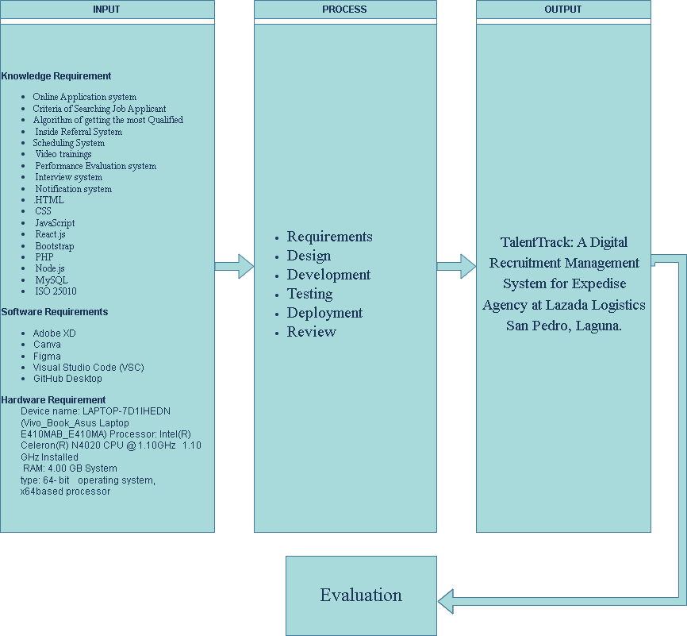

**Figure 1**. Conceptual Model of the Study

Source https://tinyurl.com/yc5e8t4a

**Input**

The input section lists the knowledge and software requirements for the project. These include various web technologies, programming languages, design tools, and the hardware specifications of the device to be used for development.

Knowledge Requirement: Online Application system, Criteria of searching job applicant, Algorithm of the Most Qualified Applicant, Referral System, Scheduling System, Tracking system, Video Trainings, Performance Evaluation System, Interview System, Notification, HTML, CSS, JavaScript, React.js, Bootstrap, PHP, Node.js, MySQL, ISO 25010.

Second, the Software Requirements that the researchers used are the following: Adobe XD, Canva, Figma, Visual Studio Code, Github Desktop.

Last are the Hardware Requirements used are the following: Device name: LAPTOP-7D1IHEDN (Vivo_Book_Asus Laptop E410MAB_E410MA) Processor: Intel(R) Celeron(R) N4020 CPU @1.10GHZ 1.10 GHz Installed RAM: 4.00 GB System type: 64-bit operating system, x64based processor.

**Process**

The process section explains the development methodology, which is the Agile Methodology. Agile is an iterative and incremental approach to software development that emphasizes flexibility, collaboration, and customer feedback. This includes phases like:

***Requirements.*** This is the gathering and documenting of user and system requirements to understand what the users need and what the system must achieve.

***Design.*** This is the conceptualizing of the system architecture and functionalities with ongoing feedback and adjustments.

***Development.*** Is the coding and building the system in small, manageable increments called sprints, each typically lasting 2-4 weeks.

***Testing.*** This is the continuously testing of the system during each sprint to ensure functionality, performance, and to identify and fix any bugs early in the process.

***Deployment.*** This is the regular deployment of increments to a production environment to make features available to users promptly.

***Review.*** Is the conducting of sprint reviews to demonstrate the working product increment to stakeholders and gather feedback.

**Output**

The output section describes the final product of the development process. It's a digital recruitment management system designed specifically for Expedise Agency, a logistics company in San Pedro Laguna. The system includes features such as:

Employee management Time and attendance tracking Performance evaluation Salary and benefits management Training and development Recruitment and onboarding.

**Evaluation**

The final step involves evaluation using ISO 25010. This standard provides guidelines for software quality evaluation, ensuring that the system meets the required standards and user expectations. The evaluation process includes assessing the system's functionality, performance, compatibility, usability, maintainability, and portability.

**Operational Definition of Terms**

The following terms or Phrases are defined to better understand the study:

***Evaluation of Practical Training System*** refers to a system that assesses the effectiveness and impact of hands-on training programs for employees.

***Human Resource Management Computer System*** refers to a system that aims to offer technical assistance for the carrier first-rate of organization human useful resource management commercial enterprise.

***Job Applicant Schedule Interview/Training System*** refers to a tool that helps organize and schedule interviews/training with job candidates.

***Monitoring of The Applicant System*** refers to a system that keeps track of applicants' status and progress throughout the hiring process.

***Online Recruitment*** refers back to the practice of using era and particularly internet-based total methods for duties which contain locating, attracting, assessing, interviewing, and hiring new personnel.

***Performance Management System*** refers to a system that measures, tracks development, and evaluates the effectiveness of worker performance.

***Profiling of the Most Qualified Applicant System*** refers to a system that identifies and highlights the best candidates for a job based on their qualifications.

***Recruitment Management System*** refers to a tool that helps manage the hiring process, from posting jobs to selecting the best candidates.

***Referral System*** refers to a method where current employees recommend potential candidates for job openings.

***Strategic Talent Management System***refers to an important situation for developing and keeping talent, which allows organizations or a corporation to compete successfully.

***TalentTrack*** refers to a Digital Recruitment Management System that will be implemented in Expedise Agency, a logistics company in San Pedro Laguna.

***Web-Based System*** refers to a utility that is accessed through HTTP.

**Chapter 3**

**METHODOLOGY**

This chapter includes the project design, project development, procedure for operation and testing, and the procedure for evaluation of the study.

**Project Design**

The project design for the Digital Human Resource Management System at Expedise Agency explained below using the UML diagrams or Unified Modeling Language diagrams, wire frame, System Flowchart and UI design.

**Use Case Diagram**

The use case diagram illustrates the interactions between Job Applicants, Expedise HR Staff, and the system within the Web - Based Job Application/Recruitment System for TalentTrack.

The diagram highlights the key actions and functionalities that each actor performs within the system. Job Applicants can use the system to login, register for jobs, manage their account, submit applications, print applications, check their account status, review their application status, and receive various notifications about their job applications, performance evaluations, referral system, profiling of the most qualified applicant system, digital interview notifications, and status updates.

Expedise HR Staff can perform a range of tasks, including managing the accounts of applicants, reviewing applications, evaluating performance, sending video training materials, providing overall evaluations, and managing notifications. They also have the ability to generate and print reports.

The system itself plays a vital role in managing and processing all the information related to job applications and applicant interactions. It handles the notification processes, manages account statuses, and provides the platform for applicants to interact with the system.

The diagram emphasizes the interconnected nature of the actors and their interactions within the system. It highlights the key functionalities that facilitate the recruitment process and ensure effective communication between applicants and the HR staff.

The diagram provides a clear and concise representation of the overall system's functionality and its interaction with the key actors involved in the recruitment process.

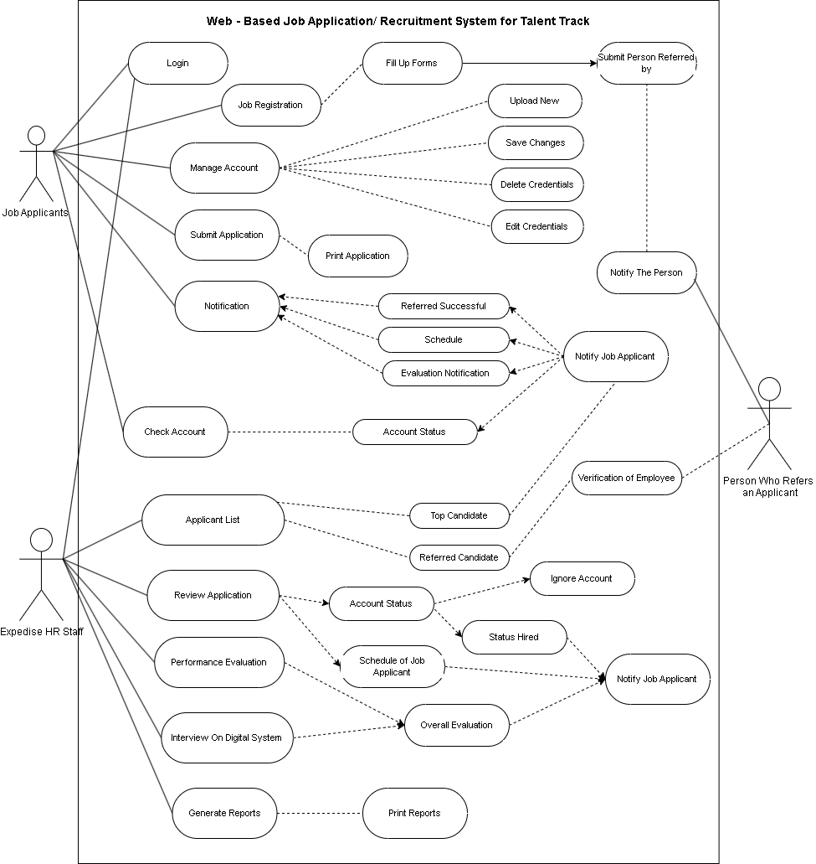

***Figure 2:*** Use Case Diagram

Job applicants engage in several functionalities, including login, job registration, fill up forms, submit application, print application, notification, manage account, upload new, save changes, delete credentials, edit credentials, check account, account status, referred successful, schedule, evaluation notification, applicant list, review application, performance evaluation, interview on digital system, generate reports, print reports, top candidate, referred candidate, status hired, and ignore account.

The "job registration" module offers options such as filling up profile information and submitting applications. In the "fill up forms" section, additional options like uploading new credentials and editing existing ones are available. Similarly, the "submit application" section extends functionalities like tracking application status and receiving notifications.

The Expedise HR staff, on the other hand, has relationships with various functionalities, including login for accessing the HR account, manage notification, interview on digital system, print reports, generate reports, manage account, notification, check account, performance evaluation, and applicant list. In the "manage account" module, there is a "check account" feature that allows HR staff to view candidate profiles. Additionally, the "performance evaluation" module includes the ability to review candidate applications and provide feedback.

By accurately representing these relationships and functionalities, the use case diagram effectively communicates the system's interactions, allowing for a comprehensive understanding of the Web-Based Job Application and Recruitment System for Talent Track and its operations.

***Model Hierarchy Chart***

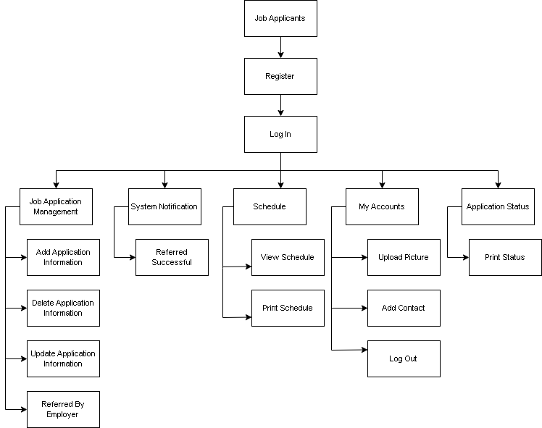

***Figure 3*:** Hierarchy Chart for Job Applicants Module

The hierarchy chart for the Job Application System presents the flow of functionalities within the "Job Applicants" system. The chart is divided into sections for users who register and then log in.

For registered users, the system offers several modules to manage their job application process. The "Job Application Management" module allows users to add, delete, and update their job application information. The "System Notification" module keeps users informed about any updates or changes related to their job application. The "Schedule" module enables users to view and print schedules related to job interviews or other events. The "My Accounts" module allows users to manage their account information and preferences. The "Application Status" module provides users with information about the current status of their job application.

After logging in or registering, users can perform common actions such as adding application information, uploading a profile picture, printing their application status or schedule, adding contact information, and logging out of the system.

The hierarchy chart provides a clear and concise overview of the functionalities available to users within the "Job Applicants" system, making it easy for them to navigate and manage their job application process.

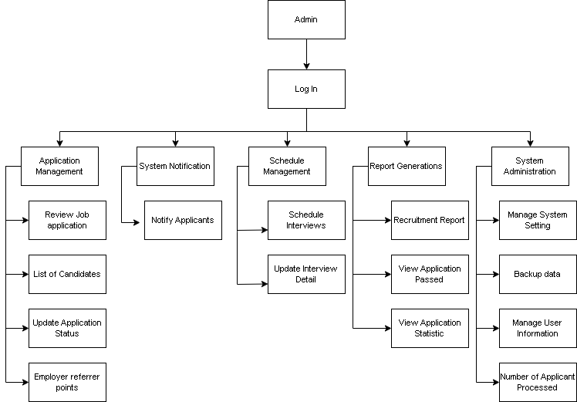

***Figure 4*:** Hierarchy Chart for HR Module

In Figure 4, the hierarchy chart for the HR module is presented in a visually appealing and accurate manner. Each module is represented by a box containing its name. The chart showcases the breakdown of the recruitment module into smaller modules for specific activities, with each sub-module connected underneath its parent module.

The recruitment module starts with the Admin who has to log in to access the functionalities. The admin has access to five main options: Application Management, System Notification, Schedule Management, Report Generations, and System Administration.

The Application Management module is responsible for reviewing the job application, maintaining a list of candidates, updating application status, and processing employer referrer points. The System Notification module sends notifications to applicants. The Schedule Management module is responsible for scheduling interviews and updating interview details. The Report Generations module handles recruitment reports, viewing applications passed, and viewing application statistics. The System Administration module manages system settings, backing up data, managing user information, and keeping track of the number of applicants processed.

***Data Flow Diagram***

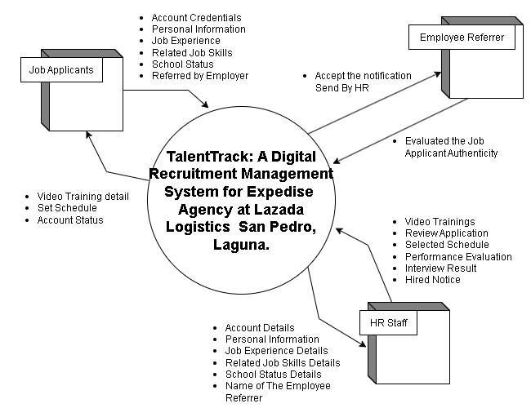

***Figure 5***. Context Level Data Flow Diagram

Figure 5 shows the Context Level Diagram of TalentTrack: A Digital Recruitment Management System for Expedise Agency at Lazada Logistics San Pedro, Laguna. This diagram shows the flow of data between the external entities and the system.

The system has three external entities interacting with it: Job Applicants, HR Staff, and Employee Referrer.

Job Applicants provide their account credentials, personal information, job experience, related job skills, school status, and details of the referrer (if any) to the system. In return, they receive video training details, set schedules, and account status updates.

HR Staff input account details, personal information, job experience details, related job skills details, school status details, and the name of the employee referrer into the system. They receive video training materials, application review capabilities, selected schedules, performance evaluations, interview results, and hired notices.

The Employee Referrer evaluates the authenticity of the job applicant and accepts notifications sent by HR. The system facilitates the recruitment process by allowing communication and data exchange between Job Applicants, HR Staff, and Employee Referrers, ensuring a seamless recruitment management experience.

***Top Level Data Flow Diagram***

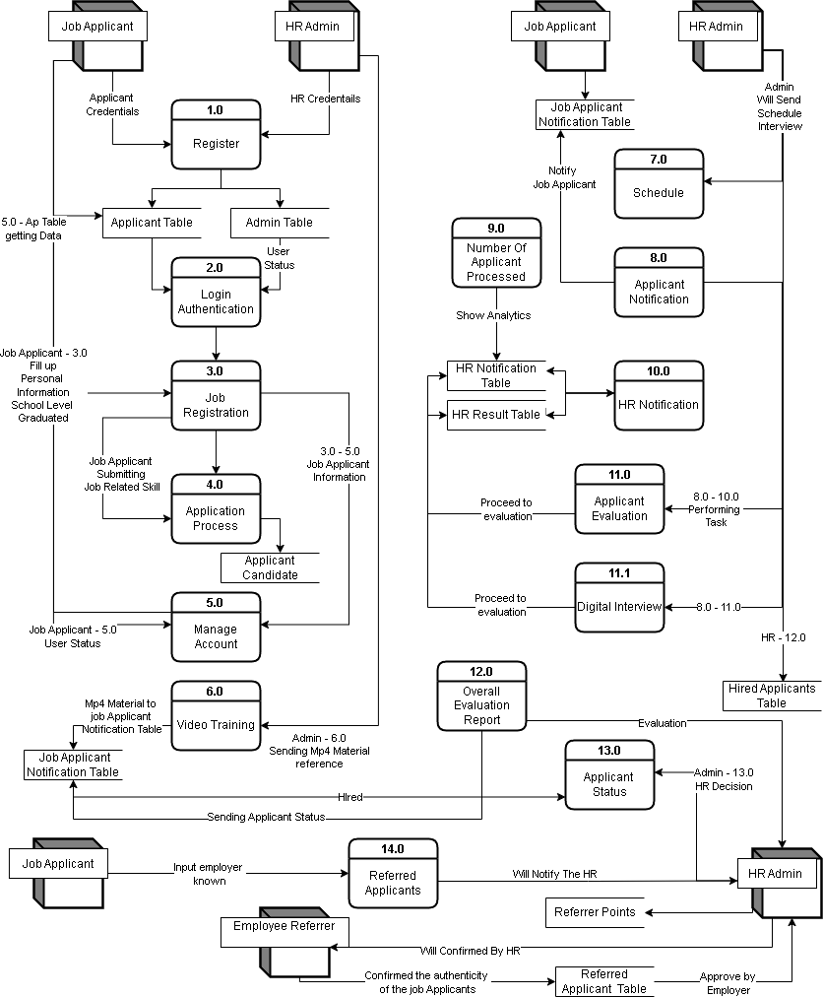

***Figure 6***. Data Flow Diagram

The figure 6 shows the Data Flow Diagram. This level shows deeper details about the flow of data in the system, including the system's subsystems and module processes.

The system has several external entities, including Job Applicants, HR Admin, and Employee Referrer. The Job Applicants represent individuals applying for a job, while the HR Admin manages the overall hiring process. The Employee Referrer represents current employees who refer new applicants.

Registration and Login:

Job Applicants register by providing credentials, which are stored in the Applicant Table and Admin Table.

Job Applicants and HR Admin login by providing their credentials, which are authenticated using the Applicant Table and Admin Table.

Job Application Process:

Job Applicants fill up personal information and submit job-related skills in the Job Registration module, which updates the Applicant Table.

The application process involves various stages, including application submission, account management, and video training. Video training materials are sent to the Job Applicant Notification Table.

Interview Scheduling and Notification:

HR Admin schedules interviews, and notifications are sent to Job Applicants via the Job Applicant Notification Table.

The system tracks the number of applicants processed and shows analytics in the HR Notification Table and HR Result Table.

Applicant Evaluation:

Job Applicants undergo performance evaluation and digital interviews. Evaluation reports are generated and stored in the Overall Evaluation Report module.

The applicant's status is updated throughout the process and stored in the Applicant Status module.

Hiring Decision:

HR Admin makes hiring decisions based on the evaluation reports. The status is updated and stored in the Hired Applicants Table.

Employee Referral:

Job Applicants can be referred by current employees. The referred applicants' information is confirmed and stored in the Referred Applicant Table.

HR Admin approves referred applicants, and referrer points are managed in the Referred Applicant Table.

***Entity Relationship diagram***

Figure 7 shows the Entity Relationship Diagram for the proposed project, illustrating the database design and the relationships between entities. The main entities include Job Applicant, Job Application, Interview, Account, Notification, Employee Referrer, and HR Expertise.

The Job Applicant entity stores information about job applicants. Each Job Applicant can submit many Job Applications, receive many Notifications, and has one Account. The Job Application entity stores information about job applications and is linked to the Job Applicant entity, where one Job Application can result in one Interview. The Interview entity, which stores details about interviews, can trigger many Notifications.

The Account entity stores information about user accounts, with each Job Applicant having one Account. The Notification entity stores details about notifications sent to users, where one Job Applicant can receive many Notifications. Notifications can also be linked to Admins, Job Applications, Interviews, and Employee Referrers.

The Employee Referrer entity stores information about employees who refer job applicants. Each Employee Referrer can be associated with multiple Notifications. The HR Expertise entity stores information about HR staff. Each HR Expertise member can manage many Notifications.

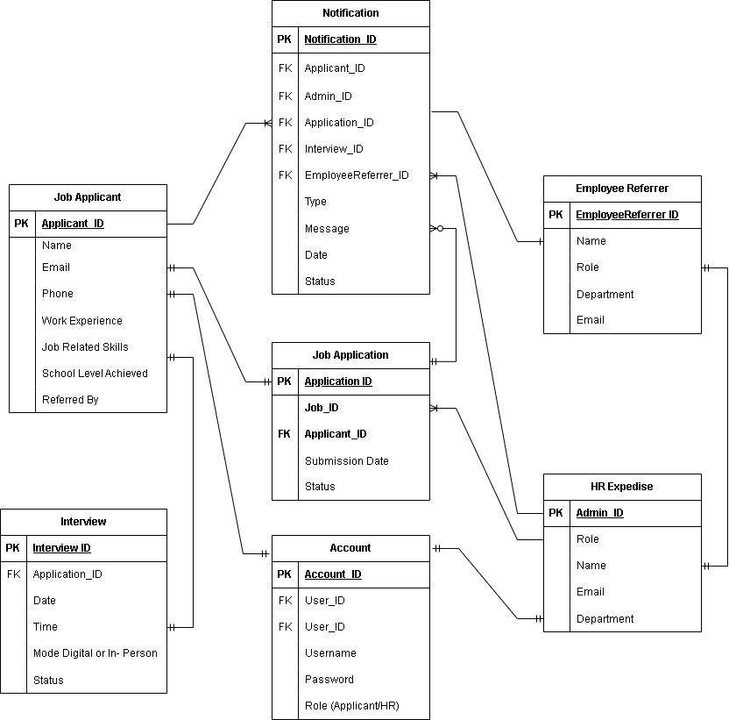

***Figure 7***. Entity Relationship Diagram**.**

***System Flow Chart***

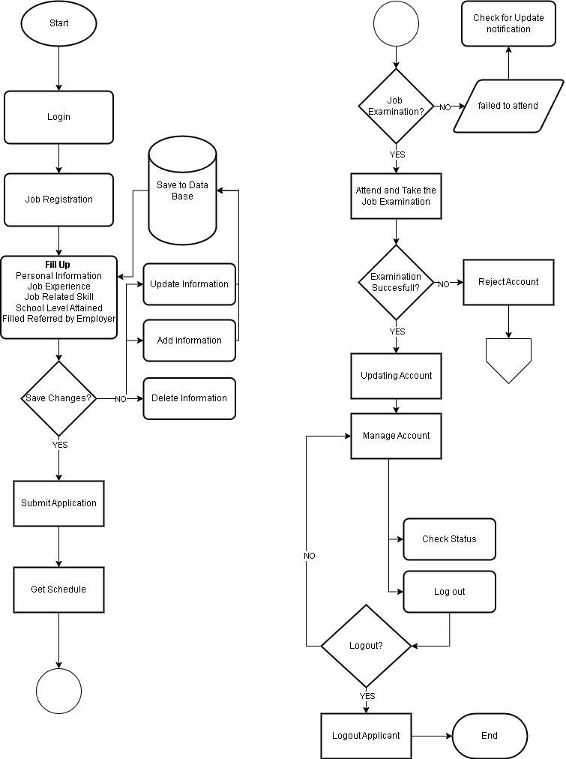

***Figure 8***. System Flow Chart Applicant Process

Figure 8 represents the complete flow of the human resource and job application system processes. The user starts by logging into the system. After logging in, the user can proceed with job registration, where they are required to fill out personal information, job experience, job-related skills, and the highest level of education achieved.

Once the information is filled out, the user can choose to save changes. If they save the changes, the information is added to the database. The user can also update or delete their information, which will also be saved to the database. After submitting their application, it is stored in the database, and the user receives a schedule for the next steps.

The system checks for job examination requirements. If a job examination is required, the user will receive a notification to attend and take the examination. If the user fails to attend the examination, they are notified to check for updates. If the examination is successful, the user's account is updated, and they proceed to manage their account, including checking the status of their application. If the examination is not successful, the user's account is rejected.

At any point, if the user wants to log out, they can choose to do so. Logging out ends the session. This flowchart ensures that each step of the job application and HR process is systematically managed, from initial application to account updates and examination results.

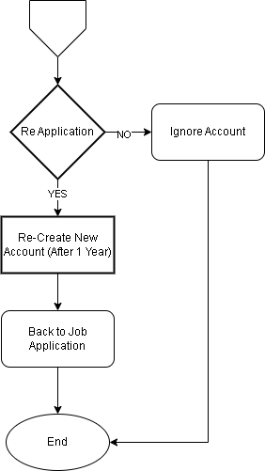

***Figure 9***. System FlowChart Reject Process

This figure 9 shows the Continuation of reject account of the system Flowchart Application/ Hiring Process. Using “Off Page Connector” we connect the rejected account and make a condition regarding on the job applicants re-application the “YES” condition will take to re-creation of account for one year or the condition of an HR/Admin to the Job Applicant to consideration. Next is to go back where the job applicant starts the process of applying, proceeding to the end of the system flowchart, while going to condition “NO” indicates ignoring it so the process will end.

***Wire Frame***

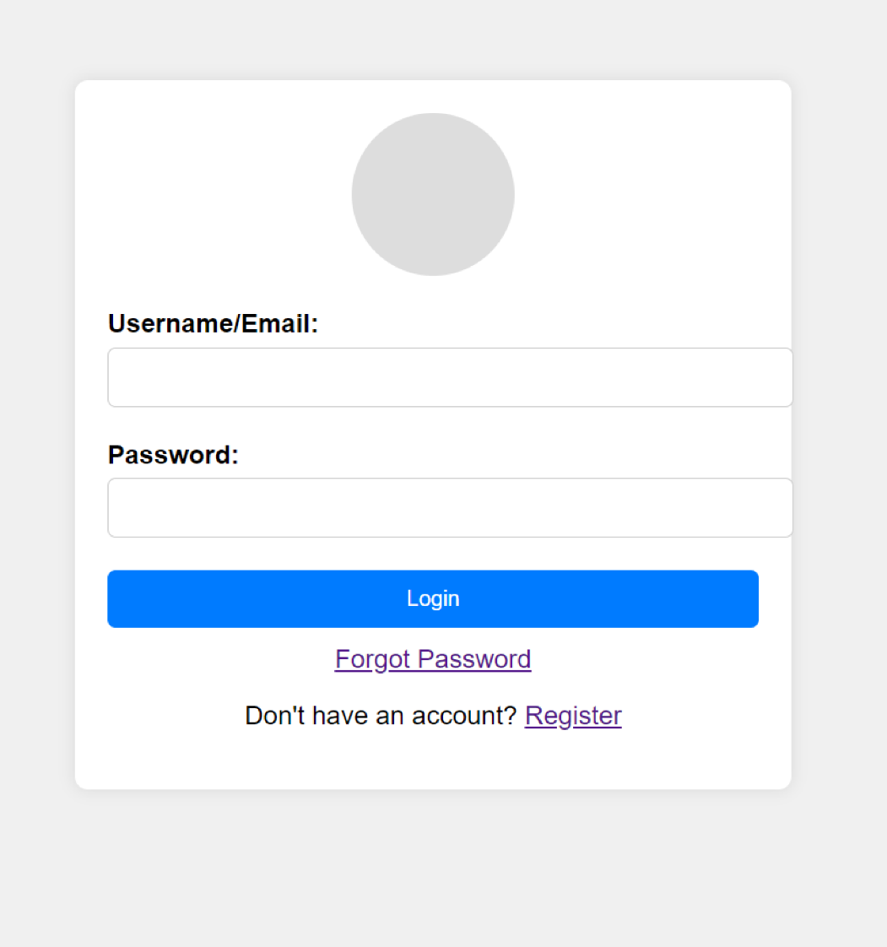

**Figure 10.** Log-In/Sign-In Page

Figure 10 showcases the Log-In/Sign-In Page for the Admin/HR and for the Job Applicant or Expedise future factory worker.

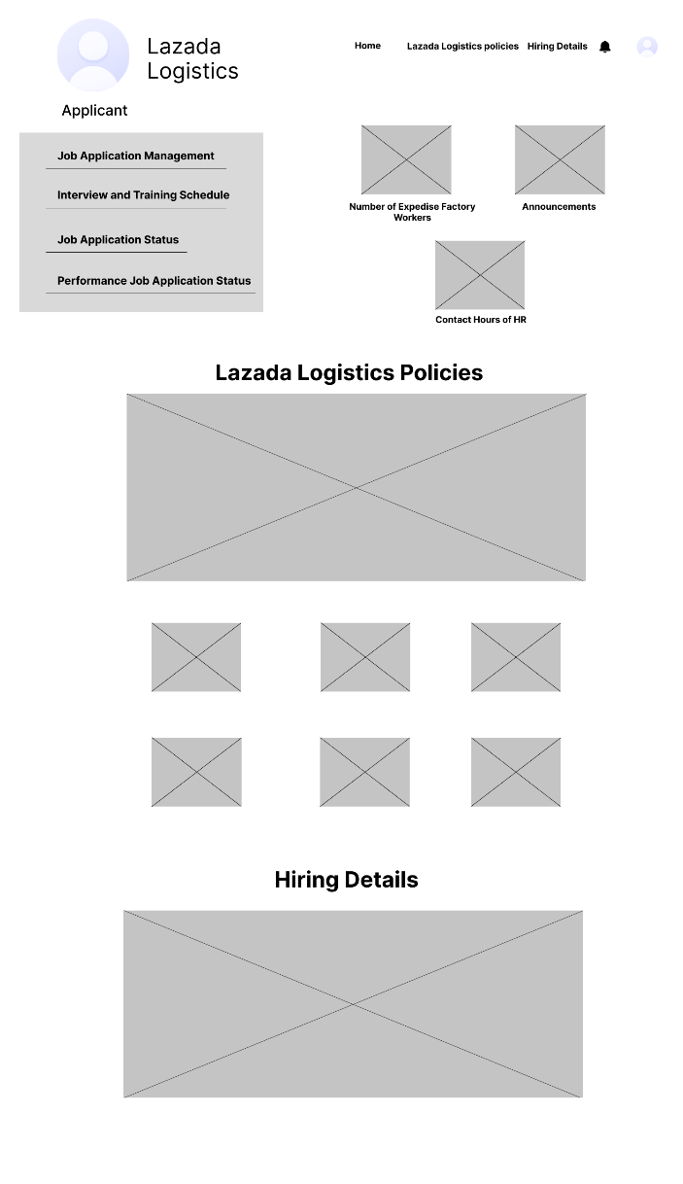

**Figure 11.** Applicants’ Home-Page

Figure 11 showcases the applicants’ home page, featuring the Home, Lazada Logistics Policies, and Hiring Details tabs. It also includes the Job Application Management tab for applying for jobs and the Interview and Training Schedule tab for checking their interview and training schedules. Additionally, applicants can view their job application status under the Application Status tab, which indicates whether their application has passed or failed. The Performance Job Application Status tab allows them to view their status after training in the warehouse and completing their digital questionnaire interview.

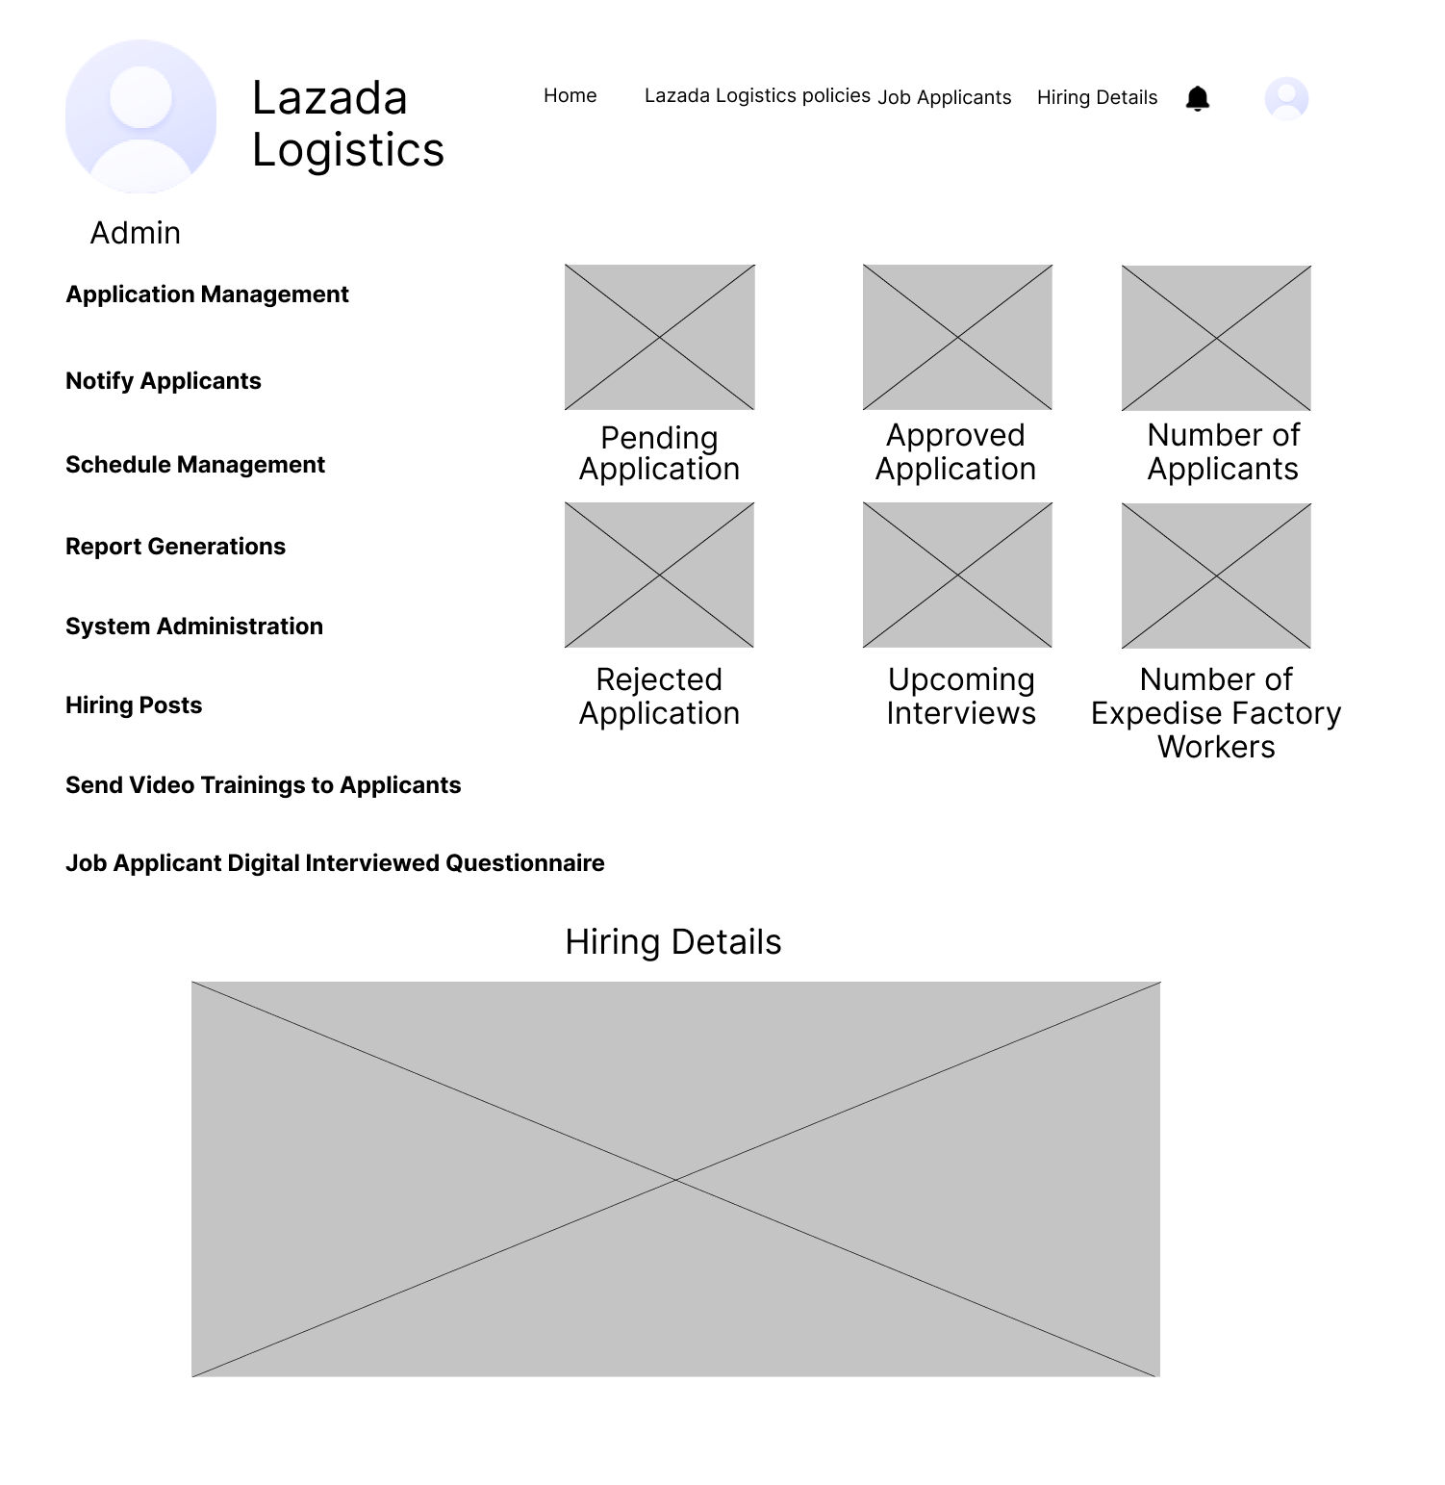

**Figure 12.** Admin Home-Page

Figure 12 shows the admin home page, which includes the Home, Lazada Logistics Policies, Job Applicants, and Hiring Details tabs. It also features Application Management for the admin to review job applications, view the list of candidates, and update application statuses. The Notify Applicants tab allows the admin to inform applicants about their application status, and more. Schedule Management is used to organize applicant interviews and training. Additional tabs include Send Video Training to Applicants, Hiring Posts, and Job Applicant Digital Interviewed Questionnaire Report Generation. The admin can also view pending and approved applications.

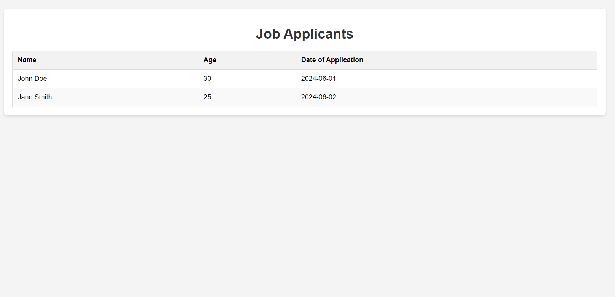

**Figure 13.** Admin Web-Page: “Job Applicants” Tab

Figure 13 shows the admin webpage where the admin can view all the job applicants.

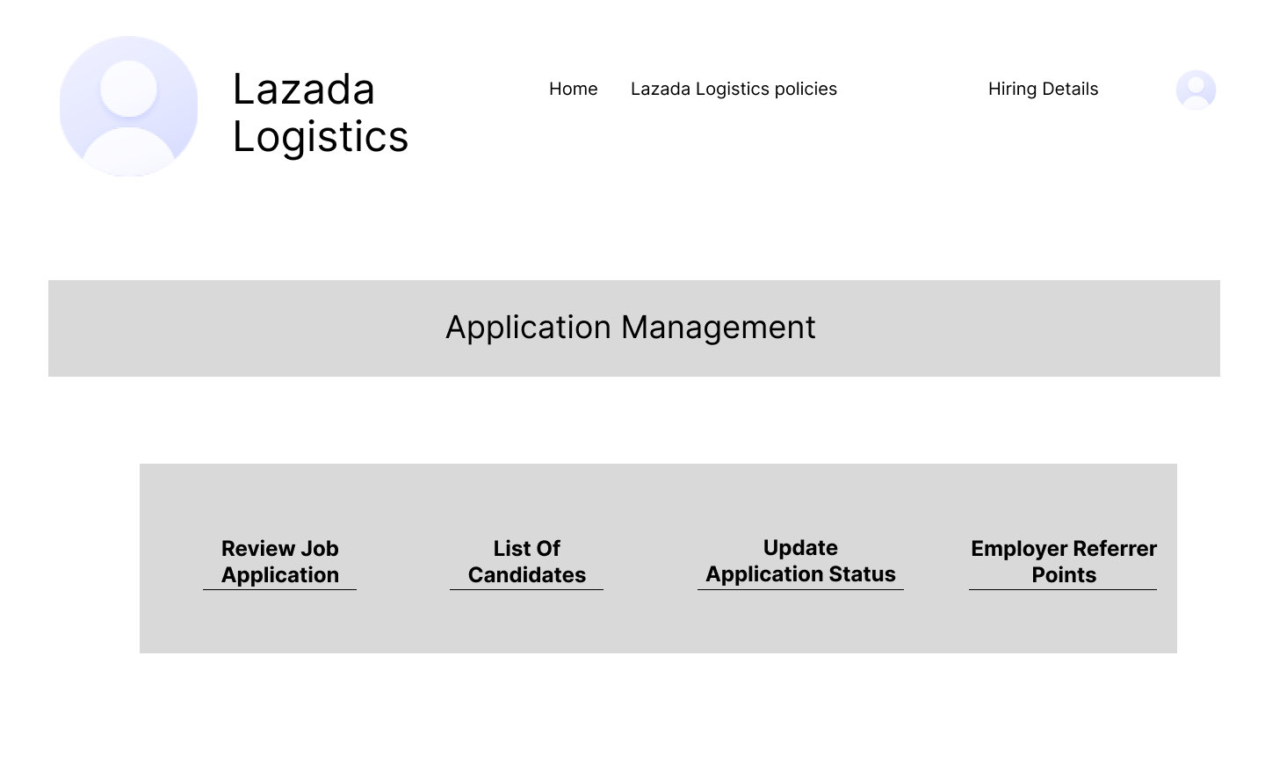

**Figure 14.** Admin Web-Page: “Application Management” Tab

Figure 14 shows the “Application Management” Tab where the admin can view the review job application, list of candidates, update application status and Employer Referrer Points.

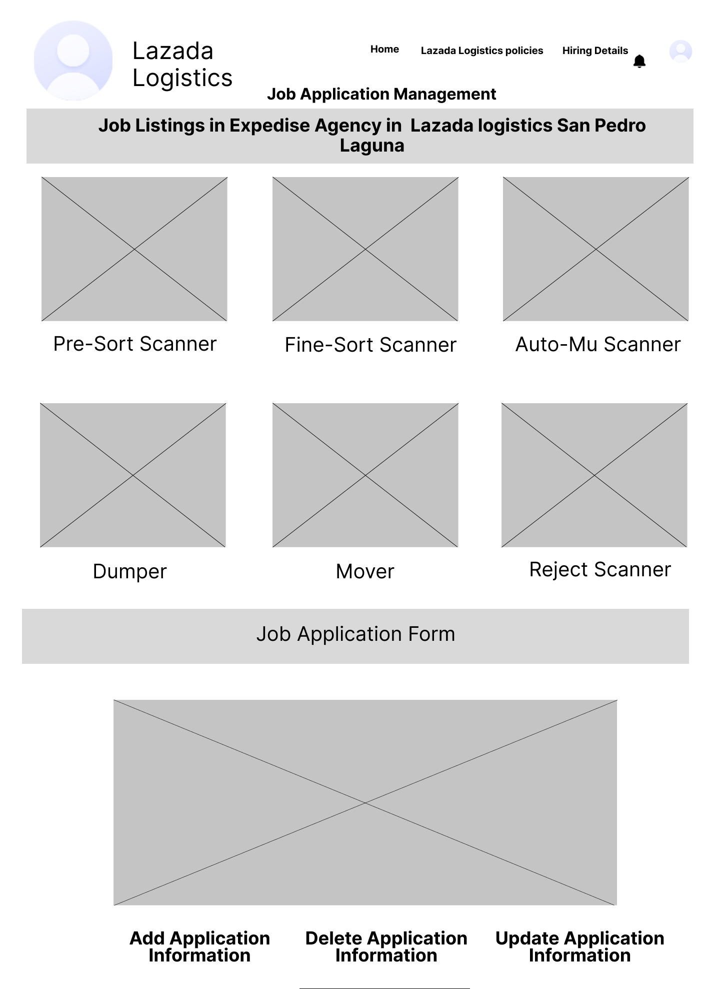

**Figure 15.** Job Applicant Web-Page: Job Application Management Tab

Figure 15 showcases the Job Application Management tab on the job applicant webpage, where applicants can view job listings and access the job application form to apply for a position at the Lazada logistics warehouse.

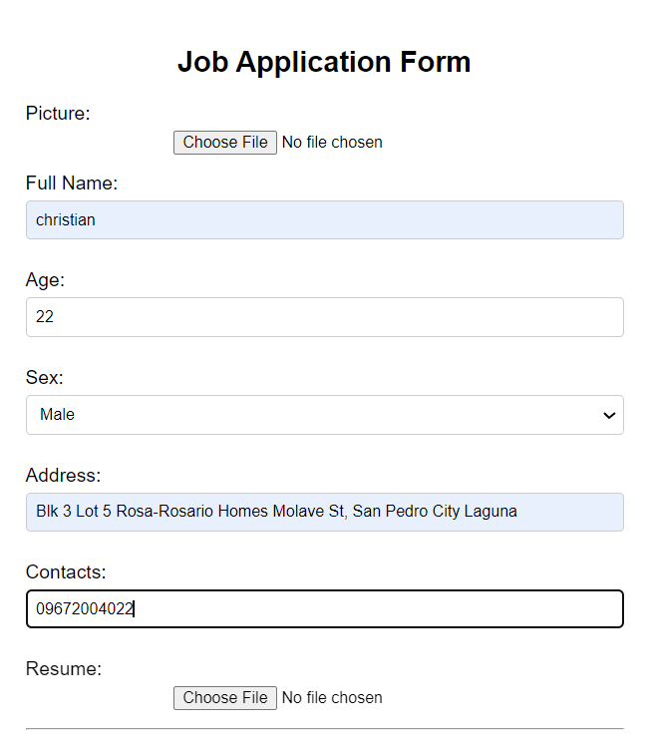

**Figure 16.** Job Applicant Web-Page: Add Application Information Tab (Job Application Form)

Figure 16 showcases the application form for the residents to fill up all their information, backgrounds, work experience and etc.

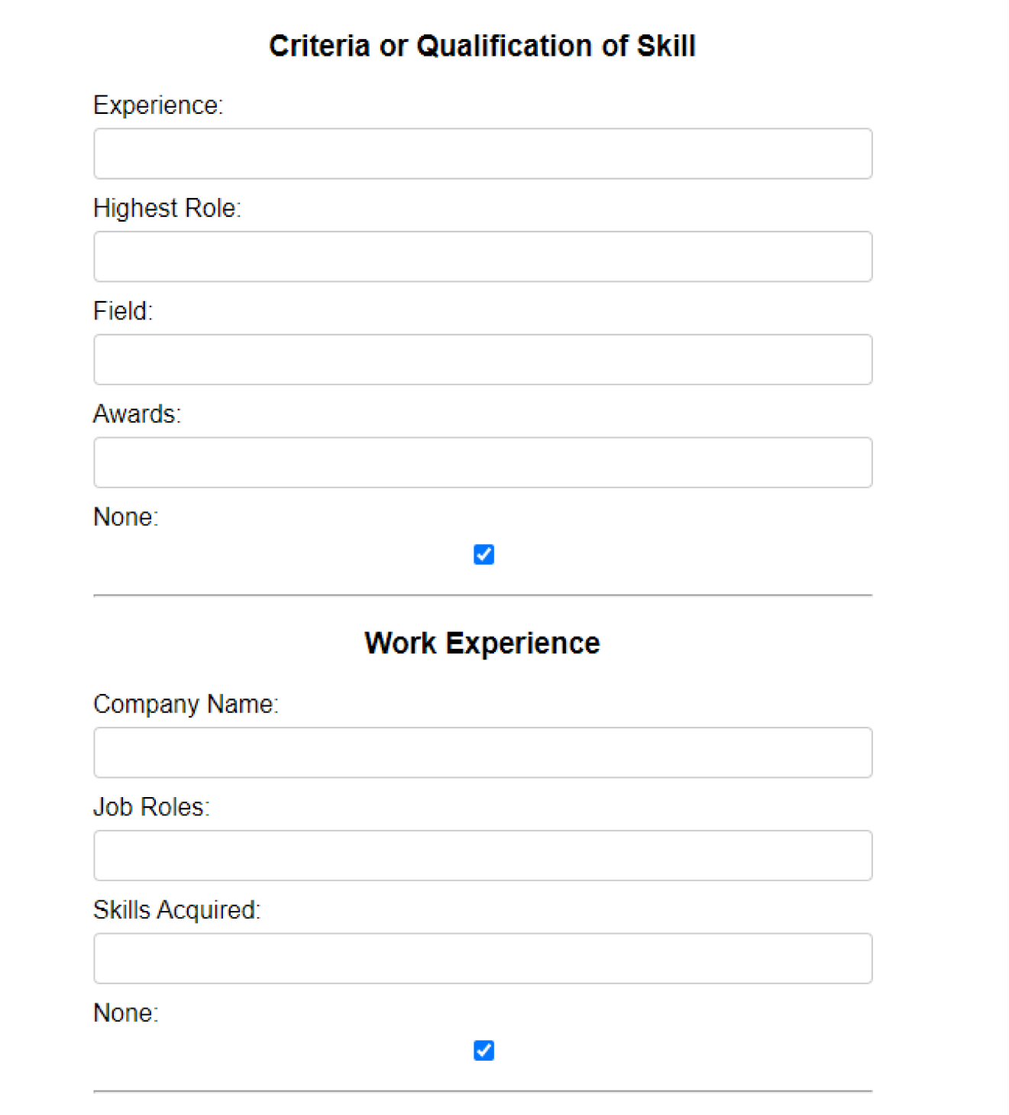

**Figure 17.** Job Applicant Web-Page: Add Application Information Tab (Job Application Form)

Figure 17 showcases the criteria or qualification of skills of the job applicant and their work experience.

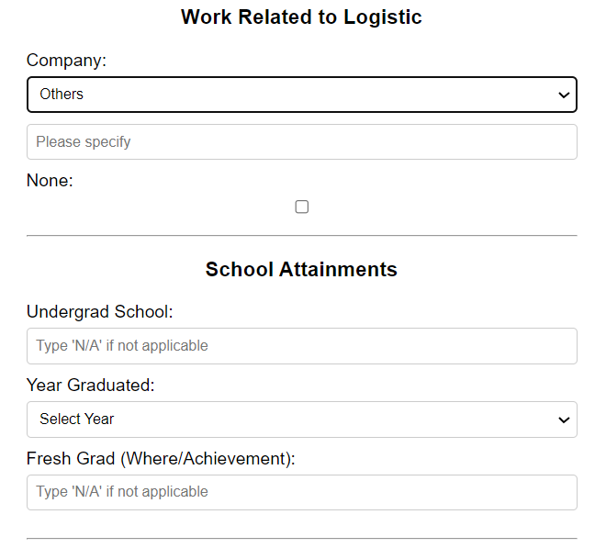

**Figure 18.** Job Applicant Web-Page: Add Application Information Tab (Job Application Form)

Figure 18 showcases their work-related experience in logistics organization and their school attainments.

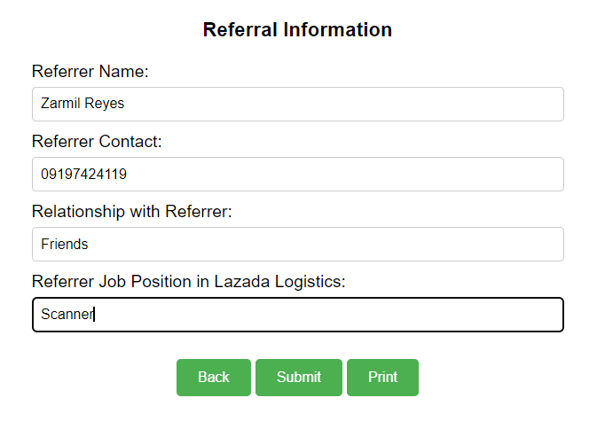

**Figure 19.** Job Applicant Web-Page: Add Application Information Tab (Job Application Form)

Figure 19 showcases the job applicant’s referral information. The job applicant can print the filled-in information and also submit their application to HR.

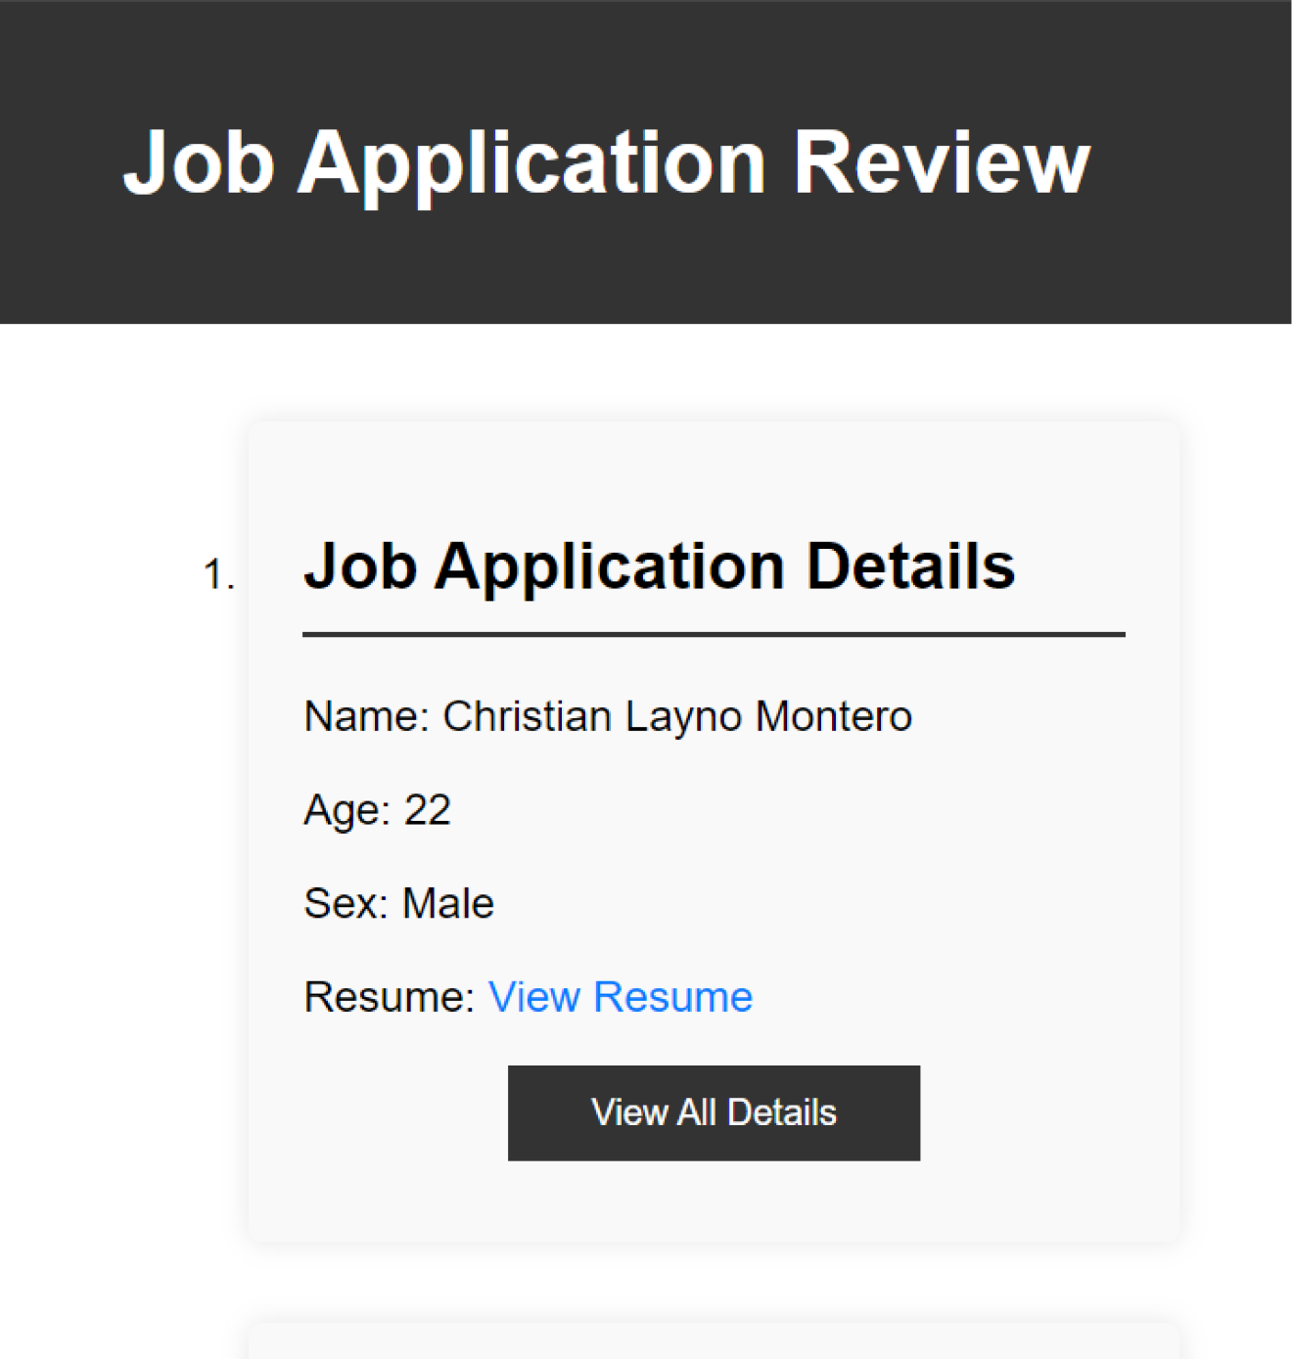

**Figure 20.** Admin Web-Page: Job Application Review Page

Figure 20 showcases the job application details in the web page of the admin after the applicant submit their application.

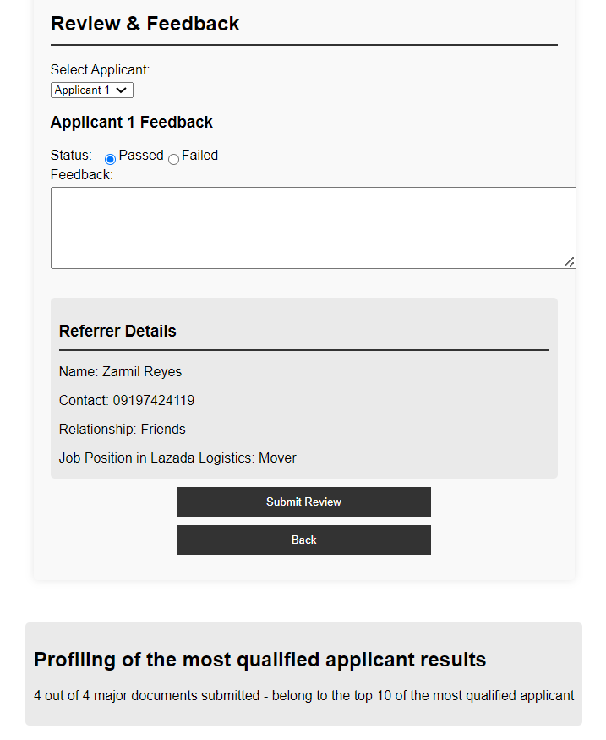

**Figure 21.** Admin Web-Page: Review Job Application Page

In Figure 21, the admin can review and set the status of the applicant as passed or failed in their job application form and the admin can also identify who is the referral person so that the admin can give bonus to the referral person. Lastly, the admin can view the Profiling of the most Qualified, These are the criteria: (has submitted the following Work Experience/, Job Related Skill, School Related Experience, Under Grad, and Year Graduated) 1.) 4 out of 4 major Document Submitted 100% to top 10. 2.) 3 out of 4 major Document Submitted 75% to top 10 3.) 2 out of 4 Major Document Submitted 50% to top 10 4.) 1 out of 4 major Document Submitted 25% to top 10.

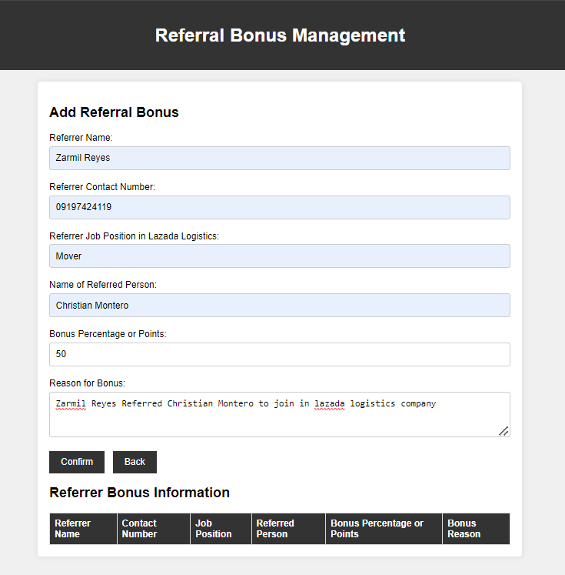



**Figure 22.** Admin Web-Page: Employer Referrer Points Page

In Figure 22, it showcases that the admin can add a referral bonus to the referral person.



**Figure 23.** Admin Web-Page: “Send Video Training to Applicants” Tab

In Figure 23, the admin can send video training to the applicant if they pass the job application. The purpose of the video training is to ensure the applicant has an idea of what to do before the actual training in the warehouse, helping to avoid mistakes.

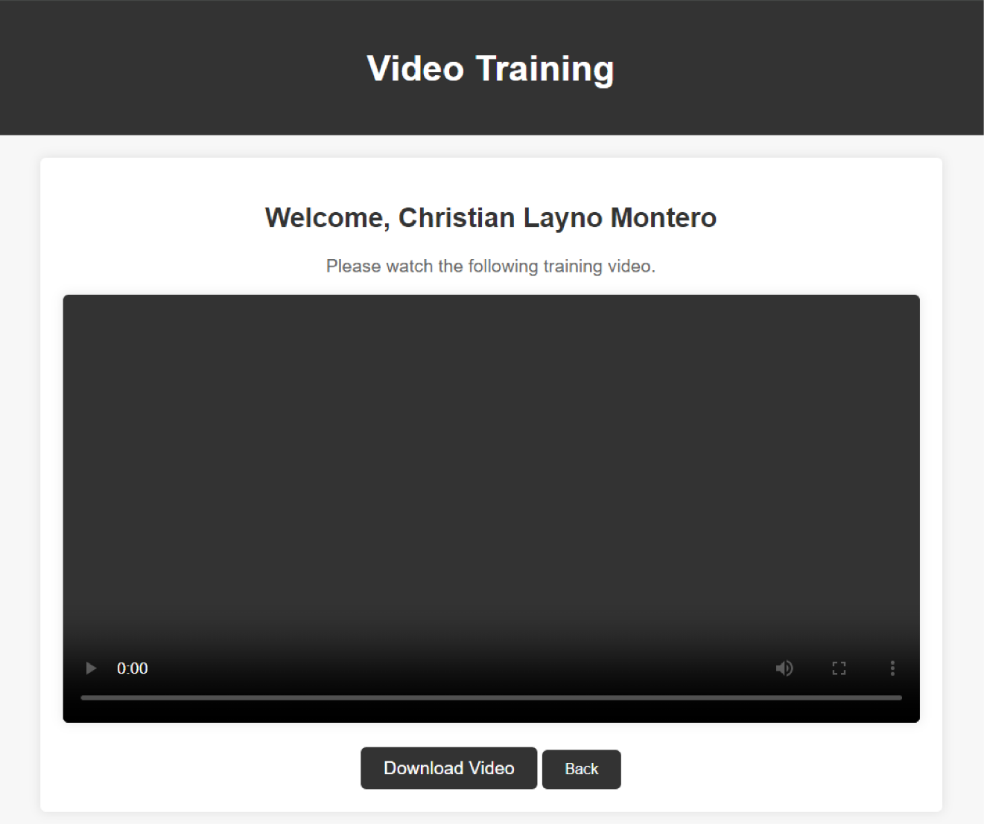

**Figure 24.** Job Applicants’ Web-Page: Video Training Page

Figure 24 presents a sample training video for the applicant, who can download it to review the job roles in the warehouse.

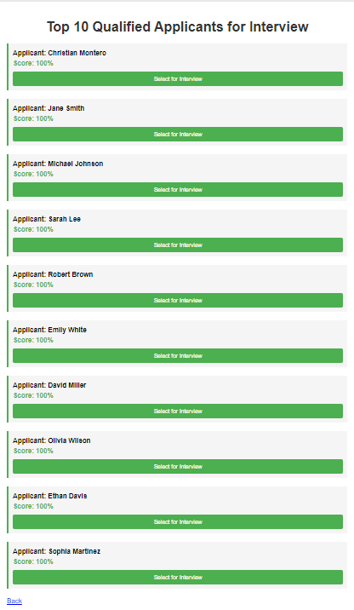

**Figure 25.** Admin Web-Page: Algorithm of The Top 10 most qualified applicants for interview Page

In figure 25, it showcases all the top 10 qualified applicants for interview, This is the Algorithm of The Top 10 most qualified applicants for interview: 1.) If all 10 candidates are 100%, they all get to top 10. 2.) If the 3 out of 10 get 75% they will go to the next batch alongside of that batch 100% candidate 3.) If 2 of them get 50% they will go to second batch if the second batch has a slot for top 10 candidates if not, they will wait for the next, next batch until we got few candidates 4.) If 1 person get 25%, they will just wait for notification

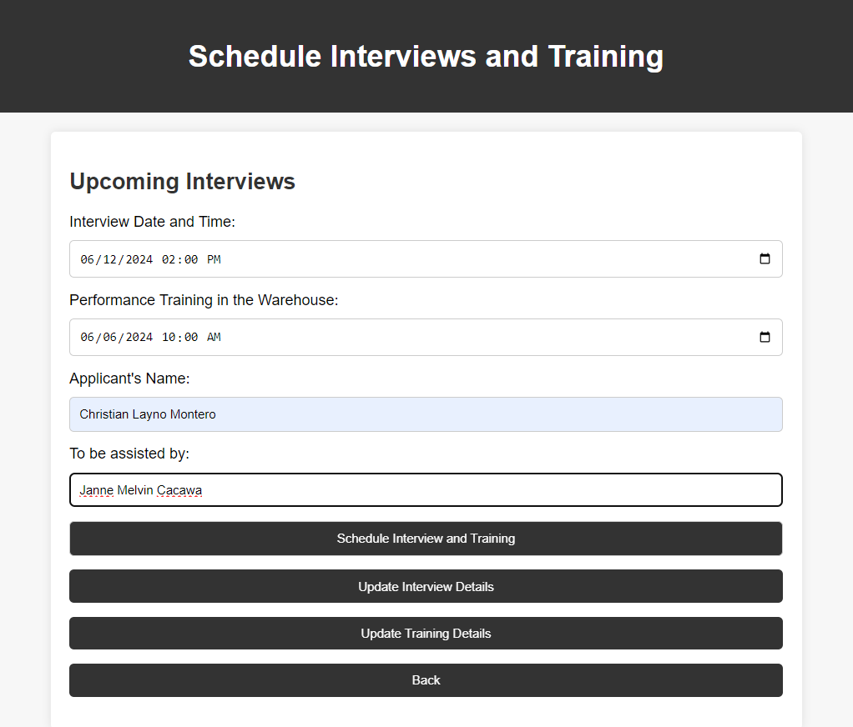

**Figure 26.** Admin Web-Page: “Schedule Interviews and Training” Tab

In figure 26, it shows how the admin can manage the interview and training schedule of the applicant.

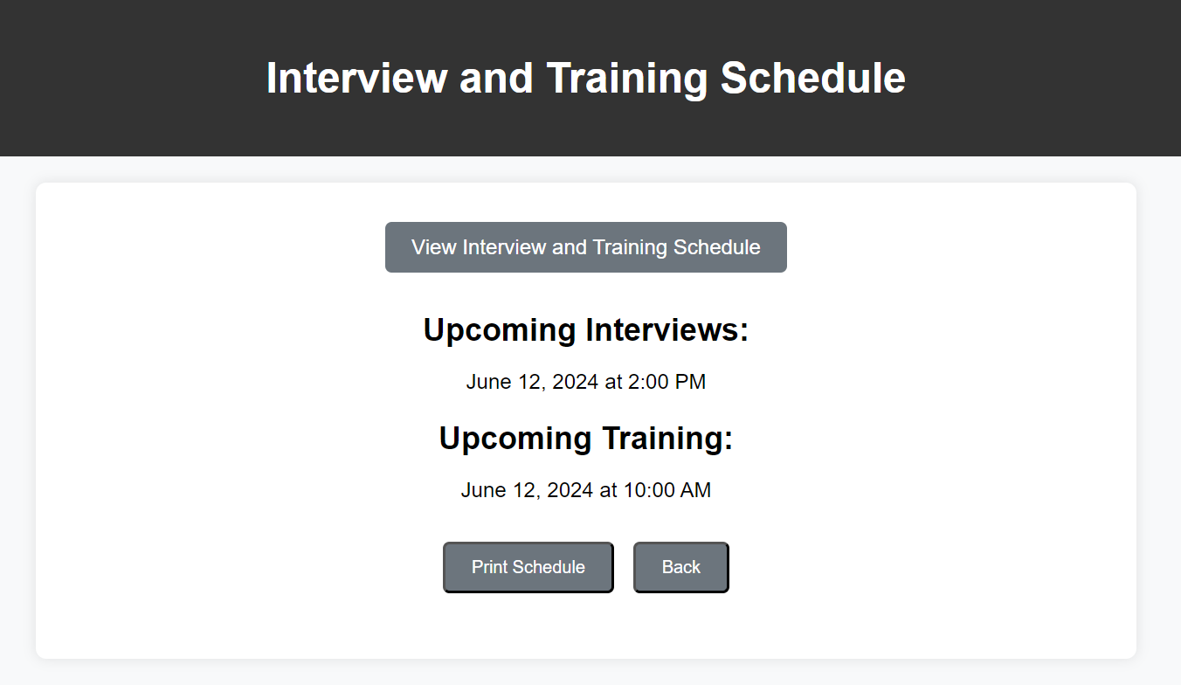

**Figure 27.** Job Applicants Web-Page: “Interview and Training Schedule” Tab

Figure 27 showcases the schedule of the interview and the training of the applicant.

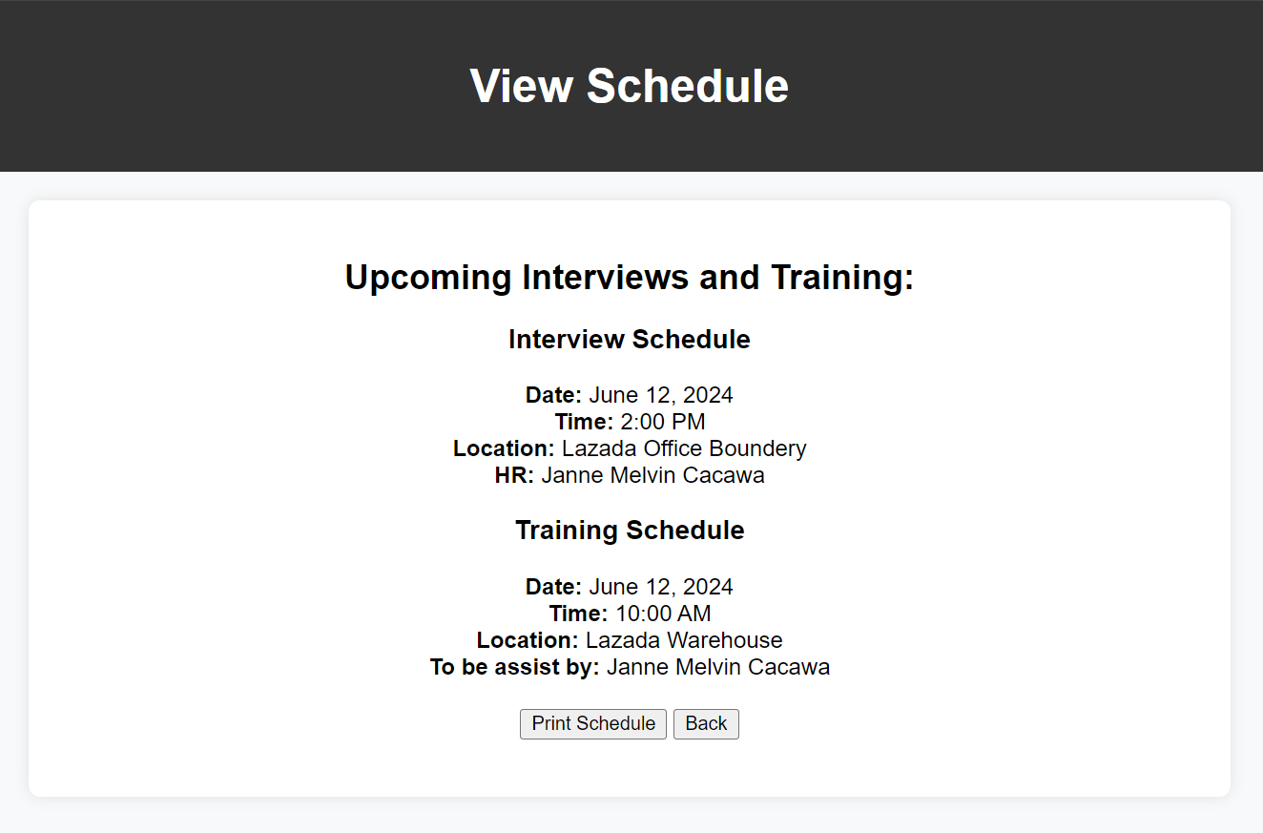

**Figure 28.** Job Applicants Web-Page: “View Interview and Training Schedule” Page

In Figure 28, after the applicant clicks the “View Interview and Training Schedule” button in Figure 27, the complete details of the interview and training schedule will be displayed.

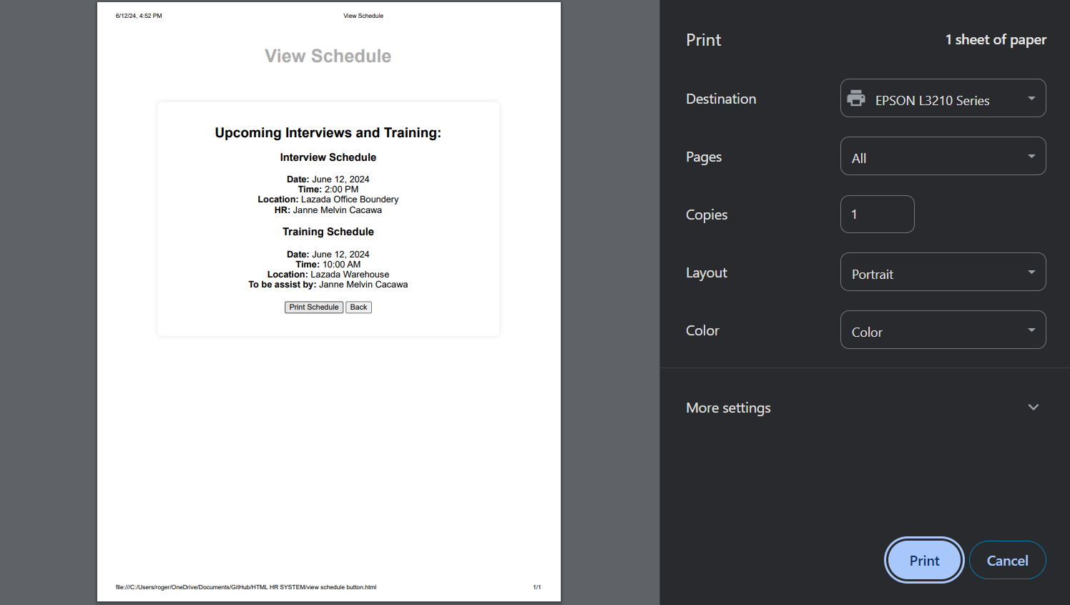

**Figure 29.** Job Applicants Web-Page: “Print Schedule” Button

In figure 29, the applicant can print the interview and training schedule to make sure they have a copy or proof of their schedule.

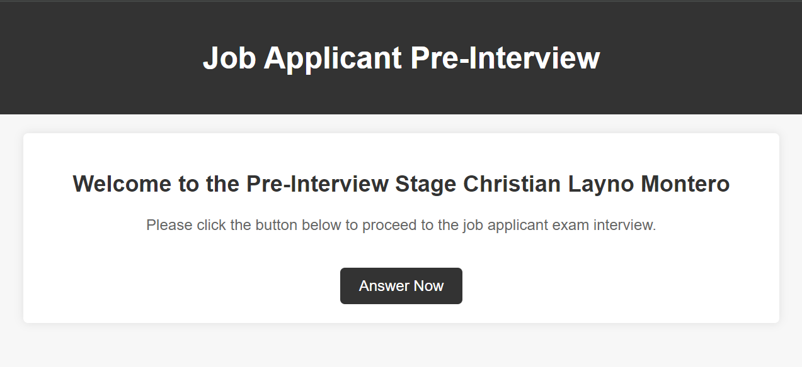

**Figure 30.** Admin Web-Page: “Job Applicant Interviewed Questionnaire” Tab

In Figure 30, it showcases the job applicant pre-interview, where the applicant will answer a questionnaire related to their training inside the warehouse.

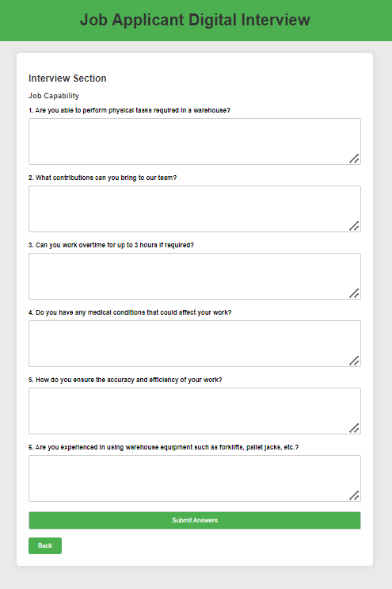

**Figure 31.** Admin Web-Page: Job Applicant Digital Interview Page

Figure 31 shows all the digital interview questionnaires related to the job roles in Lazada Logistics Warehouse, which will be answered by the job applicants in the HR Admin system.

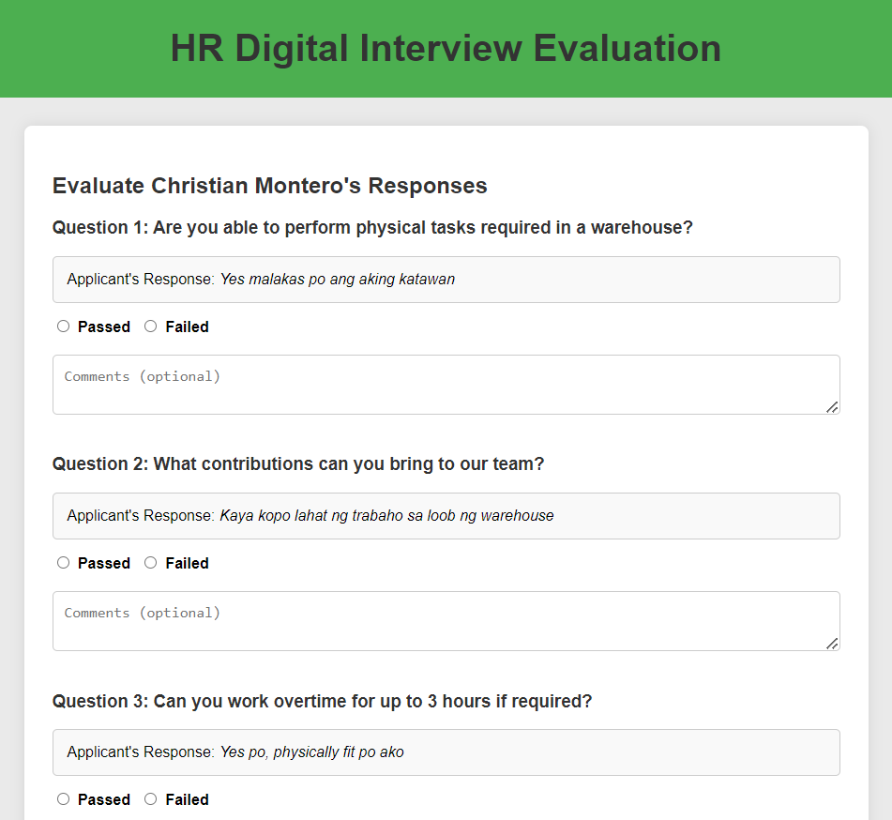

**Figure 32.** Admin Web-Page: HR Digital Interview Evaluation Page

In Figure 32, the admin can view and evaluate the applicants’ answers in their digital interview.

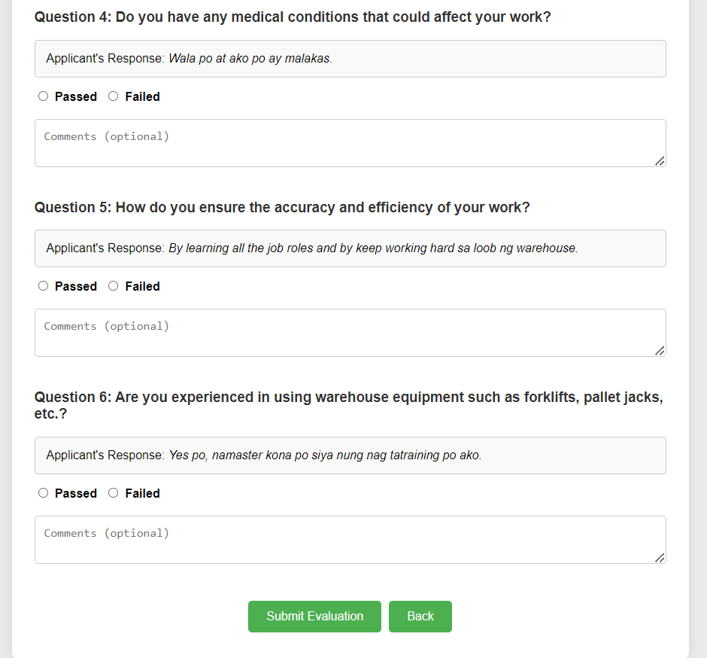

**Figure 33.** Admin Web-Page: HR Digital Interview Evaluation Page

In Figure 33, the admin can view and evaluate the applicants answer in their digital interview and they can submit the evaluation to the job applicant.

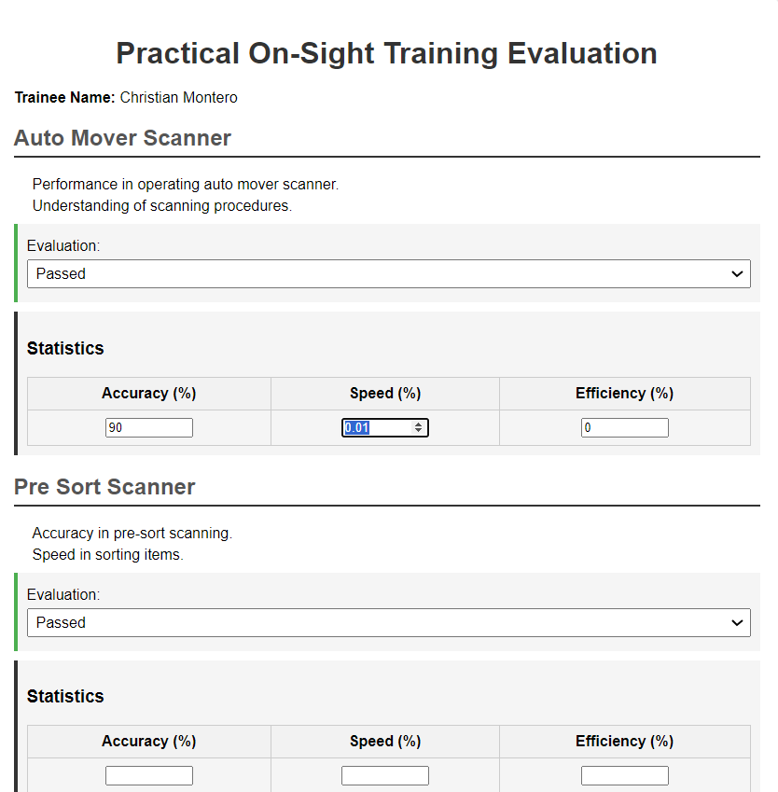

**Figure 34.** Admin Web-Page: Practical On-Sight Training Evaluation Page

In Figure 34, the admin can evaluate the applicant's performance during/after their training inside the warehouse. The admin can input statistical data and also assess whether the applicant has passed or failed based on their performance in the warehouse.

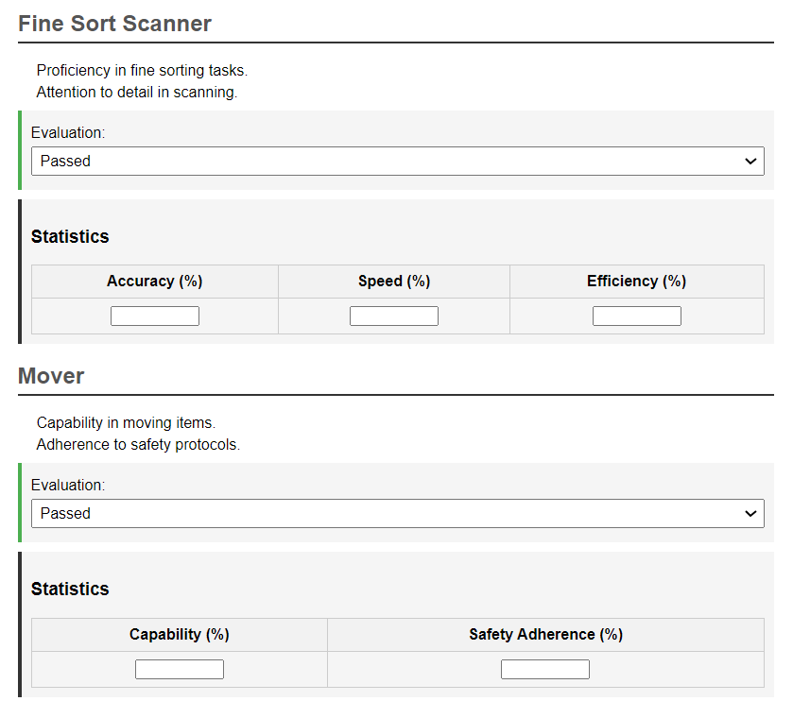

**Figure 35.** Admin Web-Page: Practical On-Sight Training Evaluation Page

In figure 35, the admin can evaluate the applicant performance during/after their training inside the warehouse. The admin can input the statistics data and the admin can also evaluate whether the applicant has passed or failed in the performance in the warehouse.

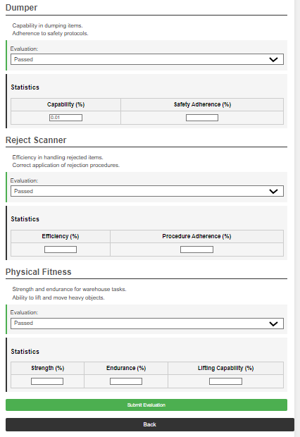

**Figure 36.** Admin Web-Page: Practical On-Sight Training Evaluation Page

In figure 36, the admin can evaluate the applicant performance during/after their training inside the warehouse. The admin can input the statistics data and the admin can also evaluate whether the applicant has passed or failed in the performance in the warehouse. After that, they can submit the evaluation to the applicant/trainee.

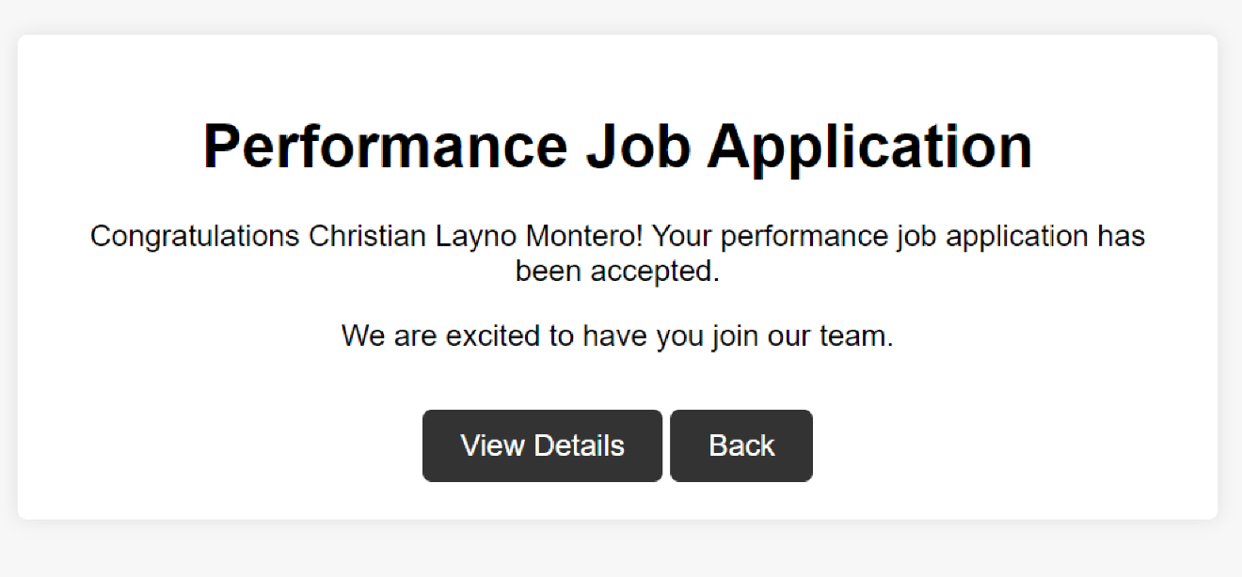

**Figure 37.** Job Applicant Web-Page: “Performance Job Application Status” Page

Figure 37 showcases the performance job application of the applicant, allowing them to view whether they have passed or failed.

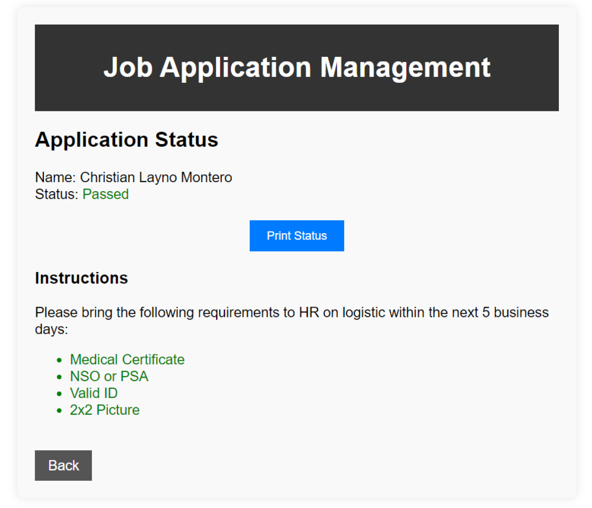

**Figure 38.** Job Applicant Web-Page: “View Details” Button under “Performance Job Application Status” Page

Figure 38 showcases the application status of the applicant, indicating whether they have passed or failed. If passed, the applicant can now bring the following requirements to HR.

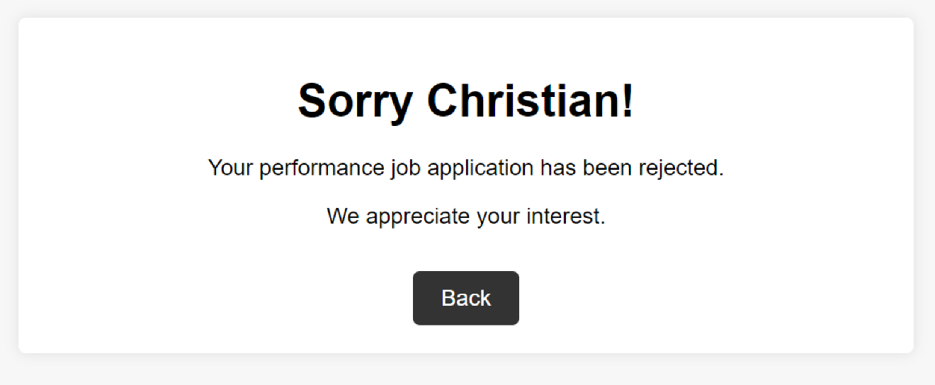

**Figure 39.** Job Applicant Web-Page: Performance Job Application Status is rejected

Figure 39 showcases that if the performance job application of the applicant has been rejected, their account will be ignored. But they can Re-create new account after 1 year.

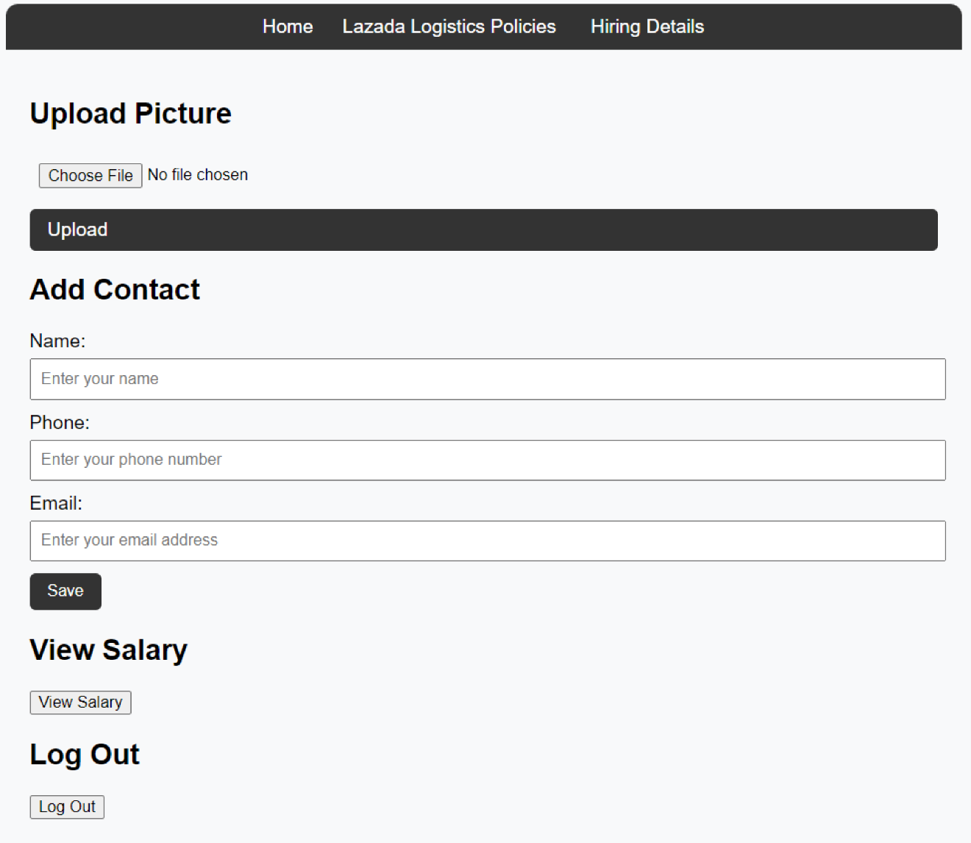

**Figure 40.** Job Applicants’ Web-Page: Manage Account Page

Figure 40 showcases the manage account page where the applicant/expedise factory worker can change their name, phone number, email, and picture, and also view their salary.

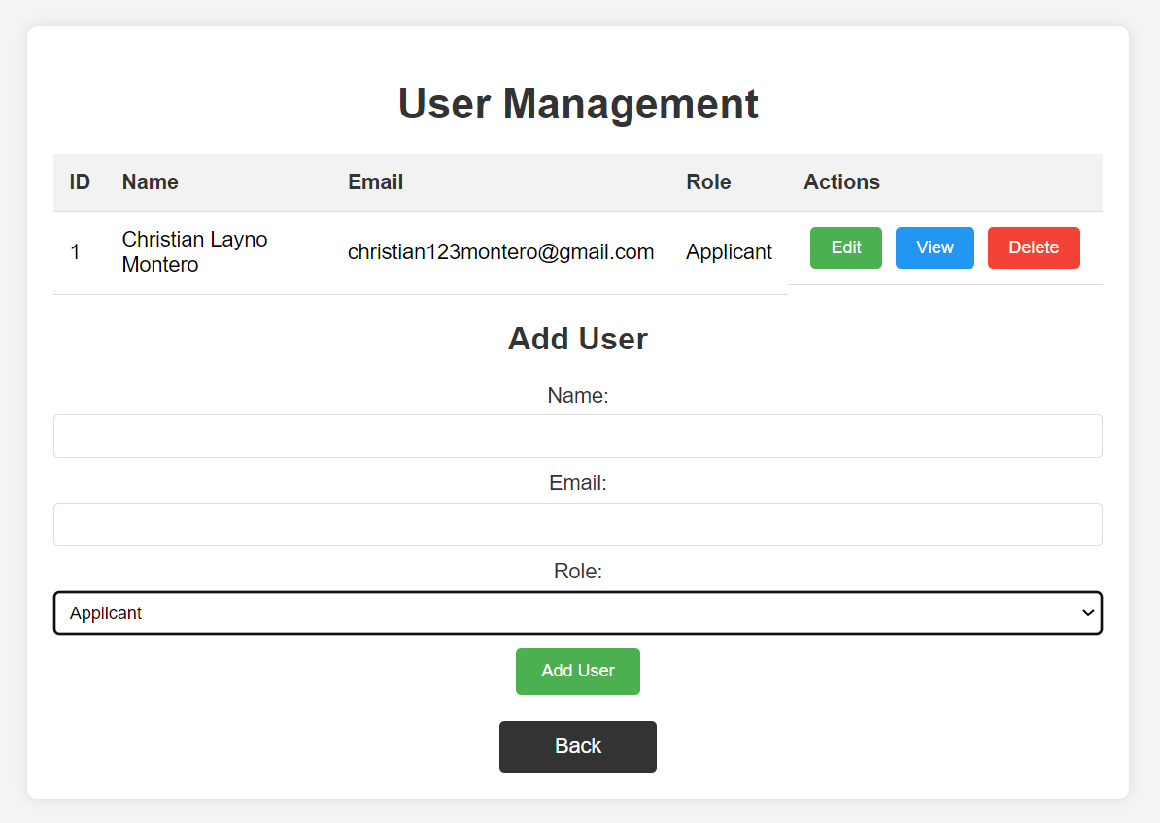

**Figure 41.** Admin Web-Page: User Management Page

Figure 41 showcases how the admin can manage the user account, they can edit, view, delete and add account.

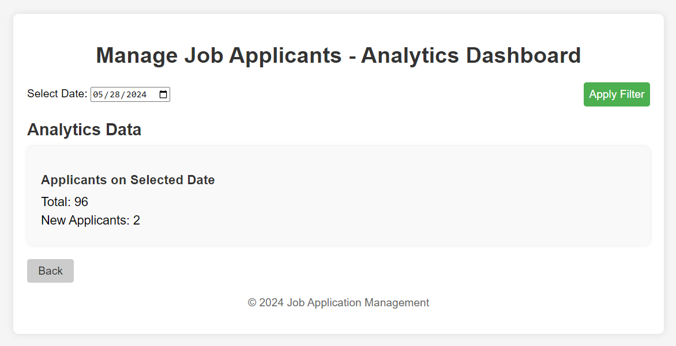

**Figure 42.** Admin Web-Page: Manage Job Applicants – Analytics Dashboard Page

Figure 42 showcases how the admin can view the analytics data of number of applicants apply per day, months, year by selecting the date and applying filter button.

***Project Development***

The Digital Recruitment Management System was developed using the Agile Methodology that helped the researchers to determine specific modules and features that are accomplished during each distinct phase of the development process. With the given methodology, the researchers easily identified the problems that are encountered by the digital human resource management system and provided solutions regarding these problems. This allowed the researchers to progress efficiently and effectively during the project development.

The agile methodology is a SCRUM-based iterative, incremental approach to web design or software development that prioritizes continuous delivery over linear, step-based milestones, and rigid objectives. In this approach, designers work in short sprints (one to two weeks) to rapidly prototype and test new features or designs at every step of the project. The agile web design process directs designers to release designs and get real-time feedback from users and other stakeholders early, providing an opportunity to make changes quickly and iteratively. The result of an agile design development methodology is an agile project that incorporates detailed feedback while sticking to relatively short timelines (Johnson, J. 2024).

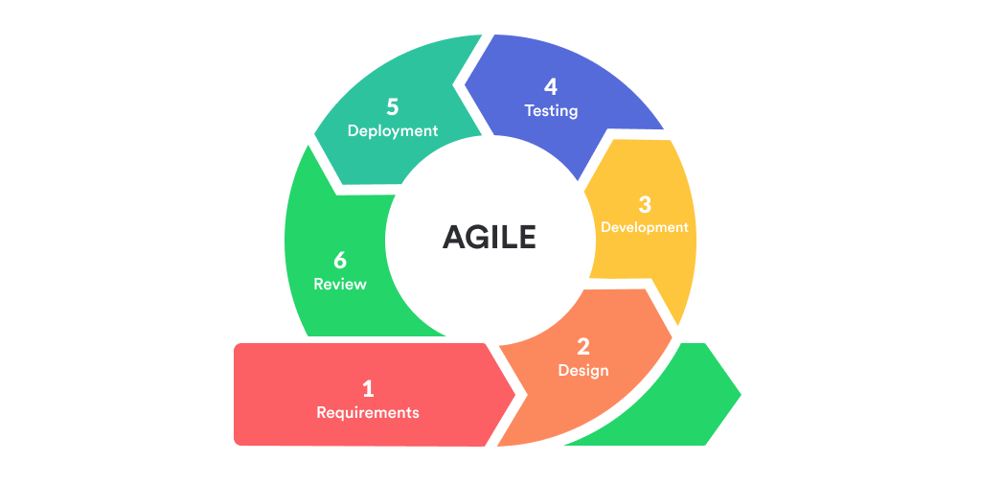

***Figure 43****.* Agile Methodology Framework

**Phases:**

***Requirements Gathering.*** In the initial phase, researchers conducted interviews and workshops to gather and document stakeholder requirements for the DRMS, ensuring a thorough understanding of user needs and translating them into specific features and functionalities.

***System Design.*** Once requirements were established, detailed planning of the system architecture, database schema, and user interface was carried out using tools such as Adobe XD or Microsoft Visio, aiming to create a blueprint that aligns with project goals and user expectations.

***Implementation.*** Following the system design phase, developers began coding and integrating different components to build the DRMS according to the specifications outlined in the design phase, utilizing Integrated Development Environments (IDEs) like Visual Studio for efficient development and debugging.

***Testing.*** Rigorous testing was conducted post-implementation to ensure the DRMS met specified requirements and functioned correctly, encompassing various types such as unit testing, integration testing, system testing, and user acceptance testing using tools like Selenium or Postman to identify and resolve issues promptly.

***Deployment.*** Once the DRMS passed all testing phases and was deemed ready for production, it was deployed to the live environment, involving the installation of software, configuration for operational use, and comprehensive training for end-users to ensure effective system utilization.

***Review.*** Post-deployment, the DRMS entered the review phase where ongoing support and updates were provided using tools such as Jira or Trello to monitor system performance, address user concerns, and align system functionality with evolving organizational needs.

**Roles:**

***Project Manager.*** The Project Manager oversaw the entire development process, ensuring adherence to timelines, budgets, and project objectives while effectively managing resources and coordinating team efforts.

***Software Developer.*** Software Developers were responsible for writing, testing, and integrating code according to design specifications, ensuring that the DRMS functionalities were implemented accurately and efficiently.

***System Analyst.*** System Analysts analyzed stakeholder requirements and translated them into detailed system specifications, ensuring that the DRMS design aligned with business goals and user needs throughout the development cycle.

***Quality Assurance Tester.*** Quality Assurance Testers conducted comprehensive testing of the DHRMS to identify and resolve any issues or bugs before deployment, ensuring high-quality standards and reliability of the system.

***Technical Support.*** Technical Support teams provided ongoing assistance to end-users, addressing issues or concerns that arose post-deployment, and ensuring smooth operation of the DHRMS through effective communication and troubleshooting.

**Tools:**

***Requirement Gathering Tools.*** Tools such as Microsoft Excel, Google Sheets, or specialized requirements gathering software were used to document and organize stakeholder requirements, facilitating clarity and prioritization of project goals.

***Design Tools.*** Design efforts were supported by tools like Adobe XD, Figma, or Microsoft Visio, enabling collaborative creation of system architecture, database schema, and user interface designs that met both functional and aesthetic requirements.

***Development Tools.*** Integrated Development Environments (IDEs) such as Visual Studio provided developers with essential tools for writing, debugging, and managing code, ensuring efficient development and integration of DRMS components.

***Testing Tools.*** Automated testing tools like Selenium, JUnit, or Postman facilitated comprehensive testing practices including unit testing, integration testing, and user acceptance testing, ensuring the DRMS met quality standards and functional requirements.

***Deployment Tools.*** Configuration management tools such as Ansible and Puppet were employed to automate the deployment process, ensuring consistency and reliability across different environments during the deployment of the DRMS to production.

***Maintenance Tools.*** Issue tracking and project management tools such as Jira, Trello, or Asana supported ongoing maintenance tasks by monitoring system performance, tracking software updates, and managing support tickets to address evolving organizational needs and ensure continued system functionality.

**Operation and Testing Procedure**

To ensure the system operates correctly, its features and functionalities will thoroughly test. Each function in the system will verify to confirm it is working as intended.

***Functional Suitability Testing*** will be performed to test if the functionality of the features of the web-based application can achieve the expected output. The following procedures will be the steps accomplished in this test. An example of how the Operation and Testing Procedure sections could be defined for the given test case will be provided. A sample test case will be shown in Table 1.

**Table 1**

*Sample Test Case*

|  |  |  |  |  |  |  |
| --- | --- | --- | --- | --- | --- | --- |
| **Test Case ID** | | |  | | **UC Reference** | |
| **Objective** | | | To track the applicant’s performance | | | |
| **Assumptions/ Preconditions** | | | User has completed the training | | | |
| **Actions** | | | **Expected Result** | | **Actual Result** | |
| 1. Navigate to performance management page 2. Track performance based on training results | | | 1. Performance Data displayed correctly | | 1. The data of performance has been displayed | |
| **Status** |  | PASSED | **Severity** |  | **Priority** |  |

The procedures and test cases ensure that each feature and functionality of the Digital Human Resource Management System is thoroughly tested for functional suitability. Any issues identified are tracked, resolved, and retested to maintain the integrity and reliability of the system. This comprehensive approach helps in streamlining and improving the HR management processes for Lazada Logistics.

**Table 2**

*Classification of Error Severity*

|  |  |
| --- | --- |
| **Severity** | **Description** |
| Critical | The problem signifies that the process has been completely stopped and cannot continue until it is resolved. |
| Major | The problem causes the system to crash. Nevertheless, some system components are still functional. |
| Minor | The problem does not result in any significant system failure |

The table offers a thorough and understandable summary of mistake severity grouping. Three levels of severity are displayed: Critical, Major, and Minor, along with explanations for each one. This table serves as a quick reference for determining the impact and intensity of a system's errors. Participants can effectively allocate and prioritize resources to classify faults into different severity levels in order to identify and resolve issues.

**Table 3**

*Classification of Error Priority Levels*

|  |  |
| --- | --- |
| **Priority** | **Description** |
| High | The problem needs to be resolved as soon as possible since it significantly affects the application. |
| Medium | The problem should be fixed throughout the normal course of development |
| Low | The problem must be resolved when a more crucial feature is taken care of. |

The chart offers a hierarchy of error priority levels, including categories such as High,   
Medium, and low with explanations for each. This table helps with setting priorities and the distribution of resources to address and resolve issues in accordance with their significance and haste. Development teams are able to effectively oversee their process and ensure that urgent problems are resolved promptly, while less urgent issues are handled at the appropriate amount of time throughout the development cycle by giving the relevant priority level to every mistake.

**Table 4**

*Overall Summary of Functionality Test Cases*

|  |  |
| --- | --- |
| **Use Case** | **No. of Test Cases** |
| Unregistered User  Verified User  Admin/HR  **Total** |  |

The "Total" entry in the table indicates the total number of test cases across all use cases. The table displays functionality test cases by use case: "Unverified User," "Verified User," and "Admin/HR." A placeholder for gathering and arranging test case data is provided by the table.

**Table 5**

*Reliability Test Cases Summary*

**Test**

**Case**

**ID**

**Objectives**

Each test case is granted a unique ID, known as the test case ID, which facilitates simple tracking and reference. Each test case's objectives include a description of the objectives and aims, detailing in detail the components of reliability that are being evaluated or confirmed.

**Table 6**

*Testing Procedure for Functionality Suitability*

|  |  |  |
| --- | --- | --- |
| **Modules** | **Steps to be taken** | **Expected Output** |
| 1. Setup Applicant Profile | 1. Access HRM system. 2. Navigate to applicant profile setup. 3. Input applicant data. | 1. Create and populate applicant profiles in the system. |
| 1. Track Performance | 1. Access performance tracking module. 2. Input performance metrics. | 1. Record performance data for applicants. |
| 1. Verify Training Completion | 1. Access training completion verification module. 2. Verify training completion status for each applicant. | 1. Check completion status of required training for applicants. |
| 1. Generate Reports | 1. Access reporting module. 2. Select report parameters and generate report. | 1. Create and review performance reports. |
| 5. Conduct Stability Test | 1. Apply normal load conditions to the system. | 1. Subject the system to normal load conditions. |
| 7. Perform Stress Testing | 1. Apply maximum user load to the system. | 1. Test system performance under maximum user load. |
|  |  |  |

**Table 7**

*Testing Execution Summary*

|  |  |  |  |
| --- | --- | --- | --- |
| **Text Execution** | **Expected Result** | **Active Result Cycle**  **1** | **Cycle 2** |
| No. of Test Cases Results of Test Cases | 100% |  |  |
| Passed | 100% |  |  |
| Failed | 0% |  |  |
| No. of Test Cases Not  Executed | 0% |  |  |

The table presents a summary of the test case executions. It shows that the test execution process has been finalized, with all test cases run and none remaining unexecuted. The column for expected results is currently empty and needs to be populated with the predicted outcomes for each test case. The results indicate that all test cases have passed without any failures. In summary, the chart provides an overview of the testing status, confirming that the execution was thorough and successful.

**Evaluation Procedure**

The evaluation procedure will follow ISO 25010 guidelines to assess the system. The evaluators will include job applicants, HR staff, and Expedise factory workers who will interact with the prototype, ensuring a diverse range of perspectives and experiences contribute to the evaluation process. The system will be demonstrated, and the respondents will also receive survey in return. The following outlines the planned evaluation process.

1. Each respondent will receive a software assessment form to evaluate the system's effectiveness.
2. A demonstration of the web-based application's functions and an explanation of its objectives will be conducted to guide users on its usage.
3. The application will be accessible to all respondents for evaluation.
4. Respondents will rate the system based on the ISO 25010 standard evaluation criteria, utilizing a 4-point Likert scale where 4 indicates the highest rating and 1 the lowest.
5. The evaluation will focus on four characteristics: functional suitability, reliability, performance efficiency and maintainability.
6. The overall weighted mean rating for each criterion and the grand weighted mean will be computed based on the collected evaluation data.
7. Evaluation outcomes will be analyzed qualitatively within the context of the weighted mean value range as depicted in the table.

**Table 8**

*Four-point Likert Scale*

|  |  |
| --- | --- |
| **Scale** | **Descriptive Rating** |
| 4 | Highly Acceptable |
| 3 | Very Acceptable |
| 2 | Fairly Acceptable |
| 1 | Not Acceptable |

The scale in the table has ratings that are both descriptive and have numerical values. This table can be used to assess or evaluate something based on its level of acceptability; higher numerical values reflect a more favourable rating. The scale runs from 1 to 4, with a 4 representing "Highly Acceptable," a 3 denoting "Very Acceptable," a 2 denoting "Fairly Acceptable," and a 1 denoting "Not Acceptable." Descriptive ratings provide subjective data about the related numerical values, which aids in the identification and evaluation of the acceptability of different criteria or objects.

**Table 9**

*The Range of Mean Ratings and the Equivalent Descriptive Rating*

|  |  |
| --- | --- |
| **Scale** | **Descriptive Rating** |
| 3.26 - 4.0 | Highly Acceptable |
| 2.51 - 3.25 | Very Acceptable |
| 1.76 - 2.50 | Fairly Acceptable |
| 1.00 - 1.75 | Not Acceptable |

The table presents different numerical ranges along with corresponding descriptive ratings. This scale can be employed to evaluate or grade something based on its level of acceptability, with each rating assigned a distinct numerical span. For instance, if a value falls within the range of 3.26 to 4.0, it is categorized as "Highly Acceptable" according to the provided descriptors. Similarly, values within other ranges are labeled as "Very Acceptable," "Fairly Acceptable," or "Not Acceptable."

**REFERENCE**

A, E. T. J. (2021). Implementation of Decision Support Personnel Recruitment System for Laguna State Polytechnic University-San Pablo City Campus. https://papers.ssrn.com/sol3/papers.cfm?abstract_id=3934151

Abramowski, N. (2023). What is CSS? A Web Developer's Guide for 2024. CareerFoundry. https://careerfoundry.com/en/blog/web-development/what-is-css/#why-is-css-important

Ahmed, A. M., Mohammed, C. N., & Ahmad, A. M. (2023). Web-based payroll management system: Design, implementation, and evaluation. SN Computer Science, 4(82). https://doi.org/10.1186/s43067-023-00082-5

Alexandrea, J. (2023). What is Bootstrap? Hostinger Tutorials. https://www.hostinger.ph/tutorials/what-is-bootstrap/

Ap, B. (2021). What is Adobe Xd? How can I use it? - Bruno Ap - Medium. Medium. https://medium.com/@bascido/what-is-adobe-xd-how-can-i-use-it-a6c301dbb0c6

Awan, S. H., Habib, N., Akhtar, C. S., & Naveed, S. (2020). Effectiveness of performance management system for employee performance through engagement. SAGE Open, 10(4), 215824402096938. https://doi.org/10.1177/2158244020969383

Bakhur, N. (2024). What Is Node.js & Why To Use It For Web Development? neklo.com. https://neklo.com/blog/what-is-node-js#:~:text=js%20usage.-,Node.,%2Dtime%20event%2Dbased%20applications.

Bell, D. (2023). An introduction to the Unified Modeling Language. https://developer.ibm.com/articles/an-introduction-to-uml/?fbclid=IwZXh0bgNhZW0CMTAAAR1I0FaSgynN9xQG-yljMUiBLR2KaZ2hbee3vWHdXwpasxxieTmCmdVp3R4_aem_AcQHNzYelOVO3538duuPA_bVJOkm8atYkDSE5o241eqm2PP0EJ2Vl61HUZKfSxyBIOVBVxiVV3urp65t2U6ROt56

Britton, J. (2021). What is ISO 25010? Perforce Software. https://www.perforce.com/blog/qac/what-is-iso-25010#:~:text=the%20quality%20models.-,ISO%2025010%20Standard%20Overview,a%20particular%20context%20of%20use.

Bydrec, I. (2020). What is PHP Used for and It’s Importance to Web Development. https://blog.bydrec.com/what-is-php-used-for

Chen, S., Lee, A. Y., & Ahlstrom, D. (2019). Strategic talent management systems and employee behaviors: the mediating effect of calling. Asia Pacific Journal of Human Resources, 59(1), 84–108. https://doi.org/10.1111/1744-7941.12229

Chen, S., Thaduri, U. R., & Ballamudi, V. K. R. (2019). Front-End Development in React: An Overview. Engineering International, 7(2), 117-126.https://www.researchgate.net/publication/374154236_Front-End_Development_in_React_An_Overview

Clark, H. (2024). Theproductmanager. https://theproductmanager.com/tools/best-web-design-software/

Deshpande, V., Bhujade, R., Amin, S., Agarwal, R., & Untawale, S. (2021). Development of employee Performance Management System using web based application. IEEE Conference Publication | IEEE Xplore. <https://ieeexplore.ieee.org/abstract/document/9498300>

Dobrovolska, V. (2024). Building websites that work: The power of PHP & MySQL. Webxloo. https://webxloo.com/blog/building-the-web-the-pillars-of-web-development-with-php-and-mysql.html

Edirisinghe, S. M. (2021). Recruitment Management System. <https://dl.ucsc.cmb.ac.lk/jspui/handle/123456789/4486>

Fachrizal, M. R., Radliya, N. R., & Manik, A. (2019). Development of E-Recruitment as a decision support system for employee recruitment. IOP Conference Series. Materials Science and Engineering, 662(2), 022018. https://doi.org/10.1088/1757-899x/662/2/022018

Fernandes, J. (2023). An introduction to designing a website on Figma. Productive Shop. https://productiveshop.com/an-introduction-to-designing-a-website-on-figma/#wireframing-on-figma

Friebel, G., Heinz, M., Hoffman, M., & Zubanov, N. (2023). What do employee referral programs do? Measuring the direct and overall effects of a management practice. Journal of Political Economy, 131(3), 633–686. https://doi.org/10.1086/721735

G, D. (2024). What is MySQL and how does it work. Hostinger Tutorials. https://www.hostinger.ph/tutorials/what-is-mysql

G. L. L. Silva I, T. L. Jayasinghe, R. H. M. Rangalla, W. K. L. Gunarathna and W. Tissera. (2022). "An Automated System for Employee Recruitment Management," 2022 4th International Conference on Advancements in Computing (ICAC), Colombo, Sri Lanka, 2022, pp. 346-351, doi: 10.1109/ICAC57685.2022.10025159.https://ieeexplore.ieee.org/abstract/document/10025159

Gaba, I. (2023). What is GitHub And How To Use It? Simplilearn.com. https://www.simplilearn.com/tutorials/git-tutorial/what-is-github#:~:text=GitHub%20is%20a%20platform%20for,%2C%20commits%2C%20and%20pull%20requests.

Gareth (2023). Welford. https://welfordmedia.co.uk/blog/10-benefits-of-canva-upgrade-canva-pro

Giaquinto, R. (2022). What is MySQL and Why Is It Important to Web Design? GreenGeeks Blog. https://www.greengeeks.com/blog/mysql-and-web-design/

Gilch, P. M., & Sieweke, J. (2020). Recruiting digital talent: The strategic role of recruitment in organisations’ digital transformation. German Journal of Human Resource Management, 35(1), 53–82. https://doi.org/10.1177/2397002220952734

Girardin, M. (2024). What is GitHub? Uses and getting started. Forage. https://www.theforage.com/blog/skills/what-is-github

Gopane, S., & Kotecha, R. (2021). Enhancing monitoring in online exams using artificial intelligence. In Lecture notes in networks and systems (pp. 183–193). https://doi.org/10.1007/978-981-16-5348-3_14

Guilizzoni, P. (2024).What are wireframes and why are they used? | Wireframing Academy | Balsamiq. https://balsamiq.com/learn/articles/what-are-wireframes/?fbclid=IwZXh0bgNhZW0CMTAAAR030Lqw4JQWpBuSSgTC1s5j0aJM66eyIjswHuFmZy45_veo6M2STl3SaWE_aem_AfpnljwYM4nUXJ7XKlo2wdiLj5fNbQ4gicV_Eo_M5J7L_B5qnQXPsfzvvGnSLz2v2rP_G7yv_PUj539yafTxomYP

Guo, J., Wang, D., Montenegro-Marin, C. E., García-Díaz, V., & Author. (2021). Design and research of intelligent screening system for graduate recruitment based on big data assisted ontology-based blockchain design. Journal of Internet Technology, 22(6), 1429-1442.

Haim, I. (2024). What Is CSS? and How to Use it in Web Design. Elementor. https://elementor.com/blog/what-is-css/

Hanak, A. (2023). What is a wireframe in web design? Digital Silk. https://www.digitalsilk.com/digital-trends/what-is-a-wireframe/?fbclid=IwZXh0bgNhZW0CMTAAAR0QlxtBPeyVlMtUDB_3eqI7oz_QTLh4GSWu2615KpnLMX6xoASUsf2IUBU_aem_AfrLo2C8RFFB63ASSt30a0xnPbPntmYoxJ2GINmqUvsTXy5eWbc1Lwm-xhSEsZVU8bvtk6DkOBRdGy1ePtv_t_Mi#:~:text=A%20wireframe%20is%20a%20basic,the%20paths%20between%20the%20pages

Hannah, J. (2024). What is a wireframe? Your best guide. CareerFoundry. https://careerfoundry.com/en/blog/ux-design/what-is-a-wireframe-guide/?fbclid=IwZXh0bgNhZW0CMTAAAR0zJMHXaYgRN7ILyK8LBy176ED8OfSaM6jc_DcKf6PBzlYDsR74OrRctIE_aem_AfooGhuhH-Jc0FBVdf8HaKFJHIGfXeMQwhyMvYWUE1Kyi-OE00XopZq5DEtbgnydrva-gY8MCTCmvwQV3jkmTgcN

Haryanto, H., Putra, Y. S., & Natasyah, N. (2020). Web-Based Employee Recruitment Management System in Pt. Tropic Abadi. APTISI Transactions on Management, 4(2), 140–149. https://doi.org/10.33050/atm.v4i2.1250

Hayes, A. (2022). HyperText Markup Language (HTML): What it is and how it works. Investopedia. https://www.investopedia.com/terms/h/html.asp#toc-the-bottom-line

Hughes, J. (2023). 6 types of Canva Graphics you can create (FREE) to grow your business. Elegant Themes Blog. https://www.elegantthemes.com/blog/tips-tricks/canva-graphics-you-can-create-free#conclusion

Hutsulyak, O. (2024). Why use React for web development: 10 reasons to apply. Blog | TechMagic. https://www.techmagic.co/blog/why-we-use-react-js-in-the-development/

Jayatilleke, B. G., Ranawaka, G. R., Wijesekera, C., & Kumarasinha, M. C. (2019). Development of mobile application through design-based research. AAOU Journal/AAOU Journal, 13(2), 145–168. https://doi.org/10.1108/aaouj-02-2018-0013

Jia, Q., Young, M., Xiao, Y., Cui, J., Liu, C., Rashid, P., & Gehringer, E. (2022). Insta-Reviewer: A Data-Driven approach for generating instant feedback on students’ project reports. <https://eric.ed.gov/?id=ED624078>

Johnson, J. (2023). *Agile Web Design Process*. <https://www.o8.agency/blog/marketing-team/agile-web-design>

Juviler, J. (2024). What Is GitHub? (And What Is It Used For?). What Is GitHub? (and What Is It Used For?). https://blog.hubspot.com/website/what-is-github-used-for

Kaliannan, M., Darmalinggam, D., Dorasamy, M., & Abraham, M. (2023). Inclusive talent development as a key talent management approach: A systematic literature review. Human Resource Management Review, 33(1), 100926. https://doi.org/10.1016/j.hrmr.2022.100926

Khalfe, A. (2023). A Comprehensive Guide to Building a Web Application with MongoDB - The Talent500 Blog. The Talent500 Blog. https://talent500.co/blog/a-comprehensive-guide-to-building-a-web-application-with-mongodb/

Khare, M. (2023). What is Node.Js and why you should use it. Kinsta®. https://kinsta.com/knowledgebase/what-is-node-js/

Koyande, B. A., Walke, R. S., Jondhale, M. G., & Shrikhande, D. (2020). Predictive Human Resource Candidate Ranking System. International Journal of Research in Engineering, Science and Management, 3(1).https://www.ijresm.com/Vol.3_2020/Vol3_Iss1_January20/IJRESM_V3_I1_72.pdf

Kugell, A. (2024). Web App Development in 2024: A Comprehensive Guide - Trio. Trio. https://trio.dev/web-app-development/

Lazuardy, M. F. S., & Anggraini, D. (2022). Modern front end web architectures with react. js and next. js. Research Journal of Advanced Engineering and Science, 7(1), 132-141.http://irjaes.com/wp-content/uploads/2022/02/IRJAES-V7N1P162Y22.pdf

Lutkevich, B., & Courtemanche, M. (2023). GitHub. IT Operations. https://www.techtarget.com/searchitoperations/definition/GitHub

Lynch, L. (2022). Why Adobe XD Is Our Choice for Web Design and Prototyping. (n.d.). buildcreate.com. https://buildcreate.com/adobe-xd-web-design-prototyping/

Mahara, N. (2020). UML (Unified Modeling Language). https://www.linkedin.com/pulse/uml-unified-modeling-language-nirajan-mahara/

Martinez, P. (2023). https://mockitt.wondershare.com/figma/figma-wireframe.html

Memeti, A., Azizi, A., & Luma-Osmani, S. (2019). HUMAN RESOURCES MANAGEMENT SYSTEM: SOA REFERENCE MODEL. | International Journal on Information Technologies & Security | EBSCOhost. <https://openurl.ebsco.com/EPDB%3Agcd%3A12%3A13279916/detailv2?sid=ebsco%3Aplink%3Ascholar&id=ebsco%3Agcd%3A141798314&crl=c>

Minoza Joemar & Cebu Technological University. (2024). Performance management system of hospitality management department of Cebu Technological University campuses. Ho Chi Minh City Open University Journal of Science. https://journalofscience.ou.edu.vn/index.php/econ-en/article/view/2697

Mir, M. A. (2023). What are the advantages and disadvantages of using Visual Studio Code or Atom? Medium. <https://medium.com/@ssc.ahmed.926748/what-are-the-advantages-and-disadvantages-of-using-visual-studio-code-or-atom-d3132bf1af85>

Mishra, D. P., Rout, K. K., & Salkuti, S. R. (2021). Modern tools and current trends in web-development. Indonesian Journal of Electrical Engineering and Computer Science, 24(2), 978-985.https://www.academia.edu/download/93413536/15706.pdf

Mleke, M. N., & Dida, M. A. (2020). A web-based monitoring and evaluation system for government projects in Tanzania: the case of Ministry of Health. Engineering, Technology and Applied Science Research/Engineering, Technology and Applied Science Research, 10(4), 6109–6115. https://doi.org/10.48084/etasr.3435

Murali, M. (2023). What is Visual Studio? All You Need to Know. blog.hubspot.com. https://blog.hubspot.com/website/what-is-visual-studio

Okoro, G. O. (2024). DIGITAL HUMAN RESOURCE PRACTICES AND EMPLOYEE DEVELOPMENT IN NIGERIAN BANKING SECTOR. https://www.bwjournal.org/index.php/bsjournal/article/view/1859

Oncioiu, I., Anton, E., Ifrim, A. M., & Mândricel, D. A. (2022). The influence of social networks on the digital recruitment of human resources: an empirical study in the tourism sector. Sustainability, 14(6), 3693. https://doi.org/10.3390/su14063693

Ouellette, A. (2023). What is Bootstrap? An Awesome Beginner's Guide. CareerFoundry. <https://careerfoundry.com/en/blog/web-development/what-is-bootstrap-a-beginners-guide/#what-is-bootstrap>

Pathinayake, Y. (2021). Online Recruitment Management System for SiLEX Solutions (Pvt) Ltd. https://dl.ucsc.cmb.ac.lk/jspui/handle/123456789/4405

Paul, C. (2024). The role of JavaScript in modern web development. https://www.linkedin.com/pulse/role-javascript-modern-web-development-charles-paul-udcbc/

Pedamkar, P. (2023). How to Build Web Applications using MongoDB. EDUCBA. https://www.educba.com/how-to-build-web-applications-using-mongodb/

Philippines - Information and Communications Technology. (2024) International Trade Administration | Trade.gov. <https://www.trade.gov/country-commercial-guides/philippines-information-and-communications-technology>

Quoy, L. (2024). Visual Studio vs Visual Studio Code: What’s the Key Difference? DistantJob - Remote Recruitment Agency. https://distantjob.com/blog/visual-studio-vs-visual-studio-code/

Rebes, p. (2024). Software Quality Standards—How and why we applied ISO 25010. https://www.monterail.com/blog/software-qa-standards-iso-25010/

Recruiteze. (2024). Recruitment Management System (RMS) – Definition & FAQ. <https://recruiteze.com/glossary/recruitment-management-system-rms/>

Recruitment Management System (RMS) - Zoho Recruit. (2024). Zoho.20Management%20System%20(RMS,manage%20your%20entire%20recruiting%20process. <https://www.zoho.com/recruit/recruitment-management-system.html#:~:text=A%20Recruitment%>

S, A. (2023). What is HTML? Hypertext Markup Language Basics explained. Hostinger Tutorials.https://www.hostinger.ph/tutorials/what-is-html#Is_HTML_Easy_to_Learn

S, A. (2024). What is PHP: Understanding the scripting Language. Hostinger Tutorials. https://www.hostinger.ph/tutorials/what-is-php/#Why_Use_PHP

Schwarz, L. (2024). What Is HTML? An Intro to HyperText Markup Language. (n.d.). https://www.netsuite.com/portal/resource/articles/data-warehouse/hypertext-markup-language-html.shtml

Senthil.k-Wp. (2024). The Benefits of Web-Based Systems for Business - Aezion. Aezion. https://www.aezion.com/blogs/the-benefits-of-web-based-systems-for-business/

Sheldon, R. (2023). Unified Modeling Language (UML). Software Quality. https://www.techtarget.com/searchsoftwarequality/definition/Unified-Modeling-Language?fbclid=IwZXh0bgNhZW0CMTAAAR2DQdBgUTvJm9GUW7Qb_cY9i_rDJCgqlEUDVOZh9Pk37twzc0cDYpkQtSk_aem_AcR-gUVaJHGfFmfHmtC10zBjwb445vKvNMY1Hw1KfKAWIiEJfyumLyfhBdtAvdxbcfWQKAYA1TxCSRnFalUrvWwA

Sima, V., Gheorghe, I. G., Subić, J., & Nancu, D. (2020). Influences of the Industry 4.0 Revolution on the human capital Development and Consumer Behavior: A Systematic review. Sustainability, 12(10), 4035. https://doi.org/10.3390/su12104035

Singh, U. (2024). Impact of Bootstrap in web development. GoDaddy Resources - India. https://www.godaddy.com/resources/in/web-pro-in/impact-of-bootstrap-in-web-development

Singla, L. (2024, April 26). What is PHP for Web Development and Why Should You Use It? Net Solutions. https://www.netsolutions.com/insights/what-is-php/

Smart Recruiting as a modern tool for HR hiring in the context of business informatization. (2021). IEEE Conference Publication | IEEE Xplore. https://ieeexplore.ieee.org/abstract/document/9548558

Technologies, O. (2023). The advantages of Web-Based systems over traditional software. https://www.linkedin.com/pulse/advantages-web-based-systems-over-traditional-software-/

Thite, M. (2020). Digital human resource development: where are we? Where should we go and how do we go there? Human Resource Development International, 25(1), 87–103. https://doi.org/10.1080/13678868.2020.1842982

Vainieri, M., Noto, G., Ferre, F., & Rosella, L. C. (2020). A performance management system in healthcare for all seasons? International Journal of Environmental Research and Public Health/International Journal of Environmental Research and Public Health, 17(15), 5590. https://doi.org/10.3390/ijerph17155590

Van Esch, P., Black, J. S., & Ferolie, J. (2019). Marketing AI recruitment: The next phase in job application and selection. Computers in Human Behavior, 90, 215–222. <https://doi.org/10.1016/j.chb.2018.09.009>

Vijayalakshmi, N. S., Lourens, M. E., AGYEI, I. T., Cotrina-Aliaga, J. C., Chabani, Z., & Hasan, A. (2022). Role of Internet of Things (IOT) to improve overall recruitment and manpower management system of an organization. International Journal of Mechanical Engineering; Vol. 7, Issue 1.https://openscholar.dut.ac.za/handle/10321/3772

Voon, L. Q., & Cheong, J. Q. (2021, June 30). Talent Management Practices and Employee Engagement-A Study in Malaysian GLCs. https://oer.ums.edu.my/handle/oer_source_files/1507

Wang, T., Li, N., & Li, H. (2021b). Design and development of human resource management computer system for enterprise employees. PloS One, 16(12), e0261594. https://doi.org/10.1371/journal.pone.0261594

Wiblen, S., & Marler, J. H. (2021). Digitalised talent management and automated talent decisions: the implications for HR professionals. International Journal of Human Resource Management, 32(12), 2592–2621. https://doi.org/10.1080/09585192.2021.1886149

Wright, G., St-Jean, E., & Thibodeau, P. (2024). recruitment management system (RMS). HR Software. <https://www.techtarget.com/searchhrsoftware/definition/recruitment-management-system>

Writes, B. (2023, December 13). How to use Figma for web design? - Alpha Efficiency. Alpha Efficiency.TM. https://alphaefficiency.com/how-to-use-figma-for-web-design

Ye, S. (2024). Research on performance management of ground service staff in Xiamen Airlines. Theseus. https://www.theseus.fi/handle/10024/856094

Zhang, J., & Chen, Z. (2023). Exploring Human Resource Management Digital Transformation in the digital Age. Journal of the Knowledge Economy. https://doi.org/10.1007/s13132-023-01214-y

Zhou, J., & Cen, W. (2023). Design and Application Research of a Digital Human Resource Management Platform based on ChatGPT. centuryscipub.com. https://doi.org/10.53469/jtpss.2023.03(07).10