**System Overview Use Case Diagram**

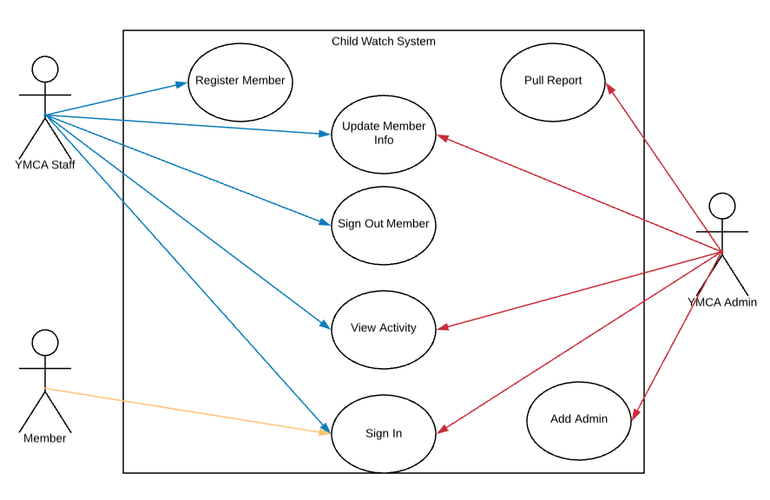

**Registration**

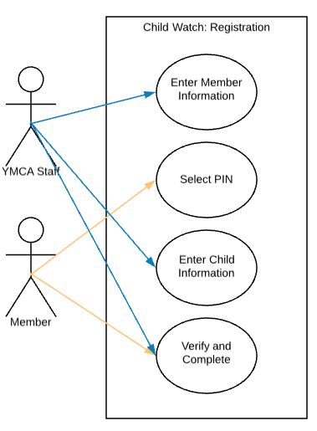

|  |  |
| --- | --- |
| New Child Watch Member Registration | |
| Actor | Member, YMCA Employee |
| Description | A YMCA member requests use of Child Watch services for first time and information is entered into the system to allow for individual sign in. |
| Successful Completion | 1. Member approaches YMCA front staff about registering into program  2. YMCA staff and member enter all relevant info about member and children  3. Member selects and enters PIN for use  4. Registration is completed |
| Alternative | 1. Member approaches YMCA front staff about registering new child into program  2. YMCA Staff pull current member information  3. Staff enter information on new child  4. Additional Child Registration completed |
| Precondition | Active YMCA member needs entry into Child Watch Program database |
| Postcondition | Member has all relevant information in system and can continue with individual sign in when utilizing Child Watch program |
| Assumption | Member has active status within the YMCA that is verified by employee at start of workflow |

**Sign In**

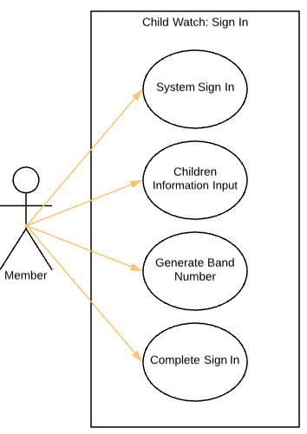

|  |  |
| --- | --- |
| Individual Member Sign in to Child Watch Program | |
| Actor | Member |
| Description | YMCA Member signs child into the Child Watch program |
| Successful Completion | 1. Signs in using YMCA barcode and personal PIN  2. Selects children to sign in  3. Gets generated band number and applies it to needed bands  4. Acknowledges completion  5. System resets for next member |
| Alternative |  |
| Precondition | Member needs to sign in child to be watched by YMCA |
| Postcondition | Child is signed in to Child Watch Program |
| Assumption | Member is active at the YMCA and has completed one-time registration for the system already. |

**Sign Out**

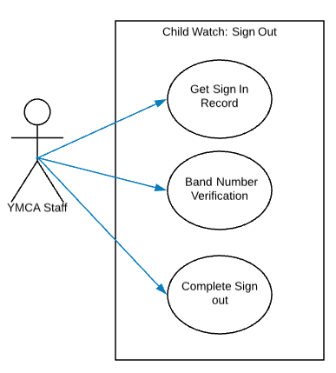

|  |  |
| --- | --- |
| Sign Out of Children from program | |
| Actor | YMCA Staff |
| Description | YMCA Staff verifies member leaving with child and completes the sign in log |
| Successful Completion | 1. YMCA Staff pulls up member sign in log for child  2. Staff verifies band numbers match what is in the system  3. Staff enters their name  4. Staff completes the log providing sign-out time |
| Alternative |  |
| Precondition | Member needs to leave with child |
| Postcondition | Member and child leaves with completed sign in log |
| Assumption | Staff available to complete verification |

**Administrator Workflows**

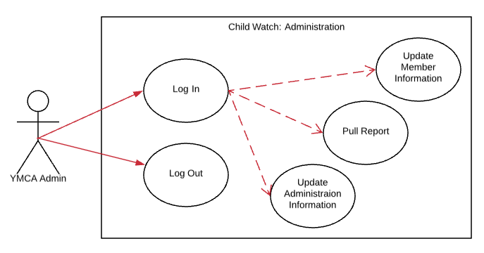

|  |  |
| --- | --- |
| Sign Out of Children from program | |
| Actor | YMCA Administrator |
| Description | YMCA Administrator uses secure log in to complete management tasks |
| Successful Completion | 1. Administrator enters username and password  2. Completes any needed tasks  a. Updates member information  i. Selects Member file  ii. Enters new information  iii. Closes file  b. Updates administration level information  i. Selects admin related file  ii. Enters new information  iii. Closes file  c. Runs BI reporting tasks  i. Selects Report to run with parameters  ii. Runs report  iii. Views Report in preferred format  3. Logs securely out of the session |
| Alternative |  |
| Precondition | Administrator needs to utilize management functionality |
| Postcondition | Management tasks completed securely |
| Assumption |  |