Portal:Erotica and pornography
- Portal
- Talk
- Read
- Edit
- View history

From Wikipedia, the free encyclopedia
Portal topics - (Random portal)
Activities
Culture
Geography
Health
History
Mathematics
Nature
People
Philosophy
Religion
Society
Technology

Welcome to the Erotica and Pornography Portal
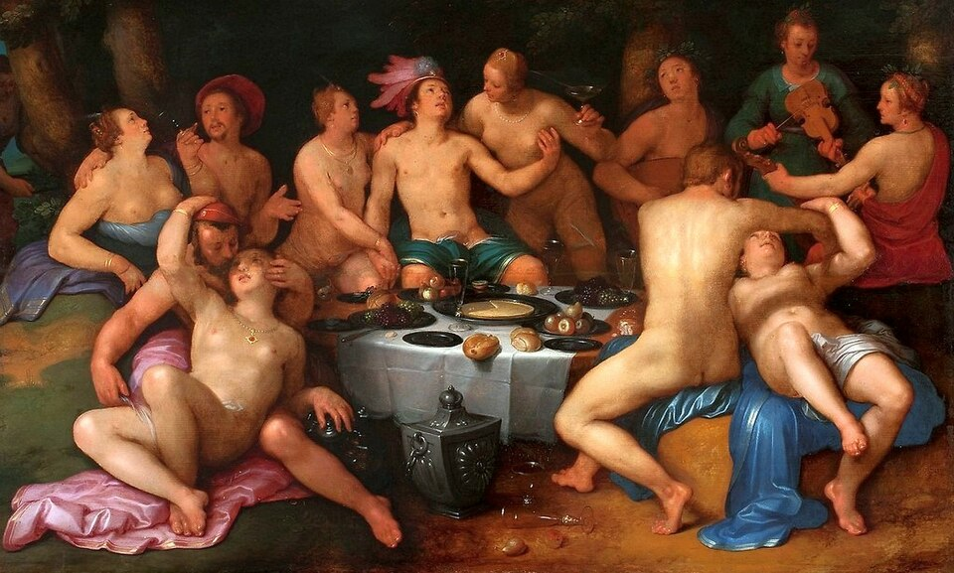
Before the Deluge by Cornelis van Haarlem, 1615
Introduction
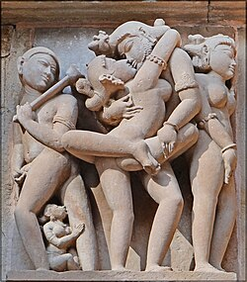Erotic Kama statues at the Khajuraho Temple, India
Shortcut
- P:XXX
Erotica is art, literature or photography that deals substantively with subject matter that is erotic, sexually stimulating or sexually arousing. Some critics regard pornography as a type of erotica, but many consider it to be different. Erotic art may use any artistic form to depict erotic content, including painting, sculpture, drama, film or music. Erotic literature and erotic photography have become genres in their own right. Erotica also exists in a number of subgenres including gay, lesbian, women's, monster, tentacle erotica and bondage erotica.
Curiosa are curiosities or rarities, especially unusual or erotic books. In the antiquarian book trade, pornographic works are often listed under "curiosa", "erotica" or "facetiae". (Full article...)

Pornography (colloquially called porn, porno, and XXX, pronounced "triple X") is sexually suggestive material, such as a picture, video, text, or audio, intended for sexual arousal. Made for consumption by adults, pornographic depictions have evolved from cave paintings, some forty millennia ago, to modern-day virtual reality presentations. A general distinction of adults-only sexual content is made, classifying it as pornography or erotica.
The oldest artifacts considered pornographic were discovered in Germany in 2008 and are dated to be at least 35,000 years old. Human enchantment with sexual imagery representations has been a constant throughout history. However, the reception of such imagery varied according to the historical, cultural, and national contexts. The Indian Sanskrit text Kama Sutra (3rd century CE) contained prose, poetry, and illustrations regarding sexual behavior, and the book was celebrated; while the British English text Fanny Hill (1748), considered "the first original English prose pornography," has been one of the most prosecuted and banned books. In the late 19th century, a film by Thomas Edison that depicted a kiss was denounced as obscene in the United States, whereas Eugène Pirou's 1896 film Bedtime for the Bride was received very favorably in France. Starting from the mid-twentieth century on, societal attitudes towards sexuality became lenient in the Western world where legal definitions of obscenity were made limited. In 1969, Blue Movie by Andy Warhol became the first film to depict unsimulated sex that received a wide theatrical release in the United States. This was followed by the "Golden Age of Porn" (1969–1984). The introduction of home video and the World Wide Web in the late 20th century led to global growth in the pornography business. Beginning in the 21st century, greater access to the Internet and affordable smartphones made pornography more mainstream. (Full article...)
Refresh with new selections below (purge)
Selected article
Tetsuji Takechi (武智 鉄二, Takechi Tetsuji; 10 December 1912 – 26 July 1988) was a Japanese theatrical and film director, critic, and author. First coming to prominence for his theatrical criticism, in the 1940s and 1950s he produced influential and popular experimental kabuki plays. Beginning in the mid-1950s, he continued his innovative theatrical work in noh, kyōgen and modern theater. In late 1956 and early 1957 he hosted a popular TV program, The Tetsuji Takechi Hour, which featured his reinterpretations of Japanese stage classics.
In the 1960s, Takechi entered the film industry by producing controversial soft-core theatrical pornography. His 1964 film Daydream was the first big-budget, mainstream pink film released in Japan. After the release of his 1965 film Black Snow, the government arrested him on indecency charges. The trial became a public battle over censorship between Japan's intellectuals and the government. Takechi won the lawsuit, enabling the wave of softcore pink films which dominated Japan's domestic cinema during the 1960s and 1970s. In the later 1960s, Takechi produced three more pink films.
Takechi did not work in film during most of the 1970s. In the 1980s, he remade Daydream twice, starring actress Kyōko Aizome in both films. The first Daydream remake (1981) is considered the first theatrical hardcore pornographic film in Japan. Though Takechi is largely unknown in Japan today, he was influential in both the cinema and the theater during his lifetime, and his innovations in kabuki were felt for decades. He also helped shape the future of the pink film in Japan through his battles against governmental censorship, earning him the titles, "The Father of Pink" and "The Father of Japanese Porn." (Full article...)
List of selected articles
Selected work of erotic literature
Ada, or Ardor: A Family Chronicle is a novel by Vladimir Nabokov. It was originally published in 1969 by McGraw Hill Book Company and is currently published by Penguin Random House.
Ada, or Ardor began to materialize in 1959, when Nabokov was flirting with two projects, "The Texture of Time" and "Letters from Terra." In 1965, he began to see a link between the two ideas, finally composing a unified novel from February 1966 to October 1968. The published cumulation would become his longest work. Ada was initially given a mixed reception. However, writing in The New York Times Book Review, noted scholar Alfred Appel called it "a great work of art, a necessary book, radiant and rapturous," and said that it "provides further evidence that he is a peer of Kafka, Proust and Joyce." (Full article...)
List of selected works
Slideshow of selected contemporary images
- 
John Stagliano
Slideshow of selected historical images
- 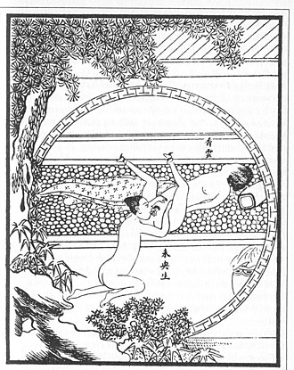
Erotic art from China, for The Carnal Prayer Mat
Did you know (auto-generated) - load new batch

- ... that later pressings of the soundtrack of the soft porn film The Stud replaced Manfred Mann's Earth Band's "Davy's on the Road Again" after a journalist blabbed its presence to the band's keyboardist?
- ... that a Hong Kong porn actress once invited her cyberbullies to talk?
- ... that some viewers of an Arizona TV station saw hardcore pornography instead of the Super Bowl?
- ... that a Florida TV station once aired a pornographic film by accident?
- ... that in 2001, around 64 percent of all films produced in Malayalam were of the soft-porn variety?
- ... that American MILF porn star Serenity Cox was a nurse for fifteen years?
- ... that Burger Continental served dishes like "Chicken Erotica" to jurors in high-profile cases, including the trials of O. J. Simpson and the Menendez brothers?
- ... that while filming a music video for her debut album at a motel, Underscores had the police called on her by the motel staff because they thought she was shooting a pornographic film?
Topics
- v
- t
- e
Pornography
Pornography | Types - Amateur - Cartoon - Hentai - Tijuana bible - Child - Erotica - Simulated - Deepfake - Feminist - Hardcore - Internet - Mobile - Phone - Revenge - Sexting - Softcore  Genres - Alt - Bisexual - Bondage - Casting couch - Celebrity - Sex tape - Clopping - Convent - Eco - Ethnic - Gang bang - Gay - Gonzo - Incest - Lesbian - MILF - Mormon - Queer - Rape - Reality - Tentacle - Transgender - Women's - Yiffing  Related - History - Film actor  Organizations - Adult Film Association of America - Critics Adult Film Association - Fans of X-Rated Entertainment - Free Speech Coalition - X-Rated Critics Organization - List of pornography companies - List of pornographic film studios
Opposition to  pornography | Movements - Anti-pornography movement in the United Kingdom - Anti-pornography movement in the United States - Antipornography Civil Rights Ordinance  Organizations - Churchmen's Committee for Decent Publications - Feminists Fighting Pornography - Fight the New Drug - The Marriage Vow - No More Page 3 - Stop Bild Sexism - Stop Child Trafficking Now - Stop Porn Culture - Women Against Pornography - Women Against Violence in Pornography and Media - XXXchurch.com  Overuse - NoFap - Content-control software - Accountability software - Parental controls - Employee monitoring software
Views | - Feminist  - Religious  - Sex-positive feminist
Media | - Audio  - Film  - Parody  - Cartoon  - Magazines  - List  - Video games  - Eroge  - Newspaper features  - Page 3
Possible effects | - Addiction  - Internet sex addiction  - Pornography addiction  - Sex addiction  - Objectification of women / sexism  - STDs
People | - Performers by decade  - British performers  - Gay male performers  - Pornographic actors who appeared in mainstream films  - Mainstream actors who have appeared in pornographic films  - Film directors
Events | - Adultcon  - AVN Adult Entertainment Expo  - Barcelona International Erotic Film Festival  - Brussels International Festival of Eroticism  - Exotic Erotic Ball  - Exxxotica Expo  - HUMP  - Porn Sunday
Miscellaneous | - Adult movie theater  - Blue Movie  - Golden Age  - Not safe for work  - Pornographication  - Pornotopia  - R18 certificate  - Rule 34  - Sex shop  - Sexualization  - X rating
See also | - Erotica  - Art  - Comics  - Film  - Literature  - Photography  - Sexual activity  - Ribaldry  - Sex-positive movement  - Sexual repression  - Sexual revolution
- Category
- Human sexuality portal
Categories

Select [►] to view subcategories
Pornography
Pornography by continent
Pornography by country
Pornography by genre
Pornographers
Adult models
Adult movie theaters
Anti-pornography movements
Adult industry awards
Censorship of pornography
Erotic art
Erotic comics
Erotic literature
Erotic photography
Feminism and pornography
Pornography-related lists
Pornography terminology
Research on the effects of pornography
Pornographic works
Works about pornography
Pornography stubs

Erotica
Pornography
Erotica people
Erotic art
Erotic comics
Erotic dance
Erotic film festivals
Erotic thrillers
Erotic events
Erotic fiction
LGBTQ erotica
Erotic literature
Sex museums
Erotic photography
Sex shops
Erotic video games
Women's erotica and pornography
Related portals
-  Film
- Human sexuality
-  Internet
-  LGBTQ
-  Literature
-  The arts
- Nudity
-  Sex work
Associated WikiProjects
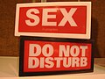 | 
Sexology and sexuality | Pornography
Associated Wikimedia
The following Wikimedia Foundation sister projects provide more on this subject:
- 

Commons
Free media repository
- 

Wikibooks
Free textbooks and manuals
- 

Wikidata
Free knowledge base
- 

Wikinews
Free-content news
- 

Wikiquote
Collection of quotations
- 

Wikisource
Free-content library
- 

Wikiversity
Free learning tools
- 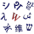

Wiktionary
Dictionary and thesaurus
Discover Wikipedia using portals
- 

List of all portals
- 

The arts portal
- 

Biography portal
- 

Current events portal
- 

Geography portal
- 

History portal
- 

Mathematics portal
- 

Science portal
- 

Society portal
- 

Technology portal
- 

Random portal
- 

WikiProject Portals

Categories:
- All portals
- Sexuality portals
- Erotica
- Pornography
- This page was last edited on 7 April 2026, at 06:50 (UTC).

