

Universidad Interamericana de Puerto Rico

Recinto de Fajardo

Departamento de Ciencias y Tecnologia

Comp 3400

This project supplies the demand of creating an automated teller machine that allows users to perform basic financial transactions. Allowing only one account per user, each user must enter their account number and pin to view their account balance, withdraw cash and deposit funds.

***The ease of bank transactions***

The purpose of this project is to make bank transactions easier for its users. With only the push of some buttons (with previous identification login) the user will be able to complete the desired transaction without the long wait of a slow and inefficient system.

The strategy is to implement the basic requirements to complete a transaction while keeping the information secure and authentic. From the login page the user’s will be able to notice the simplicity of the project. Such method will also keep the user from being distracted or overwhelmed by any images of paragraphs that have no relevance to the task being requested. After the user enters the authentication information (account number & pin) it will connect to the corresponding database and if the entered information exists within the database, then the menu page will be displayed. On this page the user will select upon 4 options: check balance, withdraw cash, deposit funds or exit. Depending on the user’s selection the respective page will be displayed, and the corresponding transaction will be started. The database will be modified corresponding to the transaction performed. After finishing the transactions, the user will be given a choice: go back to menu if the user wants to perform another transaction or exit.

As mentioned before, the objective in the project’s design was the simplicity and ease to use. Therefore, the design was implemented as follows:

Log In Menu

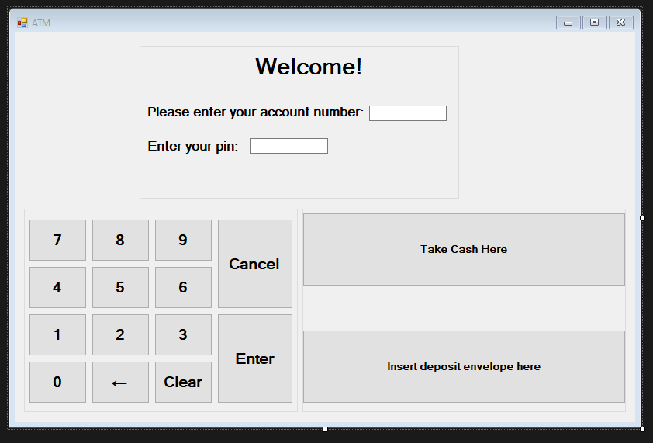 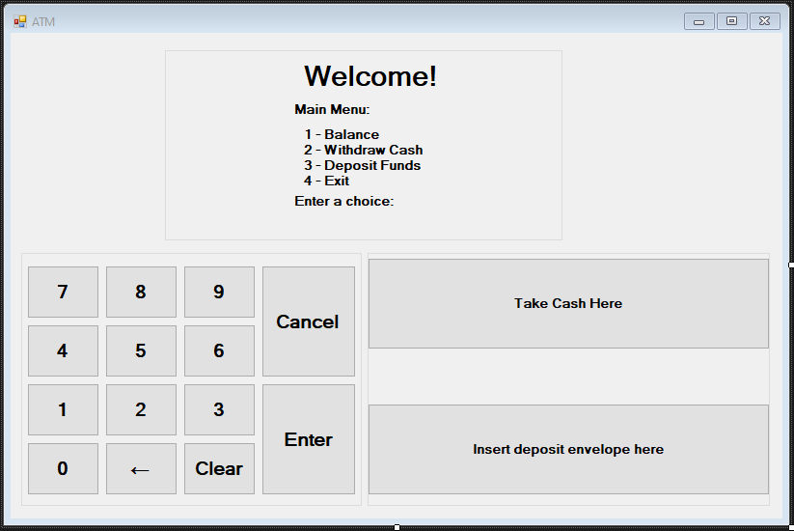

Balance Cancel

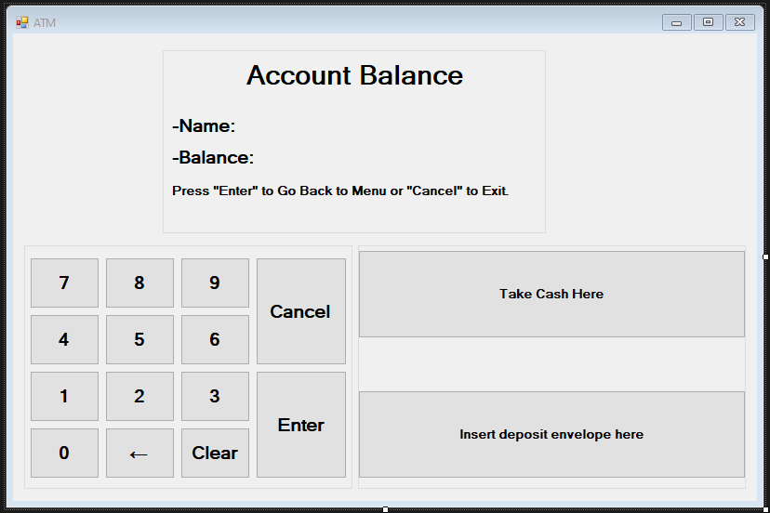 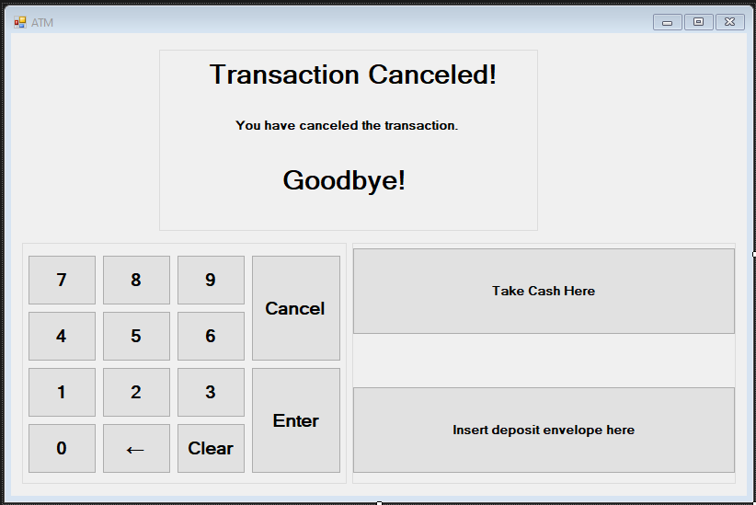

Deposit Deposit Confirmation

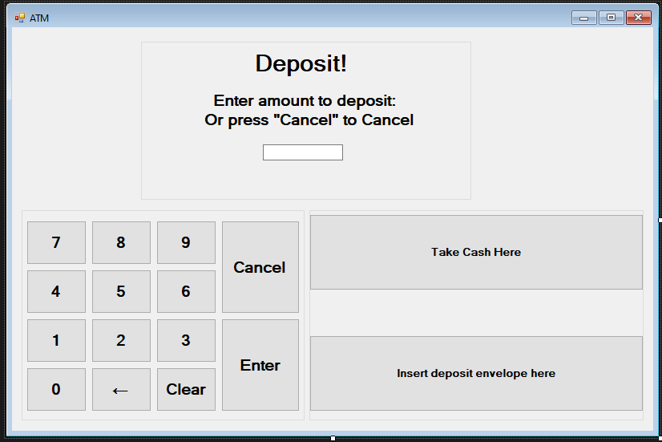 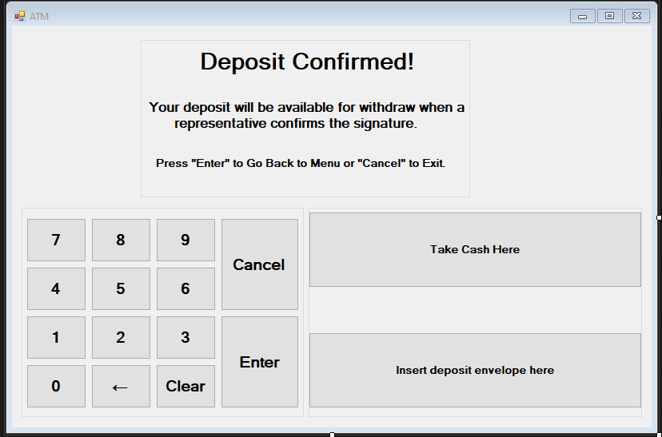

Withdraw Withdraw Confirmation

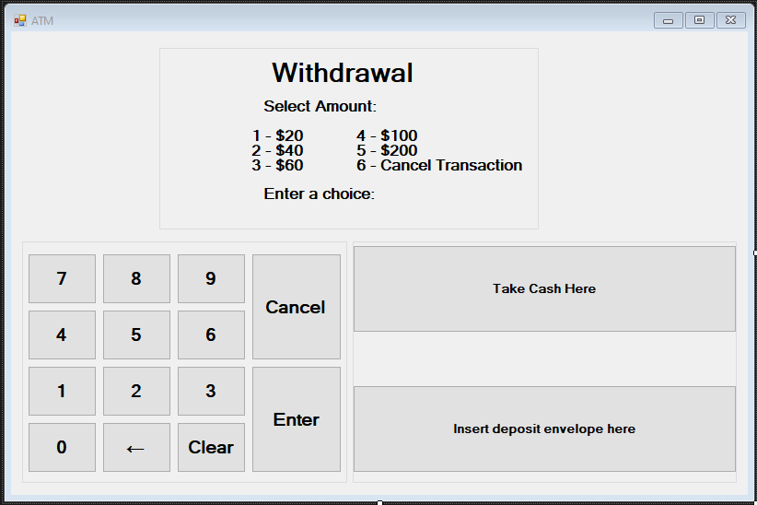 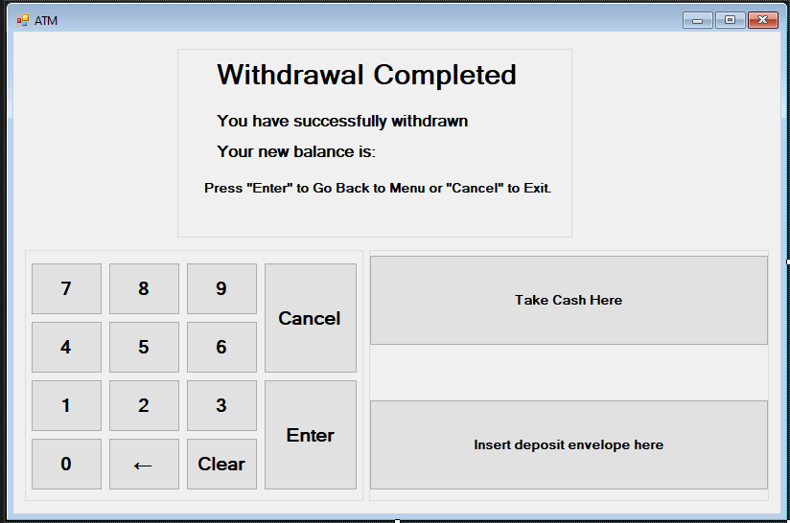

Exit

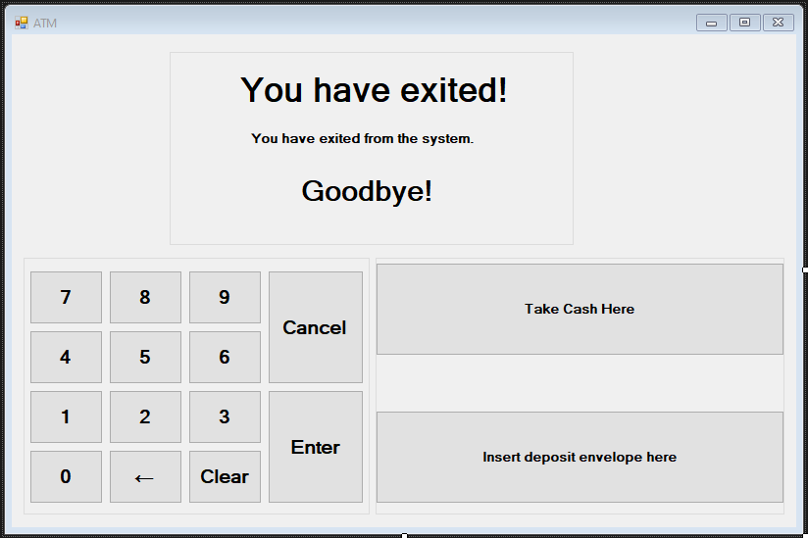

During each implementation phase the functionality was tested using the unit testing method (to ensure that the program executes as expected) & system testing (performed by another developer).

During the evaluation phase I discovered that the simplicity can come with a price, since users will probably associate it with vulnerability. The budget for the project lies within $5,000 to $10,000 considering that the teller machine will: run in a machine with basic functionality, use constant electricity and internet, and have physical security measures such as cameras and alarms. Trying to use a lower budget machine will cause the machine to look, usually, older and slower, hence many people will not use it.

In conclusion, the project behaves as expected and the code for it will be available for review on a separate file within the project’s folder. The bank’s automated teller machine successfully completes the requested tasks with simplicity and efficiency.

For future updates on the project, it will be necessary to sacrifice some simplicity for reassurance so that nonexistent users can be persuaded to use the program. Since the project does not create temporary files or exports any data, regular maintenance will probably not be required.

**References:**

ProgrammingKnowledge. (2014, August 2). *How to Make a Calculator in C# Windows Form Application Part-1*[video].Youtube. <https://www.youtube.com/watch?v=iJqB6UsM-hs>

Rumsey. (2011, May 25). *Switching between forms in C#*. Stack Overflow. <https://stackoverflow.com/questions/6121826/switching-between-forms-in-c-sharp>

**Appendix**

Topic: Page:

**Project’s Document Structure**………………………………………………….1-2

Introduction……………………………………………………………......1

Theme……………………………………………………………………...1

Concept…………………………………………………………….............1

General Description………………………………………………………..1

Planning……………………………………………………………...........1-2

**Design & Implementation**………………………………………………………2-3

Objective……………………………………………………………...........2

Images……………………………………………………………..............2-3

**Evaluation & Analysis**…………………………………………………………...4

Evaluation…………………………………………………………………..4

Analysis…………………………………………………………….............4

Conclusion ……………………………………………………………........4

Next Steps & Maintenance…………………………………………………4

**References**……………………………………………………………...................5

**Appendix**…………………………………………………………….....................6