RL summary
RL means: observe state , choose action, get reward, learn policy to maximize long term reward
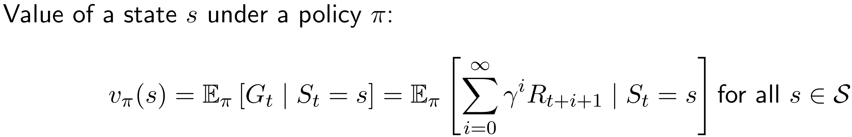

O observation
H history
Pr probability
MDP Markov Decision Process
POMDP Partially Observable Markov Decision Process
s state
a action
π/(p) policy: mapping from state to action: deterministic: a=π(s); probabilistic: π(a|s)=Pr{A|S}
π* optimal policy π*=max v_π(s) for all s (always chooses the highest return function)
p model or policy or (probability distribution) p=(r,s’|s,a)
P state transition matrix: probabilities from all states s to all successor states s’
r reward (“immediate after one action)”
R rawardfunction in matrixform
k num actions
T num trials / final timestep
t / (n) timestep
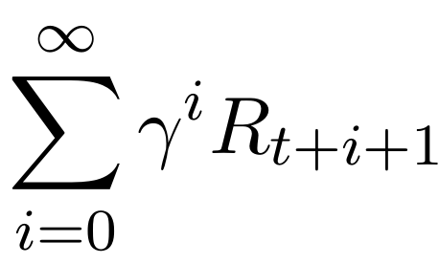
n num states
G return: expected cumulative reward. whats the difference to Q? G_t = G_t =R_{t+1} + γ kG_{t+1}
Q value / expected or mean reward = sum(R_i)/(n-1)
v q_π(s) state value; Bellman: v = (id − γP)^(−1) R
q q_π(s,a) action value, often used in RL
v* optimal value
q* =max q_π(s,a) for all s ∈ S, a ∈ A
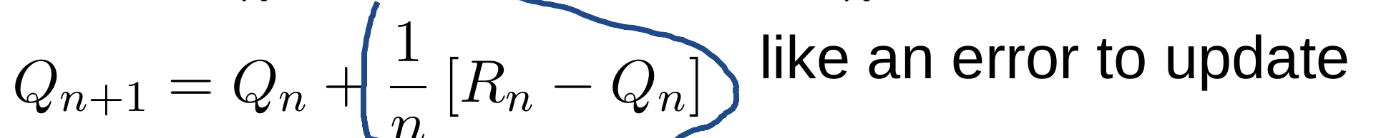
Q_hat(a) value estimate
greedy action A_t = argmax Q_t(a)
Ɛ exploration chance (non greedy action)

γ Discount rate for discounted return for infinite games
episode run til termination S_T
non-episodic task: without end or without reward after T

