EXT: Ajax mail subscription
Extension Key: ods_ajaxmailsubscription
Copyright 2008-2011, Robert Heel, <rheel@1drop.de>

Onedrop Solutions GmbH & Co. KG
Sudetenstraße 26
93073 Neutraubling
www.1drop.de

This document is published under the Open Content License
available from http://www.opencontent.org/opl.shtml

The content of this document is related to TYPO3
- a GNU/GPL CMS/Framework available from www.typo3.org

Table of Contents
EXT: Ajax mail subscription 1
Introduction 3
What does it do? 3
Screenshots 3
Users manual 4
Administration 6
Configuration 7
Reference 7
Tutorial 8
Known problems 9
To-Do list 10

Introduction

What does it do?
- Adds a plugin for subscription to direct mail newsletters.
- Uses ajax to prevent page reloads.
- Template based design.
- Change personal newsletter preferences (name).

Screenshots
- Frontend plugin:
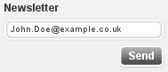
- Frontend plugin, user can change preferences:
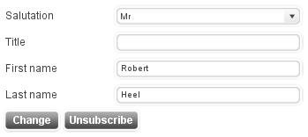

Users manual
Insert the Ajax mail subscription as frontend plugin.
- To add automatically new addresses to a mailing list, select the according list in the field “Add new recipient to group”.
- Links appearing in emails sent by this extension (e.g. "To confirm the subscription, please click here") refer to the page selected in the field “Preferences Page”. Note: The selected page has to contain this extension as well.
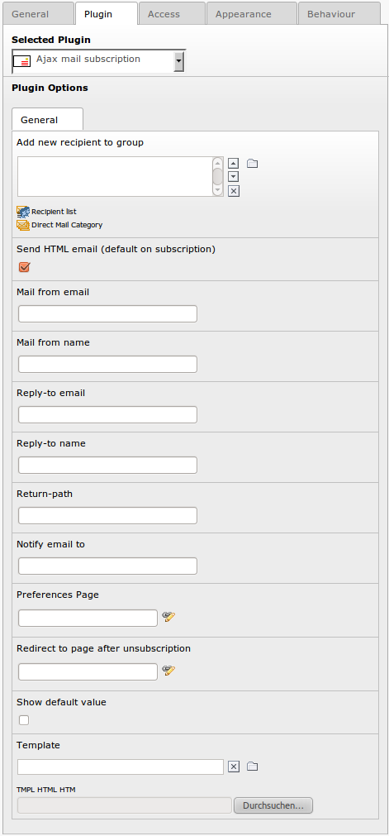
Plugin Option | TS Option
Add new recipient to group | default_group
Send HTML email (default on subscription) | default_type
Mail from email | mail_from
Mail from name | mail_from_name
Notify email to | mail_notify
Reply-to email | mail_reply
Reply-to name | mail_reply_name
Return-path | mail_return
Preferences Page | page_edit
Show default value | show_default
Template | Template
Successful subscription mail: Subject | mail_subscribe_subject
Successful subscription mail: Body | mail_subscribe_body
Successful unsubscription mail: Subject | mail_unsubscribe_subject
Successful unsubscription mail: Body | mail_unsubscribe_body
Startingpoint | page_records
Recursive | page_records_recursive

Please see configuration section for further description of fields.

Administration
- In order to add an unsubscribe link to the mail, add the following link to your newsletter template:
<a href="http://[your domain name]/index.php?id=[id to page of this plugin]&u=###USER_uid###&t=###SYS_TABLE_NAME###&a=###SYS_AUTHCODE###">unsubscribe</a>

- Unsubscribe user
  - A tt_address record won't be deleted, instead it will set to hidden (“hidden=1”). This user won't receive mails any more. If you import mail addresses using the direct_mail CSV import, the user remains unsubscribed if “Update existing user, instead renaming the new user” is set.

Template marker
Template file | Subpart | Marker | Description
ods_ajaxmailsubscription_mail.html | ###MAIL_NEW...  ###MAIL_CHANGE... | ###LINK### | Link to configuration page
ods_ajaxmailsubscription_mail.html | ###MAIL_NEW...  ###MAIL_CHANGE... | ###SERVER### | Server name
ods_ajaxmailsubscription_mail.html | ###MAIL_NEW...  ###MAIL_CHANGE... | ###UNSUBSCRIBE_LINK### | Link to unsubscribe

Configuration
- Tip: If you want to use different pages for subscription and preference settings, simply separate the two logical section into separate files.

Reference
Property: | Data type: | Description: | Default:
default_group | group list | Join to these lists or groups.  Typo3 database group list, e.g.  sys_dmail_category_1,  sys_dmail_group_1,  fe_groups_1,  sys_category_1
default_type | boolean | HTML newsletter.  Value of module_sys_dmail_html. | 1
mail_from | string | From: Sender email address in system mails. | typo3@###DOMAIN###
mail_from_name | string | From: Sender name in system mails.
mail_notify | string | Notify (un)subscriptions to this address
mail_reply | string | Reply-to: Reply email address.
mail_reply_name | string | Reply-to: Reply name.
mail_return | string | Return-path:  Bounce email address.
page_edit | integer | Link to this page in system mails. | $TSFE->id
page_redirect_unsubscribe | Integer | Redirect to this page after unsubscription.
show_default | boolean | Show default  “John.Doe@example.com”. | 0
template | string | Template file. | EXT:ods_ajaxmailsubscription/pi1/ajaxmailsubscription.tmpl
page_records | integer list | Record storage page id (Startingpoint)
page_records_recursive | integer | Recursive level | 0
edit.fields | string list | Fields used in the preference (edit) template. | gender,first_name,middle_name,last_name,birthday,title,phone,mobile,www,address,building,room,company,city,zip,region,country,fax
subscribe.fields | string list | Fields used in the subscribe template. | email
required.fields | string list | Fields required in the subscribe template. | email
authcode_fields | string | Fields used to generate authcode. | uid
authcode_expiration_time | integer | Expiration time of authorized links in email. 0 disables expiration. | 60
default_table | string | Add new users as fe_users or tt_address records. | tt_address
mail_confirmation |  |  | 0
mail_html |  |  | 0
error.stdWrap |  |  | wrap = <p class="error">|</p>
info.stdWrap |  |  | wrap = <p class="info">|</p>
javascript |  |  | EXT:ods_ajaxmailsubscription/res/ods_ajaxmailsubscription.js
mailtemplate |  |  | EXT:ods_ajaxmailsubscription/pi1/ods_ajaxmailsubscription_mail.html

Example
plugin.tx_odsajaxmailsubscription_pi1 {
default_group = sys_dmail_group_2
mail_from = newsletter@your-domain.com
}

