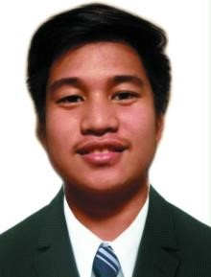
John Edgar D. Siocon
Cellphone No.: 09568853779
Address: #119 7th avenue P.Galauran Grace park west Caloocan City
E-mail: edgarsiocon18@gmail.com
A highly organized and hard-working individual looking for a responsible position to gain practical experience.

Personal  Information  Qualifications | Father’s Name: Gary L. Siocon  Mother’s Name: Editha D. Siocon  Nationality: Filipino  Caloocan High School  DEGREE: Junior High School  DURATION: 2013 – 2016 Caloocan High School  DEGREE: Senior High School  DURATION: 2018 – 2020  University of Caloocan City  DEGREE: Bachelor of Science in Information Technology  DURATION: 2021 – Present | Marital Status: Single  Religion: Catholic  Age: 19
Experience: Teacher’s Assistant 09/19/2020 – 09/29/2020
Work Immersion Company Name: Caloocan High School – English Department
(80 hours)
Description: Revising the teacher’s profile and teacher’s schedule, gathering and encoding data and making presentation charts.
References MRS. RODALINE M. GUILAS
Work Immersion Adviser
Caloocan0020High School
09394166250

