AUGUST 17, 2026
Toll Fee for ACEA Training
Total - ₱ 1,512
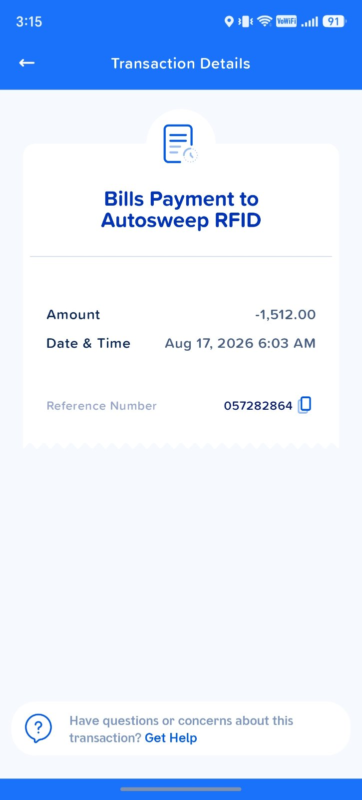
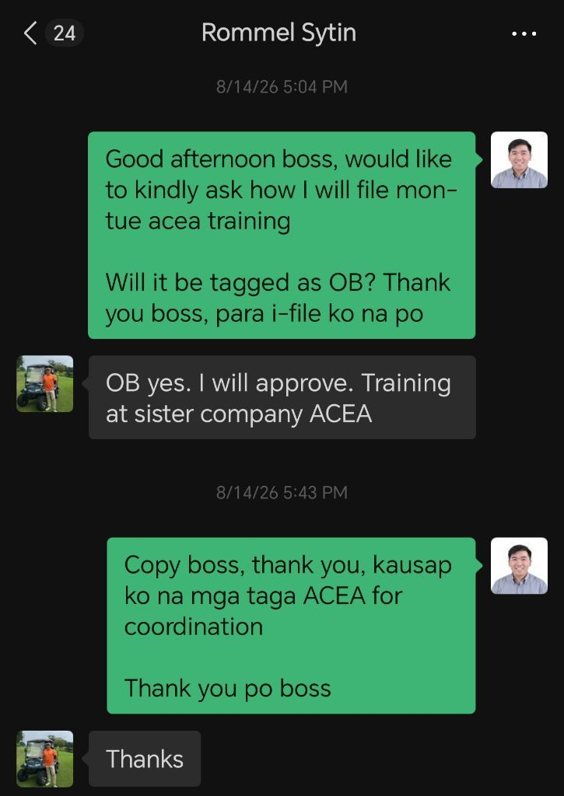

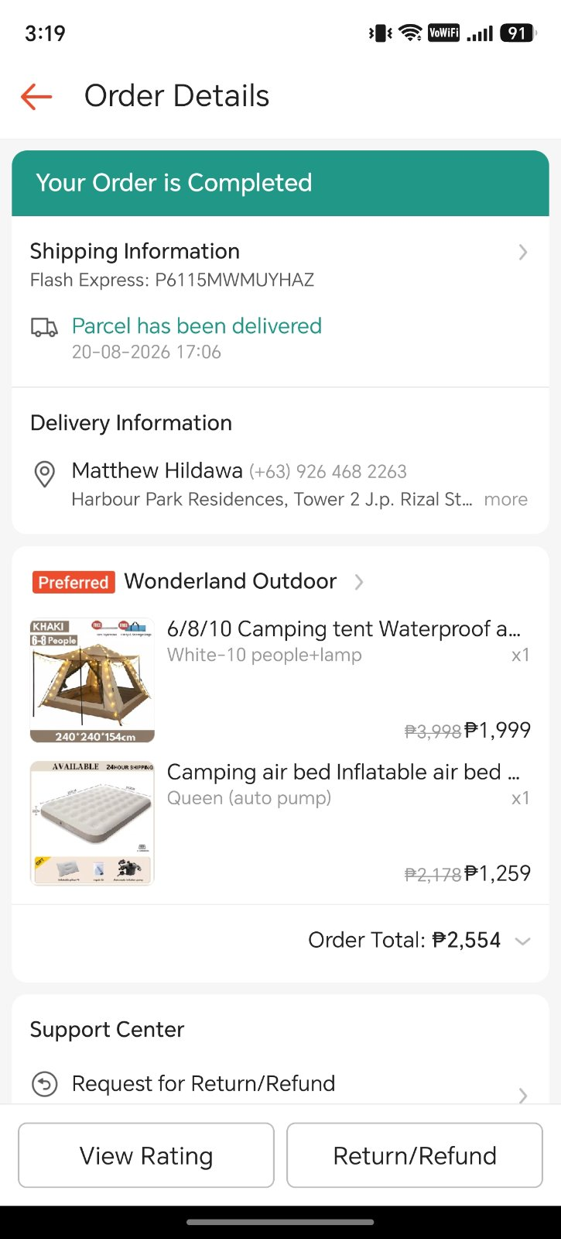

August 21, 2026
Camping Equipment
Tent + Air bed
Total - ₱ 4,553.00

August 21, 2026
Registration Fee on Eventure Tanay
Total - ₱ 3,500
