**NODE-RED PROJECT – Log File**

**Politecnico di Milano - Internet of Things (2014/2015)**

**COOJA SIMULATION OUTPUT CONSOLE**

TOO SEE THIS, UNCOMMENT ALL THE COMMENTED STATEMENTS IN *makefile,* *SensorNetworkAppC.nc* AND *SensorNetworkC.nc* FILES, BUILD THE APPLICATION E CREATE A NEW SIMULATION ON COOJA. DO NOT TURN ON SERIAL SOCKET (SERVER) ON MOTE 1.

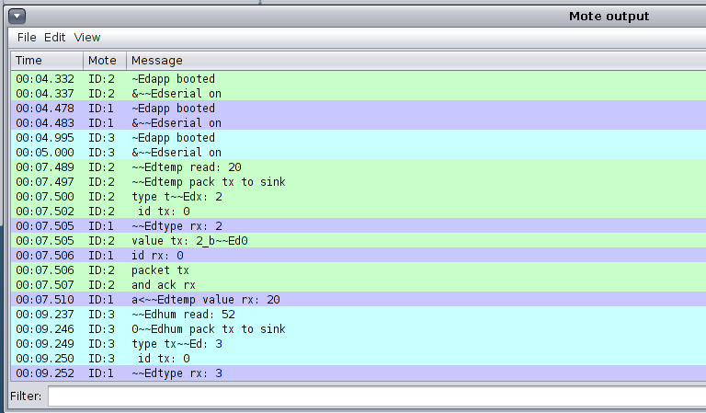

**NODE-RED DEBUG OUTPUT CONSOLE**

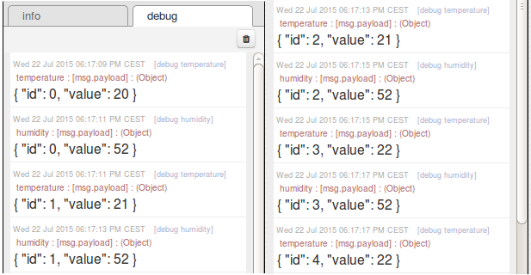

**TEMPERATURE AND HUMIDITY FILES**

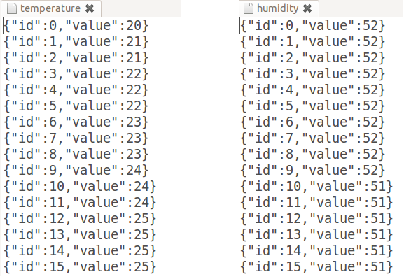

**EMAIL ALARMS**

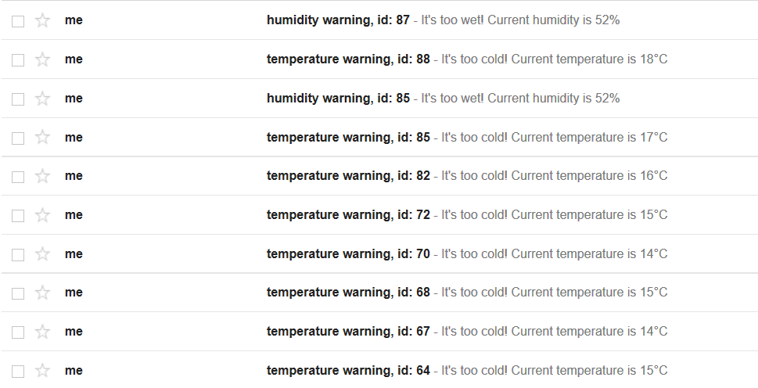

**TEMPERATURE PLOT (100 VALUES = 25 HOURS SAMPLE)**

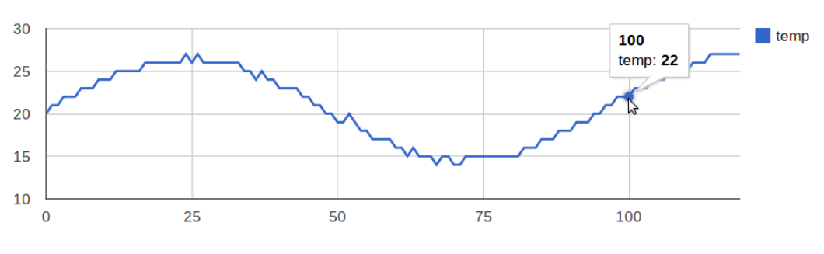

**HUMIDITY PLOT (100 VALUES = 25 HOURS SAMPLE)**

