Table of Contents

1. Introduction 2

1.1 Description of the problem 2

1.2 Goals 2

1.3 Domain Properties / Assumptions 3

1.4 Proposed system 4

2. Actors 4

3. Requirements 5

3.1 Functional requirements 5

3.2 Non Functional requirements 6

4. Specifications 12

5. Scenarios 14

6. UML models 16

6.1 Use Case diagram 16

6.2 Use Case description 16

6.3 Sequence diagrams 21

6.4 State Chart diagrams 27

6.5 Class diagram 28

7. Alloy 29

7.1 Modeling 29

7.2 Alloy analyzer 30

7.3 Worlds generated 31

8. Used tools 32

9. Hours of work 32

# Introduction

## Description of the problem

Our object is to project a system to optimize the taxi service of Big_City, which government is our stakeholder, simplifying the access of passengers to it and, at the same time, guaranteeing a fair management of taxi queues. It will be composed of a web application and a mobile application allowing users to make requests and reservations and informing them about the code of the incoming taxi and the waiting time. The system is constantly updated about the availability of taxi drivers and call confirmations from a mobile application embedded in the cars, in order to maintain the fairness of queues. Big_City is divided in zones (2 km² each) and there is a one-to-one correspondence between them and the queues, which are lists of the identifiers of available taxis. Furthermore, the system automatically computes the distribution of taxis in each zone based on the GPS information it receives from each one. If a taxi receives a ride request, it means that it is the first queueing in that zone and it has the possibility to accept or reject it. If the driver accepts, the system will send a confirmation to the passenger, else the system will move their taxi to the last position of the queue and forward the request to the second taxi queueing. Moreover, Taxi reservations must occur at least two hours before the ride, specifying origin and destination, and allocated to a taxi by the system 10 minutes before the meeting time with the passenger. Lastly, programmatic interfaces (APIs) should be provided in order to enable the development of additional services.

## Goals

When the system is online, it has to guarantee these functionalities:

* management of the queues of available taxis
* create and manage taxi ride requests
* create and manage taxi ride reservations
* scalability to additional services

## Domain Properties / Assumptions

This is a list of some domain properties and assumptions that we think has to be true:

* the taxi service is entirely controlled by the government of Big_City, that owns the taxis and assigns an username and password to taxi drivers to let them access the service
* every taxi is identified by an unique code and must have an embedded Android Auto operating system, with myTaxiService and Google Maps (maps already downloaded and available offline) as the only usable and preinstalled applications
* the city is divided in zones and the range of each one is a precondition
* when taxi drivers inform the system that their taxi is available, they cannot move from the zone where they have declared availability
* taxis have an on-board GPS that always returns their accurate location to the system when their availability is turned on
* when a passenger requests a taxi with the mobile application, the GPS embedded in the smartphone always returns their accurate location to the system
* a passenger requests a Taxi only if they can take it (no fake requests/reservations)
* there is a number of taxis large enough to allocate all requests and reservations
* when a taxi driver confirms a ride, it will always reach the passenger in 10 minutes at most (maximum waiting time)
* when a passenger reserves a taxi, they will always give the right information about meeting date, departure and arrival location, meeting time
* origin and destination of ride requests and reservations must be within Big_City
* when a user requests or reserves a taxi, the maximum number of passengers of the ride must be 4 included them

## Proposed system

The system is composed of these parts, managed by a back-end centralized server application:

* **Mobile application (for Users):** designed for Android-based and iOS-based smartphones, should be developed with the relative native programming language (Java and Swift/Objective C), or with a framework (like Ionic or Phonegap) that allows to develop a single hybrid application with web technologies (HTML5, CSS3, JavaScript) compatible with both Google and Apple operating systems
* **Web application (for Users):** composed by a front-end that should be very similar and provide the same functionalities of the mobile application to users
* **Mobile application (for Taxis):** designed for Android Auto, a particular operating system running on embedded devices for cars. All taxis in Big_City must have it installed by assumption

# Actors

The actors involved in this project are four:

* **Guest:** a person that opens either the web application or the mobile application for the first time, facing its Login page. They are not already registered in the system, so they have to sign up, completing a registration form, before accessing the service
* **User:** a person that is already registered in the service with email address and password; they can log in into the system, request or reserve a taxi ride, check the list of their booked taxis, cancel a reservation
* **Taxi driver:** a person that is employed and automatically registered into the system by the government to drive a taxi in Big_City. They can inform the system about the availability of their taxi and accept, or not, a ride assigned by the system

# Requirements

## Functional requirements

**GUEST:**

* Sign up in the web application or mobile application by filling up a form with username and password

**USER:**

* Log in into the web application or mobile application with username and password
* Create a ride request
* Create a ride reservation
* Check the list of booked taxis
* Cancel a ride reservation

**TAXI DRIVER**:

* Confirm a ride(reservation or request)
* Reject a ride(reservation or request)
* update their availability

**SYSTEM**

* propose a ride to a taxi
* confirm request or reservation to the user with related information
* insert, remove or move a taxi from a queue
* update availability of taxis

## Non Functional requirements

1. **USER INTERFACE**

The user interface of the web application and the mobile application for the users, and of the Android Auto application for the taxis must be user-friendly. To better explain it, we realized mockups for Android smartphones and Android Auto.

After downloading, installing and running the application from the Google Play Store, the user is facing the Login Page and is requested to insert their Email Address and Password, if already registered. Else, they has to tap on Create Account, action that leads to the Registration Page where desired Email Address and Password have to be inserted. If correct couple Email Address-Password inserted (i.e. it is in the database) the Sign In button, when tapped, leads to the Home Page; else, an error message appears and the user is invited to check the written information. If an Email Address is not already in the database, the Sign up button, when tapped, leads to the Home Page; else, an error message appears and the user is invited to check the written information.

When the user reaches the Home Page, they can Request a Taxi, Reserve a Taxi, check the list of the Booked Taxis and Sign Out from the service and return to the Login Page.

In the Request a Taxi page, the user is requested to turn on the GPS on their smartphone, in order to let the system automatically acquire their current position and consider it as the meeting location. This is the only difference with the web version of the application, since in that case the user is required to specify their location in a form (since laptops do not have GPS module). If the user changes their mind and do not want to request a taxi anymore, they can tap on Return to Home Page.When the Request Taxi button is tapped, the Request Confirmed page appears after the processing of the request (Processing Page that is visualized for few seconds), with all the needed information. In the Request Confirmed page, the user can go to the Booked Taxis page with the relative button, or return to the Home Page.

In the Reserve a Taxi page, the user has to fill the required fields with all the requested details and then tap on Reserve Taxi (or on Return to Home Page if they are not convinced). Then, the Reservation Confirmed page with detailed information appears. Also in this case, the user can then go to the Booked Taxis page, or Return to Home Page. A push notification will arrive on the website or the smartphone 10 minutes before the meeting time, with the code of the incoming taxi (that will be displayed also in the “Booked Taxis” section). The Booked Taxis page contains a scrollable history of all the requested and reserved taxis with all the related information. The entries of the reserved taxis have the possibility to be cancelled by tapping on the red “X” that appears only up to 10 minutes before the reserved ride (an additional yes-no “are you sure?” question is asked to the user for confirming the deletion). Also for this page, there is the possibility to Return to Home Page.

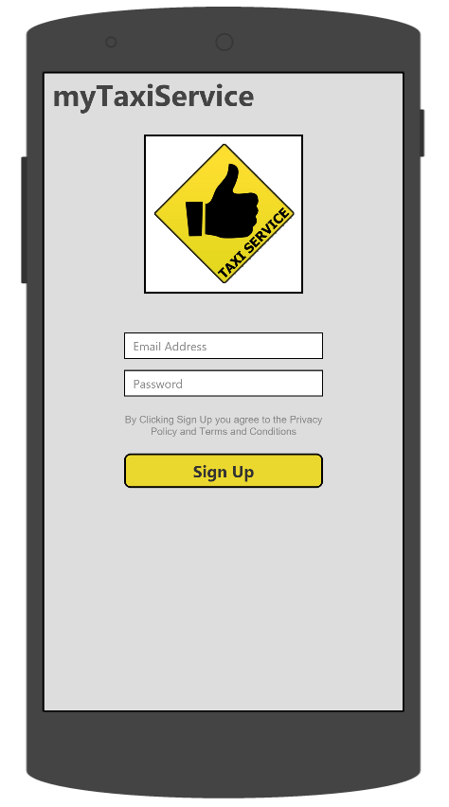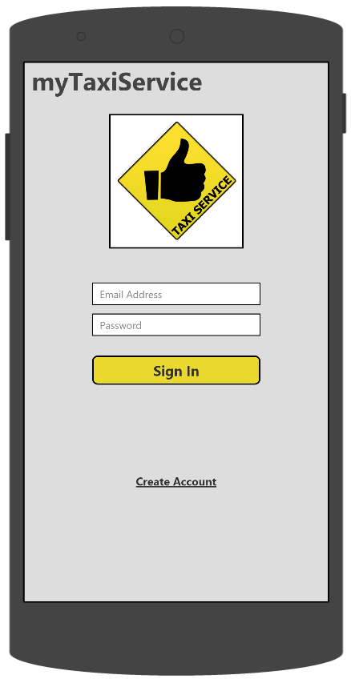

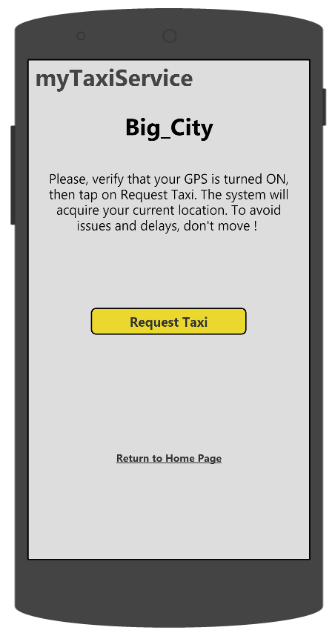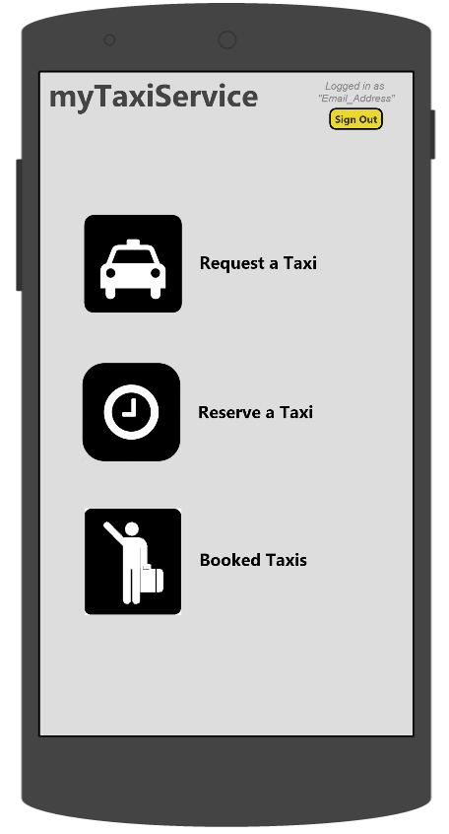

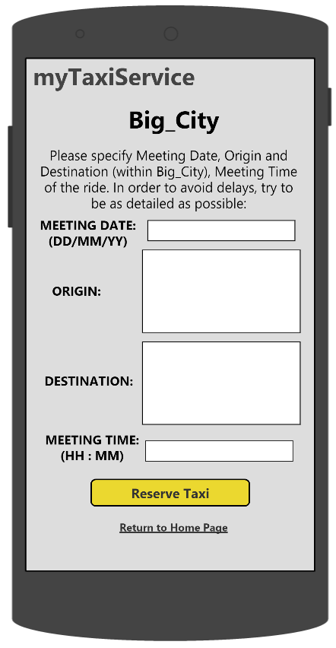

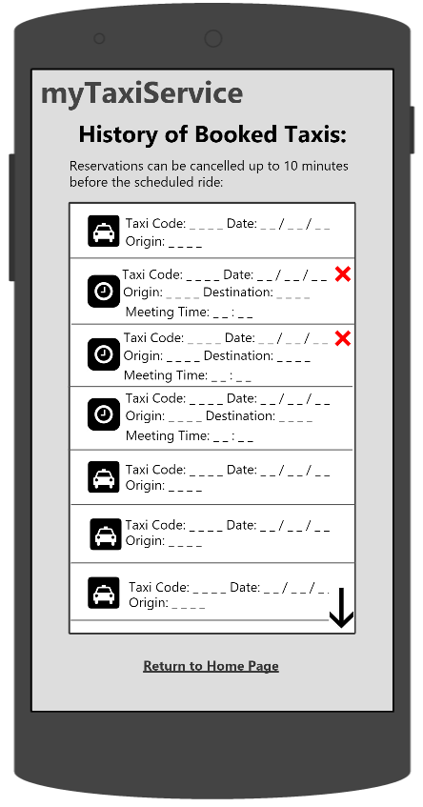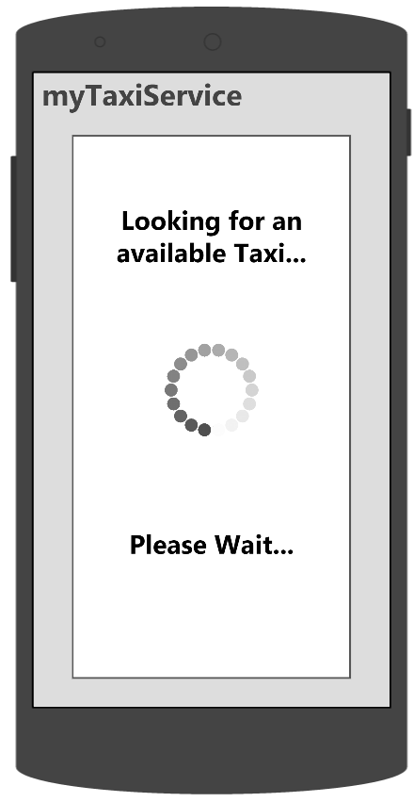

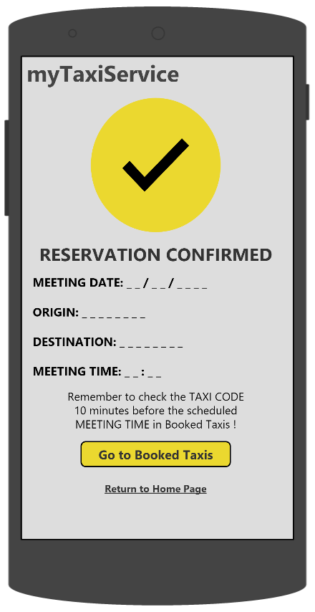

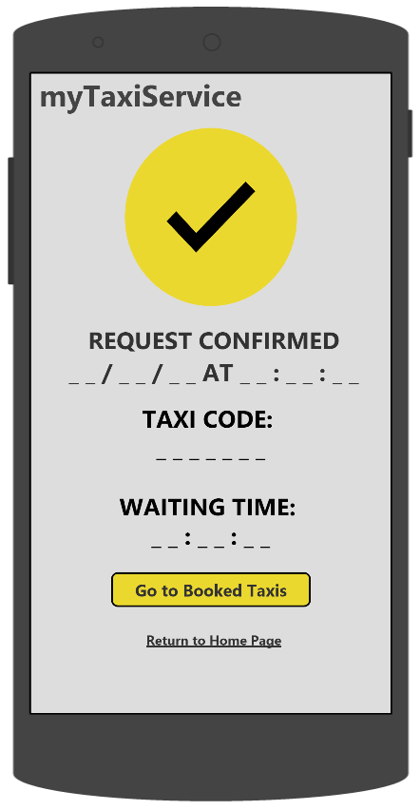

The Android Auto user interface of myTaxiService is designed to meet all the functionalities needed by taxi drivers. It is the default application that starts when the engine of the car is turned on and the driver cannot close it. When a driver begins their daily shift, they have to insert the username and password the government has provided them on a Login Page, in order to access the service and include their taxi into the system. Then, the driver is redirected to the Home Page (shown below), which provides them with the possibility to switch on and off their availability. If the availability is off the central screen remains clear, else the system can allocate a ride to the driver, which is displayed with the possibility of confirmation and rejection along with the location of the passenger (and also the destination in case the ride is reserved, else the field is empty). If the driver rejects the screen turns clear again, else Google Maps is automatically opened with the directions to the meeting location. During a ride, from the moment of confirmation, the availability switch is forced in the off state by the system and it cannot be used (else, an error message appears) until the driver taps on the “End Ride” button (this is to prevent that the system allocates a ride to a taxi that is still completing another one). When the passenger is aboard, the driver searches for the directions to the desired destination (declared at boarding time in case of requested ride). When the taxis reaches destination, the driver can close Google Maps and then the central screen of the user interface turns clear again.

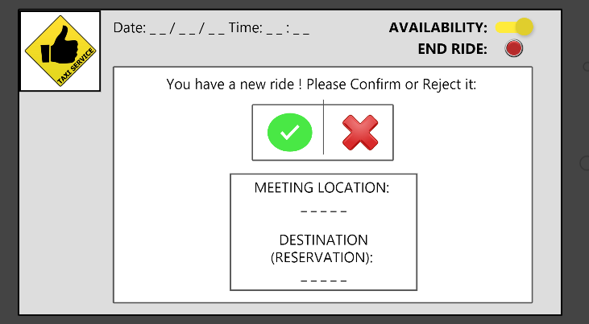

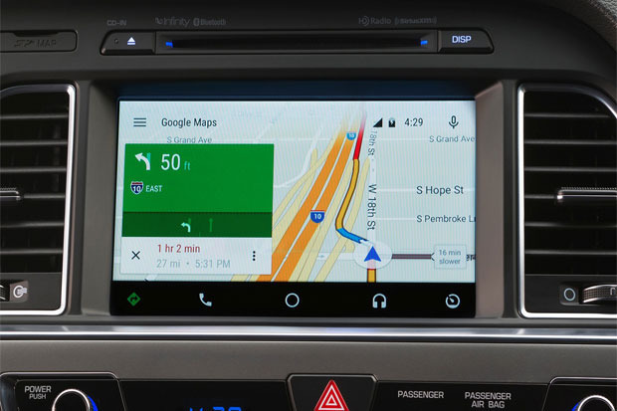

1. **DOCUMENTATION**

These are the documents about myTaxiService that will be released:

• **RASD (Requirement Analysis and Specification Document)**: contains the description of the scenarios, the use cases that describe them, and the models describing requirements and specification

• **DD (Design Document)**: contains a functional description of the system, and any other view useful to provide

1. **SOFTWARE SYSTEM ATTRIBUTES**

* **Reliability:** System shall have an availability of 99.99% (four nines), which implies a 52.56 minutes downtime per year. The reliability of the system is strictly related to the reliability of the server it runs on.
* **Availability:** The system is running 24/7 so that a user can always request or reserves a taxi.
* **Capacity:** the system should be able to manage 1000 requests/second and manage at least 4000 connected users (passengers and taxi drivers) at a given time
* **Security:** All the communications between server and clients must be protected by strong encryption using the SSL protocol. Users' passwords must be hashed, salted and then stored in the database
* **Portability:** The back-end server software will be written in Java so that it can be run on every platform that supports the Java Virtual Machine. The web application shall run on every modern browser. The mobile application for users must be supported by the last two major versions of Android and iOS. The mobile application for taxis must be supported by Android Auto
* **Robustness:** If the taxi driver loses the GPS connection for a while, the ride is not canceled, available taxis remain in the queues and updates are simply suspended

# Specifications

* **Management of taxi queues:** the system keeps a FIFO (First In First Out) queue of available taxis for each zone. When a taxi becomes available, the system will insert it in the queue of the relative zone using the location provided by the in-built GPS of the car. When a taxi becomes non-available, the system will remove it from the relative queue. When a taxi driver rejects a ride, the system will move it to the last position of the relative queue
* **Registration of a user:** the system allows a user to register once with the same email address. If they try to use it again in the registration form, the system will not allow signing up. Once a user has correctly signed up, they will be automatically logged in into the system for the first time
* **User Login:** the system allows a user to sign in using email address and password specified in the registration form. If a user inserts a wrong couple username-password (i.e. they are not in the database), the system will not allow signing in
* **Taxi ride request:** if the user uses the web application it will be required to insert their location, whereas with the mobile application the position is automatically acquired with the smartphone’s in-built GPS. The system will propose the ride to the first taxi queueing in the zone where the request comes from. If no taxi is available or everyone in that zone rejects the ride, the system will propose it to the first taxi queueing in the nearest zone. Once the ride is allocated to taxi that has accepted it, the system will send the taxi code and the waiting time to the user in a confirmation page. A User cannot make requests if they have already assigned a taxi code for a previous ride (request or reservation)
* **Taxi ride reservation:** the user is required to insert meeting date, meeting time, origin and destination of the ride. If the inserted meeting time is less than two hours from the moment of the reservation, the system will not allow the user to confirm it. The system will store the reservation of the user in a database and show a confirmation page to them.10 minutes before the scheduled meeting time, the system will inform the user about the code of the incoming taxi with a push notification. The system allows the user to cancel the reservation up to 10 minutes before the meeting time
* **List of Booked Taxis:** the system keeps a history of all the concluded and pending requests and reservations of a user and allows them to visualize it in a specific section of the application (web and mobile).
* **Taxi Driver Login:** the system allows a taxi driver to sign in inserting username and password already provided. If a taxi driver inserts a wrong couple username-password (i.e. they are not in the database), the system will not allow signing in.
* **Confirmation/Rejection of a ride:** the system allows a taxi driver to accept or reject a proposed ride. When the taxi driver accepts a request, the route to the passenger is visualized on the on-board screen. If the driver refuses, their taxi will be moved to the last position in the queue of the zone where it is. The taxi driver has only 10 seconds to answer when a ride is proposed on the screen, after which the it is automatically rejected
* **Update taxi driver availability:** the system allows the taxi driver to set their availability on or off. When the taxi driver accepts a ride, their status will be automatically set to non-available and this cannot be changed until the driver informs the system that he has reached destination (with an “End Ride” button). When the taxi driver is around a certain zone and ready to accept rides, they will switch their status into available and they can turn it off whenever they want, except during a ride.
* **Scalability to additional services:** the system provides API (Application Programming Interfaces) for developers

# Scenarios

**AN USEFUL ADVICE:**

This evening, John is going to meet Chiara at her place for dinner but he does not know how since his parents are gone away for the weekend with the family car. He is walking on the way to her home when he reminds that his friend Marco used a new application, “myTaxiService”, the day before and recommended it to him. Therefore, he decided to try it downloading and installing it on his IPhone 6S from the App Store. Once opened, he taps on “Create Account” since it is his first time using it. Then, he inserts the requested personal information and taps on “Sign Up”. Now John is inside the system and can make a taxi request. The system forwards it to Luca that has just become available after a short break. Luca, however, does not notice the ride on his display in time. In fact, 10 seconds has passed and the request to his taxi has been automatically rejected. Therefore, the ride is proposed to Leonardo that accepts it and goes taking John at the meeting location.

**MIKE’S HAPPY HOUR:**

Mike went to a happy hour with his friends and now he wants to go back home. He takes his LG Nexus 5X, opens the application “myTaxiService”, that he has already used many times, and signs in into the system. He selects “Request a Taxi” and the system acquires his location through the in-built GPS. Then, when he confirms, the system informs him that it is searching for an available Taxi. Chester, that has just begun his shift and switched his availability on, sees on the display of its Android Auto device that there is a ride request ready for him. Chester accepts the ride and goes taking the passenger. Mike sees a confirmation page with the taxi code and a waiting time of 8 minutes. After a couple of minutes, Mike forgets the taxi code and goes to the “Booked Taxis” section of the application to see it. Chester takes Mike in and asks him the desired destination. Mike arrives in front of his house, pays Chester and gets off the car. Right after, Chester decides to remain in the same zone and switches on again his availability, waiting for the system to assign him another ride.

**AURORA’S HOLIDAY:**

Aurora is on holiday in Big_City and she has planned to go back home the DD/MM at HH:MM by train. The day before that date, she decides to make a taxi reservation since she will need a lift to the station. Therefore, she takes her laptop, opens the browser and goes to “www.mytaxyservice.com” website, and reserves a taxi for the following day. She immediately visualizes the confirmation page with all the specified details. Unfortunately, half an hour before the meeting time, Aurora is informed that the train will arrive with a delay of two hours. Consequently, she decides to cancel the taxi reservation from the “Booked Taxis” section of the mobile application installed in her Samsung Galaxy S6, since she has already switched off the laptop. An hour after, she decides to make a taxi request and go to the station in advance, waiting for the train on the platform. Since it is the rush hour, a taxi with a waiting time of 10 minutes has been assigned to her. In the end, she managed to arrive at the station and after a while, the train arrived.

**THE LUNCH BREAK:**

Valentino is a taxi driver of Big_City that has just finished a ride and moved to the zone B, setting his status as available and waiting. After 15 minutes in which no ride request from the system have arrived, he decides to switch his status into non-available and have a lunch break. Afterwards, he turns on again the availability and keeps waiting. After 5 minutes, the system proposes him a ride, but he immediately notices that the passenger is not in his current zone, but in the one beside it. Valentino confirms the ride and after taking the passenger to destination, he goes back to the zone B, he stops in a parking lot and informs the system that he is available again.

# UML models

## Use Case diagram

## Use Case description

|  |  |
| --- | --- |
| Name | **A new passenger signs up into the service from the mobile application** |
| Actors | Guest |
| Entry Conditions | The Guest wants to register to “myTaxiService” |
| Flow of events | * The Guest opens the mobile application for the first time ever * The system shows to the Guest the Login page. The Guest taps on “Create an account” * The system shows the Registration page and The guest inserts their email address, password and taps on Sign up * The system checks the correctness of the inserted information, confirms and redirects the Guest, that now is a User, to the Home page |
| Exit conditions | The information are stored in the database. Now, the Guest can login into the system, becoming a User |
| Exceptions | If the Guest inserts an invalid email address, or one already present in the database, the system shows an error message |
|  |  |

|  |  |
| --- | --- |
| Name | **A passenger logs in into the service from the web application** |
| Actors | User |
| Entry Conditions | The User wants to log in into the system |
| Flow of events | * The User opens a browser from their laptop and go to www.mytaxyservice.com * The system shows them the Login page and the User inserts email address and password and clicks on the Sign in button * The system checks the correctness of the inserted information, confirms and redirects the User to the Home page |
| Exit conditions | The User is logged in into the system |
| Exceptions | If the User inserts an invalid couple email address-password, or one not present in the database, the system shows an error message |

|  |  |
| --- | --- |
| Name | **A passenger makes a taxi ride request from the mobile application** |
| Actors | User |
| Entry Conditions | The User is logged in into the service from the mobile application and wants to request a Taxi |
| Flow of events | * The passenger taps on “Request a Taxi” in the Home page of the mobile application * The application invites the User to check whether the GPS on their device is turned on, otherwise the meeting location cannot be acquired by the system * After that the GPS is correctly acquired, the User can send the request tapping the relative button. A confirmation page appears with the code of the incoming taxi and the waiting time |
| Exit conditions | A Taxi is properly assigned to the User |
| Exceptions | The User has already an active request (or reservation with an assigned Taxi code) that is not yet completed, the system shows an error message |

|  |  |
| --- | --- |
| Name | **A passenger makes a taxi ride reservation from the web application** |
| Actors | User |
| Entry Conditions | The User is logged in into the service from the web application and wants to reserve a Taxi |
| Flow of events | * The User clicks the button “Reserve a taxi” in the Home page of “www.mytaxiservice.com” website * The website displays all the forms to be completed for a successful submission:   + Meeting Date   + Origin   + Destination   + Meeting Time * The passenger confirms clicking the button “Reserve a Taxi” and a Confirmation page appears |
| Exit conditions | The User immediately receives the confirmation from the system and a push notification 10 minutes before the meeting time with the code of the incoming Taxi if the User has previously logged in into the system from the mobile application at least once. Else, the User can see the Taxi code in the “Booked Taxis” section of the website |
| Exceptions | If the specified Meeting Time is within two hours from the moment of the reservation, the reservation cannot be made (an error message appears upon clicking the “Reserve a Taxi” button) and an error message is displayed. If some information are missing, an error message is displayed |

|  |  |
| --- | --- |
| Name | **A passenger cancels a taxi ride reservation** |
| Actors | User |
| Entry Conditions | The User wants to delete a ride reservation |
| Flow of events | * The passenger goes to the section “Booked Taxis” from their mobile application, which allows him to watch and monitor the list of all their booked rides (requests and reservations) scrolling down the page * The passenger picks one reserved ride and taps on the relative red “X” icon. A confirmation message appears with a “yes-no” choice. The passenger taps “yes” |
| Exit conditions | The reservation is properly deleted |
| Exceptions | If the passenger taps “no” at the confirmation message, the reservation will not be cancelled. If the reserved ride takes place less than 10 minutes before the passenger opens the “Booked Taxis” section, it cannot be cancelled since the red “X” will not be present |

|  |  |
| --- | --- |
| Name | **A Taxi driver sets their availability on** |
| Actors | Taxi driver |
| Entry Conditions | The Taxi driver is logged in into the service and wants to start their shift or they have just finished a ride |
| Flow of events | * In the Home page of the Android Auto application the Taxi driver can tap on a switch that allows him to make themselves available * The system adds the Taxi to the queue of its current zone |
| Exit conditions | The Taxi is added to the queue and it is ready to be picked up from the system when a new request or reservation comes up. |
| Exceptions | The Taxi driver cannot switch on their availability during a ride. If they try to do it, the system shows an error message |

|  |  |
| --- | --- |
| Name | **A Taxi receives a ride from the system** |
| Actors | Taxi driver |
| Entry Conditions | The Taxi driver is available and ready to manage a new ride provided by the system. Their Taxi is the first in the availability queue of its zone so an available ride is coming soon |
| Flow of events | * The Taxi driver is notified by the system on their Android Auto application, which shows all the information about the ride to be performed * The Taxi driver can accept or reject the ride tapping on the relative buttons |
| Exit conditions | * The Taxi driver accepts the ride * Otherwise, if the Taxi driver rejects, the system will move their Taxi in the last position of the relative availability queue |
| Exceptions | If the taxi driver does not accept or reject the ride within 10 seconds, the request is automatically rejected |

## Sequence diagrams

**USER SIGN IN**

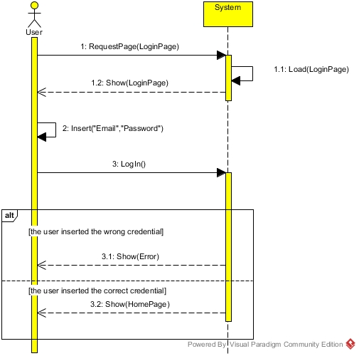

**TAXI DRIVER SIGN IN**

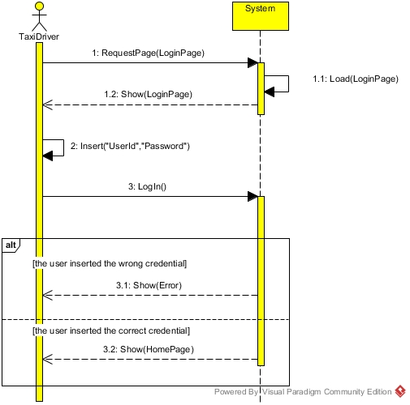

**USER MAKES A RIDE REQUEST AND A TAXI RECEIVES A RIDE**

In this Sequence diagram, there is a request made by a user and the system that sends a ride to a taxi, **which can be it or another one.**

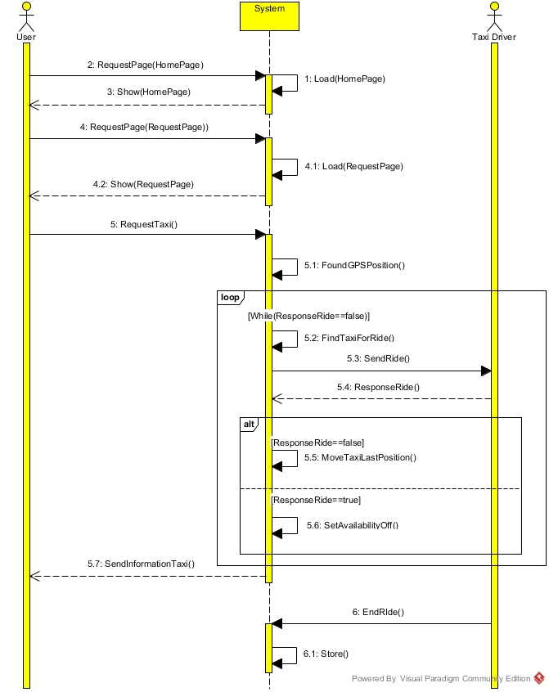

**USER MAKES A TAXI RIDE RESERVATION**

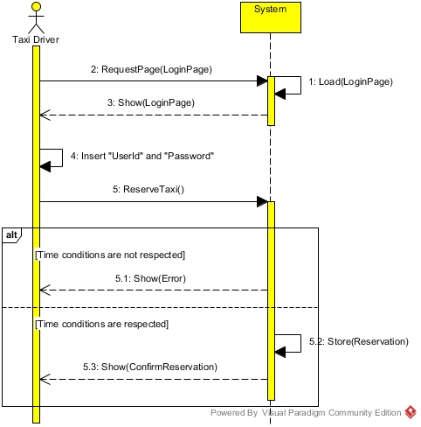

**TAXI DRIVER UPDATES THEIR AVAILABILITY (ON - OFF)**

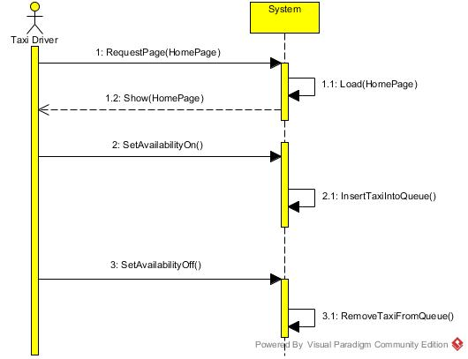

**USER VIEWS LIST OF BOOKED TAXIS AND CANCELS A TAXI RESERVATION**

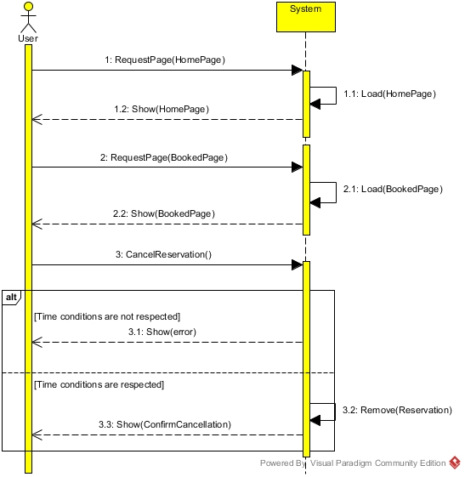

## State Chart diagrams

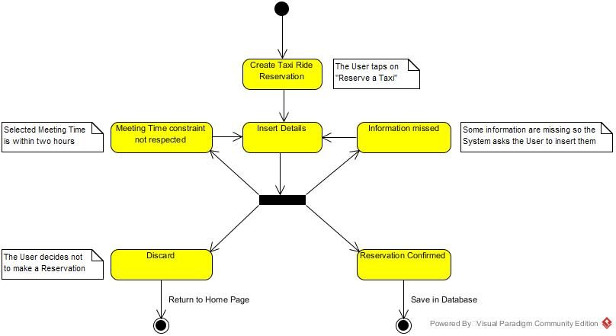 **CREATE TAXI RIDE RESERVATION**

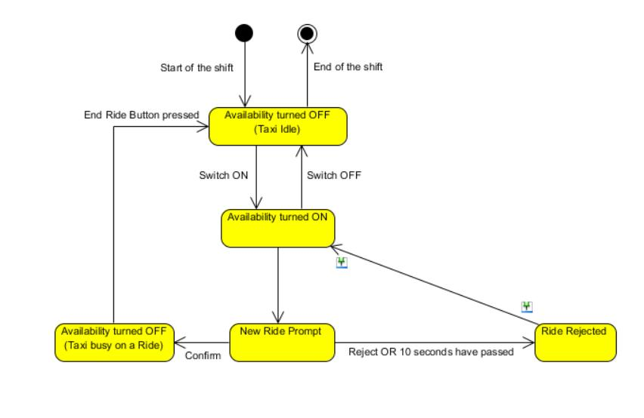 **UPDATE TAXI AVAILABILITY**

## Class diagram

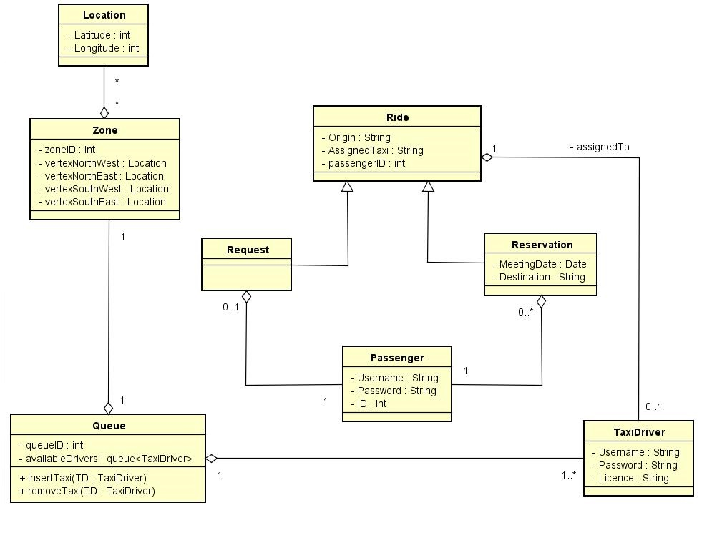

# Alloy

## Modeling

## Alloy analyzer

## Worlds generated

# Used tools

* **Microsoft Word 2013:** to redact and format the document
* **Proto.io:** to create the user interface mockups
* **Alloy Analyzer 4.2:** to explore the model of our system in terms of consistency
* **Astah Professional:** to create Use Cases Diagram and Class Diagram
* **Visual Paradigm 12.2 Community Edition:** to create State Chart Diagrams and Sequence Diagrams

# Hours of work

Since we are neighbors, we have worked **together almost all the time** at each other’s home and **equally shared all the tasks and efforts**. We have worked on this document **for a total of 45 hours.**