Christie Templeton
Sample LDAP Setup Guide

The following is an excerpt from a LDAP User Guide created previously for administrator’s usage.

LDAP Set Up Guide Part 1

Introduction
LDAP (Lightweight Directory Access Protocol) including Active Directory can be used for authenticating users on the network. LDAP is considered a standard for user authentication and for storing user profile data. Very large organizations use LDAP as it is a powerful tool to simplify user account management.
The application does not by default use LDAP but rather it stores all user data in a database and performs authentication with that data. During setup you will specify which users and groups from LDAP you want the application to use. The software will query your LDAP server to ensure that users and groups (if you want) are nominally represented in the application database (so that users can be associated with content), but will authenticate against your LDAP server.
This article will guide you through configuring the application to use your LDAP server for authentication.
Note: If you're using Active Directory, make sure it allows LDAP querying. You might also be interested in LDAP Querying Basics at the Microsoft website, or LDAP Attributes at the Computer Performance web site.

Starting the Setup Tool
The setup tool will run the first time you access the application if you've just installed it. If you've already completed the setup process and need to use the tool again to configure LDAP, do the following:
- Stop the application service from the command prompt: /etc/init.d/application stop
- Edit /usr/local/jive/applications/sbs/home/ startup.xml so that the <setup> element has the value "false" (meaning "setup has not been run").
- Start the application service from the command prompt: /etc/init.d/application start
- Point your browser at software SBS using the URL above and rerun the setup tool.

Configuring the Application for LDAP
You will give information for connecting to the server on the next three screens in the setup tool which includes querying for users and how groups should be handled. Begin by choosing a server type such as Active Directory or OpenLDAP.
- In the setup tool on the User Settings step, choose Directory Server (LDAP) as the authentication and user mode then click Continue.
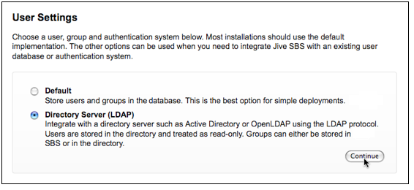
- On the Connection Settings page enter the connection values required by your LDAP server. Your server type choice will determine the default values displayed later in the setup tool.
- Click Advanced Settings to make other connection-related settings.
- Click Test Settings to confirm the connection settings for host, port, and base DN.
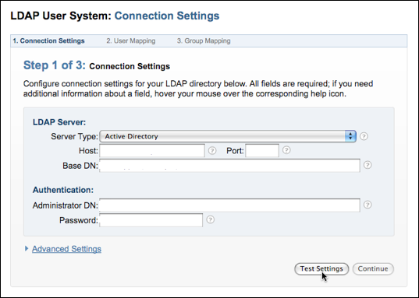

- Click Continue once you’ve gotten a successful test result.
- Enter the names of fields your LDAP server uses for user data on the User Mapping page
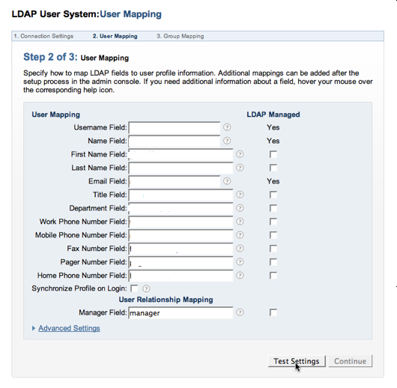
- After you've entered the values you need, click Test Settings to confirm that the values you entered are valid for your LDAP server. If any of the fields were not represented in the test results, you'll see those fields highlighted in red. For those highlighted values that you know should be mapped anyway, click the LDAP Managed check box.

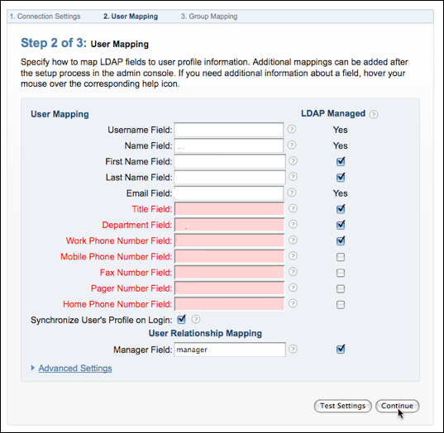

- Click Continue once you’ve gotten a successful test result.
- On the Group Mapping page select whether to use groups defined in LDAP or to define your own groups using the application.
- Select Use LDAP to manage groups if you have groups in LDAP that you want Jive SBS to be aware of. With this option selected, the application will retrieve your LDAP server's group information just as it did for your LDAP users.
- Select Use Jive SBS to manage groups if you want the application to ignore groups you have defined in LDAP. This option is useful if you want to use the application to define groups that are used only by it.

Note: Your LDAP server won't be aware of groups you define in the application. You can use the admin console to define groups; in the admin console, go to People > Management. If you select Use LDAP to manage groups, the setup tool provides default values based on the server type you chose in the Connection Settings step. In particular, you'll see the following defaults for Active Directory and OpenLDAP:
- You can use the Member Field as a way to increase performance.
- The software will use these values to query your LDAP server to retrieve information about the groups to use. The default values will include all groups found with the connection settings you gave. You may limit this to only certain groups by using an LDAP filter expression.
- After you've entered the values you need click Test Settings if you're choosing to use LDAP groups which will confirm that the values you entered are valid for your LDAP server.
- When you get a successful test, click Continue.
- Click Continue if you're choosing to define groups in the application.
- Complete the Other Settings page and click Continue.
- On the LDAP User Data Storage Mode page, enter the name of the user (retrieved from your LDAP server) who should be the system administrator.
- Click Continue to finish setting up.

