FiltraQueri
UX Overhaul Master Plan
From metadata-heavy to experience-first

Document class Product experience direction — strategic
Synthesizes FiltraQueri Data Workspace UX Review Audit (8 tab reviews)
Builds on Workspace Layout Spec . Human Mode Interaction Spec
Optimization Intelligence Architecture Spec . Consumer Architecture Spec (S5-B)
Document type Experience overhaul map (NOT a spec; the four specs govern)
Audience Product, design, frontend, leadership
Version 1.0

"FiltraQueri's challenge is no longer backend capability. It is that the product shows the user its engineering instead of giving the user an experience. This document is the map from one to the other."

Contents
1 The single root cause
2 The target — experience-first FiltraQueri
3 The five experience principles
4 Information architecture overhaul
5 Cross-cutting overhaul — the problems on every screen
6 Workspace-by-workspace overhaul direction
7 The Epic / Hartford patterns to adopt
8 Phased implementation roadmap
9 Governance — how the overhaul stays disciplined
10 Final synthesis
A Appendix — target reference visuals

1 The single root cause

Your audit reviewed eight surfaces — Data, Intelligence, Semantics, Explore, Build, Results, Analyst, Settings — independently. They produced one diagnosis, eight times. Read together, the eight reviews are not eight problems. They are one problem expressed eight ways.
"FiltraQueri exposes its engineering architecture instead of delivering an experience."
Every named pain point in the audit is a symptom of that one cause:
Audit symptom (recurring) | Is a symptom of
Metadata exposure fatigue | The system shows its internal model, not the user's task
Engineering language leaking into Human Mode | The system speaks its own vocabulary, not the user's
Context confusion, stacked panels, no isolation | The system reflects its module structure, not a workflow
Redundant navigation (pills + duplicate cards) | The system surfaces every path it has, not the one path that matters
Sidebar as a persistent metadata dump | The system reports its state, instead of assisting the task
'Ready' states everywhere, meaningless | The system narrates its own readiness instead of inviting action
Flat, monochrome, low-energy, exhausting | The system was built to be correct, not to be inhabited

This is the same finding the audit reaches on its own, in its strongest sentences: the product “thinks like the backend,” “feels like internal architecture,” “rewards architecture more than users.” The backend intelligence is genuinely strong. The UX has not yet been built; what exists is the engineering, rendered.
1.1 Why this matters strategically
FiltraQueri's intended user is explicitly someone who is overwhelmed by SQL, dashboards, and BI tools. A product that exposes its own architecture is, for that user, a harder version of the tools they were trying to escape. The current UX does not serve the target user; it serves the people who built the system. The overhaul closes that gap.
1.2 What this document is
- The synthesis the eight-part audit was building toward — one experience direction, not eight lists of fixes.
- A map: the target experience, the new information architecture, the per-workspace direction, and the order to do it in.
- Governed by the four canonical specifications already authored. This plan sets direction; the specs set the binding rules. Where this plan and a spec disagree, the spec governs.
1.3 What this document is NOT
- It is not a redesign of the backend, the Runtime Bridge, or any architecture covered by the S3 through S7 reviews. Those are healthy.
- It is not a new specification. It is the experience direction the four specs implement.

2 The target — experience-first FiltraQueri

The audit names the destination repeatedly: “invisible complexity,” “invisible intelligence,” “experience architecture,” “intelligence felt, not seen.” Made concrete, the target is a product where:
- The user sees their business question and its answer. The machinery that produced the answer is available on request and silent otherwise.
- Every screen answers one question and offers one obvious next step.
- The interface speaks the language of the user's business — deliveries, revenue, customers, managers — and never the language of the system — runtime, contract, dialect, readiness.
- Intelligence arrives as guidance and findings, not as exposed metadata. The user feels advised, not audited.
- The product feels calm, warm, and confident — an environment to think in, not a console to operate.
2.1 The reframe — three sentences
FiltraQueri stops being… | …and becomes
A surface that displays the system's state | A surface that advances the user's task
A set of panels that mirror the codebase | A set of destinations that mirror the workflow
A tool that must be operated | An assistant that guides

2.2 The user's journey, in their words
The entire product reduces to one sentence the user should be able to say at every moment:
"I know what I have, I know what I asked, I understand the answer, and I know what to do next."
Four clauses. They are the four core destinations of the overhauled product (Section 4): what I have (Data), what I asked (Analyze), the answer (Insights), and — woven through all three — what to do next (the investigation thread).
2.3 The emotional target
The audit is right that this is partly an emotional problem: the interface is “monochrome, low-energy, enterprise-heavy without warmth.” The emotional target is not decoration. It is: a user who was overwhelmed by BI tools opens FiltraQueri and feels calm, oriented, and capable. Calm is a feature. It is produced by less on screen, clearer hierarchy, plain language, and one obvious action — not by color alone.

3 The five experience principles

Five principles convert the target into decisions. Every overhaul move in this document traces to one of them. They are the experience-layer companions to the rules in the four specifications.
3.1 Invisible intelligence
The system's intelligence is felt through better questions, better guidance, and clearer findings — never through exposed metadata. Internal state (runtime, contracts, readiness, dialect, execution plans) is removed from the default experience. Analysts can summon it; Human Mode users never see it.
3.2 Focused destinations
Each part of the product is a destination the user travels to, which then fills the screen with that one context. No stacked panels, no simultaneous contexts. Clicking a navigation item replaces the screen; it does not append to it. This is the audit's “fresh-page UX” and “focused destination navigation.”
3.3 One question per screen
Every screen answers exactly one question and offers one primary action. If a screen answers two questions, it becomes two destinations. This single rule dissolves most of the audit's congestion, redundancy, and context-confusion findings.
3.4 Business language only
In Human Mode, every word on screen is a word the user's business uses. Engineering vocabulary is banned from the surface — not softened, banned. This is already law in the Human Mode Interaction Specification (§8); the overhaul enforces it everywhere.
3.5 Calm visual energy
Calm is not emptiness and not monochrome flatness. It is deliberate hierarchy: generous whitespace, one clear focal point per screen, restrained and meaningful color, warm but professional typography. Energy comes from clarity and rhythm, not from density or decoration. The visual foundation is fixed by the Workspace Layout Specification (type scale, three-layer surface system, one accent color).

4 Information architecture overhaul

The current product has eight-plus surfaces (Data with five pills, Intelligence, Semantics, Explore, Build, Results, Analyst, Settings). The audit found that several of these are the same workflow split apart, and others are internal architecture exposed as navigation. The overhauled IA is four core destinations plus two system surfaces.
4.1 The new map
CURRENT (engineering-shaped) OVERHAULED (workflow-shaped)
--------------------------- ---------------------------
Home --> Home orientation + quick start
Data (Overview/Columns/ Data "What do I have?"
Worksheets/Intelligence/ dataset understanding;
Semantics pills) Intelligence + Semantics
Explore -- merge -> fold in as understanding
aids, not separate tabs
Build --> Analyze "What do I want to know?"
guided question -> answer
Results --> Insights "What did I find?"
findings + the table
Analyst --> Analyst the same four destinations,
inspectable (a mode, not
a separate place)
Settings --> Settings real system settings,
decontaminated
4.2 The four core destinations
Destination | User question | What lives here
Home | “Where do I start?” | Orientation, recent work, quick actions, one clear next step
Data | “What do I have?” | Dataset understanding: overview, columns, worksheets. Intelligence and semantics fold in here as plain-language understanding aids.
Analyze | “What do I want to know?” | The guided question-to-answer flow. Intent first, never query structure first. Old Build, renamed and radically simplified.
Insights | “What did I find?” | The answer: business takeaway, the table as hero, supporting findings, and the investigation thread. Old Results, renamed.

4.3 The decisions behind the map
Merge Data and Explore. The audit found Explore “has no clear user purpose” and that “Data and Explore are actually one workflow.” Explore's data-understanding role folds into Data; its question-choosing role folds into Analyze. Explore disappears as a tab.
Intelligence and Semantics stop being tabs. They are not destinations; they are understanding. Intelligence becomes plain-language guidance shown inside Data and Analyze. Semantics becomes the business-meaning layer behind the scenes. Neither is a place the user navigates to.
Rename Build to Analyze. “Build” and “run query” are construction and SQL language. “Analyze” is what the user is actually doing. The audit recommends this rename explicitly.
Rename Results to Insights. “Results” is a database word for query output. “Insights” is what the user came for. The audit recommends this rename explicitly.
Analyst becomes a mode, not a parallel product. Analyst Mode is the same four destinations rendered with inspection available — SQL, plan, dialect, schema. It is not a separate application with its own navigation. This matches the Interaction Spec §10 (mode is a render decision).
Settings becomes real settings. The audit found dataset metadata and the investigation sidebar bleeding into Settings. Settings is decontaminated to genuine system settings with its own quiet layout.
4.4 Navigation behavior
Destinations replace; they do not stack. Selecting Home, Data, Analyze, or Insights fills the screen with that one context. The audit's “stacked panels” and “context confusion” findings end here.
Sub-navigation inside a destination is focused too. Data's Overview / Columns / Worksheets are focused sub-views: selecting one shows only that one. No simultaneous contexts, no scroll to find what changed.
One back behavior, everywhere. Every drill-in has a visible, single back affordance that returns the user exactly where they were. Governed by Consumer Architecture Spec §6.

5 Cross-cutting overhaul — the problems on every screen

Six problems appear in every tab review. They are fixed once, as a system, not tab by tab. Fixing these six removes the majority of the audit's findings before a single workspace is individually redesigned.
5.1 Demote metadata
Now. Readiness states, contracts, runtime status, counts of internal artifacts, and architectural labels are shown as primary content on every surface.
Target. Internal metadata is removed from Human Mode entirely. What the user needs to know — is the data ready, is the answer trustworthy — is expressed as one calm sentence or one confidence chip, never as a strip of system-state cards.
5.2 Ban engineering language
Now. “ANALYST INSPECTION,” “QUERY GENERATED,” “EXECUTION PLAN,” “SQL DIALECT,” “READINESS,” “RUNTIME SLOT,” “package planning ready” appear across Human Mode screens.
Target. Every Human Mode string is business language. The Interaction Spec §8 banned-vocabulary list is enforced by an audit check. The conformance test: could this be explained to the user's business manager who has never heard the word “runtime”?
5.3 Turn the sidebar into a contextual assistant
Now. The right sidebar is a persistent metadata dump that shows the same investigation content regardless of which surface is active.
Target. The sidebar adapts to the active destination. On Data it shows column quality and worksheet structure; on Analyze it shows the question being shaped; on Insights it is the investigation thread. When it has nothing useful to say, it collapses.
5.4 Add focus transitions
Now. After a click, content appears somewhere on a long page and the user must scroll to find it; clicks have weak feedback.
Target. Every navigation repositions the user into the new context. Selecting a worksheet, a column, a question, or a finding focuses the screen on it. The user never wonders whether a click worked.
5.5 Reduce redundancy
Now. Pills and duplicate bottom cards offer the same navigation twice; the same data point appears three to five times per screen.
Target. One navigation path per destination. Every fact appears once as the source of truth and at most once more as a reference. Duplicate navigation cards are deleted.
5.6 Give the interface calm energy and safety
Now. Flat, monochrome, text-heavy, exhausting; destructive actions (Delete, Clear Session) have no confirmation.
Target. The Workspace Layout Specification visual foundation is applied everywhere: the type scale, the three-layer flat surface system, one accent color, generous whitespace. Destructive actions get explicit confirmation. The product reads as calm and warm, not as a console.

6 Workspace-by-workspace overhaul direction

With the cross-cutting fixes applied, each destination needs a focused redesign. For each: the user question it answers, the current problem from the audit, and the key overhaul moves.
6.1 Home
User question: “Where do I start?”
Now. Home restates the system's status and offers competing entry points.
Target. Home is an orientation page modeled on the focused quick-link landing the audit admired in the Hartford reference: a calm header, a small set of clear quick actions (open data, continue recent work, start a question), and recent investigations as simple cards. Nothing technical. One obvious next step.
Key moves
- One H1, one calm subtitle, no metadata strip.
- Quick-action tiles: large, plain-language, one icon, one verb.
- Recent work as simple cards; the system's status is at most one quiet line.
6.2 Data
User question: “What do I have?”
Now. Five pills that do not isolate; Overview duplicates navigation with bottom cards; Intelligence and Semantics are dense metadata tabs; “View Results” wrongly lives here.
Target. Data is dataset understanding, with three focused sub-views — Overview, Columns, Worksheets — each of which fully replaces the screen when selected. Intelligence and semantics fold in as plain-language understanding (“FiltraQueri sees this as delivery data”), not as separate tabs. ‘View Results’ is removed; it belongs to Insights.
Key moves
- Overview is a dataset landing summary only: upload confirmation, preview, workbook identity, row and column count, one readiness sentence, basic relationships. No secondary navigation maze.
- Delete the duplicate bottom navigation cards.
- Columns and Worksheets each render in isolation; selecting a worksheet focuses the screen on it.
- Intelligence becomes one plain-language understanding panel; Semantics becomes the business-meaning layer behind it, surfaced as plain statements.
- Delete and Clear Session get confirmation dialogs.
6.3 Analyze (formerly Build)
User question: “What do I want to know?”
Now. Build is a six-step query-construction flow that thinks in SQL concepts (fields, aggregations, group by, run query); it feels bigger than the task, leaks package planning and investigation-workspace concepts, and feels like Analyst Mode disguised as Human Mode.
Target. Analyze starts with intent, not query structure. The user states a business question — in plain language or by picking a suggested one — and FiltraQueri proposes the analysis. The six-step builder is replaced by a guided three-choice flow (Interaction Spec §2): what to measure, how to slice it, which rows to consider, all in business words, with a one-sentence preview before anything runs.
Key moves
- Intent first: “What would you like to understand?” with suggested business questions, before any field selection.
- Replace the six-step builder with the three-choice guided flow; the user never configures an aggregation manually.
- Remove package planning, investigation-workspace abstractions, and “ready” state strips from Human Mode entirely.
- “Run query” becomes a plain action; nothing runs until the user approves a plain-language preview.
- The page becomes the size of the task — calm, short, one primary action.
6.4 Insights (formerly Results)
User question: “What did I find?”
Now. Results has too many surfaces, dual right sidebars, the table compressed into wasted vertical space, metadata fatigue, and engineering terminology; it feels analyst-centric rather than insight-centered.
Target. Insights leads with the business takeaway in one sentence, then the table as the hero surface — large, modern, spreadsheet-like — then supporting findings, then the investigation thread as the single right-hand companion. One sidebar, not two. Metadata removed; confidence expressed as one honest chip.
Key moves
- Business takeaway sentence leads the page (Interaction Spec §6).
- The data table becomes the hero: it expands to use the space, supports modern spreadsheet interaction, and is never compressed by metadata above it.
- Collapse the dual right sidebars into one investigation thread; make panels resizable.
- Replace “deterministic insights,” “normalization warnings,” “Query tab” and similar terms with business language.
- Supporting findings are ranked; the investigation thread offers the next steps.
6.5 Analyst Mode
Audience: the analyst who wants to see SQL, plan, schema underneath.
Now. Analyst Mode is architecturally heavy: a left sidebar that reads like an internal debug panel, horizontal metadata cards, hidden sidebars, the Monaco editor not the visual priority, everything visible at once.
Target. Analyst Mode is the same four destinations with inspection layered in. The SQL editor is the hero surface. Inspection — plan, dialect, schema, runtime context — is available through progressive disclosure, not displayed all at once. It feels like a calm professional instrument, not internal tooling.
Key moves
- The SQL editor is the visual centerpiece, given the most space.
- Inspection metadata moves behind progressive disclosure; default view is calm.
- The left debug-style sidebar is reduced to genuine navigation; resizable panels.
- Engineering terminology is condensed and de-emphasized — Analyst Mode may show it, but it is never the loudest thing on screen.
6.6 Settings
Audience: anyone configuring the product.
Now. Settings reuses the dataset workspace shell — it shows dataset metadata and the investigation sidebar, which do not belong in Settings; it does not feel like a settings environment.
Target. Settings has its own quiet layout: real system settings (mode default, confidence threshold, data residency, theme, governance and audit access), grouped in plain rows. No dataset metadata, no investigation sidebar, no workspace chrome.
Key moves
- Settings gets its own layout, not the dataset workspace shell.
- Remove dataset metadata and the investigation sidebar from Settings entirely.
- Group genuine settings into plain, calm rows.

7 The Epic / Hartford patterns to adopt

You asked early on about Epic and, in the audit, studied the Hartford HealthCare UKG portal. Those systems are dense and powerful but remain learnable because of a small set of patterns. Five are directly applicable to FiltraQueri; adopt these, not their visual style.
7.1 Focused destination navigation
In the reference systems, selecting a destination takes the user to a page that is about that one thing. The page does not append to the previous one. FiltraQueri adopts this as principle 3.2: destinations replace the screen.
7.2 The quick-link tile model
The reference landing is a calm grid of clear, single-purpose tiles — each one a plain-language door to a task. FiltraQueri's Home adopts this: a small grid of quick actions, each a plain verb, each a focused destination.
7.3 Structured navigation layers
The reference systems use clear levels: a stable primary navigation, a focused destination, and a detail within it — and the user always knows which level they are on. FiltraQueri adopts the same three levels: destination, sub-view, detail page (Consumer Architecture Spec §3, §6).
7.4 Fresh-page UX
Each destination in the reference systems is a clean, composed page — not a scroll of stacked modules. FiltraQueri adopts “fresh-page UX”: every destination is composed deliberately, with one focal point, not assembled by stacking whatever modules exist.
7.5 Reliable back navigation
The reference systems always let the user return to where they came from, predictably. FiltraQueri adopts one back behavior everywhere (Consumer Architecture Spec §6.3).
7.6 What NOT to copy
- Do not copy their visual density. Epic-class systems are dense because clinicians use them for hours daily and trade calm for throughput. FiltraQueri's user is the opposite: occasional, overwhelmed, non-technical. Borrow the navigation discipline; keep the calm.
- Do not copy their information density per screen. Adopt the structure, not the volume.

8 Phased implementation roadmap

The overhaul is sequenced so the highest-leverage, lowest-risk work lands first, and so no phase destabilizes the protected systems identified across the S3 through S7 reviews. Each phase is independently shippable.
8.1 Phase U1 — Foundation & language
- Apply the Workspace Layout Specification visual foundation everywhere: type scale, three-layer flat surfaces, one accent color, spacing rhythm. Removes the flat/monochrome/exhausting finding in one pass.
- Engineering-language audit: enforce the Interaction Spec §8 banned vocabulary across all Human Mode strings, with a CI string-check.
- Add confirmation dialogs to Delete and Clear Session.
Risk: low. No IA change, no routing change. Highest visible improvement per unit effort.
8.2 Phase U2 — Cross-cutting structure
- Destinations replace, never stack: enforce screen-replacing navigation.
- Sidebar becomes contextual: it adapts to the active destination or collapses.
- Focus transitions: every navigation repositions the user into the new context.
- Delete duplicate navigation (pills plus bottom cards); de-duplicate repeated facts.
Risk: low-to-medium. Behavior change, no new architecture.
8.3 Phase U3 — Information architecture
- Merge Explore into Data and Analyze; retire the Explore tab.
- Fold Intelligence and Semantics into Data as plain-language understanding.
- Rename Build to Analyze, Results to Insights.
- Decontaminate Settings; give it its own layout.
Risk: medium. This is the structural change; do it after U1 and U2 have stabilized the surfaces it reorganizes.
8.4 Phase U4 — Workspace redesigns (one at a time)
- U4a Home — the orientation landing.
- U4b Data — focused Overview / Columns / Worksheets.
- U4c Analyze — intent-first guided flow replacing the six-step builder.
- U4d Insights — takeaway-led, table-as-hero, single investigation thread.
- U4e Analyst — SQL editor as hero, inspection behind progressive disclosure.
Risk: medium, contained. One workspace per sub-phase; each ships and is reviewed before the next. Analyze (U4c) and Insights (U4d) are the highest-value pair.
8.5 Phase U5 — Polish & coherence
- Cross-workspace consistency pass; empty / loading / low-confidence states.
- Investigation thread coherence across Data, Analyze, Insights.
- Final calm-energy and warmth pass.
Risk: low.
8.6 Sequencing rule
"Language and foundation before structure. Structure before redesign. One workspace at a time. Never bundle a workspace redesign with an IA change."

9 Governance — how the overhaul stays disciplined

This plan sets direction. Four canonical specifications already govern the rules. The overhaul is disciplined because every phase implements a spec, and no phase invents a rule outside one.
Overhaul concern | Governed by
Visual foundation, layout, density, the IA shell | Workspace Layout Specification
Language, guided flows, explainability, mode behavior | Human Mode Interaction Specification
The Analyze flow's optimization and forecasting surfaces | Optimization Intelligence Architecture Spec
Detail pages, navigation, back behavior, view models | Consumer Architecture Spec (S5-B)

9.1 The discipline carried over from S3–S7
- No overhaul phase modifies the Runtime Bridge or any protected execution surface.
- No overhaul phase adds a governance layer; it implements existing specs.
- Workspace activation follows the S5-B and S7 sequence already established.
- Gaps in direction are resolved by amending this plan; gaps in rules by amending the relevant specification — never by ad-hoc screenshot patching.
9.2 How to know the overhaul is working
Not by counting features. By one test, applied to any screen at any phase:
"Could the user this product is for — someone overwhelmed by SQL and BI tools — look at this screen and know what it is telling them and what to do next, without learning a single system concept?"
When every screen passes that test, the overhaul is done.

10 Final synthesis

FiltraQueri started as a data-filtering idea and has become something more valuable: an AI-guided analytics workspace for people whom SQL, dashboards, and BI tools have failed. The backend to deliver that is, by the audit's own repeated finding, genuinely strong.
The gap is singular and nameable. The product currently shows the user its engineering. The overhaul makes the engineering invisible and the experience primary. That is the whole of it. Every move in this document — the four-destination IA, the six cross-cutting fixes, the per-workspace redesigns, the Epic-derived navigation patterns — serves that one reframe.
The work is sequenced so it is safe: language and foundation first, structure second, redesign third, one workspace at a time, governed by four specifications that already exist. None of it touches the healthy backend architecture. None of it requires new governance. It requires building the experience layer the product has not had yet.
"FiltraQueri's intelligence is real. The overhaul's only job is to make the user feel it instead of read it."
When a non-technical user can open FiltraQueri, understand their data, ask a real business question in their own words, read an answer they trust, and know their next step — without seeing one system concept — FiltraQueri will have become what it set out to be: not another BI tool, but the one that finally felt approachable.

Appendix A Target reference visuals

These references were produced earlier in the design process and remain the canonical visual direction for the overhaul. Where a build differs from them, the build is wrong.
A.1 Visual foundation
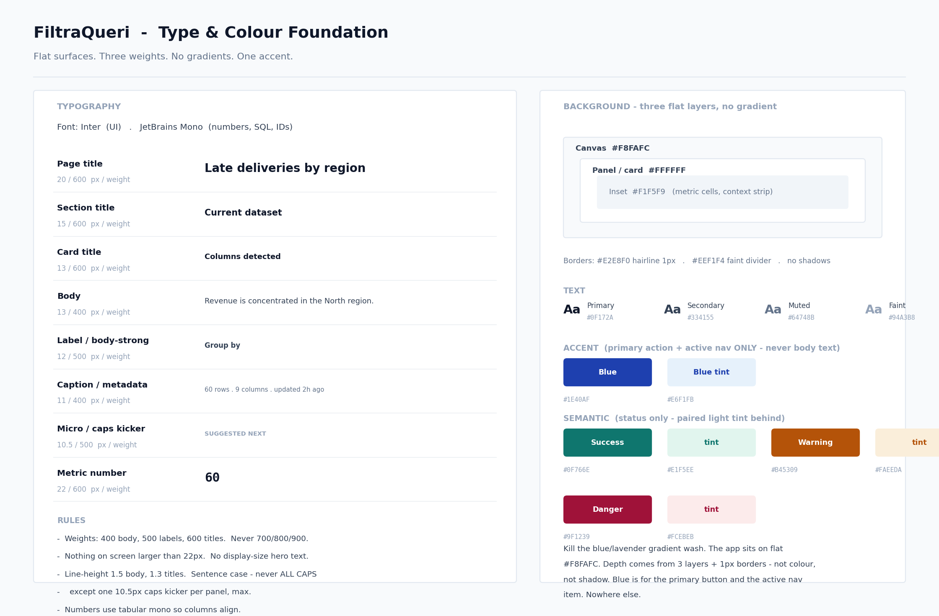
Figure A.1 — the type scale and the three-layer flat surface system. Phase U1 applies this everywhere.

A.2 Home — target direction
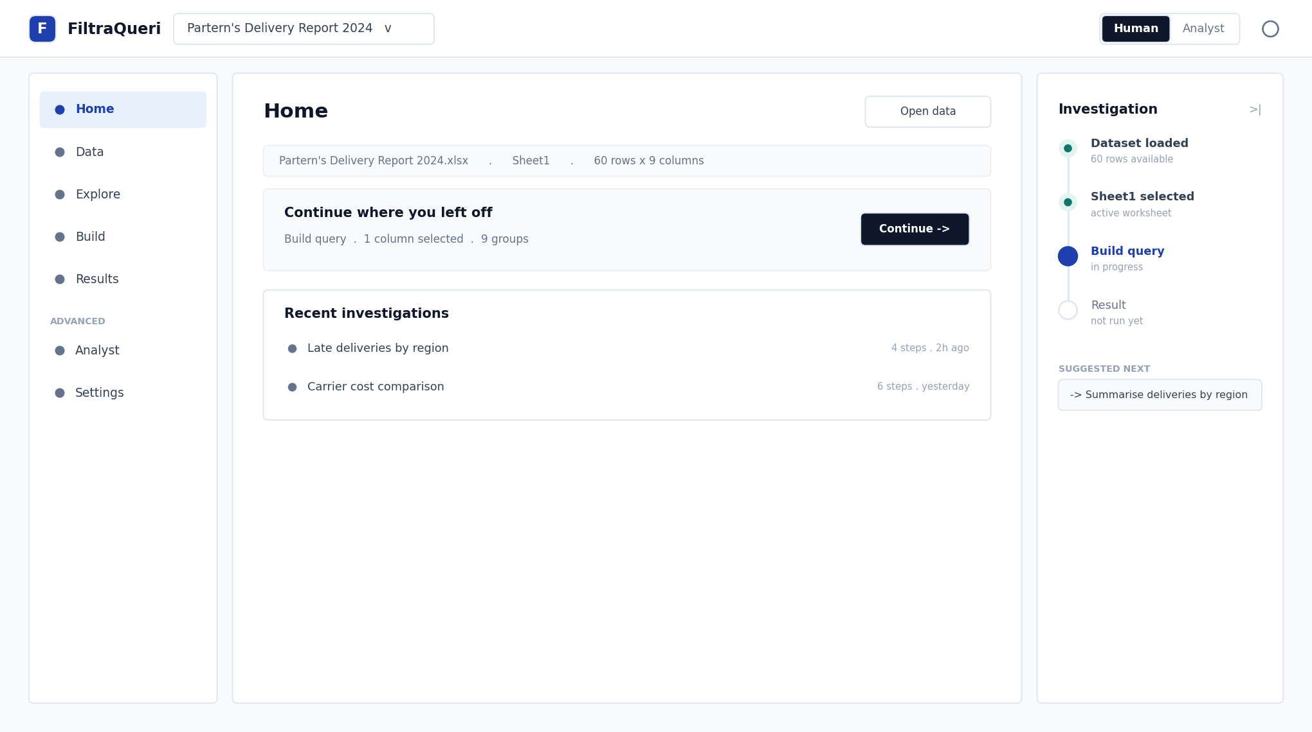
Figure A.2 — Home as a calm orientation landing: one title, context strip, a modest continue card, recent work. No metadata strip, no competing entry points.
A.3 Data — target direction
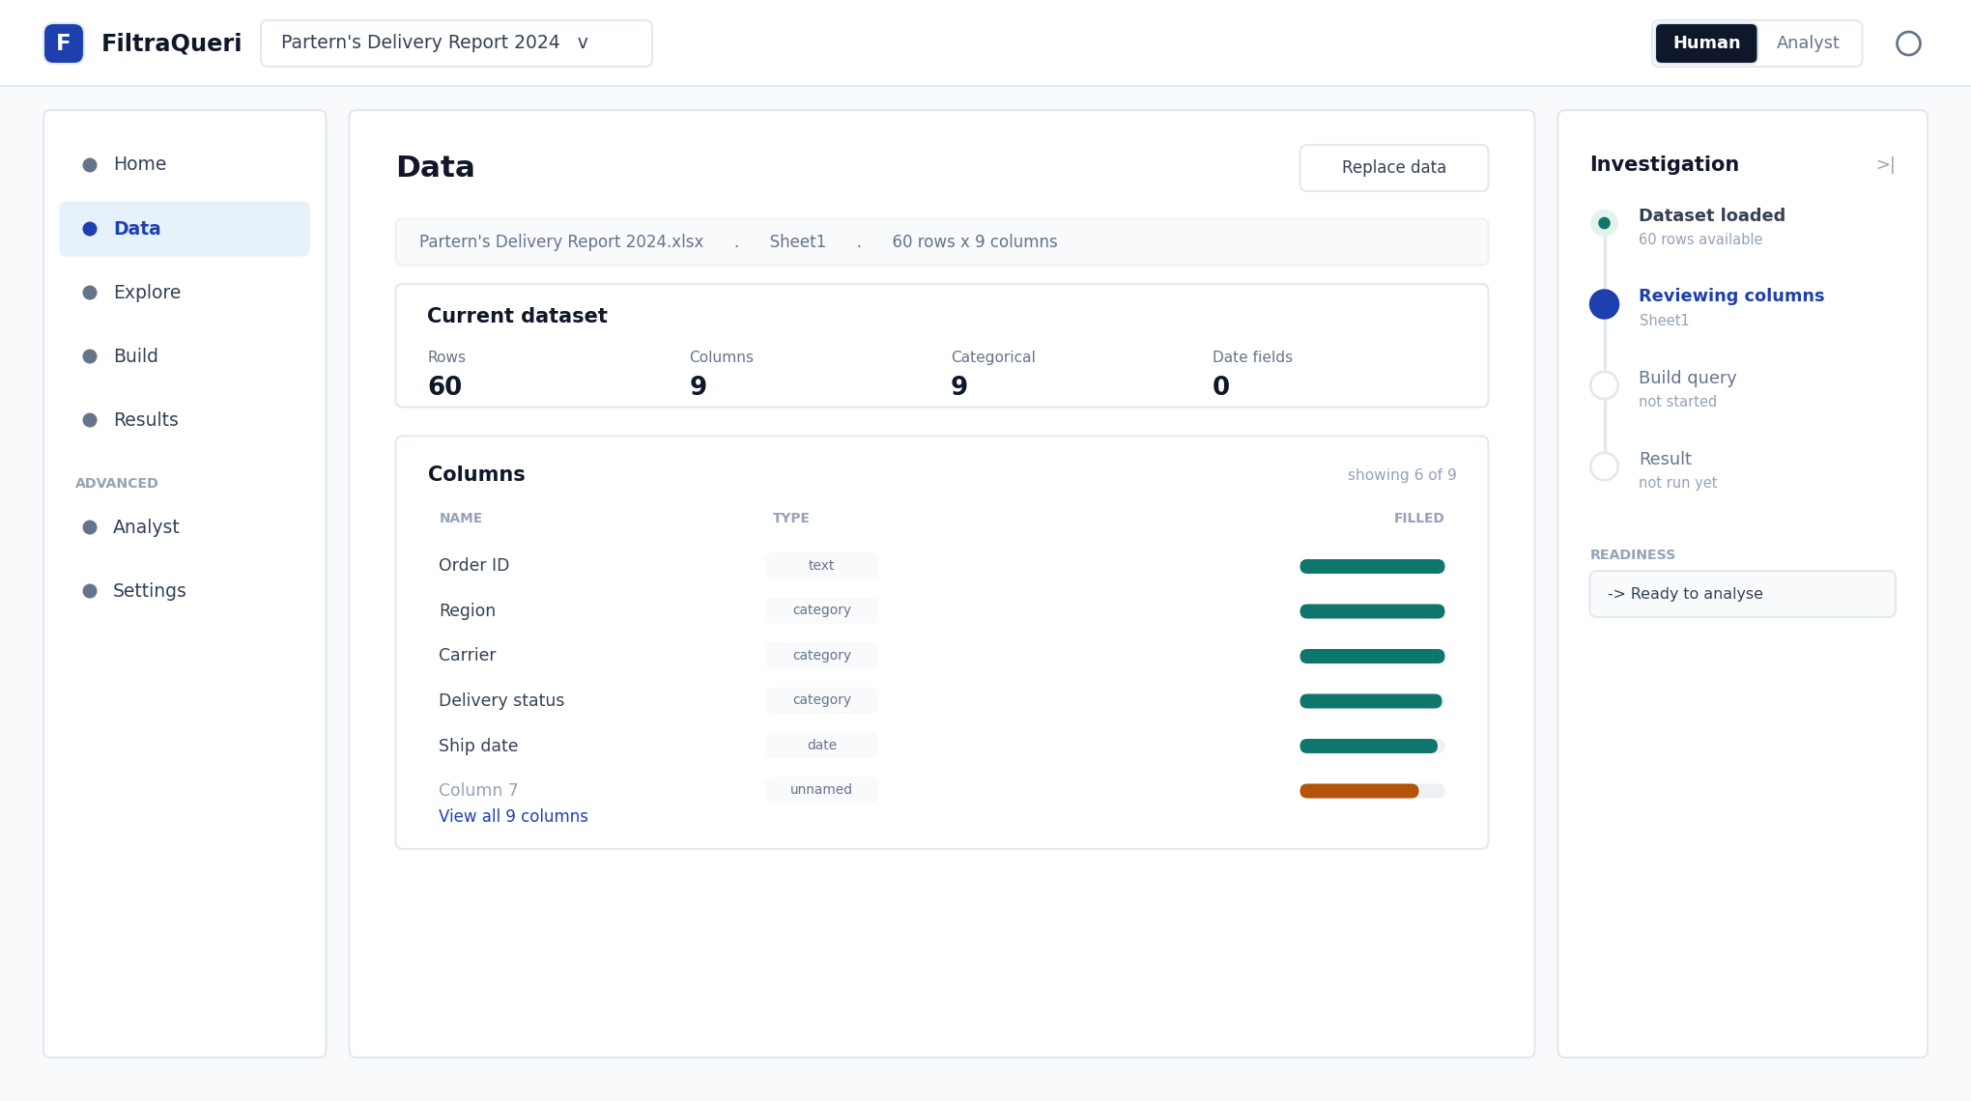
Figure A.3 — Data as focused dataset understanding: a clean summary and a flat column table. No pill maze, no duplicate navigation cards, no metadata dump.

A.4 Analyze — target direction
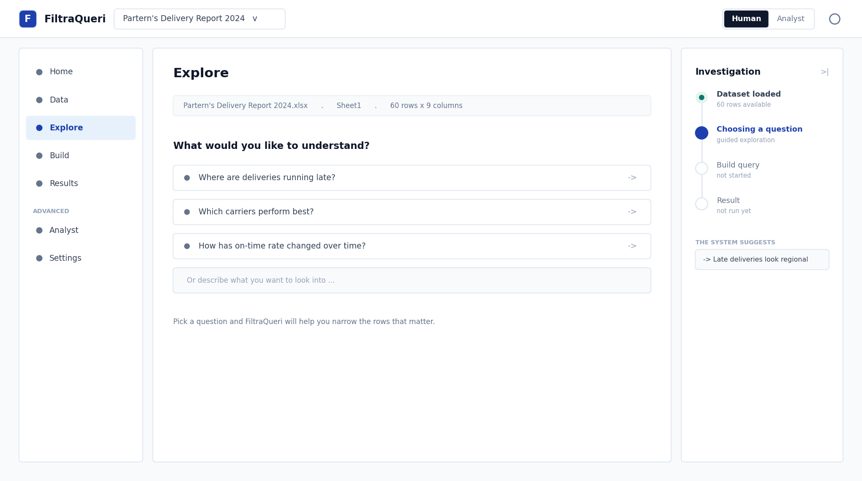
Figure A.4 — the intent-first entry for Analyze: a plain-language question prompt with suggestions, replacing the six-step query builder. One calm sentence where the current build stacks readiness cards.
A.5 Cross-reference
For the rules behind… | See
Type, color, layout, density, IA shell | Workspace Layout Specification
Language, guided flows, mode, errors, explainability | Human Mode Interaction Specification
Optimization and forecasting surfaces in Analyze | Optimization Intelligence Architecture Spec
Detail pages, navigation, back behavior | Consumer Architecture Governance Spec (S5-B)

End of master plan
FiltraQueri . UX Overhaul Master Plan . v1.0 . From metadata-heavy to experience-first

