Hubble Constant Report

Christien Davies (cd3n24)
Id: 36043753
Contents
Cepheid Period-Luminosity 2
NGC4527 Distance 3
Hubble Constant 5

Cepheid Period-Luminosity
A Cepheid variable star is one whose absolute magnitude depends on the period of its pulsation, given by the formula:
$$M= α\log_{10}{P}+ β$$
Where M is the absolute magnitude, P is the period of pulsation, and $α$ and $β$ are constants. The aim of this step is to find optimal values for these two constants.
In order to use this relationship I need to obtain values of M and P. I can use the equation:
$$M=m-5 \log_{10}{d}+5-A$$
The dataset I have been provided with contains values for the parallax angle of the star, the time period of its pulsation, its apparent magnitude and the extinction. I can use the parallax angle in the formula:
$$d= \frac{1000}{p}$$
Where $d$ is the distance to the star, and $p$ is the parallax angle. The parallax angle is given in units of milliarcseconds, therefore the units of distance are parsecs.
Errors are given for parallax and the extinction only, it can be assumed that the other values are precisely known. To calculate the uncertainty for my values of absolute magnitude, I assume the errors on parallax angle and extinction to be gaussian, and combine these with the exactly known values given to produce a gaussian distribution for each datapoint. The value for this datapoint is therefore the mean, and the error on it the standard deviation of the distribution.
With these values obtained the values of absolute magnitude and the base-10 logarithm of the period were fit to the luminosity model using the ‘curve_fit’ function. This function finds the optimal parameters to fit the model, that is those that give the lowest value of $χ2$. The figure shows this fit. This has a $χ^{2}$ = 4.14, and a reduced value $χ_{v}^{2}$ = 0.517. The acceptable range of $χ_{v}^{2}$ for this dataset with eight degrees of freedom, as I have 10 datapoints and am fitting two parameters, is 1 +- 0.5. The 0.5 is the standard deviation of the reduced $χ^{2}$ distribution calculated by:
$$\frac{\sqrt{2(10-2)}}{10-2}=0.5$$
My $χ_{v}^{2}$ value falls within this range, but near the point where I would not accept this value. While I will accept this value and take it as showing the data fits the model, it should be noted that there is likely greater error in these datapoints than has been provided to me.
It can be seen visually that my fit to the data falls within all the error ranges for each datapoint, which also suggests that this model is a good fit to the data.
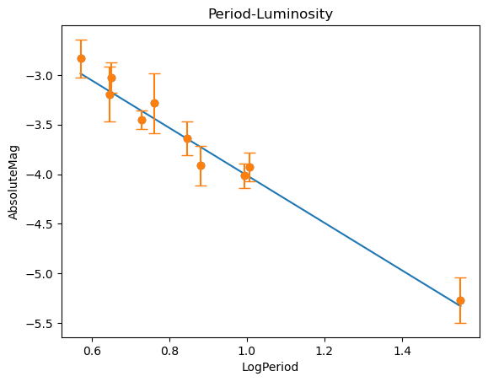
This fit gives my value of $α$ as -2.40 and $β$ as -1.61. This gives me a final model of:
$$M= -2.40\log_{10}{P}-1.61$$
The ‘curve_fit’ function also outputs a covariance matrix, from which can be obtained errors of $α$ and $β$. The error on $α$ is +- 0.24 and the error on $β$ is +- 0.21. The function takes into account the error on the y values, as can be seen in the figure, so these errors will be taken as the actual error on the parameters.
This method results in $α$ and $β$ being correlated with each other, ideally I would move the data to be centred around the line x=0, then fix the intercept, $β$, and vary the gradient of the fit, $α$, to remove the correlation. However, I did not have time to do this so it has not been included here.

NGC4527 Distance
This step’s aim is to calculate the distance to a galaxy, NGC4527, given the period and apparent magnitude of a number of stars in this galaxy. I can calculate a value for distance by equating the two formulas for absolute magnitude shown in the last step:
$$α\log_{10}{P}+β= m-5 \log_{10}{d}+5-A$$
Distance is therefore:
$${10}^{\frac{m+5-A-α\log_{10}{P}-β}{5}}$$
A, the extinction, is constant for all values in this step and is equal to 0.0682.
The dataset I have been provided with does not have estimates of errors for the period or apparent magnitude, so the errors for each value of distance come from the errors on $α$ and $β$ exclusively. Taking my fit parameters as gaussian distributions I create a gaussian for each datapoint and take the mean of the distribution as the value and the standard deviation as the error.
Now I have values of distance with errors for each datapoint, I calculate a weighted mean, which takes into account the errors. Take the difference between the raw calculation of distance, which ignores the errors, and the mean distance for each datapoint, which includes the errors. Square this difference and apply the weighted mean of the values to get the variance. The standard deviation and so error on the final weighted mean is the square root of this.
This calculates the distance to the galaxy as 15,200,000pc +- 417pc.
The error on this is exceptionally small. As the provided dataset comes with no estimates of errors for each datapoint, the error is nearly the same for all points as they come from the gaussian distributions on $α$ and $β$. So the weighted mean is extremely close to the arithmetic mean, not including the weights.
As the stars are at different points inside the galaxy, each will suffer a slightly different extinction from inside NGC4527, as light from each star will traverse a different distance to exit the galaxy. Those further away inside NGC4527 will experience a greater extinction, so should have a much larger error than those closer to us. I have not been given any estimate of this difference in extinction for each star, so I cannot include this in my calculation of error.

Hubble Constant
The aim of this step is to calculate an estimate of the Hubble Constant, $H_{0}$. Hubble’s Law is given as:
$v= H_{0}D$
Where $v$is the recessional velocity of a galaxy, measured in km/s, and $D$is the distance to the galaxy, measured in Mpc. This gives the units of $H_{0}$ as (km/s)/Mpc.
I have been given values of the recession velocity and corresponding values of distance for 7 galaxies, and this can be combined with the results from the previous step to give 8 total datapoints. I have not been given uncertainties for the values of recession velocity, so these are assumed to be known precisely. Errors are given for the values of distance however.
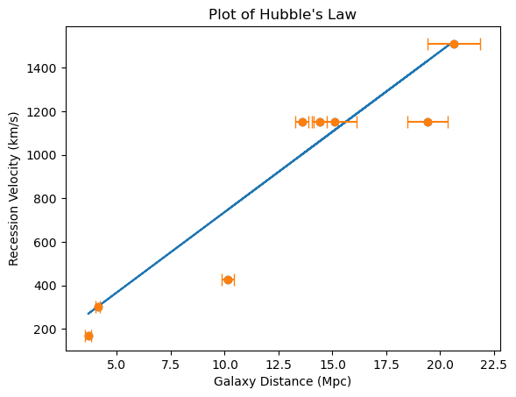
A plot of Hubble’s Law would usually be v against D, however to include the errors on the distance rather than the velocity, I fit the data to D against v. My error for the Hubble constant will come from the covariance matrix of ‘curve_fit’. This will be taken as a percent of the calculated gradient, then this percentage applied to the final Hubble constant value. As I only have errors for the values of galaxy distance, I will not be simulating errors with a gaussian distribution, unlike the previous two steps.

This fit gives my Hubble Constant = 76.0 +- 0.21
My calculated error for the Hubble Constant is small as I am only fitting one parameter and, as can be seen from the plot, the given errors on distance are small. The error bars for the majority of points fall outside the line of best fit. This would suggest that the fitting model is incorrect, however it is known that Hubble’s Law is correct. Therefore, I can conclude that the errors given in the distance to each galaxy have been underestimated. It can also be seen that the given datapoints fall across a wide range of values, with large gaps between.
More data points would significantly improve the fit. Furthermore, four datapoints share the same recession velocity, but all have different distances, which is not consistent with Hubble’s law visually, so this leads me to believe that these points have been calculated incorrectly or have not been given with a significant enough error.
These figures produce exceptionally high values of $χ^{2}$ and $χ_{v}^{2}$, 5.8x${10}^{6}$ and 8.3x${10}^{5}$ respectively, which leads me to believe that the model is unfit for the data. However, as my point before, intuition tells us that Hubble’s Law is correct, so I can conclude that the data is a bad fit to the model, due to underestimated errors.

