**TOPIC – ONLINE PLATFORM FOR PET ADOPTION**

**ABSTRACT:**

Pet adoption is a compassionate practice involving the rehoming of domestic animals, such as dogs and cats, from shelters or rescue organizations. This process provides abandoned or stray animals with a chance for a better life while offering adopters the joy of companionship. The selection criteria for adopters often include factors like compatibility and temperament. Pet adoption not only gives animals a second chance but also contributes to reducing shelter overcrowding. Emphasizing responsible ownership, this practice encourages proper care, including veterinary attention and training. Overall, pet adoption promotes empathy and responsibility, creating positive outcomes for both animals and their adoptive families.

**EXISTING SYSTEM:**

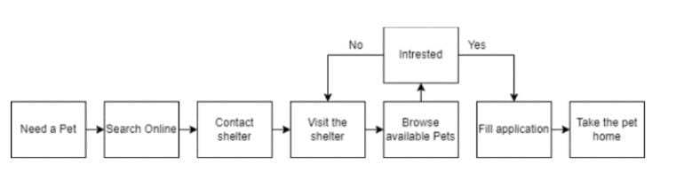

Fig.No.1. Existing Pet Adoption System

The current pet adoption process is incredibly ineffective. When someone wishes to adopt a pet, they must look up animal shelters in the area. To discover a pet they want to adopt, people must go to several animal shelters. The promotion of pet adoption on social media platforms like Instagram, Facebook, and WhatsApp is done by some people, but it is not particularly effective. The present pet adoption system in India frequently fails for a number of reasons, including:

**Lack of Standardization:**

The procedure for adopting pets is not standardised across the nation. Potential pet owners may find the procedures followed by various adoption agencies and organisations confusing.

**Lack of Regulation:**

The adoption of pets is not adequately governed or supervised. This may result in dishonest breeders or adoption organisations taking advantage of animals and potential pet owners.

**Limited Availability:**

It might be challenging for those who live in rural locations to adopt pets because adoption services are frequently only found in urban areas. Also, this restricts the choices available to prospective pet owners.

**Lack of Information:**

Frequently, prospective pet owners lack access to reliable information on the animal they are considering adopting. This may result in a mismatch between the needs of the animal and those of the potential owner, which may result in abandonment or neglect.

**PROPOSED SYSTEM:**

The suggested method is a centralised web platform where animal shelters can post listings of available pets and individuals looking to adopt can browse through a list of animals available at different animal shelters. Individuals won't need to look for animal shelters in the area. To find a pet, people won't need to go to several shelters. Via the platform, users can get in touch with the shelters directly. The adoption procedure will be extremely effective as a result.

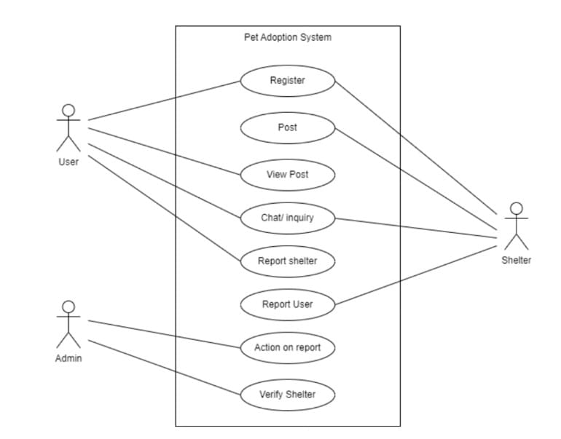

Fig.No.2. Use Case Diagram

**Standardization:**

By offering a centralised database of animal shelters and adoption organisations, a digital platform can assist in standardising the pet adoption process. Potential pet owners may find it simpler to choose the best shelter or organisation and comprehend the adoption procedure as a result.

**Accessibility:**

By offering data on animal shelters and adoption organisations around the nation, a digital platform can boost the accessibility of adoption alternatives. This can assist prospective pet owners in finding a suitable animal regardless of where they live.

**Information:**

A web-based platform can offer precise details about the animals that are up for adoption, such as their breed, age, temperament, and medical background. This can aid potential pet owners in choosing the right animal to adopt and ensuring that the needs of the animal are suitable with their lifestyle.

**SYSTEM REQUIREMENTS:**

**Hardware requirements:**

* System: Pentium IV 2.4 GHz.
* Hard Disk: 40 GB.
* Floppy Drive: 1.44 Mb.
* Monitor: 15 VGA Colour.
* Mouse: Logitech.
* RAM: 512 Mb.

**Software requirements:**

* Operating system: Windows XP/7.
* Front end: HTML, CSS, JAVASCRIPT.
* DATABASE: MYSQL.

**ENTITY RELATIONSHIP DIAGRAM:**

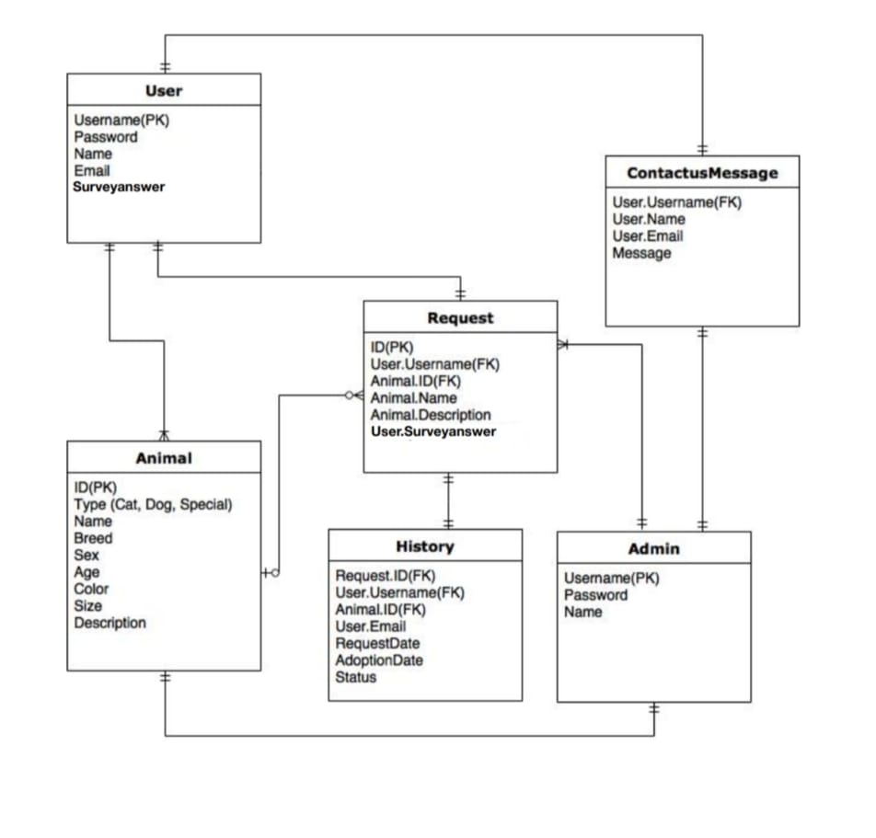

Fig. No.3. ER- diagram

**OUTPUT:**

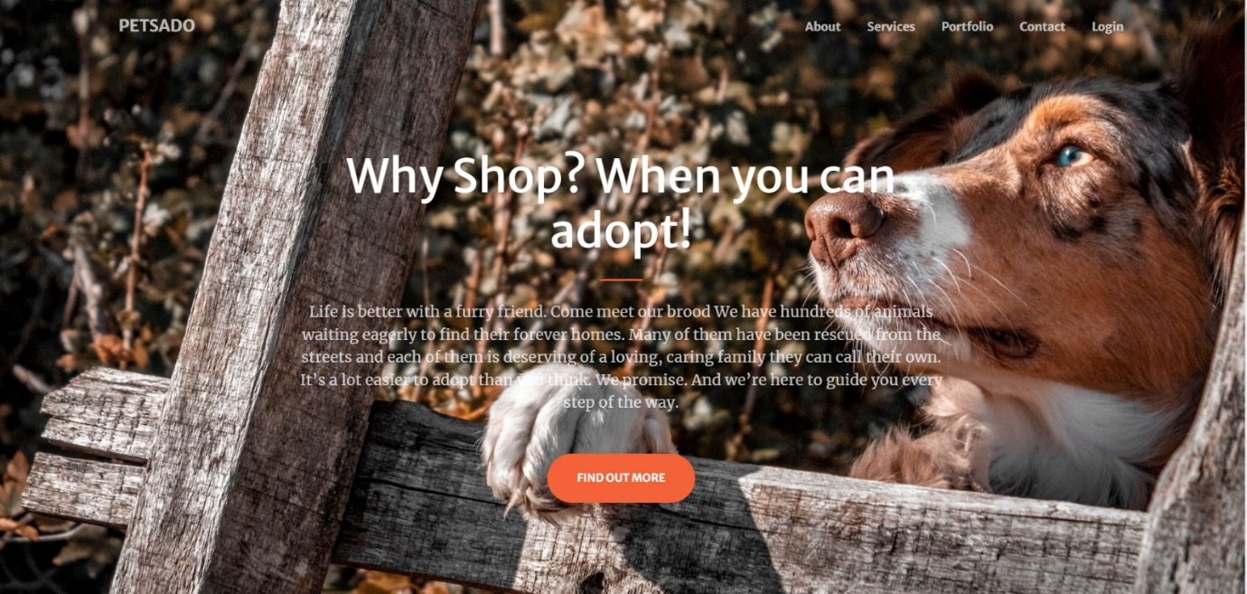

Fig.No.4.

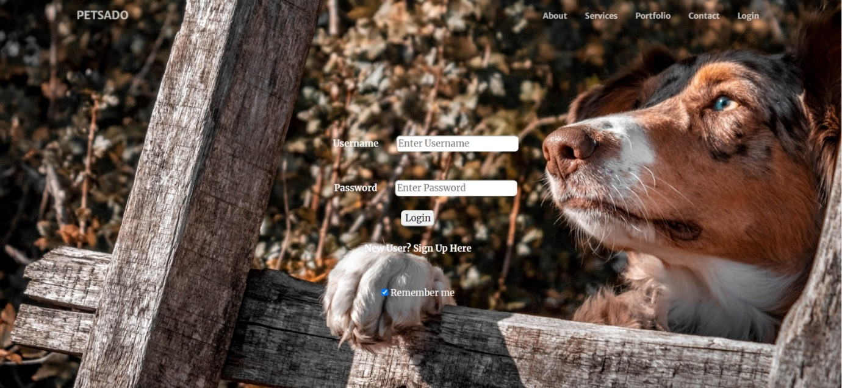

Fig.No.5.

**CONCLUSION:**

In conclusion, by raising awareness, standardisation, regulation, availability, information, and lowering costs, a digital platform for animal shelters can assist in addressing the difficulties in pet adoption in India.

Our pet adoption application's prototype was successfully created. The following are the main goals our application aims to accomplish:

• Individuals will learn about stray animals in their area that want assistance.

• There will be a decrease in the number of stray animals put to death.

• Kind hearted people will have the chance to help defenceless animals.

**REFERENCE:**

1. https://www.researchgate.net/publication/373627974_PET_ADOPTION_SYSTEM_USING_WEB_TECHNOLOGY