- Fuels
Intelimon model for ‘totalfuel load’ aka FMH/FFI ‘TotalAll’ metric was submitted to intelimon in march 2026.
- TotalAll PreBurn – model built from 59 scan/field data pairs. Included pips 1, 2, 5, 14
- TotalAll PostBurn – model build from 17 scans, including pips 1, 2, 5, 14
- TotalAll Year01 – model built from 13 scans (does not include any BM plots)

Image 1: ‘TotalAll’ fuel estimates. *only have ‘post-burn’ scan/field data for our RAP plots. But have pre and year01 scan/field data for our plots(n=4) and ben’s plots(n=7).
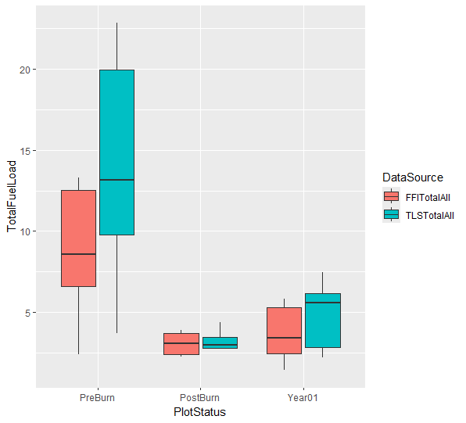

Image 2: same thing basically except im separating out ben’s plots from our fmh/rap plots. Since our plots were used to build the models, it doesn’t really mean as much that the field/tls data tracks well with each other I think.
But unfortunately, while there is no statistical difference between the field/tls estimate for our FMH plots (p > 0.1), there is for Ben’s plots for both pre and year01 data (p < 0.1)
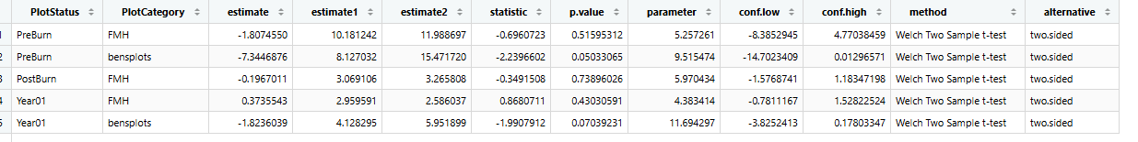
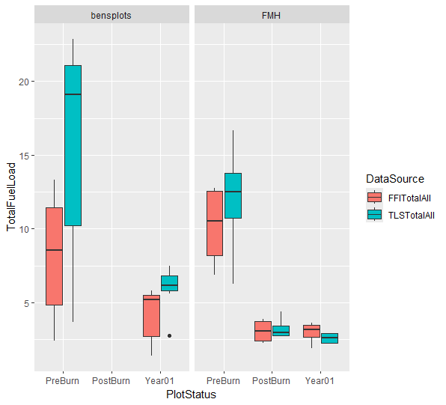

This might be sketchy… But if I remove 2/7 of bens plots (the 2 with the worst relationship between TLS and Field data) then this relationship changes. This is still 5 plots of ben’s data vs only 4 plots of our data so if we are transparent about saying we only saw this in 5/7 of his plots then maybe it is ok? Im not sure

Image 3: same as before but we remove ben’s plot 8005 and 8009. Now you can see (p > 0.1) for everything
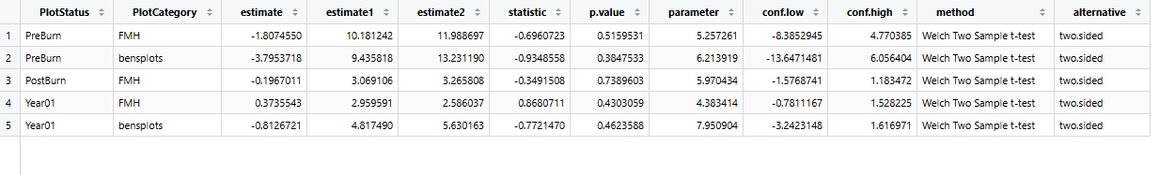
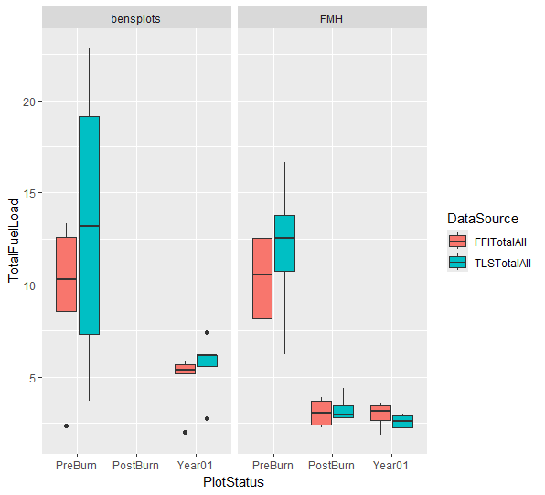

- Trees (scorch height/scorch percent/ CBH)
- Intelimon model for meanCBH was built using 52 scans from east side ROMO plots. Pre- and Post-burn scans from PIPS_14 and PIPS_05 were used to build this model
- Intelimon model for meanScPct and meanScHt was built using scans from 17 post-burn plots. These included pips 1, 2, 5, and 14

Image 1: Year01 CBH Estimates. P value for ben’s plots is 0.2, so there is still no statistical difference between CBH on his plots measured in field vs tls
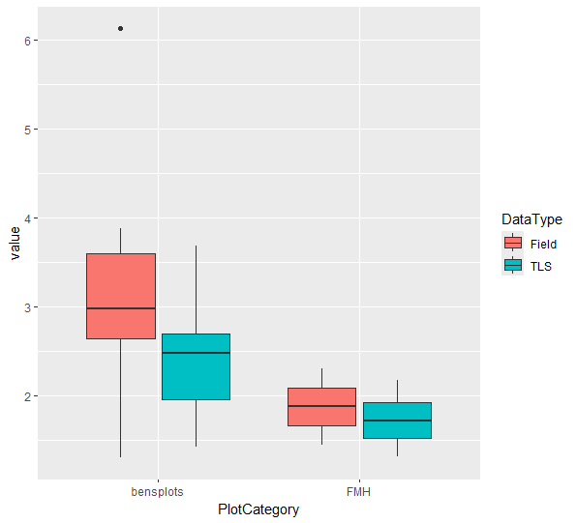

Image 2: meanScPct.
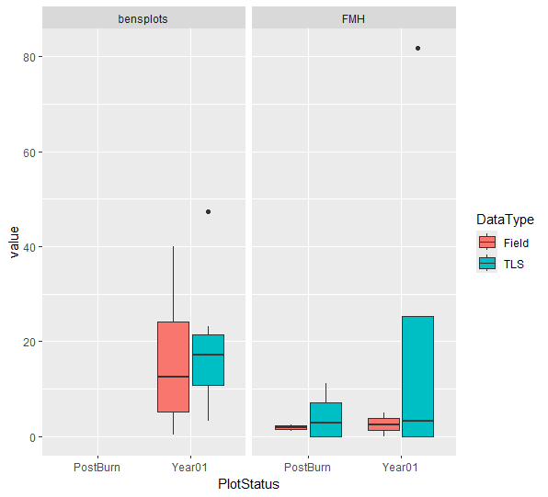

Image 3: meanScHt. Really bad relationship for both ben’s and our plots. Kind of interesting


