An Original Method of Edge Detection Based on Cellular Automata

(Homework for EE817 Emerging Computing Technologies, Prof. Marek Perkowski)

Hilton Tamanaha Goi
Student Number: 20034505

Department of Electrical Engineering and Computer Science
Korea Advanced Institute of Science and Technology
373-1 Guseong-dong, Yuseong-gu, Daejeon 305-701, South Korea
E-mail: hilton@cnr.kaist.ac.kr
Date: June 3rd 2003

Abstract: Edge detection is a fundamental operation in image processing [1]. In this project we propose an efficient and simple method of edge detection based on cellular automata.

Keywords: Edge Detection, Cellular Automata, Image Processing, Monochrome Image.

1. Introduction
The computer science field has increased expectation on technologies of computations based on Cellular Automata (CA) theory. In the area of image signal processing, several methods of Edge Detection are proposed, such as Canny-Deriche, Nalva, Iverson, Bergholm, Rothwell, Suzan, and others [2]. However, so far there is no proposed edge detection method based on CA. In this project we developed a new method for edge detection using a CA Algorithm. We confirm the results of edge detection with graphical examples. In Section 2 we explain the edge detection concept, and in Section 3 we introduce the CA Model that will be used in the edge detection architecture. In Section 4 we formulate rules of edge detection and describe the system of the proposed method. The operational results of edge detection are discussed in Section 5, and finally in Section 6 we conclude the results obtained and point out the further studies that must be continued regarding research of edge detection methods based on CA.

2. Concepts of Edge Detection
First of all, we have to clarify what is Edge Detection. Here are some definitions of edge detection: An edge is not a physical entity, just like a shadow. It is where the picture ends and the wall starts. It is where the vertical and the horizontal surfaces of an object meet. It is what happens between a bright window and the darkness of the night. Simply speaking, it has no width. If there were sensor with infinitely small footprints and zero-width point spread functions, an edge would be recorded between pixels within in an image. In reality, what appears to be an edge from the distance may even contain other edges when looked closer. The edge between a forest and a road in an aerial photo may not look like an edge any more in an image taken on the ground. In the ground image, edges may be found around each individual tree. If looked a few inches away from a tree, edges may be found within the texture on the bark of the tree. Edges are scale-dependent and an edge may contain other edges, but at a certain scale, an edge still has no width [3].
Traditionally, edges have been loosely defined as pixel intensity discontinuities within an image. While two experimenters processing the same image for the same purpose may not see the same edge pixels in the image, two for different applications may never agree. In a word, edge detection is usually a subjective task. As a user of an edge detector, one should not expect the software to automatically detect all the edge he or she wants and nothing more, because a program can not possibly know what level of details the experimenter has in mind. Usually it is easy to detect those obvious edges, or those with high S/N ratio. But what about those not very obvious? If a program detects all the pixel intensity discontinuities in an image, the result image will not be very much different from one fill of noise. On the other side, as a developer of an edge detector, one should not try to create a program that automatically produces the ideal result each and every user has in mind, because nobody can read other people's mind. Instead, a developer try to: 1) create a good but simple way to let the users express their idea about the edges they have in mind regarding a specific image; and to 2) implement a method to detect the type of edges a user ordered. In another word, an edge detector can not possibly be 100 percent automatic. It must be interactive, requiring a few input parameters at least.
The quality of edge detection is limited by what's in the image. Sometimes a user knows there should be an edge somewhere in the image but it is not shown in the result. So he adjusts the parameters of the program, trying to get the edge detected. However, if the edge he has in mind is not as obvious to the program as some other features he does not want detect, he will get the other "noise" before the desired edge is detected. Edge detecting programs process the image "as it is". As a human being, an experimenter knows there is an edge because he is using knowledge in addition to what's contained in the image. How to use such knowledge about the real world in the process of general edge detection is a huge topic that I would like to watch from a safe distance for the time being. For example, if the program knows an edge is that of a road and it is likely that it will continue on the other side of a tree branch, then it may have a chance to detect the edge of each and every visible part of a road behind a tree; otherwise, some small and not so obvious pieces of the edge may remain undetected. In a simplified special case, an edge detector may be tailored to take advantage of the domain knowledge. For example, a "straight edge" detector may be very effective in locating most buildings and objects such as tennis courts in an aerial photo.
Also because of the subjectivity of edge detection, it is difficult to compare the performance of two edge detectors on most real-world images. However, it is quite easy to compare them using synthetic images such as those shown on a separate page. In those images, the number of edge pixels should be the same as the height of the image. Whichever edge detector that produces the most edge pixels along the central line and the fewest in other areas wins. If an edge detector that performs badly on such images, it is unnecessary to try it on other real-world images. If it does well on such synthetic images, however, it may not do well in the real game.

3. Cellular Automata Model
The basic element of a Cellular Automata is the cell. A cell is a kind of a memory element and stores - to say it with easy words - states. In the model adopted in this project, each cell can have the binary states 1 or 0. In more complex simulation the cells can have more different states.
The cells arranged in a spatial web form a lattice. These cells arranged in a lattice represent a static state. To introduce dynamic into the system, we have to add rules. The "job" of these rules is to define the state of the cells for the next time step. In cellular automata a rule defines the state of a cell in dependence of the neighborhood of the cell.
Different definitions of neighborhoods are possible. Considering a two dimensional lattice the following definitions are common.
- Von Neumann Neighborhood, four cells. The cell above and below, right and left from each cell are called the Von Neumann neighborhood of this cell. The radius of this definition is 1, as only the next layer is considered. The total number of neighbor cells including itself is 9 cells
- Moore Neighbourhood, eight cells. The Moore neighborhood is an enlargement of the von Neumann neighborhood containing the diagonal cells too. In this case, the radius r=1 too. The total number of neighbor cells including itself is 9 cells.
- Extended Moore Neighborhood, equivalent to the description of Moore neighborhood above, however the neighborhood reaches over the distance of the next adjacent cells. Hence the r=2 (or larger). The total number of neighbor cells including itself is 25 cells.
- Margolus Neighborhood, a completely different approach: considers 2x2 cells of a lattice at once. We will not describe Margolus Neighborhood in details here.

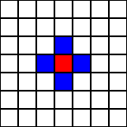 | 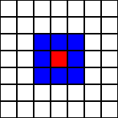 | 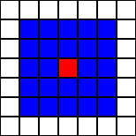
(a)Von Neumann (b)Moore Neighborhood (c)Extended Moore
Fig. 1 Models of cellular automata neighborhood.

In this project we use the Moore Neighborhood Model. The red cell is the center cell, the blue cells are the neighborhood cells. The states of these cells are used to calculate the next state of the (red) center cell according to the defined rule.
As the number of cells in a lattice has to be finite (by practical purposes) one problem occurs considering the proposed neighborhoods described above. Here we assume that opposite borders of the lattice are "sticked together". A one dimensional "line" becomes following that way a circle, a two dimensional lattice becomes a Karnaugh Map.

4. Image Data Processing in Cellular Automata Model
An image (picture, draw, graph, etc) data is formed by pixels. A two dimensional image data is represented by a (M x N) sized matrix, where M is the number of columns, and N the number of rows. The simplest example of an image data is the black and white (Monochrome) image. Assuming black color being represented by “1” and white color by “0”, we form the image data matrix in unit of binary information. For easier understanding, let’s verify the heart shape of Fig. 2. In Fig. 2 (a) an image data of 100 pixels (size 10 x 10) composed of binary information (“0” and ”1” bits) is shown. The monochrome image is visualized in Fig. 2 (b).
The next step in cellular automata is to count the number of neighbors of each cell. We can represent the number of neighbors as in Fig 3. (a), and then by plotting the image using 10 different colors for each number of neighbors (minimum 0 and maximum 9 neighbors for Moore Neighborhood Model), we obtain Fig. 3 (b).
Defining a rule similarly as in Game of Life, for certain number of neighbors a cell will die, born or keep is state. For the example above, we assume that all cells with 3 neighbors or less will die of loneliness, and those cells with 7 neighbors or more will die of over population. Only the cells with 5 neighbors will be born, and furthermore the cells with 4 or 6 neighbors keep its previous state. Taking the color out of those cells which died, we obtain the Fig. 4 (a). At last, setting the values of the dead cells to “0”, and the values of the alive cells to “1”, and then replotting the image in monochrome mode, we obtain the final result of the edge detection as shown in Fig. 4 (b).

0
0
0
0
0
0
0
0
0
0
0
0
0
0
1
0
0
0
0
0
0
0
0
1
1
1
0
0
0
0
0
0
1
1
1
1
1
0
0
0
0
1
1
1
1
1
1
1
0
0
0
1
1
1
1
1
1
1
0
0
0
1
1
1
1
1
1
1
0
0
0
0
1
1
0
1
1
0
0
0
0
0
0
0
0
0
0
0
0
0
0
0
0
0
0
0
0
0
0
0

(a) Binary data matrix (b) Monochrome image visualization
Fig 2 Example of a cellular representation of a heart-shape image

0
0
0
1
1
1
0
0
0
0
0
0
1
3
4
3
1
0
0
0
0
1
3
6
7
6
3
1
0
0
1
3
6
8
9
8
6
3
1
0
2
5
8
9
9
9
8
5
2
0
3
6
9
9
9
9
9
6
3
0
2
5
8
8
8
8
8
5
2
0
1
3
5
5
5
5
5
3
1
0
0
1
2
2
2
2
2
1
0
0
0
0
0
0
0
0
0
0
0
0
0
0
0
1
1
1
0
0
0
0
0
0
1
3
4
3
1
0
0
0
0
1
3
6
7
6
3
1
0
0
1
3
6
8
9
8
6
3
1
0
2
5
8
9
9
9
8
5
2
0
3
6
9
9
9
9
9
6
3
0
2
5
8
8
8
8
8
5
2
0
1
3
5
5
5
5
5
3
1
0
0
1
2
2
2
2
2
1
0
0
0
0
0
0
0
0
0
0
0
0

(a) Number of neighbors matrix (b) Colored image visualization
Fig 3 Write in each cell its number of neighbors

0
0
0
1
1
1
0
0
0
0
0
0
1
3
4
3
1
0
0
0
0
1
3
6
7
6
3
1
0
0
1
3
6
8
9
8
6
3
1
0
2
5
8
9
9
9
8
5
2
0
3
6
9
9
9
9
9
6
3
0
2
5
8
8
8
8
8
5
2
0
1
3
5
5
5
5
5
3
1
0
0
1
2
2
2
2
2
1
0
0
0
0
0
0
0
0
0
0
0
0

(a) Dead cells loose their colors (b) Final Monochrome image visualization
Fig 4 Heart-shape image after edge detection

Next, in Fig. 5 we show the system architecture (which also serves as flowchart for program coding) for the proposed method of edge detection based on image processing with cellular automata as explained above.

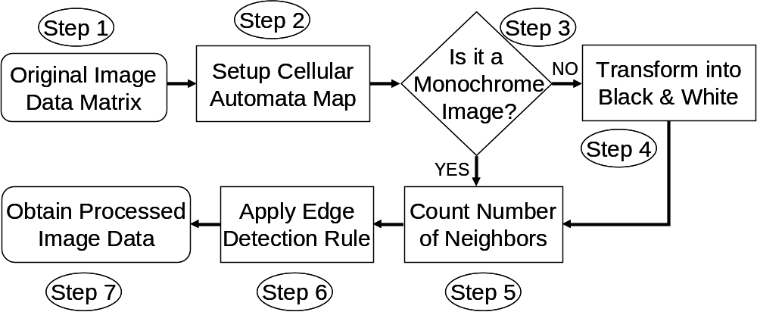

Fig. 5 Architecture of the Edge Detector Model Based on Cellular Automata

Let’s make an accurate explanation of every step of Fig. 5.
Step 1: First of all, it is necessary to read the data information that composes the image. It does not matter the format of the image (e.g. jpeg, bmp, png, gif, etc), we assume that all image data is formed by a data matrix of size M x N.

Step 2: We set up the cellular automata map which where the edge detector operation will be performed. This can be directly done by separating each pixel of the original image into one cell. As the image information is composed of a data matrix of size M x N, the cellular automata map will be also in the shape of a M x N matrix, thus with MN cells.

Step 3: Color images, gray level images, and pure monochrome (black and white) images can be processed by our proposed method. However, for color images, it is necessary to perform black & white transformation (go to step 4) before edge detection operation. On the other hand, in the case of a monochrome image this can be processed directly, jumping (ignoring and not performing) the step 4.

Step 4: As mentioned in step 3, in the case the original image is colored, there is a necessity of transforming it into black and white pattern before edge detection operation. This stage is selected and performed in this case, however is jumped (ignored and not performed) in the case the original message is monochrome already.

Step 5: Once we have a cellular map of the monochrome image data, we can then count the number of neighbors of each cell. Remembering that in this project the adopted model is the Moore Neighborhood Model as shown in Fig. 1(b).

Step 6: We apply an edge detection rule in order to select the characteristics of processing of the image. A detailed explanation of the “edge detection rules” is to be made in the next section. In this stage there will be basically a selection of the cells which will die and which will stay alive, and as the result we obtain a edge detected image.

Step 7: The final result is a monochrome edge detected image. The pixel size (number of columns and rows of the image data matrix) will be exactly the same as that of the original image data.

5. Edge Detection Rules
The type of rules employed in this project is a so called "Totalistic" Rule. That is, the state of the next state core cell is only dependent upon the sum of the states of the neighborhood cells, and its own present state. Each dead cell has state “0” as value, and each alive cell has state “1”. We calculate the sum of the states of all the adjacent and diagonal neighbors cells. In other words, in Fig. 1 (b) for instance all the blue cells are neighbors of the red central cell, plus itself. Thus the total number of neighborhood wach cell has is equal to 9. Thus the sum of the alive neighbor cells can be at maximum 9*1=9 (all the neighbor cells are alive), and at the minimum 0*1=0 (all the neighbor cells are dead).
After counting the number of alive neighbors for each cell, we apply a “decision rule” (DR) that will determine if the cell must become dead or alive. The total “number of decision rules” represented by “NDR” is calculated:
Number of states: 2. They are “1” alive, and “0” dead.
Number of neighbors: 10. The number of alive neighbors can be from 0 to 9.
Thus, NDR = 2 to power 10 = 1024. (Total of 1024 patterns).
This is a quite large number of possible rules to be tested. It is worth to realize that not all the rules are interesting, as for example if we choose a rule that kills all the cells regardless the number of alive neighbors, or the opposite, a rule that keep all the cells born regardless of the number of alive neighbors. It is interesting to select only the rules that present more efficiency for edge detecting of any kind of image.
Returning to the example given in Section 4, all the cells with 3 alive neighbors or less will die of loneliness, and those cells with 7 alive neighbors or more will die of over population. Only the cells with 5 alive neighbors will be born, and furthermore the cells with 4 or 6 alive neighbors keep its previous state. This rule can be interpreted as:
DR = 0 0 0 0 1 X 1 0 0 0
Here, the “X” state stands for don’t care, in other words keep the previous state. However, for simplification, we assume that “X” will also turn out to be “1” for primarily test, so the rule can be redefined as Rule 56:
DR = 0 0 0 0 1 1 1 0 0 0
In written words, we can explain the above rule as follows: For a given cell,
If the total number of alive neighbor is “NAC”, then the next state of the cell will be “NS”.
NAC can vary from 0 to 9, and NS is “1” or “0”.

If NAC = 0 then NS = 0
If NAC = 1 then NS = 0
If NAC = 2 then NS = 0
If NAC = 3 then NS = 0
If NAC = 4 then NS = 1
If NAC = 5 then NS = 1
If NAC = 6 then NS = 1
If NAC = 7 then NS = 0
If NAC = 8 then NS = 0
If NAC = 9 then NS = 0

Table 1 Formulation of Rule 56
NS | 0 | 0 | 0 | 0 | 1 | 1 | 1 | 0 | 0 | 0
NAC | 0 | 1 | 2 | 3 | 4 | 5 | 6 | 7 | 8 | 9
DR | 0 | 0 | 0 | 0 | 1 | 1 | 1 | 0 | 0 | 0
Thus we have DR = 0 0 0 0 1 1 1 0 0 0 (RULE 56).

Before starting simulations, it is important to reaffirm the general properties of cellular automata [4]. These 8 items have are essential for our project.
(1) CA is performed in space and time.
(2) A CA is a discrete simulation method. Hence Space and Time are defined in discrete steps.
(3) A CA is built up from cells, that are lined up in a string for one-dimensional automata arranged in a two or higher dimensional lattice for two or higher dimensional automata
(4)The number of states of each cell is finite.
(5)The states of each cell are discrete.
(6)All cells are identical.
(7)The future state of each cell depends only of the current state of the cell and the states of the cells in the neighborhood.
(8)The development of each cell is defined by so called rules.

6. Simulation
We will start the simulation of our proposed Edge Detection Method Based on Cellular Automata with a simple example, similar to the theory explained in Section 3.

(a) Original Monochrome Image (b) Rule 519 (1000000111)
Fig. 6 Example of Edge Detection of a monochrome image.

Let’s assume the monochrome image of Fig. 6(a), which resembles a person with a letter in his hand, and with an idea. The objects in this image including the person’s body, the letter and the expression of idea are completely dram in black color. The background color is white. By applying Edge Detection Method with Rule 519, we obtain the result shown in Fig. 6 (b). It is perfect edge detection; the remaining is only the contour of the image. The large areas with black color are all eliminated, thus a significant reduce in the size of image counted in bits is achieved. The data compression and image data size decrease are important aspects of edge detection operations.
However, this is a very simple example of monochrome image, which can have its edge detected by simply remaining the contour of the image. Furthermore, many rules lead to the same result, meaning it is easy to detect edges for the example given above. Next we analyze the performance of the proposed method for more complex images.

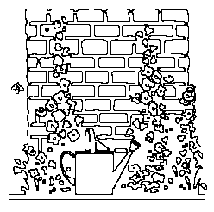
(a) Original Monochrome Image (b) Rule 535 (1000001111)
Fig. 7 Precise Edge Detection of a more complex monochrome image.

In Fig. 7 (a), a monochrome image representing a wall, flowers and a water bucket is displayed. Now, not as many rules will present good performance in edge detection compared to the previous example. With a brief trial and error analysis, it was confirmed that the Rule 535 has good performance for edge detection of complex monochrome image data, as result we observe the sharp edge detected image in Fig. 7 (b).
The data size of image shown in Fig. 7 (a) is of 248 x 246, and the time consumed to the edge detection of this example was approximately 3 seconds, using a PC of 2.0 GHz Pentium 4. The simulation is performed with a Matlab programmed code. Now, for larger images, what would be the performance of our edge detection method, regarding speed of operation? Let’s consider the next example shown in Fig. 8 (a).
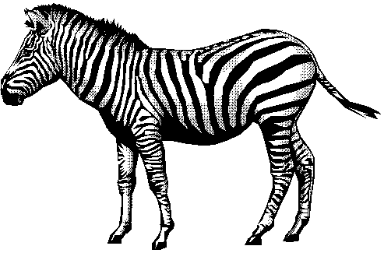
(a) Original monochrome image
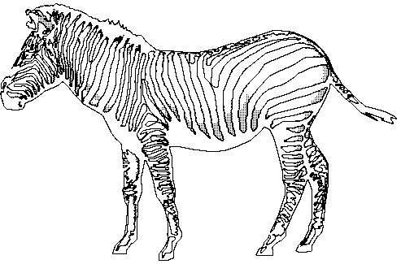
(b) Rule 783 (1100001111)
Fig. 8 Edge Detection of a large monochrome image.

The edge detection of Fig. 8 (a) was performed in 21 seconds, and the size of the image data matrix is of 493x325. The time consuming feature of our method has an increase following the enlarging size of the image data. The operation time characteristics can be improved by using code with C language, and by smoothly coding small and economic programs with few lines and few loops. However, this is a topic for future studies. In this initial phase of the edge detection method with cellular automata, we use the most convenient language for numerical calculation: MATLAB. The Rule used to detect the edges of the image in Fig. 8 (a) was Rule 783, and its result is visualized in Fig. 8 (b). As we can see in this result, the contour of the zebra’s body is displayed. Complex color images, as for example those of biomedical image field, have few essential information and many less important data. The most important information can be separated and analyzed better by applying edge detection that is why Edge Detection is an important technique used in Biomedical Image Processing.
Another important area of edge detection application is video signal processing. The sample in Fig. 9 (a) is the well known Lena image. This is a gray-scale image, and not black and white image, so there is a necessity of monochrome transformation, as shown in Fig. 9 (b) before performing edge detection, as shown if Fig. 9 (c) for Rule 543.

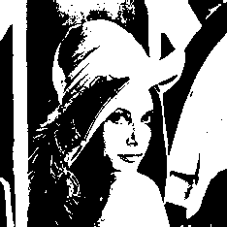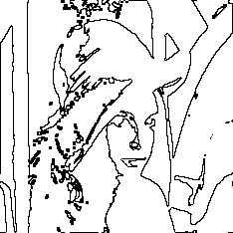
(a) Original Image (b) Monochrome Transformation (c) Rule 543 (1000011111)
Fig. 9 Monochrome Transformation and Edge Detection for color images

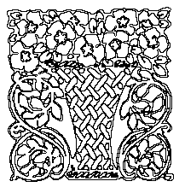
(a) Original Image (b) Rule 543 (1000011111) (c) Rule 3 (0000000011)
Fig. 10 Changing the intensity of edge contour

In general, edge detection techniques are also important for scanners and copying machines. The sample given in Fig. 10 (a) is a monochrome image of a flower bouquet. This image has first its edges detected very sharply with Rule 543, as shown in Fig. 10 (b). However, by using the Rule 3, it is possible to do the opposite, give stronger and fatter contour to the image as shown in Fig. 10 (c), meaning that the opposite operation of edge detection can also be performed by choosing an appropriate Rule.

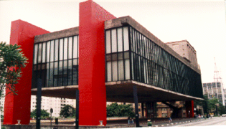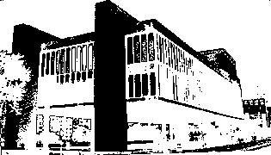
(a) Original Image (Color Picture) (b) After Monochrome Transformation

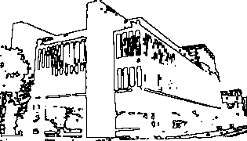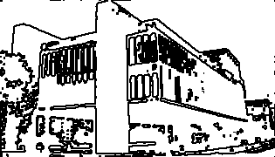
(c) Rule 543 (1000011111) (d) Rule 515 (1000000011)

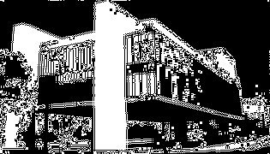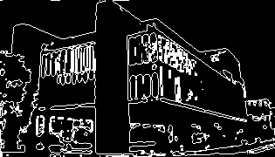
(e) Rule 682 (1010101010) (f) Rule 56 (0000111000)
Fig. 11 Multiple features of Edge Detection of a color picture.
Last but not least, let’s verify the edge detection of a color picture taken with a digital camera. This image shown in Fig 11(a) is a color picture of the beautiful Museum of Modern Arts of Sao Paulo, in Sao Paulo City, Brazil. The monochrome transformation is shown in Fig. 11(b). The first edge detection is performed with Rule 543, we observe in Fig. 11 (c) the weak contour of the edges. By using the Rule 515 it is possible to make a stronger contour of the edges, as shown in Fig. 11 (d). A completely different behavior of edge detection can be verified in Fig. 11 (e) where Rule 682 is used. Here it is not an exclusive edge detection operation, but also a block coloring operation. A similar characteristic can be seen in Fig. 11 (f) where the earlier mentioned Rule 56 is used. It is important to verify that there is a large number of choices of Rules, however in some cases they are not in fact useful for practical edge detection. The choosing of an optimal rule for a given task is important, as also the selection of rules and their characteristics. With all these results we have shown the efficiency of our proposed Edge Detection Method Based on Cellular Automata, and its probable collaboration in image processing area. The simplicity and the fast operation of our proposed method is a great advantage and the comparison with other edge detection methods is necessary for future studies.

7. Conclusions
In this project we proposed an efficient and simple method of edge detection based on cellular automata.
It is possible to formulate a large number of Rules, however in some cases they are not in fact useful for practical edge detection. The choosing of an optimal rule for a given task is important, as also the selection of rules and their characteristics, which remain as a topic for future study.
We showed the efficiency of our proposed Edge Detection Method Based on Cellular Automata and its probable collaboration in image processing area. The comparison with other edge detection methods is necessary for future studies.

References
[1] Edge Detection for Biomedical Imaging http://bigwww.epfl.ch/demo/jedgedetector/

[2] Edge Detection Comparison http://marathon.csee.usf.edu/edge/edge_detection.html

[3] A New Method of Edge Detection http://prettyview.com/edge/

[4] Cellular Automata Tutorial http://www.ifs.tuwien.ac.at/~aschatt/info/ca/ca.html#Introduction

