**Context:**

Target is a globally renowned brand and a prominent retailer in the United States. Target makes itself a preferred shopping destination by offering outstanding value, inspiration, innovation and an exceptional guest experience that no other retailer can deliver.

This particular business case focuses on the operations of Target in Brazil and provides insightful information about 100,000 orders placed between 2016 and 2018. The dataset offers a comprehensive view of various dimensions including the order status, price, payment and freight performance, customer location, product attributes, and customer reviews.

By analyzing this extensive dataset, it becomes possible to gain valuable insights into Target's operations in Brazil. The information can shed light on various aspects of the business, such as order processing, pricing strategies, payment and shipping efficiency, customer demographics, product characteristics, and customer satisfaction levels.

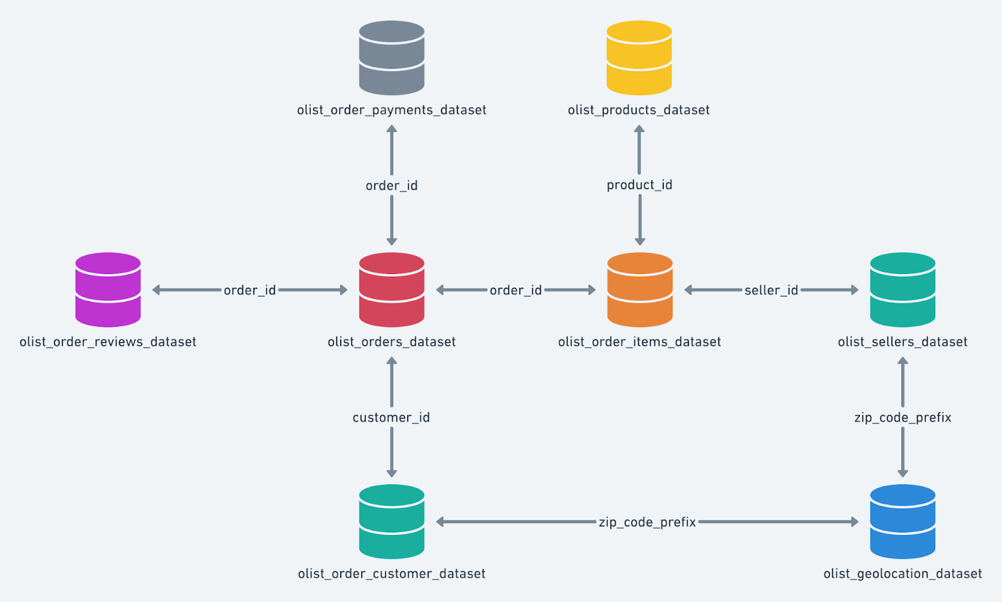

**Problem Statement:**

Analyze the given dataset to extract valuable insights and provide actionable recommendations.

**What does 'good' look like?**

1. **Import the dataset and do usual exploratory analysis steps like checking the structure & characteristics of the dataset:**
   1. Data type of all columns in the "customers" table.
   2. Get the time range between which the orders were placed.
   3. Count the Cities & States of customers who ordered during the given period.
2. **In-depth Exploration:**
   1. Is there a growing trend in the no. of orders placed over the past years?
   2. Can we see some kind of monthly seasonality in terms of the no. of orders being placed?
   3. During what time of the day, do the Brazilian customers mostly place their orders? (Dawn, Morning, Afternoon or Night)
      * 0-6 hrs : Dawn
      * 7-12 hrs : Mornings
      * 13-18 hrs : Afternoon
      * 19-23 hrs : Night
3. **Evolution of E-commerce orders in the Brazil region:**
   1. Get the month on month no. of orders placed in each state.
   2. How are the customers distributed across all the states?
4. **Impact on Economy: Analyze the money movement by e-commerce by looking at order prices, freight and others.**
   1. Get the % increase in the cost of orders from year 2017 to 2018 (include months between Jan to Aug only).  
      You can use the "payment_value" column in the payments table to get the cost of orders.
   2. Calculate the Total & Average value of order price for each state.
   3. Calculate the Total & Average value of order freight for each state.
5. **Analysis based on sales, freight and delivery time.**
   1. Find the no. of days taken to deliver each order from the order’s purchase date as delivery time.  
      Also, calculate the difference (in days) between the estimated & actual delivery date of an order.  
      Do this in a single query.  
        
      You can calculate the delivery time and the difference between the estimated & actual delivery date using the given formula:
      * **time_to_deliver** = order_delivered_customer_date - order_purchase_timestamp
      * **diff_estimated_delivery** = order_estimated_delivery_date - order_delivered_customer_date
   2. Find out the top 5 states with the highest & lowest average freight value.
   3. Find out the top 5 states with the highest & lowest average delivery time.
   4. Find out the top 5 states where the order delivery is really fast as compared to the estimated date of delivery.  
      You can use the difference between the averages of actual & estimated delivery date to figure out how fast the delivery was for each state.
6. **Analysis based on the payments:**
   1. Find the month on month no. of orders placed using different payment types.
   2. Find the no. of orders placed on the basis of the payment installments that have been paid.

**1. Import the dataset and do usual exploratory analysis steps like checking the structure & characteristics of the dataset**

**1. Data type of columns in a table**

SELECT column_name,DATA_TYPE

FROM `target-sql-382405`.Target_Dataset.INFORMATION_SCHEMA.COLUMNS

WHERE

TABLE_NAME = 'customers'

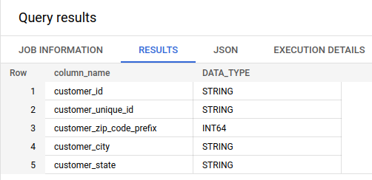

SELECT column_name,DATA_TYPE

FROM `target-sql-382405`.Target_Dataset.INFORMATION_SCHEMA.COLUMNS

WHERE

TABLE_NAME = 'geolocation'

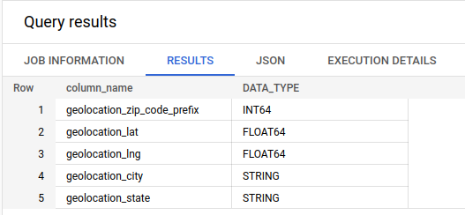

SELECT column_name,DATA_TYPE

FROM `target-sql-382405`.Target_Dataset.INFORMATION_SCHEMA.COLUMNS

WHERE

TABLE_NAME = 'order_items'

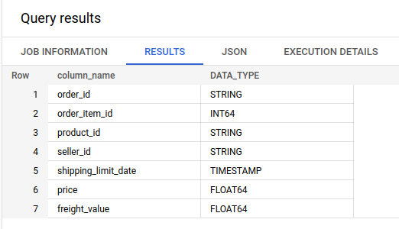

SELECT column_name,DATA_TYPE

FROM `target-sql-382405`.Target_Dataset.INFORMATION_SCHEMA.COLUMNS

WHERE

TABLE_NAME = 'order_reviews'

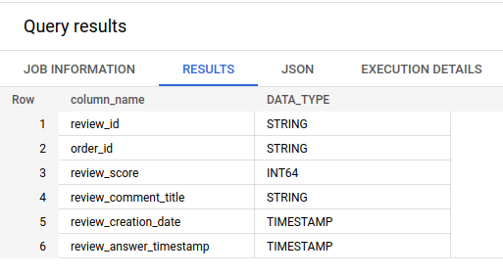

SELECT column_name,DATA_TYPE

FROM `target-sql-382405`.Target_Dataset.INFORMATION_SCHEMA.COLUMNS

WHERE

TABLE_NAME = 'orders'

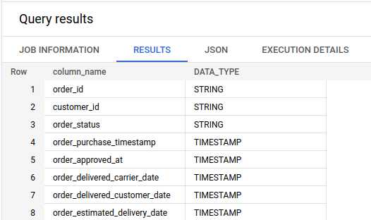

SELECT column_name,DATA_TYPE

FROM `target-sql-382405`.Target_Dataset.INFORMATION_SCHEMA.COLUMNS

WHERE

TABLE_NAME = 'payments'

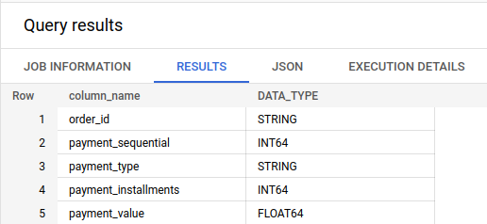

SELECT column_name,DATA_TYPE

FROM `target-sql-382405`.Target_Dataset.INFORMATION_SCHEMA.COLUMNS

WHERE

TABLE_NAME = 'products'

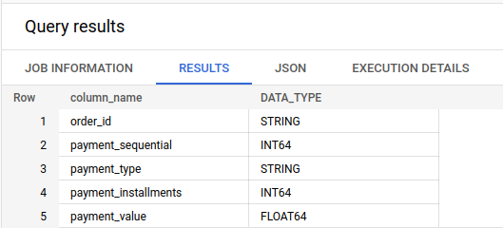

SELECT column_name,DATA_TYPE

FROM `target-sql-382405`.Target_Dataset.INFORMATION_SCHEMA.COLUMNS

WHERE

TABLE_NAME = 'sellers'

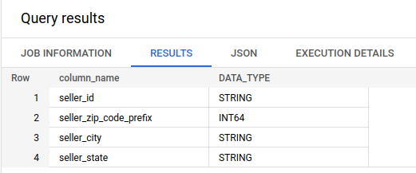

**2. Time period for which the data is given:**

SELECT min(order_purchase_timestamp) as start_time, max(order_purchase_timestamp) as end_time

FROM `target-sql-382405.Target_Dataset.orders`

Here I have considered the time period of order_purchase_timestamp since there is nothing mentioned specifically in the question.

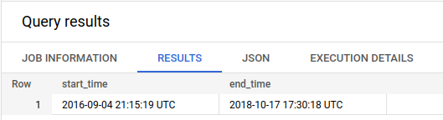

**3. City and states of customers ordered during the given time period:**

SELECT count(c.customer_id) as customer_count,customer_city,customer_state

FROM `target-sql-382405.Target_Dataset.customers` as c

join `Target_Dataset.orders` as o on c.customer_id=o.customer_id

where order_purchase_timestamp between (SELECT min(order_purchase_timestamp) FROM `target-sql-382405.Target_Dataset.orders` ) and (select max(order_purchase_timestamp) FROM `target-sql-382405.Target_Dataset.orders` )

group by customer_state,customer_city

**Assumptions:**

Here the time period is considered based on the order_purchase_timestamp.

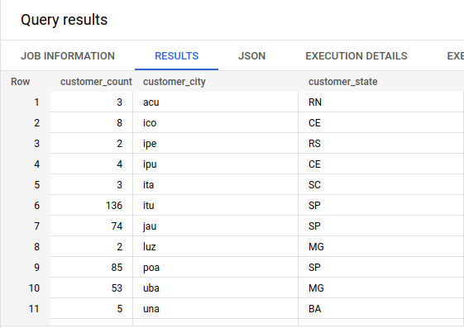

**2. In-depth Exploration:**

1. **Is there a growing trend on e-commerce in Brazil? How can we describe a complete scenario? Can we see some seasonality with peaks at specific months?**

SELECT count(customer_id) as customer_count,

extract(year FROM order_purchase_timestamp) as Year,

extract(month FROM order_purchase_timestamp) as Month

FROM `target-sql-382405.Target_Dataset.orders`

group by Year,Month

order by Year,Month

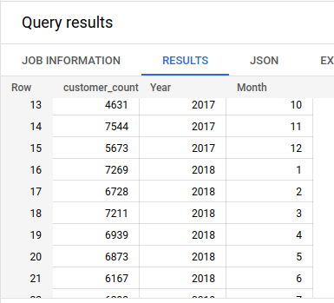

From the year 2016 month of september till 2018 month of october we have the data. Among that we could see the count of customer increase month over month. From 11th month of 2017 to 3rd month of 2018 there is some increase in between for the months november 2017,January 2018,march 2018. So the seasonality could fall under these months. Mostly late fall and winter season.

**2. What time do Brazilian customers tend to buy (Dawn, Morning, Afternoon or Night)?**

SELECT count(customer_id) as customer_count,

case

when extract(hour FROM order_purchase_timestamp) between 3 and 6 then 'Dawn'

when extract(hour FROM order_purchase_timestamp) between 7 and 12 then 'Morning'

when extract(hour FROM order_purchase_timestamp) between 13 and 18 then 'Afternoon'

else 'Night'

end as Purchase_time

from `Target_Dataset.orders` group by Purchase_time order by Purchase_time

Assumptions:

I assume that the order_purchase_timestamp is in brazilian timestamp and based on that calculated the time customers tend to buy.

Orders are counted irrespective of delivered or undelivered, cancelled or paid partially or completely

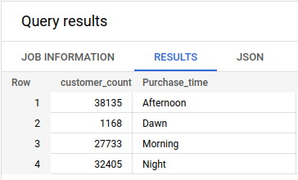

From the above result, it is observed that there is more customer traffic in the afternoon, that is between 13 hrs and 18 hrs. ‘Night’ also is have second less customer traffic.

**3. Evolution of E-commerce orders in the Brazil region:**

**1.** Get month on month orders by states

SELECT *,

ROUND((z.order_id_count - (LAG(z.order_id_count,1) OVER(PARTITION BY z.customer_state ORDER BY z.customer_state, Year, Month)))*100/LAG(z.order_id_count,1) OVER(PARTITION BY z.customer_state ORDER BY z.customer_state, Year, Month),2) AS m_o_m_per100

FROM

(SELECT DISTINCT c.customer_state,COUNT(o.order_id) AS order_id_count,

EXTRACT(year from order_purchase_timestamp) AS Year, EXTRACT(month FROM order_purchase_timestamp) AS Month

FROM `Target_Dataset.orders` AS o

JOIN `Target_Dataset.customers` AS c

USING(customer_id)

GROUP BY c.customer_state, Year, Month

ORDER BY c.customer_state, Year, Month) AS z

ORDER BY z.customer_state, Year, Month

Not exactly, there is a growing trend in orders as it initially (2016) and then later (2018) we see a sharp dip in orders. Initially we see 2017 March. We get to see a peak in 2017 March. Also, we can find peaks during 2017 Nov and 2018 Jan, March. With given data we find peak in March repeated, indicating seasonality in the region.

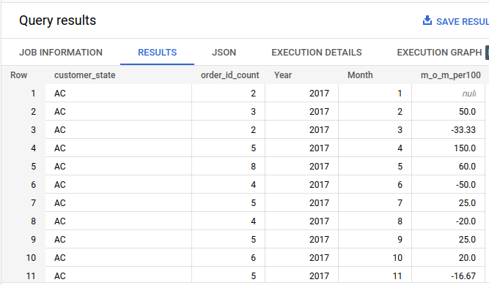

**2. Distribution of customers across the states in Brazil**

SELECT v.customer_state,concat(ROUND(v.c_count*100/SUM(v.c_count) OVER(),2),'%') AS percentage_distribution

FROM(

SELECT DISTINCT COUNT(customer_id) AS c_count, customer_state

FROM `Target_Dataset.customers`

GROUP BY customer_state) AS v

ORDER BY percentage_distribution DESC

Assumptions and insights:

From the result obtained, it is found that the maximum customer distribution is from the state named “**SP**” .

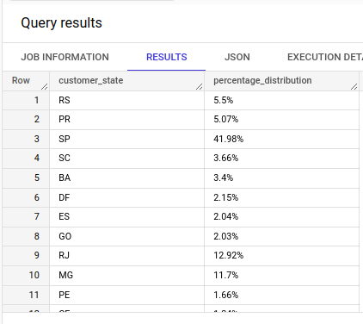

**4. Impact on Economy: Analyze the money movement by e-commerce by looking at order prices, freight and others.**

1. **Get % increase in cost of orders from 2017 to 2018 (include months between Jan to Aug only) - You can use “payment_value” column in payments table**

Assumptions and insights:

* But when we do see rise in payment value between 2016 to 2017 only considering Jan to Aug month on month even with oscillating growth percentages

SELECT *,

CONCAT(ROUND((x.tot_pay_val - (LAG(x.tot_pay_val,1) OVER(ORDER BY year, month)))*100/LAG(x.tot_pay_val,1) OVER(ORDER BY year, month),2),"%") AS m_o_m_per100

FROM

(SELECT EXTRACT(YEAR FROM DATE (order_purchase_timestamp)) AS year,

EXTRACT(MONTH FROM DATE (order_purchase_timestamp)) AS month,

ROUND(SUM(p.payment_value),2) AS tot_pay_val,

FROM `Target_Dataset.orders` AS o

JOIN `Target_Dataset.payments` AS p

ON o.order_id = p.order_id

GROUP BY year,month

ORDER BY year,month) AS x

WHERE x.year BETWEEN 2017 AND 2018 AND x.month BETWEEN 1 AND 8

ORDER BY year, month

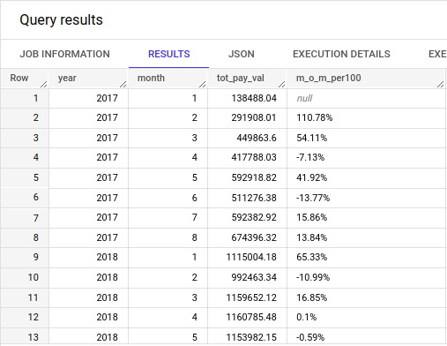

**2. Mean & Sum of price and freight value by customer state**

select

customer_state,

sum(price) as Sum_price_per_state,

sum(freight_value) as Sum_freight_per_state,

avg(price) as Mean_price_per_state,

avg(freight_value) as Mean_freight_per_state

from `Target_Dataset.order_items`,`Target_Dataset.customers`

group by customer_state

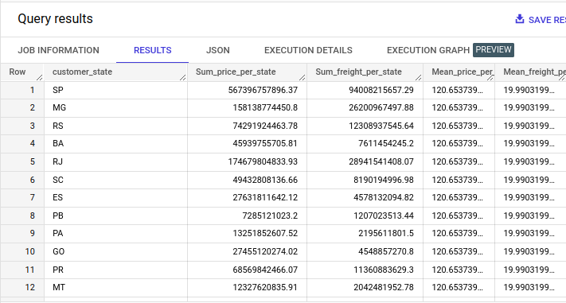

**5. Analysis on sales, freight and delivery time**

1. **Calculate days between purchasing, delivering and estimated delivery**

select

date_diff(order_purchase_timestamp, order_delivered_customer_date, day) as purchase_delivery_timeperiod,

date_diff(order_estimated_delivery_date,order_purchase_timestamp, day) as purchase_estimated_delivery,

date_diff(order_delivered_customer_date,order_estimated_delivery_date, day) as delivery_estimated_delivery

from `Target_Dataset.orders`

order by purchase_delivery_timeperiod

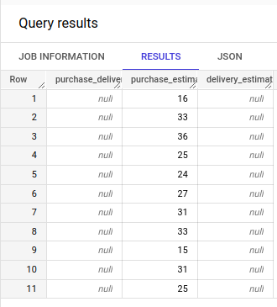

**2. Find time_to_delivery & diff_estimated_delivery. Formula for the same given below:**

* **time_to_delivery = order_purchase_timestamp-order_delivered_customer_date**
* **diff_estimated_delivery = order_estimated_delivery_date-order_delivered_customer_date**

select

date_diff(order_purchase_timestamp, order_delivered_customer_date, day) as purchase_delivery_timeperiod,

date_diff(order_estimated_delivery_date,order_delivered_customer_date, day) as delivery_estimated_deliveryy

from `Target_Dataset.orders`

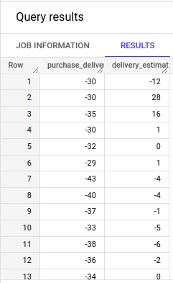

**3. Group data by state, take mean of freight_value, time_to_delivery, diff_estimated_delivery**

**4. Sort the data to get the following:**

* Top 5 states with highest average freight value - sort in desc/asc limit 5

select

customer_state,

avg(ot.freight_value) average_freight

from `Target_Dataset.order_items` as ot

join `Target_Dataset.orders` as o on ot.order_id=o.order_id

join `Target_Dataset.customers` as c on o.customer_id=c.customer_id

group by c.customer_state

order by average_freight desc

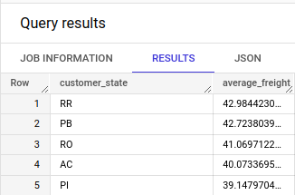

Top 5 states with highest average time to delivery

select

customer_state,

avg(DATE_DIFF(order_delivered_customer_date,order_purchase_timestamp,day)) as average_delivery

from `Target_Dataset.order_items` as ot

join `Target_Dataset.orders` as o on ot.order_id=o.order_id

join `Target_Dataset.customers` as c on o.customer_id=c.customer_id

group by c.customer_state

order by average_delivery desc limit 5

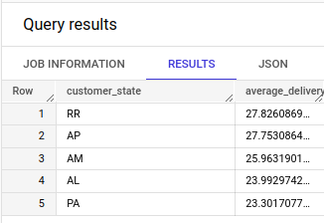

* Top 5 states where delivery is really fast/ not so fast compared to estimated date

**select *,**

(average_estimated_delivery-average_delivery) as delivery_difference

from

(

select

customer_state,

avg(DATE_DIFF(order_delivered_customer_date,order_purchase_timestamp,day)) as average_delivery,

avg(DATE_DIFF(order_estimated_delivery_date,order_purchase_timestamp,day)) as average_estimated_delivery

from `Target_Dataset.order_items` as ot

join `Target_Dataset.orders` as o on ot.order_id=o.order_id

join `Target_Dataset.customers` as c on o.customer_id=c.customer_id

group by c.customer_state

)

order by delivery_difference desc limit 5

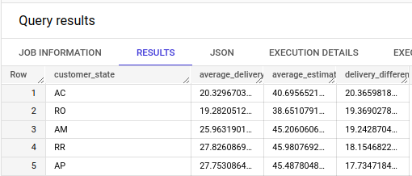

**6. Payment type analysis:**

1. Month over Month count of orders for different payment types

select *,

round(((x.order_count-lag(x.order_count) over(partition by payment_type order by Year,Month))*100)/lag(x.order_count) over(partition by payment_type order by Year,Month),2) as Month_on_Month_orders

from

(

select

count(o.order_id) as order_count,

payment_type,

extract(month from order_purchase_timestamp) as Month,

extract(year from order_purchase_timestamp) as Year

from `Target_Dataset.orders` as o join `Target_Dataset.payments` as p

on o.order_id=p.order_id

group by payment_type,Year,Month

order by payment_type,Year,Month

) as x

Assumptions and Insights:

- We see customers prefer credit card payments more than UPI and debit card.

- For those customers who pay by installments, we see high number for less than 10 installments and few for more than 10 installments

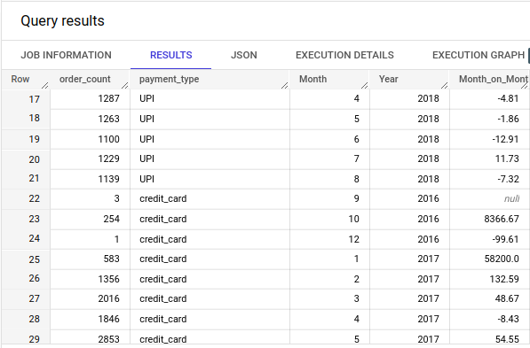

1. **Count of orders based on the no. of payment installments**

SELECT p.payment_installments, COUNT(p.order_id) AS orders_count

FROM `SQL_Target_Project.payments` AS p

JOIN `SQL_Target_Project.orders` AS o

USING(order_id)

GROUP BY p.payment_installments;

