Module 5: Presentation Layer & Application Layer

5 marks Questions

1. Compute Huffman code for the following word “wabbawabba”.

2. Discuss the steps required for compressing image using JPEG.

JPEG is an image compression standard which was developed by "Joint Photographic Experts Group". In 1992, it was accepted as an international standard. JPEG is a lossy image compression method. JPEG compression uses the DCT (Discrete Cosine Transform) method for coding transformation. It allows a tradeoff between storage size and the degree of compression can be adjusted.

Steps:

1. DCT (Discrete Cosine Transformation)

2. Quantization

3. Zigzag Scan

4. DPCM on DC component

5. RLE on AC Components

6. Entropy Coding

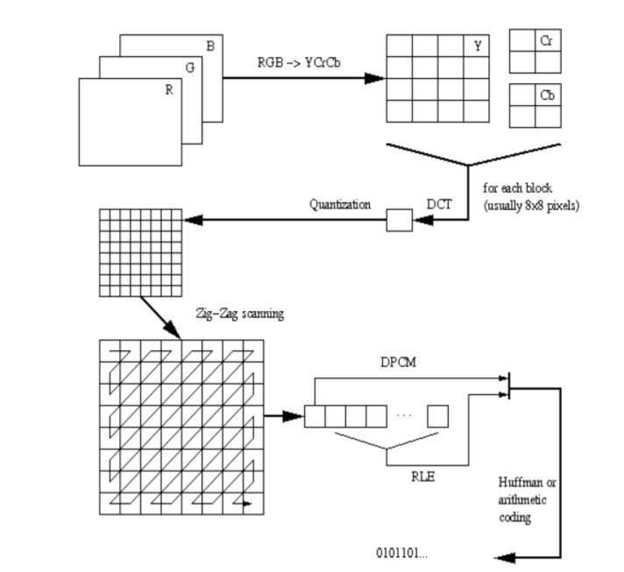

1. DCT (Discrete Cosine Transformation)

The discrete cosine transform (DCT) helps separate the image into parts (or spectral sub-bands) of differing importance (with respect to the image's visual quality).

2. Quantization

we need to quantise:

* To throw out bits
* ***Example***: 101101 = 45 (6 bits).

Truncate to 4 bits: 1011 = 11.

Truncate to 3 bits: 101 = 5.

* Quantization error is the main source of the Lossy Compression.

3. Zigzag Scan

the purpose of the Zig-zag Scan:

* to group low frequency coefficients in top of vector.
* Maps 8 x 8 to a 1 x 64 vector

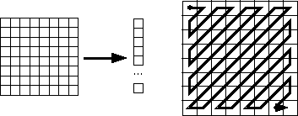

4. DPCM on DC component

besides DCT another encoding method is employed: DPCM on the DC component at least. Why is this strategy adopted:

* DC component is large and varied, but often close to previous value (like lossless JPEG).
* Encode the difference from previous 8x8 blocks - DPCM

5. RLE on AC Components

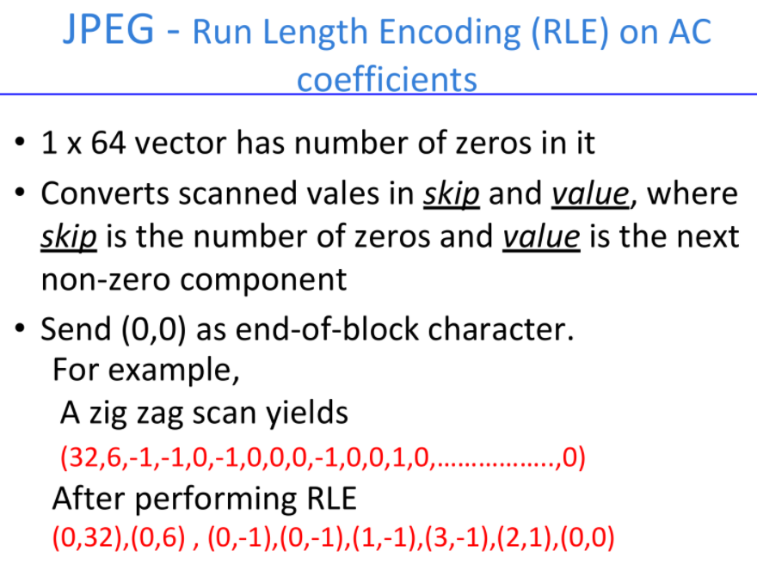

6. Entropy Coding

**Entropy encoding** which is a way of lossless **compression** that is done on an **image** after the quantization stage. It enables to represent an **image** in a more efficient way with smallest memory for storage or transmission.

3. Explain persistent HTTP with neat diagram.

Persistent HTTP: make a TCP connection and retrieve all the objects together.

Before version 1.1 http used non persistent connections. In version 1.1, persistent connection is the default.

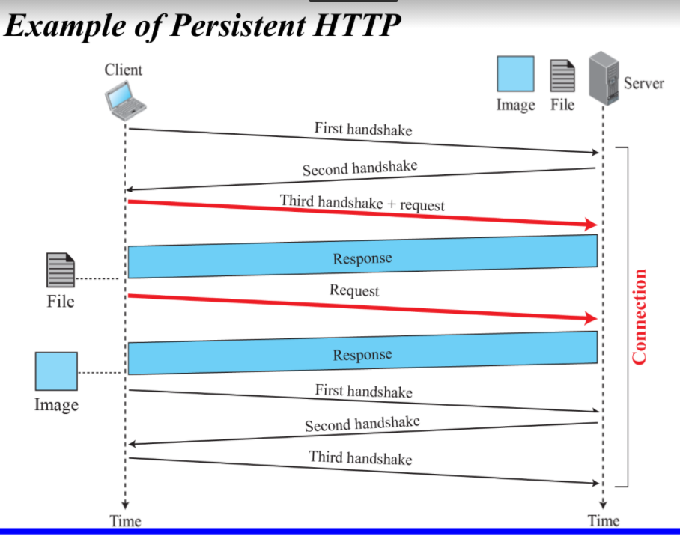

Figure shows an example of a persistent connection. The client needs to access a file that contains one link to an image. The text file and image are located on the same server

Only one connection establishment and connection termination is used, but the request for the image is sent separately.

After the connection is established, the object can be transferred. After receiving an object, another three handshake messages are needed to terminate the connection

4. Explain the two application layer paradigms in detail.

5. Elaborate the process of E-Mail transfer using SMTP.

6. Write a note on Domain Name System.

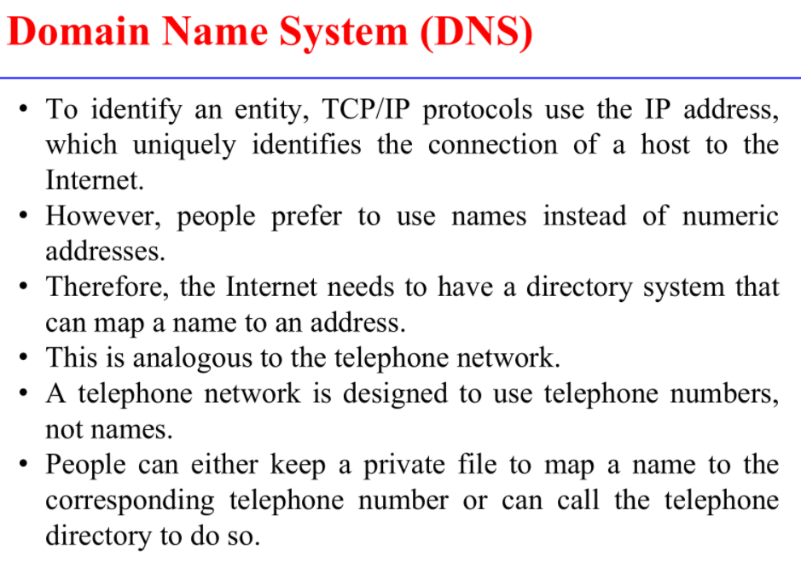

Module 6: Network Design Concepts

5 marks Questions

1. Compare the concepts of collision domain and broadcast domains.

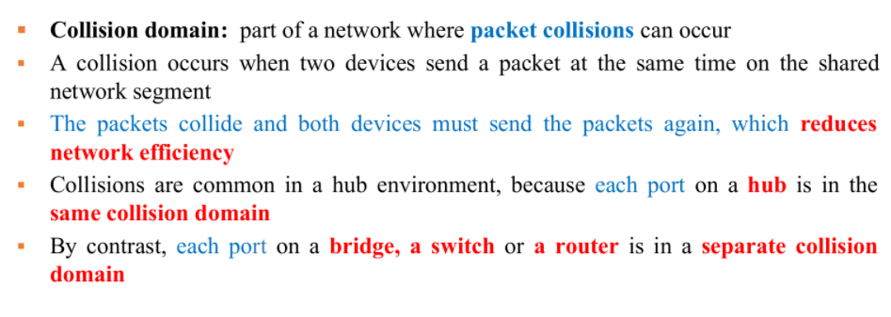

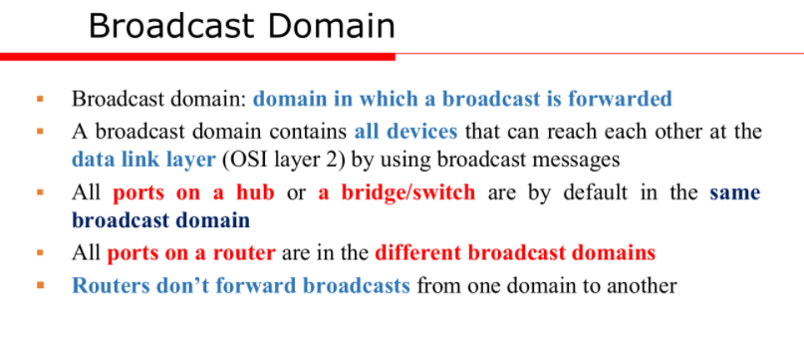

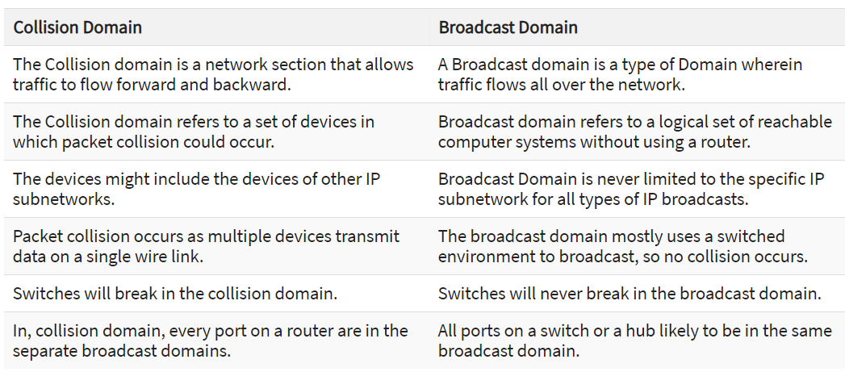

2. Write a note on Virtual LAN.

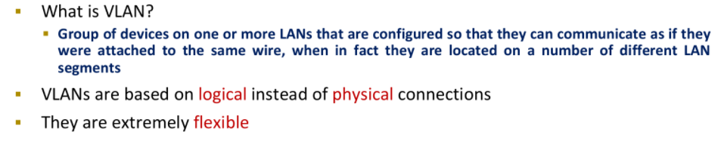

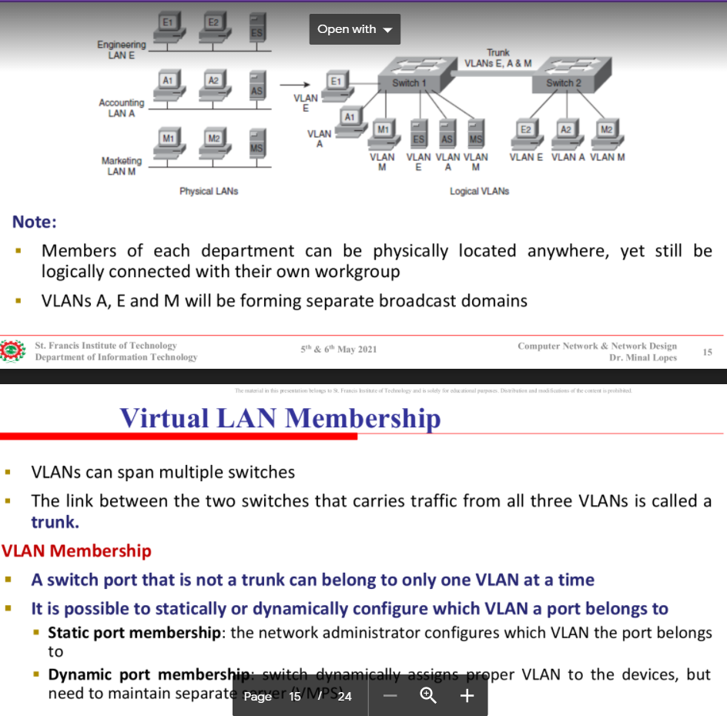

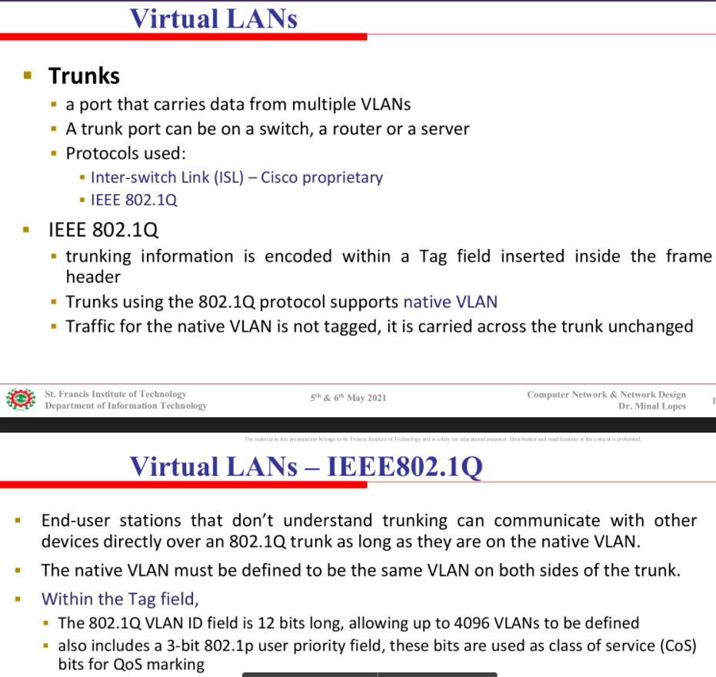

3. Write a note on Virtual Private Networks.

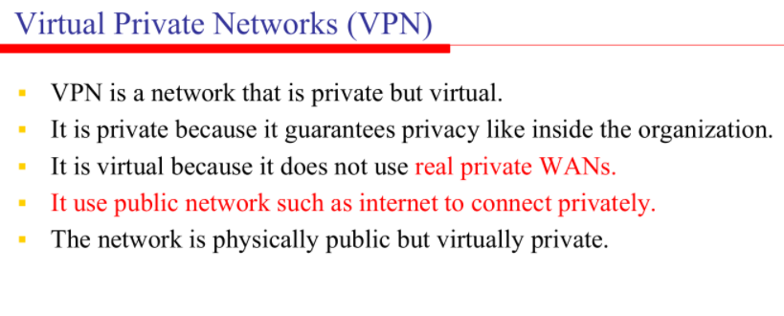

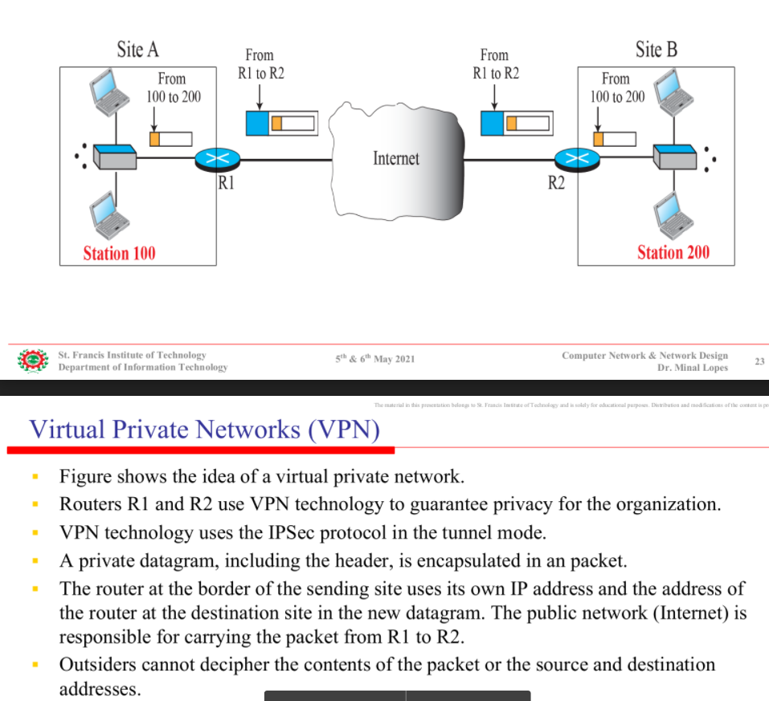

4. Draw and explain IEEE 802.1Q frame format.

5. A question on network design.