**NAME: CHRISTINA JOSE MANAKKAL**

**ROLL NO: 7 CLASS: SEITB PID: 191064**

**Experiment – 7 Python Functions and Exception Handling**

**1. Aim:** To understand how to write functions and use of functions in python.

**2. Objective:** After performing this experiment, a student will be able to use built in

functions and will be able to write user defined functions.

**3. Prerequisite:** Basics of Python

**4. Requirements:** PC, Python 3.9, Windows 10/ MacOS/ Linux

**5. Pre-experiment Exercise:**

**Theory:**

A function is a block of statements that performs a specific task.Makes the program codes

reusable , Easy to manage .

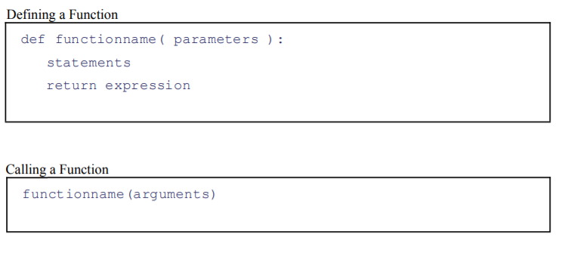

Scope of a variable is the portion of a program where the variable is recognized. Parameters andvariables defined inside a function are not visible from outside the function.The lifetime of avariable is the period throughout which the variable exists in the memory. They are destroyedonce we return from the function.Variables outside of the function are visible from inside. Theyhave a global scope.In order to modify the value of variables outside the function, they must bedeclared as global variables using the keyword global.