**NAME: CHRISTINA JOSE MANAKKAL**

**ROLL NO: 7 CLASS: SEITB PID: 191064**

**B. Results/Observations/Program output:**

Present the program input/output results and comment on the same.

1. Write a Python program to test a class named circle which has an attribute radius and two

methods which compute the area and the perimeter of the circle respectively.

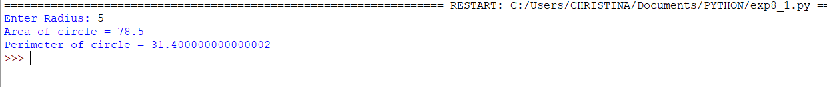

2. Write a Python program to test a class named rectangle which has attributes length and breadth and two methods which compute the area and the perimeter of the circle respectively.

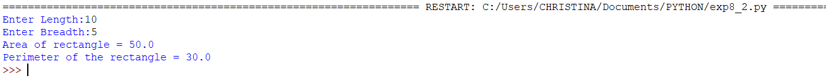

3. Write a Python program to demonstrate use of static method to count the number of instances created.



**C. Questions/Programs:**

1. Write a Python program to test a class named circle which has an attribute radius and two

methods which compute the area and the perimeter of the circle respectively.

CODE:

class circle():

def __init__(self):

self.r=float(input("Enter Radius: "))

def area(self):

return self.r**2*3.14

def perimeter(self):

return self.r*2*3.14

c=circle()

print("Area of circle =",c.area())

print("Perimeter of circle =",c.perimeter())

2. Write a Python program to test a class named rectangle which has attributes length and breadth and two methods which compute the area and the perimeter of the circle respectively.

CODE:

class rectangle():

def __init__(self):

self.l=float(input("Enter Length:"))

self.b=float(input("Enter Breadth:"))

def area(self):

return self.b*self.l

def perimeter(self):

return 2*(self.l+self.b)

r=rectangle()

print("Area of rectangle =",r.area())

print("Perimeter of the rectangle =",r.perimeter())

3. Write a Python program to demonstrate use of static method to count the number of instances created.

CODE:

class MyClass:

n=0

def __init__(self):

MyClass.n = MyClass.n+1

@staticmethod

def noObjects():

print('Number of intsances created:', MyClass.n)

obj1 = MyClass()

obj2 = MyClass()

obj3 = MyClass()

MyClass.noObjects()