**Question 1: How elastic is the supply of imported steel and aluminum to new trade tariffs?**

Christina:

* The third largest increase in volume of steel and aluminum trade ($USD) within the past five years occurred between December 2017 and January 2018
* The second largest decrease in volume of steel and aluminum trade ($USD) within the past five years occurred between January 2018 and February 2018
* Jump in metals trade imports from China in January, followed by a tumble in February

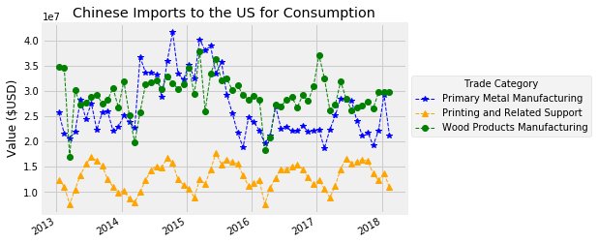

* Recent Metals Trade Volatility between the US and China large compared to Volatility between the US and South Korea, Japan
  + Large volatility in South Korea in late-2015, early-2016 preceded anti-dumping tariffs imposed on South Korea in 2016
  + Source: <https://www.washingtonpost.com/world/asia_pacific/south-koreas-steel-heartland-frets-about-looming-american-tariffs/2018/03/19/c2bf4528-2907-11e8-ab19-06a445a08c94_story.html?noredirect=on&utm_term=.0ace16fc5ba5>

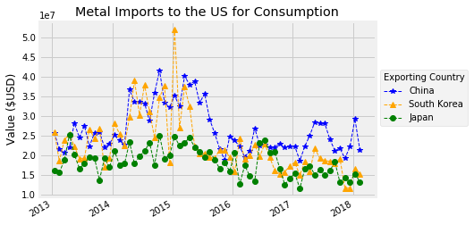

**Question 2: Did the announcements surrounding the enactment of tariffs impact the stock prices of steel and aluminum companies?**   
Tamara:

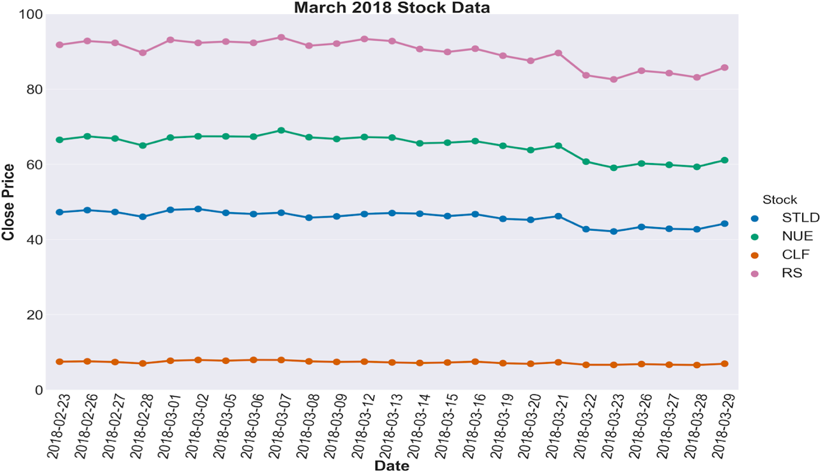

* The day prior to the announcement the Dow Jones decreased by 1.2% and by 1.5% the day of the announcement; much of this was related to concern over rate hikes
* March 8 the Dow closed down 0.3% and was down 2.9% on March 23
* Discussions regarding exemptions to Canada, Mexico, Brazil, and the EU; March 22nd announcement of exemptions
* Canada and Brazil are the two largest import sources for steel and Mexico is fourth largest
* Canada is the largest exporter of steel and aluminum to US
* China is 4th in aluminum and 11th in steel
* The day prior to the announcement metal stocks decreased but recovered the day of the tariff announcement
* Stocks remained relatively stable until March 21 which saw an increase in price and the following day several companies’ stock prices dropped but appeared to begin recovery in the following days
* US steel and aluminum companies did not seem to benefit from the announcement or enactment of tariffs
* The temporary exemptions to larger exporters may have tempered feelings towards aluminum and steel stocks
* Possible concerns regarding US steel and aluminum producers’ ability to increase production/meet demand
* Concerns regarding the Fed weighed heavy on the market during the same time period

**Question 3: How did people feel about the tariffs imposed by Donald Trump on Chinese imports of steel and aluminum?**

Ed:

* After importing 9,757 tweets, what categories did the tweets fall into and where did the tweets rank on the VADER score scale?

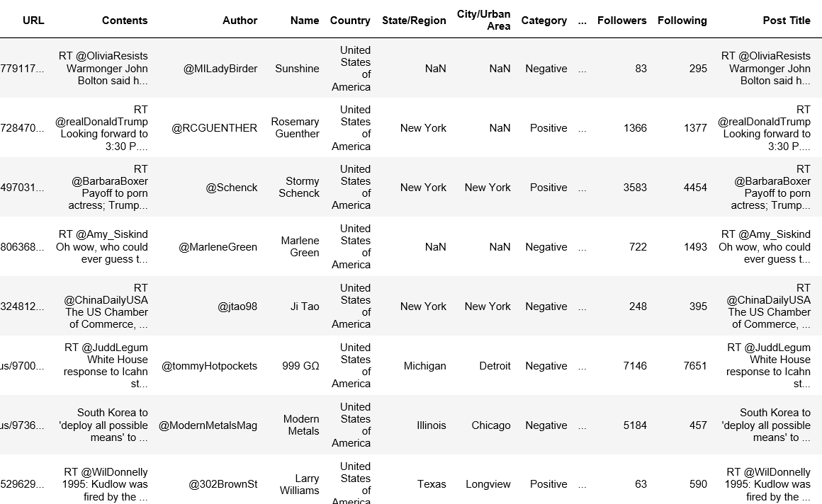

* Out of the 9,757 posts, 2,555 tweets were categorized to be positive and 7,202 were categorized to be negative.

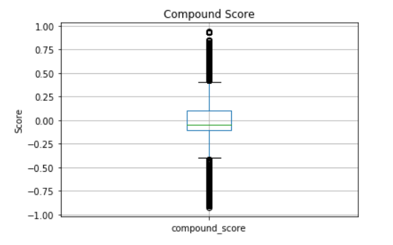

* Through looking at the VADER sentiment analysis plot graph, we can see that the posts with positive sentiments which have reached the +.75 and above mark are far less than the negative posts that have reached the -.75 and below mark.

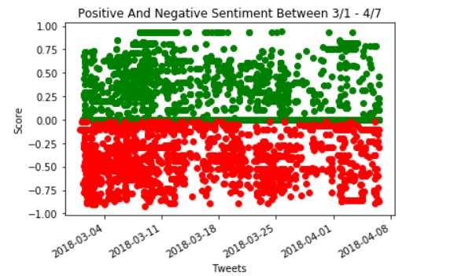

* We can also see that between 03/01-03/14, there were far more tweets with negative sentiment than any other period for the negative or positive sentiments.

Julio:

* The purpose of this research was to see the reaction of Twitter users when the President announced the tariffs on some imported goods from China.

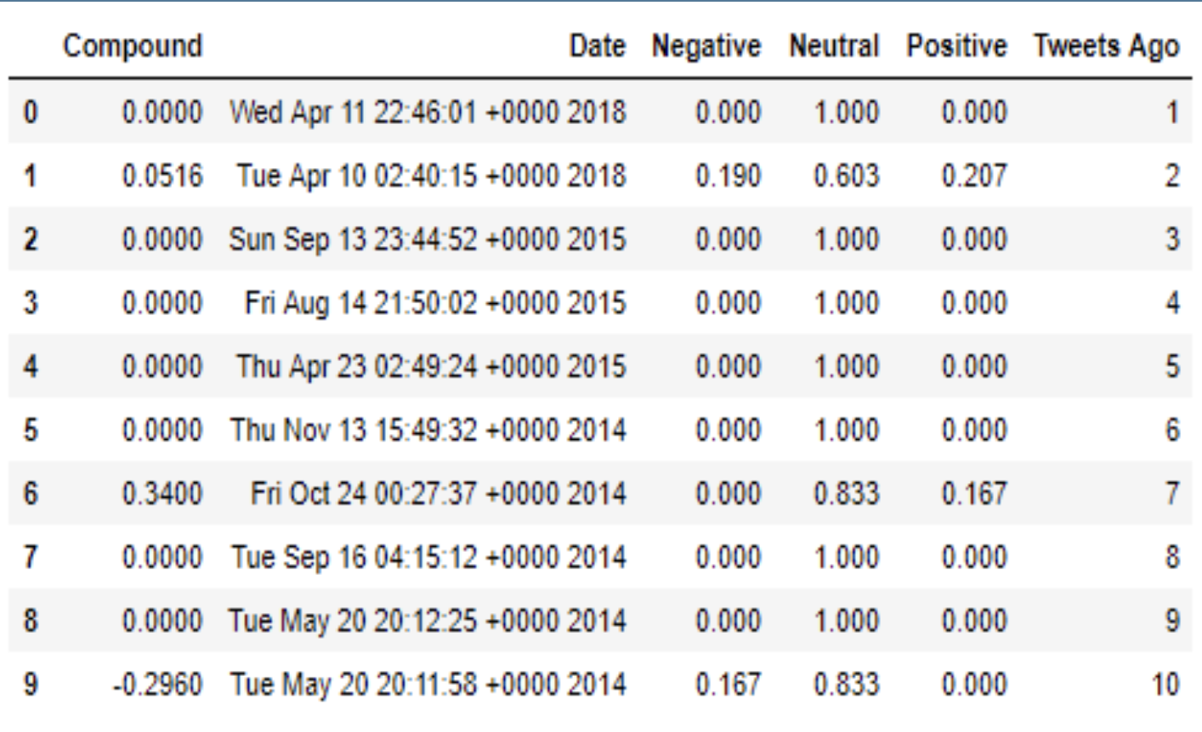

* Most tweets had a neutral sentiment when I used the Vader sentiment to measure it.

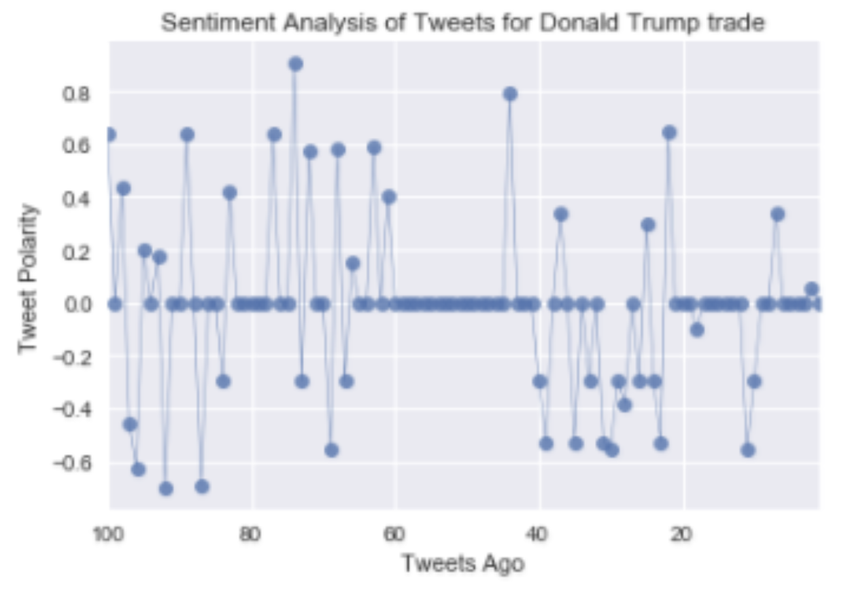

* The main reason for these results might be that most tweets were posted by the media, it’s likely that they did it without bias.
* However, some tweets that associate President Trump with the word trade were negative, mostly from users.