NMA Results
Below is a summary of the results of NMA analyses so far.

Overall results:
- 21 included trials

- Mortality data (number of deaths and number of subjects in each arm) was extracted from included trials and used in a Bayesian NMA between remdesivir, tocilizumab, and standard care/placebo. For one trial, data was extracted from a WHO evidence summary. In line with the work of Reed et al, the Bayesian NMA was conducted using a random-effects model with 3 Markov chains with 100,000 iterations after an initial burn-in of 10,000 and a thinning of 10. This was performed using the gemtc and rjags packages in R 4.2.1. (Attached project contains R code and data files)

- Attempted to also create frequentist analysis but I am struggling with this. Although I specify OR as the measurement, it doesn’t seem to be appropriately using OR in the calculations.

- Analyses: with all 21 trials, then the 19/21 trials with full calculable OR (at least 1 death in all arms), then the 17/21 trials included in Reed et al BMJ review, then the 10/20 trials (plus separation of 5 days vs 10 days) included in Selvarajan review, then an analysis of Remdesivir vs Tocilizumab with Corticosteroids in 16 trials (all Remdesivir trials plus the 8/13 Tocilizumab trials with corticosteroid use data available).

- Results overview:
Analysis |  | Odds Ratio vs P/SC | Odds Ratio vs Tocilizumab
All 20 trials
 | Remdesivir | 0.90 (0.69, 1.1) | 1.1 (0.72, 1.4)
 | Tocilizumab | 0.86 (0.72, 1.1)
19/21 trials with mortality in all arms | Remdesivir | 0.90 (0.70, 1.1) | 1.1 (0.73, 1.4)
 | Tocilizumab | 0.85 (0.75, 1.1)
17/21 trials included in Reed et al | Remdesivir | 0.90 (0.68, 1.2) | 1.0 (0.69, 1.4)
 | Tocilizumab | 0.88 (0.72, 1.2)
10/20 trials included in Selvarajan et al | Remdesivir 10 days | 0.90 (0.61, 1.3) | 0.72 (0.40, 1.2)
 | Remdesivir 5 days | 0.63 (0.27, 1.4) | 0.50 (1.9, 1.2)
 | Tocilizumab | 1.2 (0.83, 1.9)
Selvarajan results | Remdesivir 10 days | 0.78 (0.59, 1.03) | 0.66 (0.44–0.99)
 | Remdesivir 5 days | 0.95 (0.50, 1.78) | 0.80 (0.40–1.61)
 | Tocilizumab | 1.18 (0.88, 1.58)
Tocilizumab among corticosteroids | Remdesivir | 0.90 (0.68, 1.2) | 1.1 (0.67, 1.5)
 | Tocilizumab in corticosteroids users | 0.82 (0.65, 1.2)

- For the main results with all 21 trials, the current estimate with all 21 trials favors tocilizumab but is not significant in either direction (even for either Remdesivir vs Tocilizumab against standard care). The OR for Remdesivir vs standard care matches the BMJ review (0.9) and the OR for Tocilizumab vs SC lies between the BMJ calculations for tocilizumab+corticosteroids vs SC (0.8) and tocilizumab without corticosteroids vs SC (1.1).
- This is not in line with the observational evidence which showed quite a significant difference.
21 Included trials (details here)
First Author | Treatments | Risk of Bias (Randomization, deviations from intervention, missing outcome data, measurement of outcome mortality, selection of reported results for mortality). Assessed by COVID-NMA, * indicates assessment by Reed et al
Ader | Remdesivir for 10 days vs Standard Care | low, low, low, low, low
Beigel (ACTT-1) | Remdesivir up to 9 days vs Placebo | low, low, low, low, low
Criner | Remdesivir for 5 days vs 10 days vs Standard Care | *probably high, probably high, low, low, probably high
Mahajan | Remdesivir for 5 days vs Standard Care | some concerns, some concerns, some concerns, low, some concerns
WHO Solidarity (Pan) | Remdesivir for 9 days vs Standard Care | low, low, low, low, low
Spinner | Remdesivir 5 days vs 10 days vs Standard Care | low, low, low, low, some concerns
Wang | Remdesivir for 10 days vs Placebo | low, low, low, some concerns, low
Gordon (REMAP-CAP) | Tocilizumab vs Standard Care | low, some concerns, low, low, low
Hermine | Tocilizumab vs Standard Care | low, low, some concerns, low, low
Horby (RECOVERY) | Tocilizumab vs Standard Care | low, low, low, low, low
Rosas | Tocilizumab vs Placebo | low, low, low, low, low
Salama | Tocilizumab vs Placebo | low, low, low, low, low
Salvarani | Tocilizumab vs Standard Care | *low, probably high, low, low, low
Soin (COVINTOC) | Tocilizumab vs Standard Care | low, some concerns, low, low, low
Stone | Tocilizumab vs Placebo | *probably low, low, low, low, low
Talaschian | Tocilizumab vs Standard Care | some concerns, some concerns, some concerns, low, some concerns
Veiga | Tocilizumab vs Standard Care | low, some concerns, low, low, low
Declerq | Tocilizumab vs SC | low, low, low, low, low
Broman | Tocilizumab vs SC | low, low, low, low, some concerns
Rutgers | Tocilizumab vs SC | low, low, low, low, low
Islam | Remdesivir vs SC | not assessed by either source

Code included in project file.

Bayesian using all 21 trials:
Network plot:
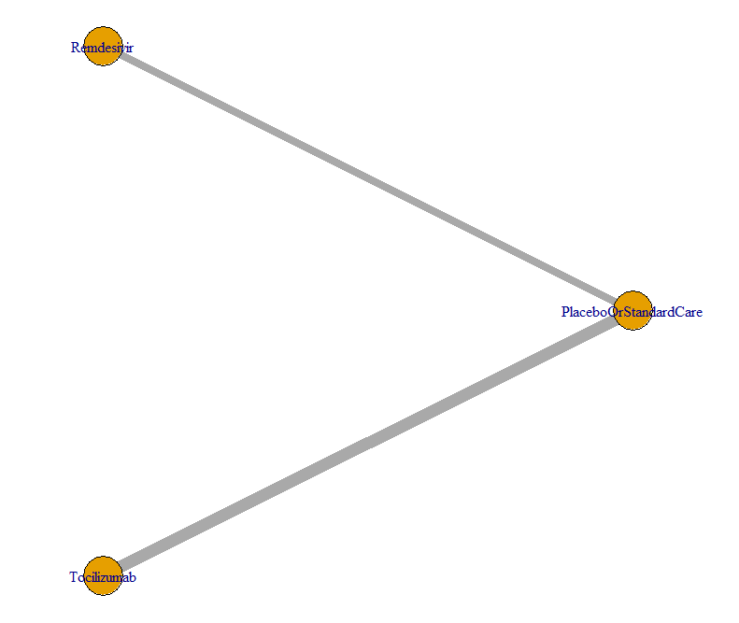
Analysis of heterogeneity: There is not considerable heterogeneity (<40%). (Note that here the pooled network estimate is not accurate as it is not using the specifications I later set in the model).
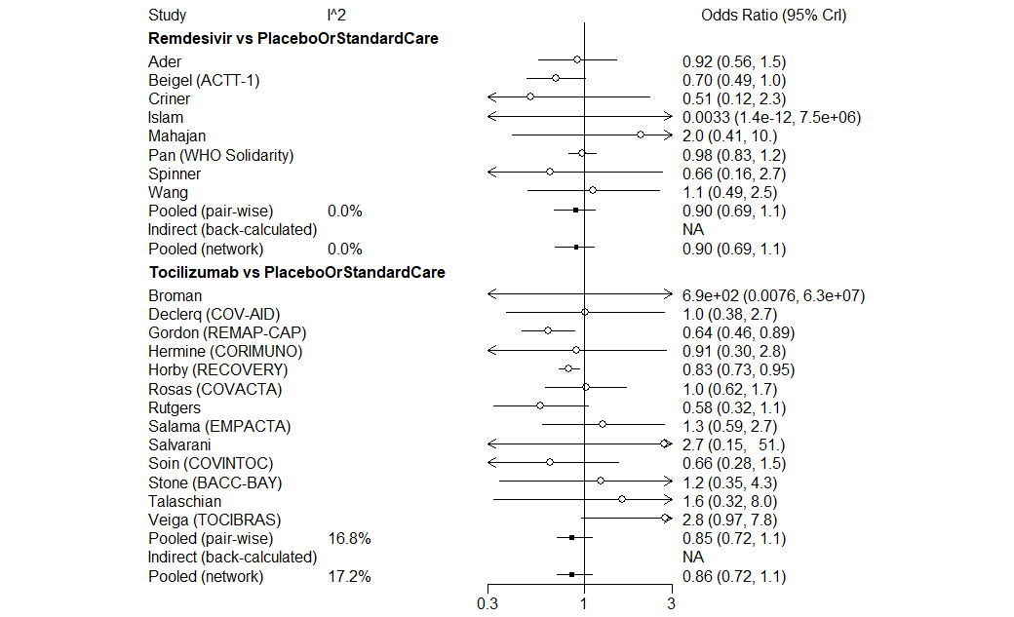
Model details:
- Link = logit (OR)
- Linear model = random (random effects)
- N.chain = 3

mcmc2 <- mtc.run(model, n.adapt = 10000, n.iter = 100000, thin = 10)
Trace plot:
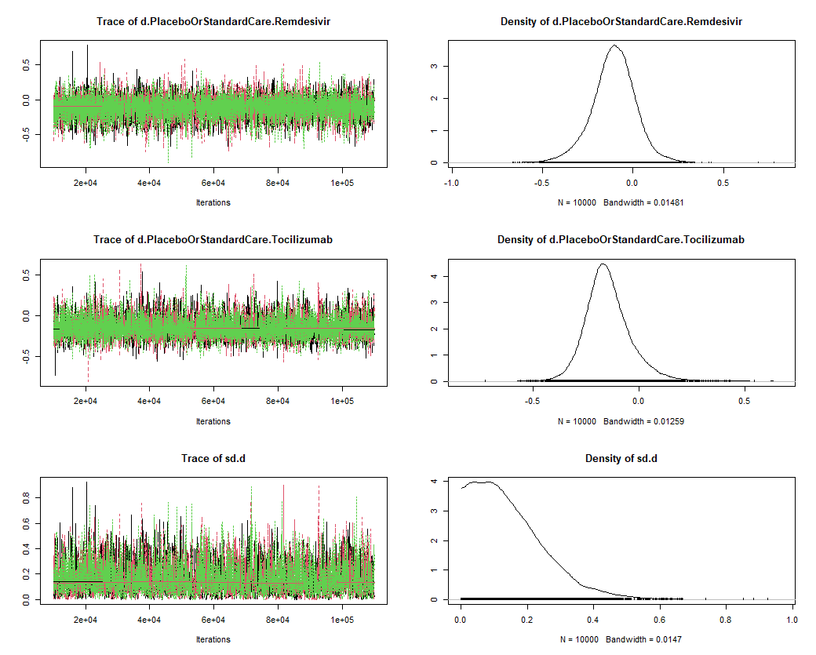
Trace has no specific pattern and chains appear entangled → suggest convergence is good.

Gelman plot:
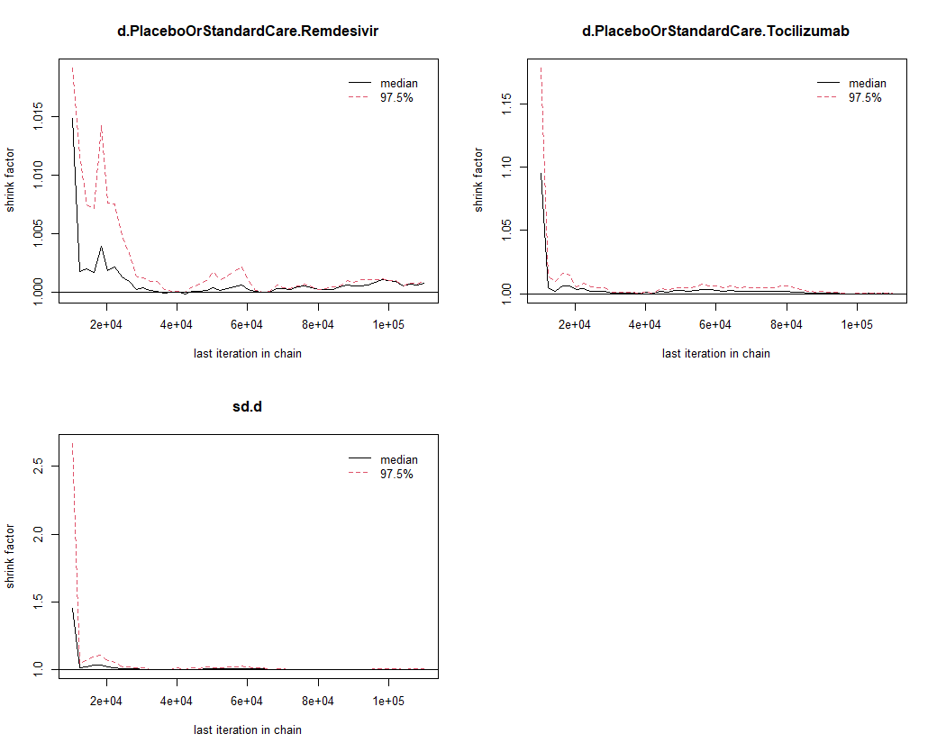
As the number of iterations increases, it approaches 1. The overall Gelman PSRF = 1.002068, which is below the threshold of 1.05.

Assessment of inconsistency through nodesplitting is not possible as there is no direct evidence to compare against indirect evidence.

Forest plot results:
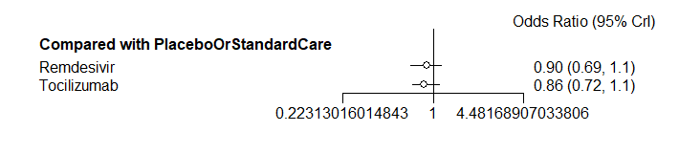
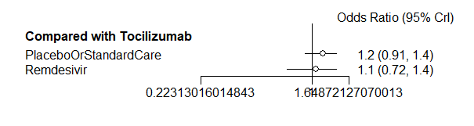

No What happens when removing the trials with results that have 0 mortality in one or both groups?
This analysis only uses the 19/21 trials with a calculable odds ratio.
Trace plot:
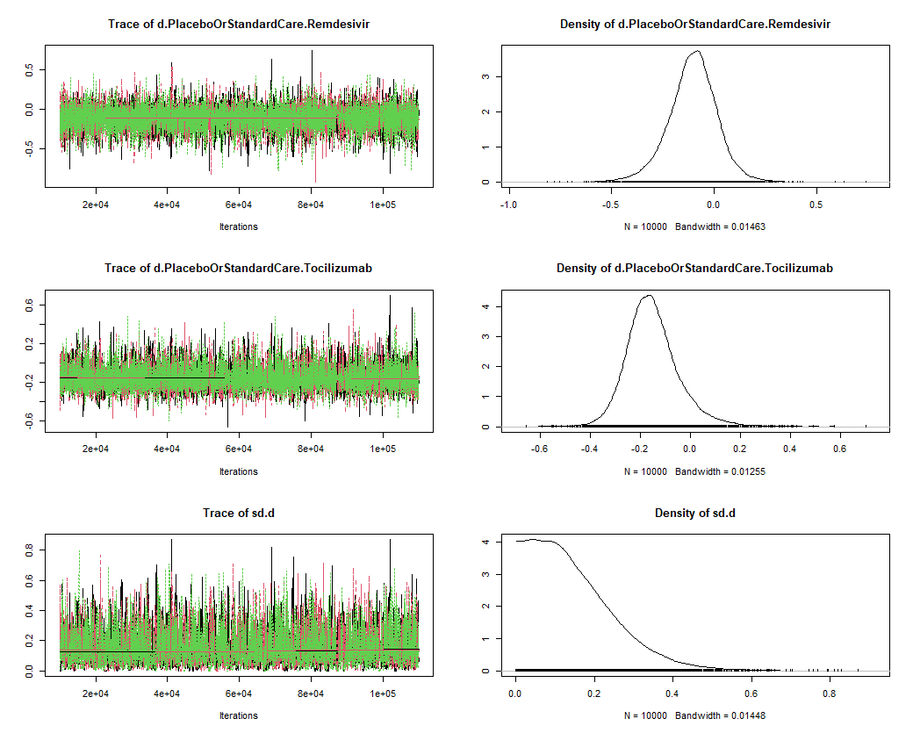
Gelman plot:
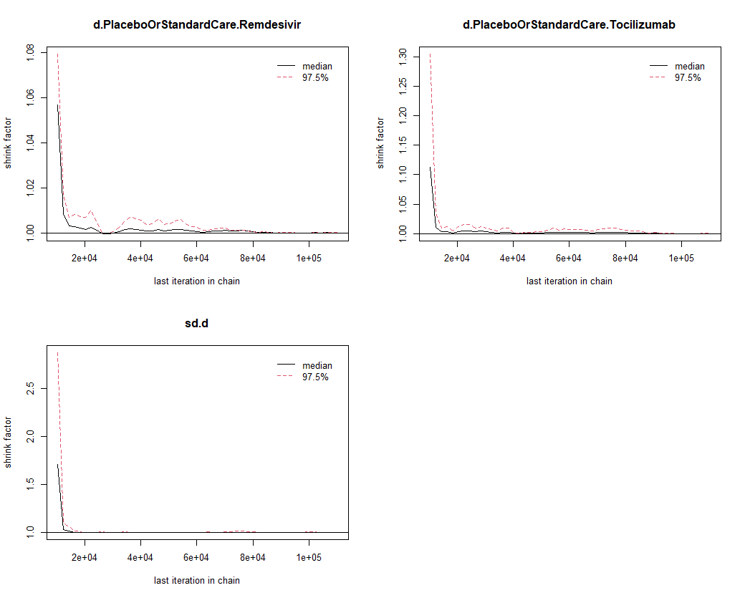
PSRF: 1.001074
Forest plot results:
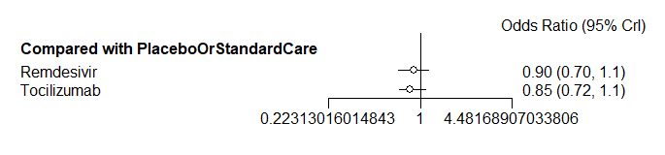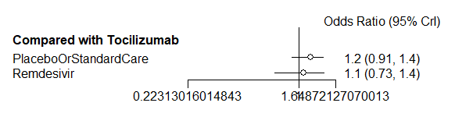

What happens when using just the trials included in Reed et al NMA (BMJ article)?
This analysis uses 17/21 articles that were included in the BMJ review.

Analysis of heterogeneity: There is not considerable heterogeneity (<40%). (Note that here the pooled network estimate is not accurate as it is not using the specifications I later set in the model). However, there is higher heterogeneity here than when all 21 articles are included.
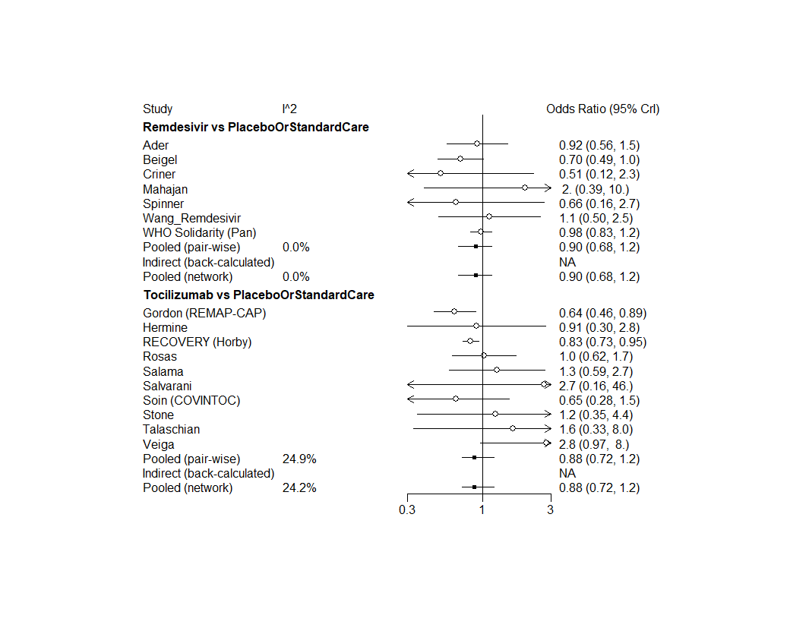
Trace plot: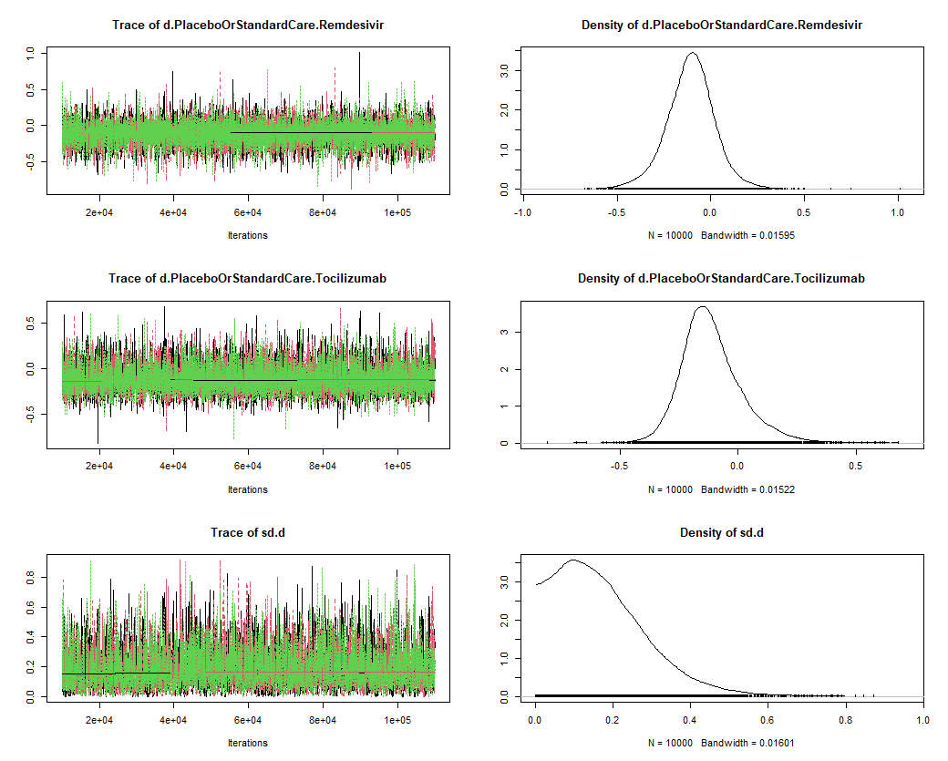
Gelman plot: 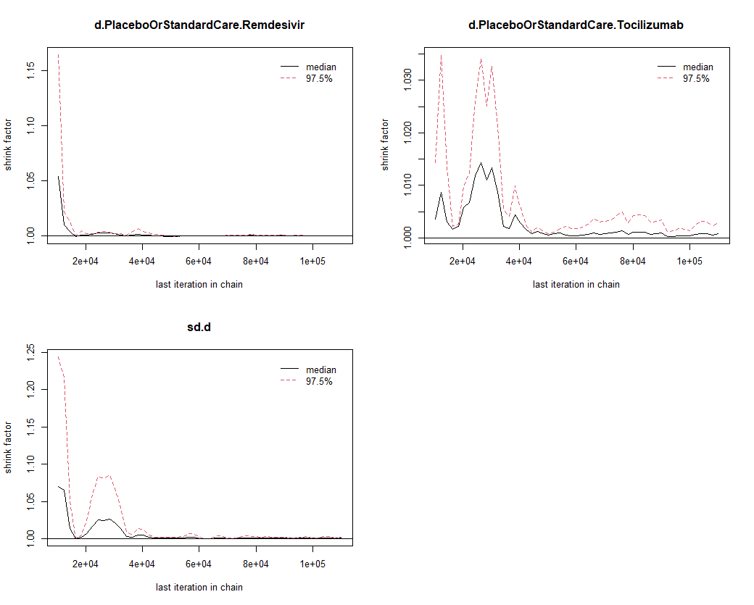
PSRF: 1.000828

Forest plots:
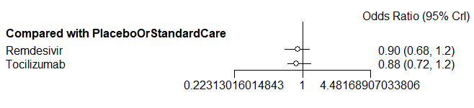
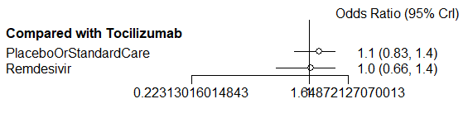

Recreating Selvarajan et al (separate 5 days vs 10 days):
This analysis only uses the 10 trials in Selvarajan and separates Remdesivir 5 days vs 10 days.
Network plot: 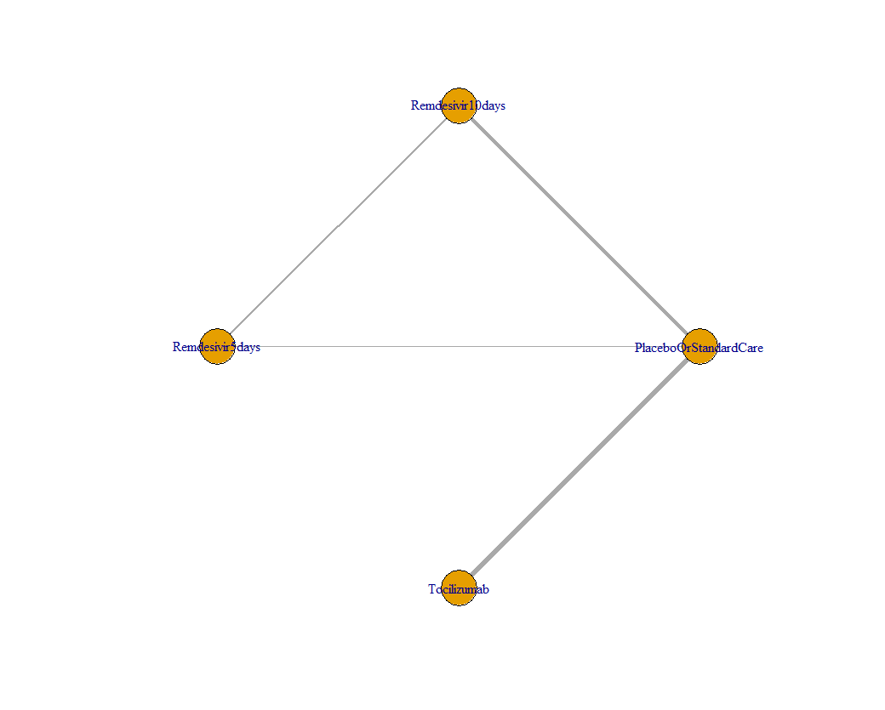
Analysis of heterogeneity: There is not considerable heterogeneity (<40%). (Note that here the pooled network estimate is not accurate as it is not using the specifications I later set in the model). 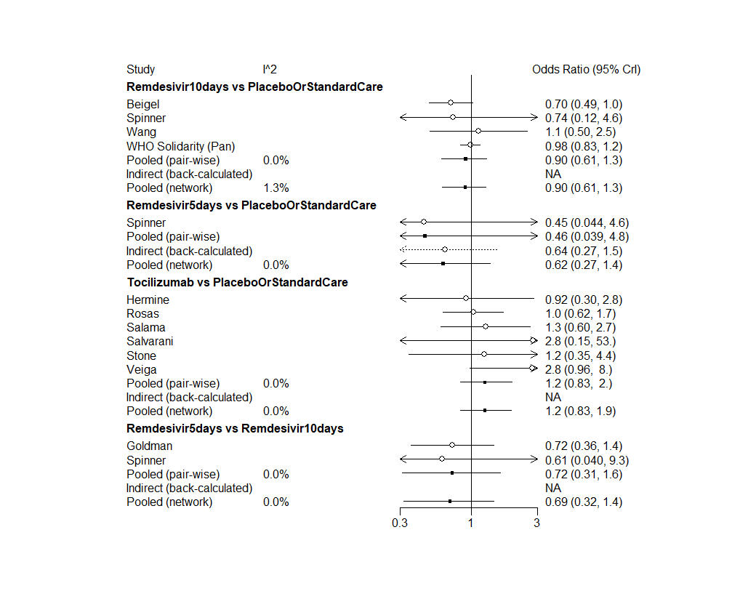

Trace plot: 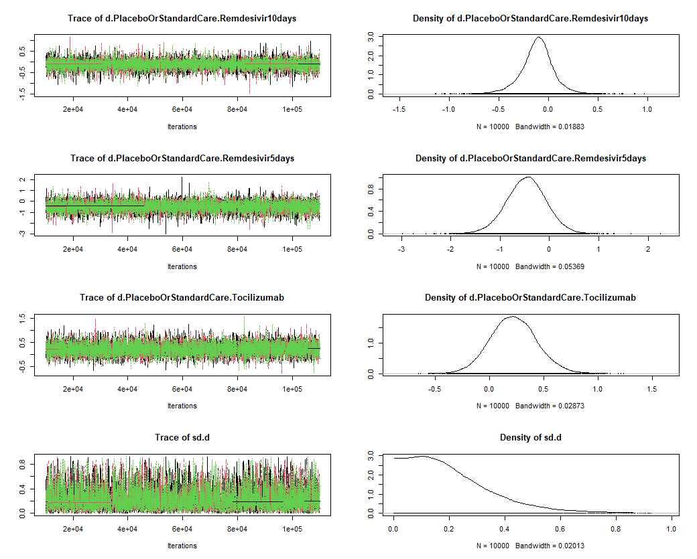
Gelman plot: 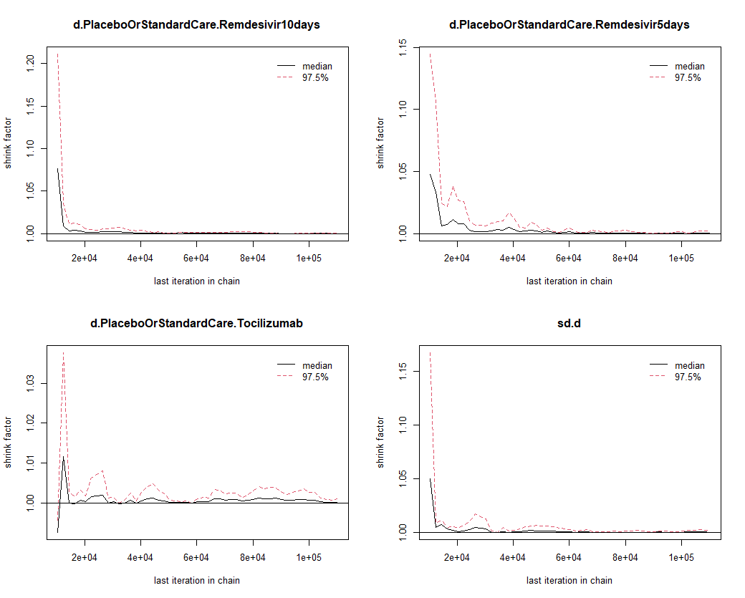
PSRF: 1.000872
Forest plots:
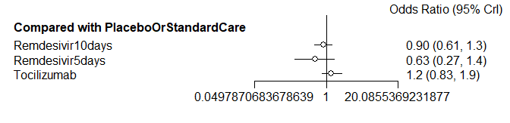

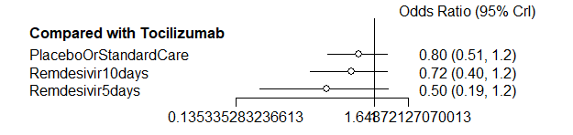

Corticosteroids analysis
This analysis included 16 studies total: all 8 Remdesivir studies plus the 8/13 Tocilizumab studies which included information on mortality among just patients receiving corticosteroids by treatment group.
To include tocilizumab with corticosteroids, I replaced the mortality numbers and patient count for both the treatment arm and control arm with just the numbers from the corticosteroid subgroup.
(All 8 Remdesivir studies were included although these may also have variance in the amount of corticosteroids use. The BMJ article also breaks IL-6 into with or without corticosteroid while leaving Remdesivir as one group without breakdown.)

Network plot: 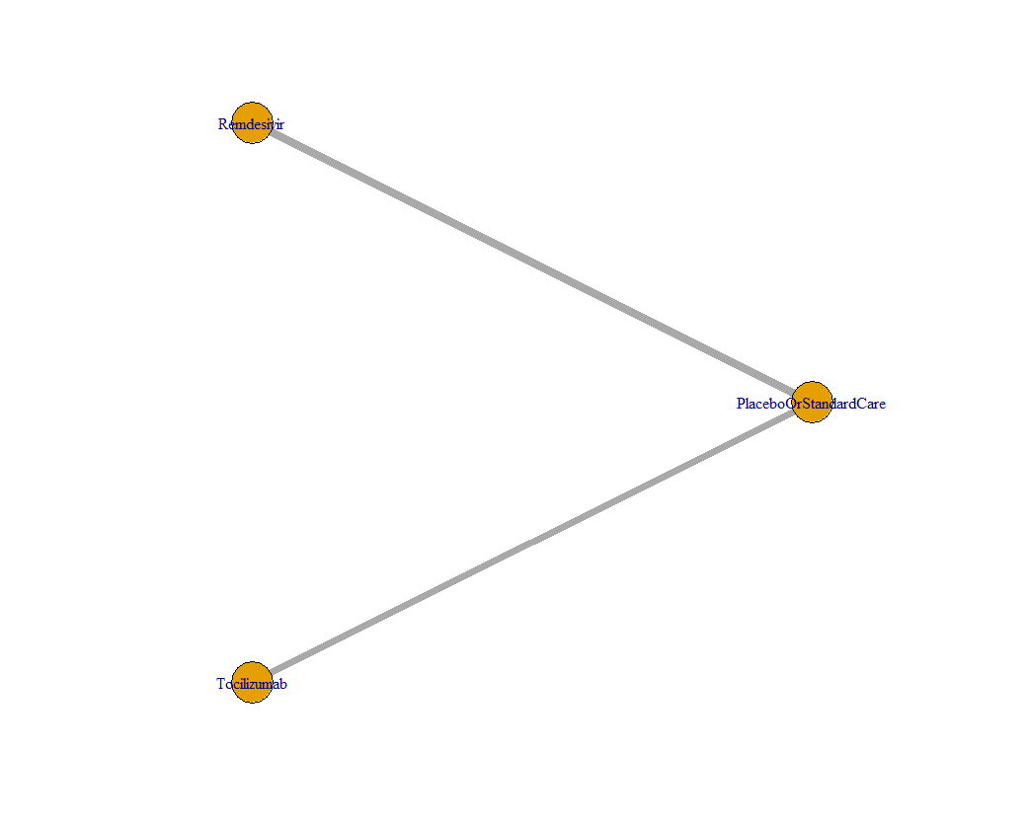
Analysis of heterogeneity: There is not considerable heterogeneity (<40%). (Note that here the pooled network estimate is not accurate as it is not using the specifications I later set in the model). Trace plot: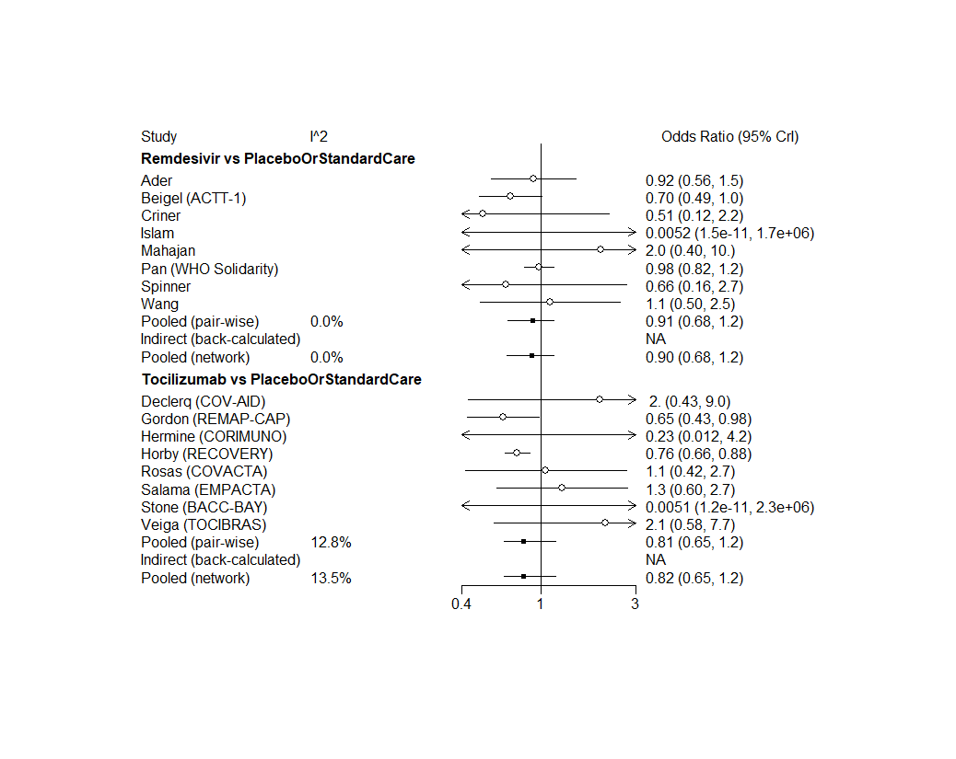
Trace plot: It looks relatively like they have converged.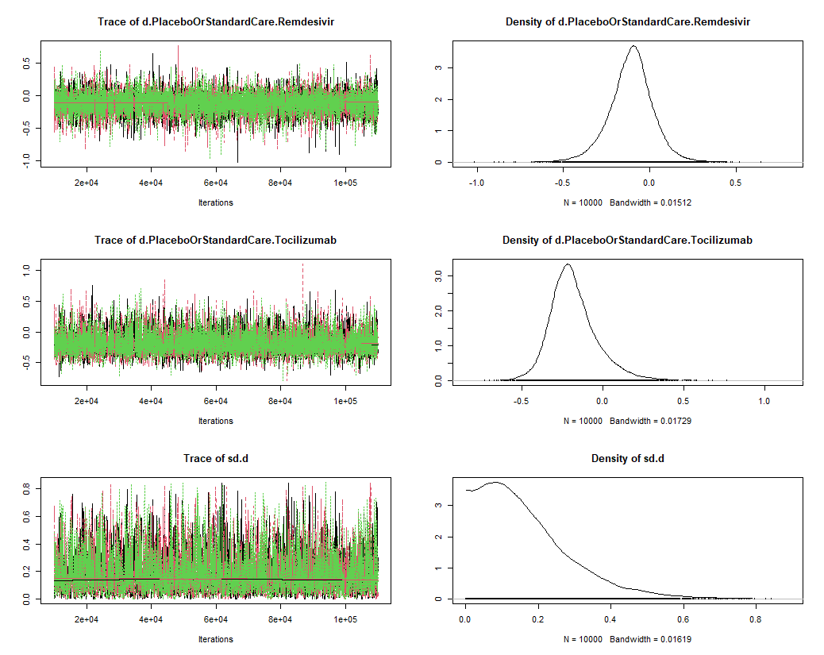
Gelman plot: 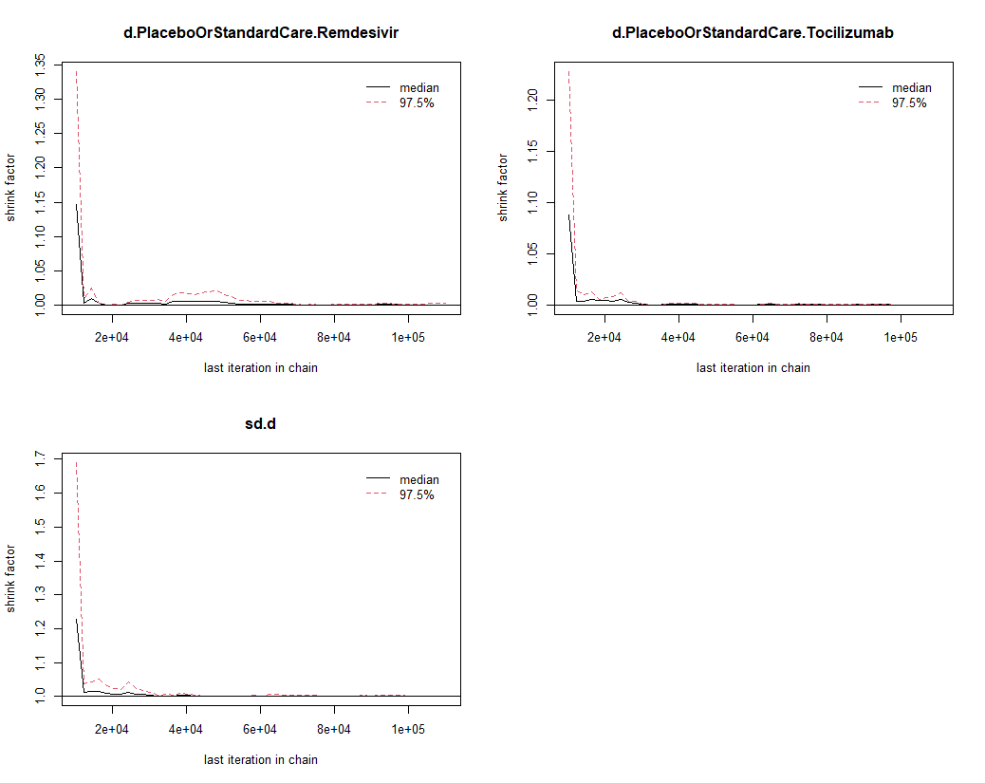
PSRF: 1.000622 (below threshold 1.05)
Forest plots:
