Final Data Management Project

Christina Chang

12/8/2017

# 1. Data Preparation

## Load Packages

# read data  
library(foreign)  
library(readr)  
  
# clean & manipulate data  
library(tidyverse)  
library(dplyr)  
library(reshape2)  
  
# plots   
library(ggplot2)  
  
# time series  
library(tseries)  
library(dynlm)  
library(urca)  
  
# forecast  
library(forecast)  
library(scales)  
  
# knit  
library(knitr)  
library(rvest)

## Import Data

By visual inspection of the file, we don’t want R to read the first two rows. NA argument to specify that any blanks (“”) or asterisks (“*”) would be considered missing data. Note: the asterisks are specified to be redacted information, based on the UNHCR website.

setwd("/Users/Berlin/Desktop/HertieDataScience/final project")  
  
d1 <- read_csv("unhcr_popstats_people of concern.csv", skip = 2, na = c("","*"))  
d2 <- read_csv("unhcr_popstats_refugee status.csv", skip = 2, na = c("", "*"))  
  
View(d1)  
View(d2)

## Tidy Data

The UNHCR data is an unbalanced panel dataset. After tidying the data, we have created a balanced panel dataset with all entities (countries) observed in all years (from 2000 to 2016).

Steps to clean and manipulate data:

str(d1)  
# Year correctly structured as integer  
# Country destination and origin correctly structured as character  
# All other variables should be numeric   
  
d1[4:11] <- lapply(d1[4:11], as.numeric)  
  
summary(d1) # years from 1951 to 2016  
  
str(d2)  
# Year correctly structured as integer  
# Country destination and origin correctly structured as character  
# Do not need RSD procedure type information  
# All other variables should be numeric   
  
d2[4] <- NULL  
  
d2[4:13] <- lapply(d2[4:13], as.numeric)  
  
summary(d2) # years from 2000 to 2016  
  
df <- merge(d1, d2, by = c("Year", "Country / territory of asylum/residence", "Origin"))  
  
View(df)  
str(df)  
summary(df) # after merge, data before the year 2000 drops out.  
  
# identify missing data  
apply(df,2, function(x) sum(is.na(x)))

# 2. Exploratory Data Analysis

## People of Concern:

# subset for only PoC category counts by year  
  
PoC_count <- df[c(1,4:10)]   
  
PoC_count <- melt(PoC_count, id=c("Year"))  
  
str(PoC_count)

## 'data.frame': 813456 obs. of 3 variables:  
## $ Year : int 2000 2000 2000 2000 2000 2000 2000 2000 2000 2000 ...  
## $ variable: Factor w/ 7 levels "Refugees (incl. refugee-like situations)",..: 1 1 1 1 1 1 1 1 1 1 ...  
## $ value : num NA NA 9 507 2 5 NA 1 5 20 ...

plot1 <- ggplot(PoC_count,aes(Year,value, na.rm = TRUE)) +  
 geom_bar(aes(fill=variable),stat="identity") +  
 labs(title="UNHCR Population Statistics Database",  
 subtitle="Populations of Concern (2000 - 2016)",  
 x="Year",   
 y="Number of People (Millions)")  
  
plot1

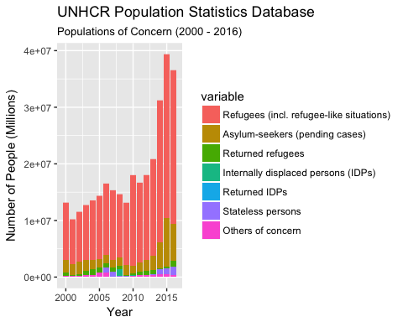

## Percent Change in Total Population by “People of Concern”

Year_Pop <- aggregate(df$`Total Population`, by=list(Year = df$Year), FUN=sum, na.rm = TRUE)  
  
Year_Pop$rate <- NA  
  
Year_Pop$rate[which(Year_Pop$Year>2000)] = 100*(diff(Year_Pop$x)/Year_Pop[-nrow(Year_Pop),]$x)  
  
View(Year_Pop)  
  
plot2 <- ggplot(Year_Pop, aes(x= Year, y= rate)) + geom_line() +   
 labs(title="Percent Change in People of Concern",  
 subtitle="(2000 - 2016)",  
 x="Year",   
 y="Percent Change")  
  
plot2

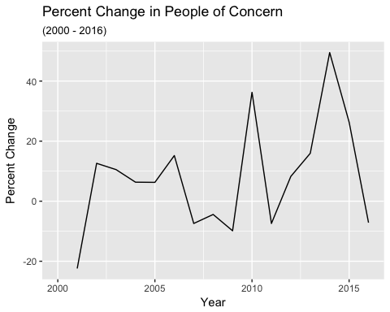

## Top Countries of Destination

destination_country_total <- df %>%  
 group_by(`Country / territory of asylum/residence`, Year) %>%  
 summarise(Total = sum(`Total Population`))  
  
View(destination_country_total)  
  
top_destcountries <- destination_country_total %>%  
 group_by(`Country / territory of asylum/residence`) %>%  
 summarise(Total = sum(Total, na.rm = TRUE)) %>%  
 top_n(20)  
  
View(top_destcountries)  
  
top_destcountries2 <- as.character(top_destcountries$`Country / territory of asylum/residence`)  
  
plot3 <- destination_country_total %>%  
 filter(`Country / territory of asylum/residence` %in% top_destcountries2) %>%  
 ggplot(mapping = aes(x = Year, y = Total)) +  
 geom_line() + coord_cartesian(ylim = c(0, 3e6)) +  
 facet_wrap(~`Country / territory of asylum/residence`, ncol=4)  
  
plot3

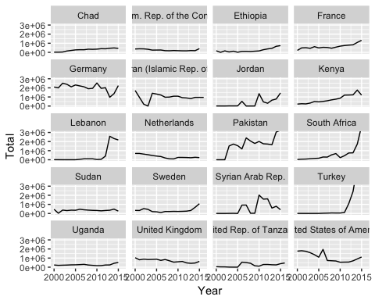

## Top Countries of Origin

origin_country_total <- df %>%  
 group_by(Origin, Year) %>%  
 summarise(Total = sum(`Total Population`))  
  
top_origcountries <- origin_country_total %>%  
 group_by(Origin) %>%  
 summarise(Total = sum(Total, na.rm = TRUE)) %>%  
 top_n(20)  
  
top_origcountries2 <- as.character(top_origcountries$Origin)  
  
plot4 <- origin_country_total %>%  
 filter(Origin %in% top_origcountries2) %>%  
 ggplot(mapping = aes(x = Year, y = Total)) +  
 geom_line() + coord_cartesian(ylim = c(0, 1e7)) +  
 facet_wrap( ~ Origin, ncol=4)  
  
plot4

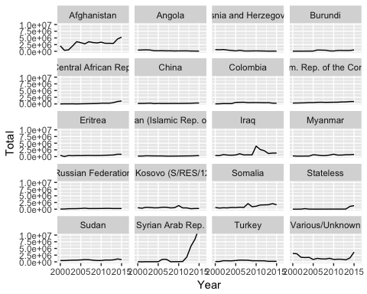

# 3. Time Series Analysis

We run a time-series analysis to see if the total number of “Persons of Concern” (POC) in world effects the total number of POCs in Germany over time. y = Total PoC in Germany; x = Total PoC in the world; t = Years (2000 to 2016)

## Prepare data for Time Series analysis

# create new dataframe  
Germany_Poc <- df %>% group_by(`Country / territory of asylum/residence`, Year) %>%   
 filter('Germany' %in% `Country / territory of asylum/residence`) %>%   
 summarise(German_Total = sum(`Total Population`, na.rm = TRUE))  
  
View(Germany_Poc)  
  
df_ts <- merge(Germany_Poc, Year_Pop, by = "Year")  
   
View(df_ts)  
  
# declare variables to be time series using ts()  
df_ts$Year <- ts(df_ts$Year)  
df_ts$German_Total<- ts(df_ts$German_Total)  
df_ts$x <- ts(df_ts$x)  
  
# run preliminary OLS model  
summary(m1 <- dynlm(German_Total ~ x, data = df_ts))

##   
## Time series regression with "ts" data:  
## Start = 1, End = 17  
##   
## Call:  
## dynlm(formula = German_Total ~ x, data = df_ts)  
##   
## Residuals:  
## Min 1Q Median 3Q Max   
## -1211808 -170365 16838 237008 1383368   
##   
## Coefficients:  
## Estimate Std. Error t value Pr(>|t|)   
## (Intercept) 1.862e+06 3.388e+05 5.494 6.17e-05 ***  
## x 1.533e-02 1.662e-02 0.922 0.371   
## ---  
## Signif. codes: 0 '***' 0.001 '**' 0.01 '*' 0.05 '.' 0.1 ' ' 1  
##   
## Residual standard error: 579400 on 15 degrees of freedom  
## Multiple R-squared: 0.05367, Adjusted R-squared: -0.009417   
## F-statistic: 0.8507 on 1 and 15 DF, p-value: 0.3709

Results of OLS model (m1): Positive and substantially small coefficient, but not statistically significant. Can only use OLS regression with time series data if the following two conditions are met:

## (a) Weak Dependence / Weak Persistence

summary(dynlm(German_Total ~ L(German_Total, 1), data = df_ts))

##   
## Time series regression with "ts" data:  
## Start = 2, End = 17  
##   
## Call:  
## dynlm(formula = German_Total ~ L(German_Total, 1), data = df_ts)  
##   
## Residuals:  
## Min 1Q Median 3Q Max   
## -1167925 -222002 -102511 197473 1559245   
##   
## Coefficients:  
## Estimate Std. Error t value Pr(>|t|)  
## (Intercept) 1.184e+06 7.852e+05 1.508 0.154  
## L(German_Total, 1) 4.728e-01 3.777e-01 1.252 0.231  
##   
## Residual standard error: 584500 on 14 degrees of freedom  
## Multiple R-squared: 0.1006, Adjusted R-squared: 0.03641   
## F-statistic: 1.567 on 1 and 14 DF, p-value: 0.2312

# The rho is less than 1, so stability condition is met  
  
acf(df_ts$German_Total, na.action = na.pass, lag.max = 5)

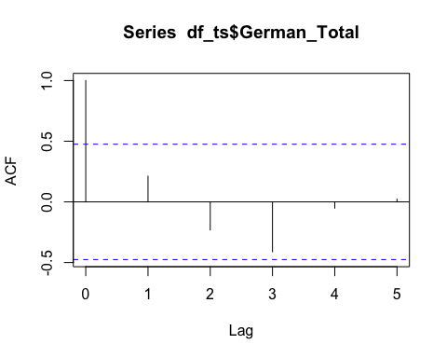

# Correlation coefficient is statistically insignificant after 1 lag, so it is not persistent

Conclusion: The data is weakly dependent allowing for a dynamically complete model.

## (b) Stationarity

# Unit Root - Dickey Fuller Test   
adf.test(df_ts$German_Total)

##   
## Augmented Dickey-Fuller Test  
##   
## data: df_ts$German_Total  
## Dickey-Fuller = -3.9925, Lag order = 2, p-value = 0.02352  
## alternative hypothesis: stationary

# p-value is less than .05, so it has no unit root  
  
# Trends  
par(mfrow = c(1, 2))  
plot(df_ts$German_Total) #Total POCs in Germany  
plot(df_ts$x) #Total POCs in the world

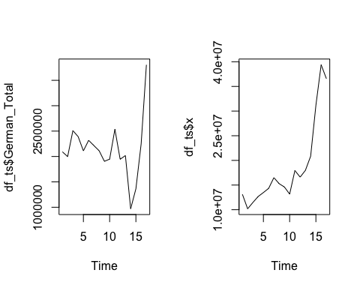

Conclusions: Total POCs in Germany looks like a stochastic (inconsistent) trend. Total POCs in the world looks like a deterministic trend. That is, it is non-stationary. Need to account for this trend in total POCs in the world before running an OLS regression.

## Method 1: First Differencing

df_ts$d.German_Total <- c(NA, diff(df_ts$German_Total))  
df_ts$d.x <- c(NA, diff(df_ts$x))  
  
par(mfrow = c(1, 2))  
plot(df_ts$d.German_Total)  
plot(df_ts$d.x)

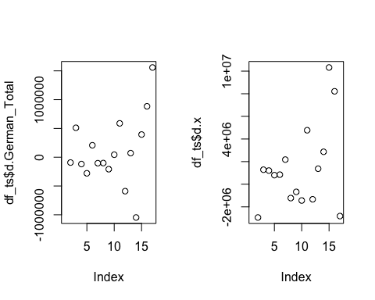

summary(m2 <- dynlm(d.German_Total ~ d.x, data = df_ts))

##   
## Time series regression with "numeric" data:  
## Start = 1, End = 16  
##   
## Call:  
## dynlm(formula = d.German_Total ~ d.x, data = df_ts)  
##   
## Residuals:  
## Min 1Q Median 3Q Max   
## -1194561 -237301 -53873 184974 1573241   
##   
## Coefficients:  
## Estimate Std. Error t value Pr(>|t|)  
## (Intercept) 6.535e+04 1.660e+05 0.394 0.700  
## d.x 2.854e-02 4.299e-02 0.664 0.518  
##   
## Residual standard error: 614200 on 14 degrees of freedom  
## (1 observation deleted due to missingness)  
## Multiple R-squared: 0.03051, Adjusted R-squared: -0.03874   
## F-statistic: 0.4406 on 1 and 14 DF, p-value: 0.5176

Results of OLS model (m2): Positive and substantially small coefficient, but not statistically significant.

The problem with first differencing is that we lose statistical power as we lose observations.

## Method 2: Detrending

fit1 <- lm(German_Total ~ Year, df_ts)  
df_ts$resid.German_Total <- residuals(fit1)  
  
fit2 <- lm(x ~ Year, df_ts)  
df_ts$resid.x <- residuals(fit2)  
  
summary(m3 <- dynlm(resid.German_Total ~ resid.x, data = df_ts))

##   
## Time series regression with "numeric" data:  
## Start = 1, End = 17  
##   
## Call:  
## dynlm(formula = resid.German_Total ~ resid.x, data = df_ts)  
##   
## Residuals:  
## Min 1Q Median 3Q Max   
## -975522 -208415 51245 174882 1348800   
##   
## Coefficients:  
## Estimate Std. Error t value Pr(>|t|)  
## (Intercept) 1.412e-11 1.330e+05 0.000 1.000  
## resid.x 4.494e-02 2.743e-02 1.638 0.122  
##   
## Residual standard error: 548500 on 15 degrees of freedom  
## Multiple R-squared: 0.1518, Adjusted R-squared: 0.09523   
## F-statistic: 2.684 on 1 and 15 DF, p-value: 0.1222

Results of OLS model (m3): Positive and substantially small coefficient, but not statistically significant

So even after detrending, there is no statistically significant coefficient to show a causal effect between the total POC in the world and the total POCs in Germany over time.

# 4. Forecasting

As we have monthly data on asylum-seekers in Germany, we can use it to predict future numbers of asylum-seekers using a forecasting model.

## Import Data

By visual inspection of the file, we don’t want R to read the first two rows.

df3 <- read_csv("unhcr_popstats_export_asylum_seekers_monthly_2017_12_04_203715.csv", skip = 2)  
  
View(df3)  
str(df3)  
summary(df3)

## Tidy Data

In the forecasting model, NA values returns errors. As such, we specify that any NA values are assigned a value of 0.

df3[5] <- lapply(df3[5], as.numeric)  
  
apply(df3,2, function(x) sum(is.na(x)))  
  
df3$Value[is.na(df3$Value)] <- 0

## Declare variables as time series

Germany_Total.Monthly <- df3 %>%  
 group_by(`Country / territory of asylum/residence`, Year, Month) %>%  
 summarise(Total = sum(Value))  
  
Germany_monthly <- ts(Germany_Total.Monthly$Total,   
 start = c(1999, 1), frequency = 12)

## Test for weak dependence (weak persistence):

summary(dynlm(Germany_monthly ~ L(Germany_monthly, 1)))

##   
## Time series regression with "ts" data:  
## Start = 1999(2), End = 2017(9)  
##   
## Call:  
## dynlm(formula = Germany_monthly ~ L(Germany_monthly, 1))  
##   
## Residuals:  
## Min 1Q Median 3Q Max   
## -57837 -1677 -1197 32 55483   
##   
## Coefficients:  
## Estimate Std. Error t value Pr(>|t|)   
## (Intercept) 1919.7596 722.1649 2.658 0.00842 **   
## L(Germany_monthly, 1) 0.8129 0.0391 20.792 < 2e-16 ***  
## ---  
## Signif. codes: 0 '***' 0.001 '**' 0.01 '*' 0.05 '.' 0.1 ' ' 1  
##   
## Residual standard error: 9061 on 222 degrees of freedom  
## Multiple R-squared: 0.6607, Adjusted R-squared: 0.6592   
## F-statistic: 432.3 on 1 and 222 DF, p-value: < 2.2e-16

# The rho is less than 1, so stability condition is met  
  
acf(Germany_monthly, na.action = na.pass, lag.max = 40)

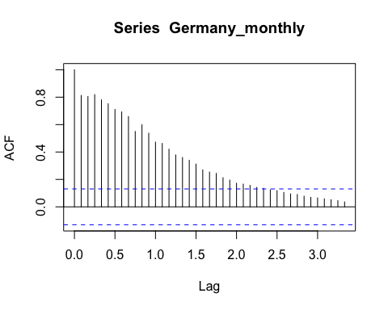

# Correlation coefficient is statistically insignificant after 2.5 lag, so it is not persistent

## Test for stationarity

# Unit Root - Dickey Fuller Test   
adf.test(Germany_monthly)

##   
## Augmented Dickey-Fuller Test  
##   
## data: Germany_monthly  
## Dickey-Fuller = -2.4282, Lag order = 6, p-value = 0.3961  
## alternative hypothesis: stationary

# p value is less than .05, there is no unit root.  
  
# Trends  
autoplot(as.zoo(Germany_monthly), geom = "line")

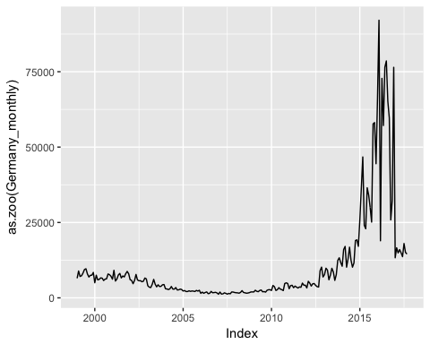

# For forecasting, just observe the trend.   
# Clear spike since 2015 that seems to have dropped off in 2016.

## Decompose

Decompose the additives of time series. This returns estimates of the seasonal component, trend component and irregular components (“random” components).

plot(decompose(Germany_monthly))

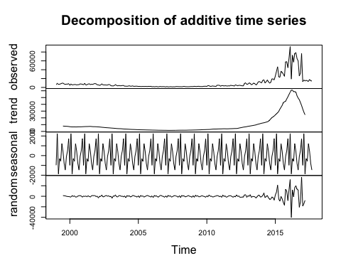

## Seasonal Changes

Look more closely at the seasonal changes in the number of asylum seekers.

stl(Germany_monthly, s.window="periodic")  
# Germany has had a positive net flow of asylum seekers in February, June, July, November and December.

We attempt two methods for forecasting future monthly flows of asylum seekers for 2018 and 2019 in Germany.

## Method 1: ARIMA Forecasting

plot(forecast(auto.arima(Germany_monthly), 30),   
 main = "ARIMA Forecast: Germany Asylum Seeker Arrivals",   
 ylab = "Number of Asylum Seekers",   
 xlab = "Year", ylim=c(0, 90000))

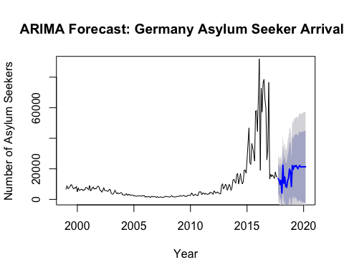

# The wide confidence intervals show the uncertainty in forecasting with the dark grey representing 95 percent confidence and the light grey representing 80 percent confidence.   
  
# ARIMA forecast values:  
forecast(auto.arima(Germany_monthly), 24)

## Point Forecast Lo 80 Hi 80 Lo 95 Hi 95  
## Oct 2017 13600.045 4001.42590 23198.66 -1079.776 28279.87  
## Nov 2017 12602.114 2690.66757 22513.56 -2556.135 27760.36  
## Dec 2017 9783.970 -539.22427 20107.16 -6003.993 25571.93  
## Jan 2018 12492.452 1138.14968 23846.75 -4872.455 29857.36  
## Feb 2018 4125.247 -8174.02286 16424.52 -14684.863 22935.36  
## Mar 2018 22453.966 9277.32413 35630.61 2302.031 42605.90  
## Apr 2018 10594.123 -3405.01062 24593.26 -10815.704 32003.95  
## May 2018 14587.126 -188.78676 29363.04 -8010.682 37184.93  
## Jun 2018 8506.528 -7007.31837 24020.38 -15219.853 32232.91  
## Jul 2018 7885.977 -8332.26208 24104.22 -16917.679 32689.63  
## Aug 2018 12268.575 -4624.71179 29161.86 -13567.478 38104.63  
## Sep 2018 13974.220 -3568.15671 31516.60 -12854.530 40802.97  
## Oct 2018 19766.918 1900.25116 37633.58 -7557.791 47091.63  
## Nov 2018 18144.497 -251.95305 36540.95 -9990.446 46279.44  
## Dec 2018 8374.367 -10523.66592 27272.40 -20527.680 37276.41  
## Jan 2019 22188.573 2857.62113 41519.53 -7375.567 51752.71  
## Feb 2019 19746.164 -8.22251 39500.55 -10465.563 49957.89  
## Mar 2019 21940.352 1771.41815 42109.29 -8905.370 52786.07  
## Apr 2019 21460.855 885.72496 42035.98 -10006.091 52927.80  
## May 2019 22219.733 1246.27226 43193.19 -9856.407 54295.87  
## Jun 2019 20951.172 -413.19458 42315.54 -11722.807 53625.15  
## Jul 2019 20087.011 -1661.23559 41835.26 -13174.062 53348.08  
## Aug 2019 21572.478 -552.98949 43697.95 -12265.504 55410.46  
## Sep 2019 22135.917 -360.44712 44632.28 -12269.303 56541.14

## Method 2: TBATS Forecasting

plot(forecast(tbats(Germany_monthly), 30),   
 main = "TBATS Forecast: Germany Asylum Seeker Arrivals",   
 ylab = "Number of Asylum Seekers",   
 xlab = "Year", ylim=c(0, 90000))

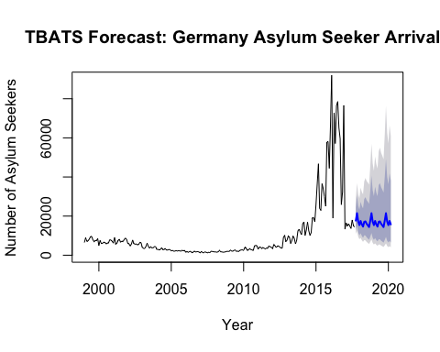

#TBATS forecast values:  
forecast(tbats(Germany_monthly), 24)

## Point Forecast Lo 80 Hi 80 Lo 95 Hi 95  
## Oct 2017 17677.72 12843.324 24331.86 10844.966 28815.39  
## Nov 2017 21482.21 15101.356 30559.19 12531.104 36827.17  
## Dec 2017 17205.55 11693.651 25315.53 9531.590 31057.88  
## Jan 2018 15371.73 10134.801 23314.71 8129.215 29066.77  
## Feb 2018 17522.07 11242.393 27309.38 8888.643 34541.02  
## Mar 2018 15753.26 9844.956 25207.34 7676.085 32329.65  
## Apr 2018 14612.84 8911.857 23960.77 6859.269 31130.86  
## May 2018 17094.15 10186.737 28685.32 7745.093 37728.38  
## Jun 2018 17283.33 10070.144 29663.29 7565.720 39482.50  
## Jul 2018 16052.74 9158.985 28135.25 6805.177 37866.81  
## Aug 2018 15243.82 8521.070 27270.52 6262.908 37103.21  
## Sep 2018 14373.66 7877.165 26227.99 5729.283 36060.75  
## Oct 2018 17677.72 9519.380 32827.97 6859.701 45556.21  
## Nov 2018 21482.21 11365.829 40602.86 8114.143 56874.17  
## Dec 2018 17205.55 8929.264 33152.89 6309.918 46915.19  
## Jan 2019 15371.73 7832.675 30167.21 5481.564 43106.30  
## Feb 2019 17522.07 8776.609 34981.94 6086.666 50441.87  
## Mar 2019 15753.26 7756.225 31995.61 5330.319 46557.28  
## Apr 2019 14612.84 7077.428 30171.27 4821.688 44286.35  
## May 2019 17094.15 8148.019 35862.68 5504.322 53087.34  
## Jun 2019 17283.33 8108.219 36840.83 5431.517 54996.34  
## Jul 2019 16052.74 7417.964 34738.70 4929.540 52274.73  
## Aug 2019 15243.82 6939.160 33487.34 4574.840 50793.91  
## Sep 2019 14373.66 6447.303 32044.75 4217.526 48986.59