Ex No:5 | LOADER
Date of Exercise | 10-02-2022

Questions
- Write a program to simulate loader.
Aim
To simulate the concept of absolute loader.

Description
LOADER
Absolute loader is a simple loader which performs loading process and need not to perform linking and program relocation processes.
ALGORITHM
- Read the Header Record
- Verify the name and length of the program.
- Read first text record from the input file.
- Process the following steps until the end record is reached.
- If object code is character form then convert it to hexadecimal representation.
- Move object codes to specified location in memory.
- Read next text record from the input file one by one until reach the end record and move them one by one to specified location.
- If it reaches the end record close the files.
SAMPLE INPUT & OUTPUT Input
Input.txt
H^SAMPLE^001000^0035
T^001000^0C^001003^071009
T^002000^03^111111
E^001000
Output
enter program name: SAMPLE
name from obj. SAMPLE
001000 00
001001 10
001002 03
001003 07
001004 10
001005 09
002000 11
002001 11
002002 11

Program
import re
loadr=0
with open("input.txt") as f:
for line in f:
data=line.split("^")
if(data[0]=="H"):
s=str(input("Enter program name:"))
s.format("sample")
print("Name from object: {}".format(data[1]))
loadr=int(data[2])
elif (data[0]=="T"):
if (loadr != data[1]):
loadr = int(data[1])
add=data[3]
ad=re.findall(r'\d\d', add)
for ob in ad:
print("00{} {}".format(loadr, ob))
loadr +=1
try:
if(data[4]):
add2=data[4]
ad2=re.findall(r"\d\d", add2)
for ob in ad2:
print("00{} {}".format(loadr,ob))
loadr +=1
except IndexError:
pass
continue

Output Screenshot
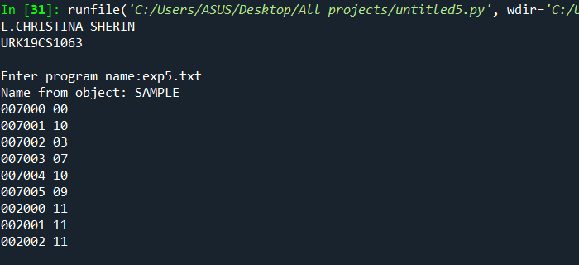
Result
Program for Loader simulation has been successfully executed and memory is allocated .

