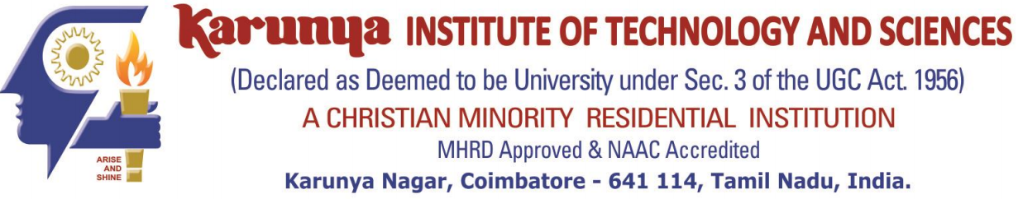

DEPARTMENT OF COMPUTER SCIENCE AND ENGINEERING

SCHOOL OF ENGINEERING AND TECHNOLOGY

LABORATORY RECORD

2021-2022

Subject Code
18CS2023

Subject Name
Web Technology Lab

Register No. URK19CS1063

It is hereby certified that this is the bonafide record of work done by Mr./Ms. L.Christina Sherin during the even semester of the academic year 2021-2022 and submitted for the University Practical Examination held on ____________________.

Staff-in-charge Head of the Department

Name:
ID:
Examiner

TABLE OF CONTENTS

S.No | Date | Title | Page. No
1
2
3
4
5
6
7
8
9
10

