Token Separation using lex | Ex. No. 6
Token Separation using lex | 25-02-2022

Aim
To write a Lex specification for token separation using regular expressions
Description
Lex helps write programs whose control flow is directed by instances of regular expressions in the input stream. It is well suited for editor-script type transformations and for segmenting input in preparation for a parsing routine.
Lex source is a table of regular expressions and corresponding program fragments. The table is translated to a program which reads an input stream, copying it to an output stream and partitioning the input into strings which match the given expressions. As each such string is recognized the corresponding program fragment is executed. The recognition of the expressions is performed by a deterministic finite automaton generated by Lex. The program fragments written by the user are executed in the order in which the corresponding regular expressions occur in the input stream.
Lex turns the user's expressions and actions (called source in this memo) into the host general-purpose language; the generated program is named yylex. The yylex program will recognize expressions in a stream (called input in this memo) and perform the specified actions for each expression as it is detected. See Figure 1.
+-------+

Procedure:
- Define the required variables
- Define the regular expressions
- Define the required auxiliary definitions
- Compile the program by using the following commands
  - lex sample.l
  - cc lex.yy.c
- Execute the program by the following command
  - ./a.out << $

PROGRAM:
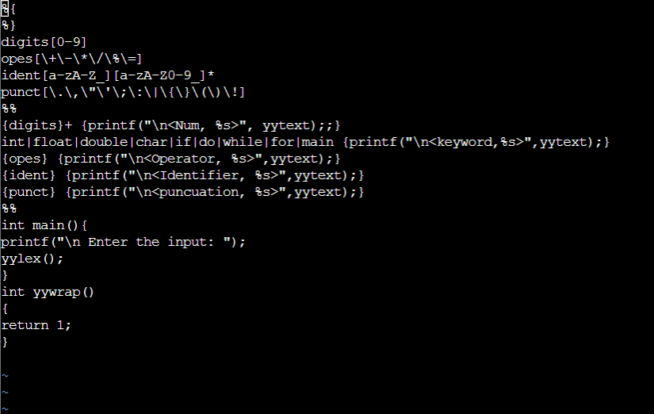

OUTPUT:
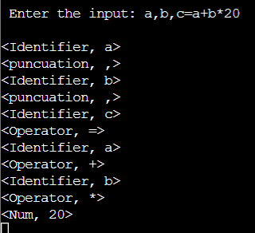

Result
Lex program for token separation has been executed and verified.

