18CS2020 - System Software and Compiler Design Lab

Ex No : 4 | SINGLE PASS ASSEMBLER FOR SIC
Date of Exercise | 10-02-2022

AIM
To simulate the concept of single pass assembler for simplified instructional computer.
DESCRIPTION
An assembler is a program that accepts as input an assembly language program (source) and produces its machine language equivalent (object code) along with the information for the loader.

Assembler
EXE
Linker
Assembly language program

Figure 1. Executable program generation from an assembly source code
Advantages of coding in assembly language are:
- Provides more control over handling particular hardware components
- May generate smaller, more compact executable modules
- Often results in faster execution

ALGORITHM
- Open and Read the input file
- If the input line has the opcode START do the following
2.1 Find if there is any operand field after START initialize the LC to the operand
Value.
  - Otherwise if there is no value in the operand field then LC is set to 0.
- Write the input line to the intermediate file.
- Do the following steps until the opcode is END.
4.1 Check the Symbol table, if the symbol isnot available then enter that symbol into
the SYMTAB, along with the memory address in which it is stored.Otherwise, the
error message will be displayed.
  - If there is a opcode
    - 1 If opcode is present in the OPTAB, then increment the LC by 3 and
Start writing the location counter, opcode and operand fields of the
corresponding statement to the output file, along with the object code.
    - If opcode isWORD then increment LC by 3
    - If opcode is BYTE then increment LC by 1
    - If opcode is RESW then increment LC by the integer equivalentof the operand value * 3
    - If opcode is RESB then increment LC by the integer equivalentof the operand value
    - If there is no symbol/label in the operand field, then the operandaddress is assigned as zero and it is assembled with the object code of the instruction
    - Write the processed lines in the intermediate file along with their along with the location counters.
- To find the length of the program, Subtract the starting address of the program from the LC.
- Close all the files.

Program
i = open("input_4.txt",'r').readlines()
op = open("optab.txt",'r').readlines()
s = open("symtab.txt",'r').readlines()
output = open('output.txt','w')
optab = {};
l = []
m = []
n = []
a = []

opcode = []
object_code = []

for line in op:
op = line.split()
optab.update({op[0]: op[1]})
for line in i:
if "START" in line:
start = line.split()[2]
x = int(start, 16)
a.append('')
else:
a.append(str(hex(x)[2:]))
x += 3

for line in i:
line = line.split()
if len(line) == 3:
l.append(line[0])
m.append(line[1])
n.append(line[2])
elif len(line) == 2:
l.append('')
m.append(line[0])
n.append(line[1])
else:
m.append(line[0])
for i in m:
if i == "START":
continue;
if i in optab:
x = str(optab[i])
y = str(a[l.index(n[m.index(i)])])
object_code.append('^' + str(x + y))

ob = ''.join(object_code)
leng = len(object_code)
x = str(hex(leng * 3)[1:])
if 'x' in x:
x = x.replace('x','0')

output.write('H^' + l[0] + '^' + '00' + a[1] + '^' + '0000' + a[len(a) - 1][2:]+ '\n')
output.write('T^' + a[1] + '^' + x + ob+'\n')
output.write('E^' + '00' + a[1]+'\n')
output.close()

print(open('output.txt').read())

Input

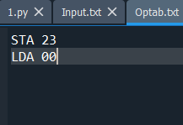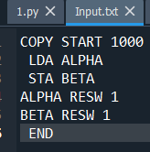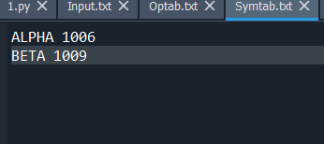
OUTPUT:
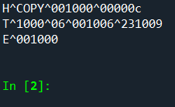

Result
Thus the program was implemented successfully and the output was verified for all possible inputs

