URK19CS1063 L.CHRISTINA SHERIN

<!DOCTYPE html>
<html>
<body>

<h2>JavaScript Operators</h2>

<p>x = 5, y = 2, calculate z = x + y, and display z:</p>

<p id="demo"></p>

<script>
let x = 5;
let y = 2;
let z = x + y;
document.getElementById("demo").innerHTML = z;
</script>

</body>
</html>

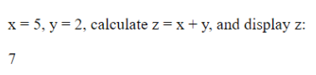

<!DOCTYPE html>
<html>
<body>

<h2>JavaScript Operators</h2>
<h3>The = Operator</h3>

<p id="demo"></p>

<script>
let x = 10;
document.getElementById("demo").innerHTML = x;
</script>

</body>
</html>

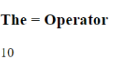

<!DOCTYPE html>
<html>
<body>

<h2>JavaScript Arithmetic</h2>
<h3>The + Operator</h3>

<p id="demo"></p>

<script>
let x = 5;
let y = 2;
let z = x + y;
document.getElementById("demo").innerHTML = z;
</script>

</body>
</html>

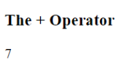

<!DOCTYPE html>
<html>
<body>

<h2>JavaScript Arithmetic</h2>
<h3>The * Operator</h3>

<p id="demo"></p>

<script>
let x = 5;
let y = 2;
let z = x * y;
document.getElementById("demo").innerHTML = z;
</script>

</body>
</html>

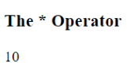

<!DOCTYPE html>
<html>
<body>

<h2>The += Operator</h2>

<p id="demo"></p>

<script>
var x = 10;
x += 5;
document.getElementById("demo").innerHTML = x;
</script>

</body>
</html>

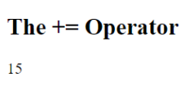

<!DOCTYPE html>
<html>
<body>

<h2>JavaScript Operators</h2>

<p>The + operator concatenates (adds) strings.</p>

<p id="demo"></p>

<script>
let text1 = "John";
let text2 = "Doe";
let text3 = text1 + " " + text2;
document.getElementById("demo").innerHTML = text3;
</script>

</body>
</html>

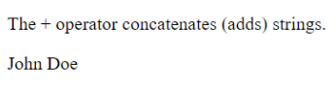

<!DOCTYPE html>
<html>
<body>

<h2>JavaScript Operators</h2>

<p>The assignment operator += can concatenate strings.</p>

<p id="demo"></p>

<script>
let text1 = "What a very ";
text1 += "nice day";
document.getElementById("demo").innerHTML = text1;
</script>

</body>
</html>

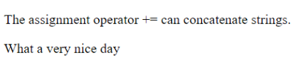

<!DOCTYPE html>
<html>
<body>

<h2>JavaScript Operators</h2>

<p>Adding a number and a string, returns a string.</p>

<p id="demo"></p>

<script>
let x = 5 + 5;
let y = "5" + 5;
let z = "Hello" + 5;
document.getElementById("demo").innerHTML =
x + "<br>" + y + "<br>" + z;
</script>

</body>
</html>

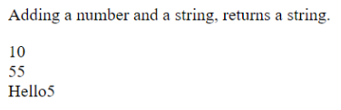

<!DOCTYPE html>
<html>
<body>

<h2>JavaScript Arithmetic</h2>
<p>A typical arithmetic operation takes two numbers and produces a new number.</p>

<p id="demo"></p>

<script>
let x = 100 + 50;
document.getElementById("demo").innerHTML = x;
</script>

</body>
</html>

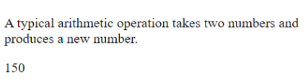
<!DOCTYPE html>
<html>
<body>

<h2>JavaScript Arithmetic</h2>
<p>A typical arithmetic operation takes two numbers (or variables) and produces a new number.</p>

<p id="demo"></p>

<script>
let a = 100;
let b = 50;
let x = a + b;
document.getElementById("demo").innerHTML = x;
</script>

</body>
</html>

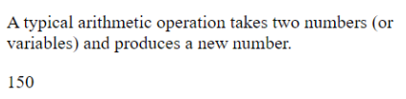

<!DOCTYPE html>
<html>
<body>

<h2>JavaScript Arithmetic</h2>
<p>A typical arithmetic operation takes two numbers (or expressions) and produces a new number.</p>

<p id="demo"></p>

<script>
let a = 3;
let x = (100 + 50) * a;
document.getElementById("demo").innerHTML = x;
</script>

</body>
</html>
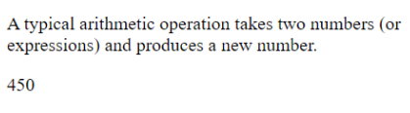

<!DOCTYPE html>
<html>
<body>

<h2>JavaScript Arithmetic</h2>
<h3>The + Operator</h3>

<p id="demo"></p>

<script>
let x = 5;
let y = 2;
let z = x + y;
document.getElementById("demo").innerHTML = z;
</script>

</body>
</html>

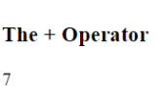

<!DOCTYPE html>
<html>
<body>

<h2>JavaScript Arithmetic</h2>
<h3>The - Operator</h3>

<p id="demo"></p>

<script>
let x = 5;
let y = 2;
let z = x - y;
document.getElementById("demo").innerHTML = z;
</script>

</body>
</html>

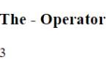

<!DOCTYPE html>
<html>
<body>

<h2>JavaScript Arithmetic</h2>
<h3>The * Operator</h3>

<p id="demo"></p>

<script>
let x = 5;
let y = 2;
let z = x * y;
document.getElementById("demo").innerHTML = z;
</script>

</body>
</html>

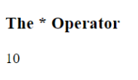

<!DOCTYPE html>
<html>
<body>

<h2>JavaScript Arithmetic</h2>
<h3>The / Operator</h3>

<p id="demo"></p>

<script>
let x = 5;
let y = 2;
let z = x / y;
document.getElementById("demo").innerHTML = z;
</script>

</body>
</html>

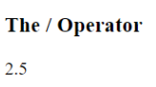

<!DOCTYPE html>
<html>
<body>

<h2>JavaScript Arithmetic</h2>
<h3>The % Operator</h3>

<p id="demo"></p>

<script>
let x = 5;
let y = 2;
let z = x % y;
document.getElementById("demo").innerHTML = z;
</script>

</body>
</html>

