## Proposal for MA 678 Midterm Project

Tong Sun

**Personal Statement:**

My future career plan is to be a background analyst of a fast fashion brand, such as analyzing the future design direction of a fashion design brand based on historical data, how to set the brand of a shopping mall in the next few years, and how to do the stock price trend of a listed company, etc. Fast fashion brands include catering, clothing, multimedia, art and design and other fields. Here my project is about analyzing Starbuck Stock Price and using related predictors to make the prediction about Starbuck Stock Price trend in the future. Starbucks Corporation has the most recognizable coffee brand in the world. Starbucks has proved it, a common argument being "people are not going to keep paying $x.xx for just a cup of coffee”, has staying power and impressive growth and the number of Starbucks stores around the world has been always growing. Unsurprisingly, the stock garnered a lot of positive press for its performance. However, there are some real risks facing the Starbucks brand in the future, including global competition, commodity prices and changing dynamics in the retail market. And the dataset in the project includes the competition brand’s stock price—Mc Donald stock price, partnerships’ influence—Walmart stock price(or Target Location), commodity price fluctuations — CPI milk average price, customer satisfactory survey with Starbucks( including some categorical variables such as customers’ gender and how often they visit Starbucks) , etc. (The thing I would like to try is whether I can add the location of some partnerships such as Target as one probable predictor. Because I found that, in the United States, the locations of Starbucks stores are related to the locations of some stores such as Barnes & Noble, Best Buy and Target stores. I think these channels are also important. But the difficult thing is that I have to transfer the location data sets into numerical items, in order to put them into R successfully.) Thus, from this project, I hope I could have a contact with this kind of data which may help me familiarize myself with the work style if I can get a job in this field in the future.

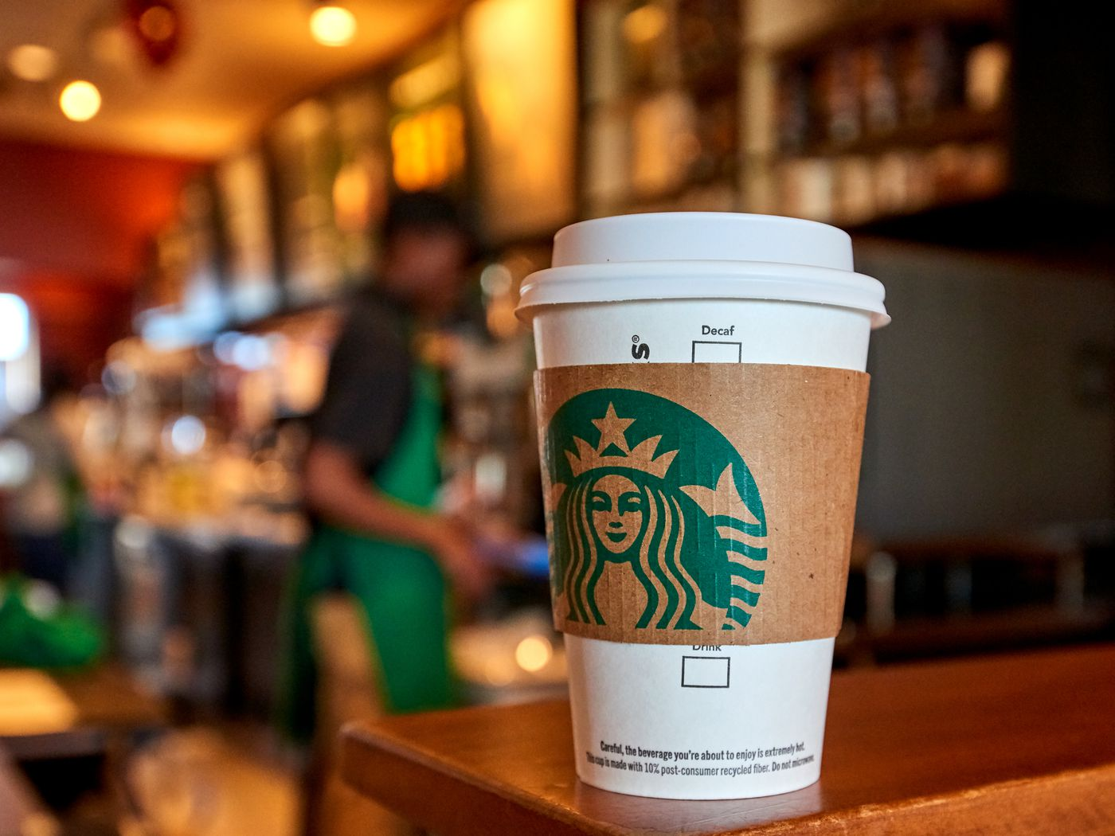

**Question:**

What factors affect the Starbucks stock price? How will the outcome influence investors’ investigation about whether a stock is a good buy based on expected future results, not on what has occurred in the past?

**Data Source:**

<https://finance.yahoo.com/quote/SBUX/history?p=SBUX>

<https://finance.yahoo.com/quote/MCD/history?p=MCD>

<https://finance.yahoo.com/quote/WMT/history?p=WMT>

(<https://www.kaggle.com/ben1989/target-store-dataset>)

<https://data.bls.gov/timeseries/APU0000709112?data_tool=XGtable>

<https://www.kaggle.com/ihormuliar/starbucks-customer-data>

**Proposed Timeline of work:**

* EDA -- Nov.5th to Nov.10th
* Data Processing -- Nov. 11th to Nov. 13th
* Modeling and Validation -- Nov. 14th to Nov. 25th
* Write up -- Nov. 25th to Dec. 1st