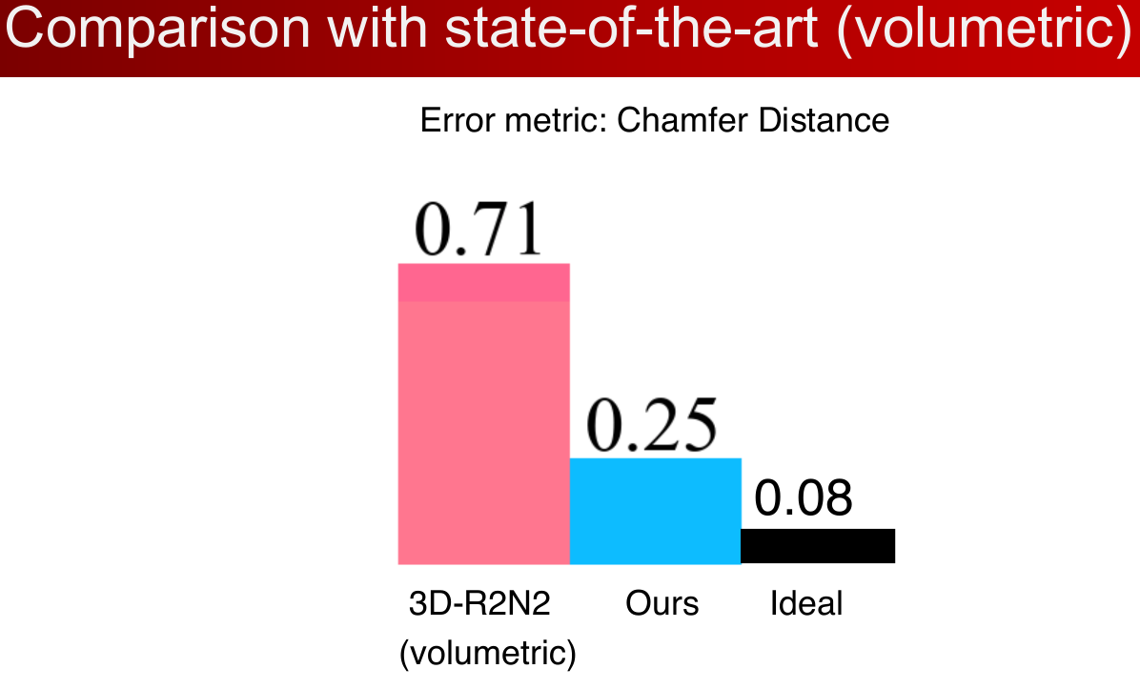
Why is ideal 0.08 ?

Learning to predict geometric forms:

polygonal mesh / point cloud / primitive-based CAD models

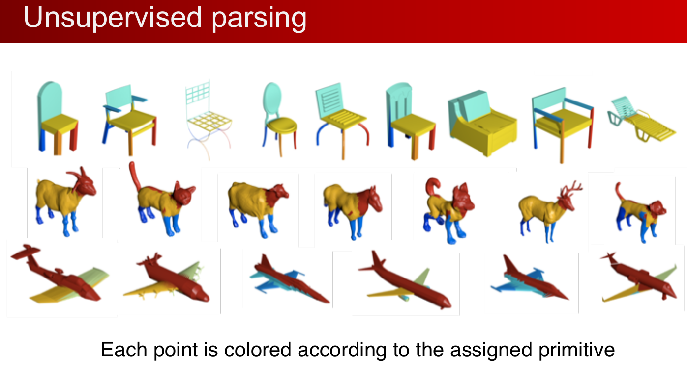
How was this done ? Was it e.g. autoencoder approach ? How are colors found and are the color options predefined ?

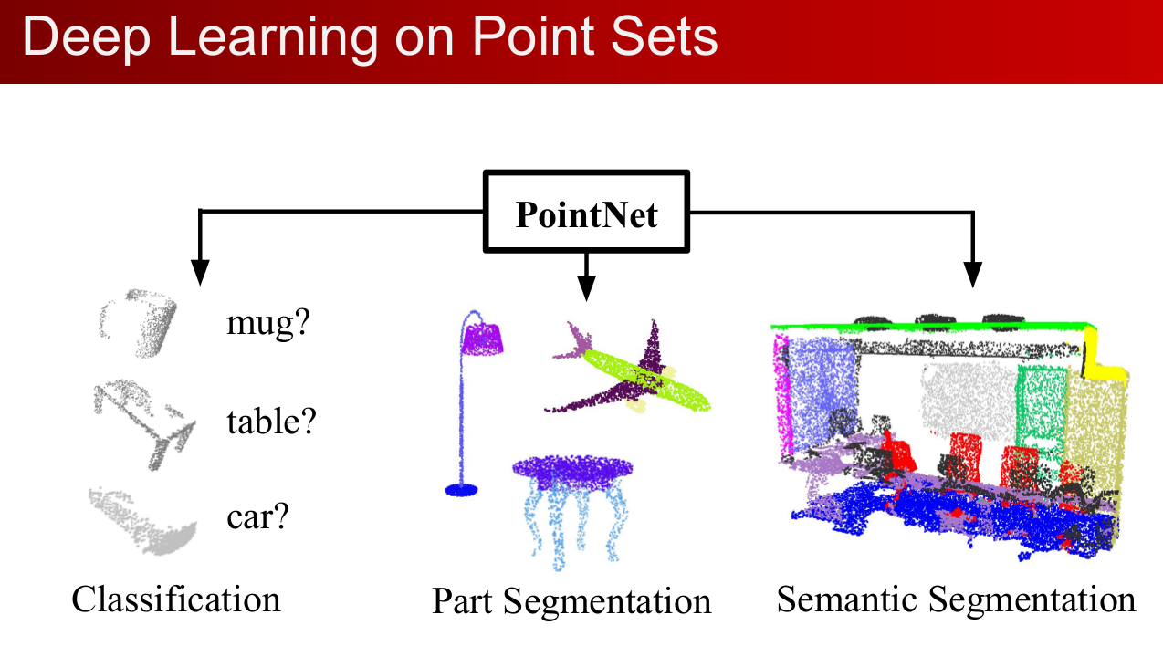

Deep learning architectures for 3D shape analysis and synthesis (Evangelos Kalogerakis):

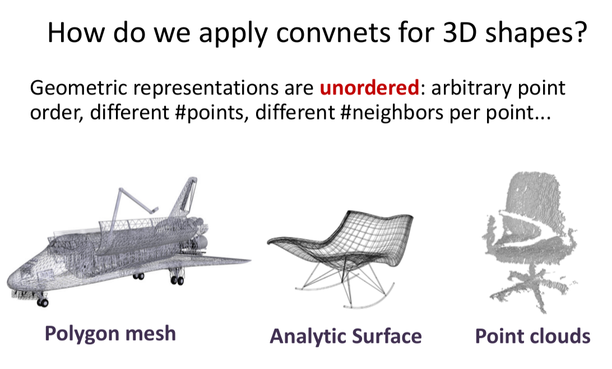
One difficulty: Scanned surfaces have noise & missing parts.

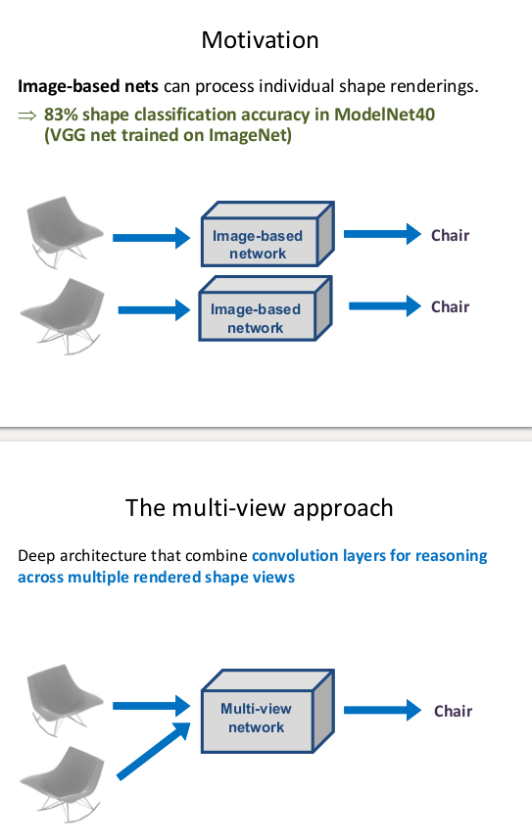

multi‐view convnets:
Deep architecture that combine convolution layers for reasoning
across multiple rendered shape views + surface‐based probabilistic
models for producing a coherent signal on the surface.

Key challenges:
• Joint reasoning about parts across multiple views + surface
• Deal with self‐occlusions / surface information loss
• Promote invariance over 3D shape rotations

View‐based convnets for 3D shapes: Segmentation Pipeline

Input: shape as a collection of rendered views
(For each input shape, infer a set of viewpoints that maximally cover its surface ... and across multiple distances from the surface.)
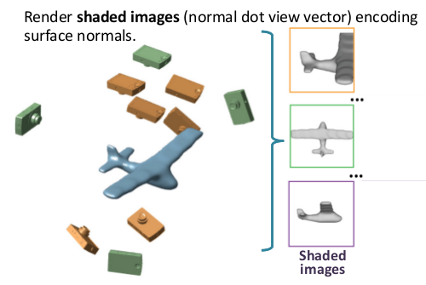

Question: what does he mean ?? are these images based on normals on surface like e.g. edge detection ?

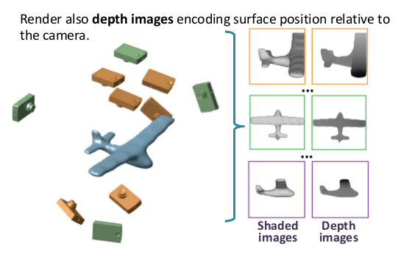

How is these ‘depth images’ align with shaded images ? isn’t the darker the furthest away ?

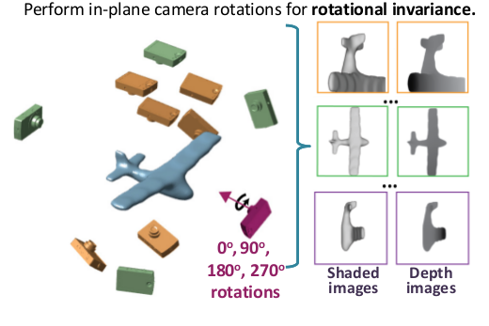

Does he mean rotations of each of these cameras i.e. with different angle+altitude?

Process: Each pair of depth & shaded images is processed by a FCN.

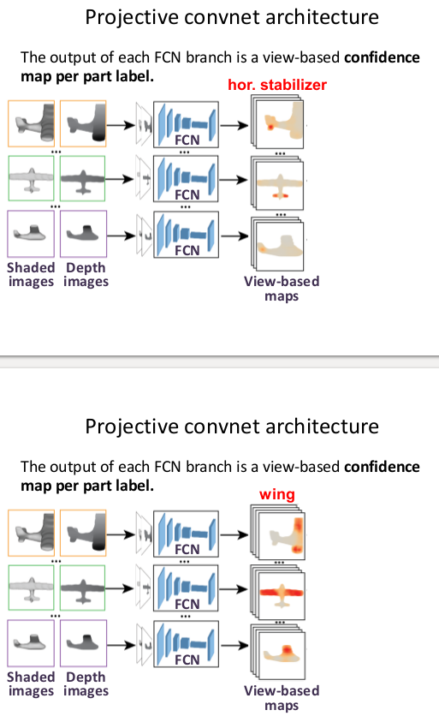

What does he mean ? Is the output of FCN a probability on each pixel for each class?

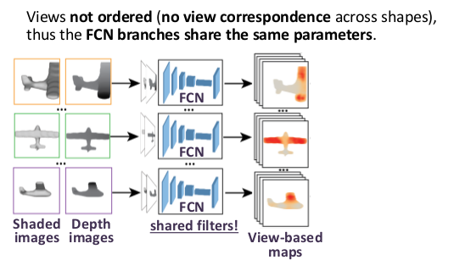

So each input can have any views :)

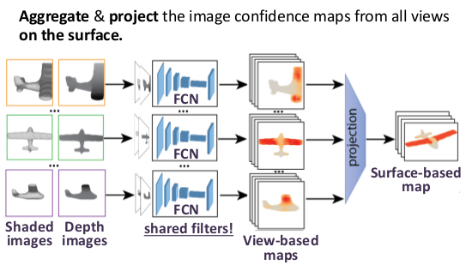

so we have a final output with each pixel assigned a class

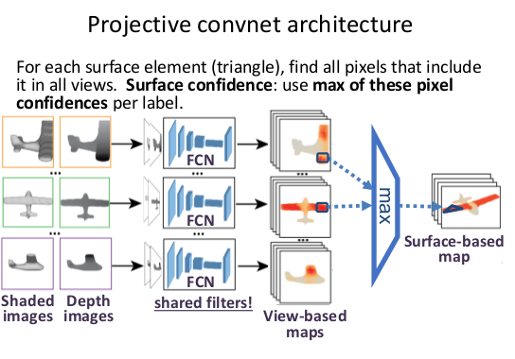

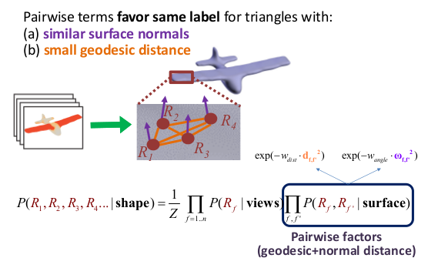
Surface model for spatially coherent labeling:
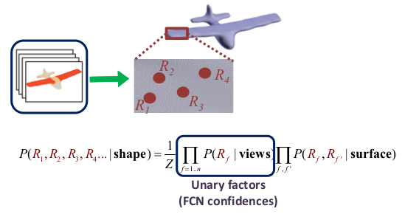

Infer most likely joint assignment to all surface random variables of the probabilistic model (Conditional Random Field)

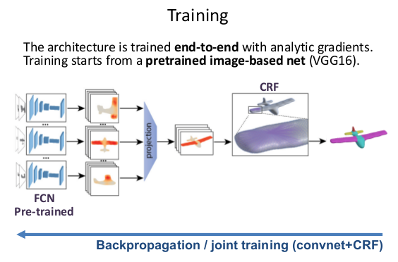

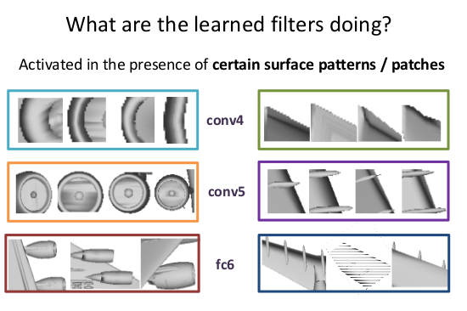

Multi‐view convnets for 3D shape analysis: Shape Classification & Retrieval:

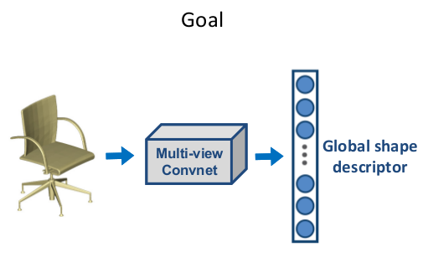

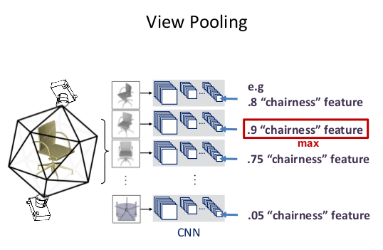

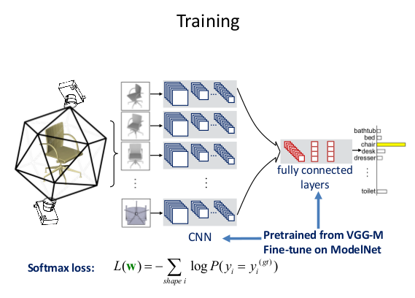

Multi‐view convnets for 3D shape analysis:Shape Correspondences:
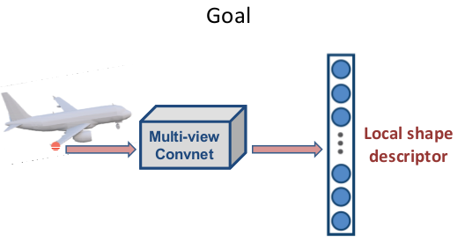

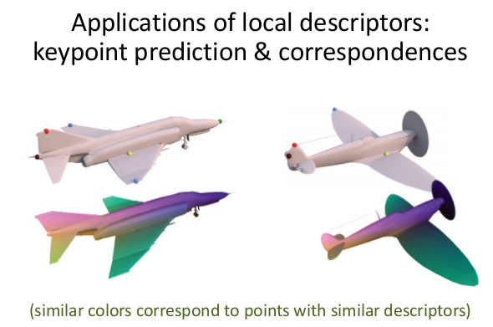

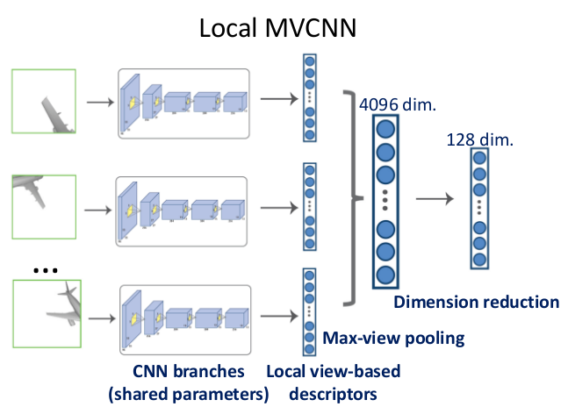

(mvcnn = multi view convnet)

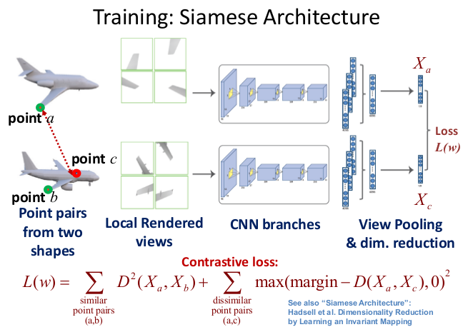

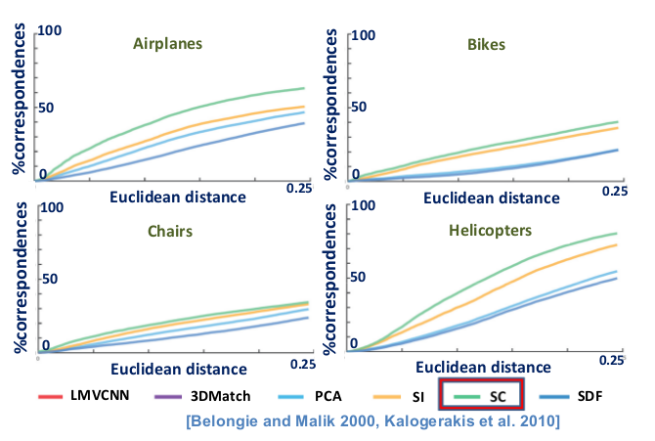

Question: why more distance gives more correspondence ????

Multi‐view convnets for 3D shape synthesis:
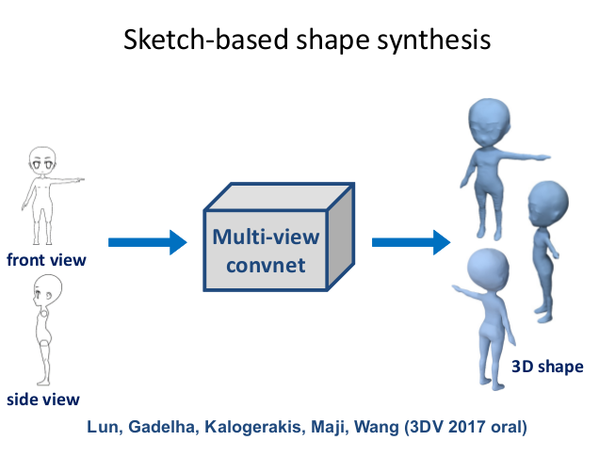

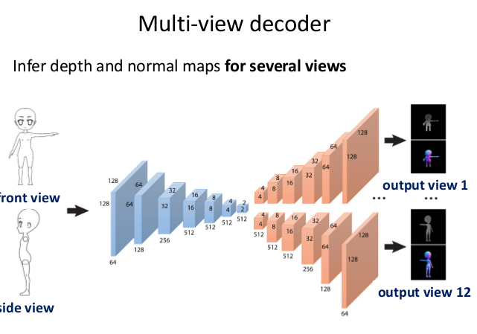

Question: what is ‘normal map’ ? Is it normal on surface i.e. indicating point coordinates?

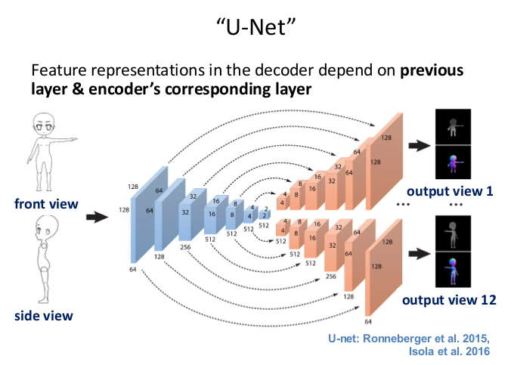

Question: how and why ‘depend on encoder’s corresponding layer’? Is this directly/indirectly dependent?

Penalize per‐pixel depth reconstruction error & per‐pixel normal reconstruction error:

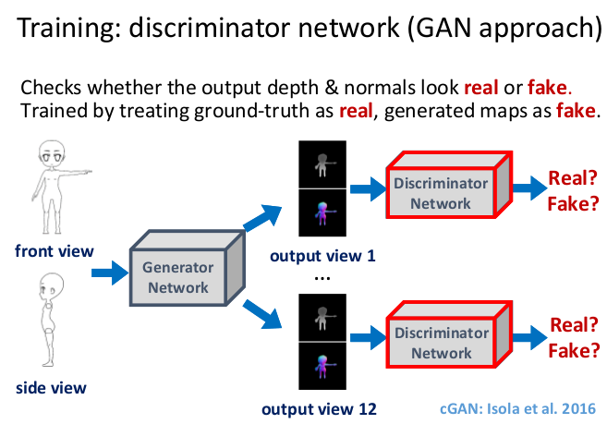

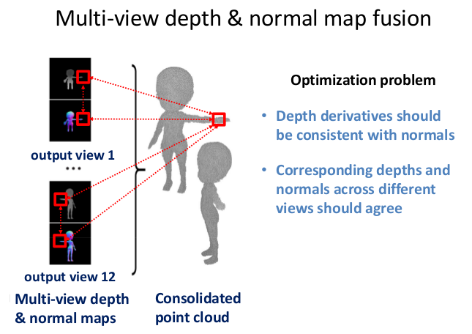

3D Deep Learning approaches:The Volumetric approach
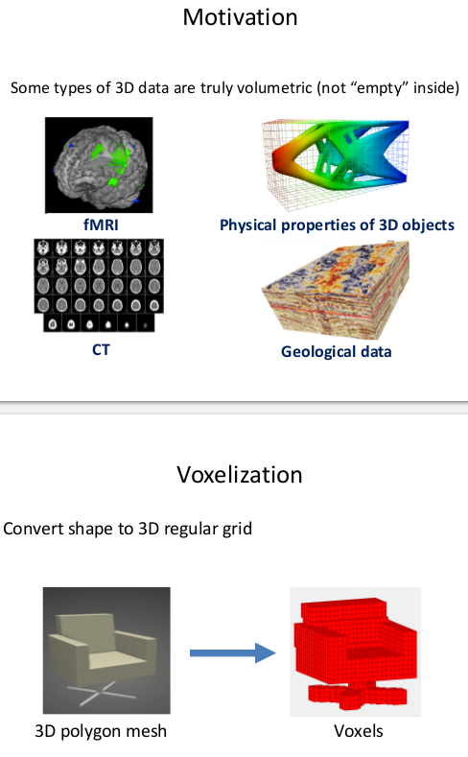

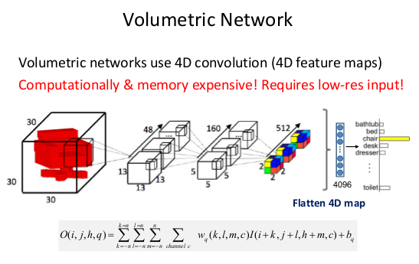

Sparsity of 3D data:

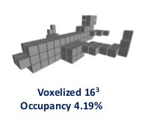
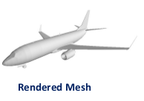
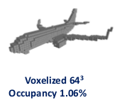

Running convolution on so much empty space is wasteful!

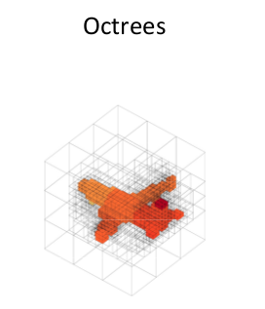
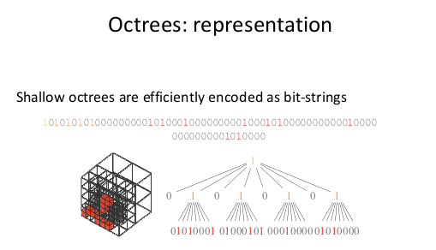

Octrees: Convolution (2D example):
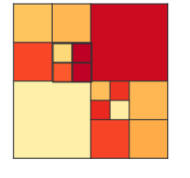
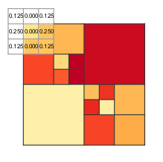
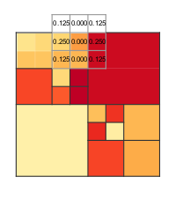
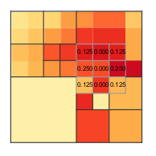

…

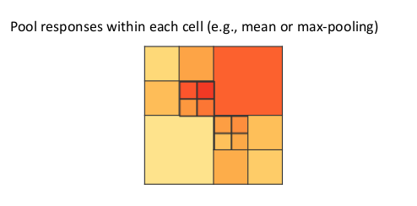

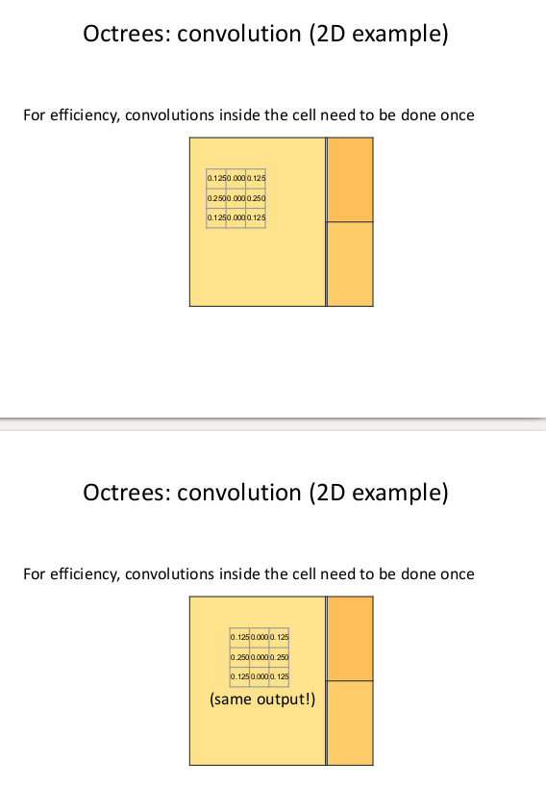

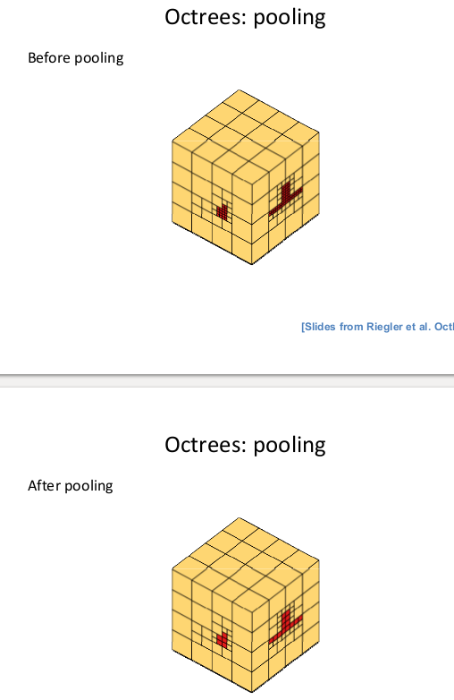

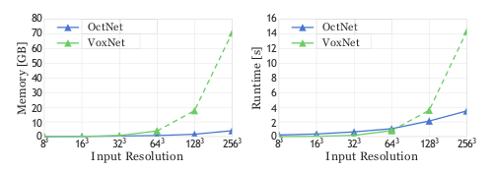

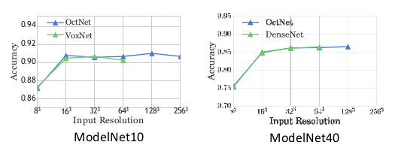

3D Deep Learning approaches: The Point-Based approach:
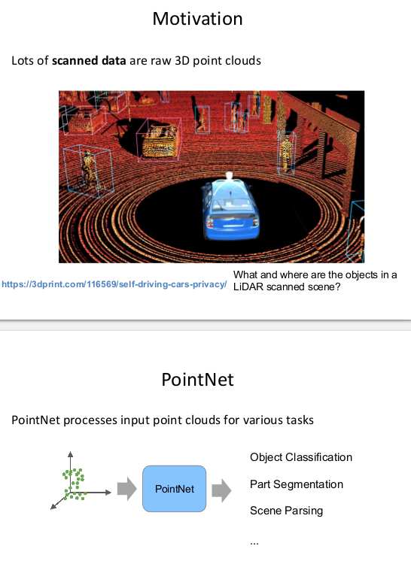

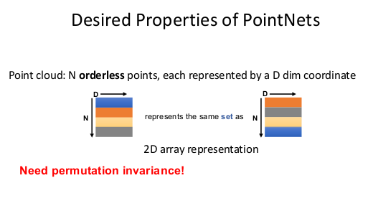

like graph nets where their definition needs to be permutation invariance

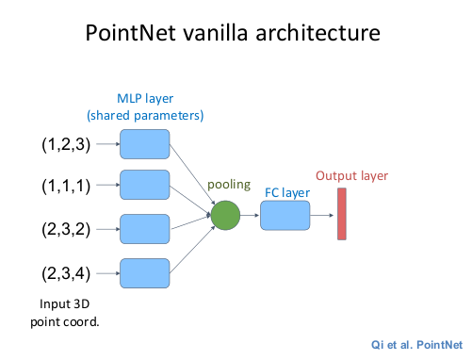
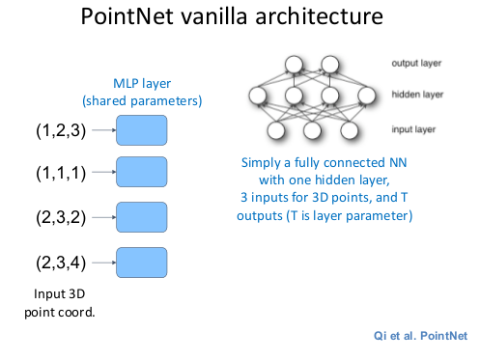

Question: this schema is correct when the input point cloud contains 4 points, right?

Notes on Mesh:
polygonal mesh: vertices, edges + faces

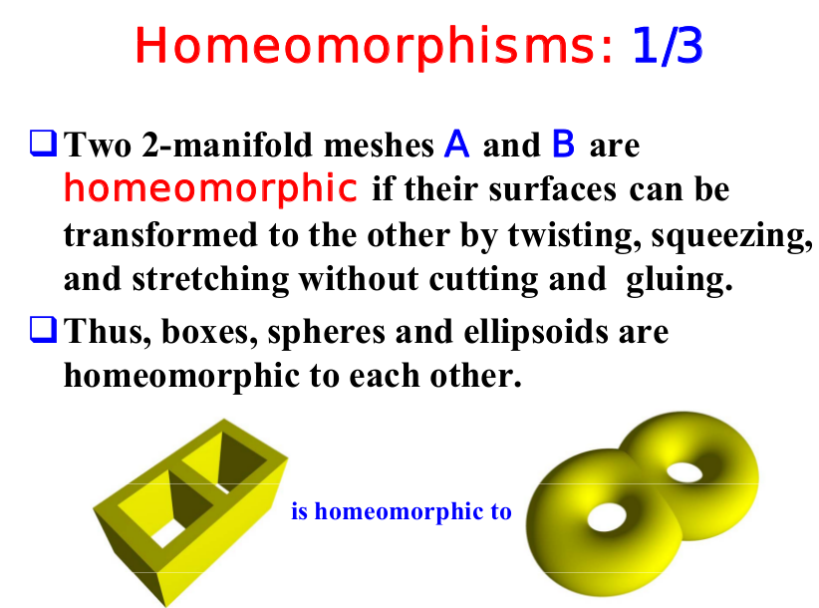

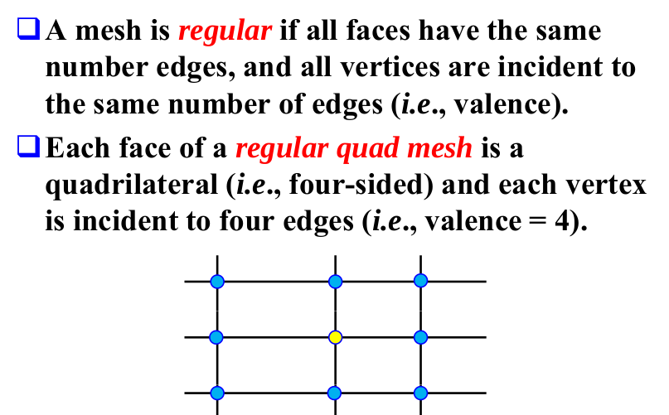

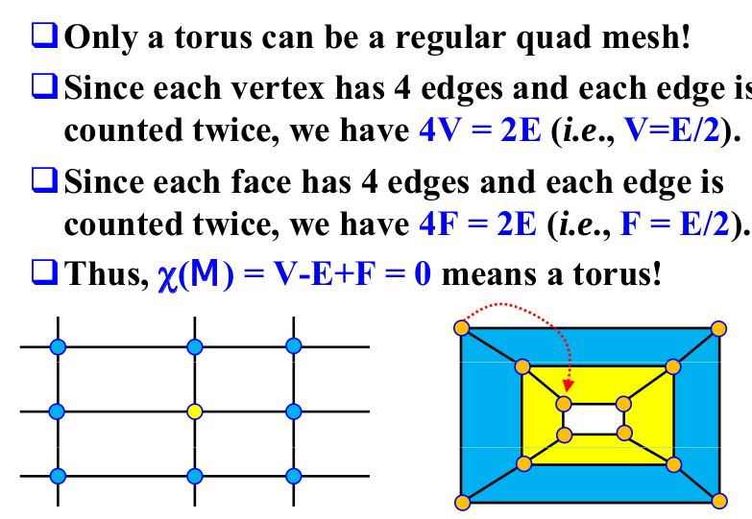

Data Structures for Meshes:

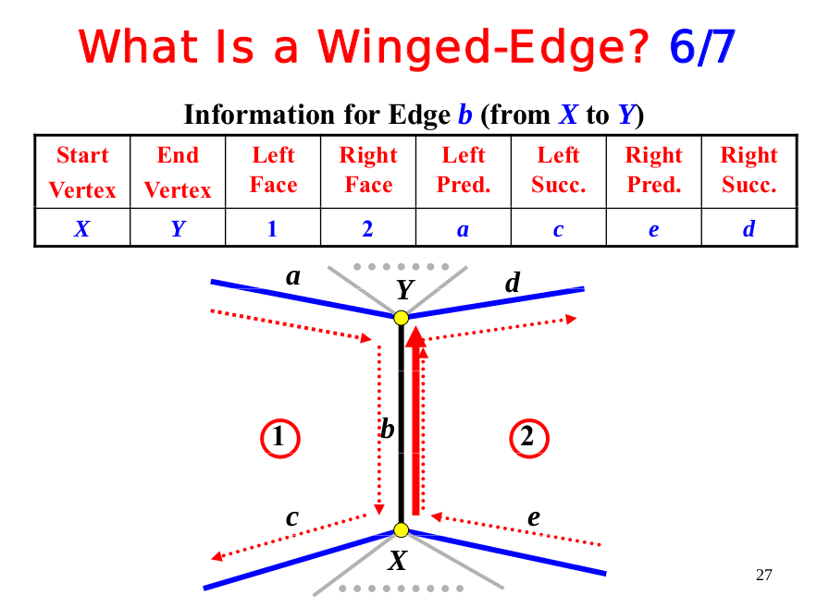

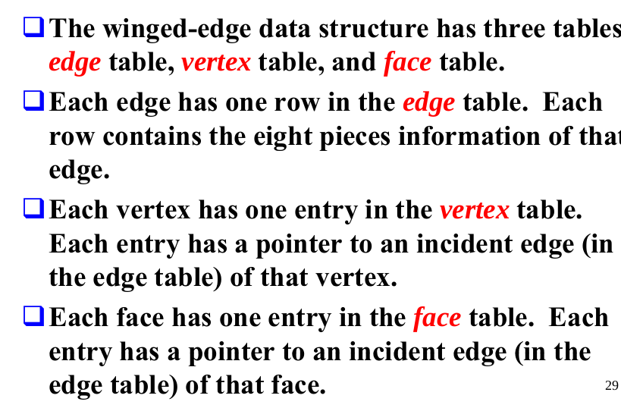

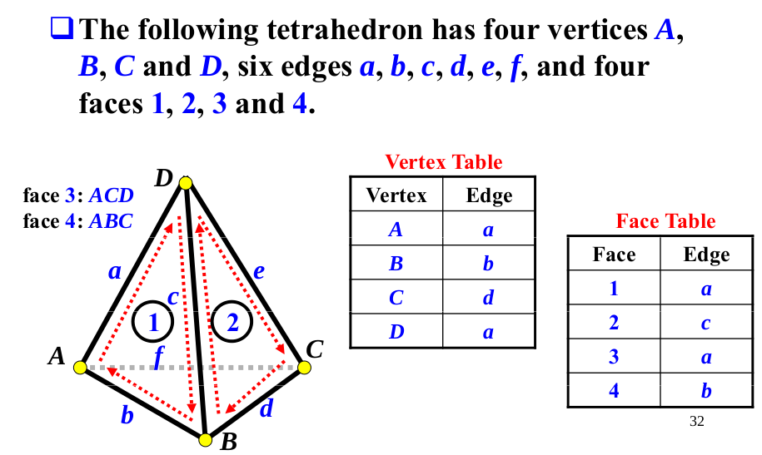
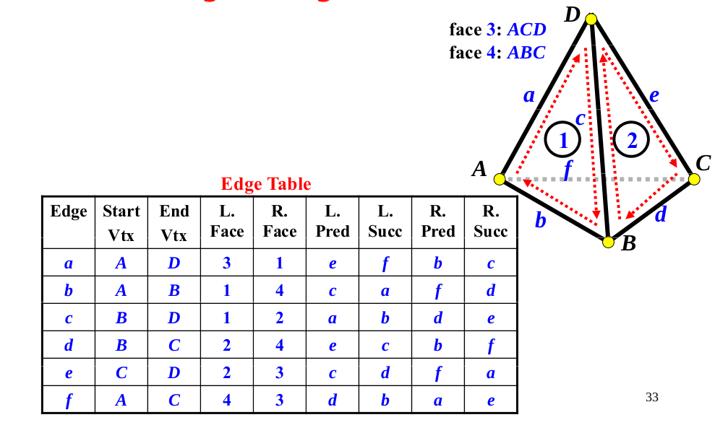
Winged-edge data structure example:

