A computational linguistic analysis on artificial intelligence and sustainability patents

Abstract
The discourse on AI and sustainability is sharply divided between those who view AI as a transformative tool to mitigate and adapt to climate change, and those who highlight AI’s own growing environmental impacts. Despite this dichotomy, little is known about how these perspectives manifest within the innovation context. In this paper, we conduct a computational linguistic analysis of 20,445 patents retrieved at the intersection of AI and sustainability to explore prevailing innovation trends. Our findings indicate a strong bias towards AI applications used to tackle a variety of sustainability challenges, with only 12% of patents addressing the environmental impacts of AI itself. These results point to a significant opportunity for prioritising innovation that reduces AI’s environmental impacts, particularly in the context of disproportionate AI infrastructural growth worldwide.

Artificial intelligence (AI) is increasingly positioned as both a tool for advancing sustainability goals and a driver of new sustainability challenges.¹ On one hand, AI systems have been applied across domains such as energy optimisation, biodiversity monitoring, and climate modelling, contributing to what is commonly referred to as AI for sustainability. On the other hand, the growing computational demands of AI infrastructures, particularly large-scale foundation models, raise concerns about the sustainability of AI itself, including energy consumption, greenhouse gas emissions, and water usage for data centre cooling. These two narratives prove the polarisation of debates around AI and sustainability, revealing a fundamental tension at the heart of AI-led innovation.²
As AI infrastructure grows worldwide, the environmental impacts associated with this technology are becoming more difficult to overlook.³ Despite widespread rhetoric positioning AI as a force for environmental good in the context of sustainable development goals (SDG),^{4,5} empirical evidence on how sustainability considerations are embedded in AI innovation processes remains limited.¹ While recent studies have begun to quantify the environmental impacts of AI supply chains, considering semiconductors and data centres life cycle assessments,^{6,7,8,9,10} far less is known about how the sustainability of AI is being prioritised within the institutional and technological contexts.^{11,12}
In this paper, we examine patents as a key empirical lens through which to investigate how sustainability is conceptualised and operationalised in AI-related innovation.¹³ Patents are a valuable proxy for measuring and understanding innovation directionality: they represent both intellectual property claims and commercial intent, and offer insight into how inventors and institutions frame the goals and impacts of their work.^{14,15} By analysing AI-related patents that incorporate sustainability-oriented language, we aim to explore how the polarised debate around AI and the environment is reflected in innovation efforts, both those that leverage AI to tackle environmental challenges and those that aim to reduce AI’s own environmental impact
This study is guided by the following research question: How is the distinction between AI for sustainability and sustainability of AI reflected in patent-based innovation, and what does this reveal about prevailing priorities in the development of AI technologies?
To address this question, we propose a computational linguistic analysis¹⁶ of patent publications that reference both AI and sustainability-related concepts. Using a curated dataset of 20,445 patent filings retrieved via the European Patent Office (EPO) API,¹⁷ we apply a classification approach to automatically distinguish between patents that apply AI to sustainability challenges and those that aim to address the environmental impact of AI infrastructure themselves.
Our findings reveal that only 12% of the analysed patents explicitly address the environmental impacts of AI, while the majority focus on using AI to advance sustainability goals⁴ in other sectors. This suggests a growing but still limited patent-based innovation focus on making AI itself more sustainable.¹⁸ These results highlight a potential misalignment between the sustainability discourse surrounding AI and the actual direction of technological development, revealing the opportunity to develop more patents considering the sustainability challenges of AI infrastructure growth,¹⁹ including mineral extractivism, greenhouse gas emissions and water withdrawal.^{20,21,22}
Results
According to our computational linguistic classifier, the total retrieved patents (n = 20,445) reveal a growing trend in patenting activity during the period May 2000 to July 2023 (see Supplementary Image XX) at the intersection of AI and sustainability. However, the patent classification is heavily unbalanced: 84.6% of patents focus on applying AI to address sustainability challenges (n=17,302), while relatively few (12.2%) target the sustainability of AI itself (n=548), with a subset adopting both perspectives (n = 2,500) or none (n=95). This extreme imbalance in innovation activity is noteworthy and indicates that, in line with the wider discourse, applying AI for sustainability is much more popular than working on reducing its environmental impact.^{5,23,24,25} Geographically, the United States (19.6%), Germany (14.67%), and Japan (14.67%) lead in patent contributions (see Supplementary Image XX).
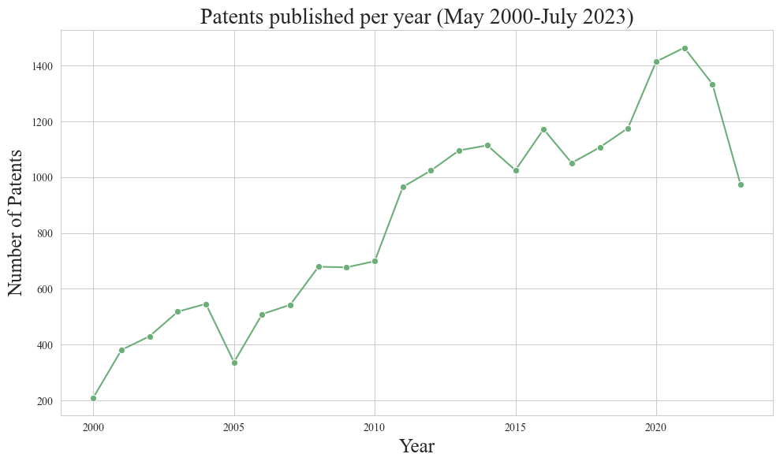
Figure XX: Number of patents retrieved at the intersection between AI and sustainability.
Patents of AI for Sustainability
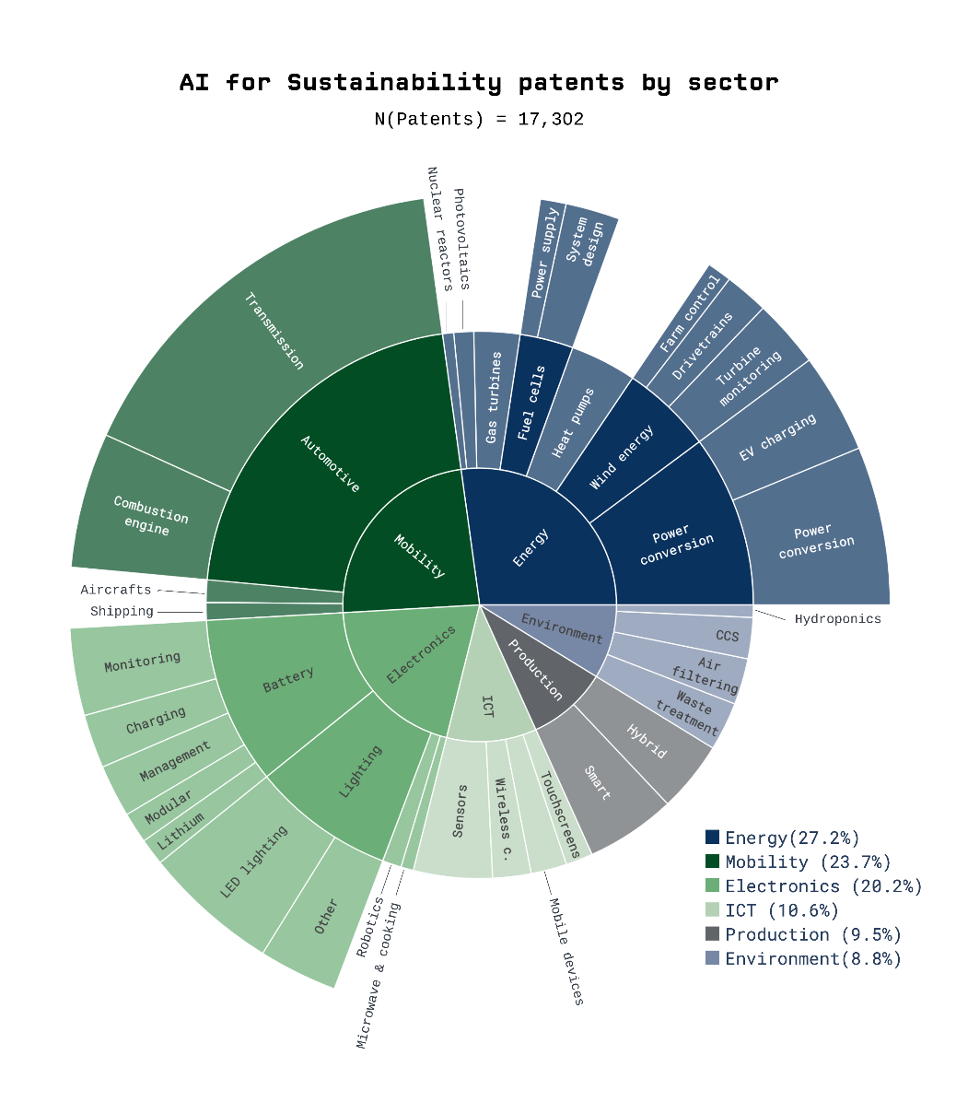
Among AI for sustainability patents (n=17,302), innovation is clustered across different sectors and technologies (Fig. XX). It is notable how widely the applications are spread, spanning six different sectors: energy, mobility, electronics, information and communication technology, production/manufacturing and environment.^{26,27} Most commonly, AI is applied in the context of sustainability in the energy sector (30.1%). Within this sector, AI is applied to power conversion on the one hand. This group captures technologies for power transfer, voltage regulation, and electric vehicle charging. On the other hand, AI is used for different types of energy production, including wind, solar, thermal, gas and nuclear energy, as well as fuel cells. This speaks to the idea that diverse opportunities arise for sustainable AI applications in the energy sector, potentially motivating closer attention from policy and funding.²⁸
Figure XX: Clusters of Patents within the field of AI for Sustainability.
The second largest sector is mobility (20.9%). This sector uses AI mostly to make automotive technologies more sustainable, for instance through vehicle transmission systems, such as designs for gear pairs, clutches and selective engagement mechanisms to improve vehicle efficiency. Within electronics, the third-largest sector (20.2%), AI applications focus mainly on batteries including battery design, charging and monitoring, and on lighting. Fourthly, AI is used to improve environmental sustainability in ICT (12.5%). Here, AI is mostly used in sensor technologies, wireless communication systems, mobile devices and touchscreen design. Within production and manufacturing (8.7%), the fifth largest sector, sustainable AI innovation has two main pillars: smart production systems, where data analysis is used to optimise manufacturing processes, as well as hybrid production methods, where 3D printing and subtractive processes (e.g., grinding or drilling) are combined in the same machines to improve efficiency in the fabrication of products. Finally, AI is also applied to specifically environment-related technologies (7.6%). For instance, it finds application in waste treatment, air filtering, carbon capture and removal as well as agriculture (e.g., hydroponics).

Patents of Sustainability of AI
In contrast, the Sustainability of AI shows very little patenting activity (n=503). Figure XX shows the distribution of patents across the AI patent, showing a strong focus on AI operations (86.3%) over data collection technologies (13.7%), such as sensors and tracking devices.
Within AI operations, the smallest cluster relates to AI platform technology, comprising 27 patents (6.1%). Platforms are frameworks providing the necessary software infrastructure and interfaces for using AI models and can span across the entire workflow, from data preparation to model design and training. The next largest cluster comprises specific AI model architectures. This cluster includes 13.6% of operations patents, with a total of 64 patents. The third-largest cluster relates to specialised AI hardware (35.3%). These patents address hardware-level innovation aimed at improving energy efficiency and computational performance.
The largest group of operations patents (45.0%) focuses on general AI infrastructure. This category includes technologies foundational to computing environments that support AI, such as power-efficient data centres and hardware-level systems. Within this group, subclusters include network connectivity (11.7%), storage (31.5%), and general-purpose hardware (56.8%).

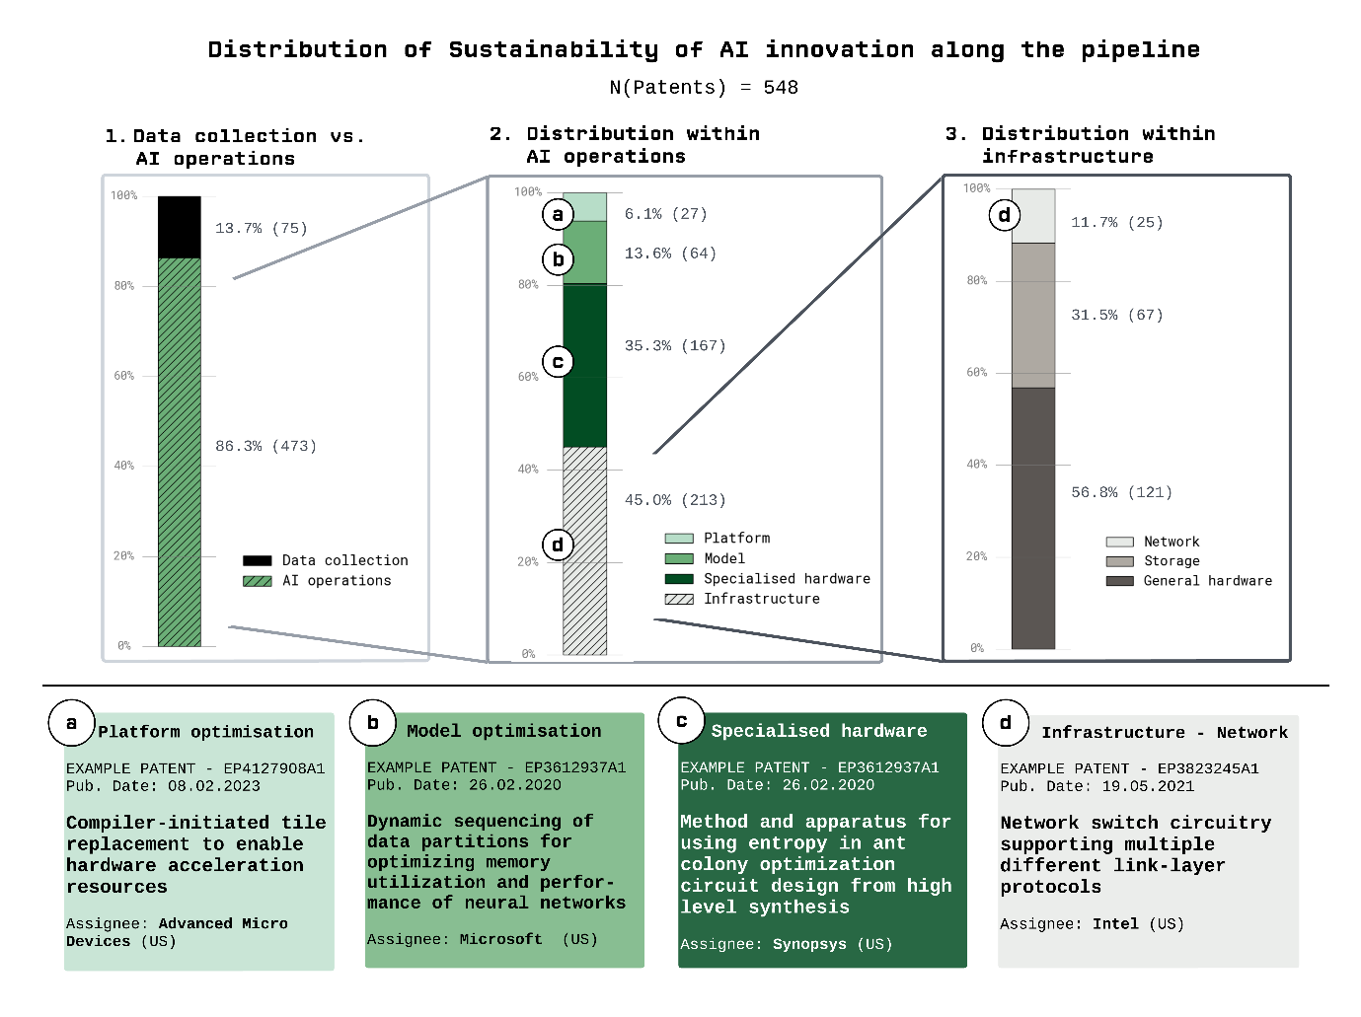

Figure XX: Categories of Patents within the field of Sustainability of AI.

Discussion
This study contributes a systematic, large-scale analysis of innovation in sustainable AI using computational linguistic methods applied to global patent data. By training a high-performing patent classifier and combining it with topic modelling, we provide an overview of how and where innovation is occurring at the intersection of AI and sustainability. Our findings expose sharp asymmetries, concentrated sectoral and technological patterns, and important gaps in the environmental focus of sustainable AI innovation. We show that patents can serve as a powerful empirical window into the debate on AI and sustainability, revealing that the debate is also polarised within the innovation context.
Asymmetries in innovation focus
One of the most striking findings is the overwhelming dominance of patents proposing AI-based solutions to sustainability challenges, compared to those targeting the environmental impacts across the AI pipeline. While the former accounts for the vast majority of activity, patents on the sustainability of AI makes up a small fraction. This disparity reflects a wider discursive tendency to frame AI as a tool for addressing sustainability, rather than a technology with its own environmental impacts. Yet as the environmental impacts of AI continue to grow, this imbalance becomes increasingly problematic.^{2,19,29,30}
Importantly, these two categories are not mutually exclusive. A small but notable share of patents aim to address both, for instance through hardware innovations that support energy-efficient AI in renewable energy contexts. However, such overlap remains the exception rather than the norm. A more integrated perspective, where environmental impacts are systematically accounted for in the design of sustainability-oriented AI systems, remains largely absent.
Sectoral and technological clustering
We observe that sustainable AI innovation is not evenly spread across economic sectors or technological domains. AI for Sustainability patents concentrate most heavily in the energy, mobility, and electronics sectors, domains that are both carbon-intensive and already subject to digital transformation. In contrast, Sustainability of AI inventions are predominantly clustered in infrastructure and hardware technologies, such as cooling systems, data storage, and low-power chips. Data acquisition, algorithm design, and software-level optimisations receive much less attention.
This divergence suggests that innovation is following existing trajectories of industrial and infrastructural development rather than systematically targeting the full range of environmental pressures associated with AI. For example, while energy efficiency is a recurring focus, other impacts such as water use in data centre cooling or rare earth extraction in hardware production are rarely addressed.^{7,21} This technological narrowness limits the sector’s ability to tackle the broader sustainability challenges AI growth nowadays faces.
Gaps in environmental scope
The environmental focus of current innovation is notably skewed. Across the patent analysis, energy efficiency dominates the sustainability discourse. This is understandable, given the centrality of electricity consumption in AI’s footprint and its relative measurability.³² However, the near absence of patents addressing material scarcity, e-waste, or water impacts points to an under-recognition of AI’s environmental impacts across the pipeline.
This blind spot has important implications.^{2,29,30} For instance, without attention to rebound effects or lifecycle carbon emissions and water withdrawal,^{7,21} energy-efficient AI technologies could paradoxically increase net environmental damage by enabling new, high-demand use cases. Similarly, neglecting water consumption or e-waste externalities risks exacerbating local environmental inequalities.^{21,33} We argue that broader environmental metrics, embedded in both research design and patent disclosures, are essential for ensuring AI contributes meaningfully to sustainability.
Institutional landscape and global inequalities
Beyond technological content, the distribution of innovation across actors and regions reveals further asymmetries. The sustainable AI patenting landscape is fragmented, with no single assignee dominating. While this decentralisation could signal healthy competition, it also suggests that major AI players are not leading in sustainability-related innovation. Notably, firms such as Google, IBM, and Microsoft, which hold significant shares of AI innovation, are absent from the top sustainability-focused assignees (see Fig XX).¹¹
Geographically, we find that most patent holders are based in high-income countries. While this reflects broader patterns in global innovation systems, it also risks deepening technological dependencies, inequality in innovation, and access gaps. At the same time, more sustainable AI systems could have positive downstream effects in lower-income contexts by reducing resource demands and enabling decentralised deployments in areas with limited infrastructure. Policies that foster inclusive innovation will be crucial to ensuring equitable benefits from sustainable AI technologies.
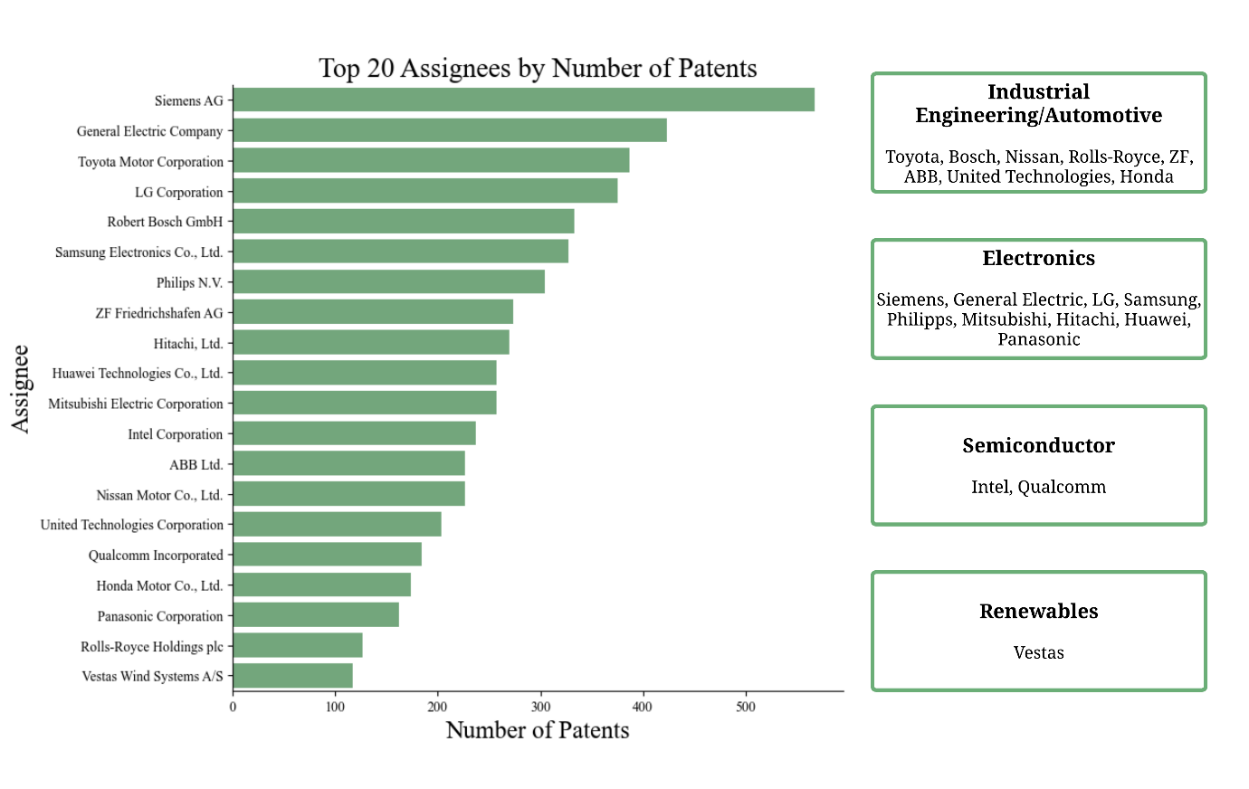
Figure XX:
Implications for governance and policy
Taken together, our results point to three main directions for future policy intervention. First, more targeted support is needed to stimulate innovation focused on the environmental impacts of AI systems, not only energy use, but also water, materials, and waste.³⁴ Second, the sustainability claims of AI applications should be subject to more rigorous scrutiny, including standardised metrics and reporting requirements that would avoid Jevon’s paradox on AI efficiency. Patents could play a leading role here, for instance by mandating sustainability disclosures. Third, regulatory frameworks must create incentives for dominant AI firms to actively mitigating their increasing environmental impacts as well as foster inclusive innovation across the Globe. This would include environmental policy interventions such as taxation or cap-and-trade systems.^{35,36,37} Given their resources and influence, shifting their innovation priorities could yield substantial environmental dividends.³⁸
Patents as a lens on sustainable AI
This work demonstrates the unique value of patents for analysing emerging sustainability innovation trends in the context of AI. While they do not capture all forms of innovation, particularly open-source or academic contributions, they offer a scalable, standardised, and globally comparable dataset that reveals macro-level patterns in technological development. Moreover, when enriched with computational linguistic techniques tools and human validation, patents can be more than legal artefacts, they can function as meaningful data points in sustainability research.
By integrating patent analysis into the broader sustainability discourse, we gain access to a previously underexplored layer of innovation activity. This, in turn, allows for more informed debates about how AI development can be aligned with long-term sustainability goals.
References
[1] Van Wynsberghe, A. Sustainable AI: AI for sustainability and the sustainability of AI. AI and Ethics, 1(3), 213-218 (2021)
[2] Luccioni, A. S., Strubell, E., & Crawford, K. From efficiency gains to rebound effects: The problem of Jevons' Paradox in AI's polarized environmental debate. In Proceedings of the 2025 ACM Conference on Fairness, Accountability, and Transparency, pp. 76-88 (2025).
[3] Ligozat, A. L., Lefèvre, J., Bugeau, A., & Combaz, J. Unraveling the hidden environmental impacts of AI solutions for environment life cycle assessment of AI solutions. Sustainability, 14(9), 5172 (2022).
[4] Vinuesa, R., Azizpour, H., Leite, I., Balaam, M., Dignum, V., Domisch, S., ... & Fuso Nerini, F. The role of artificial intelligence in achieving the Sustainable Development Goals. Nature communications, 11(1), 233 (2020).
[5] Gohr, C., Rodríguez, G., Belomestnykh, S., Berg-Moelleken, D., Chauhan, N., Engler, J. O., ... & von Wehrden, H. Artificial intelligence in sustainable development research. Nature Sustainability, 1-9 (2025).
[6] Luccioni, S., Jernite, Y., & Strubell, E. Power hungry processing: Watts driving the cost of AI deployment? In Proceedings of the 2024 ACM Conference on Fairness, Accountability, and Transparency, 85-99 (2024).
[7] Falk, S., Ekchajzer, D., Pirson, T., Lees-Perasso, E., Wattiez, A., Biber-Freudenberger, L., ... & van Wynsberghe, A. More than Carbon: Cradle-to-Grave environmental impacts of GenAI training on the Nvidia A100 GPU. Preprint at arXiv:2509.00093 (2025).
[8] Whitehead, B., Andrews, D., & Shah, A. The life cycle assessment of a UK data centre. The International Journal of Life Cycle Assessment, 20(3), 332-349 (2015).
[9] Wang, P., Zhang, L. Y., Tzachor, A., & Chen, W. Q. E-waste challenges of generative artificial intelligence. Nature Computational Science, 4(11), 818-823 (2024).
[10] Li, P., Yang, J., Islam, M. A., & Ren, S. Making AI less thirsty. Communications of the ACM, 68(7), 54-61 (2025).
[11] Rikap, C., & Weko, S. A green transition orchestrated from Big Tech clouds? Globalizations, 1-20 (2025).
[12] Verdecchia, R., Sallou, J., & Cruz, L. A systematic review of Green AI. Wiley Interdisciplinary Reviews: Data Mining and Knowledge Discovery, 13(4) (2023).
[13] Verendel, V. Tracking artificial intelligence in climate inventions with patent data. Nature Climate Change 13.1 (2023): 40-47 (2023).
[14] Yang, X., & Yu, X. Preventing patent risks in artificial intelligence industry for sustainable development: A multi-level network analysis. Sustainability, 12(20), 8667 (2020).
[15] Gittelman, M. A note on the value of patents as indicators of innovation: Implications for management research. Academy of Management Perspectives, 22(3), 21-27 (2008).
[16] Sheremetyeva, S. Natural language analysis of patent claims. In Proceedings of the ACL-2003 workshop on Patent corpus processing, 66-73, (2003).
[17] EPO. PATSTAT: The Backbone data set for statistical analysis. https://www.epo.org/en/searching-for-patents/business/patstat (2024).
[18] Wu, C. J., Raghavendra, R., Gupta, U., Acun, B., Ardalani, N., Maeng, K., ... & Hazelwood, K. Sustainable AI: Environmental implications, challenges and opportunities. Proceedings of Machine Learning and Systems, 4, 795-813 (2022).
[19] Crawford, Kate. Nature 626 (2024).
[20] Luccioni, A. S., Viguier, S., & Ligozat, A. L. Estimating the carbon footprint of bloom, a 176b parameter language model. Journal of machine learning research, 24(253), 1-15 (2023).
[21] Valdivia, A. The supply chain capitalism of AI: A call to (re) think algorithmic harms and resistance through environmental lens. Information, Communication & Society, 1-17 (2024).
[22] Roussilhe, G., Pirson, T., Xhonneux, M., & Bol, D. From silicon shield to carbon lock‐in? The environmental footprint of electronic components manufacturing in Taiwan (2015–2020). Journal of Industrial Ecology, 28(5), 1212-1226 (2024).
[23] Cowls, J., Tsamados, A., Taddeo, M., & Floridi, L. The AI gambit: leveraging artificial intelligence to combat climate change—opportunities, challenges, and recommendations. AI & Society, 38(1), 283-307 (2023).
[24] Stern, N., Romani, M., Pierfederici, R., Braun, M., Barraclough, D., Lingeswaran, S., ... & Niemann, N. Green and intelligent: the role of AI in the climate transition. npj Climate Action, 4(1), 56 (2025).
[25] Nishant, R., Kennedy, M., & Corbett, J. Artificial intelligence for sustainability: Challenges, opportunities, and a research agenda. International journal of information management, 53, 102104 (2020).
[26] Ding, C., Ke, J., Levine, M., & Zhou, N. Potential of artificial intelligence in reducing energy and carbon emissions of commercial buildings at scale. Nature Communications, 15(1), 5916 (2024).
[27] Cho, H., & Ackom, E. Artificial Intelligence (AI)-driven approach to climate action and sustainable development. Nature Communications, 16(1), 1228 (2025).
[28] Danish, M. S. S., & Senjyu, T. AI-enabled energy policy for a sustainable future. Sustainability, 15(9), 7643 (2023).
[29] Bhardwaj, E., Alexander, R., & Becker, C. Limits to AI Growth: The Ecological and Social Consequences of Scaling. Preprint at arXiv:2501.17980 (2025).
[30] Mhlanga, D. (2025). AI beyond efficiency, navigating the rebound effect in AI-driven sustainable development. Frontiers in Energy Research, 13 (2025).
[31] Kaack, L. H., Donti, P. L., Strubell, E., Kamiya, G., Creutzig, F., & Rolnick, D. Aligning artificial intelligence with climate change mitigation. Nature Climate Change, 12(6), 518-527 (2022).
[32] Wang, Q., Li, Y., & Li, R. Ecological footprints, carbon emissions, and energy transitions: the impact of artificial intelligence (AI). Humanities and Social Sciences Communications, 11(1), 1-18 (2024).
[33] Wu, J. Nature Cities (2025): 1-1 (2025). [38] Wright, D., Igel, C., Samuel, G., & Selvan, R. Efficiency Is Not Enough: A Critical Perspective on Environmentally Sustainable AI. Communications of the ACM, 68(7), 62-69 (2025).
[34] Wright, D., Igel, C., Samuel, G., & Selvan, R. Efficiency Is Not Enough: A Critical Perspective on Environmentally Sustainable AI. Communications of the ACM, 68(7), 62-69 (2025).
[35] Freire-González, J. Governing Jevons’ Paradox: policies and systemic alternatives to avoid the rebound effect. Energy Research & Social Science, 72, 101893 (2021).
[36] Mashhadi Rajabi, M. (Dilemmas of energy efficiency: A systematic review of the rebound effect and attempts to curb energy consumption. Energy Research & Social Science, 89, 102661 (2022).
[37] Hinterholzer, S., & Penzenstadler, B. Systems thinking and efficiency under emissions constraints: Addressing rebound effects in digital innovation and policy. Patterns, 4 (2) (2023).
[38] Vrikki, P. Measuring Up? The Illusion of Sustainability and the Limits of Big Tech Self-Regulation. Sustainability, 16(23) (2024).
[39] Favot, M., Vesnic, L., Priore, R., Bincoletto, A., & Morea, F.Green patents and green codes: How different methodologies lead to different results. Resources, Conservation & Recycling Advances, 18, (2023).
[40] Veefkind, V., Hurtado-Albir, J., Angelucci, S., Karachalios, K., & Thumm, N. A new EPO classification scheme for climate change mitigation technologies. World Patent Information, 34(2), 106–111 (2012).
[41] Hascic, I., & Migotto, M. (2015). Measuring environmental innovation using patent data (tech. rep.). OECD. Paris (2015).
[42] Lee, K., Ippolito, D., Nystrom, A., Zhang, C., Eck, D., Callison-Burch, C., & Carlini, N. Deduplicating Training Data Makes Language Models Better. In the 60th Annual Meeting of the Association for Computational Linguistics, (2022).
[43] Zhu, T., Wang, X., Zhao, F., & Torrico-Bascope, G. V. Impedance-Based Aggregation of Paralleled Power Factor Correction Converters in Data Centers. IEEE Transactions on Power Electronics, 38 (4), 5254–5265 (2023).
[44] Tharwat, A., & Schenck, W. A Survey on Active Learning: State-of-the Art, Practical Challenges and Research Directions. Mathematics, 11(4), 820, (2023).
[45] Lewis, D. D. A sequential algorithm for training text classifiers: Corrigendum and additional data. ACM SIGIR Forum, 29(2), 13–19 (1995).
[46] McInnes, L., Healy, J., & Melville, J. UMAP: Uniform manifold approximation and projection for dimension reduction. Preprint at arXiv:1802.03426 (2018).
[47] Stein, A. L. Artificial Intelligence and Climate Change Special Issue: Regulating the Technological Frontier. Yale Journal on Regulation, 37(3), 890– 939 (2020).
[48] Banerjee, S., Akkaya, C., Perez-Sorrosal, F., & Tsioutsiouliklis, K. Hierarchical Transfer Learning for Multi-label Text Classification. In Proceedings of the 57th Annual Meeting of the Association for Computational Linguistics, 6295–6300 (2019).
Methods
Data Retrieval
To retrieve patents, we propose a retrieval strategy at the intersection between AI and sustainability based on the comprehensive classification systems employed by patent offices.¹³ These systems assign specific codes that categorise patents into distinct technology groups, SUCH AS THE Cooperative Patent Classification (CPC) or the International Patent Classification codes (ICP), enabling the precise selection of relevant patents and avoiding different results.³⁹
For AI-related patents, we utilise three main classification schemes. First, we adopt the World Intellectual Property Organization’s (WIPO) AI framework together with Patentscope and the UK Intellectual Property Office (UK IPO), both extending WIPO’s original framework while maintaining consistent definitions and criteria.
For sustainability-related patents, we similarly combine three independent classification strategies. The first utilises CPC classes Y02 and Y04S.⁴⁰ The second employs the IPC Green Inventory, developed jointly by WIPO, the United Nations Framework Convention on Climate Change (UNFCCC), and the Intergovernmental Panel on Climate Change (IPCC). The third follows the OECD’s ENV-TECH search strategy.⁴¹ While these schemes were developed by expert groups, it is important to note that they are not based on universally accepted definitions or comprehensive conceptual frameworks of sustainability.^{39,40}
We then merged the patents codes retrieved through the AI and sustainability search strategies, resulting in a combined dataset of 20,445 patents addressing both domains. Using these combined classification strategies, we extracted the corresponding patent publication numbers from PATSTAT, the extensive patent database maintained by the EPO. Further bibliographic and textual metadata were obtained via the EPO Open Patent Service API, while assignee names and filing dates were supplemented using Google Patents.
Model Pipeline
The patent analysis conducted in this thesis consists of two main parts. In the first step, we build a patent classifier, finetuned to differentiating between patents relating to AI for Sustainability and Sustainability of AI. In the second step, we implement topic modelling to analyse which technologies are patented in the two areas.
Data cleaning
Before implementing any computational models, we conducted several data cleaning steps to ensure content quality and consistency. First, patents without English versions of the abstract, description, or claims were machine translated using Google Translate. Next, we removed duplicates. This is an essential step for natural language processing tasks, as duplication can skew results and reduce model performance.⁴² Where multiple entries shared the same publication number, country, and title, we retained the version with the richest textual content (i.e., the most complete combination of abstract, description, and claims).
Given that patent records were retrieved from multiple sources, conflicting metadata was common. In cases where discrepancies occurred (1,386 patents), titles were cross-checked manually. We selected the longer version, assuming it would contain more descriptive information. Finally, all texts were normalised to lowercase, and non-informative elements such as references to drawings were removed. Notably, stopwords were retained to preserve syntactic structure, as the downstream analysis employed transformer-based models.
Manual Labelling
To gain a clearer understanding of the types of patents retrieved, we manually annotated a subset of several hundred patents. Patents were labelled as Sustainability of AI if they addressed components of the AI development pipeline, including model training, data handling, specialised AI hardware, and infrastructure.¹⁸ Patents focusing on general energy production or grid systems were excluded, even if relevant to AI infrastructure, as they were not considered sufficiently specific to AI technologies. Conversely, patents were labelled as AI for Sustainability if they deployed AI methods to improve environmental outcomes in other domains (e.g., agriculture, manufacturing, or transportation), or if they enabled more sustainable decision-making through AI-driven insights.
Some patents were assigned to both categories. For instance, a system for automated power factor correction may enhance data centre efficiency while also supporting broader industrial sustainability goals.⁴³ Others, such as biomedical applications referencing neural networks, were excluded entirely if they were misclassified by keyword overlap but unrelated to sustainability.
Labelling was conducted in three stages. First, a simple random sample of 500 patents was manually annotated. However, this initial sample significantly underrepresented the Sustainability of AI category, yielding fewer than 20 relevant instances. To address this imbalance, a second sampling strategy was employed using targeted keyword searches designed to capture overlooked components of the AI pipeline. This yielded an additional 200 labelled patents, although this method risked introducing topical bias into the training set by favouring easily detectable terms.
To mitigate the potential limitations of random and keyword-based sampling, we employed a third stage based on Active Learning (AL). AL is designed for low-resource annotation settings and aims to maximise model performance by selecting the most informative samples for labelling. Specifically, we applied the least confidence method, which uses entropy scores from model predictions to identify uncertain classifications.^{44,45} A baseline BERT classifier was trained on the initial 700 labelled patents, then applied to the remaining unlabelled dataset to identify high-uncertainty cases. The 300 most uncertain patents were manually reviewed and labelled.
This three-stage annotation process produced a balanced training dataset of 1,000 patents, capturing all three label combinations: AI for Sustainability, Sustainability of AI, and both. This dataset served as the foundation for the classifier training detailed in the next section.
To assess the quality of manual labels, we applied K-means clustering to the patent embeddings. An elbow plot indicated that two clusters offer a good fit, aligning with our two-category labelling scheme. Figure XX shows the results of K-means clustering visualised using UMAP.⁴⁶ Trustworthiness scores above 0.9 (for up to k=50 neighbours) confirm that the projection preserves the structure of the original data.⁴⁷
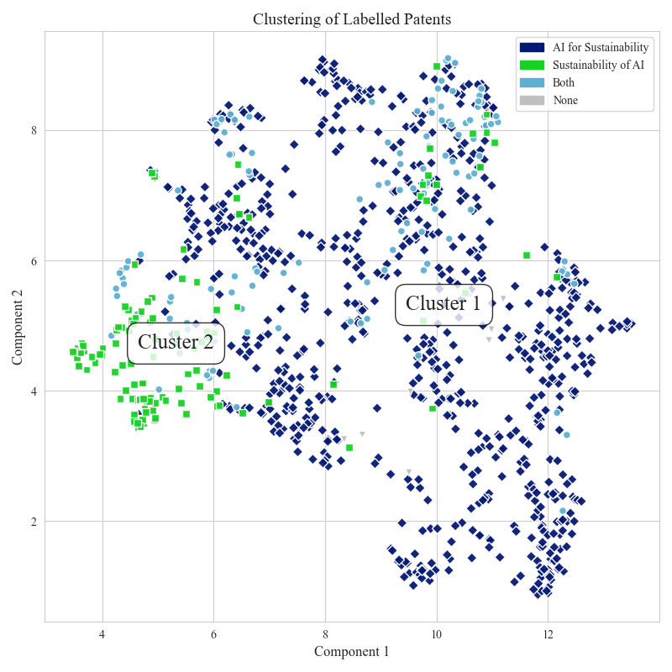
Figure XX
The clusters reflect our conceptual categories. Sustainability of AI patents are more tightly grouped, reflecting their narrower technical scope, while \ AI for Sustainability patents are more widely distributed, consistent with their broader range of applications. Patents labelled as both lie near the boundary, reinforcing the conceptual overlap between categories.
Computational linguistic classifier architecture
To classify patents into the two conceptual pillars of sustainable AI, we trained a multi-label computational linguistic classifier. This approach allows patents to be assigned to one, both, or neither category. Given the lack of existing labelled data, we constructed a dataset of 1,000 annotated patents and trained several transformer-based models using an 80/20 train-test split and 5-fold cross-validation to ensure robust performance on this limited data.
We tested multiple architectures including BERT, SciBERT, PatentSBERTa, and Longformer, reflecting recent advances in domain-specific NLP for technical texts. Text inputs included patent titles, abstracts, and partial descriptions, with Longformer additionally processing claims due to its ability to handle longer sequences. To optimise learning, we experimented with different hyperparameters, loss functions (including binary cross-entropy and class-balanced losses), and input combinations such as CPC code features alongside text.
Evaluation focused on the macro F1 score, which balances performance across imbalanced classes. Ultimately, PatentSBERTa with binary cross-entropy loss and text-only input achieved the best validation performance. This model was retrained on the full labelled dataset and used to predict categories for the remaining 20,000+ patents. The model's output underpins all subsequent analyses of sustainable AI innovation patterns.
To assess model performance, we used the macro F1 score, which calculates the unweighted average of F1 scores across classes.⁴⁸ This metric is particularly appropriate for multi-label classification with imbalanced data, as it treats all labels equally and captures both precision and recall. Model performance was averaged across five validation folds, and the best model was further evaluated on a held-out test set comprising 20% of the labelled data.
We trained and compared 222 models across multiple architectures and configurations. These included four transformer models (BERT, SciBERT, PatentSBERTa, and Longformer), three loss functions (standard binary cross-entropy, distribution-balanced loss, and class-balanced focal loss), and two input types (text only and multi-modal data with text + CPC codes). Bert-based models were tuned using different batch sizes and dropout settings, while Longformer models were trained without hyperparameter tuning due to higher computational costs.
SciBERT with multi-modal input data and with text-only input and binary cross-entropy loss achieved the highest validation performance and was selected as the final model (macro F1 = 0.881). This classifier was retrained on the full labelled dataset and used to assign labels to the remaining unlabelled patents. The resulting predictions serve as the foundation for our large-scale analysis of sustainable AI innovation.
