**Collect a small data set from a social media site of your choosing (1K+ posts)**

I collected a dataset using R from Twitter of 1,000 tweets mentioning @LiveAction. I made edges between the screennames and those accounts that the screenname mentions. Therefore, all screennames have a link to @LiveAction, but they also mentioned other usernames in their tweets, so the network is large.

**Identify the top 10 nodes based on degree, betweenness, closeness, eigenvector centrality. Report centrality values.**

**Degree**:

LiveAction CandaceCBure ChantellDawnSny

996 54 23

timedimereviews pro_real_life rapunzelssista

21 20 14

travlyngirl ask_francie Prozacookies

14 11 10

lovillalee

10

**Betweenness**:

LiveAction lillianmcrowley ProLifeWA

220251.4740 1608.0539 1326.0000

RBETTANCOURTS pro_real_life timedimereviews

1006.9162 995.1038 929.9950

Declan1497 mjschumake alfonso_lopezg

674.9041 664.0000 664.0000

FlintVal

664.0000

**Closeness**:

LiveAction timedimereviews pro_real_life

0.0004945598 0.0003734130 0.0003732736

RBETTANCOURTS lillianmcrowley TBischoff222

0.0003731343 0.0003731343 0.0003729952

Arkady2009 kh07scott ProLifeWA

0.0003729952 0.0003728561 0.0003728561

BobLavigne9

0.0003728561

**Eigenvector Centrality**:

LiveAction ChantellDawnSny rapunzelssista travlyngirl timedimereviews

1.0000000 0.3692504 0.2566800 0.2393979 0.1620590

pro_real_life jwojcik54 Rodrigo_Benitez jesus4eternlife lovillalee

0.1611753 0.1466743 0.1466743 0.1466743 0.1314966

**Calculate the diameter of the largest network component.**

The diameter of the network is 4.

**Select one opinion leader from the top nodes and explore its neighbors.**

The leader I selected is @CandaceCBure.

**Justify why you chose your node as an opinion leader**

CandaceCBure has the highest degree after Live Action; she was mentioned 54 times, almost twice as much as the next highest mentioned person.

**Provide a figure of the subgraph consisting of your chosen node, first order connections, and relationships between those first order connections. It is OK to include pendants (e.g. 2nd order nodes).**

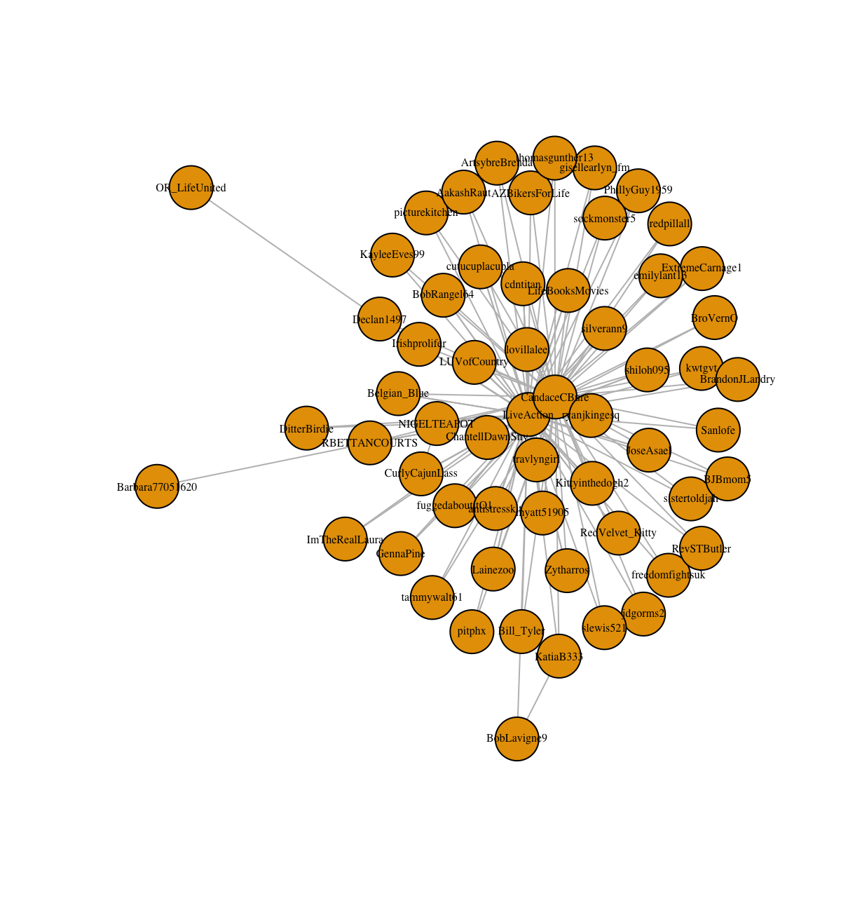

**What ego-network forces may be acting upon your chosen central node.**

Most of the accounts just mentioned CandaceCBure and LiveAction. Two accounts also mentioned BobLavigne9 (who had a high closeness score). These accounts seem to not interact much with the rest of the accounts that mentioned CandaceCBure. Since Candace is a celebrity with a large following on Twitter with 584k followers, her network influence can be explained by her large exposure. Candace is a pro-life advocate, and a portion of her many followers comment on this, thus spreading the message to *their* followers. However, she doesn’t have a strong network of edges connecting her followers, so her message may not have as strong of an impact as a more personal network environment.

**Display a diagram of your network, where nodes are colored based on a cohesive network clustering algorithm of your choosing.**

I ran the truss clustering algorithm to remove the pendant note and less-inter-connected nodes (k=3 truss) and colored the groups based on the optimal cluster’s function.

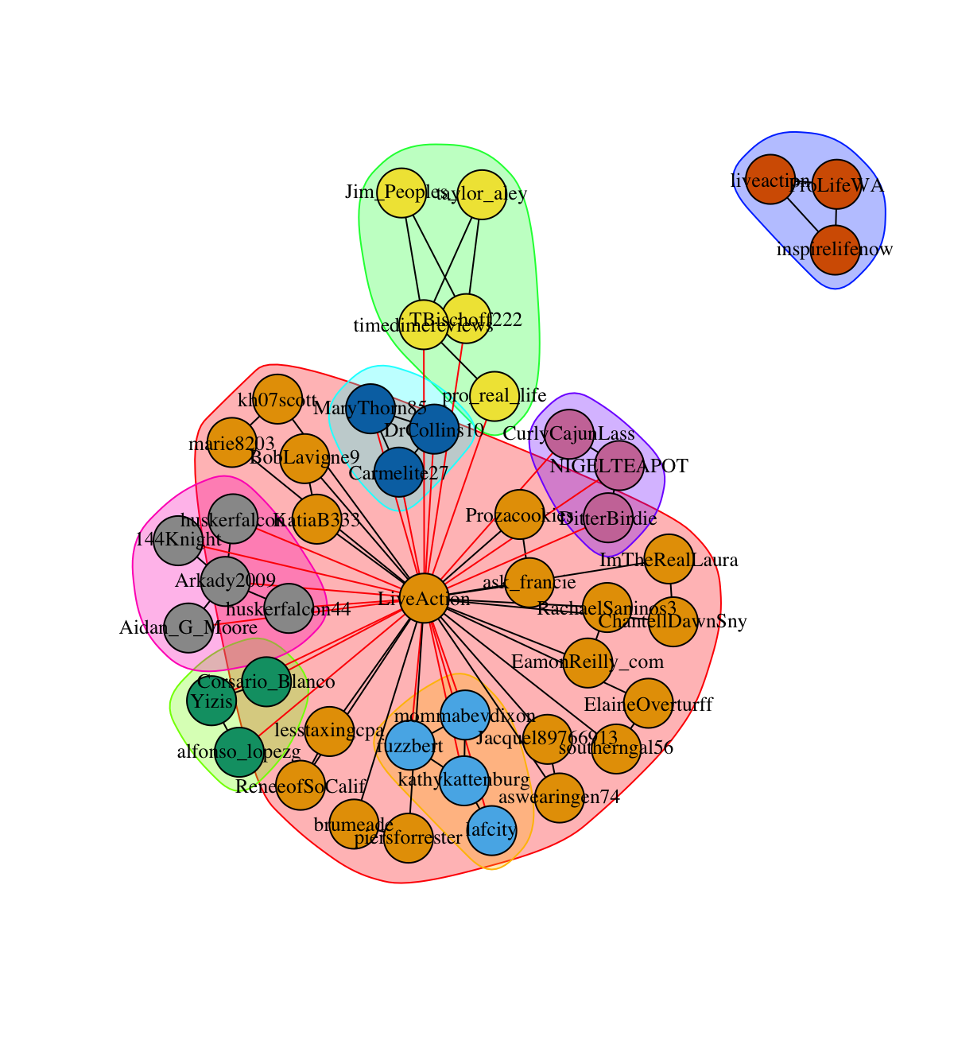

**What recommendations would you provide to promote your opinion leader’s content on social media?**

In order for Candace to increase her influence, she should form connections to unite her followers in the pro-life movement. Encouraging them to work together (or attend March of Dimes together) could foster a community. Additionally, reaching out to individual followers to establish more meaningful relationships could increase her influence. If her other followers see that she is preferential to her pro-life followers, they may make more pro-life tweets in an attempt to get noticed by their favorite actress.

**What recommendations would you provide to demote your opinion leader’s content on social media?**

If someone wanted to decrease Candace’s influence, he could spread misinformation that could hurt Candace’s credibility. For example, if he spread a rumor that she’s had an abortion, her followers could turn on her. Since her followers are not connected to one another, losing her influence would disperse the group.