Genome Browser Visualization of SQANTI3 Annotation of Isoforms

**Color code for isoform structural categories**

Full-Splice Match (FSM)

Incomplete-Splice Match (ISM)

Novel In Catalog (NIC)

Novel Not In Catalog (NNC)

Antisense

Intergenic

Genic

Genic Intron

Fusion

**Genome Browser**

Track name

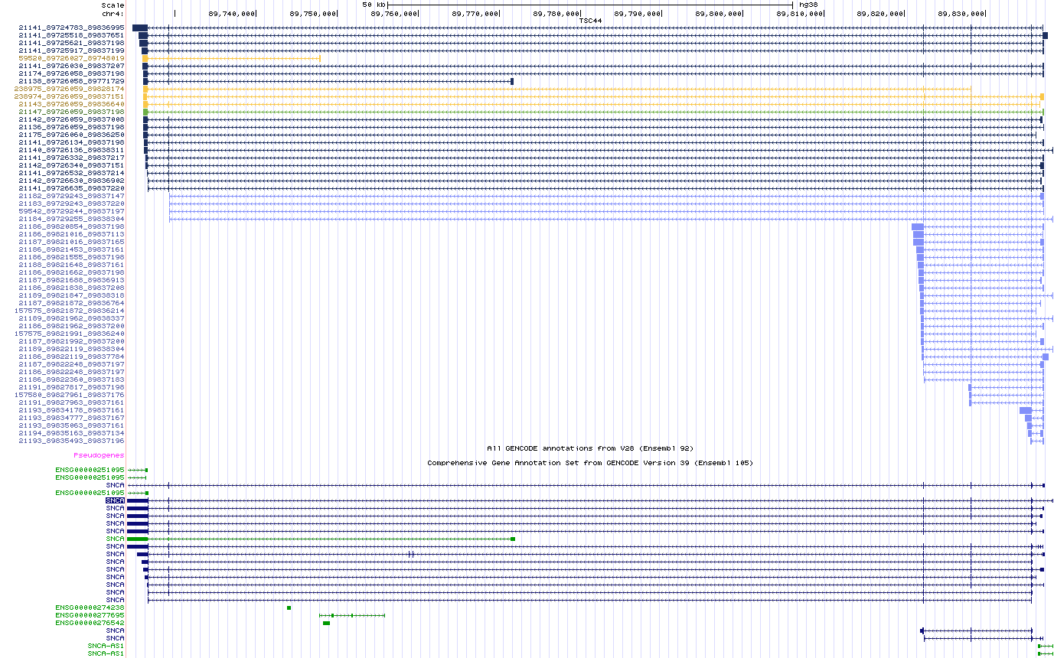

Annotation track

Isoform identifier

Track name – in this case, labeled by sample, each sample has its own track that you can show/hide/squish

Isoform identifier – made up of 3 numbers x_y_z. x is an isoform number that’s common amongst isoforms with the exact same splice junctions. y and z are the start and end coordinates respectively. Isoform identifiers are shared across different samples (ie. If TSC1 and TSC3 both have isoform x_y_z shown, it refers to the same isoform). Multiple isoforms can have the same isoform number x, but different start and end (y,z) coordinates. For example: 255_1000_4000 and 255_850_4600 have the exact same splice sites, but differ at the start/end. This could be indicative of library fragmentation OR could indicate variable TSS/TTS.

Annotation track – this should always match the reference annotation that was used to annotate the isoforms, in this case, Comprehensive GENCODE V39. (Do NOT use Basic GENCODE, it’s missing some less validated isoforms). If the isoform identifier is being cut-off in your browser configuration, go to View > Configure Browser and increase the label area width (number refers to how many characters)

**Link Sharing**

Don’t copy/paste from the address bar in your browser. It’ll direct to your temporary browser configuration and will not necessarily include the tracks that you’d want to share. Use the actual link that was provided (genome.ucsc.edu/s/csl022/Session_name_here)

**Counts**

This browser visualization doesn’t include any quantitative info reflecting the relative abundance of the isoform species.