**Christine M. Balbin**

**BSIT-4A**

Apply proper formatting for the final output.

**Situation 1:**

Create reaction paper of the article below

https://www.onenews.ph/articles/glitch-hits-bpi-computer-system

As a project manager how will you answer the following

**- what are the issue?**

Glitch Hits BPI Computer System. Customers' complaints about illegal withdrawals flooded social media, causing an issue in the Ayala-led Bank of the Philippine Islands' (BPI) operations. This was a recurrence of a "internal systems error" that affected the listed bank in June 2017.

**- who are affected in the issue?**

A number of people may be harmed by an incident like the computer system glitch that affected BPI. Customers of a bank who may suffer financial losses and worry about the security of their accounts are those who are affected by an incident most. Employees may experience increased workloads and stress, particularly in the IT and security departments. The bank may suffer financial losses, legal penalties, and reputation harm. Regulatory agencies may look into the occurrence and demand remedial action.The incident could harm the public's trust in the banking industry.

**- what are the possible factors of the issue?**

Many factors may have contributed to the "internal systems error" that resulted in unauthorized withdrawals and consumer complaints in BPI's computer system. Software bugs, cybersecurity breaches, hardware failures, and human errors can all lead to potential security breaches in a bank.

**- what are the steps to implement once the issue occur?**

Finding the issue and identifying the systems or services that are affected is the first phase in addressing an incident. Inform affected customers as well as internal and external stakeholders. Create an incident response team with an incident manager in charge. Take urgent action to address the situation and stop more illegal access. Maintain transparency and give regular updates. To ensure compliance to rules and laws, get legal advice. System and service recovery and recovery. Perform an in-depth post-incident study to comprehend the problem and pinpoint areas that need to be improved. Take preventative action by enhancing cybersecurity safeguards and system monitoring,

**- what are the proposed solutions to prevent the issue from happening?**

Regular software testing, strong cybersecurity safeguards, monitoring and anomaly detection, data backup and recovery, change management, incident response plan, employee training, and vendor risk management are just a few of the technical solutions used by the bank. These steps guarantee that the bank's infrastructure is reliable, secure, and modern. Additionally, they put in place a clear change management approach, sophisticated monitoring tools, and data backup and recovery protocols. These steps support maintaining data security and guard against security holes.

**- who are involve in the solution? define each role?**

**IT Security Team:**

This team's cybersecurity specialists are in charge of setting up and maintaining security measures. They carry out vulnerability analyses, monitor for threats, and react to security problems.

**Chief Information Officer (CIO):**

The bank's IT infrastructure and overall technology strategy fall under the CIO's purview. They supervise the application of technical solutions and guarantee that they are in line with organizational goals.

**Data Backup and Recovery Team:**

This team is in charge of implementing the procedures for data backup and recovery. They make sure that crucial data is consistently backed up and can be restored in the event of system failures or data corruption.

**Incident response team:**

The incident response team must develop and maintain an incident response strategy. This strategy outlines the roles, duties, and procedures for managing security issues properly and quickly.

**- create context diagram and DFD for the proposed solution**

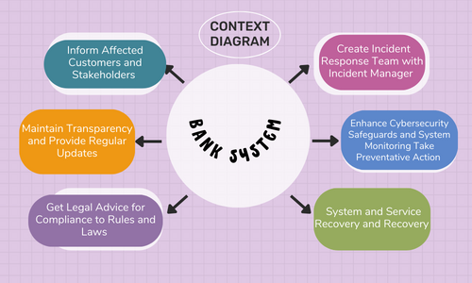

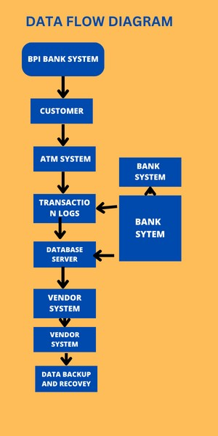

**Situation 2:**

PSU portal(during enrollment)

As a project manager how will you answer the following

**- what are the issue?**

During the enrollment of the PSU students, there are problem regarding the PSU portal such as interruption. The error says that “There was an error connecting the to the dataserver. The server might be too busy to accept your connection request. The error also says Host ‘psu.campus-erp.com’ is blocked because of many connection errors; unblock with ‘mysqladmin flush.hosts.

- **who are affected in the issue?**

PSU staff because of the delayed enrollment and the affected also is the student of the PSU due to the delayed enrollment. Operators or Administrators: Those in charge of keeping the database server and the application up to date may also be impacted.

**- what are the possible factors of the issue?**

the possible factors of the issue, there are too many students accessing the portal. Maybe the problem is also the system itself. Another cause is high server load. The data server may be overwhelmed by a high volume of connections or resource-demanding queries, making it unable to accept more connections.

**- what are the steps to implement once the issue occur?**

You need to first understand the error message and its specific codes in order to fix a database connection error. To learn more about the issue, examine the server logs. Verify that the configuration of the database connection is accurate. To avoid sending consumers meaningless error messages, incorporate error handling and retry capabilities into your code.

**- what are the proposed solutions to prevent the issue from happening?**

Establish a Content Delivery Network (CDN) to regionally distribute content. Improve table architecture, indexing, and database queries for quicker data retrieval. Implement caching techniques for data that is accessed frequently. To increase productivity, optimize the code of your application. To find problems early, use error handling and logging. Perform regular performance checks and evaluate your application's compatibility across a range of devices. Create an incident response strategy to deal with performance problems. To find problems early, use error handling and logging.

**- who are involve in the solution? define each role?**

-The project manager is in charge of making sure the project is executed  according to plan, on schedule, and within expense. Ensure consistency with the strategic goals and priorities of the organization. To keep the project on schedule, track development and make necessary adjustments.

-Developers and programmers. The one wrote the code and optimize it’s performance.

-System architect- The one who is designing the online enrollment.

-Database administrator- Ensures its efficiency, security, and integrity.

-Quality Assurance (QA) Tester- The one who find and document any flaws, such as interruption errors and sluggish loading times. They test for usability, performance, and functionality.

**- create context diagram and DFD for the proposed solution.**

