APF-Shielded Deep RL for Autonomous Racing:
Mid-term Report
Christine Chen Luddy School of Informatics,
Computing, and Engineering
Indiana University Bloomington
cch8@iu.edu
Chinmay Deshpande Luddy School of Informatics,
Computing, and Engineering
Indiana University Bloomington
chidesh@iu.edu
Gabriel Shores Luddy School of Informatics,
Computing, and Engineering
Indiana University Bloomington
gshores@iu.edu
Abstract
We race a PPO agent against three PID and Pure Pursuit opponents in F1TENTH Gym, with an artificial potential field (APF) acting as a safety shield that intervenes only when the agent’s own action is predicted to cause a crash. The full pipeline now runs end to end: track, opponents, classical baselines, shielded and unshielded PPO with the three-stage curriculum, and a race-day evaluation with all six proposed metrics. Following the proposal feedback, the shield is action-conditioned rather than additive, the simulator has friction-limited tyres, and every metric has a target. On the shared race seeds our agent finishes 43 of 50 five-lap races (PID+APF: 28, $p=0.002$), laps 8 s faster than PID+APF, crashes about 10$×$ less often during training than unshielded PPO, and meets all six metric targets on the 20-race protocol. The main open problem is variance across training seeds; a residual policy trained with the shield removes most of it (81% of 150 races finished over three seeds, PID+APF 56%) and is our final controller.

1 Introduction
Classical racing controllers such as PID steering with an APF avoidance layer are safe but slow near obstacles and cannot plan a pass; deep RL learns fast lines and tactics but crashes constantly while learning and gives no safety guarantee. Our goal is to combine them: a PPO agent races, and an APF shield steps in only when a crash is imminent, with a reward penalty for every intervention.
Updated scope. Four changes since the proposal, three of them prompted by the feedback: (1) The additive, clipped APF of the proposal’s Eq. 2–3 cannot prevent violations, and its weight $w(d)$ ignores the agent’s action. We confirmed both experimentally (Sec. 4) and replaced it with an action-conditioned shield that simulates the agent’s action and only intervenes if that action is predicted unsafe; Eq. 2–3 is kept as a baseline. (2) Stock F1TENTH tyres have no grip limit (we measured 2.4 g of lateral acceleration at $μ=1.05$), so we added a friction-circle tyre model and traction control; this also makes the “grip left over after cornering” reach physically meaningful. (3) Training efficiency is measured with the shield removed, and crashes during training are reported, because a shield trivially keeps laps clean. (4) We added a ResRace-style residual policy as a baseline to make the difference from ResRace and RaceMOP testable.
Contribution. In ResRace and RaceMOP the APF shapes every command; in ours the policy drives and the APF acts only when an exact-model rollout of the policy’s own action predicts a collision or loss of control (3% of race steps for training seed 0), with a fallback manoeuvre when no corrected action is safe.
What works now. Everything in the proposal’s plan through “race day”: the Singapore-inspired track (199 m, 2.8 m wide), three opponents, Pure Pursuit and PID+APF baselines, PPO with and without the shield on three training seeds each, the four-car race evaluation (20 shared seeds, 5 laps, nominal and randomised), all six metrics with targets and Mann–Whitney U tests, g-g and telemetry plots, and race videos. The code, a log of every run and 33 documented problems are in the team repository.

2 System Architecture
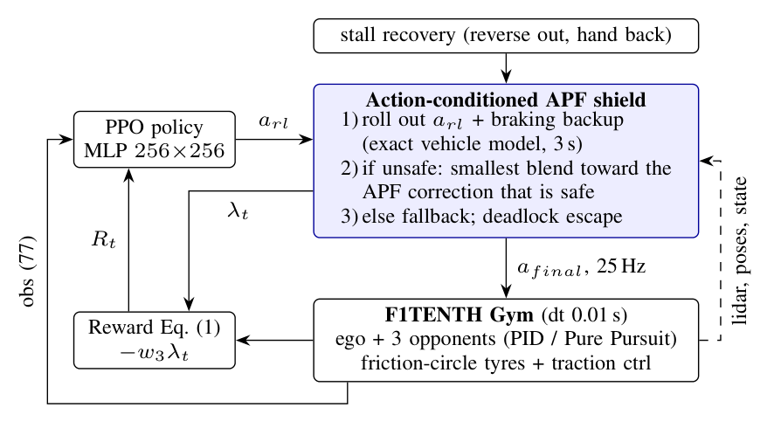
Control loop. The shield is part of the environment, so it can be switched off without touching the policy; it reports its intervention strength $λ_{t}$ to the reward and the metrics.
Fig. 1 shows the loop. At 25 Hz the policy maps a 77-value observation to an action; the shield checks it against the lidar scan (every third of the 1080 beams), the known track walls and the opponents’ poses, and passes on either the action itself or a corrected one. The simulator integrates the dynamic single-track model with RK4 at 0.01 s for all four cars. Opponents alternate PID (curvature feed-forward plus PID on cross-track error) and Pure Pursuit at 50–75% of a grip-limited speed profile, with gap keeping. We patched F1TENTH Gym’s lidar ray casting (about 10$×$ faster, $∼$400 control steps/s per core without the shield), and training runs 7 environments in parallel on a laptop CPU (3.5 M steps in about 2 h).

3 Implemented Approach

3.1 Vehicle model
F1TENTH default parameters (3.74 kg, wheelbase 0.33 m, $μ=1.0489$). Each axle’s lateral force is capped by a friction circle, $|F_{y}|≤\sqrt{(μF_{z})^{2}−(F_{z}a_{x}/g)^{2}}$, identical to the stock model below the limit; traction control clamps the speed loop’s acceleration to $\sqrt{(0.95μg)^{2}−(vr)^{2}}$. This closes the sliding exploit reported by Evans et al. .

3.2 Reinforcement learning agent
Observation: 60 min-pooled lidar sectors, speed, yaw rate, steering angle, lateral offset and heading error, the two nearest opponents (relative position and velocity), and the previous action. Action: steering in $±0.42$ rad and target speed in 1–16 m/s. Reward (proposal Eq. 1):
$$R_{t}=w_{1}v_{∥}+w_{2}Δs+w_{5}1_{pass}−w_{3}λ_{t}−w_{4}1_{collision}$$
with $(w_{1},w_{2},w_{3},w_{4},w_{5})=(0.002,0.1,0.1,10,2)$; a pass counts once the ego holds a lead of one car length for 2 s without contact. Episodes last 40 s and end on any collision. PPO (Stable-Baselines3): lr $3​×​{10}^{−4}$, 7 envs $×$ 512 steps, batch 1024, 10 epochs, $γ=0.99$, GAE 0.95, clip 0.2. Curriculum: solo laps (1.5 M steps), slow opponents (1 M), opponents at varied speeds and start gaps (1 M), with friction $×U(0.85,1.15)$ and lidar noise up to 5 cm randomised per episode. The unshielded ablation uses the same curriculum with the shield off in every stage.

3.3 APF shield
Field. For beam $i$ at angle $θ_{i}$ with clearance $c_{i}$ from the car outline, the influence distance is the braking distance on the closing speed, and each beam adds a repulsive force:
d0,i=dmin+max(vcosθi,0)22ab,ρi=clip​d0,i−cid0,i−dcrit,0,1,F=−i​ρi2 Δθ (cosθi,sinθi),
where $a_{b}=\sqrt{(μg)^{2}−(vr)^{2}}$ is the grip left after cornering (“grip reach”; a fixed 6 m/s$​^{2}$ is the alternative). Opponents add an elliptical field stretched along their heading. The lateral force becomes a steering correction and the backward force a speed reduction, giving the corrected action $a_{corr}$.
Action-conditioned decision. Let $C(a)$ be the minimum clearance of the car’s three covering circles to lidar points, map walls and opponents (assumed to brake at 6 m/s$​^{2}$) over a rollout that holds $a$ for one control step and then brakes while holding the lane, using the simulator’s own vehicle model (verified to $<2$ cm); $C(a)=−1$ if the predicted body slip exceeds 20$​^{∘}$. Then
$$a_{final}=\left\{\begin{matrix}a_{rl} & C(a_{rl})≥c_{safe} \\ (1−λ)a_{rl}+λa_{corr} & \text{smallest safe }λ∈Λ \\ \text{fallback} & \text{otherwise,}\end{matrix}\right.$$
with $Λ=\{1/4,1/2,3/4,1\}$ and $c_{safe}=5$ cm. The fallback is the braking backup itself (which keeps the check recursively feasible) or the safest of seven other braking manoeuvres. Two additions came from failures we observed on race day: a deadlock escape (when stopped inside the margin, allow 2 cm of clearance loss and slow creep or reverse manoeuvres) and a stall recovery (if the car stops nose-to-wall, reverse with the steering that turns the nose back to the track, then hand control back); both are filtered by the shield.

3.4 Baselines
Pure Pursuit on the centerline; PID+APF with the proposal’s additive Eq. 2–3 (gains grid-searched for this track); unshielded PPO; PPO trained with the additive Eq. 2–3 shield; and a ResRace-style residual policy (action = PID+APF action $+ 0.3×$ policy).

4 Preliminary Results
Shield without learning. With friction-circle tyres, scripted bad drivers (too fast, ignoring traffic, random) crash in 100% of trials with no shield and with the additive Eq. 2–3 shield; with the action-conditioned shield and fallback, 0/12/0% with fixed reach and 0/38/12% with grip reach (used by the agent). On stock tyres the additive shield is active on 98% of steps for a too-fast driver, ours on 18%.
Training safety (Fig. 2). Over 3.5 M steps the shielded agent crashed in 96–313 episodes versus 2295–2769 without the shield (3 seeds each); PPO trained with the additive shield crashed 1786–2333 times (3 seeds), hardly better than none. Before its first clean lap the shielded agent crashed 8–11 times versus 969–1080. With the shield removed for the measurement, both variants complete their first clean solo lap after 150–200 k steps, so the shield made training far safer but not faster at learning to lap. The final controller’s recipe (residual policy trained with our shield) is both: 81–133 crashes in all of training and a first solo lap under 34 s (faster than any classical lap) after 200–250 k steps, versus 450–800 k for PPO with our shield and 550–850 k without.
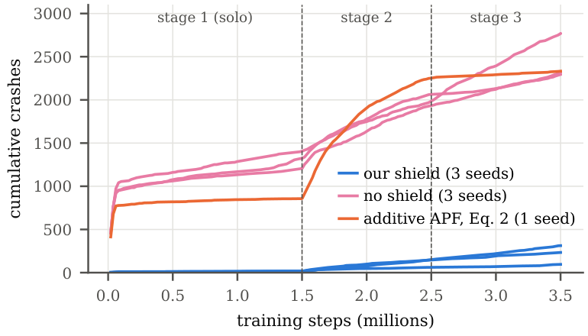
Cumulative crashes during training. Each line is one training seed.
Race day, training seed 0, nominal conditions (5 laps, 3 opponents, DNF on first collision). Lap: mean clean lap. Coll.: collisions per 10 laps. 50 races: finished on 50 shared seeds, nominal / randomised.
Controller | Fin./20 | Lap (s) | Coll. | Passes | 50 races
PPO + our shield | 19 | 34.7 | 0.10 | 3.15 | 43 / 35
Residual PPO trained w/ shield | 15 | 32.1 | 0.59 | 3.15 | 39 / 37
PPO + additive APF (Eq. 2–3) | 18 | 47.6 | 0.21 | 0.85 | 39 / 34
PID + APF | 12 | 42.8 | 1.09 | 1.35 | 28 / 25
Residual PPO (ResRace-style) | 10 | 30.4 | 1.60 | 2.20 | –
PPO, no shield | 0 | 32.5 | 7.35 | 1.35 | –
Pure Pursuit | 0 | – | 61.4 | 0 | –
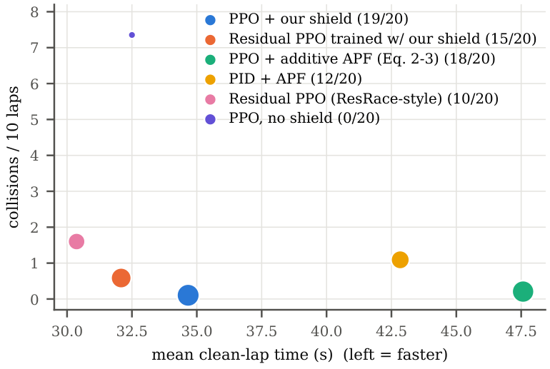
Safety versus speed (Table 1); marker size grows with races finished.
Race day (Table 1, Fig. 3). On 50 shared race seeds our agent finishes more races than PID+APF ($p=0.002$ nominal, Fisher; $p=0.07$ randomised) while lapping 8 s faster; against the additive-shield agent the finish rates are statistically tied ($p=0.44$), but ours laps 12 s faster with 2.7$×$ the passes over 50 races ($p≈{10}^{−8}$, Mann–Whitney), the timid behaviour the proposal predicted for an always-on APF. On the 20 seed-0 races our agent meets all six metric targets in both conditions: lap time 0.81$×$ PID+APF ($≤$ 0.95), 0.10 / 0.47 collisions per 10 laps ($≤$ 0.5), 85% overtake success ($≥$ 70%), shield active on 3% of steps ($≤$ 10%), 17% of time above 90% of $μg$ ($≥$ 10%) and 0.0% above 15$​^{∘}$ slip ($≤$ 1%). Over all 50 races the randomised collision rate is 0.77, which misses its target. Adding our shield to the residual policy only at race time fails (2–4 of 20 finished, deadlocks and slides), but training the residual policy with the shield works: statistically tied with ours on finishes over 50 races ($p=0.44$ / $0.82$) and 1.9–2.5 s per lap faster on all three training seeds (39–42 of 50 finished nominal, 37–40 randomised).
Across training seeds the results vary a lot (Fig. 5). With the final shield, seeds 0 and 2 finish 19/20 and seed 1 only 1/20 (13.0 $±$ 8.5, mean $±$ population s.d. over 3 seeds), versus 3.0 $±$ 2.4 without a shield; collisions per 10 laps are 1.63 $±$ 2.16 versus 4.38 $±$ 2.12. Seed 1 learned to drive at the limit: replaying a crash shows the predicted clearance shrinking for several steps while staying above the 5 cm margin, after which every braking manoeuvre is predicted to spin. Fig. 4 shows where races end: most failures of the shielded agent were in the tight 2.5 m-radius corners at 84–126 m, where the policy stalled with its nose against the wall; the stall recovery removed most of them. A fix for the sliding seed: retraining seed 1 with a slip penalty $w_{6}max(|β|−0.15,0)$ added to Eq. (1) ($w_{6}=1$, final shield from the start) gives 18/20 finished with the stall recovery (17/20 randomised), 0.11 collisions per 10 laps and 32.5 s laps. It is not a general fix: seeds 0 and 2 with the same recipe finish only 11/20 (13.3 $±$ 3.3 over three seeds). The residual policy trained with the shield is more consistent: over three seeds it finishes 16.0 $±$ 0.8 of 20 races (16.7 $±$ 0.5 randomised), with 0.47 $±$ 0.10 collisions per 10 laps and 32.2 $±$ 0.1 s laps, never stuck. We therefore adopt it as the final controller. Pooled over 150 races it meets five of six targets (lap 0.76$×$ PID+APF, 0.43 collisions per 10 laps, 91% overtake success, shield on 5% of steps, 0% slip) and misses the grip target (8.8% of time above 90% of $μg$). The g-g diagrams (Fig. 6) show that this target measures the wrong thing: plain PPO reaches 35% with a bang-bang throttle (31% of the race braking and 30% accelerating harder than $0.5μg$, clipped by traction control at $±0.95μg$) but corners above $0.6μg$ only 5% of the time, like PID+APF. The final controller corners that hard 14% of the time and brakes hard half as often, which is where its 6 s per lap come from. We will report cornering grip instead.
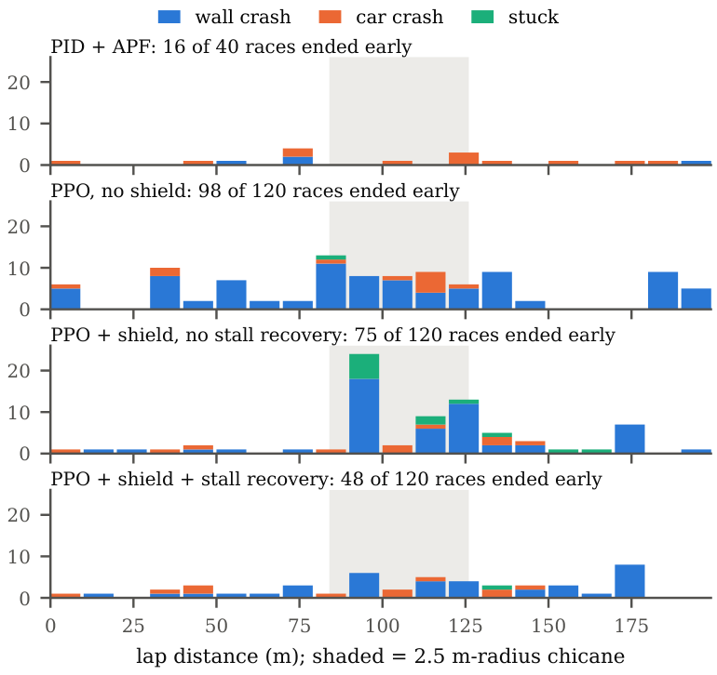
Where races end on the lap (3 training seeds, nominal and randomised races pooled).
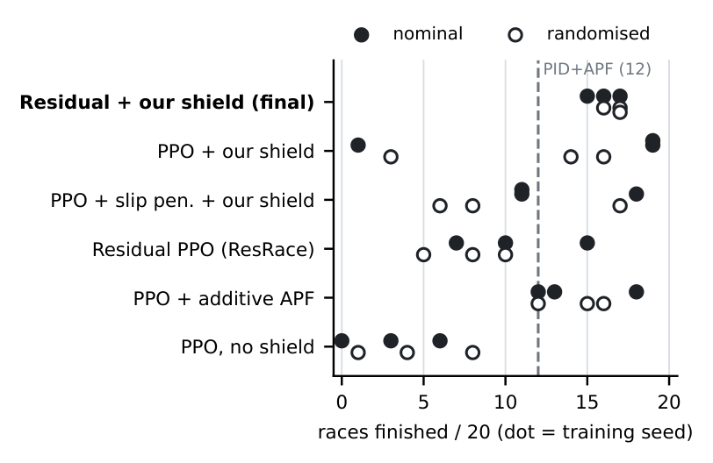
Races finished out of 20 per training seed (filled: nominal, hollow: randomised; dashed: PID+APF). The residual policy trained with our shield has the smallest spread; plain PPO with our shield has both the best and the worst seed.
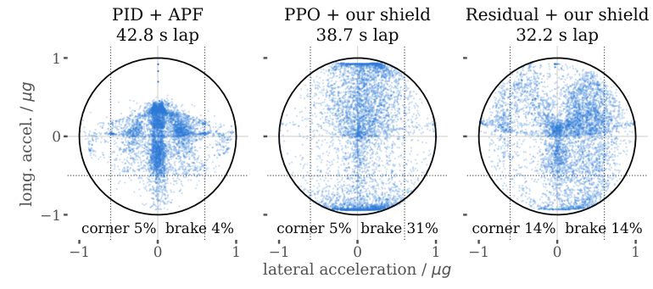
g-g diagrams, nominal races, all training seeds (circle: friction limit). Corner: time with lateral acceleration above $0.6μg$; brake: braking harder than $0.5μg$ (dotted lines).
Our shield, or any shield? Trained with the additive Eq. 2–3 shield instead of ours, the residual policy fails (0–1 of 20 finished on two seeds; 2.1$×$ the training crashes of PPO with no shield). With the policy output fixed at zero, PID+APF plus the additive shield already finishes 0/20: the residual base has its own APF, and the two fields stack. Our shield, which leaves safe actions alone, composes: PID+APF plus our shield with no learning finishes 20/20 without a collision (16/20 randomised) but laps at 42.5 s. The learned residual buys 10 s per lap on top of it.
What still fails. 60 of the final controller’s 62 non-finishes in 300 races are contacts with opponents. Of seed 0’s 24, 15 are the ego cutting back in front of a car it has just passed. The shield’s prediction lets every opponent brake at 6 m/s$​^{2}$, the worst case for a car ahead but the best case for a car just passed, which keeps its speed. Checking both (brake or hold speed), with a braking-only fallback when nothing is safe under both, and the friction estimate below, 269 of 300 finish (238 before, $p=7⋅{10}^{−4}$) with 30 car contacts (60) and no wall hit, 0.5 s per lap slower.
Outside the training friction. At friction $×$0.8 (trained on 0.85–1.15) the final controller finishes 52% of races (PID+APF 50%), 83% with the shield told the true friction ($p=4⋅{10}^{−4}$); at $×$0.7, 27% and 67%. Estimating the friction online from tyre saturation gives 90% at $×$0.8 and, smoothed, 78% at $×$0.7 at no cost in normal races. Retraining on $×$0.65–1.15 (three seeds) finishes 283 of 300 normal races (269, $p=0.05$) and 59 of 60 at $×$0.7 (41, $p=9⋅{10}^{−6}$), with no wall hit in 420 races, 0.6 s per lap slower. With one opponent all controllers finish 85–100%, with five PID+APF 48%, ours 77%.
Why the tyre model matters. On stock tyres the same recipe laps 5 s faster by cornering above the friction limit 9.7% of the time; with ours, 0%.
Generalisation. On a second track that no policy saw in training (228 m, a 55 m straight, a fast sweeper and a 2.5 m hairpin; 20 races), the final controller finishes 18.3 of 20 over three seeds (16.3 randomised) in 31.2 s with 3.8 passes per race, against PID+APF 15/20 in 39.3 s. Plain PPO + shield finishes 16.7 (14.0, one seed 5/20) in 37.5 s, PPO without a shield 1/20.
Negative results. A lower intervention penalty ($w_{3}=0.02$) let the agent hand braking to the shield (35% of steps) and deadlock. Shield dropout gave a policy that is safe with no shield (16/20) but timid (0.25 passes per race). A wider residual (scale 0.5) helped one seed (19/20) and let the other slide (14/20).

5 Plan to the Final Demo
Remaining tasks and milestones (final demo December 7):
- Nov 13–20: test the wide-friction policy on the second track and against a control trained with the old shield (running), then fix the final controller; report cornering grip instead of the grip target.
- Nov 21–27: test the three-seed baselines on both tracks; stress tests of the final shield (friction, number of opponents).
- Nov 28–Dec 3: freeze the code; run the final evaluation (all controllers, 3 training seeds, 50 race seeds, nominal and randomised); telemetry, g-g diagrams and videos.
- Dec 4–7: final report, presentation and live demo (recorded four-car races).
Evaluation plan. Controllers: Pure Pursuit, PID+APF, unshielded PPO, PPO with the additive Eq. 2–3 shield, ResRace-style residual PPO (with and without our shield) and ours. Scenarios: five-lap four-car races on 50 shared seeds, nominal and randomised, three training seeds per learned controller, and the stress tests. Metrics: the six targets (cornering grip in place of time above 90% of $μg$), races finished, crashes in training and steps to the first fast lap. Tests: Fisher’s exact test on finish rates, Mann–Whitney U on per-race values.
Team roles. [Team: fill in who owns which part (e.g., simulator and track, shield, RL training, evaluation and analysis).]

Acknowledgement
Claude (Anthropic) was used to write and debug code, run experiments, and draft this report. [Team: edit to match how you used it.]
9 R. Zhang et al., “Residual policy learning facilitates efficient model-free autonomous racing,” IEEE Robot. Autom. Lett., vol. 7, no. 4, pp. 11625–11632, 2022. R. Trumpp et al., “RaceMOP: Mapless online path planning for multi-agent autonomous racing using residual policy learning,” in Proc. IEEE/RSJ IROS, 2024, pp. 8449–8456. B. D. Evans, H. A. Engelbrecht, and H. W. Jordaan, “High-speed autonomous racing using trajectory-aided deep reinforcement learning,” IEEE Robot. Autom. Lett., vol. 8, no. 9, pp. 5353–5359, 2023.

