APF-Shielded Deep RL for Autonomous Racing:
Mid-term Report
Christine Chen
Luddy School of Informatics,
Computing, and Engineering
Indiana University Bloomington
cch8@iu.edu
Chinmay Deshpande
Luddy School of Informatics,
Computing, and Engineering
Indiana University Bloomington
chidesh@iu.edu
Gabriel Shores
Luddy School of Informatics,
Computing, and Engineering
Indiana University Bloomington
gshores@iu.edu
Abstract—We race a PPO agent against three PID and Pure Pursuit opponents in F1TENTH Gym, with an artificial potential field (APF) acting as a safety shield that intervenes only when the agent’s own action is predicted to cause a crash. The full pipeline now runs end to end: track, opponents, classical baselines, shielded and unshielded PPO with the three-stage curriculum, and a race-day evaluation with all six proposed metrics. Following the proposal feedback, the shield is action-conditioned rather than additive, the simulator has friction-limited tyres, and every metric has a target. On 50 shared race seeds our agent (training seed 0) finishes 43 five-lap races (PID+APF: 28, $p=0.002$), laps 8 s faster than PID+APF and 12 s faster than PPO with the proposal’s additive shield, crashes about 10$×$ less often during training than unshielded PPO, and meets all six metric targets on 20 races. The main open problem is variance across training seeds, the focus of the rest of the semester.

I. Introduction
Classical racing controllers such as PID steering with an APF avoidance layer are safe but slow near obstacles and cannot plan a pass; deep RL learns fast lines and tactics but crashes constantly while learning and gives no safety guarantee. Our goal is to combine them: a PPO agent races, and an APF shield steps in only when a crash is imminent, with a reward penalty for every intervention. The goal, track, opponents, reward and metrics are as proposed.
Updated scope. Three changes, all prompted by the proposal feedback: (1) The additive, clipped APF of the proposal’s Eq. 2–3 cannot prevent violations, and its weight $w(d)$ ignores the agent’s action. We confirmed both experimentally (Sec. 4) and replaced it with an action-conditioned shield that simulates the agent’s action and only intervenes if that action is predicted unsafe; Eq. 2–3 is kept as a baseline. (2) Stock F1TENTH tyres have no grip limit (we measured 2.4 g of lateral acceleration at $μ=1.05$), so we added a friction-circle tyre model and traction control; this also makes the “grip left over after cornering” reach physically meaningful. (3) Every metric has a target, training efficiency is measured with the shield removed, and crashes during training are reported, because a shield trivially keeps laps clean.
Contribution. In ResRace [1] and RaceMOP [2] the APF shapes every command; in ours the policy drives and the APF acts only when an exact-model rollout of the policy’s own action predicts a collision or loss of control (3% of race steps for training seed 0), with a fallback manoeuvre when no corrected action is safe.
What works now. Everything in the proposal’s plan through “race day”: the Singapore-inspired track (199 m, 2.8 m wide), three opponents, Pure Pursuit and PID+APF baselines, PPO with and without the shield on three training seeds each, the four-car race evaluation (shared seeds, 5 laps, nominal and randomised), all six metrics with targets and statistical tests, g-g and telemetry plots, and race videos. The code, a log of every run and every problem we hit are in the team repository.

II. System Architecture
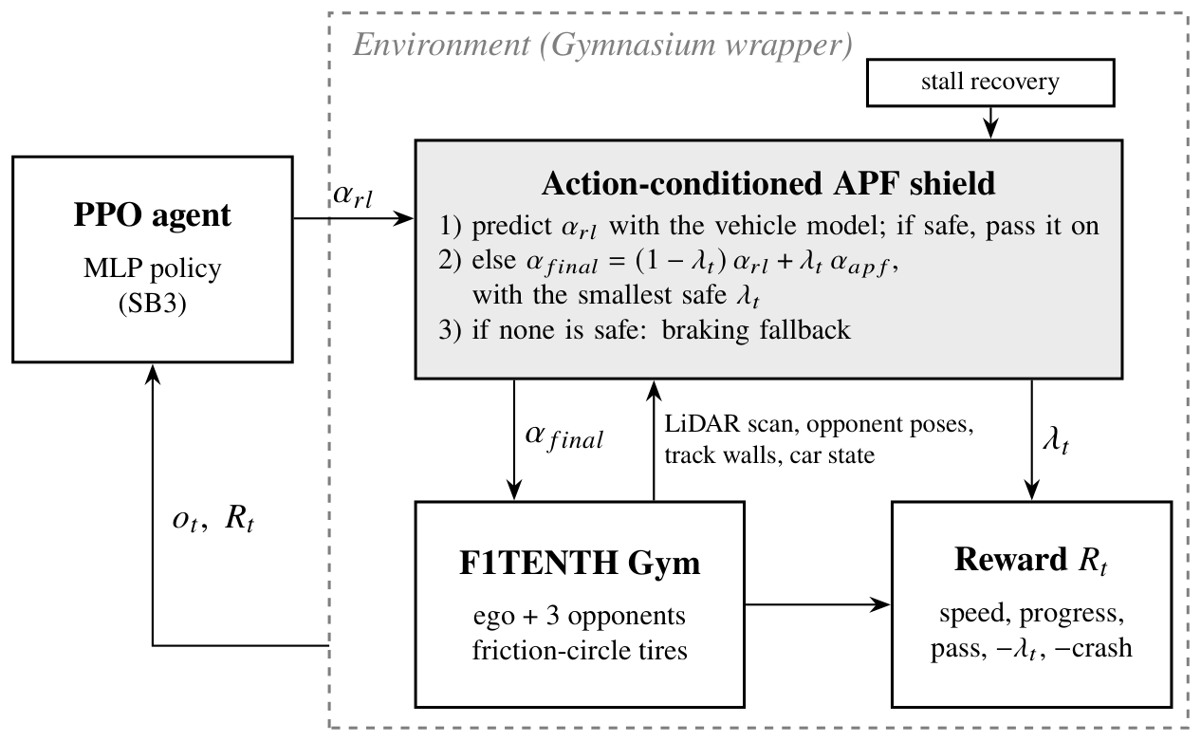
Fig. 1. Control loop (the proposal’s Fig. 1, updated). The shield is part of the environment, so it can be switched off without touching the policy; it reports its intervention strength $λ_{t}$ to the reward and the metrics.
Fig. 1 shows the loop. At 25 Hz the policy maps a 77-value observation to an action; the shield checks it against the lidar scan (every third of the 1080 beams), the known track walls and the opponents’ poses, and passes on either the action itself or a corrected one. The simulator integrates the dynamic single-track model with RK4 at 0.01 s for all four cars. Opponents alternate PID (curvature feed-forward plus PID on cross-track error) and Pure Pursuit at 50–75% of a grip-limited speed profile, with gap keeping. We patched F1TENTH Gym’s lidar ray casting (about 10$×$ faster, $∼$400 control steps/s per core without the shield), and training runs 7 environments in parallel on a laptop CPU (3.5 M steps in about 2 h).

III. Implemented Approach

A. Vehicle model
F1TENTH default parameters (3.74 kg, wheelbase 0.33 m, $μ=1.0489$). Each axle’s lateral force is capped by a friction circle, $|F_{y}|≤\sqrt{(μF_{z})^{2}−(F_{z}a_{x}/g)^{2}}$, identical to the stock model below the limit; traction control clamps the speed loop’s acceleration to $\sqrt{(0.95μg)^{2}−(vr)^{2}}$. This closes the sliding exploit reported by Evans et al. [3].

B. Reinforcement learning agent
Observation: 60 min-pooled lidar sectors, speed, yaw rate, steering angle, lateral offset and heading error, the two nearest opponents (relative position and velocity), and the previous action. Action: steering in $±0.42$ rad and target speed in 1–16 m/s. Reward (proposal Eq. 1):
$$R_{t}=w_{1}v_{∥}+w_{2}Δs+w_{5}1_{pass}−w_{3}λ_{t}−w_{4}1_{collision}$$
with $(w_{1},w_{2},w_{3},w_{4},w_{5})=(0.002,0.1,0.1,10,2)$; a pass counts once the ego holds a lead of one car length for 2 s without contact. Episodes last 40 s and end on any collision. PPO (Stable-Baselines3): lr $3​×​{10}^{−4}$, 7 envs $×$ 512 steps, batch 1024, 10 epochs, $γ=0.99$, GAE 0.95, clip 0.2. Curriculum: solo laps (1.5 M steps), slow opponents (1 M), opponents at varied speeds and start gaps (1 M), with friction $×U(0.85,1.15)$ and lidar noise up to 5 cm randomised per episode. The unshielded ablation uses the same curriculum with the shield off in every stage.

C. APF shield
Field. For beam $i$ at angle $θ_{i}$ with clearance $c_{i}$ from the car outline, the influence distance is the braking distance on the closing speed, and each beam adds a repulsive force:
d0,i=dmin+max(vcosθi,0)22ab,ρi=clip​d0,i−cid0,i−dcrit,0,1,F=−i​ρi2 Δθ (cosθi,sinθi),
where $a_{b}=\sqrt{(μg)^{2}−(vr)^{2}}$ is the grip left after cornering (“grip reach”; a fixed 6 m/s$​^{2}$ is the alternative). Opponents add an elliptical field stretched along their heading. The lateral force becomes a steering correction and the backward force a speed reduction, giving the corrected action $a_{corr}$.
Action-conditioned decision. Let $C(a)$ be the minimum clearance of the car’s three covering circles to lidar points, map walls and opponents (assumed to brake at 6 m/s$​^{2}$) over a rollout that holds $a$ for one control step and then brakes while holding the lane, using the simulator’s own vehicle model (verified to $<2$ cm); $C(a)=−1$ if the predicted body slip exceeds 20$​^{∘}$. Then
$$a_{final}=\left\{\begin{matrix}a_{rl} & C(a_{rl})≥c_{safe} \\ (1−λ)a_{rl}+λa_{corr} & \text{smallest safe }λ∈Λ \\ \text{fallback} & \text{otherwise,}\end{matrix}\right.$$
with $Λ=\{1/4,1/2,3/4,1\}$ and $c_{safe}=5$ cm. The fallback is the braking backup itself (which keeps the check recursively feasible) or the safest of seven other braking manoeuvres. Two additions came from failures we observed on race day: a deadlock escape (when stopped inside the margin, allow 2 cm of clearance loss and slow creep or reverse manoeuvres) and a stall recovery (if the car stops nose-to-wall, reverse with the steering that turns the nose back to the track, then hand control back); both are filtered by the shield.

D. Baselines
Pure Pursuit on the centerline; PID+APF with the proposal’s additive Eq. 2–3 (gains grid-searched for this track); unshielded PPO; and PPO trained with the additive Eq. 2–3 shield.

IV. Preliminary Results
Shield without learning. With friction-circle tyres, scripted bad drivers (too fast, ignoring traffic, random) crash in 100% of trials with no shield and with the additive Eq. 2–3 shield; with the action-conditioned shield and fallback, 0/12/0% with fixed reach and 0/38/12% with grip reach (used by the agent). On stock tyres the additive shield is active on 98% of steps for a too-fast driver, ours on 18%.
Training safety (Fig. 2). Over 3.5 M steps the shielded agent crashed in 96–313 episodes versus 2295–2769 without the shield (3 seeds each); PPO trained with the additive shield crashed 1786–2333 times (3 seeds), hardly better than none. Before its first clean lap the shielded agent crashed 8–11 times versus 969–1080. With the shield removed for the measurement, both variants complete their first clean solo lap after 150–200 k steps: the shield makes training far safer without slowing learning.
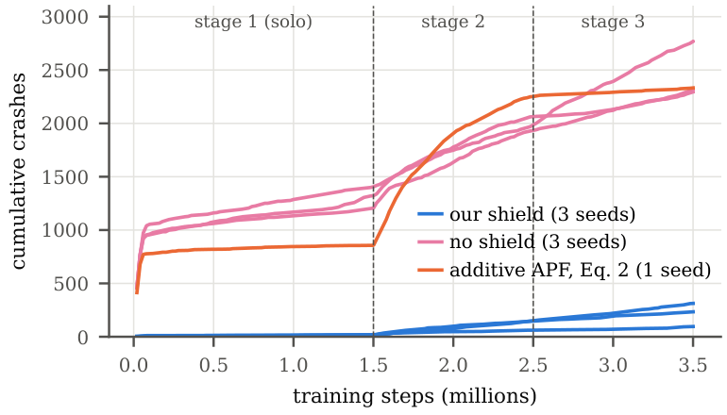
Fig. 2. Cumulative crashes during training. Each line is one training seed.
TABLE I
Race day, training seed 0, nominal conditions (5 laps, 3 opponents, DNF on first collision). Lap: mean clean lap. Coll.: collisions per 10 laps. 50 races: finished on 50 shared seeds, nominal / randomised.
Controller | Fin./20 | Lap (s) | Coll. | Passes | 50 races
PPO + our shield | 19 | 34.7 | 0.10 | 3.15 | 43 / 35
PPO + additive APF (Eq. 2–3) | 18 | 47.6 | 0.21 | 0.85 | 39 / 34
PID + APF | 12 | 42.8 | 1.09 | 1.35 | 28 / 25
PPO, no shield | 0 | 32.5 | 7.35 | 1.35 | –
Pure Pursuit | 0 | – | 61.4 | 0 | –
Race day (Table I). On 50 shared race seeds our agent finishes more races than PID+APF ($p=0.002$ nominal, Fisher; $p=0.07$ randomised) while lapping 8 s faster. Against the agent trained with the additive shield the finish rates are statistically tied ($p=0.44$), but ours laps 12 s faster with 2.7$×$ the passes ($p≈{10}^{−8}$, Mann–Whitney): the timid behaviour the proposal predicted for an always-on APF. Without a shield, PPO is as fast as ours but finishes no race. On the 20 seed-0 races our agent meets all six metric targets in both conditions: lap time 0.81$×$ PID+APF ($≤$ 0.95), 0.10 / 0.47 collisions per 10 laps ($≤$ 0.5), 85% overtake success ($≥$ 70%), shield active on 3% of steps ($≤$ 10%), 17% of time above 90% of $μg$ ($≥$ 10%) and 0.0% above 15$​^{∘}$ slip ($≤$ 1%). Over all 50 races the randomised collision rate is 0.77, which misses its target.
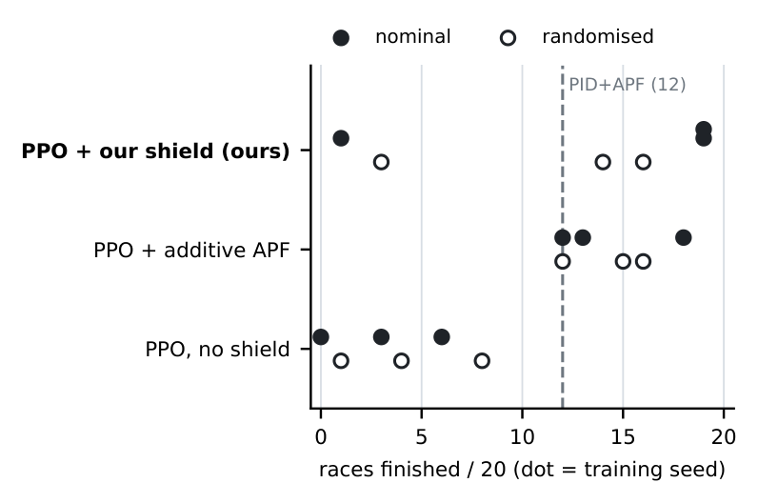
Fig. 3. Races finished out of 20 per training seed (filled: nominal, hollow: randomised; dashed: PID+APF). PPO with our shield has both the best and the worst seed.
Across training seeds the results vary a lot (Fig. 3). Seeds 0 and 2 finish 19/20 and seed 1 only 1/20 (13.0 $±$ 8.5 over 3 seeds), versus 3.0 $±$ 2.4 without a shield; collisions per 10 laps are 1.63 $±$ 2.16 versus 4.38 $±$ 2.12. Seed 1 learned to drive at the limit: replaying a crash shows the predicted clearance shrinking for several steps while staying above the 5 cm margin, after which every braking manoeuvre is predicted to spin. The additive-shield agent is more consistent across seeds (14.3 $±$ 2.6 of 20) but laps 11 s slower (49.4 vs 38.1 s) with 0.3 passes per race (ours 2.1), so the open problem is making our agent consistent without making it timid.

V. Plan to the Final Demo
Remaining tasks and milestones (final demo December 7):
- Nov 13–20: seed variance. Look for a training change that keeps every seed from sliding, for example a slip penalty in the reward or letting PPO correct a classical controller instead of driving directly, on three training seeds.
- Nov 21–27: robustness. Stress tests of the shield where time allows, such as friction outside the training range and different numbers of opponents; refine the shield where it fails.
- Nov 28–Dec 3: freeze the code; run the final evaluation; telemetry, g-g diagrams and videos.
- Dec 4–7: final report, presentation and live demo (recorded four-car races).
Evaluation plan. Controllers: Pure Pursuit, PID+APF, unshielded PPO, PPO with the additive Eq. 2–3 shield, and ours. Scenarios: five-lap four-car races on 50 shared seeds, nominal and randomised, and three training seeds per learned controller. Metrics: the six targets, races finished, crashes in training and steps to the first clean lap. Tests: Fisher’s exact test on finish rates, Mann–Whitney U on per-race values.
Team roles. [Team: fill in who owns which part (e.g., simulator and track, shield, RL training, evaluation and analysis).]

Acknowledgement
Claude (Anthropic) was used to write and debug code, run experiments, and draft this report. [Team: edit to match how you used it.]

References
[1] R. Zhang et al., “Residual policy learning facilitates efficient model-free autonomous racing,” IEEE Robot. Autom. Lett., vol. 7, no. 4, pp. 11625–11632, 2022.
[2] R. Trumpp et al., “RaceMOP: Mapless online path planning for multi-agent autonomous racing using residual policy learning,” in Proc. IEEE/RSJ IROS, 2024, pp. 8449–8456.
[3] B. D. Evans, H. A. Engelbrecht, and H. W. Jordaan, “High-speed autonomous racing using trajectory-aided deep reinforcement learning,” IEEE Robot. Autom. Lett., vol. 8, no. 9, pp. 5353–5359, 2023.

