**2.0 Product Description**

Nestlé has such business units as Food and Beverage, Nestle Waters and Nestle Nutrition. It divides its product into twelve categories which is prepared dishes and cooking aids, beverage, confectionery, ice-cream, water, pet care, milk products, nutrition and pharmacy. Nestlé biggest brands include Nescafé*,*KitKat, Nespresso, Maggi, Toll House andMilo. Investigator would like to choose milo which produced by Nestlé, Milo was originally developed by Australian Inventor Thomas Mayne in 1934 during The Great Depression where many children suffering from poor diets and malnutrition. Milo, develop a powdered chocolate malt drink designed to help build human energy. Nowadays, Milo brand is the world’s leading chocolate malt beverage that can be prepared with hot or cold milk or water. Milo had given its popularity it is a “must have” product for food service operators particularly in Asia, Africa and Oceania. Loved and trusted by parents and kids alike, Milo products offer essential vitamins and minerals that good for health. There are two types of nutrients form Milo which is Macronutrients and Micronutrients. Macronutrients are needed in higher amounts to maintain a healthy body and important to provide and store energy for our body, for growth and tissue repair. Next, micronutrients important for overall physical well-being and needed in smaller amounts. On top of that, Milo help human to gain a balanced diet, a habit of moderation and diverse menu options to obtain the nutrients for our body to stay energic and healthy. Besides, Nestlé using only natural ingredients for wholesome and balanced nutrition. Ingredients in Milo contains malted barley or malt barley and rice (total extract 38%), milk solids, sugar, cocoa, mineral (calcium and iron), maltodextrin (corn), vitamins (C, B3, B6, B2, D, B12), emulsifier (soy lecithin). Milo are also contains gluten, milk and soy. All additives are of plant or synthetic origin. Picture 1 shows the ingredients of Milo.

Picture 1: Ingredients of Milo

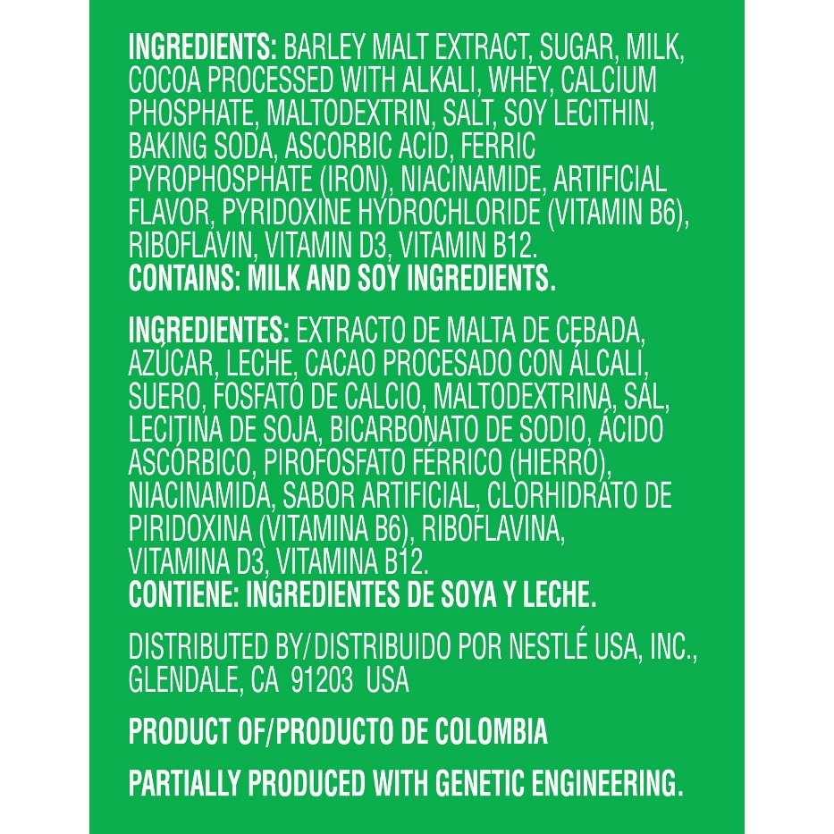

Product that are available are powder and drinks. For example, Milo powder’s product such as Milo Activ-Go soft pack (pack with 200g, 400g, 1.5kg and 2kg), Milo Tin (pack with 1kg), Milo *Kosong* (pack with 18 stick), Milo 3 in 1 (pack with 8 stick, 18 stick and 30 stick) are available. On the other hand, product for Milo drinks that are still available are Milo Can (pack with size 240ml and different flavour such as Original, Mocha, Kaw, and Ice) and Milo UHT (pack with size 125ml, 200ml and 1L). Nestlé have launching some new product to fulfil consumers needs and wants such as, Milo Chocolate Bar (pack with size 30g), Milo Nutri Pluz (pack with size 200ml) and Milo *Rasa Kurang Manis* (pack with size 10 stick). Nestlé are determined to reduced the use of single-use plastics and develop better Nestlé packaging. Start from 2020 to 2025, Nestlé will phase-out all plastics that are non-recyclable or hard-to-recycle for all Nestlé’s products worldwide. After sales service provided for the product, Nestlé would like to get the feedback or complaint about the product via Nestlé customer care service. Nestlé provided a few channels such as customer support phone numbers in every region which customer can find it from the Nestlé website, social media likes Twitter and Nestlé’s email through the contact form. Nestlé would like to engage customer relationship by receive the complaints or suggestion form customers. Customer service can help Nestlé to enhance and strengthen their brand loyalty.

<https://www.nestle.com/brands/petcare>

<https://www.nestle.com/brands/allbrands/milo_foodservice>

<https://www.milo.com.my/nourishing-goodness/goodness-of-milo?gclid=EAIaIQobChMI0r7j1ZPR5QIV0BwrCh0oPAMWEAAYASAAEgKc0_D_BwE&gclsrc=aw.ds>

<https://www.milo.com.my/nourishing-goodness/our-products#milo-with-whole-grain-cereal>

<https://www.nestle.com/ask-nestle/environment/answers/tackling-packaging-waste-plastic-bottles>

<https://www.slideshare.net/rmn2212/product-launch-and-revival-milo>

<https://www.slideshare.net/rohitparkar/nestle-milo-relaunch>

<https://www.nestle.com/ask-nestle/our-company/answers/how-do-i-contact-consumer-services>